European Food Academy as an e-learning platform for universities
Pitlik László, SZIE Gödöllő, (2010.II.25.)
Content
Previous activities 1
Poster 1
International background 1
EFA-online 1
Awareness in decision making 1
Annexes 1
Programme 1
Pictures 6

Previous activities

Poster
The poster about data-driven policy-making (http://miau.gau.hu/miau/138/poster.pdf) shows the most important statements: how and why should be involved each fact into the decision preparing.

International background
The http://assetfair.eu and also the http://assetfair.hu platform were designed to provide information to improve awareness in the decision making.

EFA-online
The draft of the online services for the European Food Academy (http://miau.gau.hu/temp/test/efa/) was created in co-operation with the experts of JLU in Giessen/Germany – based on the already closed development phase of above mentioned international projects.

Awareness in decision making
In the session of European Food Supply on the Star-Conference in Bila Tserkva in Ukraine (s. annex) were presented following core interpretations:
There is a negative development on food markets to detect. Due to competition situations the prices should be hold in a low level. Therefore more and more quasi-products are produced, which are containing less and less original ingredients as before (c.f. http://miau.gau.hu/miau2009/index_tki.php3 2010-01-24 15:18).
This negative process can be only stopped based on price/performance analyses. Price/performance should be interpreted as a multidimensional problem, which can be solved through similarity analysis. The similarity analysis is the direct link between data-driven policy making and price/performance analyses.
Operative steps (to prepare similarity analyses) are: data collecting (c.f. object-attribute matrix, where objects = foods, attributes = ingredients), structuring, standardizing and consolidating of data assets and also other knowledge elements (like regulations).
E-learning activities have a lot of parallel layers according to these operative steps: providing structured content in form of didactic well-prepared services (and ensuring online analytical capacities and FAQ-services: how to use these…
The EFA online services (http://miau.gau.hu/temp/test/efa/) demonstrate in a draft form, which headings and content elements could be offered in co-operation of international partners (like universities)…

Conclusions
The necessary data assets, documentations, regulations are given and could be structured for e-learning activities. The innovative analyse tools can be also integrated to ensure a higher level of awareness in decision making both on consumer and on governmental levels.

Annexes

Programme

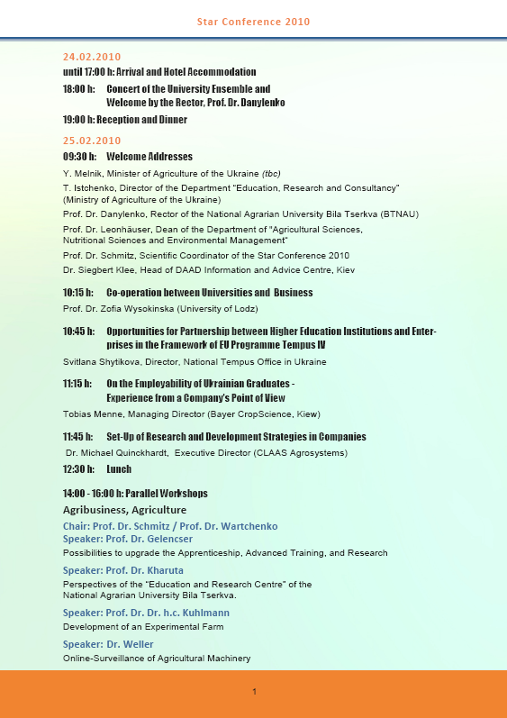
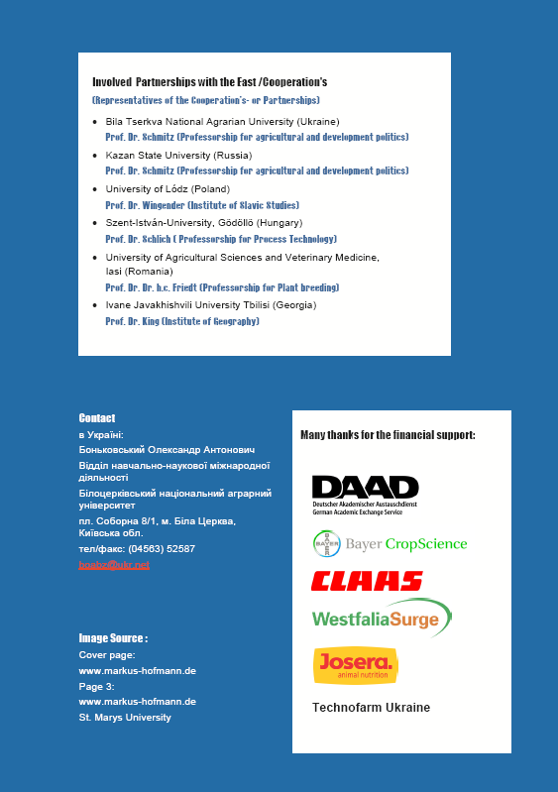

Pictures
Plenary session
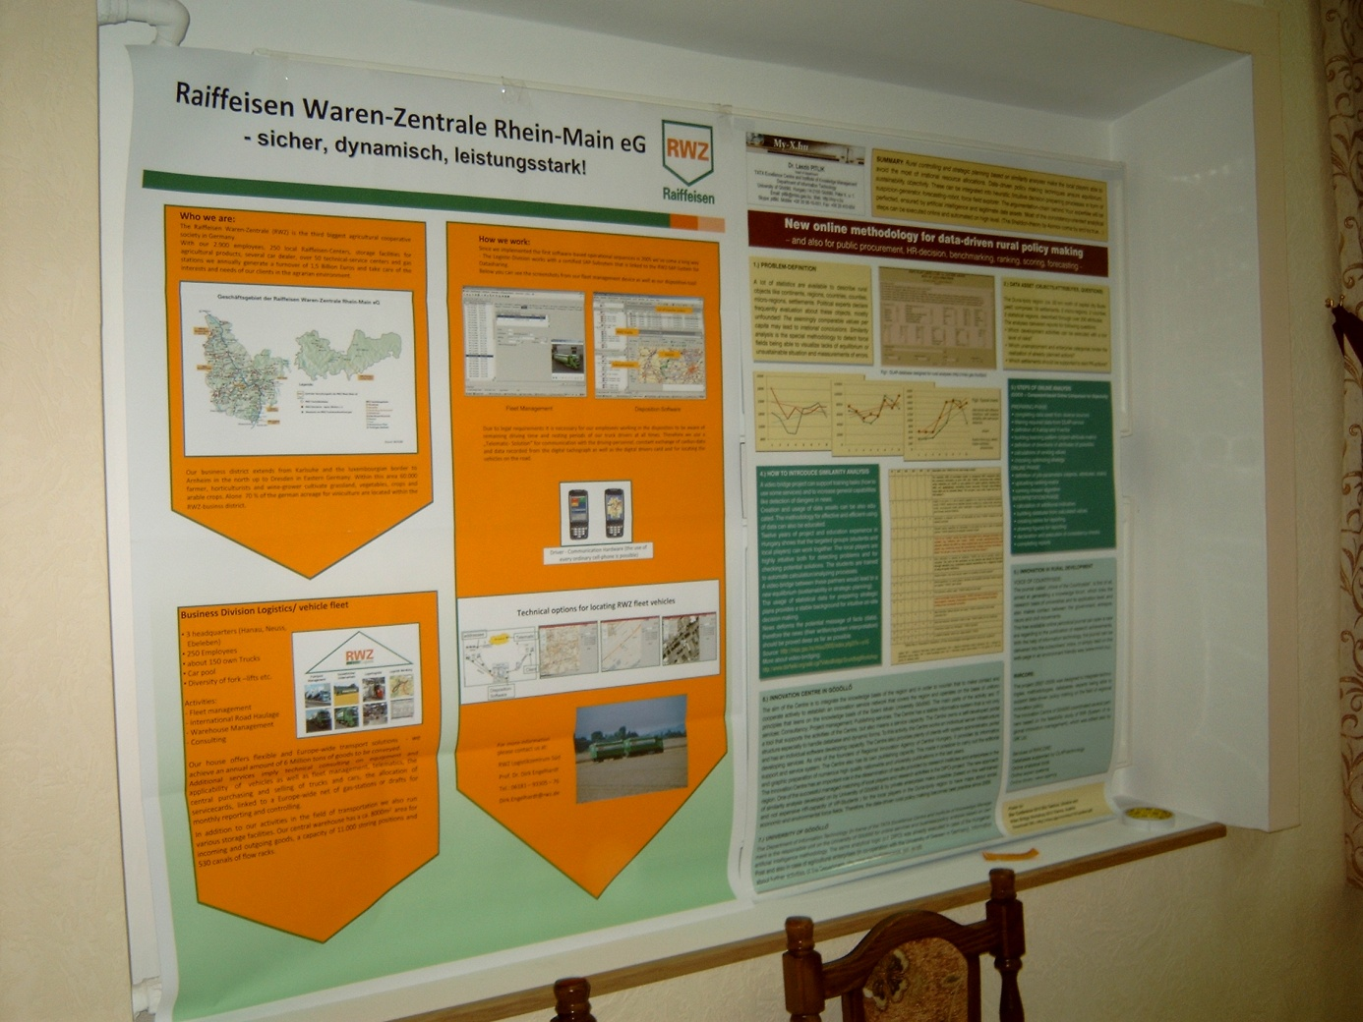
Poster session

http://web.archive.org/web/*/http://miau.gau.hu/temp/test/*

