Development of nutrition simulator or comparison modeling approaches
Pitlik, L. – Ruff, F.

Abstract. The relationship between human sodium/salt (mg/d/p) consumption and life expectancy (year) may be derived from diverse modeling strategies. The analyses have shown the following results: on system-theoretical level a kind of optimum characteristics (with a maximum value) should be identified. This statement can be derived. The coherence of multilayer argumentations, however, is unstable. The prevention strategy conducted by the government seems to be correct, but further analyses should be arranged in the future. In order to be capable of evaluating models in a more consistent way than before, new logical requirements mostly for model-series, as well as well-known statistical characteristics has been defined. A part of these evaluation factors can only be created, e.g., in case of similarity analyses. The best model can be declared through a special similarity analysis, without any necessity of the phenomenon of significance. The identified models broke one or more potential K.O. rules, therefore knowledge expected to be able to build simulators could not be derived - based on the given data asset.
Keywords: salt consumption, modeling, multilayer evaluation system, similarity analysis, consistency
1. Introduction
The following case study describes a universal bio-mathematical problem about a typical social decision situation based on an extended model evaluation concept.

1.1 Chronology and aims
The problem (proving legitimacy of governmental prevention strategy) was formulated in January 2010 [B1] after the conference for applied informatics in Kaposvár, Hungary. In this study, the following data asset was analyzed [c.f. B2]: The time interval was set between 1963 and 2003, using 10 years steps. Objects: 17 EU countries. Attributes: 15 nutrition aspects (Xi, including sodium-consumption) and life expectancy (year).
At first, the following modeling approaches have been compared: linear and polynomial regression techniques, similarity analysis [B3] and WizWhy (as decision forests, c.f. decision trees – [B4]). After that, possibilities of dietetic simulators have been proven: c.f. What kind of relationship can be observed between nutrition inputs (especially salt consumption) and the life expectancy? Finally, the genetic potential was calculated as an element of the complex model evaluation system.
Objectives: Our first task is to define a complex evaluation system for arbitrary model-types, in order to create the most consistent model without breaking legitimate K.O. criteria. In the case study, the dietetic simulator should be based on the most consistent model. If a robust model can be declared and the relationship between sodium consumption vs. life expectancy in this model has not got an inverse characteristics (c.f. the optimum value is low enough according to the Hungarian salt consumption level), then that particular prevention strategy of the Hungarian Government is legitimate. The task is therefore, to prove whether the government has the right to execute a scientifically legitimate campaign for salt reduction based on a more complex model evaluation system than before.

1.2 Problem description
The following study will describe a universal problem in the form of a concrete decision situation (c.f. physiology/biology), both to make interpretations easier and to be involved in recent political processes. The chosen decision situation is: Is the strategy to prevent salt-overconsumption of the government legitimate or not? In order to be capable of giving an appropriate answer, it is necessary to build stable models between sodium and life expectancy, which declares the type of this relationship (like direct/inverse proportionality, optimum characteristics).
Exploring legitimate ceteris paribus (all other things being equal or held constant) mechanisms is one of the most universal problems in biomathematics/biometrics [B5]. This is paralleled by a philosophical problem [B6]: Which one out of two competitive models is the better? (c.f. theory of aimlessness).

1.3 Question-catalogue
- Is it possible to create a new model evaluation system, which includes arbitrary evaluation aspects to declare the best model and subsequently the legitimate (supporting decision making) connection form between variables? Expected answer: Yes, it can be created! Alternative answer: No, it cannot be done (c.f. in this case each previous decision seems to be illegitimate).
- Is building a complex evaluation system based only on statistical evaluation characteristics effective enough? Expected answer: No, it is not effective enough. Potential answer: Yes, the well-known components are effective enough. But in this case: Why does not exist an expert system capable of standardizing each type of modeling approaches?
- Is the governmental prevention strategy according to the salt consumption legitimate? Expected answer: It cannot be evaluated precisely enough based on the involved data assets. Other potential answers: Yes or No, if unquestionable proofs are given pro or con.
2. Scientific backgrounds
As it could already be seen scientific backgrounds were chosen mostly from the Internet. All responsibility will be taken by the authors for this decision. In the 21st century, conventional editorial activities cause an unnecessarily long preparation time interval. Therefore, important new information cannot always be found without using the Internet. This kind of awareness pointed out: the only chance to create value is the content itself (not the form).

2.1 Social aspects
The scientific backgrounds have now three layers: the first one is the social layer (c.f. advising services). Reading the following three publications [B7, B8, B9] begs the question: Are there such kind of differences in publicized statements in case of an already executed prevention strategy in the 21st century (meaning a cybernetic State of Law)? The task of the scientific community is: to declare a legitimate workflow able to decide which statement is even now more (c.f. significantly) accurate or if a winner can be determined at all.
The cybernetic State of Law needs legitimate models to declare legitimate prevention strategies on the population/social level. Individual risks remain always (c.f. [B10)]: Liebig-Law for population and for individuals).
If models cannot be derived with a high legitimacy, then each centrally executed prevention strategy is a kind of careless threat financed by the government.
Pathetic or not: therefore, biomathematics has an important role in the cybernetic State of Law!
Judging by common readers, biomathematics/biometrics [c.f. B11] stands for conventional statistical knowledge these days. This study tries to point out: it is necessary to create a consistence-based workflow for automated evaluation of models.

2.2 Methodological aspects
The statistical backgrounds will not be summarized here and now. In the chapter about the expectations, new interpretations will be published to supplement the common views with special layers clarifying impacts of diverse evaluation values according to approximate modeling approaches (c.f. search strategies).
Both the evaluation of medical expert systems [B12] (searching for instabilities based on similarity analyses) and the space/time-modeling [B13] should be involved now as methodological backgrounds.
A multilingual description of the already frequently mentioned method of the similarity analysis can be found at http://miau.gau.hu/myx-free. In addition, the leading articles [B14] of the Medium of Applied/Agricultural Informatics in Hungary (MIAU) deliver a bright spectrum of application of the similarity analyses. The similarity analyses are able to use staircase functions to solve problems without legitimate solutions, like determining whether the objects are classified at all (c.f. clustering). Other questions that similarity analysis is capable of answering: How to derive an objective price/performance ratio or the NORM-value in SWOT/benchmarking analyses? How can it be useful to involve inverse learning patterns for risk management and sensitivity analysis? Which types of ceteris paribus forms can be detected using automated scanning in the n-dimensional logical space?

2.3 Physiological aspects
This layer will not be prepared here. The chapter about statistical modeling includes the necessary information about the field of physiology.
3. Catalogue of requirements
It seems to be evident or at all not surprising for experts of statistics that almost each well-trained student would be able to create at once seemingly acceptable models for the particular question (salt consumption vs. life expectancy) based on the given software tools and at first independent from legal, ethical aspects. On the other hand, famous physiological experts (in frame of a short interview) made the rigorous statement immediately: robust model cannot be built based on the above mentioned data assets.
Both attitudes (routine task vs. impossibility) should not be given parallel. The health policy can only be derived under these prevailing circumstances: data assets and their consolidation levels are always partial, pressure to take a decision are always given. In social point of view it is necessary to create a new workflow being able to ensure the highest level of legitimacy of model-based (data-driven) policy/decision making.
The following (incomplete) catalogue points out, which kind of hidden logic can be identified in the definitions of seemingly well-known statistical evaluation indicators. In addition, special requirements will be formulated in order to describe further consistency rules being capable to play the roles of K.O. criteria.
5 fields will be completed for each unit: name, short description (mostly an appropriate URL), status variable with the meaning, where the indicator can be calculated (STAT = statistical, SA = similarity analysis). In addition, a further status variable contains: whether the indicator is available for usage as K.O. criteria. Finally, detailed interpretations will be delivered in order to clarify the impacts of the indicators in case of stepwise/explorative modeling. The indicators will be presented in two groups: firstly the statistical and finally the logical group.
Before to come to the catalogue: a remark should be highlighted at all. According to the theory of the aimlessness [c.f. B15] the indicator being able to evaluate models is independent in a given space. Therefore the n-dimensional evaluation of models is the core business science has to solve. This n-dimensional evaluation is the same as a judging/negotiation or even martial law [c.f. B16].

Catalogue of indicators – statistical group:

Name: | AIC (Akaike Information Criterion)
Description: | http://en.wikipedia.org/wiki/Akaike_information_criterion
Status: | STAT & SA
Type: | Suitable for sorting. It isn’t applicable as KO criterion.
Interpretations: | It is an alternative of the . It also measures the accuracy of the estimated model (the less the better). On this basis the comparison of two models may result in the increas of and AIC at the same time. It means that too many variables (c.f. number of variables vs. ) not necessarily give the best model. It’s suitable for treatment of overfitting.

Name: | Adjusted R-squared
Description: | http://en.wikipedia.org/wiki/Coefficient_of_determination
Status: | STAT & SA
Type: | Suitable for sorting. It isn’t applicable as KO criterion.
Interpretations: | The concept of the error per variables allows avoiding the overfitting. If the number of variables increases the accuracy of the estimation also increases. Accordingly the best model would always be the model with the most variables. To prevent this problem the indicator punishes involving too many variables. It means that involving one more variable results penalty in the indicator while, of course, the increases through involving one more variable. The resultant of the two effects gives the actual value of this indicator:,  where N is the number of objects, and k is the number of variables in the model.  In an ad hoc experiment the values of the adj were examined with a constant change in the put into consideration (while the number of the variables changes by one). The results are: if the , then the number of variables → the adj function is increasingly declining, otherwise it is increasingly progressive. I.e. changing the number of the variables it is not the same that from which level it changes by one unit. This turn endangers the evaluation force of this indicator.  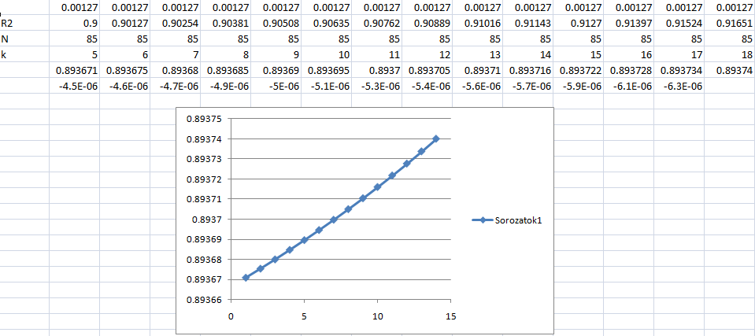  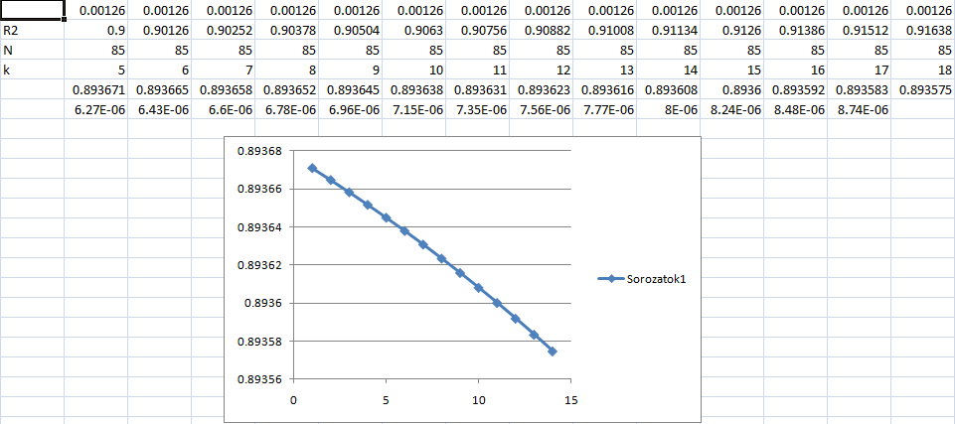  Figure 0: Simulated effects of the changes in the number of variables (Source: own figure )  Figure 0 shows the calculation based on the current sample. The principle which punishes the expansion of the variable number is in conflict with the philosophical expectation: everything is connected. However, reinforces the principle associated with the name of Einstein (cf. the simpler the better). Thus the penalty of model complexity is not suitable suppressing of the real overfitting effects (apparent correlation or spurious relationship). It can be replaced by the supplement of the multilayer consistency examination.

Name: | Multiple R-squared
Description: | http://en.wikipedia.org/wiki/Coefficient_of_determination
Status: | STAT & SA
Type: | It is applicable as KO criterion. We have to agree in an arbitrarily value (e.g. 0.8).
Interpretations: | It shows the proportion of the explained part (by the independent variables) of the total squared deviation. The indicator is not suitable for overfitting exploration, detection. As an objective function specifically tempts toward overfitting.

Name: | Residual standard error (or standard error of estimate)
Description: | http://en.wikipedia.org/wiki/Mean_squared_error
Status: | STAT & SA
Type: | Suitable for sorting. It isn’t applicable as KO criterion.
Interpretations: | It shows the average deviation of the fitted values from the real values (square root of mean squared error).  There is no indicator capable of detecting whether a huge error in case of a particular learning object may be explained by the given independent variables. With other words: the error-structure of a modeling problem can have two characteristics: errors with low standard deviations or errors with high standard deviations. The modeling expert has to decide what type of problem is given. Hence the least squares (where the impact of error minimizing are not independent from the volume of the error: e.g. error_step1=10 and error_step2=9, it means 10*10-9*9=19 vs. error_step1=1 and error_step2=0 makes 1*1-0*0=1 unit error-chaning) lead to other models as the sum of ABS(error), where each error unit has the same impact for modeling results.

Name: | F-statistic
Description: | http://en.wikipedia.org/wiki/F-test
Status: | STAT & SA
Type: | It is applicable as KO criterion. E.g. in a cybernetic State of Law could be expected to be an arbitrarily declared threshold value for the model correctness.
Interpretations: | The statistic answers the null hypothesis: are all of the coefficients equal to zero (in a given (eg. 5%) significance level)? I.e. is there at least one independent variable which has significant relationship with the dependent variable? This evaluation is a pitfall for itself because in case of two different groups of the variables the same variable may get into the model by different characters. That is this form of model evaluation isn’t content free, it is valid only in case of the given variable group.

Name: | variance analysis: residuals to fitted values  standardized residuals to fitted values (scale location)  standardized residuals to theoretical quantiles(normal Q_Q)  standardized residuals to leverage
Description: | http://en.wikipedia.org/wiki/Q-Q_plot  http://www.sciencedirect.com/science/article/pii/016794739190059B  http://stat.ethz.ch/R-manual/R-patched/library/stats/html/plot.lm.html
Status: | STAT (& SA)
Type: | It is applicable as KO criterion in case of an expected linear model.
Interpretations: | There is no rule exact system to declare a statement in an automated way based on the given figures (c.f. Figure 1).  These indicators describe not a numeric model quality, only the ability according to linearity. These indicators are seemingly adequate just for regression. On the other hand the linearity is not an inner characteristic of a model but the learning pattern. Therefore these indicators should be also interpretable in case of all (e.g. staircase) functions.

Name: | VIF-analysis
Description: | http://en.wikipedia.org/wiki/Multicollinearity
Status: | STAT & SA
Type: | It isn’t applicable as KO criterion.
Interpretations: | The VIF index measure the power of relation between the independent variables involved in the model. Regression methods require weak connection between the independent variables. Of course this indicator can’t solve the problem of apparent correlation (spurious relationship). The similarity analysis is able to handle in a model those variables which have the same effects on the dependent variable. In this case we don’t talk about multicollinearity but variable-groups with the same impact to the independent variable, which impact can not be separated according to group members.

Name: | t-test
Description: | http://www.weibull.com/DOEWeb/hypothesis_tests_in_multiple_linear_regression.htm
Status: | STAT
Type: | It isn’t applicable as KO criterion.
Interpretations: | The statistic answers the null hypothesis: is the coefficient of a given variable equals to zero (e.g. in a 5% significance level)?  There is a special question out of scope of this study: Could be declared a new K.O. criterion, if each possible combination of a given set of independent variables would be analysed as a series, because the impact of a particular variable is depending on the other variables. As it can be seen later in case of the logical requirements: models can be evaluated by comparing them to each other. Therefore each type of model-series can be involved to derive evaluation rules.

Name: | component + residual plots
Description: | http://en.wikipedia.org/wiki/Partial_residual_plot
Status: | STAT
Type: | It isn’t applicable as KO criterion.
Interpretations: | There is no exact rule system to declare a statement in an automated way based on the given figures (c.f. Figure 3).  It shows the relation between an input variable and the dependent variable taking into consideration the effects of the other input variables.

Name: | Variable relative importance: lmg
Description: | http://www.jstatsoft.org/v17/i01
Status: | STAT
Type: | It isn’t applicable as KO criterion.
Interpretations: | This indicator gives the order of priority of the variables included in the model.

Name: | Variable relative importance: pmvd
Description: | http://www.jstatsoft.org/v17/i01
Status: | STAT
Type: | It isn’t applicable as KO criterion.
Interpretations: | This indicator gives the order of priority of the variables included in the model. In case of similarity analyses the order of priority of variables can be declared in two ways: first the sum of the effective used stairs can be built as part of the whole estimation (%). The higher part has the higher priority. On the other hand: the standard deviation of the effective used stairs per variable can be interpreted as a type of priority, insofar as the impact/changing capacity of the variable is more important.

Logical requirements:

Name: | Avoiding systematic over- and under-estimations of the dependent variable
Description: | The sum of the facts for Y and the sum of estimations should be the same.
Status: | STAT & SA
Type: | It is applicable as KO criterion for one model.
Interpretations: | In case of similarity analyses the final model can be built as a hybrid solution from unique LP tasks. The integration of approximations (e.g. model error > 0 and model error < 0) can be executed in arbitrary ways (e.g. according to error-proportions without any fine tuning or by building of an average model with fine tuning afterwards). In addition this criterion can be re-formulated, in as such as the requirement will be only validated for a part (as big as possible) of observations, in order to detect consequences without interpretable causes based on the given independent variables.

Name: | Stability of importance of model variables
Description: | The more stability of importance of model variables in case of parallel solutions the more believable the ceteris paribus shape in an indirect way.
Status: | STAT & HE
Type: | It is applicable as KO criterion for model-series.
Interpretations: | On the one hand the importance of model variables will be measured in similarity analysis as part of the sum of estimations delivered by a given independent variable. On the other hand importance can be also declared as standard deviation of stairs of an independent variable. If the part of the sum will be calculated it should be always executed a kind of re-shifting being defined to ensure free searching space for LP-engines.

Name: | Stability of the shape of primary ceteris paribus formations per independent variable
Description: | The more stability of ceteris paribus formations in case of parallel solutions the more believable the ceteris paribus shape itself.
Status: | STAT & HE
Type: | It is applicable as KO criterion for model-series.
Interpretations: | If alternative ceteris paribus formations can be detected without significant difference on other model characteristics, then it is self-evident, that no model is stable enough. The similarity analysis is able to explore potential ceteris paribus formations based on the regulation logic called COCO_MCM (where the abbreviation MCM means a type of Monte Carlo Method (c.f. simulation of number of valid stairs in a given interval) for combinatorial space of the model. The similarity analysis can be also used for a kind of clustering. In this case the Y0 variation of the methodology [c.f. B20] will be applied. The Y0 modeling is able to search for stairs ensuring the most homogenous consequences of all learning objects – in ideal case each object can be seen as a valid member of one cluster. If this type of positive discrimination can be detected, it is hardly acceptable to derive any other cluster versions. In general, if a ceteris paribus formation is not linear, but the given observation do not have appropriate signs for extreme constellation delivering non-linear consequences, then ceteris paribus shapes can be accepted as monotone or linear. In the similarity analysis staircase systems can be described as a system of regressions fitted afterwards to each stair of a model.

Name: | Stability of the shape of secondary ceteris paribus formations per independent variable
Description: | The more stability of ceteris paribus formations in case of parallel solution-series the more believable the ceteris paribus shape itself.
Status: | STAT & HE
Type: | It is applicable as KO criterion for parallel model-series.
Interpretations: | In case of the explorative modeling (COCO_MCM) ceteris paribus formation can be derived based on model-series, called as secondary formation. The easiest version of secondary formation is the monotone version. Here the average of the unique trend parameters of different MCM-stairs per variable will be calculated also for stairs with wave-characteristics.

Name: | Reflecting system-theoretical frames
Description: | In the recent task non-linear relationships with minimum extreme values should be rejected.
Status: | STAT & SA
Type: | It is applicable as KO criterion for unique model.
Interpretations: | If it is well-known in case of nutrition processes, that extreme input values of a system bring always negative impacts (c.f. absence of ingredients or poison due to overloading through arbitrary components), then a non-linear extreme value in the realistic input-interval can only be a maximum value. Otherwise a wave being totally unacceptable would be detected. On the other hand wave-formation could be accepted in case of non-homogenous learning objects. Fortunately the EU-population in the last 50 years can be seen as a representative data asset. Ceteris paribus figures of non-homogenous learning objects could be interpreted as a complex mechanism reflecting more tendencies parallel. These parallelisms can cause definitely wave-shapes (c.f. polynomials).

Name: | Reflecting ceteris paribus view delivered by partial experiments
Description: | The figures explored for cells, individuals or population should be the same in the model and in the experiments having special/partial conditions.
Status: | STAT & SA
Type: | It is applicable as KO criterion for unique model.
Interpretations: | If an experiment for the clarifying of the relationship between daily salt consumption and life expectancy could be detected on cell level under ceteris paribus circumstances, than the basic question of this study would not be exist. But it is evident, that impacts between two attributes of a system are mostly dependent on the environmental conditions. Models we can build in a robust way can mostly be created with one special/average ceteris paribus figure between the dependent and an independent variable. The models being able to reflect more type of ceteris paribus formations are, however, not stable enough. In addition the set of the given variables let mostly change the acceptable model structure.

Name: | Value added effects by learning should be exist
Description: | The interval of the genetic potential and the minimal life expectancy in the model should be acceptable and broader than the known interval in the learning pattern.
Status: | STAT & SA
Type: | It is applicable as KO criterion for unique model.
Interpretations: | In the given learning pattern the minimal and maximal life expectancy are 64.8 and 80.3 years. Modeling based on real combinations of inputs should be capable to deliver consequences assuming in case of more/most ideal combination of model inputs. The ideal combination of nutrition components can be detected by explorative model approaches (like COCO MCM). If a modeling strategy can not interpret the known extreme values of the dependent variable, then it is mostly a sign for an unstable model.

Name: | The behaviour of inverse models should be realistic.
Description: | Based on the logic of double negation inverse models have to deliver symmetric reflected solutions to help interpreting direct modeling.
Status: | STAT & SA
Type: | It is applicable as KO criterion for pairs of models.
Interpretations: | In case of regressions inverse learning patterns can be realised, if the differences between a hypothetical maximum and the given input values will be calculated. A regression model seems to be symmetric without any chances to detect risks in the modeling. Similarity analyses are, however, capable to break the symmetry and therefore they are able to explore special type of risks (c.f. detecting alternative solutions). If a learning pattern consists randomized values, then the amount of inverse errors are maximal. So the ratio of “blind spots” is a kind of characteristic for robust models (c.f. according to the principle: the more, the less).

Name: | Trans-variable relationships should be realistic.
Description: | Relationships are always given between independent variables (c.f. multicollinearity). These parallelisms should be realistic: on the one hand the variable with system-theoretical analogue impacts should have similar ceteris paribus figures. On the other hand modeling approaches should be able to detect interdependencies.
Status: | STAT & SA
Type: | It is applicable as KO criterion for model-series.
Interpretations: | In case of similarity analyses each independent variable will be set as dependent variable, to see, which remained independent variable has the most importance interpreting the given Y. If the relationships can not cover the well-known relationships on the level of phenomena, then the modeling results have a hidden risk potential.

Name: | Impacts of independent variables according to Y should be robust even if the set of interpreted variable will be changed.
Description: | The ideal case is, if a modeling approach is always capable to detect the ceteris paribus characteristics of a given independent variable, even if other independent variables are involved into the learning pattern.
Status: | STAT & SA
Type: | It is applicable as KO criterion for model-series.
Interpretations: | The modeling approaches try always to minimize the model errors. Hereby they are motivated to create multivariate structures simulating special effects like substitutions. In fact multivariate models can behave as if independent variable could be substitute each other (c.f. NPK-functions for plants). These effects are, however, in the real physiological systems hardly to identify. There are indeed equivalents between input combinations according to Y, but in fact nothing more. Therefore it is more than necessary to create models in a combinatorial way, where each potential variable group will be chosen for modeling. If the simulated combinatorial space in case of some variables bring a lot of diverse charactiristics (depend on the other independent variables), then the modeling have hidden risks to manage.

Name: | Avoiding of enforced symmetry
Description: | The non-linear relationships must not be symmetric. The nominal same difference from optimum values can bring totally other impacts.
Status: | STAT & SA
Type: | It is applicable as KO criterion for model-series.
Interpretations: | The well-known regression models are mostly symmetric as far as the optimum values are concerned. If through explorative modeling other characteristics can be assumed, then the enforced symmetry should be broken (c.f. vitamin-C).

Name: | Tolerance of extreme learning patterns
Description: | The primary learning objects (direct measurements) can be completed through secondary objects delivering system-theoretical knowledge into the learning pattern. The modeling approach should be able to handle in a robust way these new challenges.
Status: | STAT & SA
Type: | It is applicable as KO criterion for model-series.
Interpretations: | The secondary inputs can enforced, that ceteris paribus figures will be formed according to system-theoretical expectations. This brings, however, mostly higher error levels for the whole model. The difference between model errors with and without secondary objects should be minimized. The same is valid for the amount of polynomials: more knowledge can not cause more illogical effects than before.

According to the above listed expectations:
- the monotone relationships should be rejected through model-series based on the primary and secondary learning patterns
- without any enforcements extreme values as maxima should only be detected
- without non-linear models with maxima in a spontaneous way the explored models should be evaluated as unstable
- therefore the prevention strategy can only be accepted by the government, where the sodium consumption (c.f. [B17]) and [B18]: NaCl consists ca. 40% Na, so ca. 7 mg/day/person Na in case of male, and 5 mg/day/person Na in case of female – based on data from 2009) and the model optimum for salt consumption show a logical robust relationship.
4. Modeling approaches

The following chapter describes the steps leading to an accepted regression model for the given problem.
4.1 Linear and polynomial regressions
Database
Independent variables: X1 - X15 (nutrient intake). Dependent variable: X16 (Y) (life expectancy) - cf. http://miau.gau.hu/miau/147/salt.xls. Observation units: data from the countries. The calculations were performed using R (R Development Core Team, 2010) development environment.
Aims
Can we detect any correlation between the explanatory variables and the independent variable?
- Is linear model appropriate to describe the relationship?
- How much of the variability of the dependent variable can explain by the constructed model?
- Is there a strong correlation between the explanatory variables?
- Which are those explanatory variables have the strongest impact for dependent variable? Is there an impact of the salt intake to the life expectancy? Is the impact significant?
- How can we choose among the constructed models? Which is the best one? Why?

Basic model (M1) - a multiple linear regression model
Setting up the basic model, all the independent variables were included in linear regression. The data of the fitted linear model:
Residual standard error: 157.9 on 69 degrees of freedom
Multiple R-squared: 0.8229, Adjusted R-squared: 0.7844
F-statistic: 21:37 on 15 and 69 DF, p-value: <2.2e-16
The explanatory power of the model is appropriate (82%), the model is significant (p-value). The assumptions of residuals are fulfilled (Figure 1).

Table 1. Coefficients of the variables in the basic model (M1) Source: own calculations
Intercept | X1 | X2 | X3 | X4 | X5 | X6 | X7 | X8 | X9 | X10 | X11 | X12 | X13 | X14 | X15
686,3 | -1.9 | 0.7 | 0.5 | -24.0 | 0.0 | -36.7 | -1.3 | 49.7 | 73.9 | 185.4 | -82.0 | 0.4 | -2.6 | 45.1 | -10.6

Based on the results we can say that the independent variable (Y) is well characterized by the dependent variables (see F-statistic).

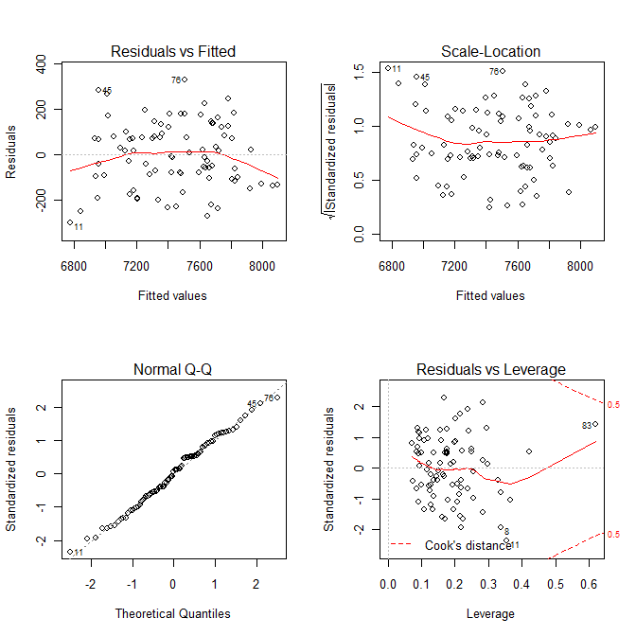
Figure 1. The graphical control of the assumptions of residuals (M1) Source: own figure

Examining the impact of certain variables (t-value) 4 explanatory variables have significant effect (5% significance level). Accordingly some explanatory variable can explain the most of the variability of the dependent variable. A contributing factor can be the independency of the explanatory variables and the Y (dependent variable), secondly, the underlying relationships between explanatory variables. If you look at the correlations of (explanatory) variables (cf. multicollinearity) e.g. with the VIF index, the values obtained are (Table 2):

Table 2. VIF indexes Source: own calculation
Var | X1 | X2 | X3 | X4 | X5 | X6 | X7 | X8 | X9 | X10 | X11 | X12 | X13 | X14 | X15
VIF | 31.8 | 8.8 | 2.4 | 1.8 | 222.9 | 2.6 | 27.1 | 654.8 | 3.8 | 230.2 | 12.8 | 27.8 | 78.8 | 2.0 | 31.8

Second model (M2) - a multiple linear regression model
The second model was developed by "stepwise" method using the basic models. At the end of the procedure, the following results were observed (Table 3):

Table 3. Evolution of the second model (M2) Source: own calculation
Variable | Coefficients | Std. Error | t value | Pr(>|t|)
(Intercept) | 3945.9 | 351.9 | 11.21 | 0.000
X3 | 0.7 | 0.1 | 6.09 | 0.000
X10 | 195.1 | 21.1 | 9.25 | 0.000
X14 | 102.6 | 15.3 | 6.72 | 0.000
X4 | -23.0 | 6.7 | -3.42 | 0.001
X2 | 0.2 | 0.1 | 2.48 | 0.015

Result: the variables included in the model have a much smaller number than it was in the previous model. Each variable has a significant effect on the dependent variable. The second model has a slightly lower explanatory power (79%) than the base model, but the model proved to be significant (F-statistic).
Residual standard error: 158.2 on 79 degrees of freedom
Multiple R-squared: 0.7965, Adjusted R-squared: 0.7836
F-statistic: 61.83 on 5 and 79 DF, p-value: < 2.2e-16
The indicators (VIF values) of relations between the explanatory variables are as follows (Table 4):

Table 4. VIF indexes (M2) Source: own calculation
Variable | X3 | X10 | X14 | X4 | X2
VIF | 1.67 | 1.08 | 1.43 | 1.56 | 1.57

These values are acceptable (<5), ie, there is no significant relationship between the variables included into the model.
The residuals of this model also satisfy the conditions (Figure 2).
Testing linearity the "component + residuals plot" (Chatterjee and Hadi, 2006) was constructed (Figure 3). Concluded that each variable is acceptable for a linear relationship, although the local regression curve (Figure 3, green graph) shows some "roughness" for the X4 and X2 variables, which indicates that it is not the best model has been developed. The test is, however, reasonable to assume: the relationship between the explanatory variables and the explained variable can be described with linear function.
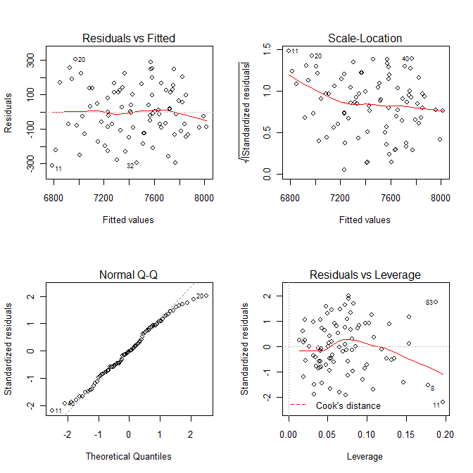
Figure 2. The graphical control of the assumptions of residuals (M2) Source: own figure

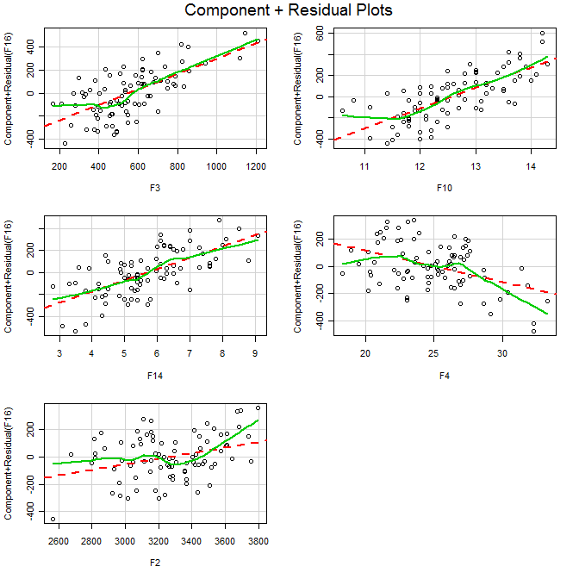
Figure 3. Component + residual plot (M2) Source: own figure

Additional background check
Selecting a model
After performing the previous tests the second model has been selected to perform further analysis. In the decision process (see choice among models with similar explanatory power) was the most important that the model with less variable has a small relations between variables, so the problems of the second-round effects can be avoided.
Ranking of variables
The next step is to examine the strength of the relationship between the exploratory variables and the X16 (ie Y) variable. This exploration was made by the help of the “relaimpo” (Grömping, 2006) package of the R statistical software, which includes a variety of metrics. The two newest one has been chosen („lmg”, „pmvd”) because of the algorithm determining the importance of the variables (they take into account the order of variables entering the model in addition the square deviations). Thus a more computationally (cf. calculation of possible permutations), but more complex metrics are obtained.

Table 5. The importance of variables (M2) Source: own calculation
Variable | lmg | pmvd
X10 | 0.326 | 0.374
X14 | 0.259 | 0.355
X2 | 0.179 | 0.061
X3 | 0.195 | 0.176
X4 | 0.041 | 0.034

All the two index give the same sort: the most important is the X10, the second one is X14 etc. (Table 5). The sum of the numbers is 1 (so can be interpreted as percentage).
The interpretation of the model
On Table 6 can be seen the list of variables and their coefficients sorting by the importance of variables.

Table 6. The list of variables (M2) Source: own calculation
ID | Variable | Coeff.
X10 | Share of calories from protein (total) in total Dietary Energy Supply | 195.12
X14 | Percentage shares of calories from poly-unsaturated fats | 102.57
X3 | Fruit and vegetable consumption (grams/person/day) | 0.67
X2 | Dietary energy supply (DES) (Kcal/p/d) | 0.20
X4 | Non-Starch Polysaccharides (grams/person/day) | -22.98

The most important variable - share of calories from protein – is in positive correlation with life expectancy, 1% increase in X10 causes 1.9 year increase in Y. The range of this variable is [10.6; 14.3] (%). In this range we can accept the theory of the linear connection, because above these values the share of calories from protein will also be appropriate (Schmidhuber, 2007). The model does not contain the other two nutrient sources: fats and carbohydrates. Investigating the relationship between these variables (correlation coefficients) can be seen that the share of energy supply from fats (X9) and carbohydrates (X8) are in strong negative relationship (r = - 0.88), so these variables alternate each other. The connection of proportion of calories from protein and carbohydrate shows a negative relationship (r = - 0.34), which explains that from the 3 variables only one has been introduced into the model.
In the same way the directions of relationships between the other variables can be explained well by our present knowledge.
However, we have got a contradiction in connection with the X4 (non-starch polysaccharides) variable. It is interesting that this variable - which probably means the cellulose - is in negative relationship with the life expectancy. The cellulose is not digestible, eliminated from the digestive system. Thus the expectation would be that it hasn’t got an effect on life expectancy (it is true its impact is the smallest). Other variables have also been examined in connection with X4. Measuring the relationship with correlation coefficient we can see more than +0.5 coefficients with carbohydrate and fruit. But then we contradict with the fact that the dependent variable and the amount of fruit (and vegetables) are in positive relation.

Summary of linear partial results
The result of the model M2 (R squared, F-statistic, VIF, t-values) are acceptable. But have been found some conflict:
- Is the linear model the best one?
- There are problems with the direction of relations.
Can be formally stated from the salt intake:
- According to the M1 model, the more the intake of salt, the higher the life expectancy. The t-value signs the week relation between X5 and Y.
- According to the model of the M2 - salt intake has no significant effect on life expectancy.
The two models with each other and with valid public prevention policy are also inconsistent. Despite the well-suited function (M2) we have to challenge the result obtained taking into account the contradictions.

Third model (M3) - polynomial regression (quadratic) model
Taking into account the possible effects of variables polynomial regression has been applied, in which each variable also were included on the second power, and then developed the model using stepwise method, in which all the variables have a significant impact. Thus, any determination of optima is possible. The resulting model can be seen on Table 7.

Table 7. Evolution of the third model (M3) Source: own calculation
Variable | Estimate | Std. Error | t value | Pr(>|t|)
X2 | -4.16E+00 | 1.29 | -3.23 | 0.002
X2² | 7.22E-04 | 0.00 | 3.68 | 0.000
X3 | 6.75E-01 | 0.16 | 4.10 | 0.000
X4 | 1.89E+02 | 58.75 | 3.22 | 0.002
X4² | -4.06E+00 | 1.16 | -3.51 | 0.001
X5 | 4.90E-01 | 0.10 | 4.70 | 0.000
X5² | -7.83E-05 | 0.00 | -4.45 | 0.000
X6² | -2.31E+00 | 0.62 | -3.71 | 0.000
X8² | 3.61E-01 | 0.12 | 2.95 | 0.004
X9 | 3.14E+02 | 47.72 | 6.57 | 0.000
X9² | -3.34E+00 | 0.71 | -4.69 | 0.000
X10² | 4.45E+01 | 19.84 | 2.24 | 0.028
X11 | -9.33E+01 | 14.45 | -6.46 | 0.000
X13² | -1.19E-02 | 0.005 | -2.27 | 0.026

Residual standard error: 116.5 on 69 degrees of freedom
Multiple R-squared: 0.9035, Adjusted R-squared: 0.8826
F-statistic: 43.09 on 15 and 69 DF, p-value: < 2.2e-16
The result shows that members of the squares are significant (at 5% level). Their coefficients are also negative and positive. This means that the partial functions have local maxima or minima. The model proved to be significant, it has great explanatory power. The necessary conditions for the residuals can be seen on Figure 4.
There are strong relationships between variables (measurement: VIF), as the square of most of variables included in the model. Therefore, the measure which was used in linear model for determining the order of importance of variables was non-useable.

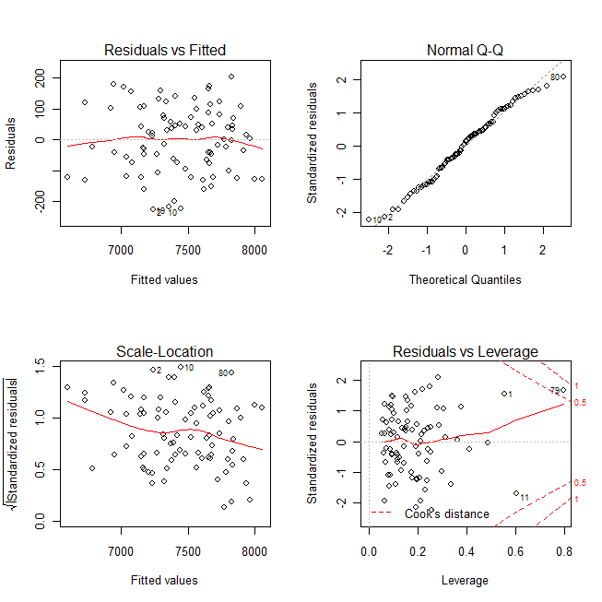
Figure 4. The graphical control of the assumptions of residuals (M3)
Source: own figure

Further analysis
Interpretation of the model M3
Where the linear factor was eliminated from the model (X6, X8, X10), there is mathematically a parabola which is symmetric to the y-axis ie, taking into account the condition of non-negativity, in the given range we get monotone increasing function (X8, X10) and monotone decreasing one (X6 ), but the relationship is not linear, but quadratic. These results are in agreement with the M1 model in connection with increase or decrease of partial function.
In the case of other quadratic expressions the local optimums are as follows: X2: 2882.7 - X4: 23.3 - X5 (salt intake): 3126.8 (mg / p / d, where the test sample has a minimum at 1315 mg / p / d, and a maximum at 5,404 mg / p / d, and there are 10 objects above the optimum: 1963PT, 1973PT, 1993DK, 1993PT, 2003DK, 2003FI, 2003GR, 2003NL, 2003PT, 2003SE) - X9: 47. These means a local minimum in the case of variable X2 and in other cases we are talking about local maxima (see the coefficients of squared variables).
The interpretation of local maxima
X4 - non-starch polysaccharides, X5 - salt consumption, X9 - share of calories from lipids in the Dietary Energy Supply. The quadratic relationship between these variables and the Y shows optimal quantity. However, the maximum point in the case of X9 is outside the tested range [20.3 to 41.5], thus we have got a monotonically increasing function that determines the values of the dependent variable in this range. Comparing with the linear model, we find that the X4 and X9 variables have been showed a negative correlation with the dependent variable, while the salt consumption was not included in it. However, assuming a quadratic relationship the X5 variable has become a significant variable of the model. The existence of the optimal input values for these variables are acceptable, it matches with our previous experience. We have to ask: Why have not received such an optimal value in connection with other variables?
- The investigated range of the independent variable doesn’t include the optimal place.
- The growth of the independent variable means the growth of financial well-being, and other variables (lifestyle, health supplies, and nutritional supplements) that have not been included in the model compensating the wrong effects of the previous variables.
The interpretation of local minima
X2 - energy intake: The local minima is difficult to explain. Would it be a level of the independent variable, which includes a minimal life expectancy? Its adoption would be contrary to the previous knowledge, unless the 85 objects don’t separate to 2 logical recognizable subsets by the local minimum (e.g. spatial, cultural, seasonal or any other character). However, this review has already exceeded the intended scope of the study...

Fourth model (M4) - polynomial regression (quadratic) model
As in the third model the relationships between variables were strong, the next target to eliminate this model. The linear transformation of the independent variables is as follows: the subtraction of the average values of variables from all its values.

Table 8. Evolution of the fourth model (M4) Source: own calculation
Variable | Estimate | Std. Error | t value | Pr(>|t|)
X2² | 1.05E-03 | 0.000 | 4.838 | 8.02e-06
X3 | 7.76E-01 | 0.121 | 6.429 | 0.000
X4² | -4.31E+00 | 1.101 | -3.911 | 0.000
X5 | 1.98E-01 | 0.040 | 5.01 | 0.000
X5² | -1.26E-04 | 0.000 | -6.366 | 0.000
X6² | -8.15E+00 | 2.633 | -3.096 | 0.003
X8² | 3.94E+00 | 1.402 | 2.812 | 0.006
X9 | 1.94E+01 | 7.465 | 2.594 | 0.012
X9² | -5.60E+00 | 1.369 | -4.092 | 0.000
X10 | 1.04E+02 | 26.530 | 3.912 | 0.000
X10² | 7.33E+01 | 18.180 | 4.034 | 0.000
X11 | -7.22E+01 | 14.530 | -4.971 | 0.000
X11² | 9.39E+00 | 3.648 | 2.574 | 0.012
X12 | 1.28E+00 | 0.398 | 3.217 | 0.002
X12² | -9.12E-03 | 0.002 | -3.767 | 0.000
X14² | 2.04E+01 | 5.859 | 3.487 | 0.001

Residual standard error: 116,2 on 67 degrees of freedom
Multiple R-squared: 0,9068, Adjusted R-squared: 0,8832
F-statistic: 38,36 on 17 and 67 DF, p-value: < 2,2e-16
The necessary conditions of setting up the model have been fulfilled (based on diagnostic plot).
Further analysis
The interpretation of local maxima
There are four variables having local extreme in the range of observation: X5, X9, X11, X12. The third one (X11) gives local minima while other ones give local maxima. The extreme points are as follows:
X5: 789.18 +2360.09 = 3149.27 (mg / p / d) - X9: 1.73 + 34.84 = 36.57 - X11: 3.85 + 12.03 = 15.88 - X12 : 70.20 + 403.81 = 474.01.
Interpreting the local maxima we can find some differences (compared to M3):
- the maximum point of X9 is already in the test range , that is, in fact there is an optimal value,
- the X12 variable is not mentioned in the previous model.
The effect of salt is considered the same as in M3. The existence of optimum input values are again matches with our experiences.
The interpretation of local minima
The local minimum issue arises again apropos of X11 (calories from cholesterol). However, the examination of the place of the extreme shows that there are only 2 objection in the right side of the minima (1963FI, 1963UK), which is not convincing in this regard. Thus, in the investigated range, the relationship between X11 and Y is rather monotone decreasing function.
Ranking of variables
Determining the order of the variables the previously (see in linear regression) presented values have been applied (Table 9).

Table 9. The importance of variables (M4) Source: own calculation
Variable | lmg | pmvd
X3 | 0.155 | 0.145
X10 | 0.140 | 0.210
X9 | 0.130 | 0.229
X12 | 0.085 | 0.051
X5 | 0.077 | 0.055
X11 | 0.072 | 0.079

The most important variables of the model are: X3, X10, X9. The two indicators give a different order, but the three most significant according to both “lmg” and “pmvd”. Two of these (X10 and X3) in the case of linear models are also included among the three most important variables.
Calculation of genetic potential
The maximum and minimum of Y has been calculated in the following way: in the domain of every independent variable has been found the value (Xmax, Xmin) which has the maximum/minimum partial Y value. And then these X values have been substituted to the regression function. The obtained values (Ymax, Ymin) are out the range of Y. E.g.
The predicted values of Y
with Xmax: Y=10323 that is 103,23 year
with Xmin: Y =3922 that is 39,22 year.

Comparison of the models

Table 10. The values of the calculated indexes Source: own calculation
Model | AIC | R2 | adj R2 | VIF | F test (5%) | Resid. st. err. | Pearson | Y_{max} | Y_{min} | Y_{fact}=Y_{estimate} | Importace
M1 | 1118 | 0.823 | 0.7844 | bad | OK | 157.9 | 0.907 | 64.11 | 35,92 | OK | F10,F14,F3
M2 | 1110 | 0.796 | 0.7836 | good | OK | 158.2 | 0.892 | 88,38 | 61,7 | OK | F10,F14,F3
M3 | 1066 | 0.903 | 0.8826 | bad | OK | 116.5 | 0.950 | 107,75 | 29,46 | OK | -
M4 | 1067 | 0.907 | 0.8832 | good | OK | 116.2 | 0.952 | 103,23 | 39,22 | OK | F3,F10,F9

Table 11. Ceteris paribus relations (X vs. Y) Source: own calculation
Variable | M1 | M2 | M3 | M4
X1 | -
X2 | + | + | min | +
X3 | + | + | + | +
X4 | - | - | max | -
X5 | + |  | max | max
X6 | - |  | - | -
X7 | -
X8 | + |  | + | +
X9 | + |  | + | max
X10 | + | + | + | +
X11 | - |  | - | min
X12 | + |  |  | max
X13 | - |  | -
X14 | + | + |  | +
X15 | -

Conclusions
The best model is: M4.
Taking into consideration the tests for validating models (Table 9) essentially M4 has in all respects the best values.
The models are the same in term of the direction of the impact of certain variables (Table 10), except in the case of optima that are not able to detect the linear models.
Based on the optimum point for the salt (Na mg/day/person) and the Hungarian reality the current state of prevention strategy may be called – from mathematical-statistical point of view - legitimate.
The M4 model sticks, however, in the problem of the local minima.

4.2 Similarity analyses
In addition to the above delivered short description about the similarity analysis it should be now focused on the staircase functions [c.f. B19]. In order to be capable to involve staircase function in the model building, the input data (having diverse scales) should be transformed to ranking values. The definition of ranks requires the definition of direction pro independent variable. These directions can be seen as a type of ceteris paribus relationship. Ranking direction can define monotone ceteris paribus shapes. The modeling without constrains for directions make possible to create explorative models. Explorative models are able to handle with arbitrary relationships between X_{i} and Y for the entire model. If the number of learning patterns (objects) is voluminous enough, then staircase function can be created for parts of the whole data asset. In this case the ceteris paribus formations between the same X and Y can be different. The adjusted impact of the partial relationships should be given as result the covering relationship based on the whole learning pattern.
The staircase function can be seen as a type of decision tree, where the nodes represent the stairs. In case of the deriving staircase function the amount of the maximal stairs should be set in advance. On the other hand: stairs can be merged. Therefore the optimal size of stairs will be derived in the (n)LP procedure. A multiplication can be executed between the amounts of valid stair-units per variable. The result of this multiplication leads to the combinatorial space at least. Each valid combination (the particular sum) of stair levels has always a consequence as model output. The set of the valid combinations can be seen as a type of a discrete simulation system.
The parameters of the staircase functions will be calculated by running of LP-tasks. If the objective function do not consist absolute or quadratic parts, then the results can be built based on two linear approximations: the model error in each model part should be minimized. The results can be derived according to two strategies: on the one hand the average of the two approximation pro stair unit can be fine tuned, while the sum of the valid stairs in the learning pattern view and the sum of each Y value will be the same. On the other hand the two approximations can be mixed in special proportion, in order to ensure, that the sum of the model estimations and the sum of the Y values are the same.
There are arbitrary model-types in the similarity analysis as well as the standard additive model: multiplicative models build their estimation through multiplication of appropriate stair levels. In addition hybrid models can be also created where the core transformation can be factual arbitrary: e.g. median of stair levels/average of stair levels pro object (like activation function in case of artificial neural networks). It is also possible to involve each primary value of the learning pattern into the core transformation as well as ranking values and their substitutes: the stair levels. Staircase function transform the problem to a combinatorial space (= rule system) or the sophisticated weighting of primary values at least. In this study were only integrated additive and multiplicative functions.
The objective function or the definition of model error can be arbitrary too. The quadratic error between estimations and fact should be only chosen, if the input variables are in fact highly responsible for the model consequences. Otherwise it should be taken the absolute errors or the above mentioned linear approximation based on two LP-tasks with the chosen integration logic.
Monotone additive models
Explorative modeling can be driven by automatisms and manual. Explorative modeling should be able to derive the most robust ceteris paribus relationships between each X and the Y variable. Monotone staircase models can build on the base of combination of ranking direction. Each independent variable can be transformed to ranking values in two ways. On the one hand (direct view) each variable should have the ideal direction, which describes a ceteris paribus relationship based on the literature. On the other hand the inverse direction will be defined contrary to the ideal one. Directions can only be two. Therefore the amount of potential models is 2^{N}, where N stand for the amount of independent variables. The most different models of them are the two models with homogenous directions (c.f. the more the more, and the more the less). The directions can be mixed, in order to ensure the highest level of R².
The comparison of direct and inverse models should give a mirrored view of the objects according to their relationship to the factual values. If the so created reflection is not totally symmetric, then it can be spoken about blind plots. The amount of the blind plots is a measurement for modeling risks (c.f. the more the more).
The reduction of the amount of stairs can be interpreted as a type of sensibility analysis. Through reduction of the combinatorial space the adjusted R² can be mostly increased, as though other model indicators will decrease.
The sum of the first levels of a staircase can be seen as a kind of genetic potential in the proven system. The same interpretation is valid for the last level of stairs too.

Interpretation of inverse models
The explorative modeling can be substituted if at first models with monotone directions will be created. If totally controversial models deliver parallel high indicators about model validity, then it cannot be spoken about a “best” of models.
In this phase 4 (monotone additive) models were created: 2 models had 85 levels (r1) in the staircase function (not visualized now). Two further models were derived with 8 levels. The reduction rule was: r2=int(r1/11)+1, where r1 stands for the original ranking value in the range 1,…,85.

Table 12. Stairs and indicators of direct (part I) and inverse (part II) models with monotone directions (Source: own calculations: Legend: each value of stairs transformed to year*100, parameters give the sums of unique stairs pro attribute.)
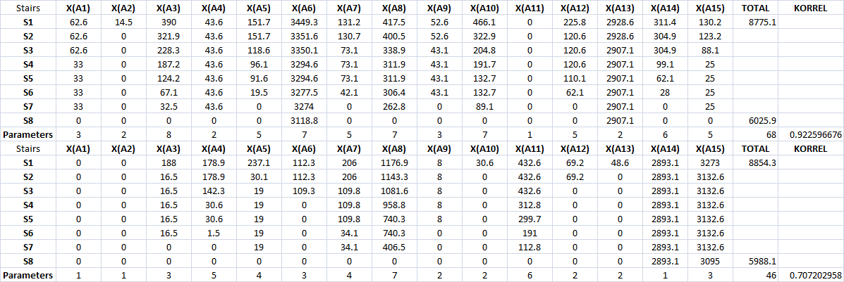

Facts:
The models with 85 stairs (c.f. 85*15 components for calculating adjusted R²) delivered high correlation values between facts and estimations: KORREL(direct)= 0.9999987, KORREL(inverse)=0.944289539. Table 12 shows the correlations decreasing in case of the models with 8 stairs pro attribute. The models with the monotone direction type “the more the more” had higher correlations and less decreasing of correlations. The genetic potentials of the models with 8 stairs bring similar values: 87.751 -- 60.259 years, and 88.543 -- 59.881 years.) The proportion of blind plots is 45% in case of the models with 85 stairs. The same value in case of the models with 8 stairs is 51%. The sum of the valid stairs could be reduced (from 68 to 46) based on inverse modeling. The impact of the salt consumption is 8 % in case of the direct model with 85 stairs and 2 % in its inverse view. The same indicators have a level of 1-1% in the models with 8 stairs.

Conclusions:
Totally different directions lead to rel. robust models (c.f. logic of the adjusted R², where decreasing of the combinatorial space gives compensation for lower correlation). Yet all together: the direction logic “the more the more” shows more stability. The increasing of the salt consumption (X₅) should bring a longer life (Y). Therefore the national prevention strategy should be illegitimate based on these partial results. The conclusions include a high level of risk, because controversial partial result could be detected.

Interpretations of secondary monotone direction

The randomized setting of directions can be substituted through explorative modeling, where the constraints for staircases pro attribute are totally excluded (c.f. MCM-modeling). In background of this chapter 4 MCM models were created. The valid amount of stairs was set as 3, 4, 5, 6. Table 13 shows the trends of the partial models. The average of these trends pro variable could be negative (the less the more: code = 1) or positive (c.f. the more the more: code = 0) according to Y.

Table 13. The results from the indirect searching for directions (Source: own calculations: Legend: each value of stairs transformed to year*100)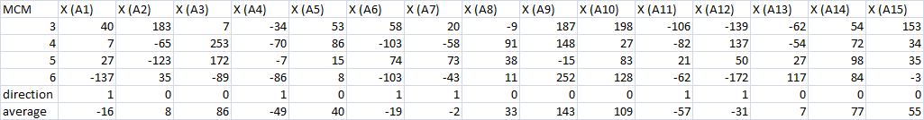

The row with the direction (0,1) describes the model with a robust combination of ceteris paribus logics. Based on these mixed directions 4 models were created: a pair (direct and inverse models) with 85 stairs, and a further pair with 8 stairs.

Table 14. Stairs and indicators of direct (part I) and inverse (part II) models with mixed directions (Source: own calculations: Legend: each value of stairs transformed to year*100, parameters give the sums of unique stairs pro attribute.)
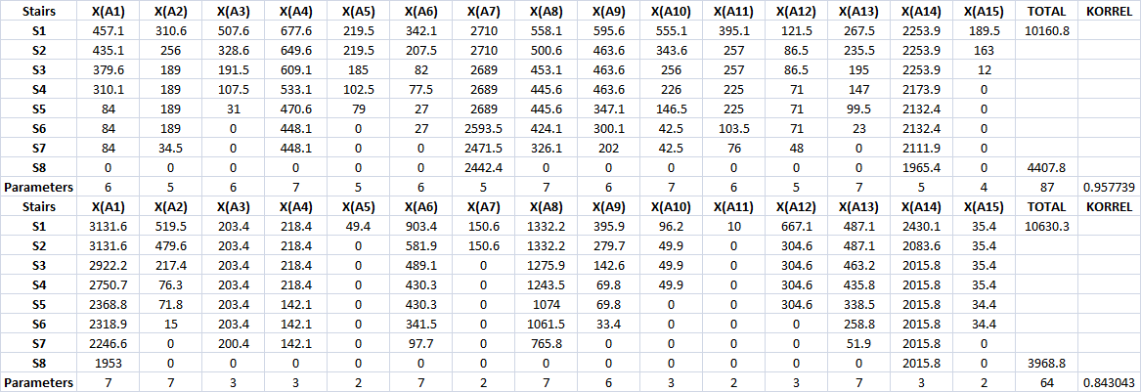

Facts according to table 14 ad Figure 5:
KORREL(direct_85)=0.9999, KORREL(inverse_85)=0.99999. The same indicators for models with 8 stairs show a decreasing but with rel. high values: higher than before in case of monotone directions. The fit and blind plots ratio decreased (43:42 vs. 41:44) according to decreasing of the amount of stairs from 85 to 8. The impact of salt decreased too: from 3% to 1 % in case of direct models with 85 and 8 levels and also from 2% to 0% in case of inverse models with 85 and 8 stairs. The valid levels of stairs for building of combinatorial space are 87 (direct) and 64 (inverse) in case of models with 8 stairs.
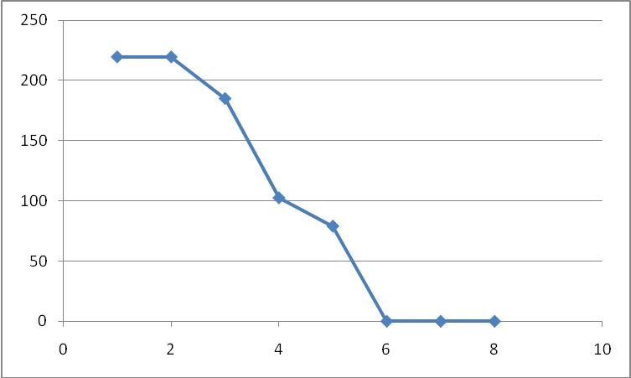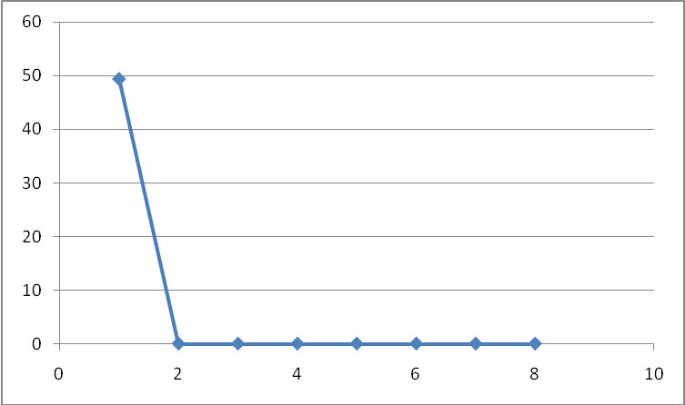
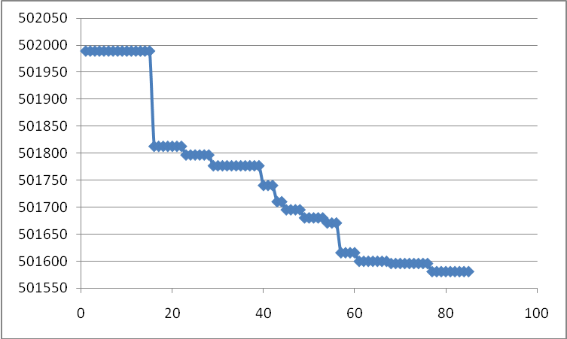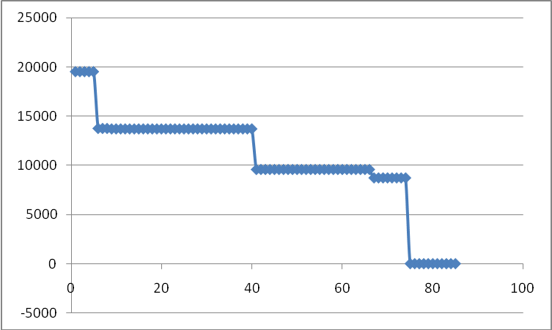
Figure 5. Staircases (8 and 85 levels) for X₅ (salt consumption)
in the models with mixed directions (Source: own figures)

Conclusions:
The chances to build a monotone additive model with low risk level are not given. The salt may have a relationship to Y according to the logic: the more the more. Argumentations are: models with mixed directions have a higher correlation level (+), but they use more valid stairs (-). The genetic potential shows a wider interval as before (+). The salt has hardly any impact (c.f. % and valid stairs) in the inverse models (+). The impacts of salt in the models with mixed directions are lower as before (-). The inverse mixed models has the higher correlation in case of 85 stairs than the direct model (-). Summa summarum: The government strategy could not be evaluated based on these partial results with high risk potential.

Non-monotone additive models
Based on the previous results, where hardly any robust conclusion could be derived, it is now necessary to switch to the real explorative modeling (c.f. COCO MCM). The direction-driven modeling leads always to models with monotone ceteris paribus relationships between each X and Y. The explorative modeling has to ensure non-monotone figures also. This is possible, if there are no constraints for stairs prescribed.
Facts based on the table 15 and figure 6 (only with ceteris paribus aspects about salt consumption and life expectancy):
- expecting two columns with red marked values (in case of 3-stairs and 9-stairs models) each other model show a robust polynomial characteristics
- the best model (according to the correlation values) is the model with 9-stairs (even without polynomials)
- the best model has a ceteris paribus relationship without any symmetric features in the visualized interval: therefore the impact of the increasing of salt consumption toward optimum is less relevant than the impact of overloading
- the optimum value is 2626.9 mg/d/p/1000 based on the next objects
- the total impact of salt is 6% in the best model and ca. 2-3% in each other case.

Table 15. Results of the explorative modeling (Source: own calculations: Legend: each value of stairs transformed to year*100, optimum value derived by countries and years. Each MCM model based on the principle: the 1. stair level means the most input pro variable.)
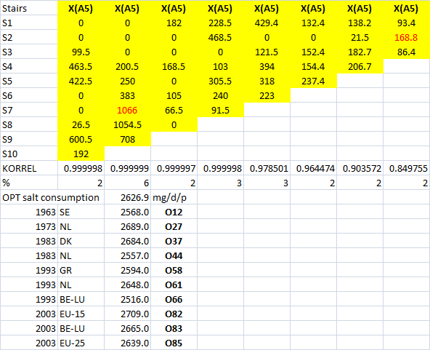

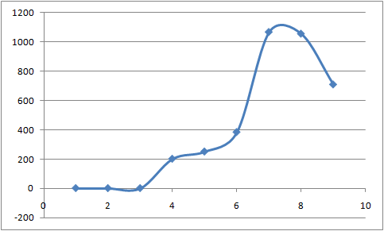
Figure 6. Ceteris paribus relationship between salt consumption stair levels (X₅) and life expectancy (year*100) in a case of explorative modeling (Source: own figure)

Conclusions:
The explorative models delivered an unstable best model with optimum characteristics for salt as independent variable, where the Hungarian average sodium consumption is over the optimum value. Therefore the Hungarian prevention strategy can be legitimated as though a high level of risks is given in the background of this expertise.

Additive models with secondary learning cases
The involving of secondary learning case can be seen as a type of stress test of the modeling: well-known conclusion for massive lacks or overloading of inputs lead in general to minimal output values. A modeling approach should be able to handle these system characteristics too.

Table 16. Results of modeling with secondary cases (Source: own calculations: Legend: each value of stairs transformed to year*100. Each MCM model based on the principle: the 1. stair level means the most input pro variable.)
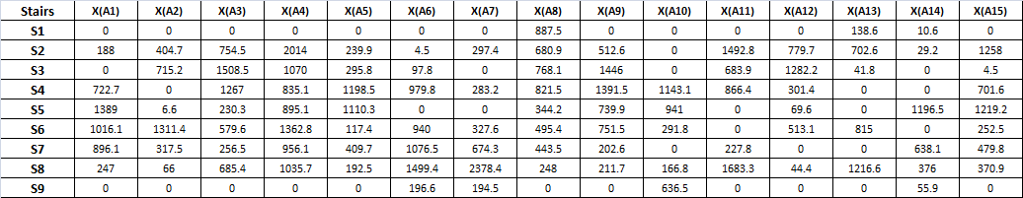

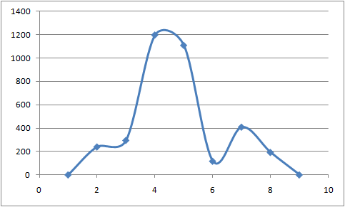
Figure 7. Ceteris paribus relationship between salt consumption stair levels (X₅) and life expectancy (year*100) in case of secondary learning items (Source: own figure)

Facts based on the table 16 and the figure 7:
Polynomials in the ceteris paribus relationships can be detected in case of the most variable. Salt (X5) shows a minimal deformation according to a classic optimum function. The other independent variables have also non-monotone relationships to Y. The correlation of this model is: 0.951557263. The extreme values of genetic potentials cover the interval of 0 and 214 years. The impact of the salt consumption is ca. 6 %. The optimum value for salt can be identified as 2240 mg/d/p/1000. The ceteris paribus figure of salt consumption is not symmetric, but it is very sensible about the optimum value.
Conclusions:
The optimum characteristic for salt with a seemingly acceptable optimum value can be assumed. Therefore the Hungarian prevention strategy is rather legitimate than not, but the coherence of the argumentation is very poor (c.f. amount of polynomials among the ceteris paribus relationships).
Multiplicative models
Based on system theoretical knowledge the optimum characteristics for each independent variable could already be derived. Argumentations for creation of multiplicative models can also be found in this field: biological systems have hardly any tolerance in case of massive lacks or overloading according to their inputs. This system characteristic can be described in a simplest way through multiplicative models, which show zero output values at once, if one of the proven variables is not able to reach the necessary level – independent of the input levels of each other variables.
Multiplicative models can only be produced in Excel: in case of 15 variables maximal 6 stair levels can be accepted, because the solver engine does not make possible an unlimited amount of constraints.
To check multiplicative system reactions, it should be created two new models: one model with 85 (primary) learning cases and a further model with 87 rows. The two secondary learning items show a massive lack and a massive overloading of inputs with consequences, where the Y value was set as zero.

Table 17. Results of multiplicative modeling without secondary cases and with 6 stairs (Source: own calculations. Legend: the multiplication of one value pro variable leads to the estimation of Y in years*100. Each MCM model based on the principle: the 1. stair level means the most input pro variable.)
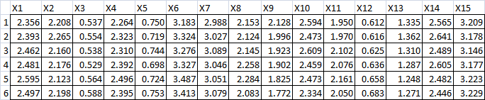

Table 18. Results of multiplicative modeling with secondary cases and with 6 stairs (Source: own calculations. Legend: the multiplication of one value pro variable leads to the estimation of Y in years*100. Each MCM model based on the principle: the 1. stair level means the most input pro variable.)
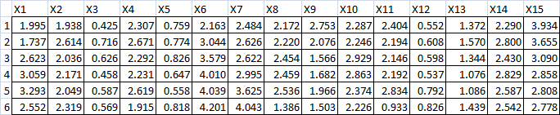

Table 19. Indicators (correlation, genetic potentials) of the multiplicative models (Source: own calculations)
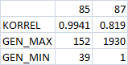

Facts based on the tables 17-19:
The coefficients for X3 (Fruit and vegetable consumption (grams/person/day)), X_{5 (salt consumption)}, X12 (Shares of calories from saturated (% of DES)) are less than 1. Therefore these variables are seemingly never able to increase in a direct way the life expectancy. In the best case these 3 variables are able to stabilize the impact of the other variables. The ceteris paribus relationships of the two models show polynomials. The learning pattern with 87 items can not be interpreted with 6 stair levels: the genetic potentials give a unrealistic wide interval. The 6 level-models are in general unstable: the amount of polynomials is high.
Conclusions:
As though these multiplicative models are not the best of their class, the correlations are high enough. Yet the real consumption levels in the proven cases do not make necessary to create multiplicative models. On the one hand: The salt consumption can be interpreted in general as a type of danger (c.f. values < 1). This is an indirect legitimating for the Hungarian prevention strategy. (On the other hand: similar “dangerous” effects should be assumed for fruit and vegetables!? This type of logical incoherence could be detected in case of polynomials for other variable as though salt had the expected optimum characteristics.)

Comparison of models made by similarity analyses
The similarity analyses delivered a lot of models with rel. high correlation levels, which had totally different ceteris paribus characteristics. This incoherence is the most important result. Ceteris paribus relationships (especially in the same time) cannot be formed according to the system theoretical necessity. Yet the explore partial results let us assume, that in case of the salt the Hungarian prevention strategy can be accepted.
In case of models based on the similarity analysis the well-known phenomenon, the significance is not necessary to be interpreted. The potentials models and the expectations according to these “pictures” produce inconsistencies. The less illogical effect leads to the more validity according to a hypothesis.
If the best model should be declared, than a set of indicators for each model (based on similarity analysis) can be calculated (only in case of a potential robust hypothesis to recommend). A direction-series for indicators can prescribe the ideal model. A last similarity analysis (called Y0-analysis) can be deriving the best model [c.f. B20]. The Y0 modeling is always searching for the set of model characteristics, which cannot be interpreted as a bad constellation according to each other model indicators. The Y0 modeling creates hereby equivalences between indicators.
In this modeling problem the ceteris paribus expectation are very unstable. Therefore it is not worth searching for the best model. The given data asset is not good enough for building a simulation system.

4.3 WizWhy
WizWhy embodies one of the newest developments in the fields of analytical reforms. The decision trees can be completed, if almost each potential rule-series will be evaluated. WizWhy are able to deliver a voluminous amount of rules with more variables in frame of a high-speed process. WizWhy offers also a type of optimized way, how to build the best rule system based on the potential rules. All together WizWhy leads as solution to following set of answers: an arbitrary set of input values should cause an ouput value higher than a threshold. This is a simulation system, based on the same logic as in the case of similarity analyses. The rules of WizWhy are mostly shorter than in a similarity analysis, where each variable can always be involved in to the model. WizWhy builds discrete and non-monotone solutions. The logic of regression is (in this study) delivered always continuous functions with predefined extreme values. The similarity analysis is able to derive arbitrary or hybridized solution, where the frequency of polynomials can be influenced. WizWhy delivers directly no optima or genetic potentials they can be derived in addition.
In case of 85 learning items WizWhy can prove 84 thresholds. The more extreme a threshold is the less chance to find robust rules for classification. Yet WizWhy offers a verification system with 84 layers in order to declare a kind of consistency. Due to limited volume in this study more details cannot be published now.
5. Discussion
The study described parallel ways to derive evaluations for hypotheses. The 3 ways were: several types of regressions, different approaches of similarity analyses and WizWhy, the “rule forest”.

5.1 Statistical aspects
Based on the well-known logic of regressions a final solution seems to be declarable. According to this solution, the Hungarian prevention strategy is legitimate concerning salt consumption.

5.2 Similarity analyses
The similarity analysis using new approaches for building models basing (n)LP-driven components, delivers a more critical view about the consistency of items in the whole verification system. Therefore the Hungarian prevention strategy for salt can be seen as legitimate, but the level of the coherence of verification fragments is very low. In a juridical process new data assets and new analyses would be prescribed.

5.3 WizWhy
The literature about verification of hypotheses does not offer appropriate components about a multilayer verification. Therefore WizWhy can be hold as a type of direction sign for the future.

6. Summary
The study declares that the verification systems of the involved modeling approaches are totally different. The well-known approach of regression has a lot of potential indicators in the verification system, but a rigorous process of validation is not given. The relatively tight space, where the potential function can be chosen and the relatively prescribed way to do it lead to the feeling that deciding which one is the best model is seemingly easy. Otherwise, the quasi unlimited combinatorial space for potential similarity analyses or decision forests shows that unexplored worlds of alternatives are available to explore. The (n)LP-driven search for the best ensures a kind of logical optimum in an effective way. The overfitting in the learning processes is in general the cause for illogical solutions. The multilayer control mechanisms can make possible to save us against them. The best model exists mostly as a combination (hybrid) of the different partial winners or can be selected through similarity analysis (Y0) from all the alternatives. A parallel way to find out the best model would be a learning process with such kind of consequences (Y) of model evaluation indicators, where the objective of the meta-modeling is the derivation of the potential fitting of an arbitrary model. In this case the theory of aimlessness could be handled in a sophisticated way. Seemingly unfortunately the number of situations without possibilities for appropriate models (based on the data assets given at any time) would be increased more and more. On the other hand, the decision based on the at least declarable models would be more robust than any decision ever before.

Acknowledgements. This study was created after closing a real project to estimate ability of payments in case of Hungarian debtors by order of OTP Factoring Ltd. Unfortunately no real data might be published in this topic, but the same methodology was involved to solve this parallel task.
References

Grömping, U. 2006. Relative Importance for Linear Regression in R: The Package relaimpo. Journal of Statistical Software, 17(1), pp.1-27
Chatterjee, S. and Hadi, A.S. 2006. Regression analysis by example. John Wiley and Sons
R Development Core Team 2010. R: A language and environment for statistical computing. R Foundation for Statistical Computing, Vienna, Austria ISBN 3-900051-07-0, URL http://www.R-project.org/ Downloaded: 2011.06.03.
Schmidhuber, J. 2007. The EU Diet – Evolution, Evaluation and Impacts of the CAP. Montreal, URL http://www.fao.org/fileadmin/templates/esa/Global_persepctives/Presentations/Montreal-JS.pdf Downloaded: 2011.06.03.
[B1]: http://miau.gau.hu/miau2009/index_tki.php3?_filterText2=*2010-01-24%2015:15 Downloaded: 2011.06.03.
[B2]: http://miau.gau.hu/miau/147/salt.xls Downloaded: 2011.06.03.
[B3]: http://my-x.hu and http://miau.gau.hu/myx-free Downloaded: 2011.06.03.
[B4]: http://miau.gau.hu/miau/150/la150.docx Downloaded: 2011.06.03.
[B5]: http://miau.gau.hu/mediawiki/index.php/Ceteris_paribus Downloaded: 2011.06.03.
[B6]: http://www.google.hu/search?q=c%C3%A9ltalans%C3%A1g+t%C3%A9tele+site:miau.gau.hu&hl=en&client=firefox&rls=com.yahoo:en-US:official&prmd=ivns&ei=CILfTfPVEo-Sswajk_HPBQ&start=10&sa=N&biw=1280&bih=687 Downloaded: 2011.06.03.
[B7]: http://www.oeti.hu/download/motesz_stopso.pdf Downloaded: 2011.06.03.
[B8]: http://www.stopso.eu/download/programfuzet.pdf Downloaded: 2011.06.03.
[B9]: http://egeszseghazugsagso.freewb.hu/so-mitosz Downloaded: 2011.06.03.
[B10]: http://lb.landw.uni-halle.de/publikationen/pfupf/pfupf.htm Downloaded: 2011.06.03.
[B11]: http://hu.wikipedia.org/wiki/Biomatematika http://hu.wikipedia.org/wiki/Biometria Downloaded: 2011.06.03.
[B12]: http://miau.gau.hu/miau2009/index.php3?x=e0&string=biom Downloaded: 2011.06.03.
[B13]: http://miau.gau.hu/miau/82/kjm_hu_ecology_full.doc Downloaded: 2011.06.03.
[B14]: http://miau.gau.hu/miau2009/index.php3?x=e080 Downloaded: 2011.06.03.
[B15]: http://miau.gau.hu/miau/31/otkastudy2.doc Downloaded: 2011.06.03.
[B16]: http://miau.gau.hu/miau/116/szigma_plrf.doc Downloaded: 2011.06.03.
[B17]: http://science-in-farming.library4farming.org/Food-Nutrition-Allowances/NUTRIENTS/Sodium-Potassium-and-Magnesium.html Downloaded: 2011.06.03.
[B18]: http://www.oeti.hu/index.php?m1id=10&m2id=228 Downloaded: 2011.06.03.
[B19]: http://miau.gau.hu/miau2009/index.php3?x=e0&string=india Downloaded: 2011.06.03.
[B20]: http://miau.gau.hu/myx-free/index.php3?x=e091 Downloaded: 2011.06.03.

SZIE GTK, H-2100 Gödöllő, Páter K. u. 1., pitlik@miau.gau.hu
SZIE GTK, H-2100 Gödöllő, Páter K. u. 1., ruff.ferenc@gtk.szie.hu

