I, Robot- Teacher/Conductor – About the similarity in an other way
jun./sen. László Pitlik

Introduction
As it happens, we come to know about the service: http://www.last.fm. This online database provides tags about tracks and artists (s. Figures 1a, 1b).
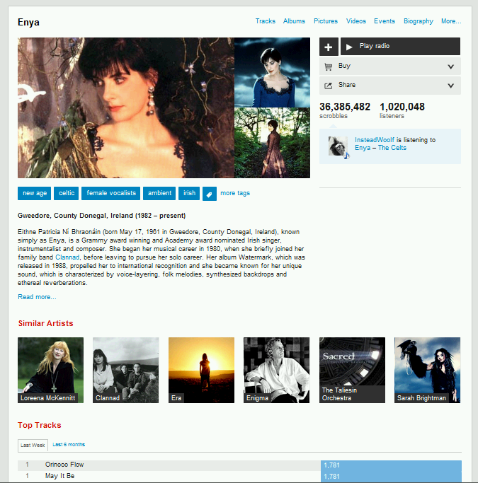
Figure 1a: Information about artists (source: http://www.last.fm/music/Enya)
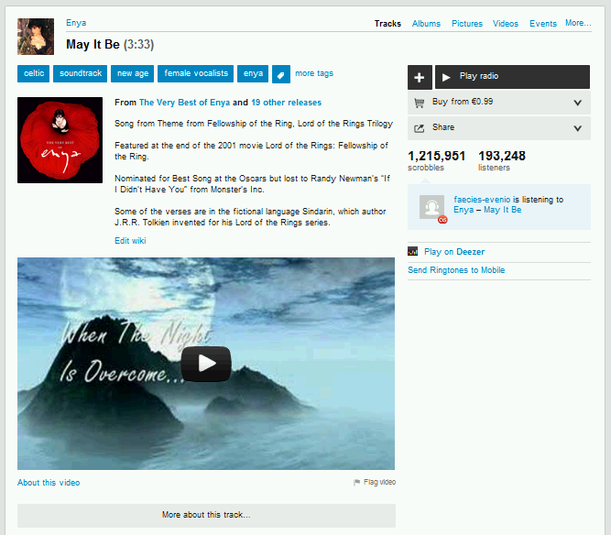
Figure 1b: Information about tracks (source: http://www.last.fm/music/Enya/_/May+It+Be)
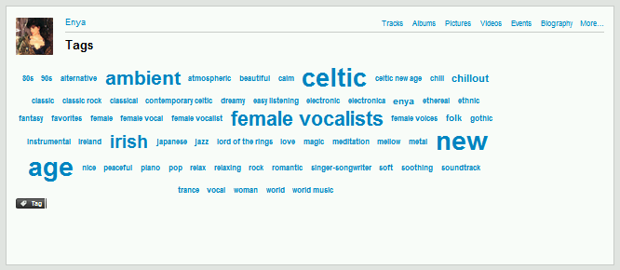
Figure 2: Cloud of tags for an artist (source: http://www.last.fm/music/Enya/+tags)
Tags of an object can be collected by experts and/or music consumers. The frequency of tags set by peoples let build a cloud of tags, where the most relevant should be written with the biggest letter. As it can be seen, there are also recommendations (c.f. similar tracks, artists) based on the tags (like related objects in YouTube). Therefore a kind of possibility can be identified to find a way of recommendations starting from an arbitrary track and arriving to an arbitrary track. In the background of this way based on recommendation (generating in an automated way) a graph (with nodes and lines) can be created. Between two arbitrary tracks more parallel paths can be exist. So the question can be asked based on the given services: Is it possible to lead the attention of somebody (being fun of a music style) to get to know/respect other styles?

Generalizing problem
The above mentioned question is seemingly a context-depended question – concerning music. However the question can be generalized: How is it to create a Robot-Teacher, who is able to advise the costumers/users/pupils/students with a minimized “jib” to have a wider horizon (to have a wider and wider interdisciplinary view) based on similarities between arbitrary objects (describing by tags)?
The generalized question is the basic question of didactics: if the possibility to change focus of interest is given at all, then the way to do this should be transformable into source codes for robots. These robots (like chess robots) will be able to use the explored rules to be faster (on the fields of finding out appropriate strategies or changing strategies in case of new information) than the humans, and as error-free as possible. Human teacher and Robot-Teacher can work together: the basic activities in the education can be conducted by Robot-Teachers. Complex problems, where the human holistic capabilities (c.f. sensors and intuition) are relevant, will be executed by humans furthermore.

Fine tuning problem
The graphs from tags make always possible to find out the potential ways between two nodes in the graph. The potential ways can be ranked (at first) through the weights of tags belonging to objects. But this sort of ranking is still not able to learn about the cases during the real operations. Therefore it seems to be necessary to describe the pupils/students (who should be transformed goal/target-oriented in a soft way) through attributes which enable to fine tune evaluations of potential ways. Attributes can be arbitrary things: in case of music-consumption the ratios of previous downloads according to tags. In case of school advising (where pupils with interest on literature should have a little bit more interest on mathematic) pupils/students can also be described with the well-known factors like sex, age, financial, educational background, etc. And the mix of these attributes can also be allowed. The learning pattern will be therefore: objects are the unique learning activities, and their attributes (Xi) are the above mentioned indicators. The Y-variable can be the distance of tags in the graph, which could be reached successful. The results of the (re)-learning (case by case) is a simulation system, where the most adequate distance in the tag-system will be derived (optimized).

Against conscious lying
A tag-system can always be created more or less adequate to the target groups of the advising. Behaviour of pupils/students can also be detected in an objective way: if it should be assumed, that pupils/students will say “no” for a transformation step (for a recommendation) only based on defiantness, but they have (by the way) spontaneous activities (like music-consumption), then these activities can be analyzed. It is also possible, to create a background scene involving loved and seemingly hated/rejected effects and to make possible to shut down or to repeat arbitrary elements of the background scene. In this case the repeating frequencies and the time aspects of rejections can be used as a type of a most objective measurement being able to describe the real minds pupils/students about the effectiveness of a given recommendation.

Clouds of expressions
It is necessary to have a clear impression about the differences between tags. The differences of tags can be approximated through text mining activities: e.g. each tag-pair will be set as a key-expression of a Google-search. The matches/result of the search activities describe, how near to tags is to each other. Based on the tag-setting for objects (like tagged tracks as a search universe) a similar way can be driven.

Summary
Seemingly spontaneous talks between human teachers and pupils/students can transform the interest of pupils/students. Through involving artificial intelligences into this process, it seems to be possible to automate this kind of education activities as well. The artificial intelligences are the capabilities of humans, who are able and ready to transform their minds into source codes. The stepwise recommendation logic (based on similarities of an expression cloud) can be optimized in different levels and through different methods (like similarity analysis). Robot-Teachers do the same as human teachers, but faster and more fine-tuned without negative human performance decreasing effect – and unfortunately without genial human intuitions…

