Wind-chill on Hungarian food-markets

László Pitlik Ph.D, István Pető

# Abstract

In this study we make an attempt to demonstrate, that (agricultural) market prices may not always interpreted in nominal form, in certain cases their “feeling” might be significantly different. The human competence to feel prices can be interpreted as a task of artificial intelligence and as a decision support problem for experts affected in procurement processes.

# Keywords

benchmarking, price analysis, Market Price Information System, SWOT-analysis, artificial intelligence

# Introduction

It seems to be a trivial statement, that prices should always be interpreted nominally. In certain cases, change of prices can/should be cleaned from the influence of inflation. However, consumers take not only these market prices into consideration but the “wind-chill” of prices (the felt prices) as well.

Wind-chill means the felt air temperature which might be different the real temperature due to several factors, like humidity on the skin or wind. In other words, the same (measured) air temperature can be felt very differently depending on other weather conditions, physical status of the perceiver etc. So, “wind-chill” used on prices means that same set of prices of a product or in a market can be felt very differently due to other factors – in this case other set of prices on the same or in other markets.

The main question of this article is, how felt prices can be identified in the agricultural markets. On the one hand this question can be investigated as a part of artificial intelligence research. Robots can produce similar relative statements (feelings) based on the difference of circumstances. The ability to identify a “wind chill”-effect of prices can legitimate economic decisions: e.g. a procurement professional that is in close contact with a certain brand (as a registered customer) should choose the brand, where the relative price level is satisfactory in comparison with the average price level of competing objects.

# Material and Methods

We identified two research issues above:

* How can the felt prices be identified?
* How can an objective rank of competitive markets/products be developed automatically?

The first task needs a so called antidiscrimination model (COCO Y0) to generate potential values (estimations) for relatively high/low price levels. The second question can be answered through a SWOT-analysis based on a set of similarity analyses. However, each problem needs special control mechanisms in order to declare, in which circumstances the analyst should declare rather nothing about a market/product instead of stigmatizing them.

## Modeling of the felt of prices

The dataset we used comes from the Research Institute of Agricultural Economics (<https://www.aki.gov.hu/>), especially the prices of honey were collected from the Market Price Information System (PAIR – <https://pair.aki.gov.hu/pair-public/>). In frame of the data asset management exercises, students collected and re-structured the necessary data (over 100.000 records) , which were transformed into an OLAP-service (see: <http://miau.gau.hu/pair>) in order to make possible flexible reporting as the first step of further analyses.

The observed time series incorporates 60 weeks (starting from 1st January 2011), the examined honey-markets were the following:

* Acacia honey – Retail market – Budapest, Fény utca: Market #1
* Acacia honey – Retail market – Budapest, Fővám tér: Market #2
* Acacia honey – Retail market – Budapest, Lehel piac: Market #3
* Acacia honey – Retail market – Debrecen: Market #4
* Acacia honey – Retail market – Kecskemét: Market #5
* Acacia honey – Retail market – Szeged: Market #6
* Acacia honey – Retail market – Szombathely: Market #7
* Acacia honey – Wholesale market – Budapest, Nagykőrösi út: Market #8
* Mixed honey – Retail market – Budapest, Fény utca: Market #9
* Mixed honey – Retail market – Budapest, Fővám tér: Market #10
* Mixed honey – Retail market – Budapest, Lehel piac: Market #11
* Mixed honey – Retail market – Kecskemét: Market #12
* Mixed honey – Retail market – Szeged: Market #13
* Mixed honey – Retail market – Szombathely: Market #14

As it can be seen, there are several cities (Szombathely, Szeged, Kecskemét, Debrecen and Budapest with more markets) in the sample. There are more products (acacia and mixed honey) and wholesale as well as retail markets in the dataset..

The antidiscrimination models (COCO Y0) are LP-models, where the target variable (Y) is a constant value (cf. idea of Plato) and the predictor factors are the prices of involved markets/products. These models try to define, whether each week bears the same advantages or are there relatively over-/underestimated weeks? With other words: It should be proven, whether the felt prices exist at all?

# Results and Discussion

## Discovering the “felt prices”

Figure 1 shows the results of the antidiscrimination models: Each nominal price and the estimated ”felt prices” are standardized (“1” stands for price maximum, “0” stands for price minimum and each other value is proportional to the original prices - measured in NC[1]/kg).

Nominal wholesale price of acacia honey in Budapest is marked with thick dashed line. The thick dotted line stands for one of the retail prices (especially for the biggest market in Budapest called Nagycsarnok in the Fővám tér). The discontinuous thick curve shows the “wind-chill” effect, the felt prices. The thin lines (dashed, dotted, and continuous) mean the linear trend line for the prices (wholesale, retail and felt price).

If a price analyst would give an interview about the processes on the honey-market, then he/she would talk about the significantly different trends of retail and wholesale prices. Based on similarity analyses the ”felt price” line can also be developed: the thick curve refers uncertainty (c.f. breaks of the line). The curve becomes discontinuous, when the direct and the control (inverse) model don’t show appropriate symmetric results. An inverse model is based on the following idea: if the learning pattern is inverted, then the result should also be inverted based on the same calculation scheme (if an object is proved underestimated in the direct model, it should be overestimated in the inverse model). When this symmetry is broken in particular weeks, these objects cannot be evaluated.

So, in this case the Robot-Expert for market analyses could define valid estimations in 70 % of the cases. The longest hiatus in the thick line can be detected in the middle part of the time series: where the wholesale and retail prices are constant, in this period we cannot interpret the “felt price”. If the estimated value of felt prices is over the average of the thick line (Y=0.49), then it can be declared, that the prices in the aggregated honey-market (described through the above mentioned data universe) are relative high – and vice versa. The trend of the highlighted retail prices (marked with thick dotted line) in Budapest (might be interesting for tourists who’d like to buy honey as souvenir) is higher, than the wind-chill-trend in the same time-interval.

We can find a controversial part in the figure (X=6), where the nominal retail price reached its maximum and yet the “felt price” value is less, than the retail price. The interpretation of this special X-ray picture: in this week might no honey was bought in the biggest retail market in Budapest. The alternative interpretation would be that value in the PAIR system of this particular market and week might be incorrect. The created models can also be used for controlling/monitoring tasks: namely to catch out problems in the data collection process (cf. using simplified DEA-analyses for problem-detection in data asset management: http://miau.gau.hu/miau/13/deaeng.doc). The increasing trend of the thick curve can be interpreted as a relative uncertainty but existing feeling about more and more disadvantageous market development.

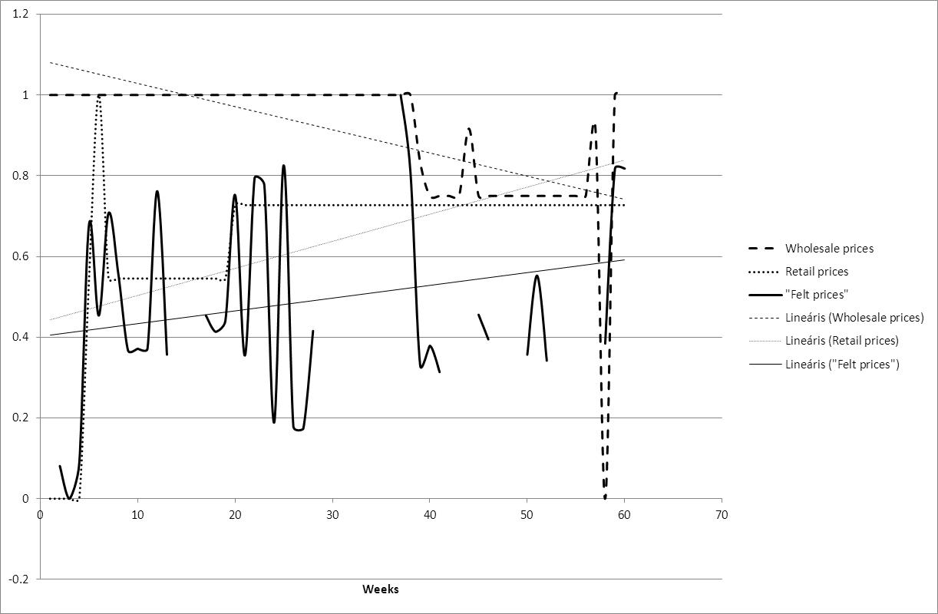

Figure 1: Standardized price developments and their trends (source: own calculations) Legend: X-axis = time (weeks), Y-axis = standardized prices (between 0-1)

## Detecting of seasonal market advantages

Figure 2 shows a complex picture about the observed markets and products (reflecting a set of similarity-based SWOT-analyses). The values in the matrix shows the differences between facts and estimations, where each prices of each market/product were modeled based on the rest of the dataset. Positions with black background mean: the price could have been lower with the given value (in %). Positions with white backgrounds mean: the price could have been higher (in %). The light gray positions indicate neutral (appropriate) price constellations. And finally, the cells with dotted background stand for uncertainty - here the estimation could not be evaluated based on the given data asset through symmetry-analyses (see in Chapter 5.1).

In the background of the result shown in Figure 2 we created a lot of models: two models per attribute for self-control. This series of models can be called as an improved SWOT-analysis, where predefined workflow and interpretation rules let declare: what is strength or weakness. This sort of SWOT can handle also the uncertainty and the possibility of neutral evaluations.

Below the matrix we created 3 indices which express the “goodness” of each market (see in Figure 3):

* the average prices (it’s calculated from the nominal prices),
* the validity ratio (it gives the proportion of valid estimations – see in Chapter 5.1) and
* the average advantage ratio (the average of over- and underestimations in a given market).



Figure 2: Multilayer analysis of price-interpretability/bubbles[2] (source: own calculations)



Figure 3: Indices of multilayer analysis (source: own calculations)

In these 3 rows we emphasize with grey background those occurrences, which are especially outstanding in comparison with other markets. On the right-hand side of the matrix in six columns the prices of mixed honey can be found with lower nominal price level in general. This can also be seen in the row of average prices below the matrix. Moreover: cells marked with grey in the last row (relative advantages) have only one match with those cheap prices: in Budapest, Fény utca (average price: 1595 Ft/kg and with the highest validity ratio of 68%. It means, that the most cells (weeks) are highlighted here somehow.. Hence we can declare that the nominally low-priced products are not always the best decisions. These products/markets could have set prices even more lower!

In order to find out, which market/product is worth taking into consideration, it can be seen the last row. The less the average advantage ratio is, the more is the potential advantage. On the other hand, it could be calculated another indicator: the amount of highlighted cells in a column. This parameter can also give us signs, how probable is to find a good day on the market – though not necessarily with the best offers.

# Conclusion

Through the two analyses (like anti-discrimination modeling and automatic SWOT-analysis) it could be seen, there are new possibilities in interpretation of market processes. Model-based approaches can support the tasks of consistence controls (see potential suspicion about wrong data). Robots can have feelings like humans about price developments (c.f. wind-chill). Based on complex similarity analyses (improved SWOT-analysis) we can well-established speak about real advantages: the presented analytical logic is able to detect, if a nominally low price may not be accepted without further investigation.

# References

1. OLAP-simulation based on the PAIR-data (2012)  
   Internet: <http://miau.gau.hu/myx-free/olap/olap_pair/>
2. Agricultural price analyses of certain market segments made by students (2012)  
   Internet: <http://miau.gau.hu/miau/169/pair>)
3. Price analyses of honey (2012)  
   Internet: <http://miau.gau.hu/miau/169/pair/mez_2.xlsx>
4. Bunkóczi, L (1999): DEA Analysis for soft wheat production in the EU after EU/SPEL databases  
   Internet: <http://miau.gau.hu/miau/13/deaeng.doc>
5. Pitlik, L (2012): Country profiles – as never seen before   
   Internet: <http://miau.gau.hu/miau/164/as_never_before.docx>
6. Pitlik, L (2012): Wind-chill on the market   
   Internet: <http://miau.gau.hu/miau/163/wind-chill-on-the-market.docx>)
7. Poór, J – Pitlik, L (2012): International benchmarking in education  
   Internet: <http://miau.gau.hu/miau/166/educ_bo_ac_ent3.rtf>

# Authors’ address

László Pitlik ([pitlik@miau.gau.hu](mailto:pitlik@miau.gau.hu)), István Pető ([peto.istvan@gtk.szie.hu](mailto:peto.istvan@gtk.szie.hu))

Tata Centre of Excellence and Institution of Informatics  
Faculty of Economics and Social Sciences,   
Szent István University  
H-2100 Gödöllő, Páter K. u.1.

1. NC = national currency
2. http://miau.gau.hu/miau2009/index.php3?x=e42