Progress report about the pharmaceutical industry in Hungary 2008-2012
(Branch-report based on the cooperation between Creditreform Ltd. & MY-X research team)
PITLIK, László, 2014. March

Content
Progress report about the pharmaceutical industry in Hungary 2008-2012 1
Content 1
Does need a branch really an idol? 1
Scenario: figures based on the whole data assets 1
Scenario: figures based on the filtered data assets 3
The Idol 4
The simulation force-field 6
Summary 6

Does need a branch really an idol?
The publishing about the pharmaceutical industry seems to be a noble challenge, therefore the basic information are always well-known for each interested person. This special report tries (here and now) to visualize messages, which could be derived based both on the data assets collecting in company information system “Amadeus” and on classic as well as innovative analytic methods.

A fundamental evaluation about the branch can be seen in the web site of MAGYOSZ: „The Hungarian pharmaceutical industry has always been played an important role in the realization of national income and export as well as in ensuring medicaments for Hungary.” Here is also declared: ”The competitiveness of the branch is characterized through the fact: the drugs produced in Hungary are available worldwide,…”

Scenario: figures based on the whole data assets
Following the logic of the cited evaluations: the exploring of an Idol for the branch should be focused on the enterprises with relevant export positions. The competitiveness can be described (using data of the company information system) e.g. through the financial values per employee.
Without filtering export-oriented enterprises, a set of 108 companies could be identified for the relevant NACE-codes. The downloaded balance-sheets and their financial positions are always present at current prices. Based on the whole dataset, the export market seems to realize a dynamic increasing from 7 % of the annual operating revenue (turnover) in 2008 to the stabilized interval of 63-69% starting from 2009.

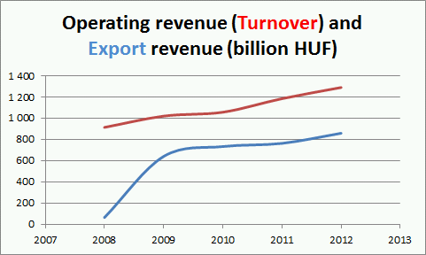

Efficiency can be characterized through ratios like cost of employees / turnover, profit both before and after tax.

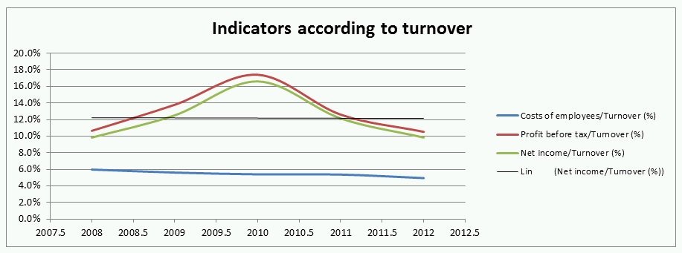

The decreasing trend in case of cost of employees follows the general logic of ensuring more and more efficiency. The profit-curves let explore a constant trends for the whole set of enterprises.

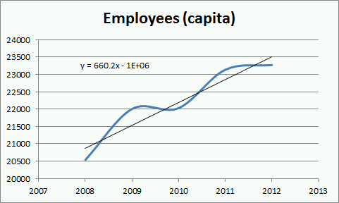

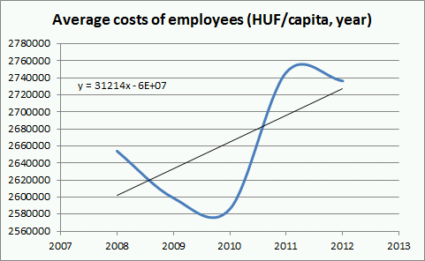

The trend of the number of employees and the cost per employee point to tendences contrary to the classic principles about increasing efficiency and managing crisis situation. In case of the annual average salaries, the quick decreasing phase turns into its opposite with a new correction at the end of the proved time intervall. The level of the wages seems to be relative low.

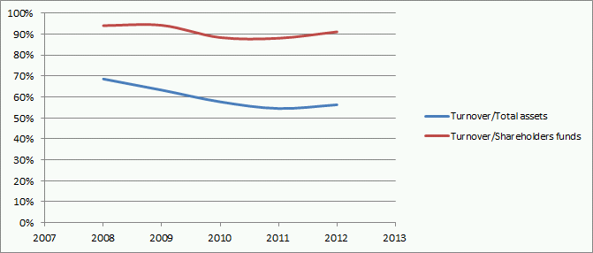

The further annual indicators like turnover / total assets and turnover / shareholders funds realize also a decreasing trend with a fine correction by the end of the 5-year periode.

Scenario: figures based on the filtered data assets
It should be repeated, that the previous figures all got generated based on the entire data assets delivered by Unfortunately the quality in several cases should be seen with some critics: e.g. how can be exist a real number of employees without any wages or vica versa? As well as critical aspects it was worth to setting a further filter: only enterprises with export revenues might be involved into the next evaluation steps. Therefore, it may be assumed, that the reduced group of enterprises (n = 32) can deliver a more realistic figure about the same indicators as before.
First it can be detected at once, that the low value of export revenue for 2008 is not longer existent in case of proved data assets. The realistic export ratios are now in the increasing intervall of 64-70%.

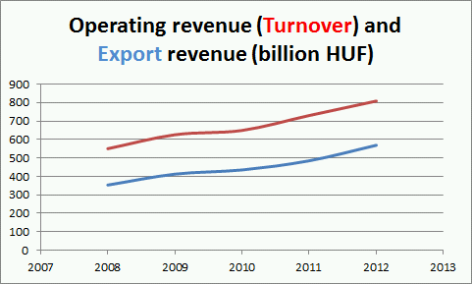

The trend of the profitability is increasing contrary to decreasing tendences of the wages in the same time intervall for the selected set of enterprises. The profits both after and before tax have visible lower values (of 10%) than in case of the whole database (c.f. 12%). Parallel, the ratio of salaries let detect a noticeable higher level (see 9-10%), than before (5-6%).

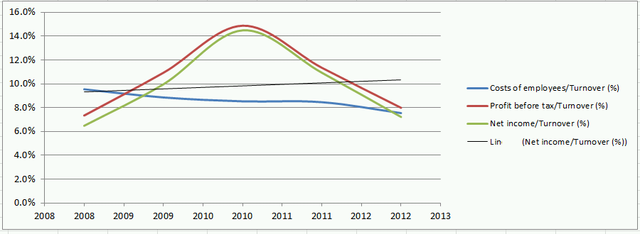

The dynamic characteristics of the number of employees was changed in case of the more qualitative dataset for the last year 2012. The average salaries show basically a similar trend, however the their values have been increased 3-times.

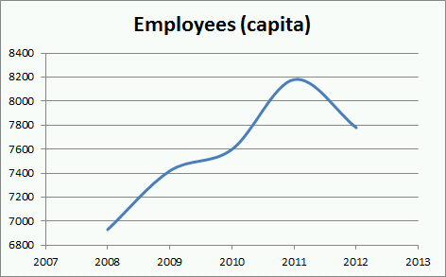

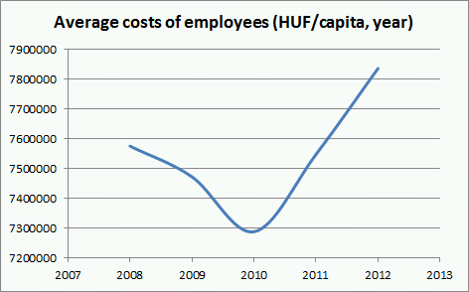

The turnover/total assets and also the turnover/shareholders funds produce the seemingly same figure as before. But the ratio between turnover and shareholders funds realize in case of the selected enterprises a higher level (of 110-120%), than in case of the whole dataset.

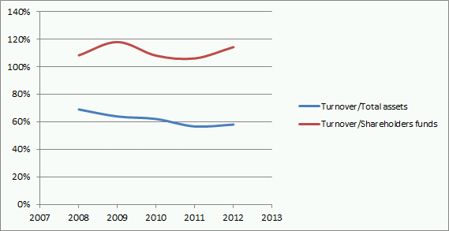

The Idol
After presenting the agrgegated characteristics, the basic question about the “prima primissima prize” could finally be answered – assumed, that this evaluation will be delivered by a robot-expert basing on the principles of data-driven policy making (c.f. similarity analyses):

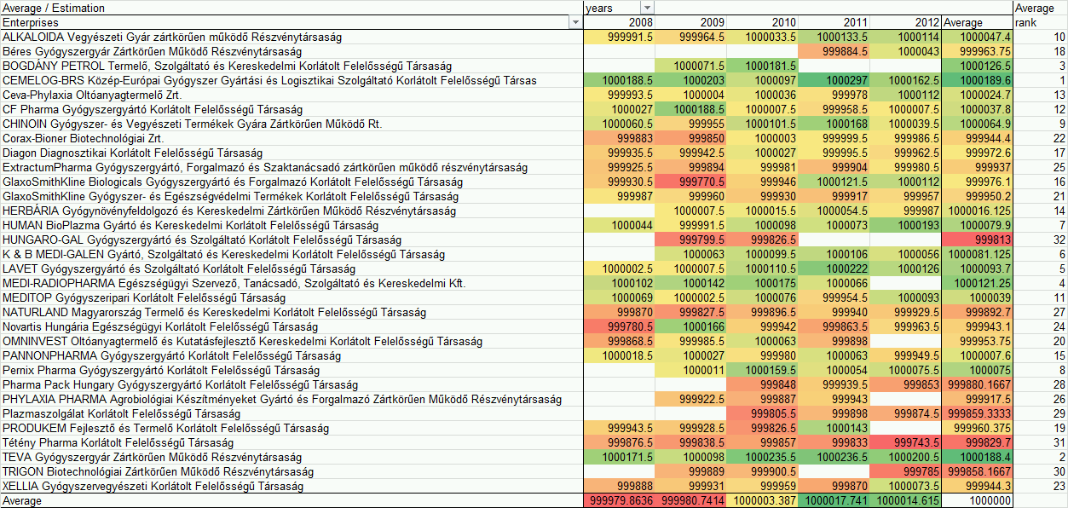
(Legend: norm-value = 1000000 ideality score)

In order to be able to declare a prize in an automated way, it is needed, in case of the before mentioned indicators to realize a kind of consensus between experts according their orientation to ideality. For the derivation of the idol following function got assumed: the less both the average cost of employees and the volume of taxation/employee the more the ideality + the more the turnover, the export revenue, the total assets, and the shareholders fund per capita the more the ideality (in case of an enterprise and year). Based on these principles the first question is for the modelling: Whether can be derived a scoring and weighting system delivering the same estimation values for the searched ideality index? If this anti-discriminative status is to realize, then it is not possible to declare an idol.
The red-yellow-green-coded cells show, which enterprise-year combination could be closer approximated the ideal position. The red sign is responsible for visualizing a dangerous (under-norm) position. Yellow stands for norm-oriented situations. Green is available, if an object was able to realize a relative sustainable set of indicators (compared enterprises and years to each other).

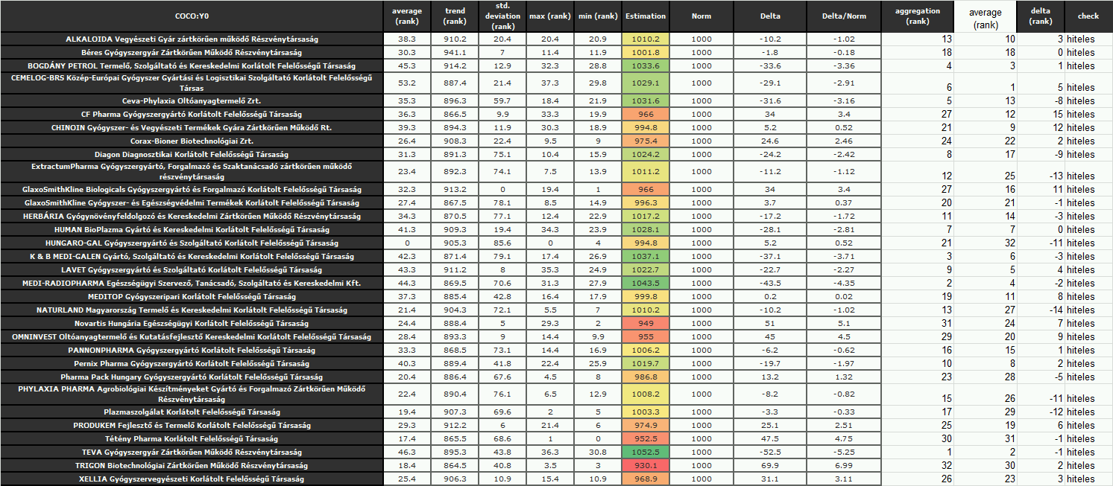
(Legend: norm-value = 1000 ideality score)

If also the trends and volumes of estimation behind the colored signs will be involved into a new evaluation (anti-discrimination) model with self-checking mechanisms instead of calculating of static average advantages, then the risks (from point of view of investors) can be visualized (see the highest differences of 14-15 ranking positions between naïve and more sofisticated/dynamic estimations). Parallel, the benchmarked idol of the branch can be derived. The winner is: TEVA!

The simulation force-field
In case of the filtered dataset, the success of business will be ensured mostly both through the reducing of taxation and salaries, and through the increasing of export revenue and income-potential.

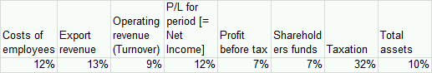

If the aggregated annual norm values are compared for enterprises with 2-5 years, then – to approximate the idol-position in an effective way – first the standard deviation should be minimized. It means minimal and/or maximal ideal indexes occurring from time to time play not a real role for evaluation of enterprises (c.f. accruals/prepayments). The aggregated impact of extreme values cannot be achieved the impact of the standard deviation to sustainability of business.

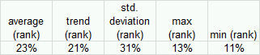

Summary
This article tries to cover following objectives: to declare a prima primissima prize in an innovative way. The core logic of the new approach (similarity analysis) can be described through the capability, creating such robot experts which only works based on the logic of data-driven policy making, and parallel aiming objective evaluations even automated.
Also to derive for managers/controllers/strategists: which kind of static and dynamic (primer and seconder) indicators have a higher impact ensuring sustainable business progress in frame of simulation systems.
In order to create a basic overview, some ratios of the involved indicators and also their trends have been transferred into figures - in case both of the whole and of a selected group of affected enterprises, where the selection ensured a more qualitative (it means: with less risk coupled) and more efficiency-oriented dataset for modelling.
The final conclusions can only be derived by the Readers: in case of enterprise-orientation, it can be suspected, what should have decided in the past and what is to do in the future? In case of independent Observers involving benchmarks from other branches or from national or international levels: the business processes of the Hungarian pharmaceutical industry can be compared to these thresholds…

Recommended literatures:
- http://miau.gau.hu/miau/178/kfi/innoswotion_1.doc, http://miau.gau.hu/miau/180/hho/h2o_v1.doc)

http://miau.gau.hu/miau/187/pharma_v1.doc
http://www.magyosz.org/hu/oldal/a-magyar-gyogyszeriparrol, ill. http://www.sci-tech.hu/gyogyszeripar.sci-tech.hu/00home/00home.htm , ill. http://www.ikt.hu/gyogyszeripar, ill. http://www.vg.hu/vallalatok/egeszsegugy/ez-jellemzi-a-magyar-gyogyszeripart-324876
http://miau.gau.hu/myx-free/

