THE OPERATIONALISM OF SUSTAINABILITY IS A MATHEMATICAL ISSUE

L. Pitlik¹, Z. Varga¹

¹Reseach group My-X, Szent István University
Páter K. u. 1., Gödöllő, H-2103, Hungary
Tel.:+36 30 9816-001, E-mail: pitlik@miau.gau.hu

Abstract: The hypothesis of this article is: Constellations of phenomena can be seen as sustainable, if the facts of the past in case of each object and attribute are arbitrary close to the norm values, where norm values are the levels of attributes, which should be given based on each other circumstances. Similarity analysis is a modelling tool, which is able to build models in an automated way to detect lacks of sustainable constellation e.g. in agricultural databases. Software products based on similarity analyses (SeaLog 2012, NGStress 2014) was prized by innovation experts on the field of IT-stress and human stress.

Keywords: artificial intelligence, automated swot-analysis, virtual robot farmer

INTRODUCTION

In general, the keyword “sustainability” is used without any proofs, like a kind of buzz-word. On the other hand, the phenomenon “sustainability” seems to be one of the most important phenomena – both on ethical and on professional level. Therefore it should be a real scientific question: what is sustainability at all?
The classic knowledge representation tries to deliver definitions based on words. But words are products of the “magic” of human intuitions, where intuition - according Konrad Lorenz (Lorenz, 1944) - seems to be available in case of each living creature. Intuition is the source (fountainhead) of human knowledge. However, intuition is always presented in subjective forms – in connection to humans. Fortunately, artificial intelligence research is already able to create terms based on measured logs about arbitrary phenomena. Parallel, definitions - based on words – are inefficient exact. Therefore a kind of motto for knowledge representation issues could be: knowledge is what can be described in form of source codes – each other form of publications should be seen as best-letters or literature – literally.
After the more or less (unavoidable) philosophical opening about the problem described in the title of this article, it is necessary to change the point of view towards mathematic/modeling: based on bubble-effects, where it is assumed, that a value of an attribute in case of an object is too low or too high, norm-values seems to be existent. Norm-values are not medians or averages. Norm-values are products of models. Norm-like is a level, where the exact value of the level is appropriate to the force-fields driven by each elements of the circumstances. With other words, it means: no pressure for norm-values can be detected to initialize changes in the given attribute. Sustainable is therefore each constellation, where indications for changing cannot be identified in the big data.
Naïve solutions like classic SWOT analysis try to approximate the complex phenomenon of sustainability. A SWOT analysis should declare bubbles: S stand for effect too high, W stands for effect too low, O = effects of improving and T = effects of depreciation. Unfortunately, the well-known SWOT could not be transformed into source code – it means: SWOT is a matured phenomenon of the “magic” of words – without any evidences behind of the declared bubble-effects. Whether a SWOT analysis could really be transformed into source codes?
SIMILARITY ANALYSIS

The following chapter tries to give a short description about the know-how developed by the My-X research group for deriving norm-values in a context dependent way.
Theory
Similarity analysis is a specific modeling technique. First, it needs an object-attribute matrix like Fig.1, where O stands for objects, X and Y for attributes and OAM means: object-attribute-matrix, where the raw inputs of X(i) should be ranked. This quasi universal form of fact-representation can be used for a lot of analytical techniques (like regressions, neural networks, etc.).
Similarity analysis delivers as solution optimized staircase-function, where a set of descending rank/stair-values will be calculated for each known attribute-level based on linear programming, if direction (preferred orientation like the more the more, or the less the more are given for each attribute). In this context, norm-values are the (cumulative and/or additive) aggregated values being created as a possible set of stairs. Each attribute can be seen as Y or X(i). Therefore it is possible to derive a specific norm-value for each position in the OAM.
Measured facts and estimated norm-values can have a difference. The direction and the level of these differences can be interpreted as an automated SWOT analysis, where the static differences are the Strengths and the Weaknesses depending on the preferred orientation of the bubbles. The dynamic differences between a set of facts and norm-values ordered in a time series can be seen as Opportunities and Threats (also depending on the direction of preferred constellation).
In extreme case, the directions can be eliminated and instead of stair cases polynomial function will be explored. But the norm-values can always be derived! Polynomial approximation can be used in case of unknown system characteristics.
Similarity analysis has an own quality assurance system (cf. tautological characteristic). Each estimation can be proved based on lot of model-symmetries, where asymmetries are signs for parameter errors.

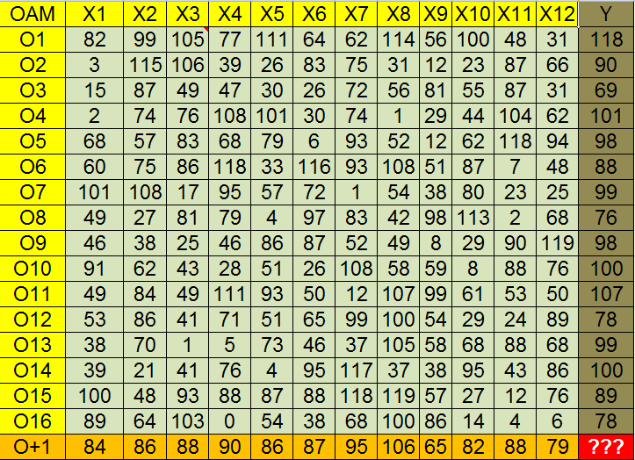
Fig. 1. Demo of an OAM (source: http://miau.gau.hu/myx-free/index.php3?x=iq)

Practice

Similarity analysis, as an online tool can be used free (http://miau.gau.hu/myx-free/). A large scaled version got developed for modelling of information safety and this version (SeaLog) got prized by ITBN 2012. Also prized (by HUNINNO, 2014) is the NGSTRESS adaptation, where the stress level of computer (mouse, keyboard) users can be derived based on context-free logs. The VRF-conception (virtual robot farmer conception) got invited to the finale of the international innovation award (2014).
The apropos of this article is: The VRF-conception can be seen as a decision support system for enterprise level, but it can also be seen as a tool for sustainability-oriented controlling on arbitrary level (like Earth, EU, country, region, county, micro-region, settlement, enterprise, parcel – c.f. precision farming issues).

COMPLEX CONTROLLING SYSTEM FOR THE AGRICULTURAL PRODUCTION

The following chapter tries to deliver a draft description about a complex controlling system for the agricultural production (CC_SAP). Assumed, that the bubble effects can be real-time explored in an automated way, it is time again the matured logic of SPEL and EAA (financed by EU/EUROSTAT – where SPEL = sektorales Produktions- und Einkommensmodell der Landwirtschaft, and EAA = Economic Accounts of Agriculture) to follow. Each measured fact should be collected in a central (driven) database and each new fact should be compared / benchmarked based on all the data being already available, in order to detect bubble-effects
The holistic project can be organized step-wise:
- partial data assets (in Hungary: KSH, AKII) should be monitored at once in the frame of the given infrastructure
- complex databases (in Hungary: TEIR, in EU-level: FADN) should be analyzed
- parts of databases should be integrated in a virtual system
The holistic project needs following large-scale developments, if databases are already given:
- OAM-generator, where the potential learning patterns should be extracted from the databases with the raw/measured data incl. pattern-generation for symmetry-analyses in the quality assurance/consistence-control layers
- parallel processed SWOT-generator, where the pattern-generator and optimization tasks should be run in the most efficient way
- interpretation-generator, where the facts and estimated values should be converted to text schemes based on the classic rule of “magic” of words
- data-visualization tool, in order to be capable to generate the most adequate visual effects
Manual-driven solutions are now available for permanent experimentations. The large scale prototype of SeaLog should be optimized and adapted. Further necessary steps before implementation:
- comparative studies are needed in order to demonstrate for the standard users (e.g. politicians, farmers) the differences of the hermeneutical potentials between classic and similarity-based approaches
- e-learning tools (c.f. MOOC-based) should be developed to ensure everyone can access the knowledge about sustainability analyses

SPECIFIC INTERPRETATION OF CC_SAP

The databases - listed above – deliver mostly ecological and financial data items. However, the analytical potential of CC_SAP is quasi unlimited (context-free). It is also possible to search for bubble-effects in case of
- mechanical constellations (e.g. modelling of depreciation of machines in diverse cases of using)
- physiological constellations (e.g. stress-detection of living creatures)
- weather constellations
- market constellations (c.f. PÁIR, stock markets) and
- behavior-patterns of humans (c.f. information units from Google Trends), etc.

Besides the direct adaptation, there are new ways already prepared to re-interpret specific problems:
- diagnoses and therapies for humans/animals/plants/ecosystems/markets can be re-interpreted as a kind of bubble-effect, assumed, that the sustainability of life and the a cured constellation are the same phenomena
- classic forecasting problems can be transformed into bubble-analyses, without exact time-information about changing bubbles

CASE STUDY: DYNAMIC FORCE-FIELDS BEHIND SUSTAINABLE SURFACES

Sustainability is a process. This process should be detectable starting from a randomized-chosen constellation (s. Fig.2., where I1 shows a random matrix with values between 0 to 99 and O(i) = objects, A(j) = attributes, i=1,…10, j=1,...,5).

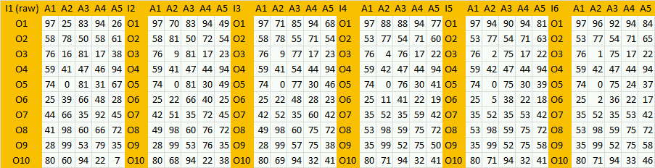
Fig. 2. Iterations (Source: http://miau.gau.hu/miau/206/super_evolution.xls - sheet(‘view’)

If standard similarity analyses (see: http://miau.gau.hu/myx-free/coco/beker_std.php) run step by step (according to the more the more direction for each attribute), where each attribute should be modelled based on the other attributes in two layers for further symmetry-analyses being able to explore invalid estimations), then each valid estimation can be seen/accepted as strategic relevant target-value. Parallel, it is necessary to ensure, that the anti-discriminative model (see: http://miau.gau.hu/myx-free/coco/beker_y0.php) for the first phase (I1) can be evaluated as static sustainable (s. Fig.3., where behind the surface-sustainability /I1/ force-fields can be identified towards exploring real potentials of objects).

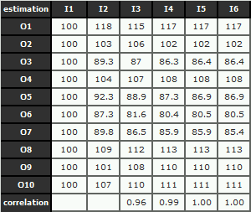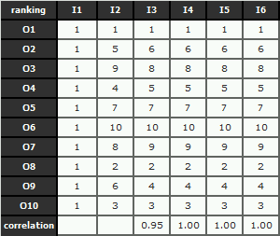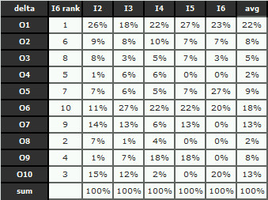
Fig. 3-4-5. Estimations/Ranking values/Differences (Source: http://miau.gau.hu/miau/206/super_evolution.xls)

Fig.4. shows ranking values of the estimations in Fig.3. Parallel, Fig.5. declares differences between iterations for each object in percent to the total of prescripted valid changes of raw-values in the previous phase.
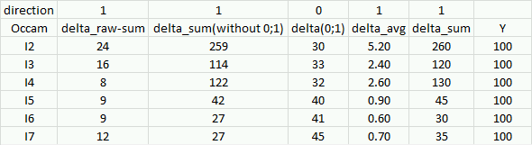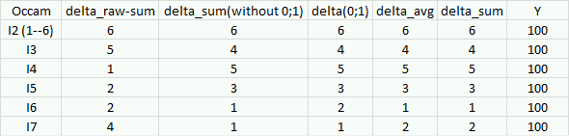
Fig. 6-7. Steps of evaluation of iterations: raw data / ranking values (Source: http://miau.gau.hu/miau/206/super_evolution.xls)

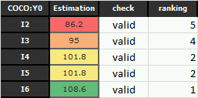
Fig. 8. Evaluation of iterations (Source: http://miau.gau.hu/miau/206/super_evolution.xls)

The iterations can have a lot of consequences. To be able to define, which phase can be seen as the best approximation, a kind of analysis based on the idea of Occam’s razor (see Fig.6-7-8, where the consequences are: difference between the sum of the raw values in the first phase and each other phase: direction = the less the more ideal / sum of each valid changes with/without position affected by integer-transformation and between of raw values of two neighboured phases: direction = the less the more ideal / amount of unchanged position: direction = the more the more ideal / average changing rate: direction = the less the more ideal).

CONCLUSIONS

Based on the principle and the detailed result of the case study, following interpretation can be formulated:
- between static sustainability, there are deep force-fields catalising changes,
- the highest average change rate can be seen in case of the king-object (O1=22%) and the also in case og the slave-object (O6=18%), it means the population of objects tries to determine a best object at any rate,
- the rank and row correlation between neighboured iteration phases let identify an approximation to a relative stable constellation (I6),
- the ranking values of the objects makes possible to realize changes according to ideality of the object compared to each other,
- similar effect can be found in case of price/performance-analyses (cf. STEP-IX - http://miau.gau.hu/myx-free/index_e8.php3?x=e08), where close to seemingly rational prices a kind of confidence interval can be identified to see the ratio of current price and the tresholds of its interval,
- after realizing the most matured iteration phase, further changes of the raw values let start a new cycle of approximation,
- the above described logic can be seen as potential interpretation for chosing a queen for bees among potential identical candidates (or waiting list in health care/front acitivities) and also as a dynamic (hidden) force-fields behind the surface of static derived sustainability (like a frozen lake),
- therefore sustainabilty is a kind of compass and not a target position,
- the compass and the appropriate navigation system can be realized based on a chain of similarity analyses,
- depending from starting values in the first raw matrix different ways can be realized based on the above described steps.

SUMMARY

The above mentioned principles and steps can be interpreted as a new type of decision making. First, sustainability can be measured based on object-attribute-matrices and their bubble-effects in case of each matrix-position. It is also possible to classify objects with static seemingly same potentials of sustainability. After creating diagnoses (or risk analyses), therapies can be derived for each objects concerning each attributes in frame of a cybernetic system, whose objects are unlimited able to follow rules.

REFERENCES
Pitlik L. (2014), About Occam’s razor http://miau.gau.hu/miau2009/index.php3?x=e0&string=occam
Pitlik L. (2014), My-X team – an idea breeding farm, https://www.researchgate.net/publication/280086739_My-X_Team_an_innovative_idea-breeding_farm, Noble Ideas Project – Virtual Robot Farmer (VRF)
Pitlik L. (2015), Modules of My-X online analytical tool, http://miau.gau.hu/myx-free/coco/index.html
ITBN (2012), https://www.itbn.hu/index.php/hu/itbn-biztonsagi-dij/2012-dijazottjai
HUNINNO-NGSTRESS (2014), http://www.ddriu.hu/htmls/?ID=594

