gUd-mOOsic: a complex simulation tool for learning and teaching music

László Pitlik, Dávid Fehér, Ferenc Szani, Mátyás Pitlik, Zsolt Fülöp, Péter Kollár

MY-X research team, University Gödöllő, Hungary

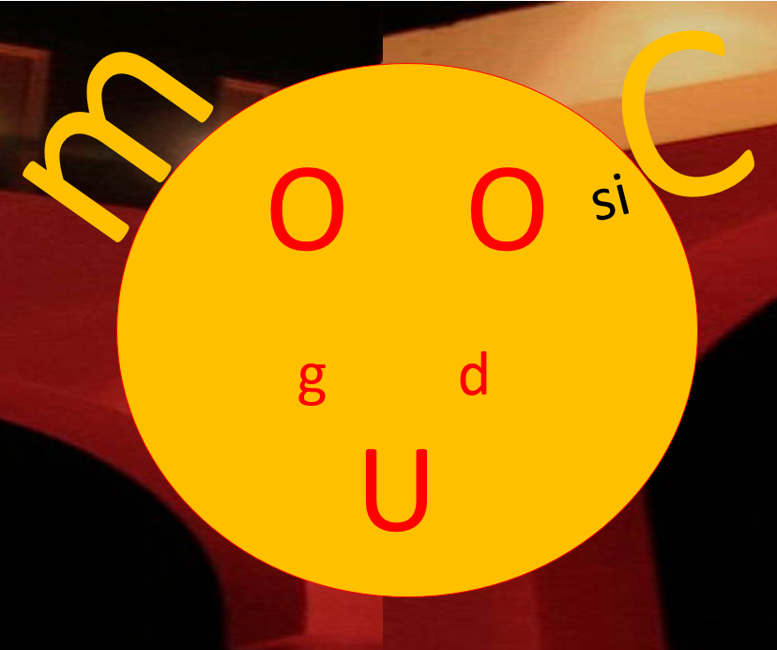

Author's Note

The following description tries to introduce each person interested in learning and/or teaching music to interpreting what can be seen as a kind of objective GOOD-ness, based on comparable constellations of learning/teaching. Without a robust inner compass about GOOD-ness, and/or a robot able to measure GOOD-ness, almost everyone is quite massively dependent on the opinions of other people.

Many thanks for the call/request from Canada (<http://www.cfplist.com/cfp.aspx?cid=5801>) about designing gamification processes, to be used later in designing games for music learning. These apropos made the integration of partial results in neighbouring disciplines possible, to support music learning and teaching. Learning and teaching should be handled as parallel phenomena: everyone is learning from their environment, and everyone has impacts on their environment.

The complex simulation tool is a virtual tool (now, and currently). It is, in essence, a thinking methodology. The gUd-mOOsic tool delivers a virtual mirror system to support the visualization of what is good, better, and maybe the best constellation (where music is the product, and/or teaching/learning is the production process), in which the objects of the evaluation can be defined in a flexible way. Objects can be melodies, learning/teaching methods, artists, markets, editors, institutions, etc.

The concept of gUd-mOOsic makes what was “simply” intuition until now, into a conscious process …

Abstract

The gUd-mOOsic complex simulation tool is a frame, a thinking methodology which makes the level of GOOD-ness in learning and/or teaching music perceivable. Why does it seem to be important to know, if an evaluation is so far correct or just a subjective opinion? Music is basically a kind of pure intuition. Intuitive processes can have contamination effects based on Konrad Lorenz’s interpretations [The Russian Manuscript, 1944]. Human intuition needs some sort of reset/restart/clearing/cleaning mechanism[1] to be able to approximate the Kazohinia concept [Szatmári: <https://en.wikipedia.org/wiki/Kazohinia>], the world of the absolute proportionalities and sustainability. How can a reset-mechanism be constructed? Each human term based on empirical conceptualisation should be re-defined: based on pure facts, and optimized mathematical processes. Similarity analysis wascreated to approximate these expectations. Milestones in this process are f.e. Mozart [http://www.dein-name-ist-musik.de/], and the logic of the ScoreAHit services [http://scoreahit.com/science]. While Mozart presented the possibility of music-generation as an intelligent way of using combinatorics, the ScoreAHit service tries to estimate evaluations for melodies already –primarily using a method based on regressions with well-known hermeneutics. Opposite to classic statistical approaches, similarity analysis is a kind of intuition generation process, using multilayered consistence control mechanisms able to derive the best model (c.f. principle of Occam’s razor). Similarity analysis needs a seemingly simple input of facts, an OAM (object-attribute-matrix), to derive evaluations based on the principle that “each object can have the same value”, and/or based on production functions.

Why might a tool like this be interpreted as a game, when the tool handles deep philosophical problems? Personality development, or in other words, clearing/cleaning contaminations of intuition mechanisms (e.g. constructed advertisements, planned media impacts) is neither work nor an art [https://en.wikipedia.org/wiki/Game]: the key components of games are goals, rules, challenges, and interactions. The gUd-mOOsic tool allows goals to be declared (e.g. best melody, or ever-green-potential of melodies, or best teaching/learning strategies, etc.) in a flexible way. Rules are the constraints originating in mathematics (c.f. a constellation that is better according to an attribute can not have less impact than a worse constellation). Challenges can be observed in the details of the knowledge management (where the evaluation processes should deliver the most objective and robust solutions). Interactions can be defined in different ways: e.g. interactions between human and machine, and/or interactions between human thinking methods with(out) similarity analysis. Increasing the level of (self)-consciousness is the game of games: as part of the music learning and/or teaching, in case of musical objects. Case studies, simulators, expert systems, forum items will be produced and shared with other people within the framework of the game. The game can be played alone (c.f. blended learning) and/or in teams. The game can be seen as a special MOOC service for autodidactic learning, where players learn to learn (possibly even from each other). Why does it seem worth to approximate music learning/teaching from this meta-level? Because in the case of music, the human race probably holds the position closest to aboriginal/instinctive intuition processes. The fundamental question is therefore: What is beauty? Can the beauty of melodies be seen as a kind of expression of performances, or interaction between human and machine during learning/teaching? Finally, gUd-mOOsic tool makes everyone capable of facing these general questions, consequentially, to face themselves.

*Keywords:* artificial intelligence, term-creation, evaluation, simulation, gamification, music learning/teaching, shared knowledge

gUd-mOOsic: a complex simulation tool for learning and teaching music

Motto: "Go down deep enough into anything and you will find mathematics." [Dean Schlichter - <https://www.physicsforums.com/threads/dean-schlicter-who.348163/>]

Introduction, or in medias res: If somebody already read/completed the abstract, s/he comes to this part evidently, or lets the briefly introduced ideas die/fall immediately. Therefore, this part is for Readers, who are interested to see thekinds of elements and connections that make it possible to create the gUd-mOOsic tool.What are these elements? Let us elaborate. The following structure tries to support the process of interpretation in a deeper level: the literary background delivers the necessary anchors to realise, that this is not a utopia.

# **Evaluation of the literary background**

The literary background will not include detailed references to prior works of the authors.

**Intuition**

Konrad Lorenz [The Russian Manuscript, 1944] outlined the concept of intuition, and extended it toeach living creature. Intuition is the capability to call ‘Heureka’, if the transactions happening permanently seem to allow for deriving some patterns with a rational level of probability.

Sándor Szathmári’s Kazohinia (1941 - <https://en.wikipedia.org/wiki/Kazohinia>) established a potential world of equilibriums – which can't immediately be seen as a utopia.

Music can be seen as a kind of pure intuition. Therefore, each influence on intuition processes catalyzes music generation in a relatively direct way. To learn about our own intuition processes leads to new interpretations of the phenomenon called MUSIC. If intuition as such is driven by impulses (data), then musicians need to be able to influence their intuition processes, especially to be able to clean/clear these biological heuristics causing the contamination of targeted virtual force fields (like manipulated multimedia environments). Our specific MOOC service can support them using their own intuitions, and therefore support the music as well.

**Combinatorics and modelling**

Parallel to the philosophical foundations, Mozart [http://www.dein-name-ist-musik.de/] created a music-generator based on the principles of combinatorics. The knowhow here/in case of Mozart is not the representation of knowledge.

ScoreAHit is a service describing music [http://scoreahit.com/science]. While Mozart presented the possibility of music-generation as an intelligent way of using combinatorics, the ScoreAHit service tries to estimate evaluations for melodies already – using a method based on regressions with well-known hermeneutics first.

**Similarity analysis**

Similarity analysis is a kind of intuition generating method. Similarities [Pitlik, 2014 - <http://miau.gau.hu/miau/196/My-X%20Team_A5%20fuzet_EN_jav.pdf>] can be used for detecting lacking areas in equilibriums. Similarities can also be seen as the mathematical approximation of sustainability (and Kazohinia). Based on similarities, music can be interpreted in a progressively more objective way. Similarities make it possible to create terms based on an artificial intelligence solution. Music and its marketing aspects are also terms which can be created based on statistics about melodies and/or market phenomena. While a MOOC is a frame for cleaning/clearing the intuition from contamination effects, similarity analysis is a real tool which is able to model the necessary complexity with its own quality assurance layers, like function symmetry and consistence control mechanisms.

Summa summarum: The literature delivers signs which let us assume that the handling of music can be based on a specific interpretation of similarities in the form of a MOOC, as a kind of game…

# **The gUd-mOOsic tool**

**Structure**

The gUd mOOsic tool can be initialized for a single unique participant (trainee). The MOOC service will start at once after registration. There are several modules in the course. Each participant also has to become a quasi-teacher at the same time – the first person has to teach its mentor on the field, s/he has the most experience in. A course is finalized if all questions of the mentor, and of the participant are answered. To become a mentor later, it is necessary to have experience as a regular participant. Of course, the first mentor could play this game with himself – in the form of a special roleplay.

The modules are:

* Preparation module (about thinking methodology)
* Data asset management module
* Modelling module
  + Music-oriented modelling
    - Music as the art
    - Music as a market
  + Learning-oriented modelling
  + Teaching-oriented modelling
* Knowledge representation module
  + Expert systems
  + Simulators

The following chapters elaborate on the above mentioned.

***Preparation module***

First s/he (the first trainee) has to perform a preparation course about thinking/modelling methodology. In this course, the participant should create texts, and discuss them with the mentor. These discussions try to focus on the terms: how conscious the participant's usage is (cf. academic writing skills). The place of the discussions is a mediawiki-service. The task to solve is the creation of a specific wiki-item (article) about a term chosen together (like music as an art, music learning, music teaching, composition of music, etc.), where the term-definition is seemingly arbitrary, but the necessary/prescribed layers of the definition processes hardly allow space for subjectivity. The layers of the wiki-item are: historical background of the phenomena, ontology (connection types) of the keywords, discussion about antagonisms in potential definitions, self- term-creation/definition, test-questions with causalities, literature (c.f. <https://miau.gau.hu/mediawiki/index.php/Szak%C3%A9rt%C5%91i_rendszer>). On the discussion site of the wiki-article, it is possible to ask/clarify question according to the definition experiments. By the end of this module, the trainee will be able to see the words from different perspectives, compared to before. In a PLA-layer (which refers to the prior learning assessment phase), the trainee should prepare the wiki-article, or should discuss already available articles, but this performance should be error-free, quasi at once. If the mentor detects massive problems, then the PLA-phase will be closed automatically, and the discussion phase leads to the iterative and co-operative learning phase.

***Data asset management***

After the participant(s) and the mentor(s) are ready and consolidated to each other, it is necessary to face the problems of constructing Big Data. The course tries to use real facts for clearing/cleaning contaminations from people’s mindsets. The initialization phase will perhaps seem subjective for the participants. Therefore, each participant should derive their own data assets (after sharing = sort of a big database). Data should/can be collected about 4 basic phenomena: about melodies (music-statistics for comparison of unique melodies), about music markets (e.g. ranking lists), teaching processes and learning processes. By the end of this module, the trainee will be able to think about phenomena as constructions made out of data. A potential PLA-layer can be considered: if the trainee has a personal database created previously, or has access to appropriate databases stored online anywhere.

***Modelling module***

In this unit of the course, there are parallel submodules available. Modelling in this case means: to be able to define object-attribute matrix-variants (OAM) for each (analytical) question based on the personal/shared big database. An OAM is the basis of comparison, and therefore the basis of the evidence validation. Databases will be prepared as a kind of OLAP service: cf. <http://miau.gau.hu/olap>. Models can be created for arbitrary questions like:

* Based on a given set of melodies (e.g. rock&roll motives), can all melodies be seen as the same – or can there be a kind of most ideal object?
* Which characteristics should have the best/better melodies?
* Based on a ranking list, and the music statistics of the ranked melodies, is it possible to describe why an object has exactly the given rank position it's in, or ranking development direction/value it's headed towards?
* Which characteristics led to which ranking positions?
* Which teaching/learning strategy lead to which measurable success indicators (like amount of rhythmic errors, etc.)?

Each potential question should be stored in an online catalogue, with links to the necessary databases, data processing tools and hermeneutics. This catalogue can be seen as kind of a complementary product shared with each participant (c.f. knowledge map).

By the end of this module, the trainee will be able to work with structures appropriate for similarity analysis. The PLA-layer needs the evidences from the trainee, that s/he was capable of using such structures already.

***Knowledge representation module***

There are parallel submodules available in this unit of the course as well. Based on modelling activities (which themselves are based on data assets, which are further based on thought experiments) new knowledge will be generated. This knowledge can be prepared as kind of a static system (cf. expert system – like Mozart’s music generator), or also as kind of a simulator, adding new parameters after each evaluation phase (robot-musician targeting one or more aims simultaneously).

Knowledge representation can be used in the form of word magic (like creating texts). This is inevitably, however, it is not preferred.

By the end of this module, the trainee will be able to interpret old/new knowledge in multiple forms (like texts, expert systems, simulators).

**Elements for course/module-building**

The toolkit of the gUd mOOsic service has a few element types: know-how, different variants of adhesive, mathematics, catalyser, generalization. It must be emphasized here and now: the manual-driven involvement of the elements from the toolkit can also be automated, if it's proven necessary.

**Similarity analysis**

Similarity analysis is a kind of mathematical tool, able to support the principle of “each-object-can-have-the-same-evaluation”. Parallel to this, the methodology is capable of deriving production functions, and also explorative modelling processes (c.f. <http://miau.gau.hu/miau/196/My-X%20Team_A5%20fuzet_EN_jav.pdf>), where the production functions are staircase functions, and the explorative modelling produces rules as bubbles (c.f. WhizWhy). Bubble rules are special polynomials. The more facts can be described through a rule, the more usefulness it has.

***Modelling of beauty in general***

Beauty (the GOOD-ness) and its modelling is a kind of philosophical adhesive, and also a kind of clue leading us to create models from raw data through the usage of OAM-structures and the similarity analysis. Beauty can not be defined in advance: beauty can be spoken of based on principles (in the form of antidiscrimination models, where the chosen attributes of melodies as objects have a manually defined direction, able to describe a conscious chosen/declared/wanted tendency: like different frequencies are more ideal as music than just one tone/note in a monotonous form), or the beauty can be detected in an indirect way: based on behavior patterns and explorative modelling (what kind of melodies have higher like-quotas? - where the attributes of the markets situations as objects do not have any directions).

***Modelling of market success in general***

If the knowledge representation (at least the literature) is able to deliver directions between attributes (like the higher the downloading quota 🡨🡪 the more live performances the artists can get), then the problem is not really a problem yet, rather a task to be solved. To create production functions is sort of a routine task nowadays. Yet, the capability to do so is also a kind of an adhesive between data and methods. It means: glue-cans are parts of a toolkit too.

**Framework – radio theatre story**

Story-based learning should not be included in each case of MOOC-using, but it is a kind of carpet with pre-painted patterns, where the patterns (roles, actions, problems, tasks, toolkits, methods, etc.) take the role of support, in order to maximize the intuitive capacities of participants. Therefore, a story (written by the participants and/or mentors – maybe together) can make the adaptation to challenges like changing mindsets easier. From a toolkit's perspective, a radio theatre is a kind of catalyser. Radio theatre stories can also be used to motivate potential trainees to participate in the MOOC.

**Evaluating learning/teaching scenarios**

The central theoretical basement is the similarity analysis, especially the antidiscriminative and/or explorative modelling (for interpretation of beauty/goodness). The similarity-based generation of production function is also a specific adhesive, which can be used in case of marketing interpretations concerning the music industry, or in case of simulations for teaching/learning strategies. Learning/teaching processes are special production processes, where the knowhow is: how can consequences be derived through changing learning/teaching parameters? Competencies concerning music should be developed under quasi-optimal teaching/learning circumstances.

***Term-creation processes***

If beauty (GOOD-ness) is the central term in the knowhow interpretation, then term-creation itself is the knowhow in the toolkit. The magic of words (used by humans) has a lot of terms. Music as such is also a term, which should be defined. What is music? What can not be considered music? What is rock&roll? What can not be considered rock&roll, where rock&roll stands for each potential music category (c.f. labels in last.fm)? Teaching and/or learning are also terms, which should be interpreted based on artificial intelligence – it means: based on measurable data, and appropriate mathematics.

***Expert systems – simulations***

Knowledge representation has different levels. The basic level is the level of raw data, especially the data structured in the form of OAMs. An OAM can also be seen as a kind of expert system, if the combinatorial space is entirely covered. Simulation refers to the question if it is possible to derive consequences of arbitrary input constellations in a combinatorial space, in a way that only a few experiences are available to generalize connections between phenomena.

**Connections**

There are specific connections between the elements of the toolkit. The next chapters show a few examples of these:

**RTS and OAM**

Storytelling makes it possible to extract phenomena from the story, and to build OAMs based on the extracted variables. An RTS is a kind of thought conditioning. Storytelling is able to support the process of deriving structured views of problems, and finding potential solutions. The bridge between music and mathematics can be defined through stories, which deliver the necessary hermeneutics.

**Learning and teaching**

Learning and teaching activities can not be seen independently from each other. The success of teaching is the success of learning. Gamification effects should have an impact on both sides. The same logic of complex similarities is helpful in analysing the success stories of teaching and/or learning (music). Self-evaluation, in other words the development of robot-teacher is an objective way of learning. Robot teachers interpret each fact in a trivial way, but also have the capability of conducting evaluation (melodies, learning and/or teaching methods) in an objective way.

**Implications**

The gUd mOOsic tool changes the perspectives about music, and its teaching and learning. The classic knowledge about music as such, using the framework of the solfeggio courses is not operationalized enough.

Building simulators/models about market success is not a part of these courses. Music is therefore the pure intuition – with a lot of rules to be followed.

The concept of the gUd mOOsic tool tries to focus on genetic potential related to music (f.e. Is there a theoretical/marketing-oriented melody, better than the existing set of melodies?) The same question is valid for the processes teaching and learning connec each other with (f.e. What will be the consequences, if parameters of teaching/learning processes are changed?)

**Music learning/teaching**

The gUd mOOsic tool makes it possible to create and analyze specific OAMs for comparing transaction-based constellations about learning/teaching processes. Objects can be teachers, students, teaching activities, groups, tasks, book, games, etc. Attributes should be any phenomenon that can be measured, and has the orientation for good-better-best direction, which can be declared in advance. The definition of OAMs is a challenge itself, because the comparative thinking is not trivial for each person in that deeply operationalized level. The declaration of direction for unique attributes also needs a specific point of view: either deep knowledge concerning literature, or readiness for iterative thought experiments, where each possible aspect should be evaluated, and compared to each other. The next challenge is the ability to ask. Modelling as such expects that the OAMs and the task can be seen as a coherent system.

The complex phenomenon of MUSIC will be disaggregated into unique measurements, and aggregated later using mathematical tools. The term MUSIC will be described similarly, like in the case of humans, yet specifically from the perspective of step-by-step realization. By the way, a few human actors are never conscious enough to be able to talk about an instinctive phenomenon as deep as music. Within the framework of the gUd mOOsic tool, it is necessary to become more aware than in classic cases. This awareness can support a kind of optimal human-machine interaction, where robots support f.e. compositions, instrumentations and marketing strategies, finally decided by humans.

**Gamification**

The gUd mOOsic tool defines a framework for increasing self-consciousness concerning music and/or teaching-learning it. The game-effect is the specialty – the out-of-box thinking. Motivation is the oldest force field, the curiosity – the attractiveness - of being different. Participants will become different persons: either through the experience of not being able to exist among the special circumstances, or through the confirmation, that s/he is capable of thinking in such ways (c.f. Inception – the movie). Based on the experiences of Students in a volume of more than a thousand, it can be declared that ca. 50% of the affected persons have problems with considering the world a lego-system, where each construct should be re-built from elementary components (in this case, from measured data). This does not mean inability, but rather a lack of willingness to want to think otherwise. For this type of potential participants, it is unnecessary to play. The other half of the population, however, showed enthusiastic behavious, if the accessibility of the required data could be evaluated easily and swiftly. The expected efficiency in case of the users is acceptable. The concept implies that this in an indirect way. On the other hand, it is also a new experience to see how far reality is from the ideal, if we speak about scenarios based on Big Data. Especially in the case of melodies, there were real problems to explore, if music statistics were required or made manually. The same tendencies are valid for marketing-oriented data. The data asset management is a Janus-faced situation: there are already information broker services in existence, but relatively few public databases are at hand, where data itself was already measured.

# **The Game**

The game, which means the conscious intent to participate begins with a consultation with a mentor. This conversation has only one aim: to identify one (or more) potential problems, where the participant’s curiosity and capability are trivial. At first, curiosity will be evaluated subjectively, but it is also possible to analyze voices/texts (e.g. voice miner, text mining) to derive whether the given person is rather curious, or not, as far as s/he is concerned. Capability will be handled via a self-evaluation. The mentor always has to define elementary tasks and deadlines. Each process will be terminated quasi at once, if the participants are not able to answer these tasks in the most detailed (operationalized) way. In case of cancellations, the task-exploring-mechanisms will be restarted by the mentor.

**Goals**

The game has one basic goal: participation in the game as long as possible! Goals on the second level are: to be better as the other participants (like collecting data faster, creating better quality, etc.), finding out new and newer items for lists (f.e. list of measurable attributes about music, teaching, learning), having good instinctual estimations about phenomena not covered by real facts (like the position of a melody in X weeks in the charts, or the potential existence of a “better” melody in a given category). The goal is of course, to learn: how a phenomenon can be measured or rebuilt through elementary data (which is also being measured)? How each intuitive evaluation can be re-evaluated based on elementary rules? How a Student, or a group of Students will behave, if the teacher offers a new possibility? Which learning/teaching method leads to appropriate success levels, in which time-interval? etc. Learning success and/or teaching success should also be measured, but never through asking questions, where the answers could be listed in advance, if possible. Evaluation of teaching/learning success will be realised through comparisons: participants will be compared to each other, and/or to previous performances of the same person (c.f. goal = to be better). The goodness is always a multilayered evaluation, based on the principle: each object can have the same evaluation through the aggregation of diverse background transactions.

A further goal is to ensure some kind of happiness. Happiness as such means letting participants make errors (c.f. trial and error). Though there are ways to become more effective already explored, but it is not a goal to enforce a sort of acceptance regarding the system's/teacher’s declarations. The intuition of the participants will always be taken into consideration, before talking about problem solving in a conscious way. In the game, there are no real constraints. The participants will undertake their necessary portion of workload, quasi automatically. The mentor evaluates nothing subjectively: it will always be asked if potential errors seem to be detected in a problem handling process. Evaluation will always be derived using other transactional data from previous system using as a comparison.

**Rules**

There are quasi no rules! Mentors can let participants run trivial wrong processes to produce kinds of experiences where they will be able to explore their own errors. Yet, there are rules on the meta-level: no subjective evaluations from mentors (see above), handling's always comparison-oriented. Working with measured data and so is mandatory, and each of the steps of a task can be automated later.

The reasons for these rules should be obvious: the known World is mostly subjective; it always pushes expectations for operationalisations aside; it inclines to declare the first solution as the final (optimal?) solution, without producing alternatives, and comparing them.

**Warm-up game**

A sort of warm-up game is the following: There are musical contests in the world, like the Eurovision Song Contest (<https://en.wikipedia.org/wiki/Eurovision_Song_Contest>). If the final ranking is derived through voting, where a song from a given country can not have votes from the same country, then final results will be influenced through both geo-politics and music quality. Extracting the music quality from the entire evaluation is a complex thought experiment for each potential participant in the gUd mOOsic tool. This warm-up game lets us focus on the parallel force fields like data assets, modelling logic, evaluation layers, consistency, etc…

**Challenges**

The gUd mOOsic tool supports thinking about music itself, therefore, this MOOC service could be a special/additional part of solfeggio. The first participants are Students, who had a robust connection to music. In the future, new participants could be gathered from music teachers, because the teacher's lecture is probably the most effective and efficient way to fine-tune the Students' interpretations of music.

For musical geniuses, this game is just a form of leisure entertainment. For other people, this MOOC service can be seen as a kind of mirror system. Evaluations from subjective sources can make instinctive opinions about beauty, which become progressively more robust. Objective evaluations (based on term creation processing through artificial intelligence and transactional data) can influence the instincts without confrontations with other people.

**Interactions**

The game offers human interaction between mentors and trainees, and also among trainees and other trainees. Parallel to this, the game offers human-machine interaction, if the participants create their own simulators, or see already finished simulators of other trainees.

Interaction can also be defined between past and present, in case of a Student who wants to see his/her own development path from several perspectives (like capability of working longer/more precisely/in more complex ways, etc.)

Interactions can be explored between non-living objects like melodies, markets, enterprises, because a wage/ or price/performance ratio can always be interpreted from the perspective of competitors.

**Summary**

The gUd mOOsic tool is a never ending game for each person who participates, in order to become more and more conscious. This game always produces simple win-win situations for participants and mentors. Problems that are seemingly impossible to solve at first can always be postponed, and handled step by step later. The basic principle of “each object can have the same evaluation” ensures a massive antidiscrimination force field. The definition of GOOD-ness will always be derived based on the acceptance of each realized constellation!

***

# **Abstracts of previous instances of usage**

Similarly to the task mentioned in the warm-up game section, some progress has already been achieved in several other music-related topics. These topics are the following:

* the mathematical definition of timeless songs and music generation
* automated classification of music pieces into music eras
* relative simplicity of melodies

**The mathematical definition of timeless songs and music generation**

(Source: <https://miau.gau.hu/mediawiki/index.php/2007:Zenei_sz%C3%A9ps%C3%A9g>)

Main question: Based on known timeless songs, is it possible to define what characteristics should a new song have to also become a big hit? If so, then is it possible to create a music generator for this purpose?

Results and difficulties: For the analyses, the frequencies of the musical notes and other data describing the rhythm of the songs (number of whole notes, half notes, quarter notes, eighth notes, etc.) were collected, using sheet music. Although the results showed some connections between popular songs, other kinds of attributes are definitely needed for further analyses (f.e. musical intervals, tonality, instruments, effects, accords – only if appropriate mathematical methods can be found for a more comprehensive description). In some cases, one also has to include that songs from different genres may not be applicable to a given analysis at the same time .

Analysed objects:

* AC/DC – Highway To Hell
* Aerosmith – Cryin'
* Black Sabbath – Paranoid
* Eric Clapton – Cocaine
* Guns N' Roses – Sweet Child of Mine
* Guns N' Roses – Don't Cry
* Jimi Hendrix – Purple Haze
* Led Zeppelin – Stairway To Heaven
* Ozzy Osbourne – Crazy Train
* Pearl Jam – Alive
* Backstreet Boys – I Want It That Way
* Backstreet Boys – Incomplete
* Backstreet Boys – Show Me The Meaning Of Being Lonely
* Backstreet Boys – I Need You Tonight
* Backstreet Boys – No One Else Comes Close
* Britney Spears – Everytime (Partition Score Piano)
* Coldplay – Scientist (Sheet Music – Piano)
* Cacophonous melody 1
* Cacophonous melody 2

Used attributes (Xi and Y):

* Is there any dotted quarter note eighth note rhythm? (y/n)
* Are there any triplets? (y/n)
* The mean of the sum of the rests per bar.
* The number of quarter notes during four bars for vocals.
* The number of eighth notes during four bars for vocals.
* Time signature.
* Tempo (bmp).
* Frequency of the tone. (Hz)
* Consequence (Y): Timeless? (y/n)

Abstract of the OAM:

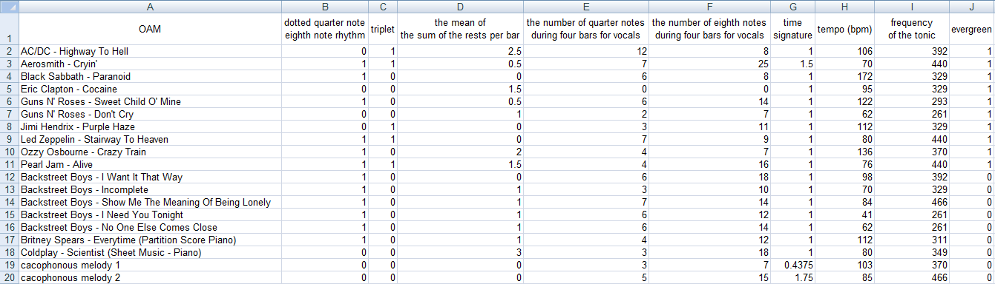

Figure 1. Object-Attribute-Matrix for classification tasks (self-made).

Conclusion: Three attributes (triplet, number of quarter notes during four bars for vocals, tempo) were enough to classify the objects without errors.

**Automated classification of music pieces into music eras**

(Source: <https://miau.gau.hu/mediawiki/index.php/ROBOTF%C3%9CL>)

Main question: Is it possible to categorize any arbitrary piece of music into music eras in an automated, objective and unbiased way? Does considering music through this "robot-ear" prevent common mistakes made by human experts?

Results and difficulties: Besides the previously mentioned music characteristics, additional attributes were defined, f.e. key signature, dissonance, usage of choir, etc. So far, only a few pieces of music are part of our database, so before the expansion of the database, it is not worth to discuss accuracy. Analysed objects:

* Dies Irae (Gregorian, Medieval)
* Bakfark (Renaissance)
* Machaut: Messe de Nostre Dame (Renaissance)
* Tallis: The Lamentation of Jeremiah (Renaissance)
* Bach: Brandenburg Concerto in F Major (Baroque)
* Handel: Messiah (Baroque)
* Beethoven: Symphony No. 5 (Classical)
* Haydn: String Quartet in G Major, Op.77 (Classical)
* Mozart: Piano Sonata No. 11 in A Major (Classical)
* Chopin: Mazurka in A Minor (Romantic)
* Puccini: La bohème (Romantic)
* Schubert: Die Forelle (Romantic)
* Bartók: Piano Concerto No. 3 (20th century)
* Kurtág: Splinters (Contemporary)

Used attributes (Xi and Y):

* harpsichord
* dynamics
* dissonance
* key signature
* number of voices for singing
* number of voices for instruments
* ambitus
* clarinet
* choir (1): yes or no
* choir (2): no or male or female or children
* chromaticism
* lute
* modulation
* brass instruments
* rhythm
* solo
* number of movements
* type of orchestra
* piano
* Consequence (Y): music era

Abstract of the OAM:

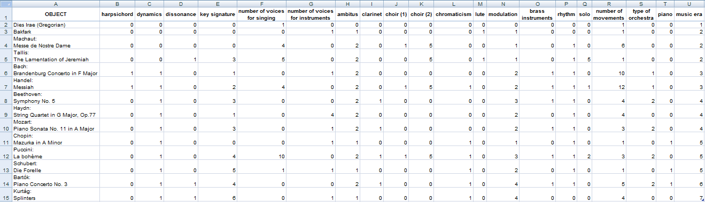

Figure 2. Object-Attribute-Matrix for modelling eras (self-made).

Conclusion: The era of each object could be identified… Analysed objects:

**Relative simplicity of melodies**

(Source: <https://miau.gau.hu/mediawiki/index.php/ZENE>)

Main question: Can (derived a simplicity index) each melody be evaluated as the same, but in an other way by using each of the previously declared attributes? If not, then is the most simple and the most complex melody harder to identify using human ears, or the robot ear?

Results and difficulties: The analysis of simplicity, based on relatively high amounts of attributes, and low amounts of objects leads to a multi-step solution, in order to integrate each attribute in the antidiscriminative classification. The different melodies can be standardised, based on the tact information.

Analysed objects:

* AC/DC – Highway To Hell
* Aerosmith – Cryin'
* Black Sabbath – Paranoid
* Eric Clapton – Cocaine
* Guns N' Roses – Don't Cry
* Guns N' Roses – Sweet Child O' Mine
* Jimi Hendrix – Purple Haze
* Ozzy Osbourne – Crazy Train
* Pearl Jam – Alive

Used attributes (Xi and Y):

* tact (attribute for standardisation)
* thirty-second note
* sixteenth note
* eighth note
* dotted eighth note
* quarter note
* dotted quarter note
* half note
* dotted half note
* whole note
* dotted whole note
* syncopation
* eighth note dotted quarter note rhythm
* sixteenth note dotted eighth note rhythm
* thirty-second note dotted sixteenth note rhythm
* dotted quarter note eighth note rhythm
* dotted eighth note sixteenth note rhythm
* dotted sixteenth note thirty-second note rhythm
* triplet eighth notes
* triplet quarter notes
* 1/16 vs. 2/16
* 2/16
* 3/16
* 4/16
* 5/16
* 6/16
* 7/16
* 8/16
* 9/16
* 10/16
* 11/16
* 12/16
* 13/16
* 14/16
* 15/16 vs. 16/16
* 1/16 vs. 2/16 (refrain)
* 2/16 (refrain)
* 3/16 (refrain)
* 4/16 (refrain)
* 5/16 (refrain)
* 6/16 (refrain)
* 7/16 (refrain)
* 8/16 (refrain)
* 9/16 (refrain)
* 10/16 (refrain)
* 11/16 (refrain)
* 12/16 (refrain)
* 13/16 (refrain)
* 14/16 (refrain)
* 15/16 vs. 16/16 (refrain)
* Consequence (Y): each object got the same initial index value

Abstract of the OAM:

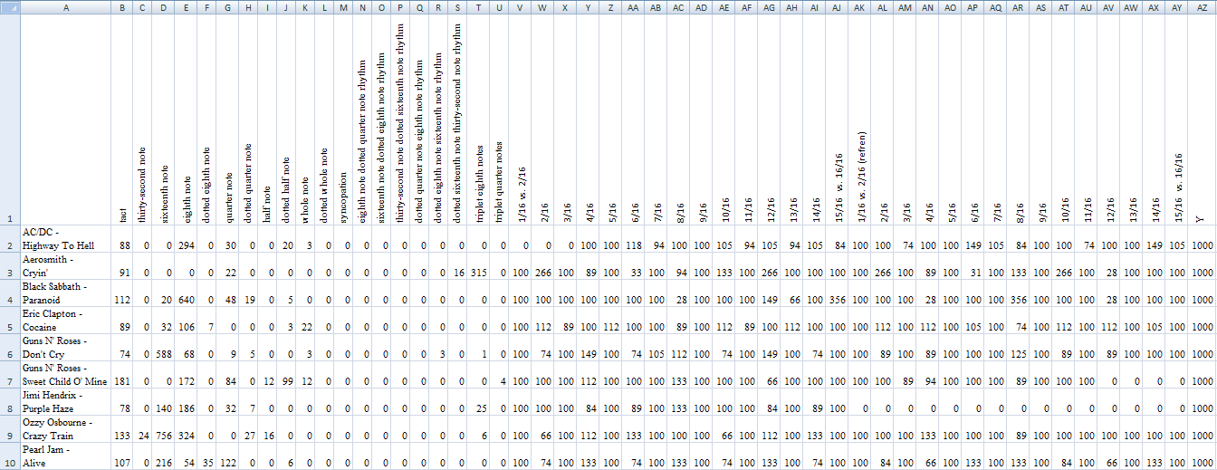

Figure 3. Object-Attribute-Matrix for modelling a simplicity index (self-made).

Conclusion: The relatively simplest object is: Purple Haze. The relatively most complex object is: Sweet Child of Mine. Each other object can be seen as an object adhering to the norm.

References

Alfred Schilken (2016). *Dein Name ist Musik*, <http://www.dein-name-ist-musik.de/>

Anonymous Student (2013). *Automated classification of music pieces into music eras or the robot-ear in MIAU-WIKI HU ISSN 14191652,* <https://miau.gau.hu/mediawiki/index.php/ROBOTF%C3%9CL>

Anonymous Student (2010). *Relative simplicity of melodies in MIAU-WIKI HU ISSN 14191652,* <https://miau.gau.hu/mediawiki/index.php/ZENE>

Anonymous Student (2008). *The mathematical definition of evergreen songs and music generation in MIAU-WIKI HU ISSN 14191652,* <https://miau.gau.hu/mediawiki/index.php/2007:Zenei_sz%C3%A9ps%C3%A9g>

Anonymous Users (2016). *Game in WIKIPEDIA,* <https://en.wikipedia.org/wiki/Game>

Anonymous Users (2016). *Dean Schlichter in Physics Forums,* <https://www.physicsforums.com/threads/dean-schlicter-who.348163/>

CFP list (2015). *Designing Gamification Processes for Music Learning: Formal and Informal Context – Call for paper in Academican Call for Papers Database,* <http://www.cfplist.com/cfp.aspx?cid=5801>

Eurovision Song Contest (2016). <https://en.wikipedia.org/wiki/Eurovision_Song_Contest>

Konrad Lorenz (1944). *The Russian Manuscript*

László Pitlik (2005). *Expert systems* *in MIAU-WIKI HU ISSN 14191652,* <https://miau.gau.hu/mediawiki/index.php/Szak%C3%A9rt%C5%91i_rendszer>

László Pitlik (2014). *Idea Breeding Farm in Noble Ideas Project ISBN: 978-963-12-0943-3*, <http://miau.gau.hu/miau/196/My-X%20Team_A5%20fuzet_EN_jav.pdf>

László Pitlik (2016). *OLAP-services in MIAU HU ISSN 14191652*, <http://miau.gau.hu/olap>

Sándor Szathmári (1941). *Kazohinia,*

<ftp://ontologia.hu/Language/Hungarian/Crawl/MEK/mek.oszk.hu/01400/01456/html/>

ScoreAHit team (2016). <http://scoreahit.com/science>

1. Mind(set) Clearing/Cleaning – Online and Open = MOOC