Website evaluation of the National Libraries (EU28)
György Losonczi
gLosonczi@gmail.com
This study addresses the issue of the competitive websites of the national libraries in the EU28 era. Why is it important for the institutions to have competitive website? Because websites are the most important form of their online appearance, as a reflection of the style, the activity and the reputation of the particular institution. The aim of the paper to evaluate and find the differences of the websites of the national libraries.
Keywords: website evaluation. national libraries. competitiveness. online marketing. CW-Index

Introduction
“Every business is an information business” P. Evans and T. Wurster leaders of the Boston Consulting Group, said [1]. According to György Bögel information has always been an important competitive factor in the modern business world [2]. The websites carry information which means specific messages for the target groups. This study addresses the issue of the competitive websites of the national libraries. Why is it important for the institutions to have competitive websites? Because websites are the most important form of their online appearance, as a reflection of the style, the activity and the reputation of the particular institution [3] and SEO’s potential is only as high as the quality of the business or website [4]. Also the relevance of the subject is legitimate because the one of the target group of my research is the Y generation, who is a student at University use the Internet, they collect every information from the internet and they are future employees [5].
In my study I am evaluating the website from not only one aspect. Considering the concept of the competitiveness my examinations have been completed by CW-Index model to evaluate the websites.

1 Theoretical Background

Overview of Website Evaluation
Many models, templates, checklists or other schemas for evaluating websites were developed for measuring the effectiveness of websites. The models around 1997 used the criteria from print media, mostly rely to the authority and reliability of websites [6] [7] [8]. Smith created 7 categories of criteria: scope, content, graphic and multimedia design, purpose and audience, reviews, workability and cost [9]. Gorski’s 7 criteria categories are: relevance, appropriateness, credibility, bias, accuracy, accessibility, navigability and multiculturality [10]. The study of Áts et al. was based on the criteria of design, content, interactivity, security and technical solutions to evaluate the websites of Hungarian secondary schools in 2000 [11]. Few years later Spencer and Ruwoldt focusing on certain relevant aspects of marketing evaluated 68 university websites. They also analysed the content and link structure of these websites [3]. Website Evaluation Questionnaire (WEQ) was developed by Elling, Lent and Menno. WEQ focused on usability and user-satisfaction with the following aspects: layout, content and navigation [12]. In 2008 Edit Bányai and her research group developed a set of criteria for evaluating the websites of Hungarian Business Schools [13]. Matt Soace et al. in 2010 analysed 10 universities focusing on landing page navigation links [14].
The conclusion of the short overview of the evaluation models or criteria lists, that all of them are focusing on one main aspects such as usability, technics, marketing or website development. There is no model that measures the competitiveness of the website especially for libraries at the moment as it needs more aspects and complexity. Studying the relevant literature and taking the above mentioned facts and approaches into consideration more than 100 criteria have been defined for analysing the competitiveness of websites, developing the "Competitive Website Index" model (CW-Index) for website evaluation [15].

CW-Index
The CW-Index framework is made up many criteria based on relevant literature. The criteria are arranged in groups, which enables the system to be extended and weighed subsequently, thus making it flexible. The model of evaluation criteria as a "gauge" measures the competitiveness of the site, the result of measuring will create the competitiveness index of the website.
The components of the model of evaluation criteria have been determined from the following aspects: business strategy, marketing, the functional utility of the website, applied web technology, quality. The first two aspects are economical approaches (strategy, marketing), the purpose of which is to determine the adequate scope of information and to forward them to the target groups. Therefore the competitiveness of the website has been examined firstly from the aspect of the strategy [16]: determining the vision, concrete orientation (whom? what? how?) and measurability. The other two aspects (functionality of the website, applied web technology) are technical approaches that indicate the operative method of realization.
The model of the evaluation criteria has a strong hierarchical structure. The five sub-groups - which are summarized by the two main groups - are sorted in further categories (Figure 1).

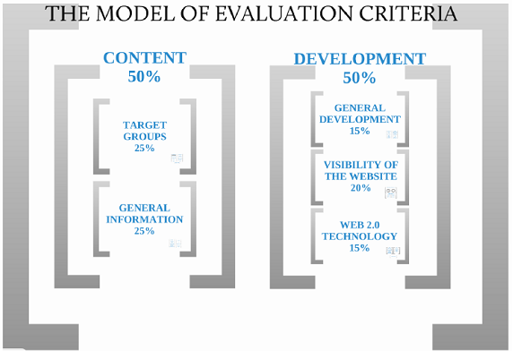
Figure 1
CW-Index Website Evaluation Model
(Source: Losonczi [15])
The criteria have been classified into two main categories with the title CONTENT and DEVELOPMENT. The system also reflects very well the already well known questions of strategy: whom, what and how? To the question WHOM the answer can be found in the “Target Groups” category while the answer to the question WHAT appears in the category "General Informations". The question HOW is represented by the category “DEVELOPMENT”, which consist of three groups: functionality ("General Development”), visibility ("Visibility of the Website"), innovation ("Web 2.0 Technology").

2 Objective and Methodology
The research has been conducted among 28 websites (28 country) and specially focused on their first landing page. All of them were evaluated in the year 2017 and saved to database. The dataset itself is made up of more than 1600 records. Figure 2 presents the according libraries and website addresses (URL).
Figure 2
Excel dataset overview of the EU28 countries
Source: Created by the author
The websites were evaluated using the CW-Index model's evaluation criteria. Except of a few of the criteria most of them work as binary variables : 1 point (true) for the existence, attainability, application of the criteria and reasonably; 0 point (false) when finding the contrary.

3 Result and Discussion
The research has been conducted among 28 library websites and specially focused on their first landing page. All of them were evaluated between 07.02.2017 – 23.04.2017. This paper will not present all the results of the website evaluation due to shortage of space, but it will focus on some part of the model to demonstrate it’s utility. Figure 3 shows the results of the target groups for EU28, EU15 and for Visegrád Four countries and it's avarages. I found differences in providing information for "Business, Partners", "Foreign Visitor", "Groups" , "Prospective Staff" target groups.

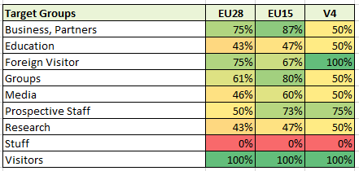Figure 3
Target Groups
(Source: Authors research)
Many libraries targeting other groups on their websites: "Publishers", "Librarians", "Readers", "Teachers". In my opinion it is a very good way to focus to the "special" visitors with special needs or interest, developing them uniqe products, programms.
Figure 4 shows, that EU15 countries providing more information of the ticket prices. All the groups are using well the "News” and “Events" contents as communication tool (Figure 5), but V4 countries communicates more on other communication chanels e.g. using newsfeeds and foreign languages to mirror their websites content for international visitors. Newsletters rarely used by V4 countries.

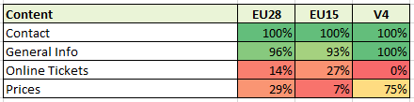Figure 4
Content
(Source: Authors research)

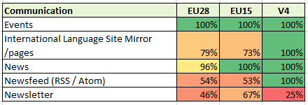Figure 5
Communication
(Source: Authors research)
Beside general information aspects, branding is also an important view of the websites (Figure 6). As we see in the results CSR still not common, declaring mission and history informations of the library are rarely used by the V4 countries. They are using well the design elements (e.g. logo, favicon in tabs). Only two libraries have mottos: British Libraries (“For research, inspiration and enjoyment”) and National Library of Finland (“SEEK AND FIND - Access the National Library’s collections with a single search”).

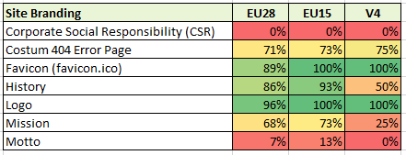Figure 6
Site Branding
(Source: Authors research)

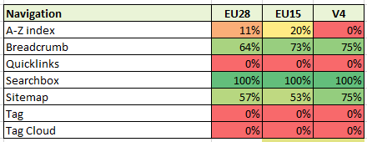Figure 7
Navigation
(Source: Authors research)
In navigation solutions their are no special differences (Figure 7), but in support aspects (Figure 8) V4 and EU15 websites are mainly optimised to mobil devices as the EU28 avarage.

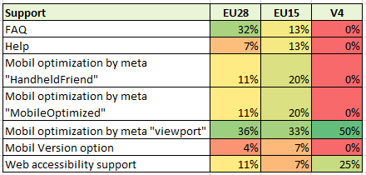Figure 8
Support
(Source: Authors research)
SEO (Search Engine Optimization) techniques results are differ in the evaluated groups. The V4 countries are using less metatag "keywords", “robots” and "robots.txt” on their sites (Figure 9). Metatags are hidden informations in the website source code, used by spider robots. For example Google is using spider robots to index and rank the evaluated website using the guidelines given in the "robots.txt" file. This means that websites can be ranked lower, therefore less visible in the Internet due to not proper usage of SEO techniques.

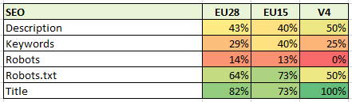Figure 9
SEO
(Source: Authors research)
Figure 10 presents the usage of the Social Media. As video, they are prefering Youtube, as picture Instragram and Pinterest, for social network they use far most Facebook and Twitter. Beside all of the mentioned media I found TripAdviser too, propably targeting the tourists. Some libraries also have their own blogs.
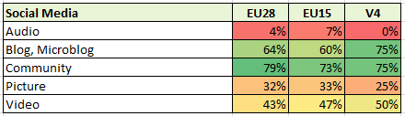Figure 10
Social Media
(Source: Authors research)

4 Conclusion
The study addresses the issue of the national libraries websites in the EU28 era. During the evaluation, I found differences between the EU28, EU15 and V4 groups. There are notable differences in target groups "Business, Partners", "Foreign Visitor", "Groups" , "Prospective Staff" target groups and EU15 countries providing more information about ticket prices.
The V4 countries has competitive websites as the EU15 or EU28 in communication field, targeting "foreign visitor” group, but there are gaps targeting "business, partners", guided tours for groups, using online ticket selling. Branding elements such as mission statement, history of the institution or Corporate Social Responsibility (CSR) can not found on the EU28 websites. V4 using less picture oriented social networks (e.g. Instagram, Flickr).
In navigation solutions their are no special differences, but in support aspects already: V4 and EU15 countries websites are mainly optimised to mobil devices as the other groups. Search Engine Optimization techniques results are differ in the evaluated groups. The V4 countries are using less metatag "keywords", “robots” and "robots.txt” on their sites. Not proper usage of SEO techniques the websites can be ranked lower, less visible in the Internet.
Final conclusion: V4 websites are less competitive compared to the EU15 in some aspects such as site branding, content structures, target group content and visibility, but overall results of the V4 countries are satisfying.

References
[1] Evans, P., Wurster, T.: Blown to Bits, Harvard Business School Press, Boston, MA, 2000, pp. 9.
[2] Bőgel Gy.: Verseny az elektronikus üzletben – Melyik békából lesz herceg?, Műszaki Könyvkiadó, Budapest, Hungary.Spencer, C., Ruwoldt, M. 200. Navigation and content on university home pages, (Online), http://repository.unimelb.edu.au/10187/1141 (downloaded: 25/5/10 2010 9:14).Authors: Title, in Proceedings of …, place and date of edition, 2000, pp.
[3] Spencer, C., Ruwoldt, M.: Navigation and content on university home pages, (Online), http://repository.unimelb.edu.au/10187/1141 (downloaded: 25/5/10 2010 9:14).Authors: Title, in Proceedings of …, place and date of edition, 2000, pp.
[4] Ohye, M.: How to hire an SEO, [Online] , Google Webmasters - Youtune Channel, https://www.youtube.com/watch?time_continue=6&v=piSvFxV_M04, 2017
[5] Kolnhofer-Derecskei, A., Reichner, R. Zs.: GenYus - Y generáció az Y generáció szemével, Vállalkozásfejlesztés a XXI. században VI. 2016, pp.229-242
[6] Leland, B.: Evaluating web sites: A guide for writers. (Online), http://www.wiu.edu/users/mfbhl/evaluate.htm (03. 12. 2007) (downloaded: 26/05/10 23:05), 1998
[7] Beck, S. E.: Evaluation Criteria. The Good, The Bad & The Ugly: or, Why It is a Good Idea to Evaluate Web Sources. (Online). http://lib.nmsu.edu/instruction/evalcrit.html (downloaded: 26/05/10 23:09), 1997
[8] Kapoun, J.: Five criteria for evaluating Web pages http://olinuris.library.cornell.edu/ref/research/webcrit.html, (Online), (downloaded: 25/5/10 2010 9:14), 1998
[9] Smith, A. G.: Testing the Surf: Criteria for Evaluating Internet Information Resources (Online), http://www.vuw.ac.nz/staff/alastair_smith/evaln/index.htm, (downloaded: 25/05/10 9:14), 1997
[10] Gorski, P.: Toward a Multicultural Approach for Evaluating Educational Web Sites, Multicultural Perspectives, (Online), http://edchange.org/multicultural/net/comps/eval.html (downloaded: 27/05/10 0:02), 1999
[11] Áts, J., Bondor E., Kovács, L.: A magyar középiskolák honlapjainak elemzése, (Online), http://ofi.hu/tamop311/egyeb/hirek-090617/magyar-kozepiskolak (downloaded: 04/22/17. április), 2000
[12] Elling, S., Lentz, L., De Jong, M. : Website Evaluation Questionnaire: Development of a Research-Based Tool for Evaluating Informational Websites, M.A. Wimmer, H.J. Scholl, and A. Grönlund (ed..): EGOV, Springer-Verlag Berlin Heidelberg, LNCS 4656, 2007, 293–304 pp..
[13] Bányai E.: The Online Marketing of Hungarian Business Schools. (Online), http://www.gti.ktk.pte.hu/files/tiny_mce/File/LetolthetoPublikaciok/BanyaiE/Edit_Banyai_nonprofitmarketing.pdf (downloaded: 05/10/10 19:42), 2008
[14] Soave, M., Campbell, M. R., Frost, K.: Competitive Analysis of Five University Hub Websites, (Online), http://www.mattsoave.com/old/cogs187a/iu_ia_redo/comparisons.html ( 09/11/11 21:48), 2010
[15] Losonczi Gy: Magyar felsőoktatási intézmények honlapjainak versenyképesség vizsgálata nemzetközi viszonylatban.). In: Juhász L., E-CONOM. 3. évf. 1., 2014, pp. 139-156. Nyugat-magyarország Egyetem Kiadó (ISSN 2063-644X) (https://bismarck.nyme.hu/24677.html?&L=1&id=24677)
[16] Boda I.: Stratégiai menedzsment: célok, küldetés, (Online), http://www.inf.unideb.hu/~bodai/menedzs/strategiai_menedzsment.html (downloaded: 09/12/10 17:45), 2006

