ICT and futurology in the strategic management
OTKA (T049013) research report
LÁSZLÓ PITLIK, (HU) – ATTILA SZANYI, (HU) – ERIKA OROSZ (HU)

ABSTRACT

The authors try to clear the necessity and the (techno-)logical possibility of a new paradigm in the strategic management both on micro, mezzo- and macro level. Based on project experiences of almost 20 years (e.g. monitoring of agricultural sector models, working out forecasts and new methods of semi-automatic knowledge acquisition and similarity analysis) it should be declared, that a deep gap could be identified between the conventional issues of strategic management and the already available ICT potential.

KEY WORDS

strategic management, equilibrium, COCO-method, automation, knowledge acquisition

INTRODUCTION

The conventional proceeding of strategy-development can be characterised as an essentially subjective phenomenon. The decision-makers decide about the weights of the attributes used in the analysis of the future, by intuitive feelings, without mathematical control. As long as the futurology would be able to estimate only partial points and trends, decision-makers cannot be sure, whether the forecasted scenarios are stable enough.
Therefore it is necessary and possible to develop such methods, which are able to ensure (based on all the “facts” of the past), that the probably “best” future scenario (cf. near consistent pixels/contour of a “future-picture”) can be identified in frame of a semi-automatic workflow.
The characteristic components of this workflow are the following: a multidimensional control system of professional consistency, a context-free monitoring of similarity along the space- and time-axels.
General aspects will be handled in frame of the above-mentioned OTKA-project. Specialities of the general concept of management issues concerning the external information system in enterprises will be described in the PhD-dissertation.
This article contains information on three level:
- 1. level: general aspects (cf. philosophical background),
- 2. level: responsibilities of the CIO (operative task in enterprises and institutions),
- 3. level: example (strategic planning of the milk production)

MATERIAL AND METHODS

Problem descriptions

- 1. level: The goal of this level can be formulated as follows: Based on the phenomena of the milk market (cf. 3. level) several rules should be constructed, which make possible to check the consistency starting from a set of single future scenarios.
- 2. level: On this level should be analysed, which problems the CIO have to solve in order to ensure data assets, applications and network for the analyse in connection to the milk market.
- 3. level: Accomplishing a set of COCO-based calculations, which provide forecasts for the milk markets
  - by several countries (5 options)
    - HU, USA, TUR, CHE, CAN
  - for several time-intervals in future (10 options)
    - from 1 to 10 years
  - by several phenomena (Y: 4 options)
    - production level
    - consumer price
    - producer support estimate
    - consumer support estimate
  - based on (2 options)
    - full and
    - partial data assets
  - supported by (2 options)
    - Excel Solver and
    - LPS.
These calculations (5*10*4*2*2=800) were started from diverse object-attribute-matrix, which includes maximal 26+1 (X+Y) attributes and 18 objects.

Data assets (example level)

Following attributes are included into the analyses (1. table):
Description | Dimension | Source
Total value of production (at farm gate) | USD Mn | http://www.oecd.org/dataoecd/33/50/32361372.ZIP
Total value of consumption (at farm gate) | USD Mn | http://www.oecd.org/dataoecd/33/50/32361372.ZIP
Producer Support Estimate (PSE) | USD Mn | http://www.oecd.org/dataoecd/33/50/32361372.ZIP
Consumer Support Estimate (CSE) | USD Mn | http://www.oecd.org/dataoecd/33/50/32361372.ZIP
Total Support Estimate (TSE) | USD Mn | http://www.oecd.org/dataoecd/33/50/32361372.ZIP
Market price support (MPS) | USD Mn | http://www.oecd.org/dataoecd/33/50/32361372.ZIP
Value Difference Between Production and Consumption | USD Mn | http://www.oecd.org/dataoecd/33/50/32361372.ZIP
PSE/TSE |  | http://www.oecd.org/dataoecd/33/50/32361372.ZIP
CSE/TSE |  | http://www.oecd.org/dataoecd/33/50/32361372.ZIP
MPS/PSE |  | http://www.oecd.org/dataoecd/33/50/32361372.ZIP
Level of Production | 1000 t | http://www.oecd.org/dataoecd/33/50/32361372.ZIP
Producer Price (at farm gate level) | USD/t | http://www.oecd.org/dataoecd/33/50/32361372.ZIP
Value of Production/Total Value of Production |  | http://www.oecd.org/dataoecd/33/50/32361372.ZIP
Level of Consumption | 1000 t | http://www.oecd.org/dataoecd/33/50/32361372.ZIP
Consumption Price (at farm gate level) | USD/t | http://www.oecd.org/dataoecd/33/50/32361372.ZIP
Value of Consumption/Total Value of Consumption |  | http://www.oecd.org/dataoecd/33/50/32361372.ZIP
Reference Price (at farm gate level) | USD/t | http://www.oecd.org/dataoecd/33/50/32361372.ZIP
Producer Price/Reference Price |  | http://www.oecd.org/dataoecd/33/50/32361372.ZIP
Consumer Price/Reference Price |  | http://www.oecd.org/dataoecd/33/50/32361372.ZIP
Producer Support Estimate (PSE) | USD Mn | http://www.oecd.org/dataoecd/33/50/32361372.ZIP
Consumer Support Estimate (CSE) | USD Mn | http://www.oecd.org/dataoecd/33/50/32361372.ZIP
Market price support (MPS) | USD Mn | http://www.oecd.org/dataoecd/33/50/32361372.ZIP
PSE/tPSE |  | http://www.oecd.org/dataoecd/33/50/32361372.ZIP
CSE/tCSE |  | http://www.oecd.org/dataoecd/33/50/32361372.ZIP
MPS/tMPS |  | http://www.oecd.org/dataoecd/33/50/32361372.ZIP
MPS/PSE |  | http://www.oecd.org/dataoecd/33/50/32361372.ZIP
Value Difference Between Production and Consumption | USD Mn | http://www.oecd.org/dataoecd/33/50/32361372.ZIP
PSE/TSE |  | http://www.oecd.org/dataoecd/33/50/32361372.ZIP
CSE/TSE |  | http://www.oecd.org/dataoecd/33/50/32361372.ZIP
MPS/tPSE |  | http://www.oecd.org/dataoecd/33/50/32361372.ZIP
MPS/TSE |  | http://www.oecd.org/dataoecd/33/50/32361372.ZIP
Import | 1000t | FAO Food Balance Sheets
Export | 1000t | FAO Food Balance Sheets
Quota | 1000t
Real GDP | USD/capita | Real GDP/capita,  Population: macro_time_series_8_2005  (http://www.nyu.edu/fas/institute/dri/dataset/macro_time_series_8_2005.xls)
1. table: data description (own presentation)
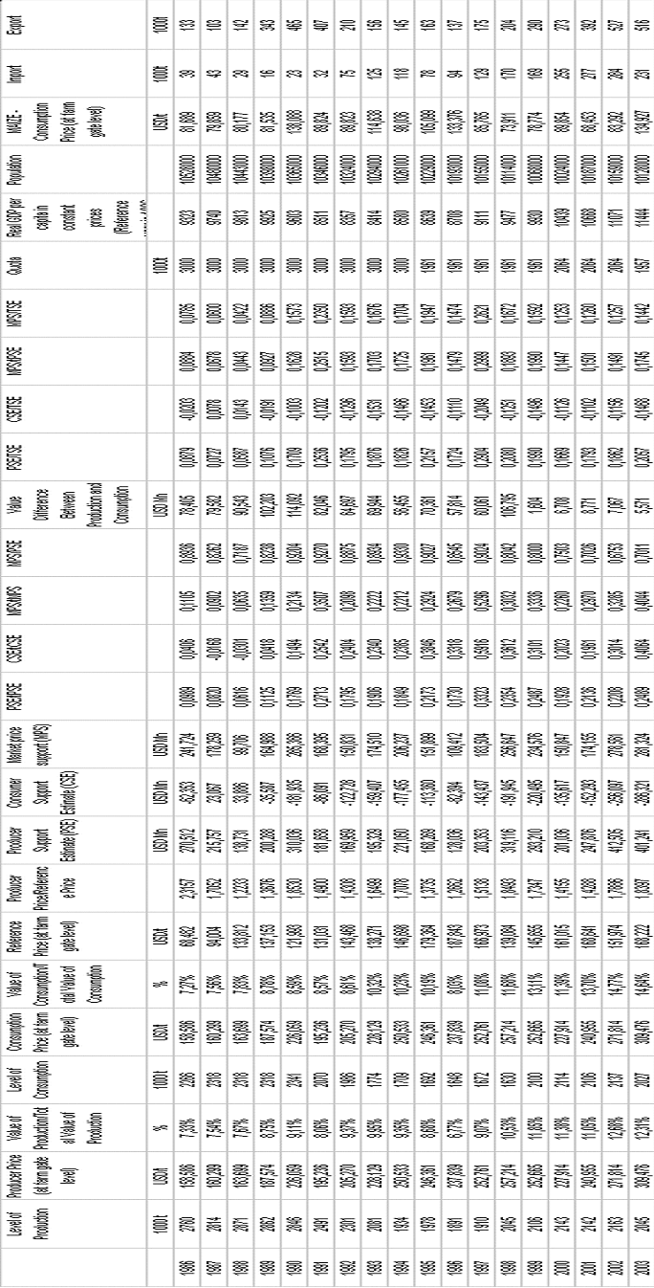
2. table: Data assets (own presentation)
Methodological background:

- COCO: The COCO method (Component-based Object Comparison for Objectivity) was developed in 2004 by Pitlik, in order to ensure such kind of context-free similarity analyses (e.g. benchmarking, forecasting), where the role of experts is limited to choose an object-attribute-matrix and the base types of ranking for each attributes (e.g.: max, min, opt). This methods calculate “stairs”, which describe, how important is certain options of the selected X-attributes in connection to the Y-variable (e.g. time-, space-coordinates, arbitrary phenomenon). Hereby objects can be evaluated in tree forms: equilibrium, over-estimated, under-estimated.

- Learning phase: In case of primer forecasting topics COCO should bring stairs, which ensure approximate equilibriums. Based on the calculated (objective) stairs scenarios (forecasts) can be simulated for several time-intervals.

- Initialising (testing) phase: The first estimation should be made in case of years, which Y-values are known, in order to initialise the long time patterns.

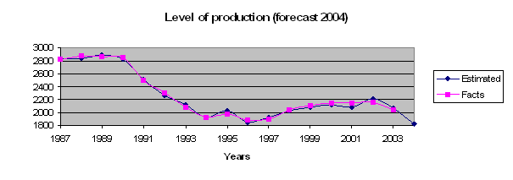
1. figure: Short term forecasting (own calculation)

- Visualisation: So COCO let us calculate automatically future-picture with more or less “fuzzy” contours. Therefore the real problem can be defined as a fine-tuning (focus) of future-pictures.
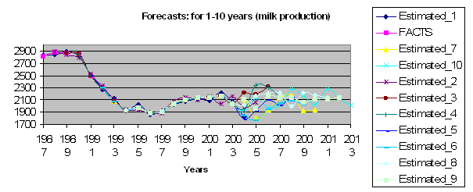
2. figure: “Fuzzy” forecasting picture (own calculation)
- Solver: A COCO problem can be solved by several techniques: Excel Solver is able to make approximations for non-linear (e.g. quadratic error sum) objective function and limited set of restrictions.

- LPS: Based on classical linear programming tools COCO problems can be solved by 2 calculations (approximation of zero error in positive and in negative interval).

- Roxfort-approximation: It is possible to develop such kind of search techniques, which can ensure to find a correct set of stairs (without LP).

- Consistency check of future-pictures: After the generation of a big set of primer pixels to the future-picture, which was calculated from diverse angles, it is necessary to select patterns, which are consistent. Consistency checks has several types:
  - Choosing patterns based on initial similarity of time series.
  - Developing subjective rules for more phenomena (incl. countries). In this case should be controlled, whether (e.g.) the increasing of phenomenon_1 allow the parallel increasing of phenomenon_2, etc.
  - Calculation of contextual puzzle pieces (e.g. heads by age groups of pigs) and intuitive search for secondary patterns, which help to close the biological connections between the diverse age groups.
  - Calculation of contextual puzzle pieces (e.g. weather attributes) and methodical search for secondary patterns, which help to close the phenomenon-depend connections through control-calculation of time-shift. In this case the estimated fragments of a future-picture (as X-variables) should give the year “code” (or other abstraction of the time: e.g. SIN, in order to make an adequate frame for interaction of wave-based phenomena), which these forecasts represent.
  - The same logic as by point 4 can be also used for space-coordinates.

RESULTS

- 3. level:
  - Learning phase: almost error-free passed
  - Testing phase: flexible, realistic single pattern for the future founded
- 2. level:
  - Operative topics for the strategy-building: Behind of the strategy-building it can be identified following steps:
    - generating numerously fragments to future-picture
    - identification of consistent fragments
    - specifying strategic plans based on the (concerning on decision) independent attributes and the objective functions
The large number of future-fragments can be generated only on the base of stable data assets and adequate analyzing tools, especially in connection with automizableness of analysing steps and interpretation rules (e.g. text panels).
  - CIO-topics:
    - Macro-level: The leading staff of a sector should have to solve the automatic generation of future-fragments basing on each new data. This is to only do effective, if
      - each data can be automatic included to the data assets (e.g. time series) without methodological consolidation,
      - an EDI-connection is given between data collecting and analyzing,
      - the primer data assets was controlled concerning to consistency.
Such kind of plans can be identified neither on EU-level nor in national level.
    - Mezzo-level: Experts of product councils, chambers, extension services, research institutions and universities have to identify errors in the automatic generating and interpreting procedures of the future-pictures only in that case, if the government is able to publish future-pictures without ad hoc manipulations. The explored errors and the codes for the improving should be iterative included to the knowledge base of the whole sector in order to provide new automatic procedures and to ensure a potential loss-free knowledge transfer between expert-roles and generations.
    - Micro-level: The enterprises provide not only primer data into this system. They are also responsible for the case-specific interpretation and error-detection as the experts on the mezzo level.
The CIO has to plane and control (on the strategic level) all the mechanisms of this knowledge manipulation system, especially concerning to the theory of Konrad Lorenz about the deep automatic identification of “figures” behind the intuitive human procedures. This approach has a strong focus on the basic version of the definition of science: only such kind of knowledge can be seen as realistic, which can be formed to source-code and which can be controlled objective (e.g. in advance stored and later evaluated forecasts). All other phenomena should be called as artistic potential.

- 1. level:
  - Building of (expert) system for selection of consistent patterns:
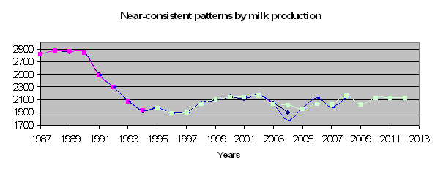
3. figure: The “best” forecastings (own calculation)

Based on the known data for 2004 and the expected value for 2005/2006 it can be selected two patterns: pattern_5 and pattern_9. The rule for selection is very simply: such pattern is consistent, where the last known data (2003) is higher as the data for 2004-2006.

  - Improving instable patterns: In case of the so-called wrong pattern can be analysed, whether a smoothing by extreme waves or a shifting with 1 unit bring more harmonised patterns. Through smoothing it can be ensured, that the year-to-year extreme waves (caused by single, extreme stairs) show a solid course. In background of shifting can be searched for effects, which make impossible the direct

DISCUSSION

Thesis 1: Automation of the market analysis is possible from point of view of ICT (- passed)
Thesis 2: Direct including of such kind of charts (future pictures) into the strategic planning is possible (- passed)

Risk 1: In the management of data assets can not be identified any strategic approach
Risk 2: The CIO is working in a misunderstood role (c.f. maintaining of IT or plan of knowledge transfers)
Risk 3: The education helps only hardly to include
- numerously forecasts through automated processes,
- objective controls and
- iterative knowledge management into the strategy-building
Neither the EU-constitution nor the IT-infected strategic experts declare clear the real challenges of the information society:
- no more secrets (each measured facts should be defined as non-profit source, which has to catalyze the intuition of the human
- each knowledge-form should be transferred to source-code
- strategy-building means the most realistic future-picture

LITERATURE
- http://miau.gau.hu/miau/91/bulletin_en.doc
- http://miau.gau.hu/miau/74/mtn2004_full.doc & http://miau.gau.hu/miau/74/cocomtn.xls
- http://miau.gau.hu/miau/81/iamo2005_en.doc & http://miau.gau.hu/miau/74/iamo_coco_poster.doc
- http://miau.gau.hu/miau/71/iamo_coco.doc
- http://miau.gau.hu/miau/91/gewisola2006_abstract.doc
- http://miau.gau.hu/miau/73/gewisola_end.doc & http://miau.gau.hu/miau/73/gewisolafulltext.doc
- http://miau.gau.hu/miau/69/gilfull.doc
- http://miau.gau.hu/miau/85/gil26_full.doc
- Konrad Lorenz, 1944-1948: Az orosz kézirat, 4. fejezet, Cartafilus Kiadó, 1998, ISBN 963 85882 0 9

CONTACT ADDRESS
http://miau.gau.hu/miau/contact.html

The English-version of this study was supported by the automatic translation services: http://babelfish.altavista.com

