- Dear Professors, I have brought out the attributes i thought would be suitable. Leaf Shape:
  - Extract features related to the overall shape of the leaves, such as length-to-width ratio, perimeter, and curvature.<--theoretically = excellent, on the other hand = do you have ideas, how to measure these attributes in case of real pictures? (different circumstances, rotation, angles, cloud/covering, etc.?
- Leaf Texture:
  - Analyze textural patterns on the leaf surface, including variations in color, smoothness, or the presence of veins. <--theoretically = excellent, on the other hand = do you have ideas, how to measure these attributes in case of real pictures? (different circumstances, rotation, angles, cloud/covering, etc.? e.g. Colours are depending on filters/sort of light/illumination sources… Maybe grey-scaling in general?
- Flower Characteristics:
  - Identify and extract features related to the color, size, and arrangement of flowers, if visible in the images. (see above)
- Plant Coloration:
  - Capture the color distribution of different parts of the plant, such as leaves, stems, and flowers.<--hopefully, even the colour distributions especially for grey-scaled pictures could deliver immediately raw data based on real pictures (however: the identification of leafs, flowers, etc. are always a problem let alone: young / old parts of a plant)
- Stem Structure:
  - Analyze features related to the structure and texture of the plant stem, including thickness and patterns.<--see above
- Contextual Surroundings:
  - Consider features related to the environment, like the type of soil, presence of other plants, or specific habitats where the plant is found. <--see above
- Growth Stage:
  - Incorporate features that indicate the growth stage of the plant, such as bud formation, flowering, or seed development. <--see above
- Spatial Arrangement:
  - Analyze how different parts of the plant are spatially arranged, including the relative positions of leaves, flowers, and stems. <--see above
- Seasonal Changes:
  - Account for features that may change with seasons, such as color variations, leaf shedding, or flowering patterns. <--see above
- Environmental Conditions:
  - Include features related to external conditions, like lighting, weather, and time of day, to enhance the model's adaptability to different environments. <--see above

Summa summarum: The theoretically correct recommendations (e.g. of the ChatGPT) are given (for descriptions in the 2. Chapter: Literature).
On the other hand: we need to test out capabilities here and now =
https://t4.ftcdn.net/jpg/02/69/89/23/240_F_269892329_Qsf2HJx4gAgmxtSyQfNkYGUdMfNJqY26.jpg
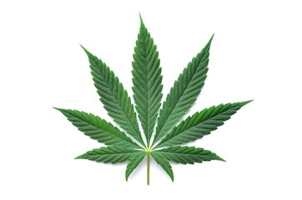
This already digital(ized) picture should be our first test-case!
Please, create mp4-files about your steps and voice-comments: how it is possible at all, to derive real raw data (measured values) following the above-listed aspects?

