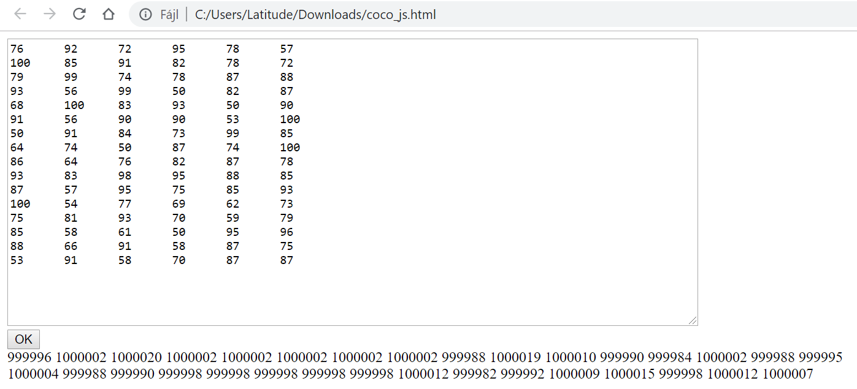

76 92 72 95 78 57

100 85 91 82 78 72

79 99 74 78 87 88

93 56 99 50 82 87

68 100 83 93 50 90

91 56 90 90 53 100

50 91 84 73 99 85

64 74 50 87 74 100

86 64 76 82 87 78

93 83 98 95 88 85

87 57 95 75 85 93

100 54 77 69 62 73

75 81 93 70 59 79

85 58 61 50 95 96

88 66 91 58 87 75

53 91 58 70 87 87

999996 1000002 1000020 1000002 1000002 1000002 1000002 1000002 999988 1000019 1000010 999990 999984 1000002 999988 999995

1000004 999988 999990 999998 999998 999998 999998 999998 1000012 999982 999992 1000009 1000015 999998 1000012 1000007

|  |  |
| --- | --- |
|  | <!DOCTYPE html> |
|  | <html lang="en"> |
|  |  |
|  | <head> |
|  | <meta charset="UTF-8"> |
|  | <meta name="viewport" content="width=device-width, initial-scale=1.0"> |
|  | <meta http-equiv="X-UA-Compatible" content="ie=edge"> |
|  | <title>COCO fetch demo</title> |
|  |  |
|  | <script> |
|  | function transpose(array) { |
|  | return array[0].map((_, col) => array.map(row => row[col])); |
|  | } |
|  |  |
|  | function rankArray(array, asc = false) { |
|  | const compare = asc ? (a, b) => a.val - b.val : (a, b) => b.val - a.val; |
|  | let sorted = array.map((val, idx) => ({ val, idx })); |
|  | sorted.sort(compare); |
|  |  |
|  | let cnt = 0; |
|  | for (let i = 0; i < sorted.length; ++i) { |
|  | sorted[i].rank = i + 1 - cnt; |
|  | if (sorted[i + 1] && sorted[i].val === sorted[i + 1].val) { |
|  | ++cnt; |
|  | } |
|  | else { |
|  | cnt = 0; |
|  | } |
|  | } |
|  |  |
|  | return array.map((_, i) => { |
|  | for (let x of sorted) { |
|  | if (x.idx === i) return x.rank; |
|  | } |
|  | }); |
|  | } |
|  |  |
|  | function coco(inverse = false) { |
|  | const input = document.getElementById('input').value; |
|  | const data = input.trim().split('\n').map(x => |
|  | x.trim().split(/\s+/).map(parseFloat)); |
|  |  |
|  | const oam = transpose(transpose(data).map(x => rankArray(x, inverse))); |
|  | oam.forEach(x => x.push(1000000)); |
|  |  |
|  | const str = oam.map(x => x.join('%09')).join('%0D'); |
|  | fetch('https://miau.my-x.hu/myx-free/coco/engine3_curl_cors.php', { |
|  | body: 'modell=Y0&matrix=' + str + '??', |
|  | headers: { |
|  | 'Content-Type': 'application/x-www-form-urlencoded', |
|  | }, |
|  | method: 'POST', |
|  | // mode: 'cors', |
|  |  |
|  | }) |
|  | .then(x => x.text()) |
|  | .then(output => { |
|  | document.getElementById(inverse ? 'output2' : 'output1').innerHTML = output; |
|  | }) |
|  | .catch(console.log); |
|  | } |
|  | </script> |
|  | </head> |
|  |  |
|  | <body> |
|  | <div> |
|  | <textarea id="input" rows="20" cols="100"></textarea> |
|  | </div> |
|  | <div> |
|  | <button id="button">OK</button> |
|  | </div> |
|  | <div> |
|  | <div id="output1"></div> |
|  | <div id="output2"></div> |
|  | </div> |
|  |  |
|  | <script> |
|  | document.getElementById('button').addEventListener('click', _ => {coco(); coco(true);}); |
|  | </script> |
|  | </body> |
|  |  |
|  | </html> |