Wind-chill on the market
László Pitlik, University of Gödöllő (2012.III.)

Introduction
Everybody knows the terms “temperature” and “wind-chill”. The temperature is an objective measureable one; however the wind-chill (the feeling of temperatures) is a subjective phenomenon. The wind-chill could be seen as the perception/embodiment of the intuition. The wind-chill is the aggregation of each input in the observer. In the background of the wind-chill should always be a model (integrating the impacts of the input channels). The wind-chill can also be interpreted in the music: monotonous sounds have a new message (lead to a new feeling) after each repeating phase. Finally the wind-chill as a type of feelings can be founded again on markets: constant prices in an environment characterised through continuous changes will also be received as relative advantage or even relative disadvantage compared to the waving of the price structure about them.

The data assets and their preparation for analyses
Cross rates of national currencies can be downloaded e.g. from the server of the National Bank of Hungary (http://www.mnb.hu/arfolyam-lekerdezes). The courses (compared to HUF) for almost 300 days (01.01.2011-02.24.2012.) are available here (on the worksheet “mnb”): http://miau.gau.hu/oktatas/2012tavasz/MNBubbles.xls. The worksheet “mnb2” consists the a selected version of the raw data: involving the European currencies (CHF, EUR, CZK, DKK, GBP, HRK, LTL, LVL, NOK, PLN, RUB, RON, SEK, TRY) as well as the most important international units (CNY, JPY, USD) – altogether 17 attributes per day for exactly 293 days. The abbreviations can be solved through the worksheet “iso-codes”. The worksheet “OAM” shows the object-attribute-matrix, the basic view of the learning pattern. The ranks were compressed from 293 to 59 (in case of several currencies to 50) in order to ensure online runs of the necessary similarity analyses. In case of USD the first days should be rejected to ensure the memory-limited processes. The worksheet “swot_basics” was created to support the construction of currency-specific patterns in an easy way. For each currency (worksheets always signed through iso-codes) were designed two patterns (a direct one and an inverse one) in order to be able to prove the symmetry of staircase function in case of double negation. The asymmetric positions (e.g. #?#) should be defined as blind spots – unable for further analyses. The two worksheets about suspicion (HUF = weak/strong) visualized the aggregated market feeling according to HUF.

Results
The final outputs of the models can be seen on the worksheet “wind-chill map”. The green-coloured cells show the days with relative advantages, the yellow cells visualized the neutral situations as well as the red-marked cells, which define a sort of disadvantages. The proven days and the proven currencies could be modelled with different amount of blind spots. The model correlations seem to be high enough to speak about an appropriate model approach: the direction of the currencies was always 0, (c.f. direct proportionality). The high correlations between facts und estimations make valid the hypothesis: the courses are moving (increasing and decreasing) mostly parallel. Inverse effects can be seen in case of following currencies: RUB, TRY, PLN (c.f. headers of last tables on the worksheets for currencies – yellow/red-marked – s Figure 1).
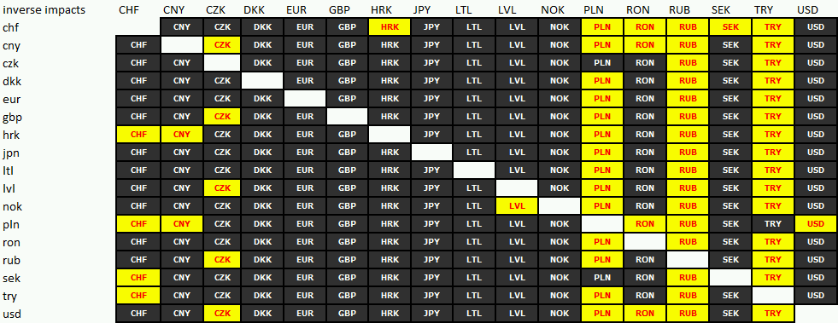
Figure 1: Inverse impacts (source: own calculations)
The less interpretable currencies are CHF, TRY, PLN (s. worksheet “wind-chill-map, row=299). Here bubbles can be assumed (s. figure 2a/b).
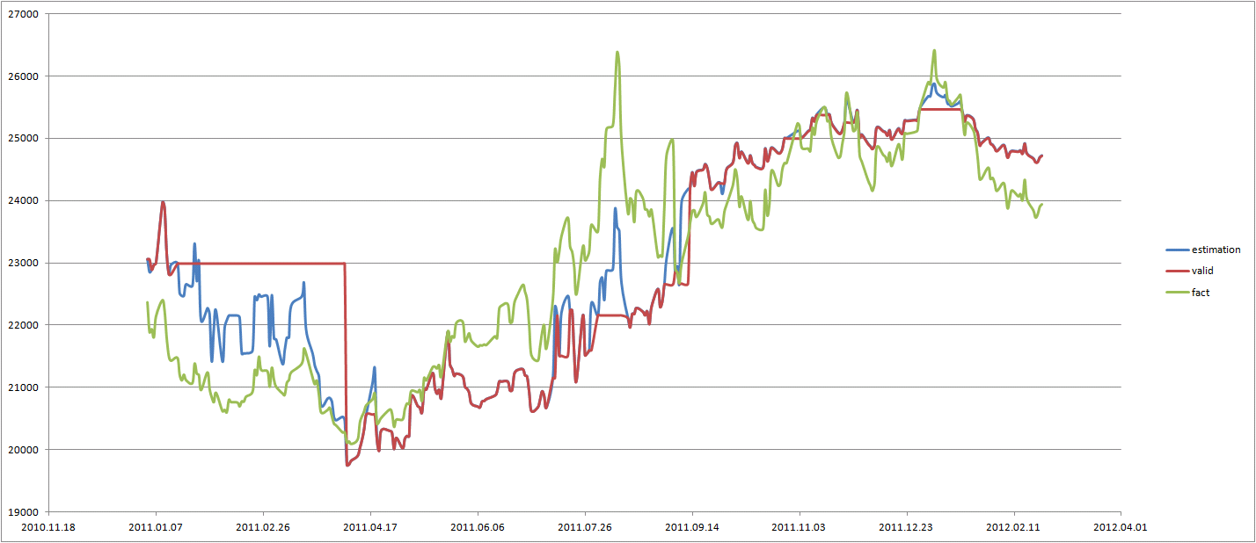
Figure 2a: CHF-bubbles (source: own calculations, Y-axis = course in HUF/100, X-axis = days)
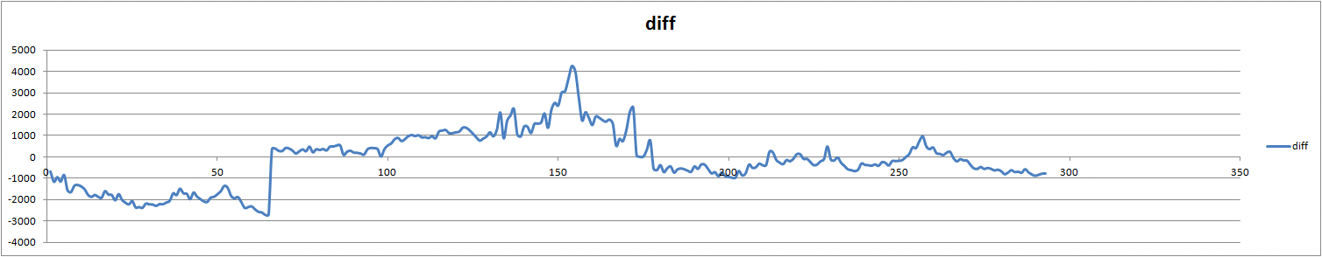
Figure 2b: CHF-movements about the logical level “0” (source: own calculations, Y-axis = course in HUF/100, X-axis = days)
Legends: horizontal red line-parts = invalid estimations (after symmetry-control), diff = difference between facts and valid estimations
Interpretations: If the line in figure 2b is over the null-level, then it can be expected, that the course will be changed in the reverse direction. Therefore the CHF is now relative cheap. The same effect can be identified in figure 2a, where the red line (estimation) is over the green one (fact). Bubbles can exist relative long – but there must always be existing a force field (speculation?!) in the background. These figures cannot be used as a direct type of estimation: these can only be interpreted as feelings/intuitions. The derivation of the more exact time, when the expected changes should come, needs further models.
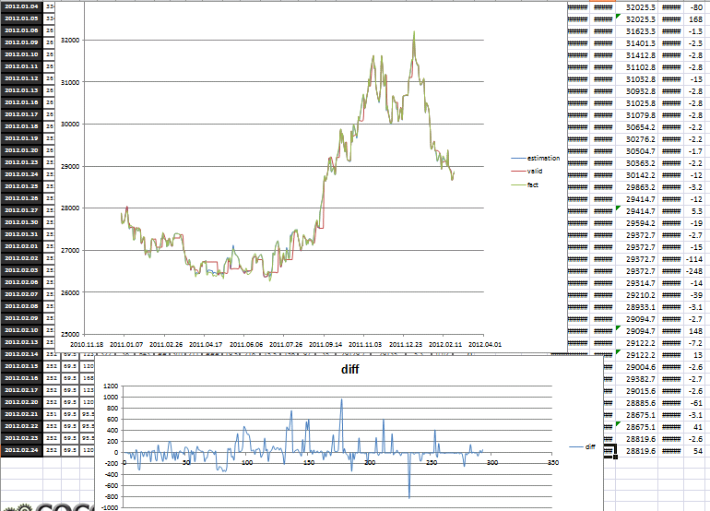
Figure 3: EUR-movements (source: own calculations, Y-axis = course in HUF/100, X-axis = days)
Figure 3 shows the most interpretable currency (based on the other currencies). There is hardly any relevant bubble for EUR and also hardly any invalid modelled days. Positive and negative peaks will always be regenerated. The course for EUR/HUF is now quasi in equilibrium.

Discussion
Wind-chill on the markets can be derived in a special SW(ot)-process: Strengths (green) and weaknesses (red) can be visualized through colours (s. Figure 4. – grey = invalid spots, yellow = balanced spots).
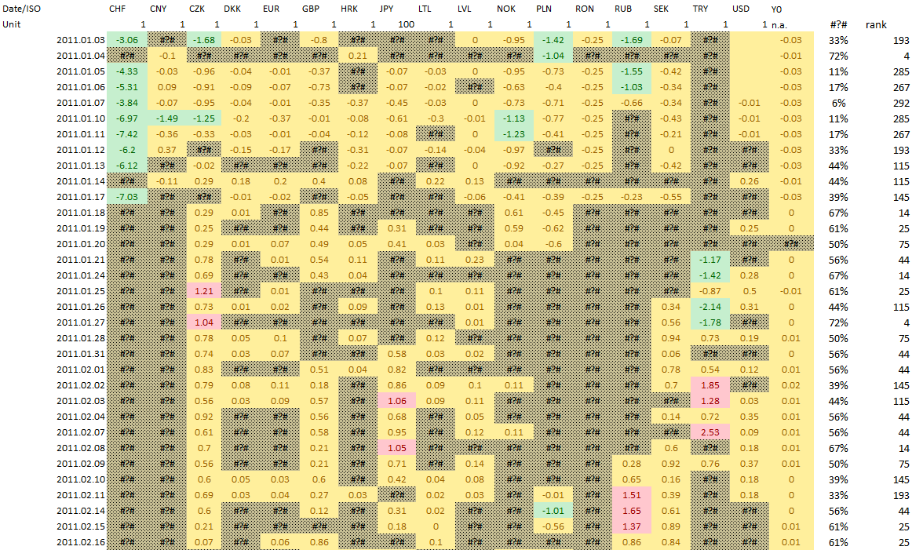
Figure 4: Wind-chill map for prices/courses (source: own calculations)
Dynamic effects (swOT) could not be involved into the process. As well as symmetry-controls, further validation can be initialized: the Y0-model shows a monotonous equilibrium for the whole (focused) market. The 17 currencies together show the same conclusion, although some of the currencies can be seen as strong or weak in waves. Hence the global financial market is well-balanced – as needed. Against speculations everybody can be saved through diversification of the currency-portfolio. If everybody follows the suggested diversification, then the global world pre-currency can be observed through an n-dimensional risk management.
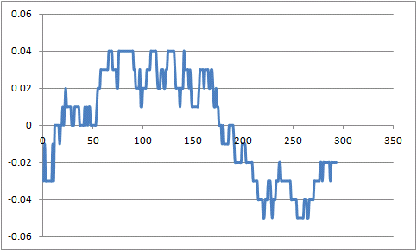
Figure 5: Micro-movements behind the global equilibrium (source: own calculations – y-axis = differences between estimation and model constant in the anti-discrimination model, called Y0 before, X-axis = days)
The figure 5 shows a bubble (weak HUF) in 2011 and an other one (strong HUF) till now. The equilibrium (0 level) should be reach in the next month. Based on this trend (indirect forecast) the HUF will be more and more weak again. A new breaking point in the wave can be expected, when the IMF-consultations will be closed in positive atmosphere…

Summary: Dissemination and extension
The same workflow can be worked out for arbitrary markets (e.g. vegetables and fruits). Wind-chill effects on each market can be derived based on similarity analyses. The decision-makers can get support in every moment about relative advantages/disadvantages. In addition, interpretations of life expectancies of bubbles can be created in an intuitive way…

Annex: http://miau.gau.hu/oktatas/2012tavasz/MNBubbles.xls
Pre-history: https://miau.gau.hu/mediawiki/index.php/PAIR_1

Attention!
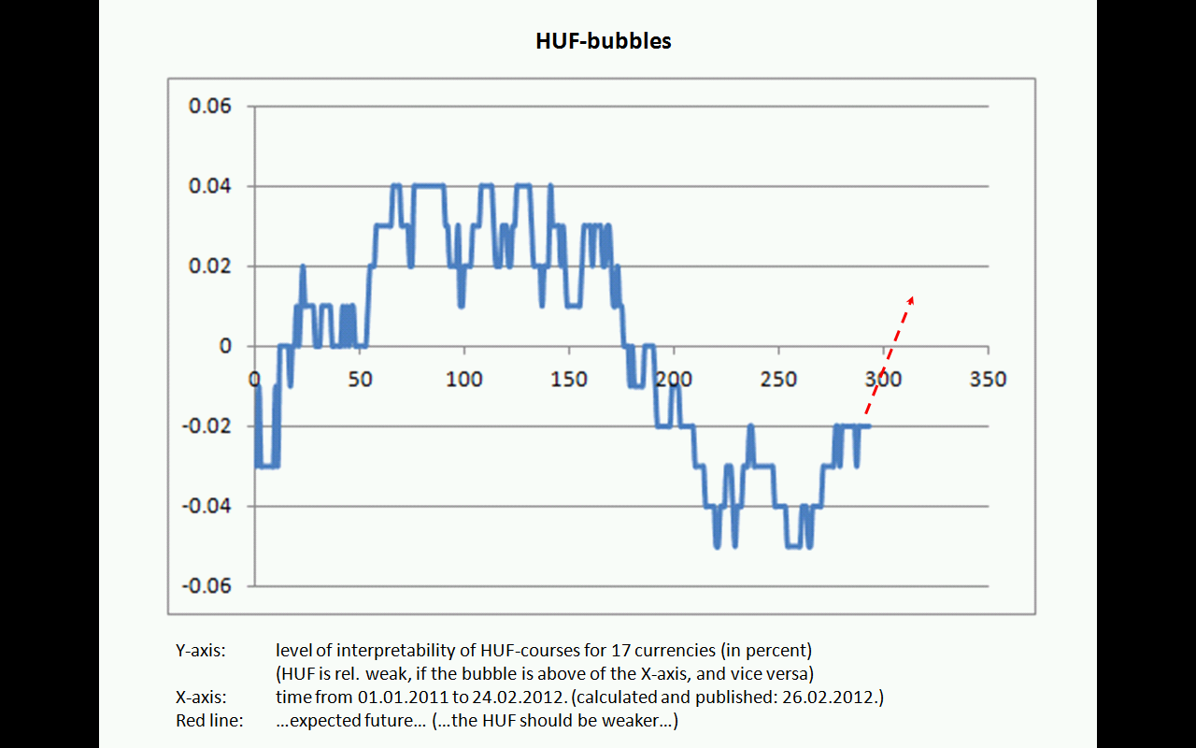
This picture was visible several weeks long at miau.gau.hu in the main frame as visualization support for this article. Nobody made a sign to ask or to declare, that the interpretation of the red line is arbitrary or follows an inverse logic although this article should be read by ca. 100 students. This is a very bad experience about motivation level, attention-level, and discussion-capability of students.
After this test a new task got defined: http://miau.gau.hu/miau/163/huf_bubble_2.xlsx
Based on a longer time-series (II.24 V.07.) the same Y0-model got created to prove, whether the new estimations are helpful to interpret the figures before in the right way.
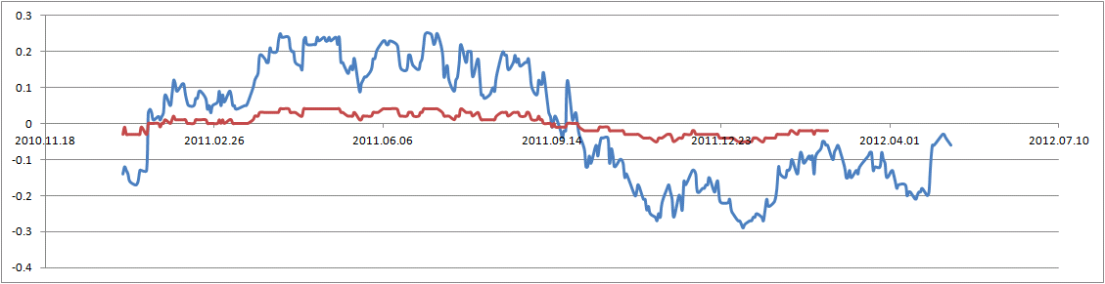
Interpretation of the figure: The red line comes from the previous analysis (2011.I.01.-2012.II.24). The blue line got derived in the new analysis (2011.I.01.-2012.V.07). Both lines have the same characteristics (the same wave-form). The blue line has however a higher amplitude, which means: the speculation level can be explored more the before. In the background (after 2012.II.24.) the course of HUF changed irrational based on good news from politic areas (like chance of starting IMF/EU-negotiations).
The old figure on the top of this site should be interpreted as follows: the red line (red arrow) should have placed later in time. The length of the half-wave is much longer, than the length of the accepted second half-wave. Therefore the course should remain on the negative side. It means: the HUF is weak for further months (ca. during the summer 2012 – length of waves is 9-10 months – first inflexion can be seen 2011.IX/X – next inflexion will be ca. 2012. VII/VIII). (The Y-axis is of the figures is the difference between facts and estimation and not the estimation themselves).

