The FIFA video game in the eSport- demonstration with an animation

Method Gapminder application/Rosling animation

Data: Google Trends

Combination space: 6146 data line

Object: 41 countries

**Author: Czúni Dániel**

**Date: 27.04.2017.**

The reason for the survey:

* the eSport, namely spreading of the FIFA game series - the FIFA series is the most popular/ most well-known among the sport video games.
* - it can be handled as a proved fact that dynamic pictures attract the human brain more, and it can understand better them than long series of numbers, but visualization of the information has not only the aim of spectacle but to make the spectator’s understanding quicker, namely for an insight.

**Extraction**

The aim of the survey was to find out how the popularity of eSport, namely the FIFA game has changed recently, firstly in Europe between 2004 and 2016, which means 1-144 months. I add that FIFA series was dated as FWIC from 2004.

According to the interest, the survey can be completed with further countries.

I would have liked to make the survey with 45 countries, but not every country had enough relevant data so at the end the survey was made with 41 countries/objects[1].

Using Google Trends(<https://trends.google.hu/trends/?hl=hu>) application, I got monthly interest data. I examined frequency of eSport and FIFA game expressions, this data was collected to xls. file and it was completed with data of GDP, population, population density and GDP/person/year. Later, the gained data was loaded into the GAPMINDER (<http://www.gapminder.org/>) application. With the usage of the mentioned software, we are able to visualize 6,146 record data in the view of six dimensions with the help of the animation in a two-dimension coordinate system. The animation graph, like a colourful constellation, shows the popularity of the eSport, FIFA game with the help of colourful bubbles in the examined countries. The graph jumps in the given time interval.

I made four demonstrating videos for an example:

The animation shows the situation of eSport/FIFA in Europe.

Scenarios:

1. The interest of eSport in each country, reflecting GDP/population.

1st video :<http://miau.gau.hu/miau/224/esport/scenario_1.mp4>

x axle=GDP/person per year(logarithm)

y axle= demand of eSport on Google (logarithm)

the size of the bubble= change of population in each country

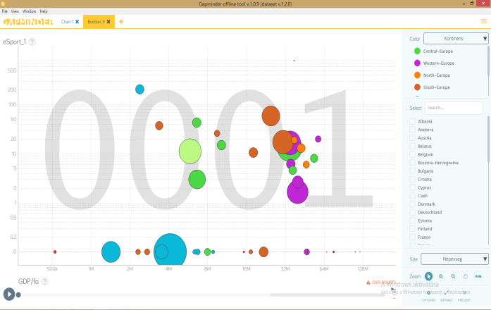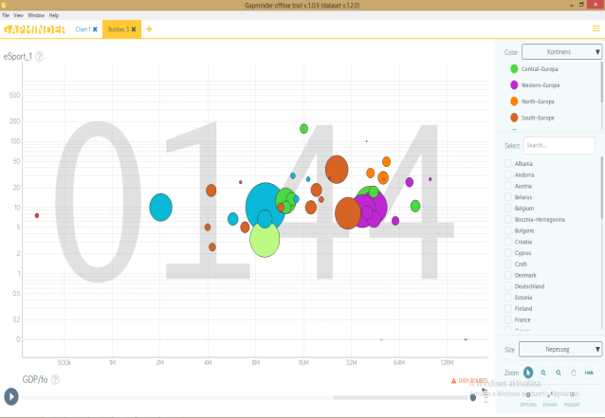

The video shows the dispersion of beginning months clearly - in 2004 there is a huge difference between the countries. But as the time goes, the data focuses after 144 months. By 2016, the deflection potential moderates/decreases significantly, which means the closing up of the dropped behind countries, namely the popularity/acceptance of eSport increased in the countries of Europe. The visualization proves clearly that eSport is spreading more stably. The developing tendency of eSport is unbroken in the analysed time so the conclusion is that there will be a time when the eSport will be a respectable sport as an innovation sport. This happened in some countries.

II. The interest of FIFA game series in each country, reflecting the GDP/population.

1. video: <http://miau.gau.hu/miau/224/esport/scenario_2.mp4>

x axle=GDP/person/year (logarithm)

y axle= demand of FIFA video game on Google (logarithm)

size of bubble= change of population in each country

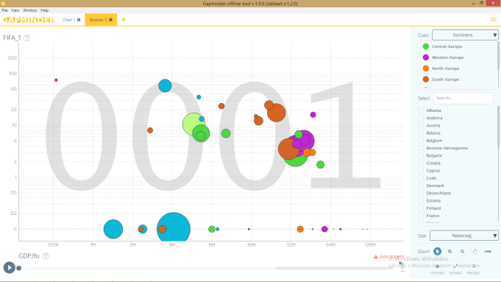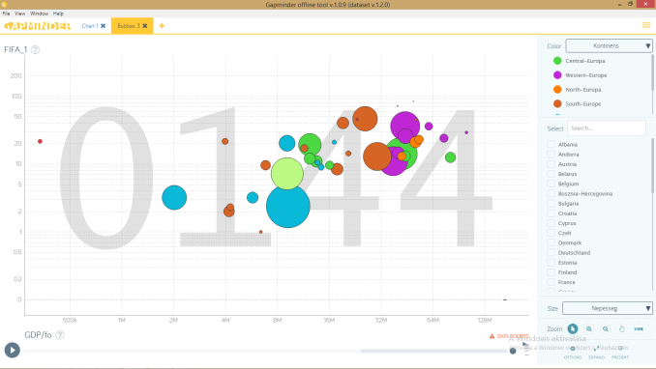

The esSport contains more games/section of games. The survey is about only the FIFA series.

The second video shows the concentration of data of FIFA games, where the same development tendency can be found very clearly, just like on the first video. This means that the FIFA game is spreading too, it has a more stable position in eSport so the acknowledge/popularity of the game is spreading in countries of Europe.

The popularity of the FIFA7 game is proved by the sales data[2]too, however this is a worldwide data, but the result of the survey can be true for Europe too.

1. The demand of FIFA video game in each country, reflecting the GDP, and population density.
2. video: <http://miau.gau.hu/miau/224/esport/scenario_3.mp4>

x axle= GDP/person/year(linear)

y axle= demand of FIFA video game on Google (logarithm)

the size of the bubble= change in population density in a year

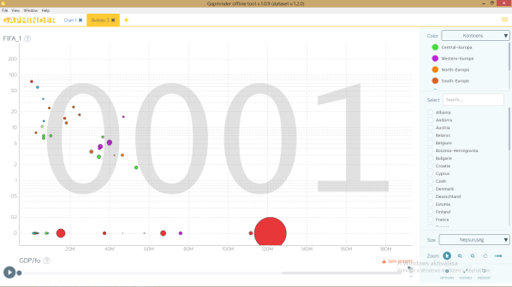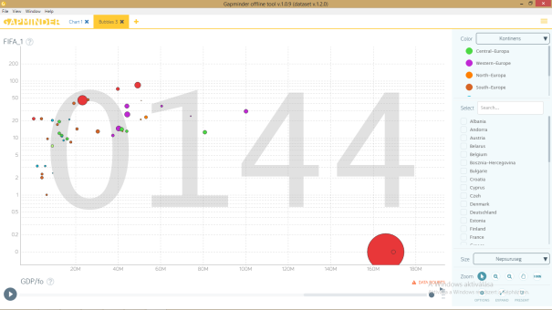

The third video shows how the change of population density, which changes year by year, affects the popularity of FIFA series. This animation shows more concentrated data and bubbles clearly, as time goes. The change of GDP and population density has positive effect, which strengthens the increasing of popularity of the FIFA series.

1. The interest of eSport, reflecting the GDP and population density.
2. video: <http://miau.gau.hu/miau/224/esport/scenario_4.mp4>

x axle= GDP/person/year (linear)

y axle= demand of eSport on Google (logarithm)

the size of the bubble= change of population density per year

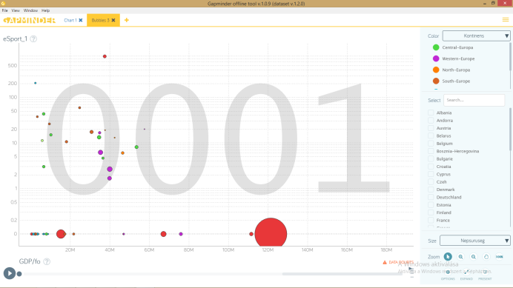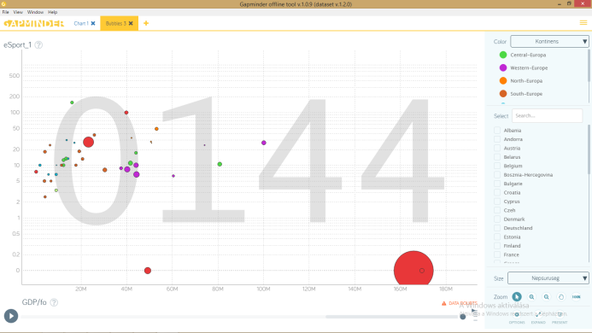

The fourth video shows the development of “eSport” divided into months, containing the GDP and the change in population density. The same change can be felt in the animation just like in the third. As the months go, the countries are focusing with each other and at the end of the time interval they are almost together.

It can be proved with the four videos, after using four indicators: population, GDP and the population density as a relative indicator that the eSport/FIFA is spreading with an increasing standard. This has a serious business value in the given dimension.

***

To make the changes more understandable I choose two countries on a subjective basis:

Hungary - green

Russia -blue

Certainly, any kind of countries from the survey can be compared.

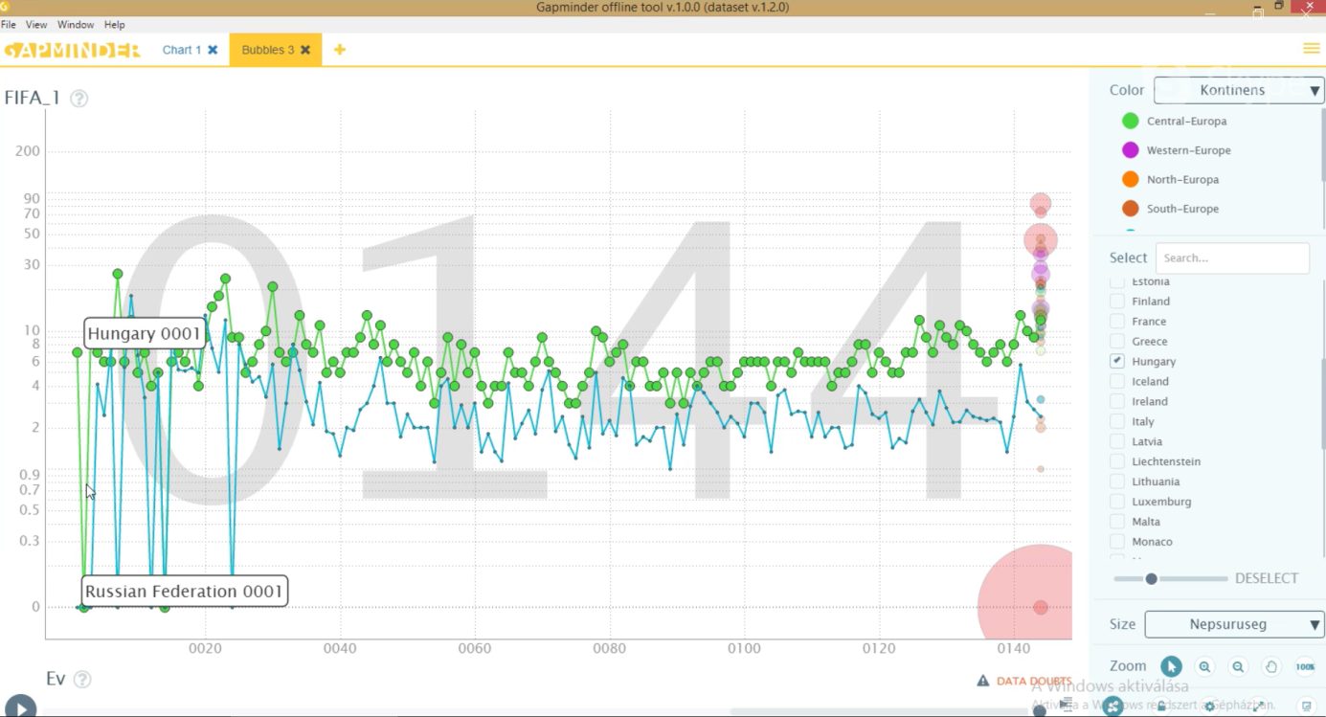

The graphic shows the change of FIFA in the two countries well, in a shape of line diagram as the months pass. At the beginning, the results are very diverged, in the first months a downward diagram can be found but this tendency goes to a positive direction, at the end the data focuses and the difference minimalizes, there is no high difference. The diagram becomes more consistent.

The illustration shows the difference and the changes between the two countries. I will evaluate them later because they do not belong to survey directly.

To prove myself I asked the data of the two chosen countries from the Google Trends separately and cumulated it in an xls. board. The picture resulting from representing the line diagram is the same with the picture published above.

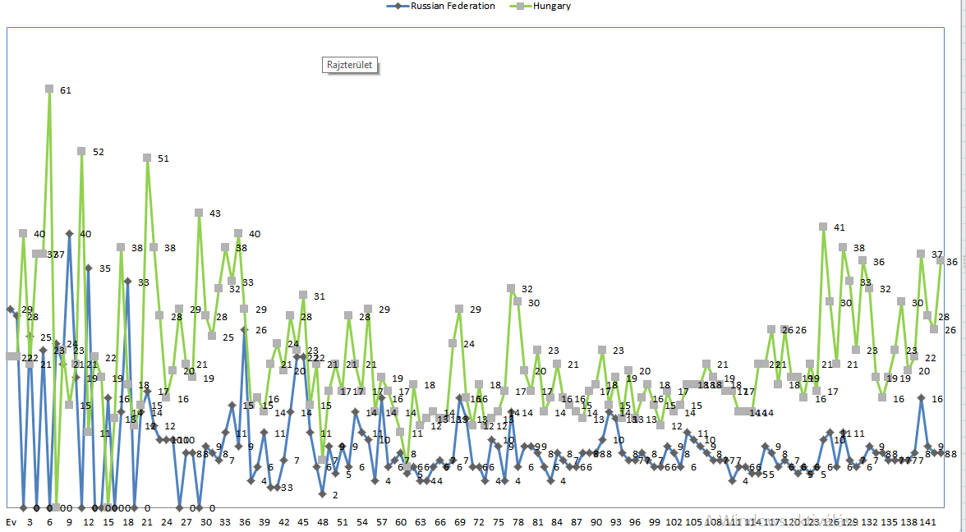

The conclusion is clear:

The opinion about eSport and FIFA game series is positive, popularity and development of it are increasing, they are going to one direction.

1. The list of the countries: Hungary, Norway, Sweden, Finland, Denmark, Iceland, United-Kingdom, Ireland, France, Belgium, Netherland, Luxemburg, Portugal, Spain, Italy, Slovenia, Croatia, Bosnia-Hercegovina, Albania, Bulgaria, Greece, Estonia, Latvia, Lithuania, Romania, Russia, Ukraine, Belarus, Turkey, Germany, Switzerland, Austria, Czech Republic, Poland, Slovakia, Cyprus, Malta, Monaco, San Marino, Andorra, Liechtenstein
2. Source: URL =<https://sg.hu/cikkek/jatek/121586/franchise-rekordot-allitott-be-a-fifa-17>