Pairwise object comparison based on Likert-scales and time series - – or about the term of human-oriented science from the point of view of artificial intelligence and value surveys

Ferenc, Szani, László Pitlik, Anikó Balogh, Apertus Nonprofit Ltd.

Abstract: Statements about human preferences concerning values, e.g. data based on the Likert scale deliver information. Time series of behavior patterns can also be converted to inputs to pairwise comparison in order to explore the potential of irrationality of humans. The conversion of data into pairwise comparison described on Likert scales is made possible through correlation-oriented rules. Pure logic is inflexible and produce mostly high index values for inconsistence. Fuzzy-like approximations (numeric models) ensure a higher level on flexibility. However, it is always important to visualize whether a data set of scores or time series are capable of delivering consistent constellations between objects. Questionnaires produce not hard enough data in general – and the interpretations of these quasi-data need every possible methodical support.

Keywords: correlation-based conversion, sameness-oriented evaluation, logical-fuzzy-numerical transformation, objectivity, subjectivity, value survey

# Introduction

Questionnaires are capable of delivering data about satisfaction levels and/or opinions/evaluations concerning arbitrary objects (e.g. courses, subjects, teachers, partners, programs, events, etc.). The pairwise comparison of objects (in order to rank them) suffers from combinatorial explosion, because the amount of objects and the parameters of the questions (like the order of objects, used phrases, anonymity, repetition/reversion of pairs, offered relation codes, possibility to search for previous answers, etc.) describe an almost unlimited amount of constellations. The person asked is not able to play with in this voluminous space for an arbitrary length. Therefore it is more comfortable to avoid pairwise evaluations and prefer e.g. Likert-scales (c.f. <https://en.wikipedia.org/wiki/Likert_scale>), where a relative great number of objects can be scored in a subjective way. These scores are mostly interpreted as sums or averages without to check whether a conversion into pairwise comparison is possible at all. Parallel, it should also be mentioned, that measured (objective) characteristics of objects (like time series about phenomena being capable of expressing a kind of satisfaction – e.g. data about income, downloads, spent time in a system, etc.) could also be transformed into pairwise comparisons. Namely, pairwise comparisons are the only frame where the evaluation is based on standard logical rules without any fuzzy-like effects.

In this paper, the authors present theoretical point of views and practical experiences about the transformed data into pairwise comparison involved data of Likert-scales or data of time series. The aim of the paper is to demonstrate that the consistence level of Likert-scaled answers or data of time series can also be evaluated based on pure logic (c.f. transitivity of pairwise evaluation in the chain of object ranking). It is important to highlight that subjective opinions of human individuals about evaluation problems never deliver as hard facts as standard (objective) measurements. It means questionnaires cannot be seen as a standard measurement. The level of inconsistence of the independent subjective evaluations can, and should, be derived in order to know how massive/hard data units of the questionnaires are.

# State of the art

Likert-type scales are frequently used in education and education research. Understanding the interpretation and analysis of data obtained from Likert scales is crucial for those working in education research. Developed in 1932 by Rensis Likert to measure attitudes, the typical Likert scale is an 5- or 7-point ordinal scale. Users rate the degree to which they agree or disagree with a statement. In an ordinal scale, responses can be rated or ranked, but the distance between responses is not measurable. Thus, the differences between “always,” “often,” and “sometimes” on a frequency response Likert scale are not necessarily equal. In other words, one cannot assume that the difference between responses is equidistant even though the numbers assigned to those responses are.

McIver and Carmines (1981) describe the Likert scale as follows: „A set of items, composed of approximately an equal number of favorable and unfavorable statements concerning the attitude object, is given to a group of subjects. They are asked to respond to each statement in terms of their own degree of agreement or disagreement. Typically, they are instructed to select one of five responses: strongly agree, agree, undecided, disagree, or strongly disagree. The specific responses to the items are combined so that individuals with the most favorable attitudes will have the highest scores while individuals with the least favorable (or unfavorable) attitudes will have the lowest scores. While not all summated scales are created according to Likert’s specific procedures, all such scales share the basic logic associated with Likert scaling.

Descriptive statistics, such as means and standard deviations, have a vague meaning when applied to Likert scale responses. For example, what does the average of “never” and “rarely” mean? Does “rarely and a half” have a useful meaning? Also, if responses are clustered at the high and low extremes, the mean may appear to be the neutral or medium response, but this may not characterize the data.

# Conversion data from Likert-scale to pairwise comparison

Data from a Likert scale are integer numbers (scores). In the next two sections the case of a particular person and also the case of the crowd as such will be described.

## Evaluation of persons – Checking consistence

Data (as decisions of a given person) represented on a Likert scale, cannot deliver inconsistences contrary to pairwise comparison of objects, where the complexity is hardly manageable and therefore almost each person makes one or more inconsistent votes. Evaluations on the Likert scale about objects and their ranking lead to trivial constellations: there will be object islands with the same score, and the islands have trivial ranks compared to each other.

The following steps demonstrate the conversion to pairwise constellations, the building of bridges between objects based on sameness (relation id=3), the derivations of object islands and at least the ranking of objects/islands:

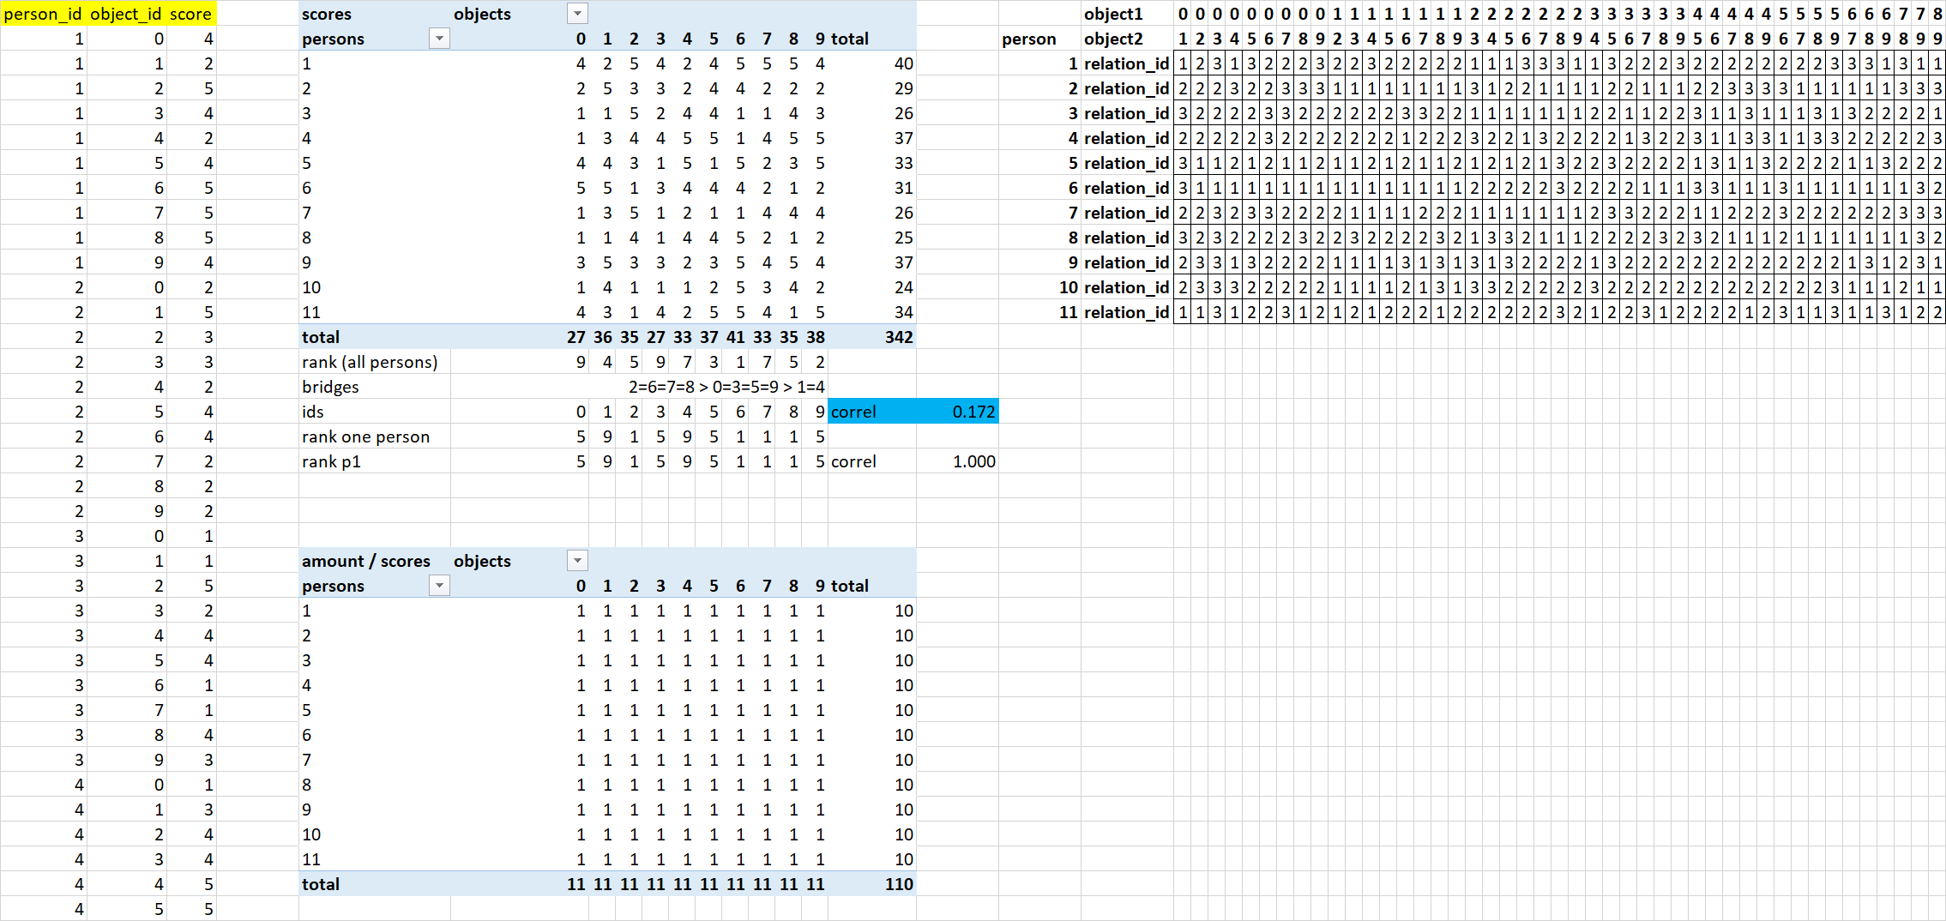

Remarks: if score for object(i)>score for object(j), then relation id = 1; if score for object(i)<score for object(j), then relation id = 2; if score for object(i)=score for object(j), then relation id = 3

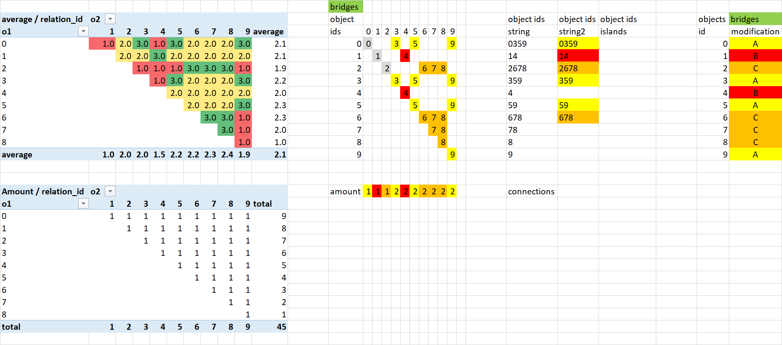

Remarks: used scores = 2;4;5, therefore amount of object islands = 3

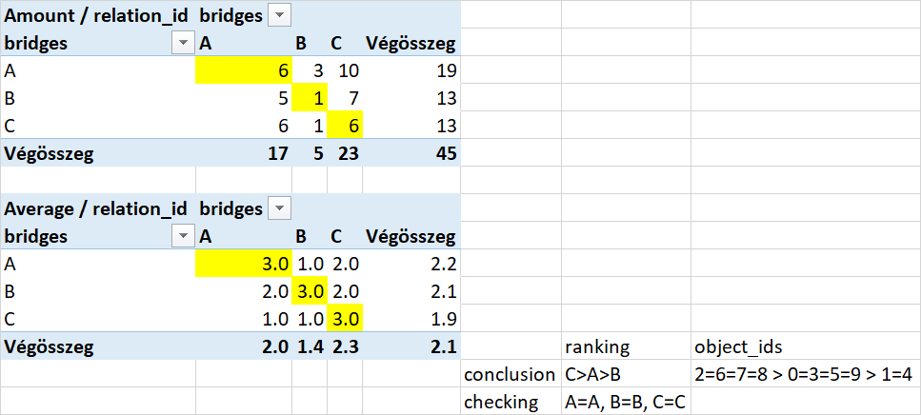

Remarks: ranks based on object island = ranks based on Excel-Ranking-Function

## Evaluation of crowds - Correlation-based conversion

Conversions from Likert scale to pairwise comparison need a rule set being exact for each possible constellation.

If the correlation between the scores or ranks for two arbitrary objects is high (greater than 0.1) and the sums of the scores for the two objects are not equal, then high-graded polynomials (grade=6) for voting persons (X) and scores (Y) demonstrate a clear difference between the objects, where the object with higher scores determines the relation id “1” or “2”:

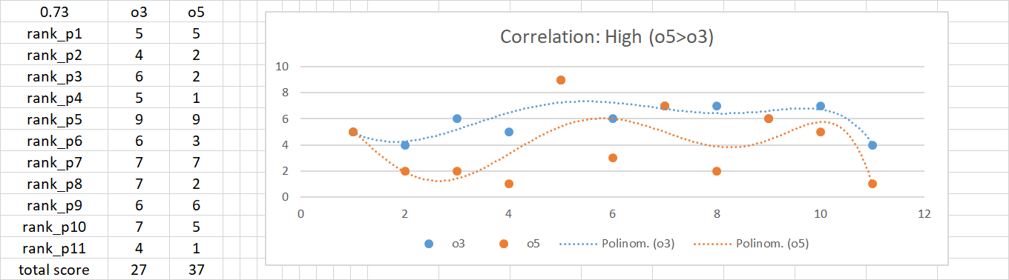

If the correlation between scores or ranks of objects is close to zero (+/-0.1), then the objects can be considered the same (relation id=3).

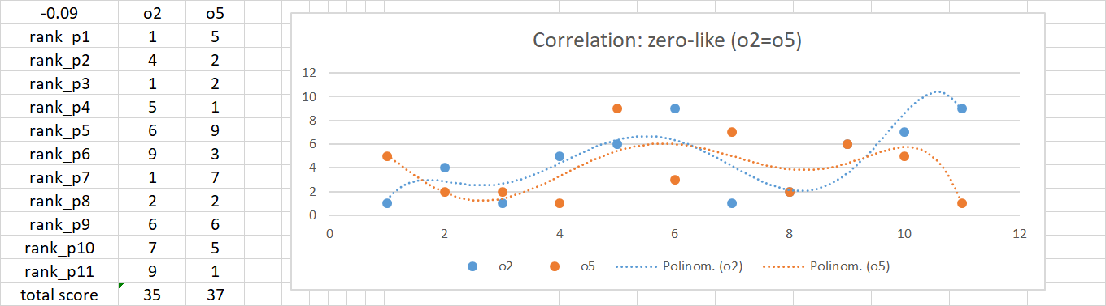

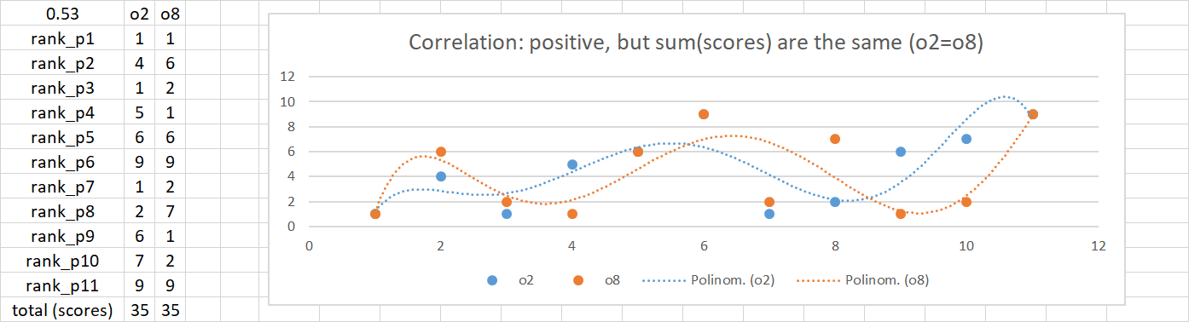

If the correlation between scores or ranks of objects is high, but the sums of the scores of objects are the same, then the objects can also be considered the same (relation id=3).

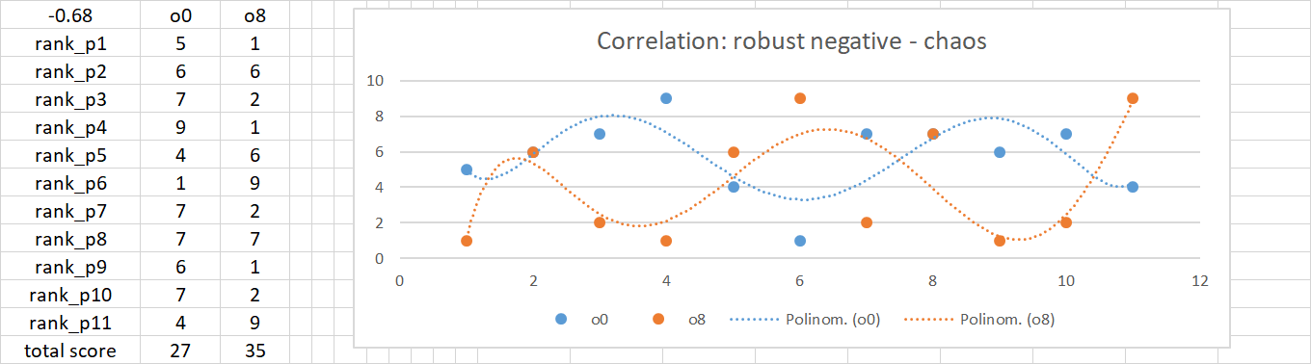

In case of a massive negative correlation between scores or ranks of objects, the high-graded polynomials demonstrate a kind of chaos. Therefore the relation id = 4 (it means: hidden vote, hidden decision, lack of clear information).

As it can be seen, the conversion of scores of persons (crowd) can be executed based on the above declared rule set, where the thresholds (+/-0.1) is just a kind of estimation without any evidence.

## Ideal constellation

The scores coming from Likert scale in case of a lot of people could be ideal if the persons could give more and more scores for better objects:

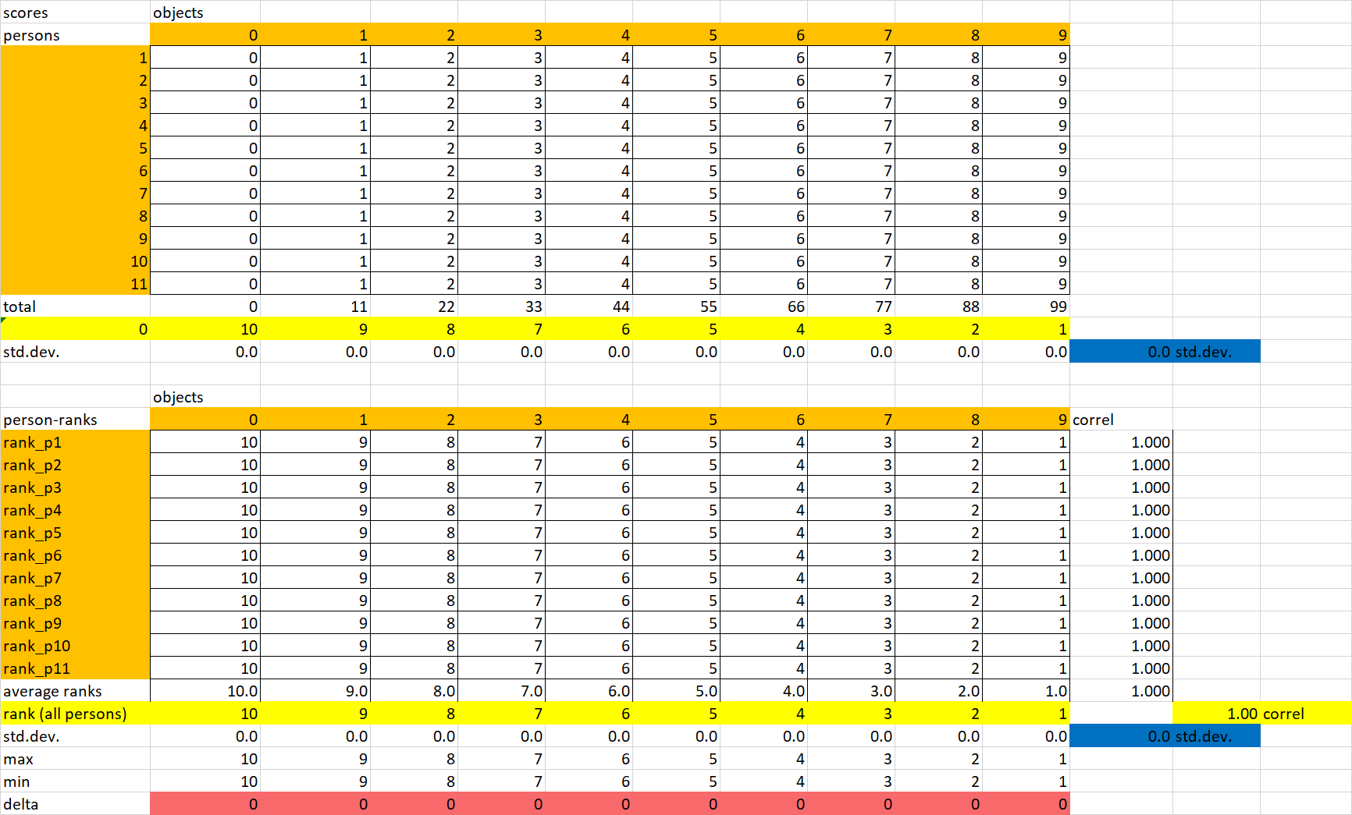

## Process

The preparation phase of a correlation-based conversion is starting from the scores and will finish when the correlations are calculated:

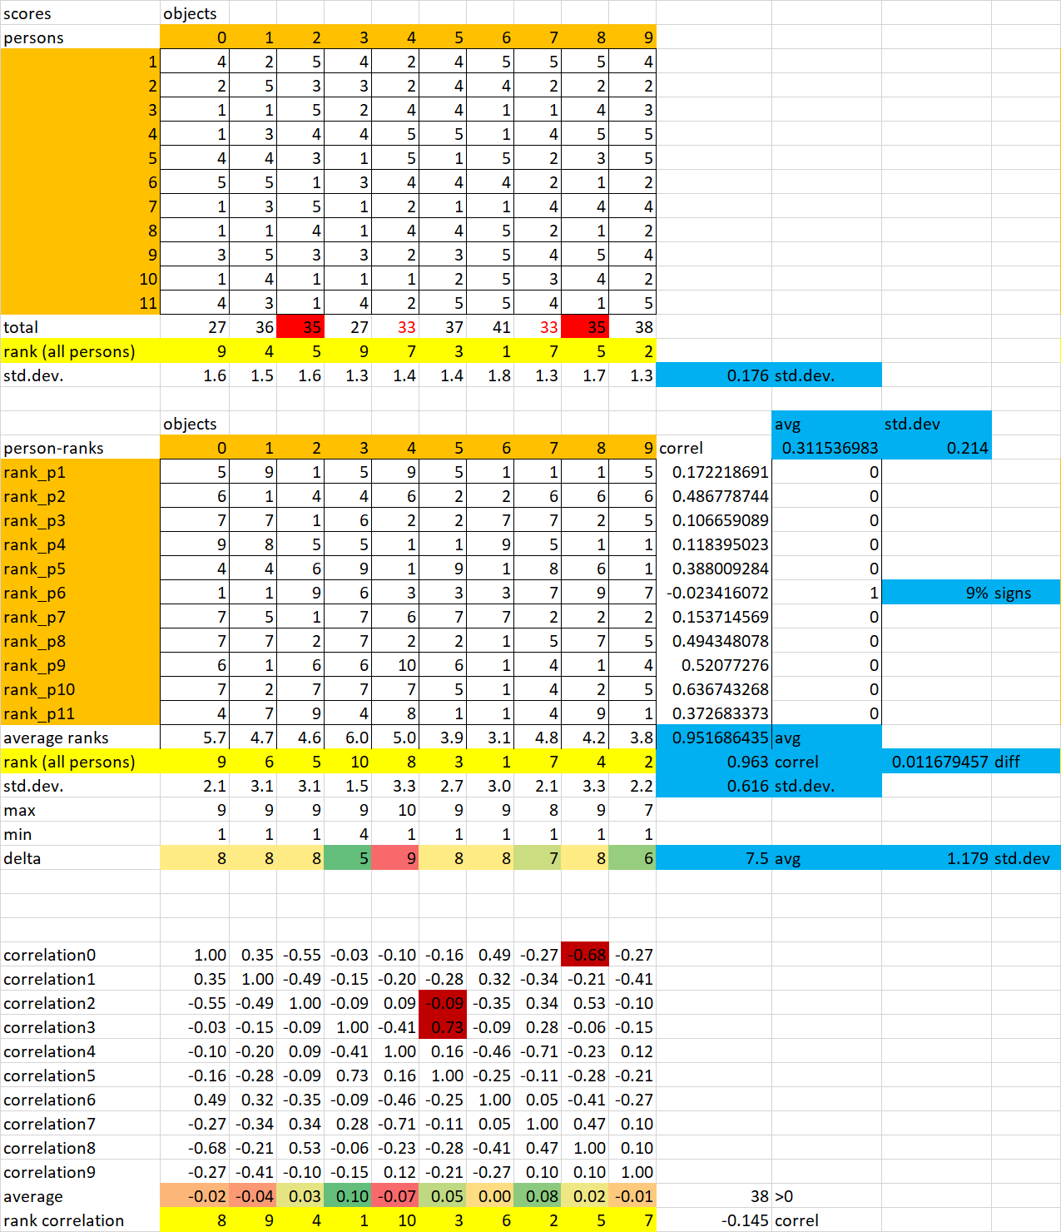

Remarks: The correlation matrix is triangular, it means: the diagonal (where the objects are the same) have always the value 1.00. The colored cells were used for the creation of the high-graded polynomials above.

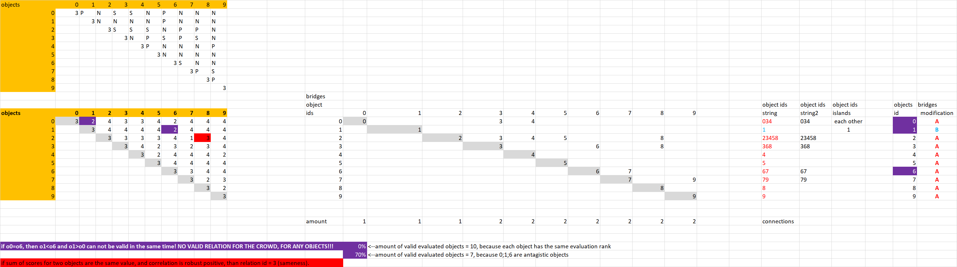

Remarks: The rule set derived above leads to alphabetical codes: like P=positive, N=negative, and S=same. The alphabetical codes can be transformed to relation ids (1;2;3;4). The red cell stands for the objects where the sum of scores are of the same value. Random scores bring two object islands A and B, where o1>o0 and o1<o6 signifies inconsistence between island “A” with 9 objects and island “B” with one object. Island “B” cannot have parallel positions above and below the island “A”.

## Multi-dimensional evaluation of a consistence index for the crowd

The blue marked positions demonstrate the attributes for an anti-discriminative analyses, where the hypothesis is: each crowd (or sociological subgroup: like men vs. women, etc.) has the same inconsistence potential.

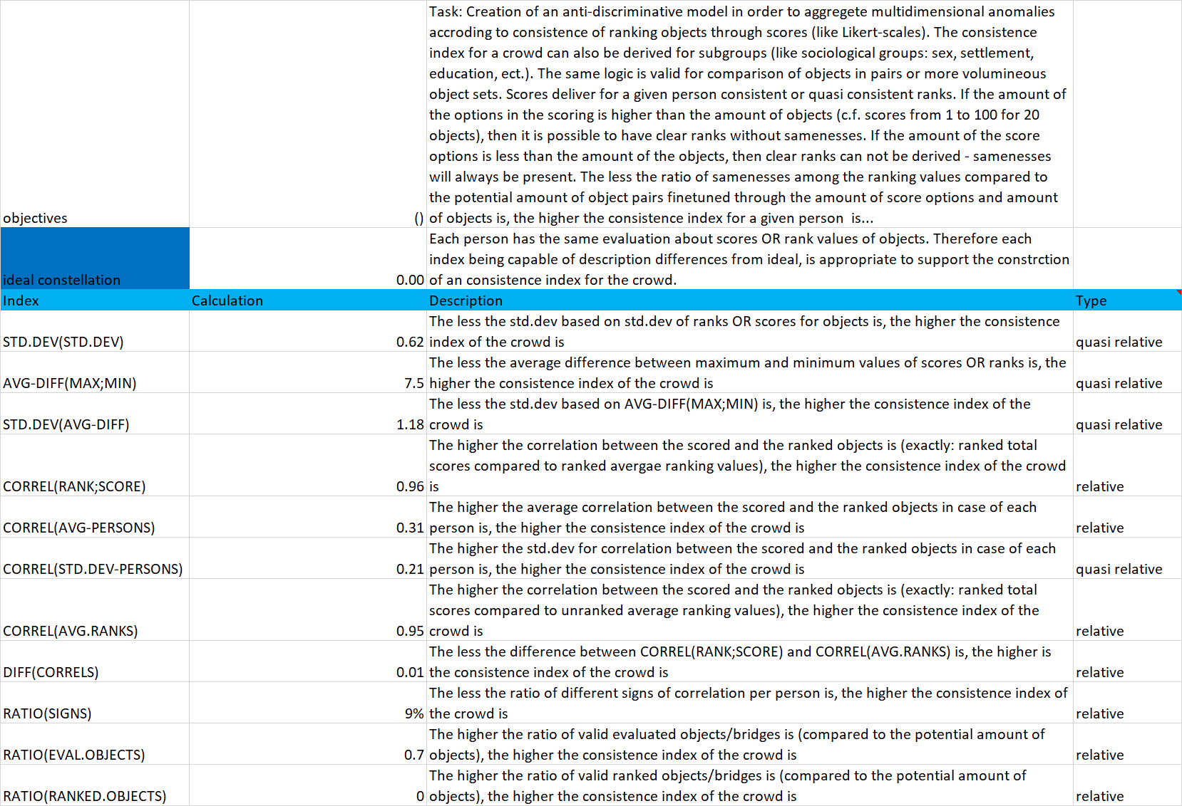

# Anti-discriminative evaluation of objects

The scores from Likert scale can be transformed into ranking values in case of a given person concerning all objects:

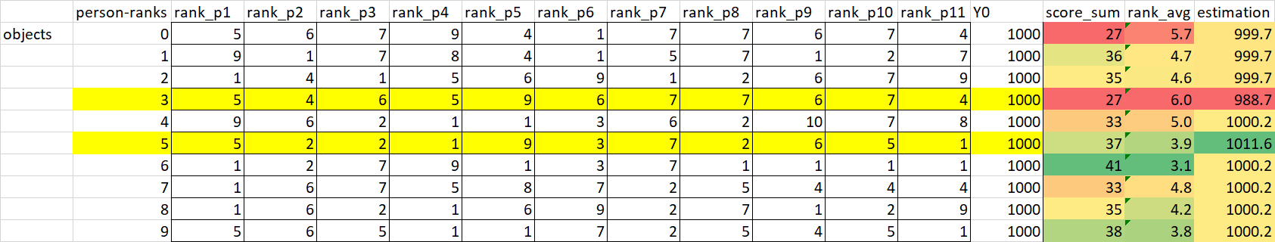

Based on similarity analyses anti-discriminative ranks can be derived (see estimation above). The standard evaluation of scores makes it possible to calculate a kind of sum for each object. Parallelly it is also possible to derive the average ranks for the objects. Anti-discriminative estimations, average ranks and sums of scores are alternative solutions for the question: which object has the highest/lowest exposure. The three solutions can have different characteristics. The 4th solution is the correlation-based evaluation (see above).

The correlation-based transformation steps could find no logical constellations between objects. The anti-discriminative similarity analyses deliver 4 valid object islands. Sums of scores and averages of ranks in case of different objects deliver classic/standard ranking values.

## Conversion of time series

Time series consist of numeric values. The difference of the neighboring periods in case of given objects compared to the earlier value can be interpreted as a kind of double percentile scale (+/-100%). The conversion to quasi Likert scale needs objects and their relative differences for each time period (see above). The correlations can be calculated based on relative differences or their ranks built for each period. From now on, the conversion rules are the same as before based directly on the Likert scales as input values.

# Conclusion

The sums of scores and the averages of ranks can be characterized as a kind of numeric transformation based on numeric inputs without any preparations: [N-…-N]. The calculations and the equivalences of scores or ranks is arbitrary [A].

The correlation-based approach converts numeric inputs to codes based on a rule set. The codes are interpreted based on further (logical) rule sets: [N-L-L]. The thresholds of the rule sets are arbitrary [A].

The similarity analyses convert numeric inputs to ranking values, which are neither standard numeric values nor standard logical symbols, but the derivation of ranks can be seen as logical transformation. The ranking values are converted to estimation values based on LP-engines: [N-L-n], where the numerical characteristic of the estimation can be reduced to a lower amount of object islands (c.f. anti-discriminative principle: each object can have the same evaluation value). The ranking and the derivation of estimations for exposure of objects are exact/partially optimized [O].

The codes in the brackets [] above stand for two dimensions: a scale for arbitrary and optimized parameters [A--O] and a scale for numerical and logical values [N--L].

The simple figure below makes visible what is fuzzy (logic) from the philosophical point of view, if a specific scenario will be involved into the figure: similarity analyses (called intuition generators) can deliver alternative solutions in form of staircase functions. Assumed, that a more detailed specified algorithm is capable of avoiding parallel solutions, then the dimension “A—O” can achieve its highest level:

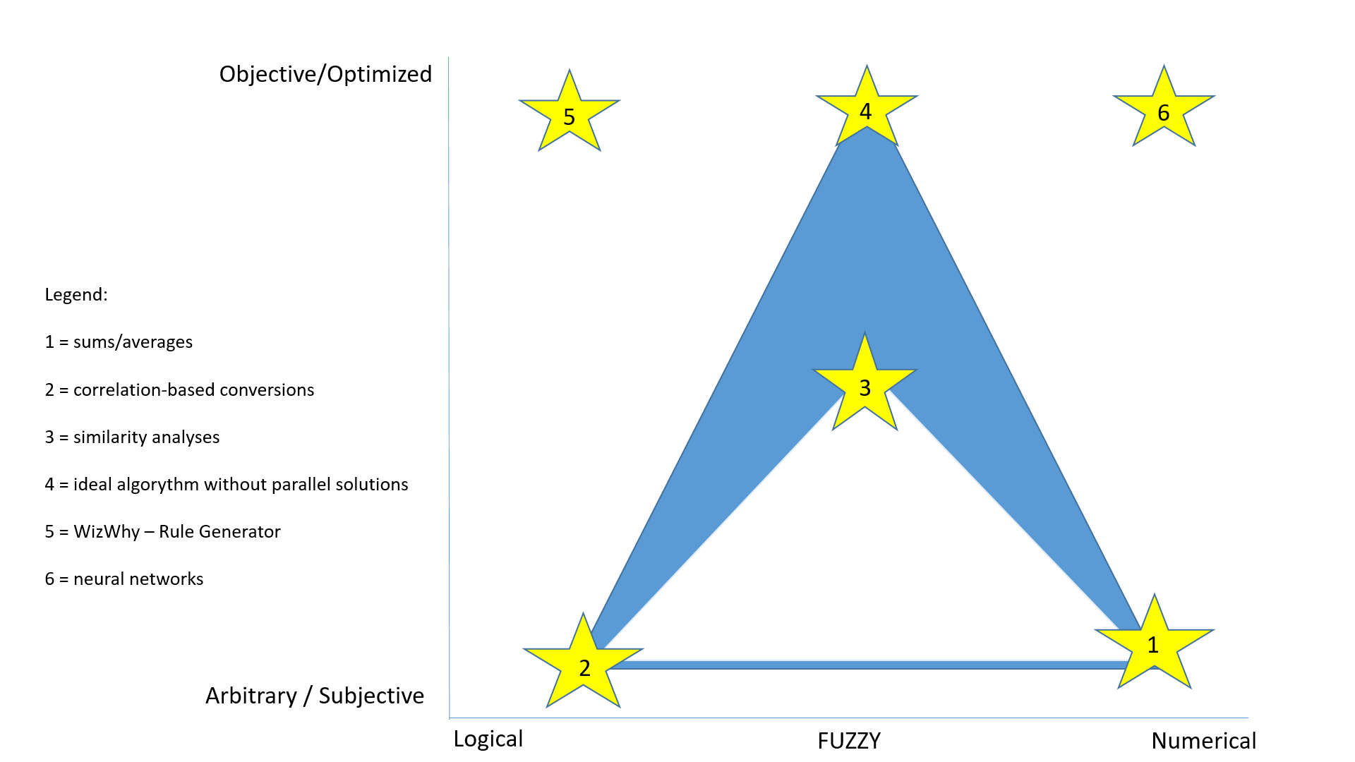

Remarks: Logic-based approximations (2;5) are quite inflexible and produce signs about inconsistences. Numerical solutions (1;6) can be too flexible with the risk of massive problems in the hermeneutics (c.f. polynomials in statistics), where flexibility is a kind of 3th dimension. Standard fuzzy logic or further solution between logical and numerical force fields are quasi optimal for artificial intelligence solution.

Reference study for using correlation-based conversions concerning time series: <http://miau.gau.hu/miau/229/szarvas>

References

Allen, I. E., & Seaman, C. A. (2007). Likert scales and data analyses. *Quality progress*, *40*(7), 64.

Clason, D. L., & Dormody, T. J. (1994). Analyzing data measured by individual Likert-type items. *Journal of agricultural education*, *35*, 4.

Gliem, J. A., & Gliem, R. R. (2003). Calculating, interpreting, and reporting Cronbach’s alpha reliability coefficient for Likert-type scales. Midwest Research-to-Practice Conference in Adult, Continuing, and Community Education.

McIver, J., & Carmines, E. G. (1981). *Unidimensional scaling* (Vol. 24). Sage.

Pitlik, L. (2016). A multikulturalitás matematikája, avagy a „szómágiától” a robot-szakértőkig. *Studia Mundi–Economica*, *3*(1), 118-130.

Sullivan, G. M., & Artino Jr, A. R. (2013). Analyzing and interpreting data from Likert-type scales. *Journal of graduate medical education*, *5*(4), 541-542.