Digitális érettség fogalmának mesterséges intelligencia-alapú megalkotása az EUROSTAT adatai alapján nemzetközi összehasonlítási céllal

(Term creation of the digital matureness in frame of artificial intelligence techniques and based on the data assets of EUROSTAT for international benchmarking)

Pitlik László (sen), Szani Ferenc, Mihályi Gabriella, Pitlik László (jun), Pitlik Mátyás, Pitlik Marcell - My-X team

Kivonat: Az emberi fogalmak olyan absztrakciók, melyek mindaddig, míg a knuth-i értelemben nem vállnak a tudományosság részévé, azaz nem írhatók át algoritmusokba, csak a szómágia szabályai szerint hatnak – alapvetően kiszámíthatatlanul. Jelen tanulmány reprodukálható, operacionalizált példát mutat arra, miként lehet nemzetköz benchmarking erőtereket úgy felépíteni statisztikák és anti-diszkriminatív módszertanok alapján, hogy annak minden érintett haszonélvezője lehessen. A knuth-i elv egyben azt is jelenti, hogy minden Rendszer fokozatosan képes az automatizálhatóság tetszőleges szintjét közelíteni, ami lehetőséget ad a mindenkori gazdasági erőterek racionális felhasználására.

Kulcsszavak: hasonlóságelemzés, döntéstámogatás, objektivitás, automatizálás

Abstract: The terms created by humans, are abstractions following the rules of the magic of words and therefore they are risky. However, human terms can be transformed into source codes (concerning the principle of Knuth) and so they becoming a part of science. This paper presents an operationalized case study having a high level reproducubility in order to demonstrate, how international benchmarking processes can be driven based on international statistics and appropriate online modelling tools concerning common interests. The principle of Knuth means also, that the System as such is capable of approximing arbitrary levels of automation parallel with using the given resources in an rational way.

Keywords: similarity analysis, decision support, objectivity, automation

# Bevezetés

A digitális érettség mérése, mint minden ember által intuitíven alkotott jelenség mérése kétféleképpen lehetséges: egyrészt olyan (önbevallásos) kérdőívekkel, melyekben a kérdések maguk is egy/több, csak és kizárólag intuitív=szubjektív módon értelmezhető fogalmakkal operálnak (pl. Ön mennyire elégedett, ill. Ön mennyire tartja ért egyet a számítógépek oktatási célú felhasználásának adott szintjével? 1 = semennyire, …, 5 = teljes mértékben). A másik út a tények, állapotok objektív felmérése (pl. az összes tanóra összes tanmenete alapján a tanórák hány százaléka érintett számítógépes prezentációk által? forrás: tanmenetek, módszertan: szövegbányászat).

Mint érezhető, a két út egymástól karakteresen eltérő hitelességű információval kecsegtet: a bizonylatmentes személyes attitűd akármilyen hatásoknak ki lehet téve, sőt, maga a kérdés sem kell, hogy minden megkérdezett számára egyértelmű legyen: pl. mi is számít oktatási célú számítógépfelhasználásnak? pl. az osztálypénz havi beszedését támogató Excel-táblázat létét miként illik figyelembe venni – figyelembe illik-e venni egyáltalán?). Az szubjektív állapotok felmérése azonban rel. gyors és rel. olcsó. A kérdés már csak az, vajon ezen impulzívan változó „aurafelvételek” alapján milyen döntéseket milyen kockázatok mellett lehet meghozni?

Az objektív mérések elvileg félre nem érthető jelenségek mennyiségi aspektusait tárják fel (vö. előző példa: vagy szerepel pl. egy tanmenetben pl. a kötelező prezentáció formátum – .PPT* - karaktersora, vagy nem, s ez a speciális karaktersor feltárható automatizmusok révén, különösen, ha ennek előfordulási helyét jelző fejezetcím is szabványos, s így pl. az ajánlott irodalmaktól a prezentáció egyértelműen megkülönböztethető – de ezek hiányában is egy-egy adatrögzítő ember, saját minimális intelligenciáját hasznosítva el kell, hogy tudja dönteni kellő pontossággal, hogy egy-egy ppt-s utalás a tanóra keretében bemutatni tervezett prezentációt jelez-e, vagy sem?)

A fentiek kapcsán a digitális érettség fogalma nem más naiv (azaz nem optimalizált, nem minőségbiztosított) hétköznapi közelítésben, mint a jó tanuló fogalma, ahol sokféle tantárgy jegyeinek átlaga alapján mindenki számára látszólag teljesen egyértelmű: ki a jó tanuló és ki kevésbé az?!

A naiv-fogalomértelmezések szintjét elhagyva: A digitális érettség kapcsán tehát egy tetszőlegesen sokrétegű jelenségkört (vö. tantárgyak száma formálisan akár mennyi lehet – különösen az életen át tartó tanulás keretében) kell aggregáltan (vö. pl. naiv jegyátlag formájában) kifejezni tudni, ahol az aggregálás akkor nem naiv, ha antidiszkriminatív modellek keretében az kerül elsődlegesen bizonyításra, lehet-e a mindenkor vizsgált objektumok (személyek, intézmények, országok, stb.) összes jellemzőja alapján minden objektumok másként egyformán digitálisan érettnek tekinteni?!

Az alábbiakban a digitális érettség értelmezésének hazai és nemzetközi példái kerülnek röviden kritikai bemutatásra, majd pedig az EUROSTAT oktatási statisztikái alapján egy tételes, reprodukálható példa következik annak demonstrálására, miként lehet eljutni az intézményi statisztikai adatfelvételezésből kiindulva a nemzetközi (egyelőre statikus országösszehasonlításig, benchmarking-ig).

# Szakirodalmi feldolgozás

Magyarországon az eLEMÉR rendszer által kialakított rendszer az alábbi infografika által válik mindenki számára egyszerűen és gyorsan értelmezhetővé:

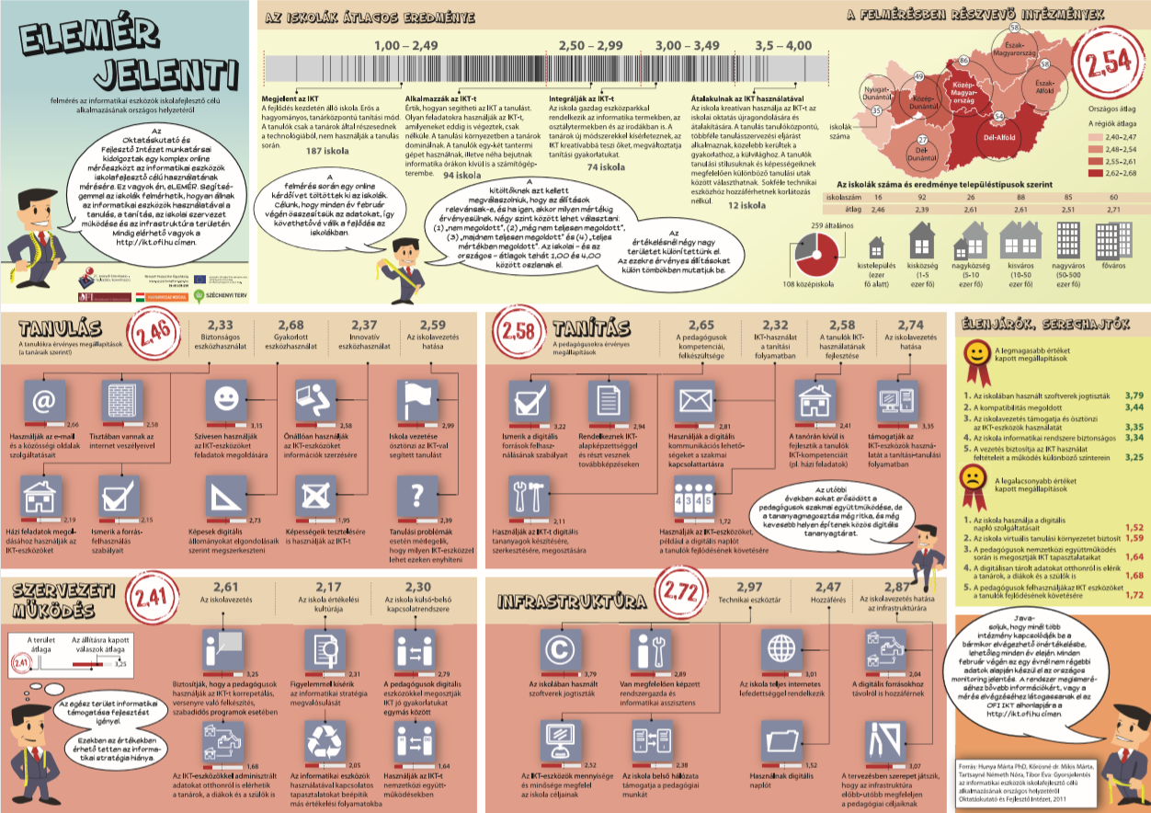

Forrás: eLemer_jelenti_infografika.pdf

A bevezetés alapján világos illik, hogy legyen mindenki számára, hogy itt elsődlegesen az első, vagyis a szubjektív adatgyűjtésre támaszkodik a rendszer, melynek rétegei önkényes számúak, tartalmúak és kockázatos egyértelműségűek, mint ahogy a rétegek csoportosítása is önkényes és a csoportátlagok, rendszerátlag kialakítása is naiv (= nem optimalizált).

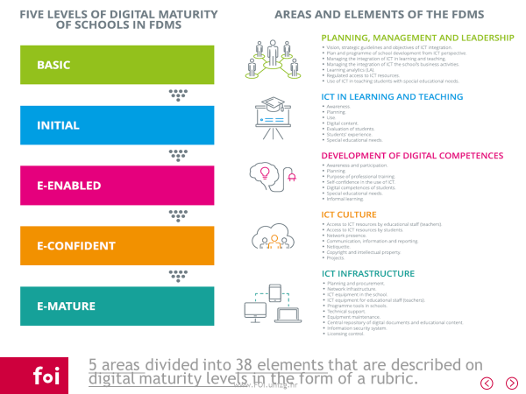

Forrás: FOI_Framework_INFOTER_Begicevic02_2017.pptx

A horvát példa kapcsán csak egy magas komplexitási szintű tervvázlat kerül itt és most felvillantásra, mely mögött lehet éppenséggel a magyar megoldáshoz hasonló, de épp úgy lehet bizonylat-alapú, s végső soron akár vegyes minőségű alapadat-rendszer is.

Mindkét megoldás világosan mutatja, hogy a hagyományos, leíró világértelmezés igyekszik fogalmakban, de legfőképpen fogalomcsoportokban gondolkodni évszázadok óta (vö. reál vs. humán tantárgyak).

A jelenségcsoportok kapcsán el kell mondani, ezen csoportosítások önkényessége általában véve az alapoktól kockázatként értelmezendő. A statisztikai megközelítésekben a jelenségek egy részének kihagyásához feltárt érvek kétséges értékűek az adatvesztésből fakadó torzulások esélyeivel összevetve.

Külön kiemelést érdemel az a matematikai alapvetés, hogy anti-diszkrimiinatív modellek esetén a jelenségek egységes rendszerként való kezelésének eredményétől a tetszőleges csoportokba sorolt jelenségek csoportonkénti értelmezése, majd a csoport eredmények aggregálása szinte tetszőlegesen alacsony R2-értékre vezethet a csoportosításmentes és a csoportosításokra alapozó értékelések között. Ez a kettősség egyben egy fajta kockázatelemzésként, érzékenységvizsgálatként is értelmezhető és segít minimalizálni a demagóg döntéshozatal kockázatait, a modellekre épülő szimulációk félreérthetőségét, vagyis az irracionális értelmezések kialakulását. A minden objektum lehet másként egyforma elv fel nem használása eleve feltételezi, hogy olyan rangsorok alakulnak ki jelenségcsoportonként és/vagy rendszerszinten, melyeknek végső soron nincs információértéke…

# Digitális érettség index EUROSTAT adatok alapján

Az 1. számú és a 2. számú melléklet bemutatja, milyen oktatási statisztikákat ismer az EUROSTAT. Az 1. ábra arra mutat rá, ezen EUROSTAT jelenségek halmazában miként lehet feltárni a digitális érettség fogalma számára releváns rétegeket:

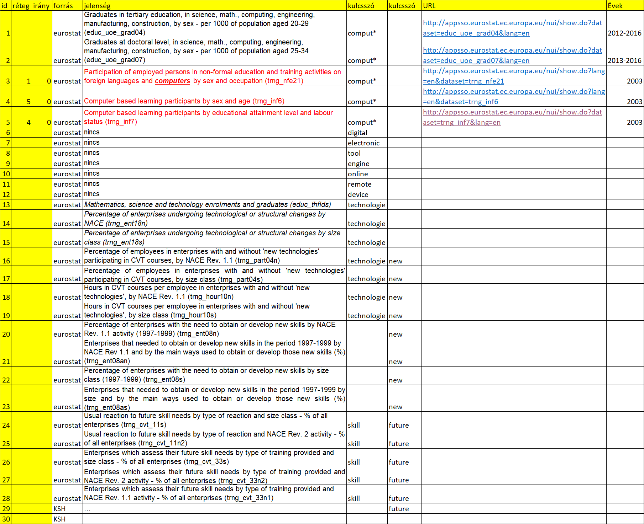

1. ábra: Bizonyos kulcsszavak mentén potenciálisan releváns jelenségek feltárása (forrás: saját ábrázolás)

Az EUROSTAT adatbázisának pontos ismerete nélkül is, amennyiben a táblakódok már feltárásra kerültek (pl. trng_inf6), akkor a Google az „eurostat trng_inf6” keresési kifejezésre az első találatok között illik, hogy hozza az EUROSTAT adatbázisához a megfelelő bejárat URL-jét: pl. <http://appsso.eurostat.ec.europa.eu/nui/show.do?lang=en&dataset=trng_inf6>

Egy-egy, a kulcsszavak alapján potenciálisan hasznosnak tűnő jelenség akkor válik a digitális érettség mesterséges intelligencia-alapú modellezése számára releváns inputréteggé, amennyiben a jelenség kapcsán teljes egyértelműséggel, szakmai konszenzussal kijelenthető: minél nagyobb/kisebb a jelenség értéke, annál inkább lehet a digitális értettség ideális közelítéséről beszélni?!

Jelen esetben 3 jelenségkörből (vö. 1. ábra piros szövegrészeiből) került mindösszesen 4+5+1=10 jelenség kiválasztásra. Az adatvagyon részleteit a dnr_demo_eurostat.xlsx állomány tartalmazza (vö. ’computer’ munkalap – ill. 2. ábra: oszlopfejlécei).

Az adatvagyon egységes szerkezetbe hozatala, konszolidálása megköveteli, hogy az objektumok, s ezek teljes/részleges azonossága, azonosító kódjainak azonossága feltárásra kerüljön. Emellett értelmezni kell az egyes jelenségek alábontásait: pl. nemek szerinti bontás, ill. válaszok szerinti bontás, sőt: ezek kombinációja (szorzata: 2 nem * 3 válaszopció /igen, nem, nincs adat/ = 6 alréteg).

A megfelelő konszolidációs lépések nyomán az alábbi nyers OAM (objektum-attribútum-mátrix) alakult ki jelen esettanulmány adatalapjaként (vö. 2. ábra):

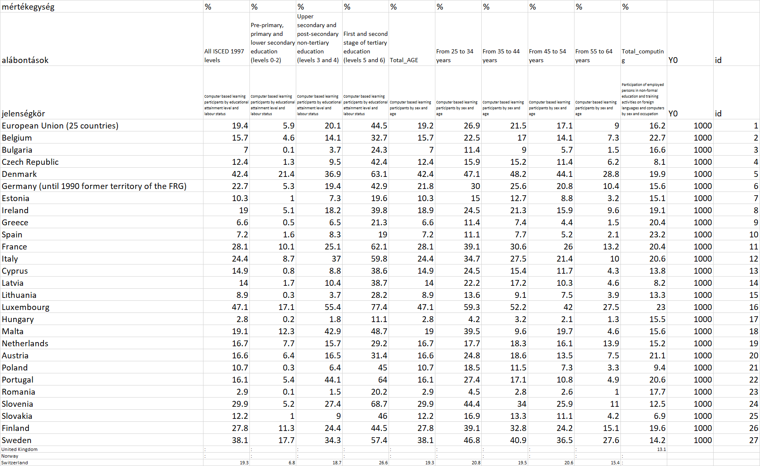

1. ábra: A nyers OAM (forrás: saját ábrázolás)

A 2. ábra tetején látható mértékegység-sor világosan jelzi, minden attribútum méretfüggetlen, vagyis a legkisebb és a legnagyobb ország (objektum) esetén is összehasonlításra alkalmasan értelmezhető a százalékos arány fogalma. Három ország (UK, NO, CH) adatai hiányosak – ezért végső soron csak 27 objektum adata kerül hasznosításra. Az adathiányok kezelése nem fókusza jelen tanulmánynak.

A 3. ábra a 2. ábra oszloponkénti rangsorait adja meg a minél nagyobb, annál jobb elv minden oszlopra való érvényesítése keretében. A 3. ábra naiv, azaz nem optimalizált kiértékelése is lehetséges, amennyiben az egyes országok 10 versenyszámban (attribútum) kapcsán elért helyezései átlagolásra kerülnek (vö. iskolai jegyátlag). Elébe menve az optimalizáló anti-diszkriminatív elemzés mibenlétének, a 3. ábrán látható, hogy a naiv és az optimalizált országsorrendek nem is különböznek annyira egymástól (hétköznapi szóhasználattal élve: vö. színkódok harmóniája – ill. korreláció = 0.96 akár az átlagok, akár ezek rangsorai kerülnek figyelembe vételre). Az országrangsorok eltérésének maximuma azonban 9 egység, ami egy 27 elemű rangsorban jelentős – különösen, hogy az oktatáspolitikák az objektivitás által jelentősen érintett területek (vö. Pisa-tanulmányok és ezek hatásai a nemzeti kormányokra, szakpolitikákra, politikusokra). Jelen esetben éppen Spanyolország (ES) az az objektum, mely a naiv értékelés alapján 21. lenne, míg az optimalizálás keretében már 12., hiszen a spanyol 10. attribútum, vagyis az alkalmazottak részvétel nem formális számítástechnikai képzésekben egy 1. helyet jelent, szemben a többi attribútum 20+ helyezéseivel. S ez az egyetlen példa világosan rámutat arra, hogy egy-egy kiváló helyezés értéke nem kezelhető minden további nélkül a naiv jegyátlagolás mindent egybemosó hatásmechanizmusa szerint, ahol az ének jeles és a matematikai jeles azonos értékű, hasonlóan az ének 2-ről 3-ra javításának és a matematikai 4-ről 5-re javításának értékével…

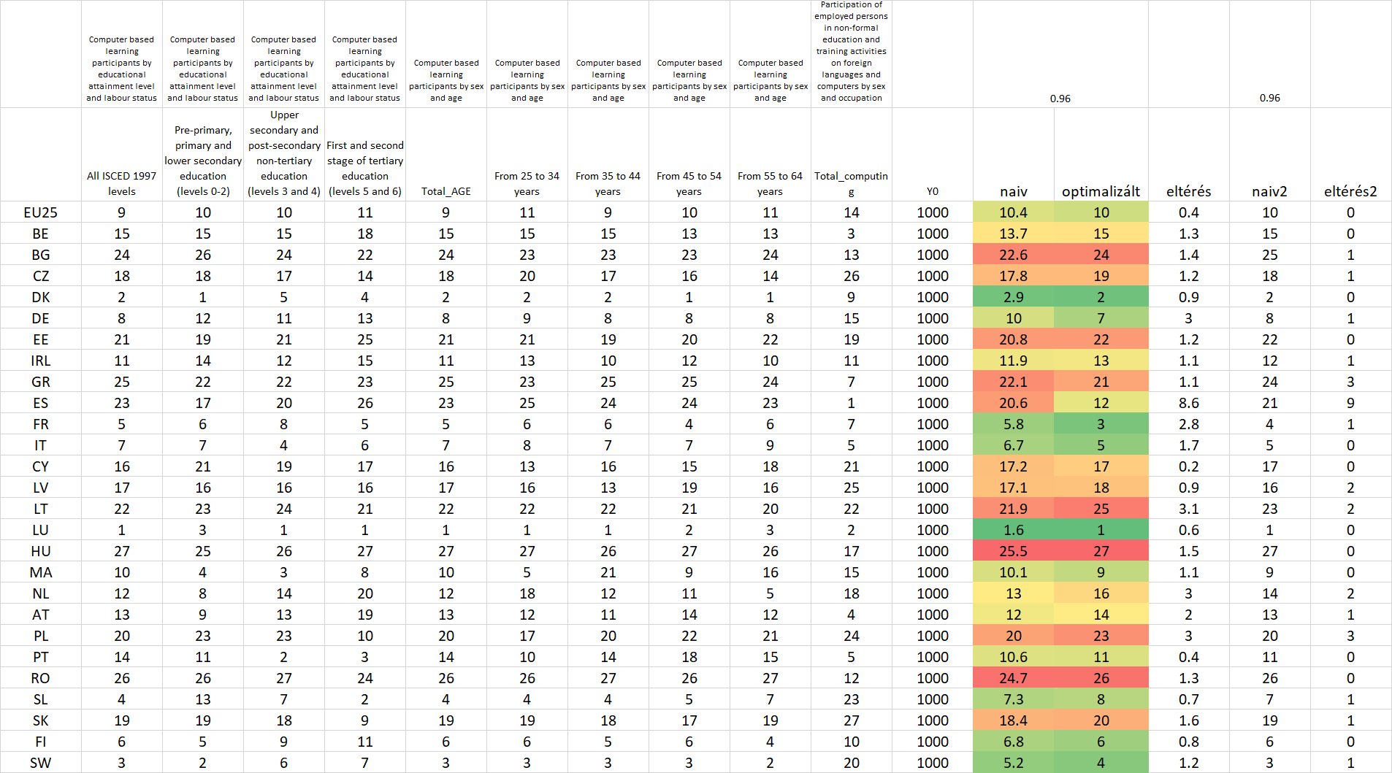

1. ábra: Az anti-diszkriminatív modellezés inputját jelentő OAM (forrás: saját számítások)

Egyértelmű azonban, hogy 2003-ban, az EUROSTAT által biztosított egyetlen egy évnyi adattömeg alapján Luxemburg a leginkább tekinthető digitálisan érettnek és éppen Magyarország az utolsó (27.). A regionális logikák alapján: a 2003-ben éppen az EU-csatlakozás előtt álló országok és a régi EU-tagországok eltérő érettsége triviálisan szembeötlő. Az EU25-ös jelű objektum aggregált 10. helye azt jelenti a 27 elemű objektum-halmazban, hogy több, apróbb és gyengébb tagország van, mint nagyobb és jobb – s ez már előrevetíti a modellszámítások kapcsán azt, hogy a modell technikai normája és az EU25-ös átlagobjektum viszonya nem lesz arányos, vagyis az EU25-ös objektumnak a technikai norma felett kell állnia a súlyozások torzulásai miatt (vö. 4. ábra – 1041.5>1000):

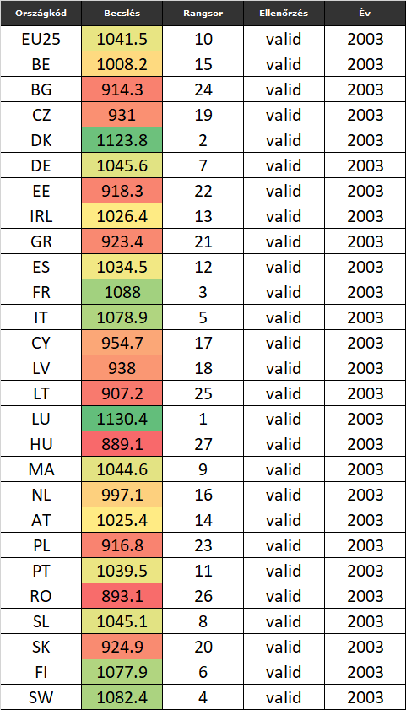

1. ábra: A modellbecslések értékei (ahol a technikai norma = 1000 jóság/érettség-pont – forrás: saját számítások)

A 4. ábra rámutat arra, hogy a 27 objektum mindegyike értelmezhető az optimalizálás keretében, vagyis valid becslések álltak elő a modellszimmetria-vizsgálatok keretében (<http://miau.gau.hu/myx-free/coco/beker_y0.php>).

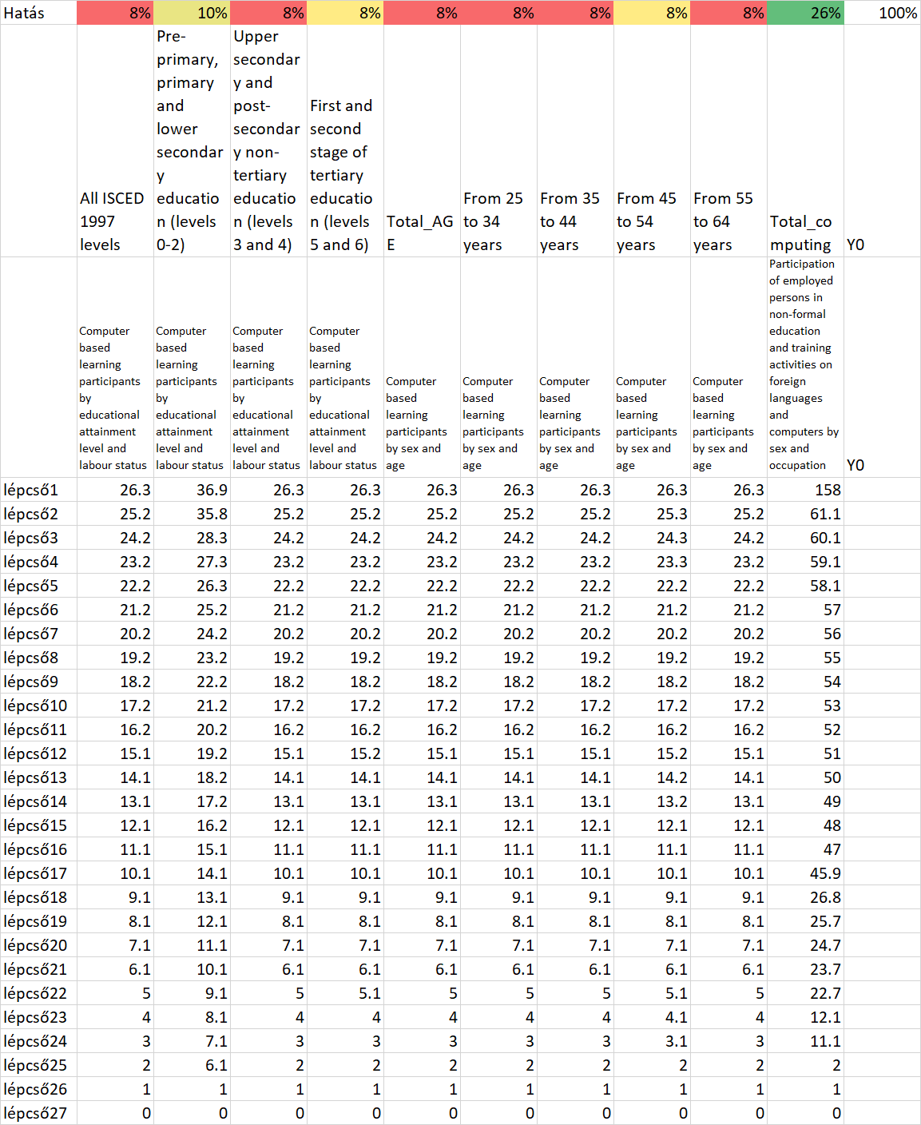

1. ábra: A modell összefüggésrendszere (forrás: saját számítások)

Az 5. ábra bemutatja az optimalizáló modell belső szerkezetét, a lépcsős függvény. Az 5. ábra felső sora rámutat arra, hogy az első kilenc attribútum hatásmechanizmusa lényegében hasonló, míg a 10. attribútum (melyben a fentebb jelzettek szerint egy egyébként digitális érettségét tekintve gyengének tűnő Spanyolország első helyre lépett, éppen pl. ezért felértékelendő, s így a minden objektum másként egyforma elv minél jobb teljesüllése érdekében ez a jelenség nagyobb hatással bír, mint a többi (vö. 8-10% vs. 26%)

# A szimuláció és a döntéstámogatás lehetőségei

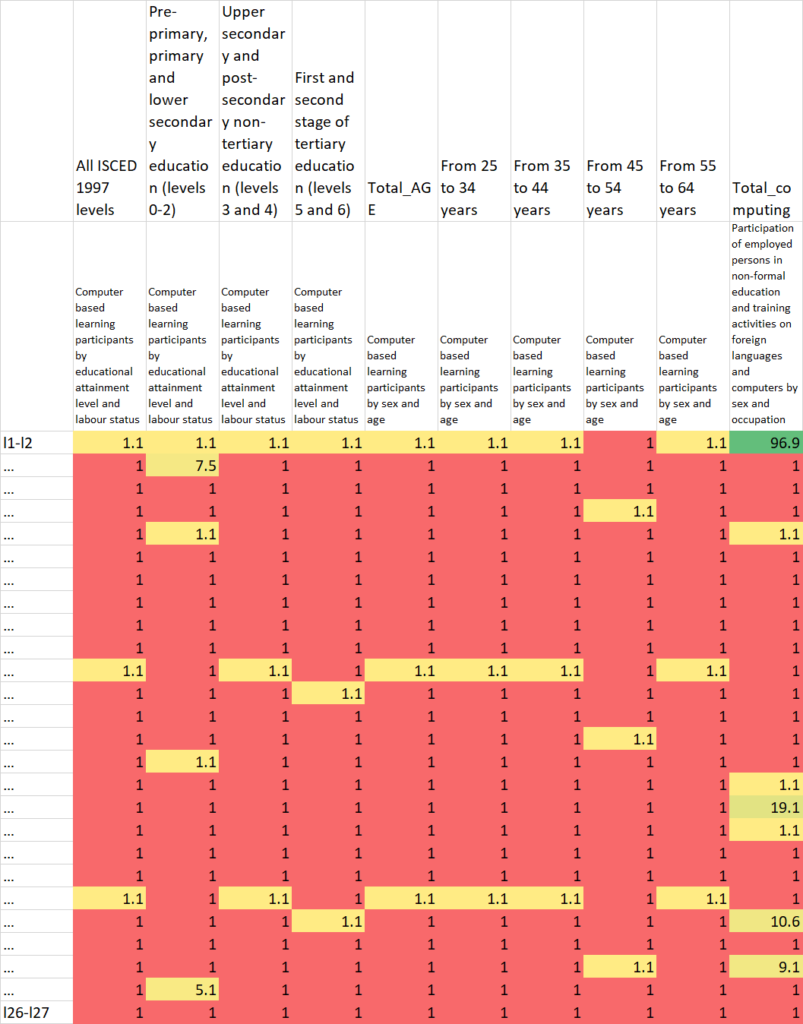

1. ábra: A feltárt összefüggés belső szerkezete (forrás saját számítások)

A 6. ábra világosan rámutat arra, hogy a 10. attribútum a legérzékenyebb, s ezt követi a 2. attribútum, hiszen a legtöbb nem 1-es, ill. kerekítések miatt 1.1-es alapérték ezekben található a lépcsők különbségeként. A jobb felső sarok masszív zöld foltja Spanyolország kapcsán jött létre. A többi, a 10. változó esetén látható nem alapérték is azt jelzi, hogy az első kilenc, egymással analóg jelenségkörhöz (vagyis a számítógéppel támogatott oktatáson való részvételi arányokhoz) képest a 10. jelenség (vagyis az alkalmazottak számítástechnikai képzése, ennek aránya) egészen más aspektusait írja le a digitális érettségnek. Az első kilenc jelenség leginkább az ún. reguláris folyamatokról szól, míg a 10. jelenség már az LLL irányába mutat, s felfogható a 10. jelenség az 1-9. jelenség során felhalmozott elmaradások pótlásának is.

Itt kell megjegyezni, hogy az itt és most alkalmazott OAM abban az esetben forgatható át intézményi szintre is az országok, mint objektumok intézmények, mint objektumok jellegű átértelmezésével egyszerűen, amennyiben az intézmények maguk széles spektrumú aktivitásokat folytatnak, azaz majd mindegyik attribútum esetén van jelenteni valójuk. Amennyiben egyes intézmények nem minden szinten (levels), s nem minden kororsztályban (ages) aktívak, akkor is érvényes rájuk a modell, de a széles aktivitási spektrummal rendelkező intézmények digitális érettsége erőteljesebbnek fog tűnni a teljes minta esetén. Ezt elkerülendő, érdemes az intézmények tipizálni, s csak olyan modelleket építeni, melyben az OAM mindenkor teljes, nincsenek nulla százalékkal, azaz aktivitás hiánnyal feltöltött cellák.

A szimuláció az a döntéstámogató folyamat, amikor egy döntéselőkészítő arra tesz kísérletet, hogy egy/több intézkedés várható hatását előre modellezze. Jelen esetben ilyen intézkedés lehet pl. egyetlen egy objektum megsegítése, ill. minden objektumra vonatkozó új támogatási szabályok megalkotása. Mindkét beavatkozás célja alapvetően a minden objektum legyen másként egyforma elv közelítése lenne, vagyis a digitális érettség becsült értékeinek kisebb max-min intervallumba kényszerítése alacsonyabb szórásérték mellett, de a becslések átlagának csökkenését nem megengedve. Vagyis a rendszer jobb állapotba kerülése önmagában is egy többrétegű elemzési probléma, ahol sok szcenárió (potenciális döntési alternatíva) verseng egymással a legjobb hatásmechanizmus címéért, s majd ennek ismeretében a leghatékonyabb beavatkozás címéért, amely eredménye akkor tér el a leghatásosabb beavatkozás címéért folytatott verseny eredményétől, ha nem egy fix összeg kerül eltérő módokon felhasználásra az oktatási rendszer érdekében, hanem eltérő nagyságú projektek versenyeznek a fajlagosan leghatékonyabb beavatkozás címéért, vagyis magának a megvalósulásnak a jogért.

A döntési alternatívák elsődlegesen a nyers OAM-ra hatnak. Értelemszerűen célszerű, ha minden cella csak felfelé módosulhat, vagyis nincsenek úm. vezéráldozatok: vö. adott intézkedés növeli ugyan az egyik cella értékét egy adott országban, de ezzel egyidejűleg egy/több másik cellára negatív hat(hat) – pl. adott ösztöndíjkeret esetén adott nem/korosztály támogatása megnő, de a keret logikája értelmében máshol az ösztöndíjjal támogathatók száma, ill. az ösztöndíjak mértéke csökken, ami a részvételi százalékokat csökkentheti.

Olyan döntési alternatívák esetén, melyek hatása az OAM változóira nem vezethető le direkt módon (pl. beiratkozási kvóták hatása rel. egyértelmű, (ha pl. eddig azért nem vehettek részt többen adott nem/korosztály esetén egy képzésben, mert nem volt férőhely – vs. a fenti ösztöndíjpélda: mely direkt hatása a részvételi arányokra már nem triviális), akkor a nyers OAM-ra gyakorolt várható hatásokat önálló modellekkel kell becsülni. Ezen modellezési lehetőségtöbblet demonstrálása nem fókusza jelen tanulmányak.

# Konklúziók

Amennyiben az EUROSTAT a tagországi statisztikai hivataloktól kapja adatait, s az adatfelvételezés is a tagországok feladata (volt), akkor értelemszerűen vélelmezhető, hogy az adatszolgáltatók (jelen esetben pl. az oktatási intézmények) mindegyike ismert, megszólításra került, vagyis az országos statisztika formálisan az intézményi alapadatokból állt elő. Így az intézményekre vonatkozóan egyenként és tételesen is ismert minden adat, ami a 2. ábrában most országokhoz, mint objektumokhoz köthető. Mivel tehát az intézmények is lehetnek objektumok, nem csak az országok, így akár országon belül lehetséges regionális objektumok és/vagy intézménycsoport-objektumok (pl. iskolatípusok) szerinti objektumképzés is. Az objektumcsoportok kialakítása lehet az elemzés előtt nyers adatszinten és lehet az elemzési eredmények birtokában, ezek összevonása alapján is.

A szimuláció keretében a digitális érettség mesterséges fogalma egyszerre nyer stratégiai és operatív értelmet, mert az érettségi index nem csak egy potenciális kitüntetés vagy stigma lesz adott objektum esetén, hanem az index alakulásától döntések, aktivitások függnek – közvetlenül és/vagy közvetve.

# Jövőkép

A fenti statikus, adatok híján csak egy évre vonatkozó modellszámítás természetesen évről évre elvégezhető lenne, vagyis a vizsgált objektumok neve mellé a 4. ábrába több digitális érettségi indexérték is bekerülne egy idősor formájában. Ebben az esetben már feltehető a kérdés: melyik objektum fejlődik ideálisabban, mint a többi? Ahol az idealitásnak két nézete verseng egymással: az evolúciós nézet, ahol nőni kell lehetőség szerint állandóan és nagymértékben, ill. a kazohin nézet, ahol a rendszer egyenszilárdsága (vö. fentebb) kell, hogy egyre erősebb legyen, akár a rendszerátlag szintentartása (=a belső arányok racionális átcsoportosítása) mellett is. Ennek a tanulmányak nem feladata a fenntarthatóság és az evolúció fogalmának filozófiai egységesítése, de a matematikai apparátusok a naiv megoldások támogatására képesek az adatvagyon mennyiségétől és minőségétől függően egyre több potenciális kockázatos döntést előre felismertetni és így ezek felvállalását elkerülni. Utólag mindenképpen objektív bizonyítást nyer majd minden döntés hatásmechanizmusa, s ezen változások hatásának iránya és mértéke a célváltozók (vö. növekedési kényszer vs. egyensúlymaximalizálás)…

# Hivatkozások

…hivatkozások a szövegközben…

# Mellékletek I. – Tételes adatvagyon kinyerése

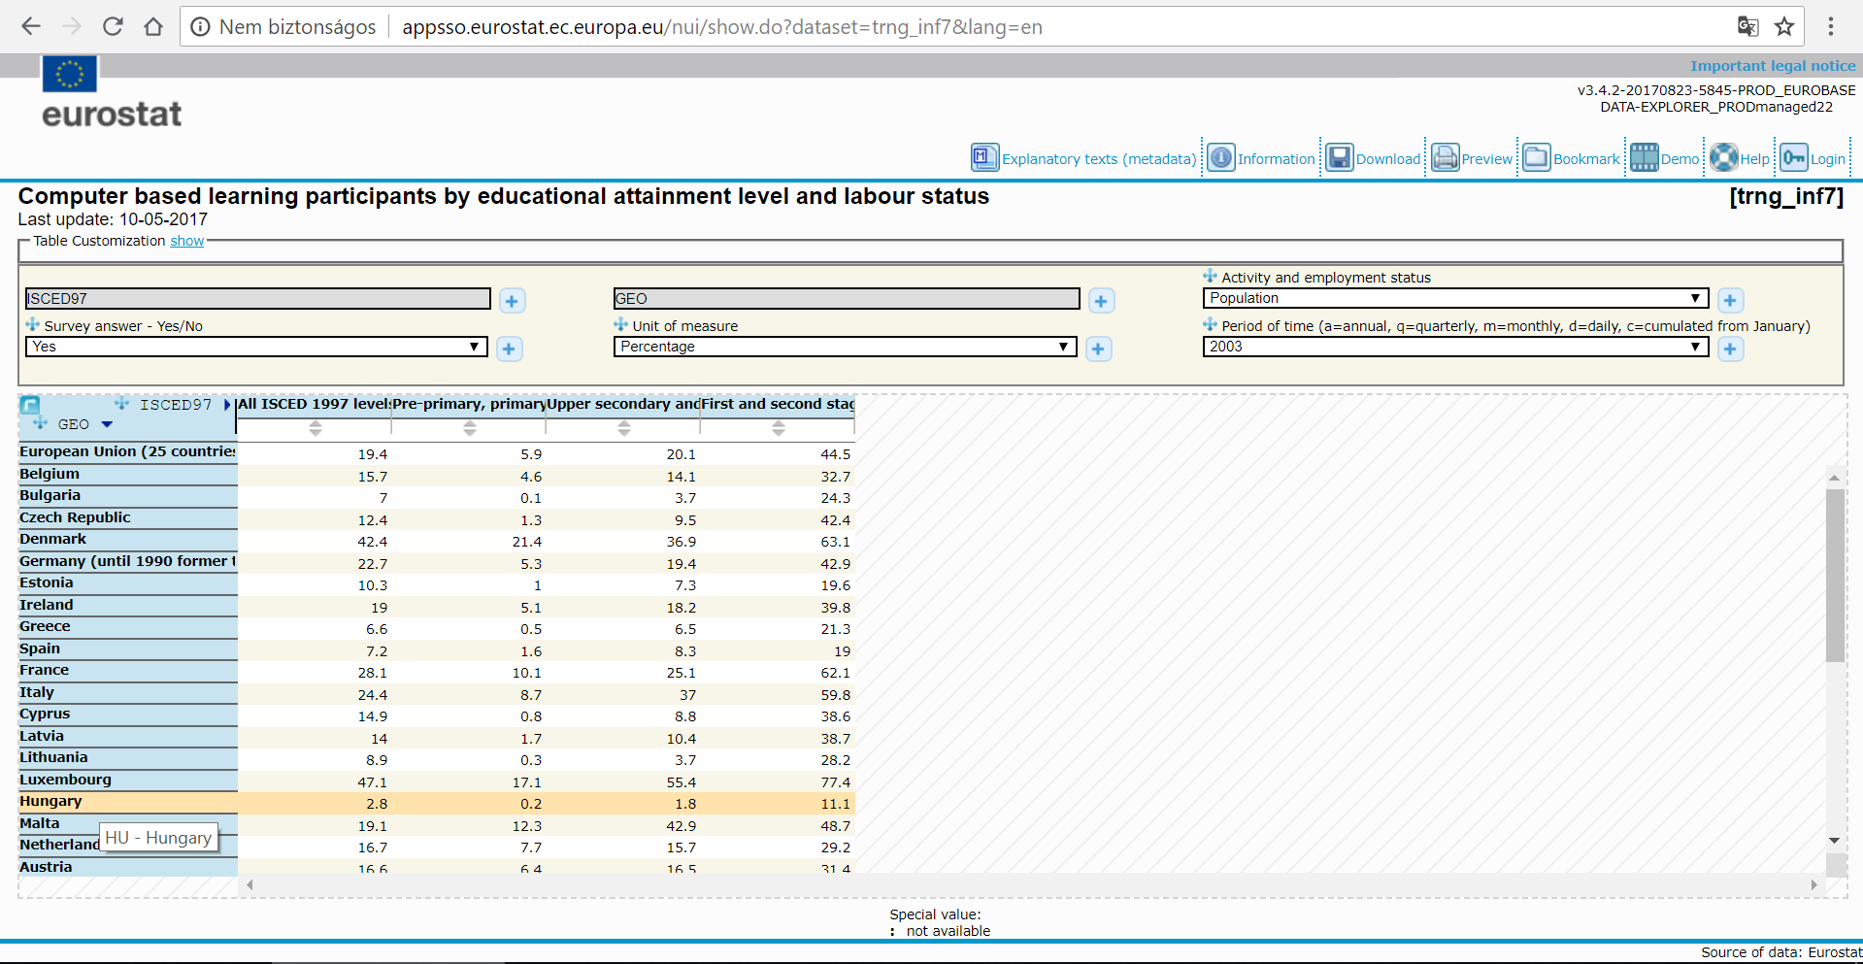

Survey: yes or no or no response, minden más dimenzió egyértékű, ahogyan látható (3 táblázat) /1 táblázat 4 oszlopa felhasználva/

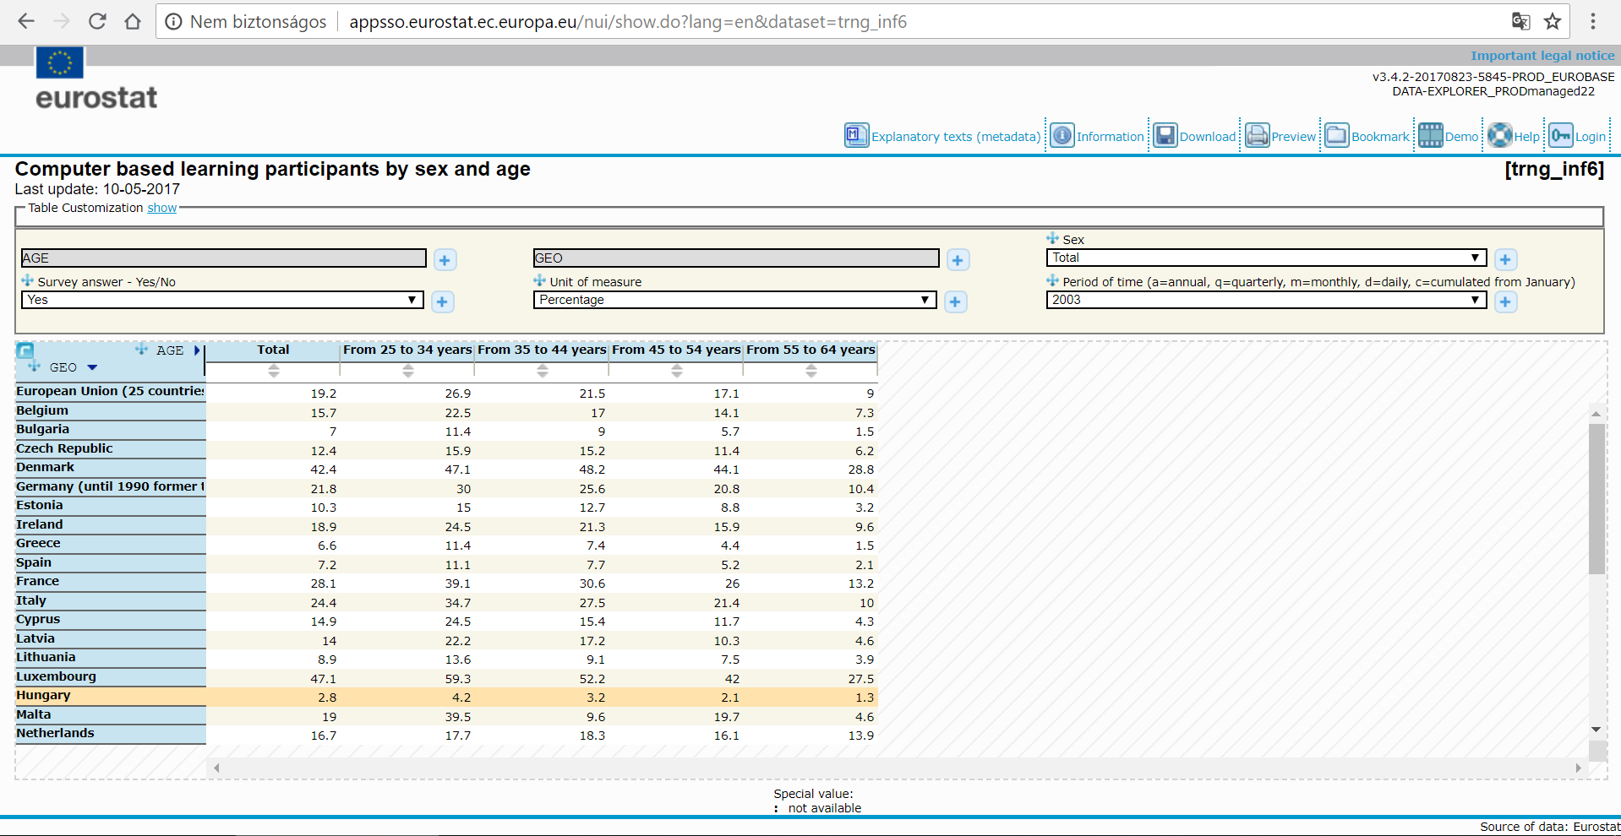

Sex: Total, male, female ÉS Survey: yes or no or no response, minden más dimenzió egyértékű, ahogy látható (9 táblázat) /1 táblázat 5 oszlopa felhasználva/

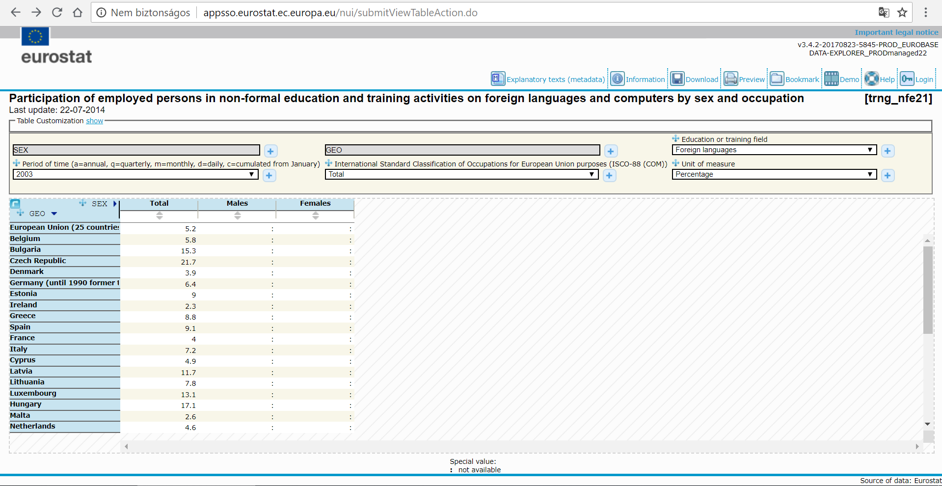

field: 4 ÉS unit: 2 = 8 táblázat /1 táblázat 1 oszlopa felhasználva/, minden más dimenzió egyértékű, ahogy látható

# Mellékeltek II. – A potenciális adatvagyon feltárása

EUROSTAT

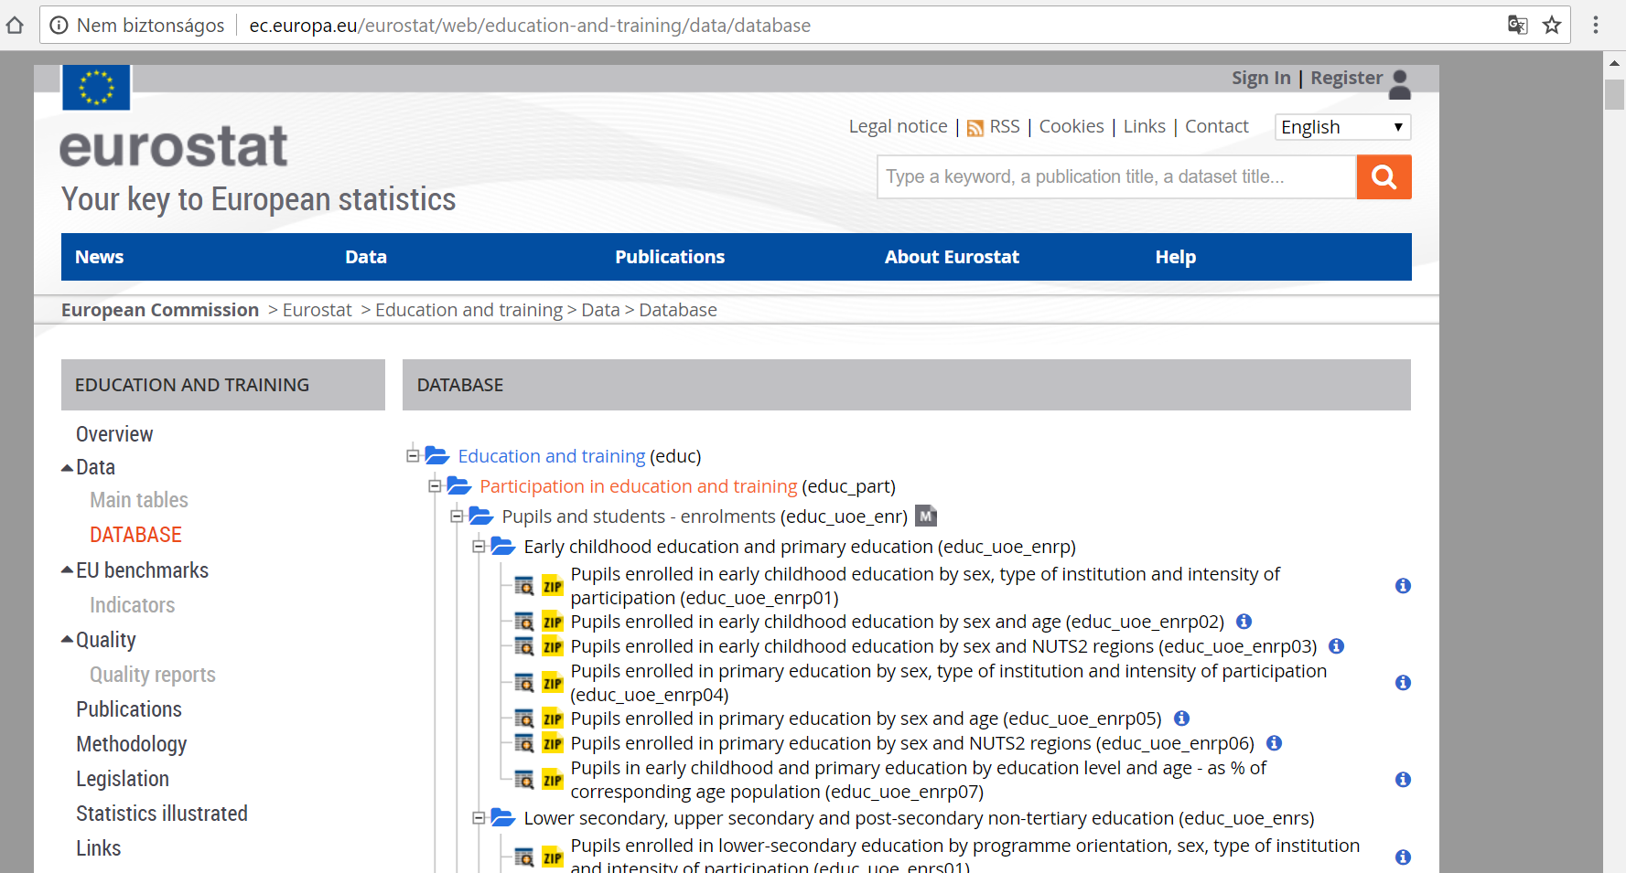



<--potenciális benchmarkok /// adatok --->

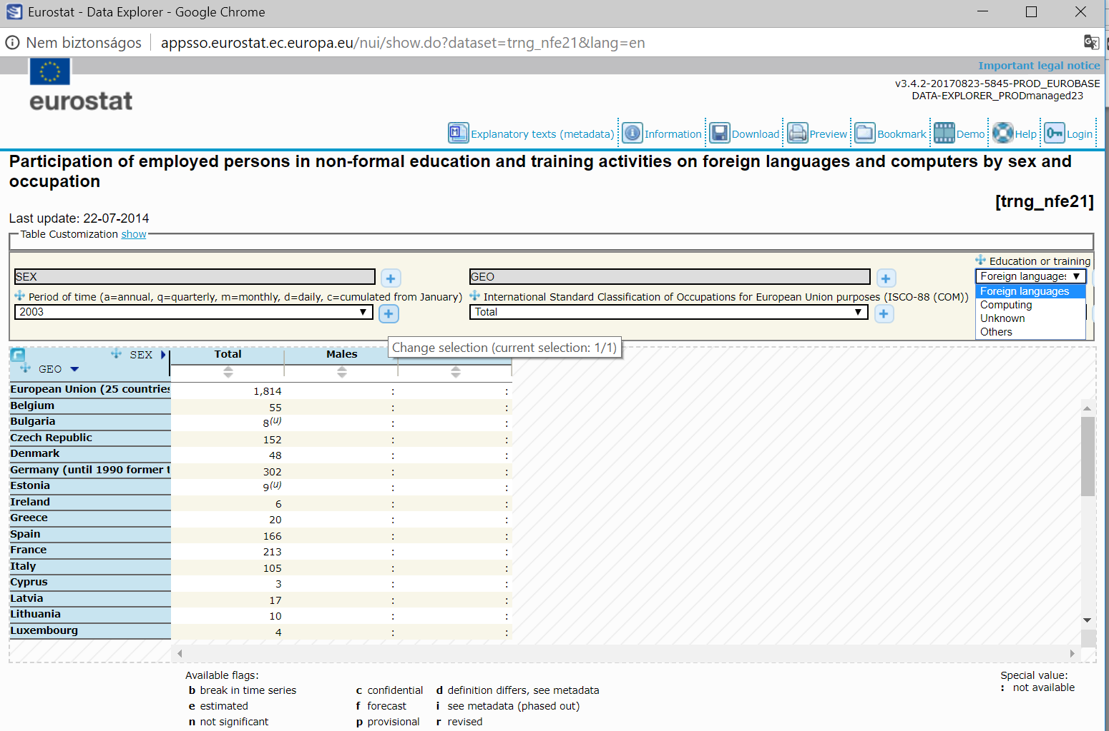

<http://ec.europa.eu/eurostat/web/education-and-training/data/database>

[European Commission](http://ec.europa.eu/index_en.htm)

[Eurostat](http://ec.europa.eu/eurostat/web/main)

[Education and training](http://ec.europa.eu/eurostat/web/education-and-training)

Data

Database

EDUCATION AND TRAINING

[Overview](http://ec.europa.eu/eurostat/web/education-and-training/overview)

Data

[Main tables](http://ec.europa.eu/eurostat/web/education-and-training/data/main-tables)

[DATABASE](http://ec.europa.eu/eurostat/web/education-and-training/data/database)

[EU benchmarks](http://ec.europa.eu/eurostat/web/education-and-training/eu-benchmarks)

[Indicators](http://ec.europa.eu/eurostat/web/education-and-training/eu-benchmarks/indicators)

[Quality](http://ec.europa.eu/eurostat/web/education-and-training/quality)

[Quality reports](http://ec.europa.eu/eurostat/web/education-and-training/quality/quality-reports)

[Publications](http://ec.europa.eu/eurostat/web/education-and-training/publications)

[Methodology](http://ec.europa.eu/eurostat/web/education-and-training/methodology)

[Legislation](http://ec.europa.eu/eurostat/web/education-and-training/legislation)

[Statistics illustrated](http://ec.europa.eu/eurostat/web/education-and-training/statistics-illustrated)

[Links](http://ec.europa.eu/eurostat/web/education-and-training/links)

DATABASE

The navigation tree is loading...

|  |  |  |  |  |
| --- | --- | --- | --- | --- |
|  |  |  | Education and training (educ) |  |

|  |  |  |  |  |  |
| --- | --- | --- | --- | --- | --- |
|  |  |  |  | Participation in education and training (educ_part) |  |

|  |  |  |  |  |  |  |
| --- | --- | --- | --- | --- | --- | --- |
|  |  |  |  |  | Pupils and students - enrolments (educ_uoe_enr) |  |

|  |  |  |  |  |  |  |  |
| --- | --- | --- | --- | --- | --- | --- | --- |
|  |  |  |  |  |  | Early childhood education and primary education (educ_uoe_enrp) |  |

|  |  |  |  |  |  |  |  |
| --- | --- | --- | --- | --- | --- | --- | --- |
|  |  |  |  |  |  | Pupils enrolled in early childhood education by sex, type of institution and intensity of participation(educ_uoe_enrp01) |  |

|  |  |  |  |  |  |  |  |
| --- | --- | --- | --- | --- | --- | --- | --- |
|  |  |  |  |  |  | Pupils enrolled in early childhood education by sex and age (educ_uoe_enrp02) |  |

|  |  |  |  |  |  |  |  |
| --- | --- | --- | --- | --- | --- | --- | --- |
|  |  |  |  |  |  | Pupils enrolled in early childhood education by sex and NUTS2 regions (educ_uoe_enrp03) |  |

|  |  |  |  |  |  |  |  |
| --- | --- | --- | --- | --- | --- | --- | --- |
|  |  |  |  |  |  | Pupils enrolled in primary education by sex, type of institution and intensity of participation (educ_uoe_enrp04) |  |

|  |  |  |  |  |  |  |  |
| --- | --- | --- | --- | --- | --- | --- | --- |
|  |  |  |  |  |  | Pupils enrolled in primary education by sex and age (educ_uoe_enrp05) |  |

|  |  |  |  |  |  |  |  |
| --- | --- | --- | --- | --- | --- | --- | --- |
|  |  |  |  |  |  | Pupils enrolled in primary education by sex and NUTS2 regions (educ_uoe_enrp06) |  |

|  |  |  |  |  |  |  |  |
| --- | --- | --- | --- | --- | --- | --- | --- |
|  |  |  |  |  |  | Pupils in early childhood and primary education by education level and age - as % of corresponding age population (educ_uoe_enrp07) |  |

|  |  |  |  |  |  |  |  |
| --- | --- | --- | --- | --- | --- | --- | --- |
|  |  |  |  |  |  | Lower secondary, upper secondary and post-secondary non-tertiary education (educ_uoe_enrs) |  |

|  |  |  |  |  |  |  |  |
| --- | --- | --- | --- | --- | --- | --- | --- |
|  |  |  |  |  |  | Pupils enrolled in lower-secondary education by programme orientation, sex, type of institution and intensity of participation (educ_uoe_enrs01) |  |

|  |  |  |  |  |  |  |  |
| --- | --- | --- | --- | --- | --- | --- | --- |
|  |  |  |  |  |  | Pupils enrolled in lower-secondary education by programme orientation, sex and age (educ_uoe_enrs02) |  |

|  |  |  |  |  |  |  |  |
| --- | --- | --- | --- | --- | --- | --- | --- |
|  |  |  |  |  |  | Pupils enrolled in lower-secondary education by programme orientation, sex and NUTS2 regions (educ_uoe_enrs03) |  |

|  |  |  |  |  |  |  |  |
| --- | --- | --- | --- | --- | --- | --- | --- |
|  |  |  |  |  |  | Pupils enrolled in upper secondary education by programme orientation, sex, type of institution and intensity of participation (educ_uoe_enrs04) |  |

|  |  |  |  |  |  |  |  |
| --- | --- | --- | --- | --- | --- | --- | --- |
|  |  |  |  |  |  | Pupils enrolled in upper-secondary education by programme orientation, sex and age (educ_uoe_enrs05) |  |

|  |  |  |  |  |  |  |  |
| --- | --- | --- | --- | --- | --- | --- | --- |
|  |  |  |  |  |  | Pupils enrolled in upper secondary education by programme orientation, sex and NUTS2 regions (educ_uoe_enrs06) |  |

|  |  |  |  |  |  |  |  |
| --- | --- | --- | --- | --- | --- | --- | --- |
|  |  |  |  |  |  | Pupils enrolled in post-secondary non-tertiary education by programme orientation, sex, type of institution and intensity of participation (educ_uoe_enrs07) |  |

|  |  |  |  |  |  |  |  |
| --- | --- | --- | --- | --- | --- | --- | --- |
|  |  |  |  |  |  | Pupils enrolled in post-secondary non-tertiary education by programme orientation, sex and age (educ_uoe_enrs08) |  |

|  |  |  |  |  |  |  |  |
| --- | --- | --- | --- | --- | --- | --- | --- |
|  |  |  |  |  |  | Pupils enrolled in post-secondary non-tertiary education by programme orientation, sex and NUTS2 regions (educ_uoe_enrs09) |  |

|  |  |  |  |  |  |  |  |
| --- | --- | --- | --- | --- | --- | --- | --- |
|  |  |  |  |  |  | Pupils enrolled in vocational upper secondary and post-secondary non-tertiary education by education level, sex and field of education (educ_uoe_enrs10) |  |

|  |  |  |  |  |  |  |  |
| --- | --- | --- | --- | --- | --- | --- | --- |
|  |  |  |  |  |  | Tertiary education (educ_uoe_enrt) |  |

|  |  |  |  |  |  |  |  |
| --- | --- | --- | --- | --- | --- | --- | --- |
|  |  |  |  |  |  | Students enrolled in tertiary education by education level, programme orientation, sex, type of institution and intensity of participation (educ_uoe_enrt01) |  |

|  |  |  |  |  |  |  |  |
| --- | --- | --- | --- | --- | --- | --- | --- |
|  |  |  |  |  |  | Students enrolled in tertiary education by education level, programme orientation, sex and age (educ_uoe_enrt02) |  |

|  |  |  |  |  |  |  |  |
| --- | --- | --- | --- | --- | --- | --- | --- |
|  |  |  |  |  |  | Students enrolled in tertiary education by education level, programme orientation, sex and field of education (educ_uoe_enrt03) |  |

|  |  |  |  |  |  |  |  |
| --- | --- | --- | --- | --- | --- | --- | --- |
|  |  |  |  |  |  | Distribution of students enrolled at tertiary education levels by sex and field of education(educ_uoe_enrt04) |  |

|  |  |  |  |  |  |  |  |
| --- | --- | --- | --- | --- | --- | --- | --- |
|  |  |  |  |  |  | Ratio of the proportion of tertiary students over the propotion of the population by NUTS1 and NUTS2 regions (educ_uoe_enrt05) |  |

|  |  |  |  |  |  |  |  |
| --- | --- | --- | --- | --- | --- | --- | --- |
|  |  |  |  |  |  | Students enrolled in tertiary education by education level, programme orientation, sex and NUTS2 regions (educ_uoe_enrt06) |  |

|  |  |  |  |  |  |  |  |
| --- | --- | --- | --- | --- | --- | --- | --- |
|  |  |  |  |  |  | Students in tertiary education by age groups - as % of corresponding age population (educ_uoe_enrt07) |  |

|  |  |  |  |  |  |  |  |
| --- | --- | --- | --- | --- | --- | --- | --- |
|  |  |  |  |  |  | Students in tertiary education - as % of 20-24 years old in the population (educ_uoe_enrt08) |  |

|  |  |  |  |  |  |  |  |
| --- | --- | --- | --- | --- | --- | --- | --- |
|  |  |  |  |  |  | All education levels (educ_uoe_enra) |  |

|  |  |  |  |  |  |  |  |
| --- | --- | --- | --- | --- | --- | --- | --- |
|  |  |  |  |  |  | Pupils and students enrolled by education level, sex, type of institution and intensity of participation (educ_uoe_enra01) |  |

|  |  |  |  |  |  |  |  |
| --- | --- | --- | --- | --- | --- | --- | --- |
|  |  |  |  |  |  | Pupils and students enrolled by education level, sex and age (educ_uoe_enra02) |  |

|  |  |  |  |  |  |  |  |
| --- | --- | --- | --- | --- | --- | --- | --- |
|  |  |  |  |  |  | Pupils and students enrolled by education level, sex and field of education (educ_uoe_enra03) |  |

|  |  |  |  |  |  |  |  |
| --- | --- | --- | --- | --- | --- | --- | --- |
|  |  |  |  |  |  | Pupils and students by education level - as % of total age population (educ_uoe_enra04) |  |

|  |  |  |  |  |  |  |  |
| --- | --- | --- | --- | --- | --- | --- | --- |
|  |  |  |  |  |  | Pupils and students in education by age groups - as % of corresponding age population (educ_uoe_enra05) |  |

|  |  |  |  |  |  |  |  |
| --- | --- | --- | --- | --- | --- | --- | --- |
|  |  |  |  |  |  | Pupils and students in education aged 30 and over - per 1000 of corresponding age population (educ_uoe_enra06) |  |

|  |  |  |  |  |  |  |  |
| --- | --- | --- | --- | --- | --- | --- | --- |
|  |  |  |  |  |  | Expected school years of pupils and students by education level (educ_uoe_enra07) |  |

|  |  |  |  |  |  |  |  |
| --- | --- | --- | --- | --- | --- | --- | --- |
|  |  |  |  |  |  | Students in post-compulsory education - as % of the total population of post-compulsory school age (educ_uoe_enra08) |  |

|  |  |  |  |  |  |  |  |
| --- | --- | --- | --- | --- | --- | --- | --- |
|  |  |  |  |  |  | Students participation at the end of compulsory education - as % of the corresponding age population (educ_uoe_enra09) |  |

|  |  |  |  |  |  |  |  |
| --- | --- | --- | --- | --- | --- | --- | --- |
|  |  |  |  |  |  | Pupils aged between 4 years old and the starting age of compulsory education, by sex - as % of the population of the corresponding age group (educ_uoe_enra10) |  |

|  |  |  |  |  |  |  |  |
| --- | --- | --- | --- | --- | --- | --- | --- |
|  |  |  |  |  |  | Pupils and students enrolled by education level, sex and NUTS2 regions (educ_uoe_enra11) |  |

|  |  |  |  |  |  |  |  |
| --- | --- | --- | --- | --- | --- | --- | --- |
|  |  |  |  |  |  | Pupils and students enrolled by sex, age and NUTS2 regions (educ_uoe_enra12) |  |

|  |  |  |  |  |  |  |  |
| --- | --- | --- | --- | --- | --- | --- | --- |
|  |  |  |  |  |  | Distribution of pupils and students enrolled in general and vocational programmes by education level and NUTS2 regions (educ_uoe_enra13) |  |

|  |  |  |  |  |  |  |  |
| --- | --- | --- | --- | --- | --- | --- | --- |
|  |  |  |  |  |  | Participation rates of selected age groups in education at regional level (educ_uoe_enra14) |  |

|  |  |  |  |  |  |  |  |
| --- | --- | --- | --- | --- | --- | --- | --- |
|  |  |  |  |  |  | Participation rates in selected education levels at regional level (educ_uoe_enra15) |  |

|  |  |  |  |  |  |  |  |
| --- | --- | --- | --- | --- | --- | --- | --- |
|  |  |  |  |  |  | Pupils and students enrolled by education level, programme orientation, completion and sex (educ_uoe_enra16) |  |

|  |  |  |  |  |  |  |  |
| --- | --- | --- | --- | --- | --- | --- | --- |
|  |  |  |  |  |  | Pupils aged between 4 years old and the starting age of compulsory education, by NUTS2 regions - as % of the population of the corresponding age group (educ_uoe_enra17) |  |

|  |  |  |  |  |  |  |  |
| --- | --- | --- | --- | --- | --- | --- | --- |
|  |  |  |  |  |  | Pupils aged between 5 years old and the starting age of compulsory education, by sex - as % of the population of the corresponding age group (educ_uoe_enra18) |  |

|  |  |  |  |  |  |  |  |
| --- | --- | --- | --- | --- | --- | --- | --- |
|  |  |  |  |  |  | Pupils aged 4 years old, by sex - as % of the population of the corresponding age group (educ_uoe_enra19) |  |

|  |  |  |  |  |  |  |  |
| --- | --- | --- | --- | --- | --- | --- | --- |
|  |  |  |  |  |  | Pupils aged 3 years old, by sex - as % of the population of the corresponding age group (educ_uoe_enra20) |  |

|  |  |  |  |  |  |  |
| --- | --- | --- | --- | --- | --- | --- |
|  |  |  |  |  | Pupils and students - entrants (educ_uoe_ent) |  |

|  |  |  |  |  |  |  |
| --- | --- | --- | --- | --- | --- | --- |
|  |  |  |  |  | New entrants by education level, programme orientation, sex and age (educ_uoe_ent01) |  |

|  |  |  |  |  |  |  |
| --- | --- | --- | --- | --- | --- | --- |
|  |  |  |  |  | New entrants by education level, programme orientation, sex and field of education (educ_uoe_ent02) |  |

|  |  |  |  |  |  |  |
| --- | --- | --- | --- | --- | --- | --- |
|  |  |  |  |  | Distribution of new entrants at education level and programme orientation by sex and field of education (educ_uoe_ent03) |  |

|  |  |  |  |  |  |  |
| --- | --- | --- | --- | --- | --- | --- |
|  |  |  |  |  | Adult learning (trng) |  |

|  |  |  |  |  |  |  |  |
| --- | --- | --- | --- | --- | --- | --- | --- |
|  |  |  |  |  |  | Main indicators on adult participation in learning - LFS data from 1992 onwards (trng_lfs_4w0) |  |

|  |  |  |  |  |  |  |  |
| --- | --- | --- | --- | --- | --- | --- | --- |
|  |  |  |  |  |  | Participation rate in education and training (last 4 weeks) by sex and age (trng_lfse_01) |  |

|  |  |  |  |  |  |  |  |
| --- | --- | --- | --- | --- | --- | --- | --- |
|  |  |  |  |  |  | Participation rate in education and training (last 4 weeks) by sex and labour status (trng_lfse_02) |  |

|  |  |  |  |  |  |  |  |
| --- | --- | --- | --- | --- | --- | --- | --- |
|  |  |  |  |  |  | Participation rate in education and training (last 4 weeks) by sex and educational attainment level (trng_lfse_03) |  |

|  |  |  |  |  |  |  |  |
| --- | --- | --- | --- | --- | --- | --- | --- |
|  |  |  |  |  |  | Participation rate in education and training (last 4 weeks) by NUTS 2 regions (trng_lfse_04) |  |

|  |  |  |  |  |  |  |  |
| --- | --- | --- | --- | --- | --- | --- | --- |
|  |  |  |  |  |  | Participation in education and training (last 4 weeks) - population aged 18+ (trng_lfs_4w1) |  |

|  |  |  |  |  |  |  |  |
| --- | --- | --- | --- | --- | --- | --- | --- |
|  |  |  |  |  |  | Participation rate in education and training (last 4 weeks) by sex and age (trng_lfs_01) |  |

|  |  |  |  |  |  |  |  |
| --- | --- | --- | --- | --- | --- | --- | --- |
|  |  |  |  |  |  | Participation rate in education and training (last 4 weeks) by sex, age and educational attainment level (trng_lfs_02) |  |

|  |  |  |  |  |  |  |  |
| --- | --- | --- | --- | --- | --- | --- | --- |
|  |  |  |  |  |  | Participation rate in education and training (last 4 weeks) by sex, age and labour status (trng_lfs_03) |  |

|  |  |  |  |  |  |  |  |
| --- | --- | --- | --- | --- | --- | --- | --- |
|  |  |  |  |  |  | Participation rate in education and training (last 4 weeks) by sex, age and citizenship (trng_lfs_12) |  |

|  |  |  |  |  |  |  |  |
| --- | --- | --- | --- | --- | --- | --- | --- |
|  |  |  |  |  |  | Participation rate in education and training (last 4 weeks) by sex, age and country of birth (trng_lfs_13) |  |

|  |  |  |  |  |  |  |  |
| --- | --- | --- | --- | --- | --- | --- | --- |
|  |  |  |  |  |  | Participation rate in education and training (last 4 weeks) by sex, age and degree of urbanisation (trng_lfs_14) |  |

|  |  |  |  |  |  |  |  |
| --- | --- | --- | --- | --- | --- | --- | --- |
|  |  |  |  |  |  | Participation in education and training (last 4 weeks) - employed persons aged 18+ (trng_lfs_4w2) |  |

|  |  |  |  |  |  |  |  |
| --- | --- | --- | --- | --- | --- | --- | --- |
|  |  |  |  |  |  | Participation rate in education and training (last 4 weeks) by sex, age and occupation (trng_lfs_04) |  |

|  |  |  |  |  |  |  |  |
| --- | --- | --- | --- | --- | --- | --- | --- |
|  |  |  |  |  |  | Participation rate in education and training (last 4 weeks) by sex, age and employment contract (trng_lfs_05) |  |

|  |  |  |  |  |  |  |  |
| --- | --- | --- | --- | --- | --- | --- | --- |
|  |  |  |  |  |  | Participation rate in education and training (last 4 weeks) by sex, age and full-time/part-time employment (trng_lfs_06) |  |

|  |  |  |  |  |  |  |  |
| --- | --- | --- | --- | --- | --- | --- | --- |
|  |  |  |  |  |  | Participation rate in education and training (last 4 weeks) by sex, age and size of the local unit (trng_lfs_07) |  |

|  |  |  |  |  |  |  |  |
| --- | --- | --- | --- | --- | --- | --- | --- |
|  |  |  |  |  |  | Participation rate in education and training (last 4 weeks) by sex, age and NACE Rev. 1.1 activity (trng_lfs_08a) |  |

|  |  |  |  |  |  |  |  |
| --- | --- | --- | --- | --- | --- | --- | --- |
|  |  |  |  |  |  | Participation rate in education and training (last 4 weeks) by sex, age and NACE Rev. 2 activity (trng_lfs_08b) |  |

|  |  |  |  |  |  |  |  |
| --- | --- | --- | --- | --- | --- | --- | --- |
|  |  |  |  |  |  | Participation in education and training (last 4 weeks) - population aged 15+, by type of education (trng_lfs_4w3) |  |

|  |  |  |  |  |  |  |  |
| --- | --- | --- | --- | --- | --- | --- | --- |
|  |  |  |  |  |  | Participation rate in education and training (last 4 weeks) by type, sex and age (trng_lfs_09) |  |

|  |  |  |  |  |  |  |  |
| --- | --- | --- | --- | --- | --- | --- | --- |
|  |  |  |  |  |  | Participation rate in education and training (last 4 weeks) by type, sex, age and educational attainment level (trng_lfs_10) |  |

|  |  |  |  |  |  |  |  |
| --- | --- | --- | --- | --- | --- | --- | --- |
|  |  |  |  |  |  | Participation rate in education and training (last 4 weeks) by type, sex, age and labour status (trng_lfs_11) |  |

|  |  |  |  |  |  |  |  |
| --- | --- | --- | --- | --- | --- | --- | --- |
|  |  |  |  |  |  | Distribution of participation in formal education and training (last 4 weeks) by education programme, sex and age (trng_lfs_15) |  |

|  |  |  |  |  |  |  |  |
| --- | --- | --- | --- | --- | --- | --- | --- |
|  |  |  |  |  |  | Participation in education and training (last 12 months) (trng_aes_12m0) |  |

|  |  |  |  |  |  |  |  |
| --- | --- | --- | --- | --- | --- | --- | --- |
|  |  |  |  |  |  | Participation rate in education and training by sex (trng_aes_100) |  |

|  |  |  |  |  |  |  |  |
| --- | --- | --- | --- | --- | --- | --- | --- |
|  |  |  |  |  |  | Participation rate in education and training by age (trng_aes_101) |  |

|  |  |  |  |  |  |  |  |
| --- | --- | --- | --- | --- | --- | --- | --- |
|  |  |  |  |  |  | Participation rate in education and training by educational attainment level (trng_aes_102) |  |

|  |  |  |  |  |  |  |  |
| --- | --- | --- | --- | --- | --- | --- | --- |
|  |  |  |  |  |  | Participation rate in education and training by labour status (trng_aes_103) |  |

|  |  |  |  |  |  |  |  |
| --- | --- | --- | --- | --- | --- | --- | --- |
|  |  |  |  |  |  | Participation rate in education and training by occupation (trng_aes_104) |  |

|  |  |  |  |  |  |  |  |
| --- | --- | --- | --- | --- | --- | --- | --- |
|  |  |  |  |  |  | Participation rate in education and training by degree of urbanisation (trng_aes_105) |  |

|  |  |  |  |  |  |
| --- | --- | --- | --- | --- | --- |
|  |  |  |  |  |  |

|  |  |  |  |  |  |  |  |
| --- | --- | --- | --- | --- | --- | --- | --- |
|  |  |  |  |  |  | Participation rate in job-related non-formal education and training by type and sex (trng_aes_120) |  |

|  |  |  |  |  |  |  |  |
| --- | --- | --- | --- | --- | --- | --- | --- |
|  |  |  |  |  |  | Participation rate in job-related non-formal education and training by type and age (trng_aes_121) |  |

|  |  |  |  |  |  |  |  |
| --- | --- | --- | --- | --- | --- | --- | --- |
|  |  |  |  |  |  | Participation rate in job-related non-formal education and training by type and educational attainment level (trng_aes_122) |  |

|  |  |  |  |  |  |  |  |
| --- | --- | --- | --- | --- | --- | --- | --- |
|  |  |  |  |  |  | Participation rate in job-related non-formal education and training by type and labour status (trng_aes_123) |  |

|  |  |  |  |  |  |  |  |
| --- | --- | --- | --- | --- | --- | --- | --- |
|  |  |  |  |  |  | Participation rate in job-related non-formal education and training by type and occupation (trng_aes_124) |  |

|  |  |  |  |  |  |  |  |
| --- | --- | --- | --- | --- | --- | --- | --- |
|  |  |  |  |  |  | Participation rate in job-related non-formal education and training by degree of urbanisation (trng_aes_125) |  |

|  |  |  |  |  |  |  |  |
| --- | --- | --- | --- | --- | --- | --- | --- |
|  |  |  |  |  |  | Distribution of education and training activities by field (ISCED-F 2013) (trng_aes_166) |  |

|  |  |  |  |  |  |  |  |
| --- | --- | --- | --- | --- | --- | --- | --- |
|  |  |  |  |  |  | Distribution of education and training activities by field (ISCED-F 1999) (trng_aes_165) |  |

|  |  |  |  |  |  |  |  |
| --- | --- | --- | --- | --- | --- | --- | --- |
|  |  |  |  |  |  | Distribution of non-formal education and training activities by provider (trng_aes_170) |  |

|  |  |  |  |  |  |  |  |
| --- | --- | --- | --- | --- | --- | --- | --- |
|  |  |  |  |  |  | Distribution of non-formal education and training activities by type and sex (trng_aes_188) |  |

|  |  |  |  |  |  |  |  |
| --- | --- | --- | --- | --- | --- | --- | --- |
|  |  |  |  |  |  | Distribution of non-formal education and training activities by type and age (trng_aes_189) |  |

|  |  |  |  |  |  |  |  |
| --- | --- | --- | --- | --- | --- | --- | --- |
|  |  |  |  |  |  | Distribution of non-formal education and training activities by type and educational attainment level (trng_aes_190) |  |

|  |  |  |  |  |  |  |  |
| --- | --- | --- | --- | --- | --- | --- | --- |
|  |  |  |  |  |  | Participation in informal learning (last 12 months) (trng_aes_12m4) |  |

|  |  |  |  |  |  |  |  |
| --- | --- | --- | --- | --- | --- | --- | --- |
|  |  |  |  |  |  | Participation rate in informal learning by learning form and sex (trng_aes_200) |  |

|  |  |  |  |  |  |  |  |
| --- | --- | --- | --- | --- | --- | --- | --- |
|  |  |  |  |  |  | Participation rate in informal learning by learning form and age (trng_aes_201) |  |

|  |  |  |  |  |  |  |  |
| --- | --- | --- | --- | --- | --- | --- | --- |
|  |  |  |  |  |  | Participation rate in informal learning by learning form and educational attainment level (trng_aes_202) |  |

|  |  |  |  |  |  |  |  |
| --- | --- | --- | --- | --- | --- | --- | --- |
|  |  |  |  |  |  | Participation rate in informal learning by learning form and labour status (trng_aes_203) |  |

|  |  |  |  |  |  |  |  |
| --- | --- | --- | --- | --- | --- | --- | --- |
|  |  |  |  |  |  | Participation rate in informal learning by learning form and occupation (trng_aes_204) |  |

|  |  |  |  |  |  |  |  |
| --- | --- | --- | --- | --- | --- | --- | --- |
|  |  |  |  |  |  | Participation rate in informal learning by learning form and degree of urbanisation (trng_aes_205) |  |

|  |  |  |  |  |  |  |  |
| --- | --- | --- | --- | --- | --- | --- | --- |
|  |  |  |  |  |  | Access to information on education and training (last 12 months) (trng_aes_12m1) |  |

|  |  |  |  |  |  |  |  |
| --- | --- | --- | --- | --- | --- | --- | --- |
|  |  |  |  |  |  | Search for information on learning possibilities by type of learning and sex (trng_aes_182) |  |

|  |  |  |  |  |  |  |  |
| --- | --- | --- | --- | --- | --- | --- | --- |
|  |  |  |  |  |  | Search for information on learning possibilities by type of learning and age (trng_aes_183) |  |

|  |  |  |  |  |  |  |  |
| --- | --- | --- | --- | --- | --- | --- | --- |
|  |  |  |  |  |  | Search for information on learning possibilities by type of learning and educational attainment level (trng_aes_184) |  |

|  |  |  |  |  |  |  |  |
| --- | --- | --- | --- | --- | --- | --- | --- |
|  |  |  |  |  |  | Result of the search for information on learning possibilities (trng_aes_186) |  |

|  |  |  |  |  |  |  |  |
| --- | --- | --- | --- | --- | --- | --- | --- |
|  |  |  |  |  |  | Distribution of sources to look for information on learning possibilities (trng_aes_187) |  |

|  |  |  |  |  |  |  |  |
| --- | --- | --- | --- | --- | --- | --- | --- |
|  |  |  |  |  |  | Time spent on education and training (last 12 months) (trng_aes_12m2) |  |

|  |  |  |  |  |  |  |  |
| --- | --- | --- | --- | --- | --- | --- | --- |
|  |  |  |  |  |  | Mean instruction hours spent by participant in education and training by sex (trng_aes_151) |  |

|  |  |  |  |  |  |  |  |
| --- | --- | --- | --- | --- | --- | --- | --- |
|  |  |  |  |  |  | Mean instruction hours spent by participant in education and training by age (trng_aes_147) |  |

|  |  |  |  |  |  |  |  |
| --- | --- | --- | --- | --- | --- | --- | --- |
|  |  |  |  |  |  | Mean instruction hours spent by participant in education and training by educational attainment level (trng_aes_148) |  |

|  |  |  |  |  |  |  |  |
| --- | --- | --- | --- | --- | --- | --- | --- |
|  |  |  |  |  |  | Mean instruction hours spent by participant in education and training by labour status (trng_aes_149) |  |

|  |  |  |  |  |  |  |  |
| --- | --- | --- | --- | --- | --- | --- | --- |
|  |  |  |  |  |  | Mean instruction hours spent by participant in education and training by occupation (trng_aes_150) |  |

|  |  |  |  |  |  |  |  |
| --- | --- | --- | --- | --- | --- | --- | --- |
|  |  |  |  |  |  | Mean instruction hours spent by participant in education and training by degree of urbanisation (trng_aes_152) |  |

|  |  |  |  |  |  |  |  |
| --- | --- | --- | --- | --- | --- | --- | --- |
|  |  |  |  |  |  | Distribution of instruction hours by field (ISCED-F 2013) (trng_aes_174) |  |

|  |  |  |  |  |  |  |  |
| --- | --- | --- | --- | --- | --- | --- | --- |
|  |  |  |  |  |  | Distribution of instruction hours by field (ISCED-F 1999) (trng_aes_173) |  |

|  |  |  |  |  |  |  |  |
| --- | --- | --- | --- | --- | --- | --- | --- |
|  |  |  |  |  |  | Obstacles to participation in education and training (last 12 months) (trng_aes_12m3) |  |

|  |  |  |  |  |  |  |  |
| --- | --- | --- | --- | --- | --- | --- | --- |
|  |  |  |  |  |  | Distribution of the will to participate, or participate more, in education and training (trng_aes_175) |  |

|  |  |  |  |  |  |  |  |
| --- | --- | --- | --- | --- | --- | --- | --- |
|  |  |  |  |  |  | Reasons for not participating in education and training by sex (trng_aes_195) |  |

|  |  |  |  |  |  |  |  |
| --- | --- | --- | --- | --- | --- | --- | --- |
|  |  |  |  |  |  | Reasons for not participating in education and training by age (trng_aes_196) |  |

|  |  |  |  |  |  |  |  |
| --- | --- | --- | --- | --- | --- | --- | --- |
|  |  |  |  |  |  | Reasons for not participating in education and training by educational attainment level (trng_aes_197) |  |

|  |  |  |  |  |  |  |  |
| --- | --- | --- | --- | --- | --- | --- | --- |
|  |  |  |  |  |  | Obstacles to participation in education and training by sex (trng_aes_176) |  |

|  |  |  |  |  |  |  |  |
| --- | --- | --- | --- | --- | --- | --- | --- |
|  |  |  |  |  |  | Obstacles to participation in education and training by age (trng_aes_177) |  |

|  |  |  |  |  |  |  |  |
| --- | --- | --- | --- | --- | --- | --- | --- |
|  |  |  |  |  |  | Obstacles to participation in education and training by educational attainment level (trng_aes_178) |  |

|  |  |  |  |  |  |  |  |
| --- | --- | --- | --- | --- | --- | --- | --- |
|  |  |  |  |  |  | Main obstacle to participation in education and training (trng_aes_179) |  |

|  |  |  |  |  |  |  |
| --- | --- | --- | --- | --- | --- | --- |
|  |  |  |  |  | Continuing vocational training in enterprises (trng_cvt) |  |

|  |  |  |  |  |  |  |  |
| --- | --- | --- | --- | --- | --- | --- | --- |
|  |  |  |  |  |  | Provision of CVT courses and other forms of CVT (trng_cvt_00) |  |

|  |  |  |  |  |  |  |  |
| --- | --- | --- | --- | --- | --- | --- | --- |
|  |  |  |  |  |  | Enterprises providing training by type of training and size class - % of all enterprises (trng_cvt_01s) |  |

|  |  |  |  |  |  |  |  |
| --- | --- | --- | --- | --- | --- | --- | --- |
|  |  |  |  |  |  | Enterprises providing training by type of training and NACE Rev. 2 activity - % of all enterprises (trng_cvt_01n2) |  |

|  |  |  |  |  |  |  |  |
| --- | --- | --- | --- | --- | --- | --- | --- |
|  |  |  |  |  |  | Enterprises providing training by type of training and NACE Rev. 1.1 activity - % of all enterprises (trng_cvt_01n1) |  |

|  |  |  |  |  |  |  |  |
| --- | --- | --- | --- | --- | --- | --- | --- |
|  |  |  |  |  |  | Enterprises not providing training by reason for non-provision and size class - % of non-training enterprises (trng_cvt_02s) |  |

|  |  |  |  |  |  |  |  |
| --- | --- | --- | --- | --- | --- | --- | --- |
|  |  |  |  |  |  | Enterprises not providing training by reason for non-provision and NACE Rev. 2 activity - % of non-training enterprises (trng_cvt_02n2) |  |

|  |  |  |  |  |  |  |  |
| --- | --- | --- | --- | --- | --- | --- | --- |
|  |  |  |  |  |  | Enterprises not providing training by reason for non-provision and NACE Rev. 1.1 activity - % of non-training enterprises (trng_cvt_02n1) |  |

|  |  |  |  |  |  |  |  |
| --- | --- | --- | --- | --- | --- | --- | --- |
|  |  |  |  |  |  | Enterprises providing training by factor limiting provision and size class - % of training enterprises (trng_cvt_03s) |  |

|  |  |  |  |  |  |  |  |
| --- | --- | --- | --- | --- | --- | --- | --- |
|  |  |  |  |  |  | Enterprises providing training by factor limiting provision and NACE Rev. 2 activity - % of training enterprises (trng_cvt_03n2) |  |

|  |  |  |  |  |  |  |  |
| --- | --- | --- | --- | --- | --- | --- | --- |
|  |  |  |  |  |  | Enterprises providing training by factor limiting provision and NACE Rev. 1.1 activity - % of training enterprises (trng_cvt_03n1) |  |

|  |  |  |  |  |  |  |  |
| --- | --- | --- | --- | --- | --- | --- | --- |
|  |  |  |  |  |  | Enterprises providing training by participation intensity, type of training and size class - % of training enterprises (trng_cvt_04s) |  |

|  |  |  |  |  |  |  |  |
| --- | --- | --- | --- | --- | --- | --- | --- |
|  |  |  |  |  |  | Enterprises providing training by participation intensity, type of training and NACE Rev. 2 activity - % of training enterprises (trng_cvt_04n2) |  |

|  |  |  |  |  |  |  |  |
| --- | --- | --- | --- | --- | --- | --- | --- |
|  |  |  |  |  |  | Enterprises providing training by participation intensity, type of training and NACE Rev. 1.1 activity - % of training enterprises (trng_cvt_04n1) |  |

|  |  |  |  |  |  |  |  |
| --- | --- | --- | --- | --- | --- | --- | --- |
|  |  |  |  |  |  | Enterprises providing training in previous year by type of training and size class - % of all enterprises (trng_cvt_06s) |  |

|  |  |  |  |  |  |  |  |
| --- | --- | --- | --- | --- | --- | --- | --- |
|  |  |  |  |  |  | Enterprises providing training in previous year by type of training and NACE Rev. 2 activity - % of all enterprises (trng_cvt_06n2) |  |

|  |  |  |  |  |  |  |  |
| --- | --- | --- | --- | --- | --- | --- | --- |
|  |  |  |  |  |  | Enterprises providing training in previous year by type of training and NACE Rev. 1.1 activity - % of all enterprises (trng_cvt_06n1) |  |

|  |  |  |  |  |  |  |  |
| --- | --- | --- | --- | --- | --- | --- | --- |
|  |  |  |  |  |  | CVT strategies (trng_cvt_01) |  |

|  |  |  |  |  |  |  |  |
| --- | --- | --- | --- | --- | --- | --- | --- |
|  |  |  |  |  |  | Enterprises with CVT planning by type of planning, type of training provided and size class - % of all enterprises (trng_cvt_07s) |  |

|  |  |  |  |  |  |  |  |
| --- | --- | --- | --- | --- | --- | --- | --- |
|  |  |  |  |  |  | Enterprises with CVT planning by type of planning, type of training provided and NACE Rev. 2 activity - % of all enterprises (trng_cvt_07n2) |  |

|  |  |  |  |  |  |  |  |
| --- | --- | --- | --- | --- | --- | --- | --- |
|  |  |  |  |  |  | Enterprises with CVT planning by type of planning, type of training provided and NACE Rev. 1.1 activity - % of all enterprises (trng_cvt_07n1) |  |

|  |  |  |  |  |  |  |  |
| --- | --- | --- | --- | --- | --- | --- | --- |
|  |  |  |  |  |  | Enterprises with CVT agreement by type of agreement, type of training provided and size class - % of all enterprises (trng_cvt_08s) |  |

|  |  |  |  |  |  |  |  |
| --- | --- | --- | --- | --- | --- | --- | --- |
|  |  |  |  |  |  | Enterprises with CVT agreement by type of agreement, type of training provided and NACE Rev. 2 activity - % of all enterprises (trng_cvt_08n2) |  |

|  |  |  |  |  |  |  |  |
| --- | --- | --- | --- | --- | --- | --- | --- |
|  |  |  |  |  |  | Enterprises with CVT agreement by type of agreement, type of training provided and NACE Rev. 1.1 activity - % of all enterprises (trng_cvt_08n1) |  |

|  |  |  |  |  |  |  |  |
| --- | --- | --- | --- | --- | --- | --- | --- |
|  |  |  |  |  |  | Enterprises with staff representatives involved in the management of CVT by type of involvement and size class - % of all enterprises (trng_cvt_09s) |  |

|  |  |  |  |  |  |  |  |
| --- | --- | --- | --- | --- | --- | --- | --- |
|  |  |  |  |  |  | Enterprises with staff representatives involved in the management of CVT by type of involvement and NACE Rev. 2 activity - % of all enterprises (trng_cvt_09n2) |  |

|  |  |  |  |  |  |  |  |
| --- | --- | --- | --- | --- | --- | --- | --- |
|  |  |  |  |  |  | Enterprises with staff representatives involved in the management of CVT by type of involvement and NACE Rev. 1.1 activity - % of all enterprises (trng_cvt_09n1) |  |

|  |  |  |  |  |  |  |  |
| --- | --- | --- | --- | --- | --- | --- | --- |
|  |  |  |  |  |  | Main skills needed for the development of the enterprise by type of skill and size class - % of all enterprises (trng_cvt_10s) |  |

|  |  |  |  |  |  |  |  |
| --- | --- | --- | --- | --- | --- | --- | --- |
|  |  |  |  |  |  | Main skills needed for the development of the enterprise by type of skill and NACE Rev. 2 activity - % of all enterprises (trng_cvt_10n2) |  |

|  |  |  |  |  |  |  |  |
| --- | --- | --- | --- | --- | --- | --- | --- |
|  |  |  |  |  |  | Usual reaction to future skill needs by type of reaction and size class - % of all enterprises (trng_cvt_11s) |  |

|  |  |  |  |  |  |  |  |
| --- | --- | --- | --- | --- | --- | --- | --- |
|  |  |  |  |  |  | Usual reaction to future skill needs by type of reaction and NACE Rev. 2 activity - % of all enterprises (trng_cvt_11n2) |  |

|  |  |  |  |  |  |  |  |
| --- | --- | --- | --- | --- | --- | --- | --- |
|  |  |  |  |  |  | Participants in CVT courses (trng_cvt_02) |  |

|  |  |  |  |  |  |  |  |
| --- | --- | --- | --- | --- | --- | --- | --- |
|  |  |  |  |  |  | Participants in CVT courses by sex and size class - % of persons employed in all enterprises (trng_cvt_12s) |  |

|  |  |  |  |  |  |  |  |
| --- | --- | --- | --- | --- | --- | --- | --- |
|  |  |  |  |  |  | Participants in CVT courses by sex and NACE Rev. 2 activity - % of persons employed in all enterprises (trng_cvt_12n2) |  |

|  |  |  |  |  |  |  |  |
| --- | --- | --- | --- | --- | --- | --- | --- |
|  |  |  |  |  |  | Participants in CVT courses by sex and NACE Rev. 1.1 activity - % of persons employed in all enterprises (trng_cvt_12n1) |  |

|  |  |  |  |  |  |  |  |
| --- | --- | --- | --- | --- | --- | --- | --- |
|  |  |  |  |  |  | Participants in CVT courses by sex and size class - % of persons employed in enterprises providing CVT courses (trng_cvt_13s) |  |

|  |  |  |  |  |  |  |  |
| --- | --- | --- | --- | --- | --- | --- | --- |
|  |  |  |  |  |  | Participants in CVT courses by sex and NACE Rev. 2 activity - % of persons employed in enterprises providing CVT courses (trng_cvt_13n2) |  |

|  |  |  |  |  |  |  |  |
| --- | --- | --- | --- | --- | --- | --- | --- |
|  |  |  |  |  |  | Participants in CVT courses by sex and NACE Rev. 1.1 activity - % of persons employed in enterprises providing CVT courses (trng_cvt_13n1) |  |

|  |  |  |  |  |  |  |  |
| --- | --- | --- | --- | --- | --- | --- | --- |
|  |  |  |  |  |  | Participants in CVT courses by type of CVT planning and size class - % of persons employed in all enterprises (trng_cvt_14s) |  |

|  |  |  |  |  |  |  |  |
| --- | --- | --- | --- | --- | --- | --- | --- |
|  |  |  |  |  |  | Participants in CVT courses by type of CVT planning and NACE Rev. 2 activity - % of persons employed in all enterprises (trng_cvt_14n2) |  |

|  |  |  |  |  |  |  |  |
| --- | --- | --- | --- | --- | --- | --- | --- |
|  |  |  |  |  |  | Participants in CVT courses by type of CVT planning and NACE Rev. 1.1 activity - % of persons employed in all enterprises (trng_cvt_14n1) |  |

|  |  |  |  |  |  |  |  |
| --- | --- | --- | --- | --- | --- | --- | --- |
|  |  |  |  |  |  | Participants in CVT courses by type of CVT agreement and size class - % of persons employed in all enterprises (trng_cvt_15s) |  |

|  |  |  |  |  |  |  |  |
| --- | --- | --- | --- | --- | --- | --- | --- |
|  |  |  |  |  |  | Participants in CVT courses by type of CVT agreement and NACE Rev. 2 activity - % of persons employed in all enterprises (trng_cvt_15n2) |  |

|  |  |  |  |  |  |  |  |
| --- | --- | --- | --- | --- | --- | --- | --- |
|  |  |  |  |  |  | Participants in CVT courses by type of CVT agreement and NACE Rev. 1.1 activity - % of persons employed in all enterprises (trng_cvt_15n1) |  |

|  |  |  |  |  |  |  |  |
| --- | --- | --- | --- | --- | --- | --- | --- |
|  |  |  |  |  |  | Costs of CVT courses (trng_cvt_03) |  |

|  |  |  |  |  |  |  |  |
| --- | --- | --- | --- | --- | --- | --- | --- |
|  |  |  |  |  |  | Cost of CVT courses by type and size class - % of total labour cost of all enterprises (trng_cvt_16s) |  |

|  |  |  |  |  |  |  |  |
| --- | --- | --- | --- | --- | --- | --- | --- |
|  |  |  |  |  |  | Cost of CVT courses by type and NACE Rev. 2 activity - % of total labour cost of all enterprises (trng_cvt_16n2) |  |

|  |  |  |  |  |  |  |  |
| --- | --- | --- | --- | --- | --- | --- | --- |
|  |  |  |  |  |  | Cost of CVT courses by type and NACE Rev. 1.1 activity - % of total labour cost of all enterprises (trng_cvt_16n1) |  |

|  |  |  |  |  |  |  |  |
| --- | --- | --- | --- | --- | --- | --- | --- |
|  |  |  |  |  |  | Cost of CVT courses by type and size class - cost per person employed in all enterprises (trng_cvt_17s) |  |

|  |  |  |  |  |  |  |  |
| --- | --- | --- | --- | --- | --- | --- | --- |
|  |  |  |  |  |  | Cost of CVT courses by type and NACE Rev. 2 activity - cost per person employed in all enterprises (trng_cvt_17n2) |  |

|  |  |  |  |  |  |  |  |
| --- | --- | --- | --- | --- | --- | --- | --- |
|  |  |  |  |  |  | Cost of CVT courses by type and NACE Rev 1.1 activity - cost per person employed in all enterprises (trng_cvt_17n1) |  |

|  |  |  |  |  |  |  |  |
| --- | --- | --- | --- | --- | --- | --- | --- |
|  |  |  |  |  |  | Cost of CVT courses by type and size class - cost per person employed in enterprises providing CVT courses (trng_cvt_18s) |  |

|  |  |  |  |  |  |  |  |
| --- | --- | --- | --- | --- | --- | --- | --- |
|  |  |  |  |  |  | Cost of CVT courses by type and NACE Rev. 2 activity - cost per person employed in enterprises providing CVT courses (trng_cvt_18n2) |  |

|  |  |  |  |  |  |  |  |
| --- | --- | --- | --- | --- | --- | --- | --- |
|  |  |  |  |  |  | Cost of CVT courses by type and NACE Rev 1.1 activity - cost per person employed in enterprises providing CVT courses (trng_cvt_18n1) |  |

|  |  |  |  |  |  |  |  |
| --- | --- | --- | --- | --- | --- | --- | --- |
|  |  |  |  |  |  | Cost of CVT courses by type and size class - cost per participant (trng_cvt_19s) |  |

|  |  |  |  |  |  |  |  |
| --- | --- | --- | --- | --- | --- | --- | --- |
|  |  |  |  |  |  | Cost of CVT courses by type and NACE Rev. 2 activity - cost per participant (trng_cvt_19n2) |  |

|  |  |  |  |  |  |  |  |
| --- | --- | --- | --- | --- | --- | --- | --- |
|  |  |  |  |  |  | Cost of CVT courses by type and NACE Rev. 1.1 activity - cost per participant (trng_cvt_19n1) |  |

|  |  |  |  |  |  |  |  |
| --- | --- | --- | --- | --- | --- | --- | --- |
|  |  |  |  |  |  | Cost of CVT courses by type and size class - cost per training hour (trng_cvt_20s) |  |

|  |  |  |  |  |  |  |  |
| --- | --- | --- | --- | --- | --- | --- | --- |
|  |  |  |  |  |  | Cost of CVT courses by type and NACE Rev. 2 activity - cost per training hour (trng_cvt_20n2) |  |

|  |  |  |  |  |  |  |  |
| --- | --- | --- | --- | --- | --- | --- | --- |
|  |  |  |  |  |  | Cost of CVT courses by type and NACE Rev. 1.1 activity - cost per training hour (trng_cvt_20n1) |  |

|  |  |  |  |  |  |  |  |
| --- | --- | --- | --- | --- | --- | --- | --- |
|  |  |  |  |  |  | Time spent in CVT courses (trng_cvt_04) |  |

|  |  |  |  |  |  |  |  |
| --- | --- | --- | --- | --- | --- | --- | --- |
|  |  |  |  |  |  | Hours spent in CVT courses by size class - hours per 1000 hours worked in all enterprises (trng_cvt_21s) |  |

|  |  |  |  |  |  |  |  |
| --- | --- | --- | --- | --- | --- | --- | --- |
|  |  |  |  |  |  | Hours spent in CVT courses by NACE Rev. 2 activity - hours per 1000 hours worked in all enterprises (trng_cvt_21n2) |  |

|  |  |  |  |  |  |  |  |
| --- | --- | --- | --- | --- | --- | --- | --- |
|  |  |  |  |  |  | Hours spent in CVT courses by NACE Rev. 1.1 activity - hours per 1000 hours worked in all enterprises (trng_cvt_21n1) |  |

|  |  |  |  |  |  |  |  |
| --- | --- | --- | --- | --- | --- | --- | --- |
|  |  |  |  |  |  | Hours spent in CVT courses by size class - hours per 1000 hours worked in enterprises providing CVT courses (trng_cvt_22s) |  |

|  |  |  |  |  |  |  |  |
| --- | --- | --- | --- | --- | --- | --- | --- |
|  |  |  |  |  |  | Hours spent in CVT courses by NACE Rev. 2 activity - hours per 1000 hours worked in enterprises providing CVT courses (trng_cvt_22n2) |  |

|  |  |  |  |  |  |  |  |
| --- | --- | --- | --- | --- | --- | --- | --- |
|  |  |  |  |  |  | Hours spent in CVT courses by NACE Rev. 1.1 activity - hours per 1000 hours worked in enterprises providing CVT courses (trng_cvt_22n1) |  |

|  |  |  |  |  |  |  |  |
| --- | --- | --- | --- | --- | --- | --- | --- |
|  |  |  |  |  |  | Hours spent in CVT courses by size class - hours per person employed in all enterprises (trng_cvt_23s) |  |

|  |  |  |  |  |  |  |  |
| --- | --- | --- | --- | --- | --- | --- | --- |
|  |  |  |  |  |  | Hours spent in CVT courses by NACE Rev. 2 activity - hours per person employed in all enterprises (trng_cvt_23n2) |  |

|  |  |  |  |  |  |  |  |
| --- | --- | --- | --- | --- | --- | --- | --- |
|  |  |  |  |  |  | Hours spent in CVT courses by NACE Rev. 1.1 activity - hours per person employed in all enterprises (trng_cvt_23n1) |  |

|  |  |  |  |  |  |  |  |
| --- | --- | --- | --- | --- | --- | --- | --- |
|  |  |  |  |  |  | Hours spent in CVT courses by size class - hours per person employed in enterprises providing CVT courses (trng_cvt_24s) |  |

|  |  |  |  |  |  |  |  |
| --- | --- | --- | --- | --- | --- | --- | --- |
|  |  |  |  |  |  | Hours spent in CVT courses by NACE Rev. 2 activity - hours per person employed in enterprises providing CVT courses (trng_cvt_24n2) |  |

|  |  |  |  |  |  |  |  |
| --- | --- | --- | --- | --- | --- | --- | --- |
|  |  |  |  |  |  | Hours spent in CVT courses by NACE Rev. 1.1 activity - hours per person employed in enterprises providing CVT courses (trng_cvt_24n1) |  |

|  |  |  |  |  |  |  |  |
| --- | --- | --- | --- | --- | --- | --- | --- |
|  |  |  |  |  |  | Hours spent in CVT courses by size class - hours per participant (trng_cvt_25s) |  |

|  |  |  |  |  |  |  |  |
| --- | --- | --- | --- | --- | --- | --- | --- |
|  |  |  |  |  |  | Hours spent in CVT courses by NACE Rev. 2 activity - hours per participant (trng_cvt_25n2) |  |

|  |  |  |  |  |  |  |  |
| --- | --- | --- | --- | --- | --- | --- | --- |
|  |  |  |  |  |  | Hours spent in CVT courses by NACE Rev. 1.1 activity - hours per participant (trng_cvt_25n1) |  |

|  |  |  |  |  |  |  |  |
| --- | --- | --- | --- | --- | --- | --- | --- |
|  |  |  |  |  |  | Hours spent in CVT courses by type of course and size class - % of total hours spent in CVT courses (trng_cvt_26s) |  |

|  |  |  |  |  |  |  |  |
| --- | --- | --- | --- | --- | --- | --- | --- |
|  |  |  |  |  |  | Hours spent in CVT courses by type of course and NACE Rev. 2 activity - % of total hours spent in CVT courses (trng_cvt_26n2) |  |

|  |  |  |  |  |  |  |  |
| --- | --- | --- | --- | --- | --- | --- | --- |
|  |  |  |  |  |  | Hours spent in CVT courses by type of course and NACE Rev. 1.1 activity - % of total hours spent in CVT courses (trng_cvt_26n1) |  |

|  |  |  |  |  |  |  |  |
| --- | --- | --- | --- | --- | --- | --- | --- |
|  |  |  |  |  |  | Hours spent in CVT courses by type of CVT planning and size class - hours per person employed in all enterprises (trng_cvt_27s) |  |

|  |  |  |  |  |  |  |  |
| --- | --- | --- | --- | --- | --- | --- | --- |
|  |  |  |  |  |  | Hours spent in CVT courses by type of CVT planning and NACE Rev. 2 activity - hours per person employed in all enterprises (trng_cvt_27n2) |  |

|  |  |  |  |  |  |  |  |
| --- | --- | --- | --- | --- | --- | --- | --- |
|  |  |  |  |  |  | Hours spent in CVT courses by type of CVT planning and NACE Rev. 1.1 activity - hours per person employed in all enterprises (trng_cvt_27n1) |  |

|  |  |  |  |  |  |  |  |
| --- | --- | --- | --- | --- | --- | --- | --- |
|  |  |  |  |  |  | Hours spent in CVT courses by type of CVT agreement and size class - hours per person employed in all enterprises (trng_cvt_28s) |  |

|  |  |  |  |  |  |  |  |
| --- | --- | --- | --- | --- | --- | --- | --- |
|  |  |  |  |  |  | Hours spent in CVT courses by type of CVT agreement and NACE Rev. 2 activity - hours per person employed in all enterprises (trng_cvt_28n2) |  |

|  |  |  |  |  |  |  |  |
| --- | --- | --- | --- | --- | --- | --- | --- |
|  |  |  |  |  |  | Hours spent in CVT courses by type of CVT agreement and NACE Rev. 1.1 activity - hours per person employed in all enterprises (trng_cvt_28n1) |  |

|  |  |  |  |  |  |  |  |
| --- | --- | --- | --- | --- | --- | --- | --- |
|  |  |  |  |  |  | Characteristics of CVT courses (trng_cvt_05) |  |

|  |  |  |  |  |  |  |  |
| --- | --- | --- | --- | --- | --- | --- | --- |
|  |  |  |  |  |  | Main skills targeted by CVT courses by type of skill and size class - % of enterprises providing CVT courses (trng_cvt_29s) |  |

|  |  |  |  |  |  |  |  |
| --- | --- | --- | --- | --- | --- | --- | --- |
|  |  |  |  |  |  | Main skills targeted by CVT courses by type of skill and NACE Rev. 2 activity - % of enterprises providing CVT courses (trng_cvt_29n2) |  |

|  |  |  |  |  |  |  |  |
| --- | --- | --- | --- | --- | --- | --- | --- |
|  |  |  |  |  |  | Main providers used for external CVT courses by type of provider and size class - % of enterprises providing external CVT courses (trng_cvt_30s) |  |

|  |  |  |  |  |  |  |  |
| --- | --- | --- | --- | --- | --- | --- | --- |
|  |  |  |  |  |  | Main providers used for external CVT courses by type of provider and NACE Rev. 2 activity - % of enterprises providing external CVT courses (trng_cvt_30n2) |  |

|  |  |  |  |  |  |  |  |
| --- | --- | --- | --- | --- | --- | --- | --- |
|  |  |  |  |  |  | Assessment of CVT activities (trng_cvt_06) |  |

|  |  |  |  |  |  |  |  |
| --- | --- | --- | --- | --- | --- | --- | --- |
|  |  |  |  |  |  | Enterprises which assess the outcomes of CVT activities by type of training provided and size class - % of training enterprises (trng_cvt_31s) |  |

|  |  |  |  |  |  |  |  |
| --- | --- | --- | --- | --- | --- | --- | --- |
|  |  |  |  |  |  | Enterprises which assess the outcomes of CVT activities by type of training provided and NACE Rev. 2 activity - % of training enterprises (trng_cvt_31n2) |  |

|  |  |  |  |  |  |  |  |
| --- | --- | --- | --- | --- | --- | --- | --- |
|  |  |  |  |  |  | Enterprises which assess the outcomes of CVT activities by assessment method and size class - % of training enterprises (trng_cvt_32s) |  |

|  |  |  |  |  |  |  |  |
| --- | --- | --- | --- | --- | --- | --- | --- |
|  |  |  |  |  |  | Enterprises which assess the outcomes of CVT activities by assessment method and NACE Rev. 2 activity - % of training enterprises (trng_cvt_32n2) |  |

|  |  |  |  |  |  |  |  |
| --- | --- | --- | --- | --- | --- | --- | --- |
|  |  |  |  |  |  | Enterprises which assess the outcomes of CVT activities by assessment method and NACE Rev. 1.1 activity - % of training enterprises (trng_cvt_32n1) |  |

|  |  |  |  |  |  |  |  |
| --- | --- | --- | --- | --- | --- | --- | --- |
|  |  |  |  |  |  | Enterprises which assess their future skill needs by type of training provided and size class - % of all enterprises (trng_cvt_33s) |  |

|  |  |  |  |  |  |  |  |
| --- | --- | --- | --- | --- | --- | --- | --- |
|  |  |  |  |  |  | Enterprises which assess their future skill needs by type of training provided and NACE Rev. 2 activity - % of all enterprises (trng_cvt_33n2) |  |

|  |  |  |  |  |  |  |  |
| --- | --- | --- | --- | --- | --- | --- | --- |
|  |  |  |  |  |  | Enterprises which assess their future skill needs by type of training provided and NACE Rev. 1.1 activity - % of all enterprises (trng_cvt_33n1) |  |

|  |  |  |  |  |  |  |  |
| --- | --- | --- | --- | --- | --- | --- | --- |
|  |  |  |  |  |  | Provision of initial vocational training (IVT) (trng_cvt_07) |  |

|  |  |  |  |  |  |  |  |
| --- | --- | --- | --- | --- | --- | --- | --- |
|  |  |  |  |  |  | Enterprises employing IVT participants by size class - % of all enterprises (trng_cvt_34s) |  |

|  |  |  |  |  |  |  |  |
| --- | --- | --- | --- | --- | --- | --- | --- |
|  |  |  |  |  |  | Enterprises employing IVT participants by NACE Rev. 2 activity - % of all enterprises (trng_cvt_34n2) |  |

|  |  |  |  |  |  |  |  |
| --- | --- | --- | --- | --- | --- | --- | --- |
|  |  |  |  |  |  | Enterprises employing IVT participants by NACE Rev. 1.1 activity - % of all enterprises (trng_cvt_34n1) |  |

|  |  |  |  |  |  |  |  |
| --- | --- | --- | --- | --- | --- | --- | --- |
|  |  |  |  |  |  | Enterprises employing IVT participants by reason and size class - % of enterprises employing IVT participants (trng_cvt_35s) |  |

|  |  |  |  |  |  |  |  |
| --- | --- | --- | --- | --- | --- | --- | --- |
|  |  |  |  |  |  | Enterprises employing IVT participants by reason and NACE Rev. 2 activity - % of enterprises employing IVT participants (trng_cvt_35n2) |  |

|  |  |  |  |  |  |
| --- | --- | --- | --- | --- | --- |
|  |  |  |  | Learning mobility (educ_uoe_mob) |  |

|  |  |  |  |  |  |  |
| --- | --- | --- | --- | --- | --- | --- |
|  |  |  |  |  | Mobile students from abroad (educ_uoe_mobs) |  |

|  |  |  |  |  |  |  |
| --- | --- | --- | --- | --- | --- | --- |
|  |  |  |  |  | Mobile students from abroad enrolled by education level, sex and field of education (educ_uoe_mobs01) |  |

|  |  |  |  |  |  |  |
| --- | --- | --- | --- | --- | --- | --- |
|  |  |  |  |  | Mobile students from abroad enrolled by education level, sex and country of origin (educ_uoe_mobs02) |  |

|  |  |  |  |  |  |  |
| --- | --- | --- | --- | --- | --- | --- |
|  |  |  |  |  | Share of mobile students from abroad enrolled by education level, sex and country of origin(educ_uoe_mobs03) |  |

|  |  |  |  |  |  |  |
| --- | --- | --- | --- | --- | --- | --- |
|  |  |  |  |  | Distribution of mobile students from abroad enrolled at education level by sex and field of education (educ_uoe_mobs04) |  |

|  |  |  |  |  |  |  |
| --- | --- | --- | --- | --- | --- | --- |
|  |  |  |  |  | Degree mobile graduates from abroad (educ_uoe_mobg) |  |

|  |  |  |  |  |  |  |
| --- | --- | --- | --- | --- | --- | --- |
|  |  |  |  |  | Degree mobile graduates from abroad by education level, sex and field of education (educ_uoe_mobg01) |  |

|  |  |  |  |  |  |  |
| --- | --- | --- | --- | --- | --- | --- |
|  |  |  |  |  | Degree mobile graduates from abroad by education level, sex and country of origin (educ_uoe_mobg02) |  |

|  |  |  |  |  |  |  |
| --- | --- | --- | --- | --- | --- | --- |
|  |  |  |  |  | Share of degree mobile graduates from abroad by education level, sex and country of origin(educ_uoe_mobg03) |  |

|  |  |  |  |  |  |  |
| --- | --- | --- | --- | --- | --- | --- |
|  |  |  |  |  | Distribution of degree mobile graduates from abroad at education level by sex and field of education (educ_uoe_mobg04) |  |

|  |  |  |  |  |  |  |
| --- | --- | --- | --- | --- | --- | --- |
|  |  |  |  |  | Credit mobile graduates (educ_uoe_mobc) |  |

|  |  |  |  |  |  |  |
| --- | --- | --- | --- | --- | --- | --- |
|  |  |  |  |  | Credit mobile graduates (at least 3 months abroad) by education level, type of mobility scheme, type of mobility and sex (educ_uoe_mobc01) |  |

|  |  |  |  |  |  |  |
| --- | --- | --- | --- | --- | --- | --- |
|  |  |  |  |  | Credit mobile graduates (at least 3 months abroad) by education level, country of destination, type of mobility and sex (educ_uoe_mobc02) |  |

|  |  |  |  |  |  |  |
| --- | --- | --- | --- | --- | --- | --- |
|  |  |  |  |  | Credit mobile graduates (less than 3 months abroad) by education level, country of destination, type of mobility and sex (educ_uoe_mobc03) |  |

|  |  |  |  |  |  |
| --- | --- | --- | --- | --- | --- |
|  |  |  |  | Education personnel (educ_uoe_per) |  |

|  |  |  |  |  |  |  |
| --- | --- | --- | --- | --- | --- | --- |
|  |  |  |  |  | Teachers and academic staff (educ_uoe_perp) |  |

|  |  |  |  |  |  |  |
| --- | --- | --- | --- | --- | --- | --- |
|  |  |  |  |  | Classroom teachers and academic staff by education level, programme orientation, sex and age groups (educ_uoe_perp01) |  |

|  |  |  |  |  |  |  |
| --- | --- | --- | --- | --- | --- | --- |
|  |  |  |  |  | Classroom teachers and academic staff by education level, programme orientation, sex, type of institution and employment status (educ_uoe_perp02) |  |

|  |  |  |  |  |  |  |
| --- | --- | --- | --- | --- | --- | --- |
|  |  |  |  |  | Classroom teachers working full-time and part-time in primary, lower-secondary and upper-secondary education - as % of total active population (educ_uoe_perp03) |  |

|  |  |  |  |  |  |  |
| --- | --- | --- | --- | --- | --- | --- |
|  |  |  |  |  | Ratio of pupils and students to teachers and academic staff by education level and programme orientation (educ_uoe_perp04) |  |

|  |  |  |  |  |  |  |
| --- | --- | --- | --- | --- | --- | --- |
|  |  |  |  |  | Distribution of teachers and academic staff (educ_uoe_perd) |  |

|  |  |  |  |  |  |  |
| --- | --- | --- | --- | --- | --- | --- |
|  |  |  |  |  | Distribution of teachers at education level and programme orientation by age groups (educ_uoe_perd01) |  |

|  |  |  |  |  |  |  |
| --- | --- | --- | --- | --- | --- | --- |
|  |  |  |  |  | Distribution of academic staff at education level by age groups (educ_uoe_perd02) |  |

|  |  |  |  |  |  |  |
| --- | --- | --- | --- | --- | --- | --- |
|  |  |  |  |  | Female teachers - as % of all teachers, by education level (educ_uoe_perd03) |  |

|  |  |  |  |  |  |  |
| --- | --- | --- | --- | --- | --- | --- |
|  |  |  |  |  | Female school-management personnel - as % of total school-management personnel, by education level(educ_uoe_perd04) |  |

|  |  |  |  |  |  |  |
| --- | --- | --- | --- | --- | --- | --- |
|  |  |  |  |  | Teachers working part-time - as % of all teachers, by education level (educ_uoe_perd05) |  |

|  |  |  |  |  |  |
| --- | --- | --- | --- | --- | --- |
|  |  |  |  | Education finance (educ_uoe_fin) |  |

|  |  |  |  |  |  |  |
| --- | --- | --- | --- | --- | --- | --- |
|  |  |  |  |  | Expenditure on education (educ_uoe_fine) |  |

|  |  |  |  |  |  |  |
| --- | --- | --- | --- | --- | --- | --- |
|  |  |  |  |  | Total educational expenditure by education level, programme orientation and type of source (educ_uoe_fine01) |  |

|  |  |  |  |  |  |  |
| --- | --- | --- | --- | --- | --- | --- |
|  |  |  |  |  | Public educational expenditure by education level, programme orientation, type of source and expenditure category (educ_uoe_fine02) |  |

|  |  |  |  |  |  |  |
| --- | --- | --- | --- | --- | --- | --- |
|  |  |  |  |  | Private educational expenditure by education level, programme orientation, type of source and expenditure category (educ_uoe_fine03) |  |

|  |  |  |  |  |  |  |
| --- | --- | --- | --- | --- | --- | --- |
|  |  |  |  |  | Public expenditure on education in current prices, by education level and programme orientation (educ_uoe_fine04) |  |

|  |  |  |  |  |  |  |
| --- | --- | --- | --- | --- | --- | --- |
|  |  |  |  |  | Public expenditure on education by education level and programme orientation - as % of GDP (educ_uoe_fine06) |  |

|  |  |  |  |  |  |  |
| --- | --- | --- | --- | --- | --- | --- |
|  |  |  |  |  | Public subsidies to the private sector by education level and programme orientation (educ_uoe_fine07) |  |

|  |  |  |  |  |  |  |
| --- | --- | --- | --- | --- | --- | --- |
|  |  |  |  |  | Public expenditure on education by education level and programme orientation - as % of public expenditure or % of GNI (educ_uoe_fine08) |  |

|  |  |  |  |  |  |  |
| --- | --- | --- | --- | --- | --- | --- |
|  |  |  |  |  | Public expenditure on education per pupil/student based on FTE by education level and programme orientation (educ_uoe_fine09) |  |

|  |  |  |  |  |  |  |
| --- | --- | --- | --- | --- | --- | --- |
|  |  |  |  |  | Pupils and students enrolled by education level and programme orientation with coverage adjusted to statistics on educational finance and aligned to financial year (educ_uoe_fine10) |  |

|  |  |  |  |  |  |  |
| --- | --- | --- | --- | --- | --- | --- |
|  |  |  |  |  | Expenditure of/on public and private educational institutions (educ_uoe_fini) |  |

|  |  |  |  |  |  |
| --- | --- | --- | --- | --- | --- |
|  |  |  |  | Financial aid to students by education level - as % of total public expenditure (educ_uoe_fina01) |  |

|  |  |  |  |  |  |
| --- | --- | --- | --- | --- | --- |
|  |  |  |  | Funding of education by education level, programme orientation and recipient of funding (educ_uoe_finf01) |  |

|  |  |  |  |  |  |
| --- | --- | --- | --- | --- | --- |
|  |  |  |  | Funding of vocational education by education level, type of source and recipient of funding (educ_uoe_finf02) |  |

|  |  |  |  |  |  |
| --- | --- | --- | --- | --- | --- |
|  |  |  |  | Education and training outcomes (educ_outc) |  |

|  |  |  |  |  |  |  |
| --- | --- | --- | --- | --- | --- | --- |
|  |  |  |  |  | Graduates (educ_uoe_grad) |  |

|  |  |  |  |  |  |  |
| --- | --- | --- | --- | --- | --- | --- |
|  |  |  |  |  | Graduates by education level, programme orientation, completion, sex and age (educ_uoe_grad01) |  |

|  |  |  |  |  |  |  |
| --- | --- | --- | --- | --- | --- | --- |
|  |  |  |  |  | Graduates by education level, programme orientation, sex and field of education (educ_uoe_grad02) |  |

|  |  |  |  |  |  |  |
| --- | --- | --- | --- | --- | --- | --- |
|  |  |  |  |  | Distribution of graduates at education level and programme orientation by sex and field of education(educ_uoe_grad03) |  |

|  |  |  |  |  |  |  |
| --- | --- | --- | --- | --- | --- | --- |
|  |  |  |  |  | Graduates in tertiary education, in science, math., computing, engineering, manufacturing, construction, by sex - per 1000 of population aged 20-29 (educ_uoe_grad04) |  |

|  |  |  |  |  |  |  |
| --- | --- | --- | --- | --- | --- | --- |
|  |  |  |  |  | Graduates in tertiary education by age groups - per 1000 of population aged 20-29 (educ_uoe_grad05) |  |

|  |  |  |  |  |  |  |
| --- | --- | --- | --- | --- | --- | --- |
|  |  |  |  |  | Graduates at doctoral level by sex and age groups - per 1000 of population aged 25-34 (educ_uoe_grad06) |  |

|  |  |  |  |  |  |  |
| --- | --- | --- | --- | --- | --- | --- |
|  |  |  |  |  | Graduates at doctoral level, in science, math., computing, engineering, manufacturing, construction, by sex - per 1000 of population aged 25-34 (educ_uoe_grad07) |  |

|  |  |  |  |  |  |  |
| --- | --- | --- | --- | --- | --- | --- |
|  |  |  |  |  | Educational attainment level (edat) | [(Implementation of ISCED 2011)](http://ec.europa.eu/eurostat/documents/10186/6246844/Implementation-ISCED2011-EE-EN.pdf) |

|  |  |  |  |  |  |  |  |
| --- | --- | --- | --- | --- | --- | --- | --- |
|  |  |  |  |  |  | Population by educational attainment level (edat1) |  |

|  |  |  |  |  |  |  |  |
| --- | --- | --- | --- | --- | --- | --- | --- |
|  |  |  |  |  |  | Population by educational attainment level, sex and age (%) - main indicators (edat_lfse_03) |  |

|  |  |  |  |  |  |  |  |
| --- | --- | --- | --- | --- | --- | --- | --- |
|  |  |  |  |  |  | Population aged 25-64 by educational attainment level, sex and NUTS 2 regions (%) (edat_lfse_04) |  |

|  |  |  |  |  |  |  |  |
| --- | --- | --- | --- | --- | --- | --- | --- |
|  |  |  |  |  |  | Population aged 30-34 by educational attainment level, sex and NUTS 2 regions (%) (edat_lfse_12) |  |

|  |  |  |  |  |  |
| --- | --- | --- | --- | --- | --- |
|  |  |  |  |  |  |

|  |  |  |  |  |  |  |  |
| --- | --- | --- | --- | --- | --- | --- | --- |
|  |  |  |  |  |  | Population by educational attainment level, sex and age (1 000) (edat_lfs_9901) |  |

|  |  |  |  |  |  |  |  |
| --- | --- | --- | --- | --- | --- | --- | --- |
|  |  |  |  |  |  | Population by educational attainment level, sex, age and labour status (1 000) (edat_lfs_9902) |  |

|  |  |  |  |  |  |  |  |
| --- | --- | --- | --- | --- | --- | --- | --- |
|  |  |  |  |  |  | Population by sex, age and educational attainment level (1 000) (lfsa_pgaed) |  |

|  |  |  |  |  |  |  |  |
| --- | --- | --- | --- | --- | --- | --- | --- |
|  |  |  |  |  |  | Population by educational attainment level, sex and age (%) (edat_lfs_9903) |  |

|  |  |  |  |  |  |  |  |
| --- | --- | --- | --- | --- | --- | --- | --- |
|  |  |  |  |  |  | Population by educational attainment level, sex, age and labour status (%) (edat_lfs_9904) |  |

|  |  |  |  |  |  |  |  |
| --- | --- | --- | --- | --- | --- | --- | --- |
|  |  |  |  |  |  | Population by educational attainment level, sex, age and citizenship (%) (edat_lfs_9911) |  |

|  |  |  |  |  |  |  |  |
| --- | --- | --- | --- | --- | --- | --- | --- |
|  |  |  |  |  |  | Population by educational attainment level, sex, age and country of birth (%) (edat_lfs_9912) |  |

|  |  |  |  |  |  |  |  |
| --- | --- | --- | --- | --- | --- | --- | --- |
|  |  |  |  |  |  | Population by educational attainment level, sex, age and degree of urbanisation (%) (edat_lfs_9913) |  |

|  |  |  |  |  |  |  |  |
| --- | --- | --- | --- | --- | --- | --- | --- |
|  |  |  |  |  |  | Population by educational attainment level, sex, age, country of birth and degree of urbanisation (%) (edat_lfs_9915) |  |

|  |  |  |  |  |  |  |  |
| --- | --- | --- | --- | --- | --- | --- | --- |
|  |  |  |  |  |  | Population by educational attainment level, sex, age, citizenship and degree of urbanisation (%) (edat_lfs_9916) |  |

|  |  |  |  |  |  |  |  |
| --- | --- | --- | --- | --- | --- | --- | --- |
|  |  |  |  |  |  | Population by educational attainment level, sex, age, country of birth and NUTS 2 regions (%) (edat_lfs_9917) |  |

|  |  |  |  |  |  |  |  |
| --- | --- | --- | --- | --- | --- | --- | --- |
|  |  |  |  |  |  | Population by educational attainment level, sex, age, citizenship and NUTS 2 regions (%) (edat_lfs_9918) |  |

|  |  |  |  |  |  |  |  |
| --- | --- | --- | --- | --- | --- | --- | --- |
|  |  |  |  |  |  | Population aged 15-34 by educational attainment level, sex, age and programme orientation (%) (edat_lfs_9914) |  |

|  |  |  |  |  |  |
| --- | --- | --- | --- | --- | --- |
|  |  |  |  |  |  |

|  |  |  |  |  |  |  |  |
| --- | --- | --- | --- | --- | --- | --- | --- |
|  |  |  |  |  |  | Employees by educational attainment level, sex, age and occupation (%) (edat_lfs_9905) |  |

|  |  |  |  |  |  |  |  |
| --- | --- | --- | --- | --- | --- | --- | --- |
|  |  |  |  |  |  | Employees by educational attainment level, sex, age and employment contract (%) (edat_lfs_9906) |  |

|  |  |  |  |  |  |  |  |
| --- | --- | --- | --- | --- | --- | --- | --- |
|  |  |  |  |  |  | Employees by educational attainment level, sex, age and full-time/part-time employment (%) (edat_lfs_9907) |  |

|  |  |  |  |  |  |  |  |
| --- | --- | --- | --- | --- | --- | --- | --- |
|  |  |  |  |  |  | Employees by educational attainment level, sex, age and size of the local unit (%) (edat_lfs_9908) |  |

|  |  |  |  |  |  |  |  |
| --- | --- | --- | --- | --- | --- | --- | --- |
|  |  |  |  |  |  | Employees by educational attainment level, sex, age and NACE Rev. 1.1 activity (%) (edat_lfs_9909) |  |

|  |  |  |  |  |  |  |  |
| --- | --- | --- | --- | --- | --- | --- | --- |
|  |  |  |  |  |  | Employees by educational attainment level, sex, age and NACE Rev. 2 activity (%) (edat_lfs_9910) |  |

|  |  |  |  |  |  |  |  |
| --- | --- | --- | --- | --- | --- | --- | --- |
|  |  |  |  |  |  | Labour status by educational attainment level (edat2) |  |

|  |  |  |  |  |  |  |  |
| --- | --- | --- | --- | --- | --- | --- | --- |
|  |  |  |  |  |  | Activity rates by sex, age and educational attainment level (%) (lfsa_argaed) |  |

|  |  |  |  |  |  |  |  |
| --- | --- | --- | --- | --- | --- | --- | --- |
|  |  |  |  |  |  | Employment rates by sex, age and educational attainment level (%) (lfsa_ergaed) |  |

|  |  |  |  |  |  |  |  |
| --- | --- | --- | --- | --- | --- | --- | --- |
|  |  |  |  |  |  | Unemployment rates by sex, age and educational attainment level (%) (lfsa_urgaed) |  |

|  |  |  |  |  |  |  |  |
| --- | --- | --- | --- | --- | --- | --- | --- |
|  |  |  |  |  |  | Inactive population by sex, age and educational attainment level (1 000) (lfsa_igaed) |  |

|  |  |  |  |  |  |  |  |
| --- | --- | --- | --- | --- | --- | --- | --- |
|  |  |  |  |  |  | Employment by sex, age and educational attainment level (1 000) (lfsa_egaed) |  |

|  |  |  |  |  |  |  |  |
| --- | --- | --- | --- | --- | --- | --- | --- |
|  |  |  |  |  |  | Employment by sex, occupation and educational attainment level (1 000) (lfsa_egised) |  |

|  |  |  |  |  |  |  |  |
| --- | --- | --- | --- | --- | --- | --- | --- |
|  |  |  |  |  |  | Self-employment by sex, age and educational attainment level (1 000) (lfsa_esgaed) |  |

|  |  |  |  |  |  |  |  |
| --- | --- | --- | --- | --- | --- | --- | --- |
|  |  |  |  |  |  | Employees by sex, age and educational attainment level (1 000) (lfsa_eegaed) |  |

|  |  |  |  |  |  |  |  |
| --- | --- | --- | --- | --- | --- | --- | --- |
|  |  |  |  |  |  | Temporary employees by sex, age and educational attainment level (1 000) (lfsa_etgaed) |  |

|  |  |  |  |  |  |  |  |
| --- | --- | --- | --- | --- | --- | --- | --- |
|  |  |  |  |  |  | Full-time and part-time employment by sex, age and educational attainment level (1 000) (lfsa_epgaed) |  |

|  |  |  |  |  |  |  |  |
| --- | --- | --- | --- | --- | --- | --- | --- |
|  |  |  |  |  |  | Employed persons having a second job by sex and educational attainment level (1 000) (lfsa_e2ged) |  |

|  |  |  |  |  |  |  |
| --- | --- | --- | --- | --- | --- | --- |
|  |  |  |  |  | Transition from education to work (edatt) |  |

|  |  |  |  |  |  |  |  |
| --- | --- | --- | --- | --- | --- | --- | --- |
|  |  |  |  |  |  | Young people by educational and labour status (incl. neither in employment nor in education and training - NEET) (edatt0) |  |

|  |  |  |  |  |  |  |  |
| --- | --- | --- | --- | --- | --- | --- | --- |
|  |  |  |  |  |  | Population aged 15-34 by sex and age (1 000) (edat_lfse_17) |  |

|  |  |  |  |  |  |  |  |
| --- | --- | --- | --- | --- | --- | --- | --- |
|  |  |  |  |  |  | Participation rate of young people in education and training by sex, age and labour status (incl. NEET rates) (edat_lfse_18) |  |

|  |  |  |  |  |  |  |  |
| --- | --- | --- | --- | --- | --- | --- | --- |
|  |  |  |  |  |  | Participation rate of young people in formal education by sex, age and labour status (edat_lfse_19) |  |

|  |  |  |  |  |  |  |  |
| --- | --- | --- | --- | --- | --- | --- | --- |
|  |  |  |  |  |  | Young people neither in employment nor in education and training by sex, age and labour status (NEET rates) (edat_lfse_20) |  |

|  |  |  |  |  |  |  |  |
| --- | --- | --- | --- | --- | --- | --- | --- |
|  |  |  |  |  |  | Young people neither in employment nor in education and training by sex, age and citizenship (NEET rates) (edat_lfse_23) |  |

|  |  |  |  |  |  |  |  |
| --- | --- | --- | --- | --- | --- | --- | --- |
|  |  |  |  |  |  | Young people neither in employment nor in education and training by sex, age and country of birth (NEET rates) (edat_lfse_28) |  |

|  |  |  |  |  |  |  |  |
| --- | --- | --- | --- | --- | --- | --- | --- |
|  |  |  |  |  |  | Young people neither in employment nor in education and training by sex, age and educational attainment level (NEET rates) (edat_lfse_21) |  |

|  |  |  |  |  |  |  |  |
| --- | --- | --- | --- | --- | --- | --- | --- |
|  |  |  |  |  |  | Young people neither in employment nor in education and training by sex and NUTS 2 regions (NEET rates) (edat_lfse_22) |  |

|  |  |  |  |  |  |  |  |
| --- | --- | --- | --- | --- | --- | --- | --- |
|  |  |  |  |  |  | Young people neither in employment nor in education and training by sex, age and degree of urbanisation (NEET rates) (edat_lfse_29) |  |

|  |  |  |  |  |  |  |  |
| --- | --- | --- | --- | --- | --- | --- | --- |
|  |  |  |  |  |  | Young people neither in employment nor in education and training by sex, age, country of birth and degree of urbanisation (NEET rates) (edat_lfse_35) |  |

|  |  |  |  |  |  |  |  |
| --- | --- | --- | --- | --- | --- | --- | --- |
|  |  |  |  |  |  | Young people neither in employment nor in education and training by sex, age, citizenship and degree of urbanisation (NEET rates) (edat_lfse_36) |  |

|  |  |  |  |  |  |  |  |
| --- | --- | --- | --- | --- | --- | --- | --- |
|  |  |  |  |  |  | Young people neither in employment nor in education and training by sex, age, country of birth and NUTS 2 regions (NEET rates) (edat_lfse_37) |  |

|  |  |  |  |  |  |  |  |
| --- | --- | --- | --- | --- | --- | --- | --- |
|  |  |  |  |  |  | Young people neither in employment nor in education and training by sex, age, citizenship and NUTS 2 regions (NEET rates) (edat_lfse_38) |  |

|  |  |  |  |  |  |
| --- | --- | --- | --- | --- | --- |
|  |  |  |  |  |  |

|  |  |  |  |  |  |  |  |
| --- | --- | --- | --- | --- | --- | --- | --- |
|  |  |  |  |  |  | Young people aged 15-24 neither in employment nor in education and training (NEET), by sex - quarterly data (lfsi_neet_q) |  |

|  |  |  |  |  |  |  |  |
| --- | --- | --- | --- | --- | --- | --- | --- |
|  |  |  |  |  |  | Early leavers from education and training (edatt1) |  |

|  |  |  |  |  |  |  |  |
| --- | --- | --- | --- | --- | --- | --- | --- |
|  |  |  |  |  |  | Early leavers from education and training by sex and labour status (edat_lfse_14) |  |

|  |  |  |  |  |  |  |  |
| --- | --- | --- | --- | --- | --- | --- | --- |
|  |  |  |  |  |  | Early leavers from education and training by sex and citizenship (edat_lfse_01) |  |

|  |  |  |  |  |  |  |  |
| --- | --- | --- | --- | --- | --- | --- | --- |
|  |  |  |  |  |  | Early leavers from education and training by sex and country of birth (edat_lfse_02) |  |

|  |  |  |  |  |  |  |  |
| --- | --- | --- | --- | --- | --- | --- | --- |
|  |  |  |  |  |  | Early leavers from formal education by sex and labour status (edat_lfse_15) |  |

|  |  |  |  |  |  |  |  |
| --- | --- | --- | --- | --- | --- | --- | --- |
|  |  |  |  |  |  | Early leavers from education and training by sex and NUTS 2 regions (edat_lfse_16) |  |

|  |  |  |  |  |  |  |  |
| --- | --- | --- | --- | --- | --- | --- | --- |
|  |  |  |  |  |  | Early leavers from education and training by sex and degree of urbanisation (edat_lfse_30) |  |

|  |  |  |  |  |  |  |  |
| --- | --- | --- | --- | --- | --- | --- | --- |
|  |  |  |  |  |  | Labour status of young people by years since completion of highest level of education (edatt2) |  |

|  |  |  |  |  |  |  |  |
| --- | --- | --- | --- | --- | --- | --- | --- |
|  |  |  |  |  |  | Employment rates of young people not in education and training by sex, educational attainment level and years since completion of highest level of education (edat_lfse_24) |  |

|  |  |  |  |  |  |  |  |
| --- | --- | --- | --- | --- | --- | --- | --- |
|  |  |  |  |  |  | Employment rates of young people not in education and training by sex, educational attainment level, years since completion of highest level of education and citizenship (edat_lfse_31) |  |

|  |  |  |  |  |  |  |  |
| --- | --- | --- | --- | --- | --- | --- | --- |
|  |  |  |  |  |  | Employment rates of young people not in education and training by sex, educational attainment level, years since completion of highest level of education and country of birth (edat_lfse_32) |  |

|  |  |  |  |  |  |  |  |
| --- | --- | --- | --- | --- | --- | --- | --- |
|  |  |  |  |  |  | Employment rates of young people not in education and training by sex, educational attainment level, years since completion of highest level of education and NUTS 2 regions (edat_lfse_33) |  |

|  |  |  |  |  |  |  |  |
| --- | --- | --- | --- | --- | --- | --- | --- |
|  |  |  |  |  |  | Employment rates of young people not in education and training by sex, educational attainment level, years since completion of highest level of education and degree of urbanisation (edat_lfse_34) |  |

|  |  |  |  |  |  |  |  |
| --- | --- | --- | --- | --- | --- | --- | --- |
|  |  |  |  |  |  | Unemployment rates of young people not in education and training by sex, educational attainment level and years since completion of highest level of education (edat_lfse_25) |  |

|  |  |  |  |  |  |  |  |
| --- | --- | --- | --- | --- | --- | --- | --- |
|  |  |  |  |  |  | Activity rates of young people not in education and training by sex, educational attainment level and years since completion of highest level of education (edat_lfse_26) |  |

|  |  |  |  |  |  |  |  |
| --- | --- | --- | --- | --- | --- | --- | --- |
|  |  |  |  |  |  | Inactivity rates of young people not in education and training by sex, educational attainment level and years since completion of highest level of education (edat_lfse_27) |  |

|  |  |  |  |  |  |  |  |
| --- | --- | --- | --- | --- | --- | --- | --- |
|  |  |  |  |  |  | Entry of young people into the labour market - LFS ad-hoc module 2009 (edatt3) |  |

|  |  |  |  |  |  |  |  |
| --- | --- | --- | --- | --- | --- | --- | --- |
|  |  |  |  |  |  | Average age when leaving formal education by sex and educational attainment level for persons who left within the last 3 or 5 years (edat_lfso_09t1) |  |

|  |  |  |  |  |  |  |  |
| --- | --- | --- | --- | --- | --- | --- | --- |
|  |  |  |  |  |  | Average time between leaving formal education and starting the first job by age, sex and educational attainment level for persons who left within the last 3 or 5 years - (months) (edat_lfso_09t2) |  |

|  |  |  |  |  |  |  |  |
| --- | --- | --- | --- | --- | --- | --- | --- |
|  |  |  |  |  |  | Employment rates by age, sex, educational attainment level and number of years after leaving formal education (edat_lfso_09t3) |  |

|  |  |  |  |  |  |  |  |
| --- | --- | --- | --- | --- | --- | --- | --- |
|  |  |  |  |  |  | Entry of young people into the labour market - LFS ad-hoc module 2000 (edatt4) |  |

|  |  |  |  |  |  |  |  |
| --- | --- | --- | --- | --- | --- | --- | --- |
|  |  |  |  |  |  | Youth transitions from education to working life in Europe (in number of months) (edat_lfso_00t1) |  |

|  |  |  |  |  |  |  |  |
| --- | --- | --- | --- | --- | --- | --- | --- |
|  |  |  |  |  |  | Employed in service sector and occupational status of recent school-leavers (edat_lfso_00t2) |  |

|  |  |  |  |  |  |  |  |
| --- | --- | --- | --- | --- | --- | --- | --- |
|  |  |  |  |  |  | Young people's social origin, educational attainment level and labour outcomes in Europe (edat_lfso_00t3) |  |

|  |  |  |  |  |  |  |  |
| --- | --- | --- | --- | --- | --- | --- | --- |
|  |  |  |  |  |  | Parents educational attainment level (edat_lfso_00t4) |  |

|  |  |  |  |  |  |  |  |
| --- | --- | --- | --- | --- | --- | --- | --- |
|  |  |  |  |  |  | Job mismatches and their labour market effects among school-leavers in Europe (edat_lfso_00t5) |  |

|  |  |  |  |  |  |
| --- | --- | --- | --- | --- | --- |
|  |  |  |  | Underachieving 15-year-old students by sex and field - PISA survey (source: OECD) (educ_outc_pisa) |  |

|  |  |  |  |  |  |
| --- | --- | --- | --- | --- | --- |
|  |  |  |  | Languages (educ_lang) |  |

|  |  |  |  |  |  |  |
| --- | --- | --- | --- | --- | --- | --- |
|  |  |  |  |  | Language learning (educ_uoe_lang) |  |

|  |  |  |  |  |  |  |
| --- | --- | --- | --- | --- | --- | --- |
|  |  |  |  |  | Pupils by education level and modern foreign language studied - absolute numbers and % of pupils by language studied (educ_uoe_lang01) |  |

|  |  |  |  |  |  |  |
| --- | --- | --- | --- | --- | --- | --- |
|  |  |  |  |  | Pupils by education level and number of modern foreign languages studied - absolute numbers and % of pupils by number of languages studied (educ_uoe_lang02) |  |

|  |  |  |  |  |  |  |
| --- | --- | --- | --- | --- | --- | --- |
|  |  |  |  |  | Average number of foreign languages studied per pupil by education level (educ_uoe_lang03) |  |

|  |  |  |  |  |  |  |
| --- | --- | --- | --- | --- | --- | --- |
|  |  |  |  |  | Self-reported language skills (educ_lang_00) |  |

|  |  |  |  |  |  |  |  |
| --- | --- | --- | --- | --- | --- | --- | --- |
|  |  |  |  |  |  | Number of foreign languages known (edat_aes_l2) |  |

|  |  |  |  |  |  |  |  |
| --- | --- | --- | --- | --- | --- | --- | --- |
|  |  |  |  |  |  | Number of foreign languages known (self-reported) by sex (edat_aes_l21) |  |

|  |  |  |  |  |  |  |  |
| --- | --- | --- | --- | --- | --- | --- | --- |
|  |  |  |  |  |  | Number of foreign languages known (self-reported) by age (edat_aes_l22) |  |

|  |  |  |  |  |  |  |  |
| --- | --- | --- | --- | --- | --- | --- | --- |
|  |  |  |  |  |  | Number of foreign languages known (self-reported) by educational attainment level (edat_aes_l23) |  |

|  |  |  |  |  |  |  |  |
| --- | --- | --- | --- | --- | --- | --- | --- |
|  |  |  |  |  |  | Number of foreign languages known (self-reported) by labour status (edat_aes_l24) |  |

|  |  |  |  |  |  |  |  |
| --- | --- | --- | --- | --- | --- | --- | --- |
|  |  |  |  |  |  | Number of foreign languages known (self-reported) by occupation (edat_aes_l25) |  |

|  |  |  |  |  |  |  |  |
| --- | --- | --- | --- | --- | --- | --- | --- |
|  |  |  |  |  |  | Number of foreign languages known (self-reported) by degree of urbanisation (edat_aes_l26) |  |

|  |  |  |  |  |  |  |  |
| --- | --- | --- | --- | --- | --- | --- | --- |
|  |  |  |  |  |  | Level of the best-known foreign language (edat_aes_l3) |  |

|  |  |  |  |  |  |  |  |
| --- | --- | --- | --- | --- | --- | --- | --- |
|  |  |  |  |  |  | Level of the best-known foreign language (self-reported) by sex (edat_aes_l31) |  |

|  |  |  |  |  |  |  |  |
| --- | --- | --- | --- | --- | --- | --- | --- |
|  |  |  |  |  |  | Level of the best-known foreign language (self-reported) by age (edat_aes_l32) |  |

|  |  |  |  |  |  |  |  |
| --- | --- | --- | --- | --- | --- | --- | --- |
|  |  |  |  |  |  | Level of the best-known foreign language (self-reported) by educational attainment level (edat_aes_l33) |  |

|  |  |  |  |  |  |  |  |
| --- | --- | --- | --- | --- | --- | --- | --- |
|  |  |  |  |  |  | Level of the best-known foreign language (self-reported) by labour status (edat_aes_l34) |  |

|  |  |  |  |  |  |  |  |
| --- | --- | --- | --- | --- | --- | --- | --- |
|  |  |  |  |  |  | Level of the best-known foreign language (self-reported) by occupation (edat_aes_l35) |  |

|  |  |  |  |  |  |  |  |
| --- | --- | --- | --- | --- | --- | --- | --- |
|  |  |  |  |  |  | Level of the best-known foreign language (self-reported) by degree of urbanisation (edat_aes_l36) |  |

|  |  |  |  |  |  |  |  |
| --- | --- | --- | --- | --- | --- | --- | --- |
|  |  |  |  |  |  | Level of the foreign language reported as best-known in the country (edat_aes_l5) |  |

|  |  |  |  |  |  |  |  |
| --- | --- | --- | --- | --- | --- | --- | --- |
|  |  |  |  |  |  | Level of the foreign language reported as best-known in the country (self-reported) by sex (edat_aes_l51) |  |

|  |  |  |  |  |  |  |  |
| --- | --- | --- | --- | --- | --- | --- | --- |
|  |  |  |  |  |  | Level of the foreign language reported as best-known in the country (self-reported) by age (edat_aes_l52) |  |

|  |  |  |  |  |  |  |  |
| --- | --- | --- | --- | --- | --- | --- | --- |
|  |  |  |  |  |  | Level of the foreign language reported as best-known in the country (self-reported) by educational attainment level (edat_aes_l53) |  |

|  |  |  |  |  |  |  |  |
| --- | --- | --- | --- | --- | --- | --- | --- |
|  |  |  |  |  |  | Level of the foreign language reported as best-known in the country (self-reported) by labour status (edat_aes_l54) |  |

|  |  |  |  |  |  |  |  |
| --- | --- | --- | --- | --- | --- | --- | --- |
|  |  |  |  |  |  | Level of the foreign language reported as best-known in the country (self-reported) by occupation (edat_aes_l55) |  |

|  |  |  |  |  |  |  |  |
| --- | --- | --- | --- | --- | --- | --- | --- |
|  |  |  |  |  |  | Level of the foreign language reported as best-known in the country (self-reported) by degree of urbanisation (edat_aes_l56) |  |

|  |  |  |  |  |  |
| --- | --- | --- | --- | --- | --- |
|  |  |  |  | Education-administrative data until 2012 (ISCED1997) (educ_uoe_h) |  |

|  |  |  |  |  |  |  |
| --- | --- | --- | --- | --- | --- | --- |
|  |  |  |  |  | Thematic indicators - progress towards the Lisbon objectives in education and training (educ_them_ind) |  |

|  |  |  |  |  |  |  |
| --- | --- | --- | --- | --- | --- | --- |
|  |  |  |  |  | Teachers and trainers age distributions and pupils per teachers ratio (educ_thpertch) |  |

|  |  |  |  |  |  |  |
| --- | --- | --- | --- | --- | --- | --- |
|  |  |  |  |  | Mathematics, science and technology enrolments and graduates (educ_thflds) |  |

|  |  |  |  |  |  |  |
| --- | --- | --- | --- | --- | --- | --- |
|  |  |  |  |  | Investments in education and training (educ_thexp) |  |

|  |  |  |  |  |  |  |
| --- | --- | --- | --- | --- | --- | --- |
|  |  |  |  |  | Participation rates in education by age and sex (educ_thpar) |  |

|  |  |  |  |  |  |  |
| --- | --- | --- | --- | --- | --- | --- |
|  |  |  |  |  | Foreign language learning (educ_thfrlan) |  |

|  |  |  |  |  |  |  |
| --- | --- | --- | --- | --- | --- | --- |
|  |  |  |  |  | Student mobility (educ_thmob) |  |

|  |  |  |  |  |  |  |
| --- | --- | --- | --- | --- | --- | --- |
|  |  |  |  |  | Education indicators - non-finance (educ_indic) |  |

|  |  |  |  |  |  |  |
| --- | --- | --- | --- | --- | --- | --- |
|  |  |  |  |  | Context (educ_igen) |  |

|  |  |  |  |  |  |  |
| --- | --- | --- | --- | --- | --- | --- |
|  |  |  |  |  | Distribution of pupils/ students by level (educ_ilev) |  |

|  |  |  |  |  |  |  |
| --- | --- | --- | --- | --- | --- | --- |
|  |  |  |  |  | Participation/ enrolment in education (ISCED 0-4) (educ_ipart) |  |

|  |  |  |  |  |  |  |
| --- | --- | --- | --- | --- | --- | --- |
|  |  |  |  |  | Tertiary education participation (educ_itertp) |  |

|  |  |  |  |  |  |  |
| --- | --- | --- | --- | --- | --- | --- |
|  |  |  |  |  | Participation/ enrolment in education by sex (educ_ipart_s) |  |

|  |  |  |  |  |  |  |
| --- | --- | --- | --- | --- | --- | --- |
|  |  |  |  |  | Tertiary education graduates (educ_itertc) |  |

|  |  |  |  |  |  |  |
| --- | --- | --- | --- | --- | --- | --- |
|  |  |  |  |  | Teaching staff (educ_iteach) |  |

|  |  |  |  |  |  |  |
| --- | --- | --- | --- | --- | --- | --- |
|  |  |  |  |  | Pupil/ student - teacher ratio and average class size (ISCED 1-3) (educ_iste) |  |

|  |  |  |  |  |  |  |
| --- | --- | --- | --- | --- | --- | --- |
|  |  |  |  |  | Language learning (educ_ilang) |  |

|  |  |  |  |  |  |  |
| --- | --- | --- | --- | --- | --- | --- |
|  |  |  |  |  | Indicators on education finance (educ_finance) |  |

|  |  |  |  |  |  |  |
| --- | --- | --- | --- | --- | --- | --- |
|  |  |  |  |  | Expenditure on education in current prices (educ_fiabs) |  |

|  |  |  |  |  |  |  |
| --- | --- | --- | --- | --- | --- | --- |
|  |  |  |  |  | Expenditure on education in constant prices (educ_fiexpc) |  |

|  |  |  |  |  |  |  |
| --- | --- | --- | --- | --- | --- | --- |
|  |  |  |  |  | Expenditure on education as % of GDP or public expenditure (educ_figdp) |  |

|  |  |  |  |  |  |  |
| --- | --- | --- | --- | --- | --- | --- |
|  |  |  |  |  | Expenditure on public educational institutions (educ_fipubin) |  |

|  |  |  |  |  |  |  |
| --- | --- | --- | --- | --- | --- | --- |
|  |  |  |  |  | Expenditure on public and private educational institutions (educ_fitotin) |  |

|  |  |  |  |  |  |  |
| --- | --- | --- | --- | --- | --- | --- |
|  |  |  |  |  | Financial aid to students (educ_fiaid) |  |

|  |  |  |  |  |  |  |
| --- | --- | --- | --- | --- | --- | --- |
|  |  |  |  |  | Funding of education (educ_fifunds) |  |

|  |  |  |  |  |  |  |
| --- | --- | --- | --- | --- | --- | --- |
|  |  |  |  |  | Enrolments, graduates, entrants, personnel and language learning (educ_isced97) |  |

|  |  |  |  |  |  |  |
| --- | --- | --- | --- | --- | --- | --- |
|  |  |  |  |  | Students by ISCED level, age and sex (educ_enrl1tl) |  |

|  |  |  |  |  |  |  |
| --- | --- | --- | --- | --- | --- | --- |
|  |  |  |  |  | Students by ISCED level, type of institution and study intensity (educ_enrl1at) |  |

|  |  |  |  |  |  |  |
| --- | --- | --- | --- | --- | --- | --- |
|  |  |  |  |  | Students by ISCED level, study intensity and sex (educ_enrl1ad) |  |

|  |  |  |  |  |  |  |
| --- | --- | --- | --- | --- | --- | --- |
|  |  |  |  |  | Tertiary students (ISCED 5-6) by field of education and sex (educ_enrl5) |  |

|  |  |  |  |  |  |  |
| --- | --- | --- | --- | --- | --- | --- |
|  |  |  |  |  | Tertiary students (ISCED 5-6) non-citizens, non-residents by field of education (educ_enrl6) |  |

|  |  |  |  |  |  |  |
| --- | --- | --- | --- | --- | --- | --- |
|  |  |  |  |  | Tertiary students (ISCED 5-6) by country of citizenship (educ_enrl8) |  |

|  |  |  |  |  |  |  |
| --- | --- | --- | --- | --- | --- | --- |
|  |  |  |  |  | Graduates in ISCED 3 and 4 by age and sex (educ_grad2) |  |

|  |  |  |  |  |  |  |
| --- | --- | --- | --- | --- | --- | --- |
|  |  |  |  |  | Graduates in ISCED 5 and 6 by age and sex (educ_grad4) |  |

|  |  |  |  |  |  |  |
| --- | --- | --- | --- | --- | --- | --- |
|  |  |  |  |  | Graduations in ISCED 3 to 6 by field of education and sex (educ_grad5) |  |

|  |  |  |  |  |  |  |
| --- | --- | --- | --- | --- | --- | --- |
|  |  |  |  |  | New entrants to ISCED 3 to 6 by age and sex (educ_entr2tl) |  |

|  |  |  |  |  |  |  |
| --- | --- | --- | --- | --- | --- | --- |
|  |  |  |  |  | Teachers (ISCED 0-4) and academic staff (ISCED 5-6) by age and sex (educ_pers1d) |  |

|  |  |  |  |  |  |  |
| --- | --- | --- | --- | --- | --- | --- |
|  |  |  |  |  | Teachers (ISCED 0-4) and academic staff (ISCED 5-6) by employment status and sex (educ_pers1t) |  |

|  |  |  |  |  |  |  |
| --- | --- | --- | --- | --- | --- | --- |
|  |  |  |  |  | Students in ISCED 1-3 by modern foreign language studied (educ_enrllng1) |  |

|  |  |  |  |  |  |  |
| --- | --- | --- | --- | --- | --- | --- |
|  |  |  |  |  | Students in ISCED 1-3 by number of modern foreign languages studied (educ_enrllng2) |  |

|  |  |  |  |  |  |  |
| --- | --- | --- | --- | --- | --- | --- |
|  |  |  |  |  | Student mobility and foreign students in tertiary education (educ_mo) |  |

|  |  |  |  |  |  |  |  |
| --- | --- | --- | --- | --- | --- | --- | --- |
|  |  |  |  |  |  | Mobile students (educ_momo) |  |

|  |  |  |  |  |  |  |  |
| --- | --- | --- | --- | --- | --- | --- | --- |
|  |  |  |  |  |  | Students from abroad by level of education and sex (educ_momo_gen) |  |

|  |  |  |  |  |  |  |  |
| --- | --- | --- | --- | --- | --- | --- | --- |
|  |  |  |  |  |  | Students from abroad by level and field of education (educ_momo_fld) |  |

|  |  |  |  |  |  |  |  |
| --- | --- | --- | --- | --- | --- | --- | --- |
|  |  |  |  |  |  | Students from abroad by level of education and origin (educ_momo_orig) |  |

|  |  |  |  |  |  |  |  |
| --- | --- | --- | --- | --- | --- | --- | --- |
|  |  |  |  |  |  | Graduates from abroad by level of education and sex (educ_momo_grd) |  |

|  |  |  |  |  |  |  |  |
| --- | --- | --- | --- | --- | --- | --- | --- |
|  |  |  |  |  |  | Students going abroad by level of education and destination (educ_momo_dst) |  |

|  |  |  |  |  |  |  |  |
| --- | --- | --- | --- | --- | --- | --- | --- |
|  |  |  |  |  |  | Foreign students (educ_mofo) |  |

|  |  |  |  |  |  |  |  |
| --- | --- | --- | --- | --- | --- | --- | --- |
|  |  |  |  |  |  | Foreign students by level of education and sex (educ_mofo_gen) |  |

|  |  |  |  |  |  |  |  |
| --- | --- | --- | --- | --- | --- | --- | --- |
|  |  |  |  |  |  | Foreign students by level and field of education (educ_mofo_fld) |  |

|  |  |  |  |  |  |  |  |
| --- | --- | --- | --- | --- | --- | --- | --- |
|  |  |  |  |  |  | Foreign students by level of education and country of origin (educ_mofo_orig) |  |

|  |  |  |  |  |  |  |  |
| --- | --- | --- | --- | --- | --- | --- | --- |
|  |  |  |  |  |  | Foreign graduates by level of education and sex (educ_mofo_grd) |  |

|  |  |  |  |  |  |  |  |
| --- | --- | --- | --- | --- | --- | --- | --- |
|  |  |  |  |  |  | Foreign students by level of education and country of destination (educ_mofo_dst) |  |

|  |  |  |  |  |  |  |
| --- | --- | --- | --- | --- | --- | --- |
|  |  |  |  |  | EU region (educ_regio) |  |

|  |  |  |  |  |  |  |
| --- | --- | --- | --- | --- | --- | --- |
|  |  |  |  |  | Students by level of education, orientation, sex and NUTS 2 regions (educ_renrlrg1) |  |

|  |  |  |  |  |  |  |
| --- | --- | --- | --- | --- | --- | --- |
|  |  |  |  |  | Students by age, sex and NUTS 2 regions (educ_renrlrg3) |  |

|  |  |  |  |  |  |  |
| --- | --- | --- | --- | --- | --- | --- |
|  |  |  |  |  | Education indicators by NUTS 2 regions (educ_regind) |  |

|  |  |  |  |  |  |
| --- | --- | --- | --- | --- | --- |
|  |  |  |  | Past series (trng_h) |  |

|  |  |  |  |  |  |  |
| --- | --- | --- | --- | --- | --- | --- |
|  |  |  |  |  | Lifelong learning - LFS ad-hoc module 2003 (trng_aes_005h) |  |

|  |  |  |  |  |  |  |
| --- | --- | --- | --- | --- | --- | --- |
|  |  |  |  |  | Participation in any learning activities by sex and age (trng_any1) |  |

|  |  |  |  |  |  |  |
| --- | --- | --- | --- | --- | --- | --- |
|  |  |  |  |  | Participation in any learning activities by educational attainment level and labour status (trng_any2) |  |

|  |  |  |  |  |  |  |
| --- | --- | --- | --- | --- | --- | --- |
|  |  |  |  |  | Participation in any learning activities by degree of urbanisation (trng_any3) |  |

|  |  |  |  |  |  |  |
| --- | --- | --- | --- | --- | --- | --- |
|  |  |  |  |  | Participation in any learning activities by NACE Rev. 1.1 activity (trng_any4) |  |

|  |  |  |  |  |  |  |
| --- | --- | --- | --- | --- | --- | --- |
|  |  |  |  |  | Participation in any learning activities by size of the local unit (trng_any5) |  |

|  |  |  |  |  |  |  |
| --- | --- | --- | --- | --- | --- | --- |
|  |  |  |  |  | Participation in any learning activities by occupation (trng_any6) |  |

|  |  |  |  |  |
| --- | --- | --- | --- | --- |
|  |  |  |  |  |

|  |  |  |  |  |  |  |
| --- | --- | --- | --- | --- | --- | --- |
|  |  |  |  |  | Participation in formal education by sex and age (trng_fed1) |  |

|  |  |  |  |  |  |  |
| --- | --- | --- | --- | --- | --- | --- |
|  |  |  |  |  | Participation in formal education by educational attainment level and labour status (trng_fed2) |  |

|  |  |  |  |  |  |  |
| --- | --- | --- | --- | --- | --- | --- |
|  |  |  |  |  | Participation in formal education by degree of urbanisation (trng_fed3) |  |

|  |  |  |  |  |  |  |
| --- | --- | --- | --- | --- | --- | --- |
|  |  |  |  |  | Participation in formal education by sex and labour status (trng_fed6) |  |

|  |  |  |  |  |  |  |
| --- | --- | --- | --- | --- | --- | --- |
|  |  |  |  |  | Fields of study in formal education by sex and labour status (trng_fed8) |  |

|  |  |  |  |  |
| --- | --- | --- | --- | --- |
|  |  |  |  |  |

|  |  |  |  |  |  |  |
| --- | --- | --- | --- | --- | --- | --- |
|  |  |  |  |  | Participation in non-formal education and training by sex and age (trng_nfe1) |  |

|  |  |  |  |  |  |  |
| --- | --- | --- | --- | --- | --- | --- |
|  |  |  |  |  | Participation in non-formal education and training by number of activities (trng_nfe2) |  |

|  |  |  |  |  |  |  |
| --- | --- | --- | --- | --- | --- | --- |
|  |  |  |  |  | Participation in non-formal education and training by educational attainment level and labour status (trng_nfe3) |  |

|  |  |  |  |  |  |  |
| --- | --- | --- | --- | --- | --- | --- |
|  |  |  |  |  | Participation in non-formal education and training by degree of urbanisation (trng_nfe4) |  |

|  |  |  |  |  |  |  |
| --- | --- | --- | --- | --- | --- | --- |
|  |  |  |  |  | Participation in job-related non-formal education and training by size of the local unit (trng_nfe5) |  |

|  |  |  |  |  |  |  |
| --- | --- | --- | --- | --- | --- | --- |
|  |  |  |  |  | Participation in non-formal education and training by main reason for participating in the taught activity (trng_nfe6) |  |

|  |  |  |  |  |  |  |
| --- | --- | --- | --- | --- | --- | --- |
|  |  |  |  |  | Participation in non-formal education and training within (or not) paid working hours (trng_nfe7) |  |

|  |  |  |  |  |  |  |
| --- | --- | --- | --- | --- | --- | --- |
|  |  |  |  |  | Participation in non-formal education and training by number of taught activities, sex and age (trng_nfe8) |  |

|  |  |  |  |  |  |  |
| --- | --- | --- | --- | --- | --- | --- |
|  |  |  |  |  | Participation in non-formal education and training by number of taught activities, sex and labour status (trng_nfe9) |  |

|  |  |  |  |  |  |  |
| --- | --- | --- | --- | --- | --- | --- |
|  |  |  |  |  | Participation of employed persons in non-formal education and training by sex and occupation (trng_nfe11) |  |

|  |  |  |  |  |  |  |
| --- | --- | --- | --- | --- | --- | --- |
|  |  |  |  |  | Participation of employed persons in non-formal education and training by sex and NACE Rev. 1.1 activity (trng_nfe12) |  |

|  |  |  |  |  |  |  |
| --- | --- | --- | --- | --- | --- | --- |
|  |  |  |  |  | Mean instruction hours per employed participant in non-formal education and training by sex and NACE Rev. 1.1 activity (trng_nfe13) |  |

|  |  |  |  |  |  |  |
| --- | --- | --- | --- | --- | --- | --- |
|  |  |  |  |  | Mean instruction hours per participant in non-formal education and training by sex and age (trng_nfe14) |  |

|  |  |  |  |  |  |  |
| --- | --- | --- | --- | --- | --- | --- |
|  |  |  |  |  | Mean instruction hours per participant in non-formal education and training by sex and labour status (trng_nfe15) |  |

|  |  |  |  |  |  |  |
| --- | --- | --- | --- | --- | --- | --- |
|  |  |  |  |  | Mean instruction hours per employed participant in non-formal education and training by sex and occupation (trng_nfe16) |  |

|  |  |  |  |  |  |  |
| --- | --- | --- | --- | --- | --- | --- |
|  |  |  |  |  | Mean instruction hours per participant in non-formal education and training by field of learning (trng_nfe18) |  |

|  |  |  |  |  |  |  |
| --- | --- | --- | --- | --- | --- | --- |
|  |  |  |  |  | Participation of employed persons in non-formal education and training activities on foreign languages and computers by sex and occupation (trng_nfe21) |  |

|  |  |  |  |  |  |  |
| --- | --- | --- | --- | --- | --- | --- |
|  |  |  |  |  | Participation of employed persons in non-formal education and training by field of study, sex and NACE Rev. 1.1 activity (trng_nfe23) |  |

|  |  |  |  |  |  |  |
| --- | --- | --- | --- | --- | --- | --- |
|  |  |  |  |  | Participation in non-formal education and training within (or not) paid hours by sex and labour status (trng_nfe25) |  |

|  |  |  |  |  |
| --- | --- | --- | --- | --- |
|  |  |  |  |  |

|  |  |  |  |  |  |  |
| --- | --- | --- | --- | --- | --- | --- |
|  |  |  |  |  | Participation in informal learning by sex and age (trng_inf1) |  |

|  |  |  |  |  |  |  |
| --- | --- | --- | --- | --- | --- | --- |
|  |  |  |  |  | Participation in informal learning by educational attainment level and labour status (trng_inf2) |  |

|  |  |  |  |  |  |  |
| --- | --- | --- | --- | --- | --- | --- |
|  |  |  |  |  | Participation in informal learning by degree of urbanisation (trng_inf3) |  |

|  |  |  |  |  |  |  |
| --- | --- | --- | --- | --- | --- | --- |
|  |  |  |  |  | Self-studying (with printed materials) participants by sex and age (trng_inf4) |  |

|  |  |  |  |  |  |  |
| --- | --- | --- | --- | --- | --- | --- |
|  |  |  |  |  | Self-studying (with printed materials) participants by educational attainment level and labour status (trng_inf5) |  |

|  |  |  |  |  |  |  |
| --- | --- | --- | --- | --- | --- | --- |
|  |  |  |  |  | Computer based learning participants by sex and age (trng_inf6) |  |

|  |  |  |  |  |  |  |
| --- | --- | --- | --- | --- | --- | --- |
|  |  |  |  |  | Computer based learning participants by educational attainment level and labour status (trng_inf7) |  |

|  |  |  |  |  |  |  |
| --- | --- | --- | --- | --- | --- | --- |
|  |  |  |  |  | Participants studying by making use of educational broadcasting by sex and age (trng_inf8) |  |

|  |  |  |  |  |  |  |
| --- | --- | --- | --- | --- | --- | --- |
|  |  |  |  |  | Participants studying by making use of educational broadcasting by educational attainment level and labour status (trng_inf9) |  |

|  |  |  |  |  |  |  |
| --- | --- | --- | --- | --- | --- | --- |
|  |  |  |  |  | Participants studying in libraries or learning centres by sex and age (trng_inf10) |  |

|  |  |  |  |  |  |  |
| --- | --- | --- | --- | --- | --- | --- |
|  |  |  |  |  | Participants studying in libraries or learning centres by educational attainment level and labour status (trng_inf11) |  |

|  |  |  |  |  |  |  |
| --- | --- | --- | --- | --- | --- | --- |
|  |  |  |  |  | Continuing vocational training in enterprises - reference year 1999 (trng_cvts2) |  |

|  |  |  |  |  |  |  |  |
| --- | --- | --- | --- | --- | --- | --- | --- |
|  |  |  |  |  |  | Training/non training enterprises by NACE (trng_entn) |  |

|  |  |  |  |  |  |  |  |
| --- | --- | --- | --- | --- | --- | --- | --- |
|  |  |  |  |  |  | Training enterprises as % of all enterprises, by type of training and NACE Rev 1.1 (trng_ent03n) |  |

|  |  |  |  |  |  |  |  |
| --- | --- | --- | --- | --- | --- | --- | --- |
|  |  |  |  |  |  | Enterprises providing any other form of training as % of all enterprises, by form of training and NACE Rev 1.1 (trng_ent03bn) |  |

|  |  |  |  |  |  |  |  |
| --- | --- | --- | --- | --- | --- | --- | --- |
|  |  |  |  |  |  | Percentage of enterprises providing any other form of training, by form of training and NACE Rev 1.1 (trng_ent03an) |  |

|  |  |  |  |  |  |  |  |
| --- | --- | --- | --- | --- | --- | --- | --- |
|  |  |  |  |  |  | Percentage of all enterprises providing CVT courses, by type of course and NACE Rev 1.1 (trng_ent04n) |  |

|  |  |  |  |  |  |  |  |
| --- | --- | --- | --- | --- | --- | --- | --- |
|  |  |  |  |  |  | Percentage of all non-training enterprises, by reason for not providing CVT and NACE Rev 1.1 (trng_ent05n) |  |

|  |  |  |  |  |  |  |  |
| --- | --- | --- | --- | --- | --- | --- | --- |
|  |  |  |  |  |  | Enterprises assessing their future manpower and/or skill needs as % of all enterprises, by type of training and NACE Rev 1.1 (trng_ent06n) |  |

|  |  |  |  |  |  |  |  |
| --- | --- | --- | --- | --- | --- | --- | --- |
|  |  |  |  |  |  | Enterprises assessing the skills and training needs of employees as % of all enterprises, by type of training, type of assessment and NACE Rev 1.1 (trng_ent07n) |  |

|  |  |  |  |  |  |  |  |
| --- | --- | --- | --- | --- | --- | --- | --- |
|  |  |  |  |  |  | Percentage of enterprises with the need to obtain or develop new skills by NACE Rev. 1.1 activity (1997-1999) (trng_ent08n) |  |

|  |  |  |  |  |  |  |  |
| --- | --- | --- | --- | --- | --- | --- | --- |
|  |  |  |  |  |  | Enterprises that needed to obtain or develop new skills in the period 1997-1999 by NACE Rev 1.1 and by the main ways used to obtain or develop those new skills (%) (trng_ent08an) |  |

|  |  |  |  |  |  |  |  |
| --- | --- | --- | --- | --- | --- | --- | --- |
|  |  |  |  |  |  | Enterprises with a training plan including CVT as % of all enterprises, by type of training and NACE Rev 1.1 (trng_ent09n) |  |

|  |  |  |  |  |  |  |  |
| --- | --- | --- | --- | --- | --- | --- | --- |
|  |  |  |  |  |  | Percentage of enterprises with a training plan including CVT, by reason for having this plan, by type of training and NACE (trng_ent10n) |  |

|  |  |  |  |  |  |  |  |
| --- | --- | --- | --- | --- | --- | --- | --- |
|  |  |  |  |  |  | Percentage of enterprises without a training plan including CVT, by reason for not having this plan, by type of training and NACE (trng_ent11n) |  |

|  |  |  |  |  |  |  |  |
| --- | --- | --- | --- | --- | --- | --- | --- |
|  |  |  |  |  |  | Enterprises with a training budget including provision for CVT as % of all enterprises, by type of training and NACE (trng_ent12n) |  |

|  |  |  |  |  |  |  |  |
| --- | --- | --- | --- | --- | --- | --- | --- |
|  |  |  |  |  |  | Enterprises with a training centre used exclusively or partly for CVT as % of all enterprises, by type of training and NACE (trng_ent13n) |  |

|  |  |  |  |  |  |  |  |
| --- | --- | --- | --- | --- | --- | --- | --- |
|  |  |  |  |  |  | Enterprises with an agreement on CVT as % of all enterprises, by type of training, type of agreement and NACE (trng_ent14n) |  |

|  |  |  |  |  |  |  |  |
| --- | --- | --- | --- | --- | --- | --- | --- |
|  |  |  |  |  |  | Enterprises evaluating the effect of CVT courses as % of all enterprises providing CVT courses, by NACE (trng_ent15n) |  |

|  |  |  |  |  |  |  |  |
| --- | --- | --- | --- | --- | --- | --- | --- |
|  |  |  |  |  |  | Percentage of enterprises evaluating the effect of CVT courses, by type of evaluation and NACE (trng_ent16n) |  |

|  |  |  |  |  |  |  |  |
| --- | --- | --- | --- | --- | --- | --- | --- |
|  |  |  |  |  |  | Percentage of enterprises not evaluating the effect of CVT courses, by reason for not evaluating and NACE (trng_ent17n) |  |

|  |  |  |  |  |  |  |  |
| --- | --- | --- | --- | --- | --- | --- | --- |
|  |  |  |  |  |  | Percentage of enterprises undergoing technological or structural changes by NACE (trng_ent18n) |  |

|  |  |  |  |  |  |  |  |
| --- | --- | --- | --- | --- | --- | --- | --- |
|  |  |  |  |  |  | Percentage of enterprises providing continuing vocational training (CVT) by NACE Rev. 1.1 activity (1997-1998) (trng_ent19n) |  |

|  |  |  |  |  |  |  |  |
| --- | --- | --- | --- | --- | --- | --- | --- |
|  |  |  |  |  |  | Enterprises with planned provision of CVT in 2000/2001 by NACE and type of training (%) (trng_ent20n) |  |

|  |  |  |  |  |  |  |  |
| --- | --- | --- | --- | --- | --- | --- | --- |
|  |  |  |  |  |  | Enterprises that changed their approach towards CVT in 1999 compared to 1997 and 1998 by subject and type of change (%) (trng_ent21) |  |

|  |  |  |  |  |  |  |  |
| --- | --- | --- | --- | --- | --- | --- | --- |
|  |  |  |  |  |  | Enterprises providing CVT courses by percentage of participation of employees, by NACE and occupational group (%) (trng_ent22n) |  |

|  |  |  |  |  |  |  |  |
| --- | --- | --- | --- | --- | --- | --- | --- |
|  |  |  |  |  |  | Enterprises providing CVT courses, by type of contribution to collective funding arrangements (%) (trng_ent23) |  |

|  |  |  |  |  |  |  |  |
| --- | --- | --- | --- | --- | --- | --- | --- |
|  |  |  |  |  |  | Enterprises providing CVT courses, by type of receipt from collective funding arrangements (%) (trng_ent24) |  |

|  |  |  |  |  |  |  |  |
| --- | --- | --- | --- | --- | --- | --- | --- |
|  |  |  |  |  |  | Enterprises providing 'other forms' of training, by form of training and occupational group (%) (trng_ent26) |  |

|  |  |  |  |  |  |  |  |
| --- | --- | --- | --- | --- | --- | --- | --- |
|  |  |  |  |  |  | Training/non training enterprises by size class (trng_ents) |  |

|  |  |  |  |  |  |  |  |
| --- | --- | --- | --- | --- | --- | --- | --- |
|  |  |  |  |  |  | Training enterprises as % of all enterprises, by type of training and size class (trng_ent03s) |  |

|  |  |  |  |  |  |  |  |
| --- | --- | --- | --- | --- | --- | --- | --- |
|  |  |  |  |  |  | Percentage of enterprises providing any other form of training, by form of training and size class (trng_ent03as) |  |

|  |  |  |  |  |  |  |  |
| --- | --- | --- | --- | --- | --- | --- | --- |
|  |  |  |  |  |  | Enterprises providing any other form of training as % of all enterprises, by form of training and size class (trng_ent03bs) |  |

|  |  |  |  |  |  |  |  |
| --- | --- | --- | --- | --- | --- | --- | --- |
|  |  |  |  |  |  | Percentage of all enterprises providing CVT courses, by type of course and size class (trng_ent04s) |  |

|  |  |  |  |  |  |  |  |
| --- | --- | --- | --- | --- | --- | --- | --- |
|  |  |  |  |  |  | Percentage of all non-training enterprises, by reason for not providing CVT and size class (trng_ent05s) |  |

|  |  |  |  |  |  |  |  |
| --- | --- | --- | --- | --- | --- | --- | --- |
|  |  |  |  |  |  | Enterprises assessing their future manpower and/or skill needs as % of all enterprises, by type of training and size class (trng_ent06s) |  |

|  |  |  |  |  |  |  |  |
| --- | --- | --- | --- | --- | --- | --- | --- |
|  |  |  |  |  |  | Enterprises assessing the skills and training needs of employees as % of all enterprises, by type of training, type of assessment and size class (trng_ent07s) |  |

|  |  |  |  |  |  |  |  |
| --- | --- | --- | --- | --- | --- | --- | --- |
|  |  |  |  |  |  | Percentage of enterprises with the need to obtain or develop new skills by size class (1997-1999) (trng_ent08s) |  |

|  |  |  |  |  |  |  |  |
| --- | --- | --- | --- | --- | --- | --- | --- |
|  |  |  |  |  |  | Enterprises that needed to obtain or develop new skills in the period 1997-1999 by size and by the main ways used to obtain or develop those new skills (%) (trng_ent08as) |  |

|  |  |  |  |  |  |  |  |
| --- | --- | --- | --- | --- | --- | --- | --- |
|  |  |  |  |  |  | Enterprises with a training plan including CVT as % of all enterprises, by type of training and size class (trng_ent09s) |  |

|  |  |  |  |  |  |  |  |
| --- | --- | --- | --- | --- | --- | --- | --- |
|  |  |  |  |  |  | Percentage of enterprises with a training plan including CVT, by reason for having this plan, by type of training and size class (trng_ent10s) |  |

|  |  |  |  |  |  |  |  |
| --- | --- | --- | --- | --- | --- | --- | --- |
|  |  |  |  |  |  | Percentage of enterprises without a training plan including CVT, by reason for not having this plan, by type of training and size class (trng_ent11s) |  |

|  |  |  |  |  |  |  |  |
| --- | --- | --- | --- | --- | --- | --- | --- |
|  |  |  |  |  |  | Enterprises with a training budget including provision for CVT as % of all enterprises, by type of training and size class (trng_ent12s) |  |

|  |  |  |  |  |  |  |  |
| --- | --- | --- | --- | --- | --- | --- | --- |
|  |  |  |  |  |  | Enterprises with a training centre used exclusively or partly for CVT as % of all enterprises, by type of training and size class (trng_ent13s) |  |

|  |  |  |  |  |  |  |  |
| --- | --- | --- | --- | --- | --- | --- | --- |
|  |  |  |  |  |  | Enterprises with an agreement on CVT as % of all enterprises, by type of training, by type of agreement and size class (trng_ent14s) |  |

|  |  |  |  |  |  |  |  |
| --- | --- | --- | --- | --- | --- | --- | --- |
|  |  |  |  |  |  | Enterprises evaluating the effect of CVT courses as % of all enterprises providing CVT courses, by NACE (trng_ent15s) |  |

|  |  |  |  |  |  |  |  |
| --- | --- | --- | --- | --- | --- | --- | --- |
|  |  |  |  |  |  | Percentage of enterprises evaluating the effect of CVT courses, by type of evaluation and size class (trng_ent16s) |  |

|  |  |  |  |  |  |  |  |
| --- | --- | --- | --- | --- | --- | --- | --- |
|  |  |  |  |  |  | Percentage of enterprises not evaluating the effect of CVT courses, by reason for not evaluating and size class (trng_ent17s) |  |

|  |  |  |  |  |  |  |  |
| --- | --- | --- | --- | --- | --- | --- | --- |
|  |  |  |  |  |  | Percentage of enterprises undergoing technological or structural changes by size class (trng_ent18s) |  |

|  |  |  |  |  |  |  |  |
| --- | --- | --- | --- | --- | --- | --- | --- |
|  |  |  |  |  |  | Percentage of enterprises providing continuing vocational training (CVT) by size class (1997-1998) (trng_ent19s) |  |

|  |  |  |  |  |  |  |  |
| --- | --- | --- | --- | --- | --- | --- | --- |
|  |  |  |  |  |  | Enterprises with planned provision of CVT in 2000/2001 by size and type of training (%) (trng_ent20s) |  |

|  |  |  |  |  |  |  |  |
| --- | --- | --- | --- | --- | --- | --- | --- |
|  |  |  |  |  |  | Enterprises providing CVT courses by percentage of participation of employees, by size class and occupational group (%) (trng_ent22s) |  |

|  |  |  |  |  |  |  |  |
| --- | --- | --- | --- | --- | --- | --- | --- |
|  |  |  |  |  |  | Participants in CVT courses by NACE, size class and sex (trng_part) |  |

|  |  |  |  |  |  |  |  |
| --- | --- | --- | --- | --- | --- | --- | --- |
|  |  |  |  |  |  | Percentage of employees (all enterprises) participating in CVT courses, by sex and NACE Rev. 1.1 (trng_part01n) |  |

|  |  |  |  |  |  |  |  |
| --- | --- | --- | --- | --- | --- | --- | --- |
|  |  |  |  |  |  | Percentage of employees (all enterprises) participating in CVT courses, by sex and size class (trng_part01s) |  |

|  |  |  |  |  |  |  |  |
| --- | --- | --- | --- | --- | --- | --- | --- |
|  |  |  |  |  |  | Percentage of employees (only enterprises with CVT courses) participating in CVT courses, by sex and NACE Rev. 1.1 (trng_part02n) |  |

|  |  |  |  |  |  |  |  |
| --- | --- | --- | --- | --- | --- | --- | --- |
|  |  |  |  |  |  | Percentage of employees (only enterprises with CVT courses) participating in CVT courses, by sex and size class (trng_part02s) |  |

|  |  |  |  |  |  |  |  |
| --- | --- | --- | --- | --- | --- | --- | --- |
|  |  |  |  |  |  | Percentage of employees in enterprises with and without a joint CVT agreement participating in CVT courses, by NACE Rev. 1.1 (trng_part03n) |  |

|  |  |  |  |  |  |  |  |
| --- | --- | --- | --- | --- | --- | --- | --- |
|  |  |  |  |  |  | Percentage of employees in enterprises with and without a joint CVT agreement participating in CVT courses, by size class (trng_part03s) |  |

|  |  |  |  |  |  |  |  |
| --- | --- | --- | --- | --- | --- | --- | --- |
|  |  |  |  |  |  | Percentage of employees in enterprises with and without 'new technologies' participating in CVT courses, by NACE Rev. 1.1 (trng_part04n) |  |

|  |  |  |  |  |  |  |  |
| --- | --- | --- | --- | --- | --- | --- | --- |
|  |  |  |  |  |  | Percentage of employees in enterprises with and without 'new technologies' participating in CVT courses, by size class (trng_part04s) |  |

|  |  |  |  |  |  |  |  |
| --- | --- | --- | --- | --- | --- | --- | --- |
|  |  |  |  |  |  | Costs of CVT courses by NACE and size class (trng_cost) |  |

|  |  |  |  |  |  |  |  |
| --- | --- | --- | --- | --- | --- | --- | --- |
|  |  |  |  |  |  | Cost of CVT courses as % of total labour cost (all enterprises), by type of cost and NACE Rev. 1.1 (trng_cost01n) |  |

|  |  |  |  |  |  |  |  |
| --- | --- | --- | --- | --- | --- | --- | --- |
|  |  |  |  |  |  | Cost of CVT courses as % of total labour cost (all enterprises), by type of cost and size class (trng_cost01s) |  |

|  |  |  |  |  |  |  |  |
| --- | --- | --- | --- | --- | --- | --- | --- |
|  |  |  |  |  |  | Cost of CVT courses per participant, by type of cost and NACE Rev. 1.1 (trng_cost02n) |  |

|  |  |  |  |  |  |  |  |
| --- | --- | --- | --- | --- | --- | --- | --- |
|  |  |  |  |  |  | Cost of CVT courses per participant, by type of cost and size class (trng_cost02s) |  |

|  |  |  |  |  |  |  |  |
| --- | --- | --- | --- | --- | --- | --- | --- |
|  |  |  |  |  |  | Cost of CVT courses per employee (only enterprises with CVT courses), by type of cost and NACE Rev. 1.1 (trng_cost03n) |  |

|  |  |  |  |  |  |  |  |
| --- | --- | --- | --- | --- | --- | --- | --- |
|  |  |  |  |  |  | Cost of CVT courses per employee (only enterprises with CVT courses), by type of cost and size class (trng_cost03s) |  |

|  |  |  |  |  |  |  |  |
| --- | --- | --- | --- | --- | --- | --- | --- |
|  |  |  |  |  |  | Cost of CVT courses per training hour, by type of cost and NACE Rev. 1.1 (trng_cost04n) |  |

|  |  |  |  |  |  |  |  |
| --- | --- | --- | --- | --- | --- | --- | --- |
|  |  |  |  |  |  | Cost of CVT courses per training hour, by type of cost and size class (trng_cost04s) |  |

|  |  |  |  |  |  |  |  |
| --- | --- | --- | --- | --- | --- | --- | --- |
|  |  |  |  |  |  | Percentage of direct cost of CVT courses, by type of direct cost (trng_cost05) |  |

|  |  |  |  |  |  |  |  |
| --- | --- | --- | --- | --- | --- | --- | --- |
|  |  |  |  |  |  | Structure of costs of CVT courses per employee in enterprises with CVT courses (PPS) (trng_cost07) |  |

|  |  |  |  |  |  |  |  |
| --- | --- | --- | --- | --- | --- | --- | --- |
|  |  |  |  |  |  | Structure of costs of CVT courses per participant (PPS) (trng_cost08) |  |

|  |  |  |  |  |  |  |  |
| --- | --- | --- | --- | --- | --- | --- | --- |
|  |  |  |  |  |  | Cost of CVT courses per employee (all enterprises), by type of cost and NACE Rev. 1.1 (trng_cost09n) |  |

|  |  |  |  |  |  |  |  |
| --- | --- | --- | --- | --- | --- | --- | --- |
|  |  |  |  |  |  | Cost of CVT courses per employee (all enterprises), by type of cost and size class (trng_cost09s) |  |

|  |  |  |  |  |  |  |  |
| --- | --- | --- | --- | --- | --- | --- | --- |
|  |  |  |  |  |  | Hours spent on CVT courses by NACE, size class and sex (trng_hour) |  |

|  |  |  |  |  |  |  |  |
| --- | --- | --- | --- | --- | --- | --- | --- |
|  |  |  |  |  |  | Hours in CVT courses per participant, by sex and NACE Rev. 1.1 (trng_hour01n) |  |

|  |  |  |  |  |  |  |  |
| --- | --- | --- | --- | --- | --- | --- | --- |
|  |  |  |  |  |  | Hours in CVT courses per participant, by sex and size class (trng_hour01s) |  |

|  |  |  |  |  |  |  |  |
| --- | --- | --- | --- | --- | --- | --- | --- |
|  |  |  |  |  |  | Percentage of the total hours in external CVT courses, by training provider and NACE Rev. 1.1 (trng_hour03n) |  |

|  |  |  |  |  |  |  |  |
| --- | --- | --- | --- | --- | --- | --- | --- |
|  |  |  |  |  |  | Percentage of the total hours in external CVT courses, by training provider and size class (trng_hour03s) |  |

|  |  |  |  |  |  |  |  |
| --- | --- | --- | --- | --- | --- | --- | --- |
|  |  |  |  |  |  | Percentage of the total hours in CVT courses, by field of training and NACE Rev. 1.1 (trng_hour04n) |  |

|  |  |  |  |  |  |  |  |
| --- | --- | --- | --- | --- | --- | --- | --- |
|  |  |  |  |  |  | Percentage of the total hours in CVT courses, by field of training and size class (trng_hour04s) |  |

|  |  |  |  |  |  |  |  |
| --- | --- | --- | --- | --- | --- | --- | --- |
|  |  |  |  |  |  | Hours in CVT courses per employee (all enterprises), by sex and NACE Rev. 1.1 (trng_hour05n) |  |

|  |  |  |  |  |  |  |  |
| --- | --- | --- | --- | --- | --- | --- | --- |
|  |  |  |  |  |  | Hours in CVT courses per employee (all enterprises), by sex and size class (trng_hour05s) |  |

|  |  |  |  |  |  |  |  |
| --- | --- | --- | --- | --- | --- | --- | --- |
|  |  |  |  |  |  | Hours in CVT courses per 1 000 hours worked (all enterprises), by NACE Rev. 1.1 (trng_hour06n) |  |

|  |  |  |  |  |  |  |  |
| --- | --- | --- | --- | --- | --- | --- | --- |
|  |  |  |  |  |  | Hours in CVT courses per 1 000 hours worked (all enterprises), by size class (trng_hour06s) |  |

|  |  |  |  |  |  |  |  |
| --- | --- | --- | --- | --- | --- | --- | --- |
|  |  |  |  |  |  | Percentage of the total hours in CVT courses, by type of course and NACE Rev. 1.1 (trng_hour07n) |  |

|  |  |  |  |  |  |  |  |
| --- | --- | --- | --- | --- | --- | --- | --- |
|  |  |  |  |  |  | Percentage of the total hours in CVT courses, by type of course and size class (trng_hour07s) |  |

|  |  |  |  |  |  |  |  |
| --- | --- | --- | --- | --- | --- | --- | --- |
|  |  |  |  |  |  | Hours in CVT courses per 1 000 hours worked (only enterprises with CVT courses), by NACE Rev. 1.1 (trng_hour08n) |  |

|  |  |  |  |  |  |  |  |
| --- | --- | --- | --- | --- | --- | --- | --- |
|  |  |  |  |  |  | Hours in CVT courses per 1 000 hours worked (only enterprises with CVT courses), by size class (trng_hour08s) |  |

|  |  |  |  |  |  |  |  |
| --- | --- | --- | --- | --- | --- | --- | --- |
|  |  |  |  |  |  | Hours in CVT courses per employee in enterprises with and without a joint CVT agreement, by NACE Rev. 1.1 (trng_hour09n) |  |

|  |  |  |  |  |  |  |  |
| --- | --- | --- | --- | --- | --- | --- | --- |
|  |  |  |  |  |  | Hours in CVT courses per employee in enterprises with and without a joint CVT agreement, by size class (trng_hour09s) |  |

|  |  |  |  |  |  |  |  |
| --- | --- | --- | --- | --- | --- | --- | --- |
|  |  |  |  |  |  | Hours in CVT courses per employee in enterprises with and without 'new technologies', by NACE Rev. 1.1 (trng_hour10n) |  |

|  |  |  |  |  |  |  |  |
| --- | --- | --- | --- | --- | --- | --- | --- |
|  |  |  |  |  |  | Hours in CVT courses per employee in enterprises with and without 'new technologies', by size class (trng_hour10s) |  |

|  |  |  |  |  |  |  |  |
| --- | --- | --- | --- | --- | --- | --- | --- |
|  |  |  |  |  |  | Employees in enterprises by NACE, size class and sex (trng_empl) |  |

|  |  |  |  |  |  |  |  |
| --- | --- | --- | --- | --- | --- | --- | --- |
|  |  |  |  |  |  | Percentage of employees in all enterprises by type of training, sex and NACE Rev. 1.1 (trng_empl01n) |  |

|  |  |  |  |  |  |  |  |
| --- | --- | --- | --- | --- | --- | --- | --- |
|  |  |  |  |  |  | Percentage of employees in all enterprises by type of training, sex and size class (trng_empl01s) |  |