MIAU – HU ISSN 1419-1652 – Special Edition 2020 Spring - Editorials: The papers in MIAU Nr.261 (2020.V) are products of a new education frame system “QuILT” (https://miau.my-x.hu/mediawiki/index.php/QuILT). The goals of QuILT are supporting/conducting Students on the way of KNUTH, who said (1992): Knowledge is, what can be transformed into source code, each other human activity is a kind of artistic performance. It also means we need to leave the world of the magic of words step by step. A solid evidence that we all are capable of going this way is: creating publications behind which the human expertise and the robotized knowledge (like online engines: https://miau.my-x.hu/myxfree/coco/index.html --- offering context free = quasi General-Problem-Solving force fields) can be integrated in case of a rational and relevant decision making scenario. The cyborg effects make possible to face the classic naïve and/or intuitive approaches and parallel the optimized approximations. This way can be realized without deep competences about mathematics, Excel (spreadsheets), statistics, etc. The new (inter/trans/multi-disciplinary) way just expects from us to be able and willing to co-operate with the best moments of the history – it means, with the already prepared robotized elements in order to build something creative one! Parallel, in the second QuILT-semester - https://miau.my-x.hu/mediawiki/index.php/QuILT2_parts - there are not only classic publication possibilities like robotizing the investigative journalism – there are further specific tasks too like 2DM-games, gamification in general, thinking experiments, etc.

# **KJE – Service Science Publication**

Abstract: The derivation of the real impacts of didactical actions could not be part of the classic education processes, but the big-data-orientation makes more and more possible to analyse daily learning/teaching processes. The impact of different didactical actions depends on the previous actions and on the frame system of the teaching/learning incl. personality of the Students.

Keywords: big-data, proving culture, experiments, didactics, artificial intelligence, chained effects

## **Introduction**

### **Publication purposes**

According to the Merriam-Webster dictionary, the definition of knowledge is “the fact or condition of knowing something with familiarity gained through experience or association”[1]. Nowadays knowledge is one of the highest, if not the highest possession one could possess. The satirical thing is, that the best and the quickest way to learn something or gain knowledge is if one gives his or her knowledge to the others.

Philosophers have been debating about the definition of knowledge since ancient times and the basis of the classical definition that we use today was described by one of the most famous philosopher Plato. Plato lived in Ancient Greece and was the founder of the Platonist school called Academy, which was the first institution in the Western world that counted as higher education[2].

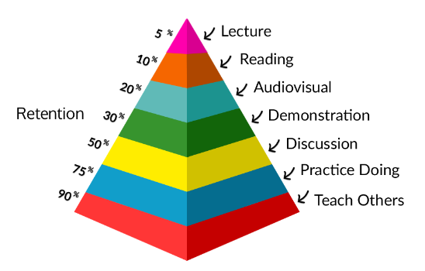Many different guides have been created to help others understand the gaining of knowledge, but the question is, are those guides dependable? Is there a guide that can be applied to every person and every situation? We will look at a learning pyramid discussed by Michael Simmons, who is an award-winning social entrepreneur, a teacher, and a writer. He has contributed to publications like Forbes, Fortune, Time, Business Insider, and several more[3].

## **Test Introduction & Hypothesis**

Teaching a German grammar lesson by a German language teacher, to a language student and English language teacher, who is not learning German in general.

### **Profile of the participants**

#### **Teacher’s profile**

The teacher is Anna Laura Bódis, a multilingual native Hungarian, who has been around languages ever since she was little. She attended a German-speaking school throughout her childhood and decided later on to become a language teacher. She now is Language Teacher Trainee at the Eötvös Loránd University majoring in German language and culture and English language and culture. Besides the three above mentioned languages, she has had experiences with other various languages like French, Italian or Chinese, and is now learning Spanish. At the age of 22, she has been teaching both English and German for multiple years now and is planning to continue doing so in the future.

#### **Student’s profile**

Luca Klára Bodolay is a Hungarian-English bilingual teacher of the English language. Currently an English Linguist student at university, she has also been actively studying the French language for one year (now at level B1 and preparing for B2). She also has experience with the following languages: Arabic, Spanish, and Korean. She is 21 years old.

### **Hypothesis**

#### **Teacher’s Hypothesis**

The way people acquire a language depends hugely on their age and the amount of time they can devote to the process. German is a language within the Indo-European language family in the Germanic subcategory. Between 90-100 million people have German as their mother tongue or are native speakers, and around 10-15 million people have been learning German or are L2 speakers. Since both German and English are Germanic languages, I think for someone who speaks English, German is much easier to learn then for someone who has had no experience with Germanic languages.

But even though they are similar, German has a much more difficult grammatical system, which I, after 14+ years of German still find somewhat confusing. In English there is only one definite article “the” and you don’t have to think about what article to use, even the indefinite articles “a, an” are extremely easy to master. Well, in German three genders decide the article, but there are four cases and the article has a different form in most of them. Also, the articles have to be studied together with the nouns to be able to speak correctly, and there aren’t a lot of ways that make you guess them correctly.

However, I believe that the German definite and indefinite articles are easy to master if knowing the gender and the case of the noun, and I am curious what the results of this research are going to be.I believe that with the last given material/help, the student will be able to score above 80%.

#### **Student’s Hypothesis**

I expect that learning German grammar will be challenging but not too difficult due to some crucial factors, on which language learning depends.

Firstly, one crucial factor when learning languages is the attitude of the student. In my previous teaching and learning experiences.[4] If the students work hard and try their best, that is what counts towards their success the most. Students must be diligent and put in the time and effort to achieve the target task.

Secondly, the student’s ability and background can aid the process. A bilingual student has a higher skill and ability in learning new language materials[5], in comparison to monolingual students. Furthermore, a student who is currently an active language(s) student will have less difficulty, because the brain works in such a way that when exercising a certain part of it, that part will become stronger just like the rest of the body e.g. the student’s Wernicke’s and Broca’s[6] area of the brain[7].

Thirdly[8], the nature of the language itself of course plays a huge role in ease of learning, in this regard I would suggest that the student may have some difficulties, since they are learning German from English, and the grammatical rules of these languages differ greatly.

## **The test and the materials**

### **Structure**

The test is made out of four steps, and those four steps are after the learning pyramid of Michael Simmons, shown above. These 4 steps are:

* Lecture
* Reading
* Audio-visual
* Demonstration

The student will be given a material in the same order (1st Lecture, 2nd Reading, 3rd Audio-visual, 4th Demonstration)[9] and after receiving the material, the student can review it as many times as he/she wants. And he/she will also be able to access previous materials. After each material, the student will have to fill out the same 50-question long test. The results will only be available for the student to see after all tests were filled out and corrected.

### **1st Material – Lecture**

This is a sound material that was recorded by the teacher based upon the Grimm Grammar website’s[10] explanation of the Grammar rules of the definite and indefinite article. Here you can find the sound material:



In case of a broken link: <https://drive.google.com/file/d/1cQ5K6G2hzoCojuNmdDN4MaKbz0z2b9w3/view?usp=sharing> or https://miau.my-x.hu/miau/quilt/2020/5percent/1.%20Lecture.m4a

#### **Teacher’s Hypothesis**

Understanding a grammatical system of an unknown language after a sound lecture is incredibly hard if not impossible in my opinion. I think the results will be between 0-20%[11] and all correct answers will be a matter of luck.

#### **Student’s Hypothesis**

I think that listening to a lecture is normally the easiest part. Especially for myself I can learn and understand easily from lectures, and I listen to them if I want to gain knowledge regarding anything. I am not sure what to expect however as I have never learnt any German before, so it should be quite challenging, but I imagine the lecture will be in English with the German words in German. However, some may misinterpret the speaker, or the speaker may not be clear sometimes this is where our following lesson steps will prove useful.

### **2nd Material – Reading**

This reading material has the same text as the sound material, but it is written down. The student will be able to use both materials. Seeing the text might help the student to understand the concepts better.

#### **Teacher’s Hypothesis**

This reading material is still not very useful for someone who does not speak the German language but being able to see the text should improve the percentage. I believe the success rate of this exercise will be between 20-30%.

#### **Student’s Hypothesis**

Reading materials can be the best especially for visual learners, beside demonstartions, so I preadict that seeing the new words will make it easier to clarify any missunderstandings that could have possibly come from the lecture. I predict however that there will not be any new information, therefore if there is to be a better mark achieved, then it will be from the student’s faileure in retaining the information from the lecture part of the lesson.

[12]

### **3rd Material – Audio-visual**

This audio-visual material is the most helpful material that can be found anywhere. This picture shows the genders and the cases with which the student should be able to complete the test without any errors. If the gender and the case are given, anybody should be able to find out the correct definite and indefinite articles that are missing from the text.



#### **Teacher’s Hypothesis**

I strongly believe that the student can score at least an 80% on the test since both the gender and the case is given in the test. They just have to check the chart and fill out the missing articles.

#### **Student’s Hypothesis**

Visual aids are always helpful, they structure the materials discussed, and help to better memorise nem information. All teachers tend to make use of such aids, which improve understanding, therefore I belive this part will make a huge difference in the results of test 3.

### **4th Material – Demonstration**

This is almost the same picture as the previous one except for the fact that on this one we can see examples that can help with the answers of the test. German is a logical language and even though it is not that easy to learn, the logical grammar allows it to easily be understandable.



#### **Teacher’s Hypothesis**

With the last two materials, there should not be any problems with the exam (100%). It is logical and if we know the gender and the case, there shouldn’t be any problem.

#### **Student’s Hypothesis**

Demonstrations work like a last resort. Seeing how the new information learnet should be used is a very good way to retain the information. This should be the easiest lesson due to the repetition of the others, therefore there should be almost full marks gained at the end. However I am not entirely trusting of the chart being tested, I am sure there will be some point where we will find that all the steps are not necessary.

## **The Test, or in other words the Questionnaire**

The questionnaire/test has two parts. The first part is about the definite articles and the second part is about the indefinite articles. Both parts have 25 questions, which together make up 50 points. The grading will be done in a percentage. The first part was created after an online exercise from the Deutschlernerblog.de[13] and the second part was created also after the same website but different exercises[14].

|  |
| --- |
| **Bestimmte Artikeln**   1. Hast du  Film gesehen? **(der, Akk)** 2. Film gefällt mir sehr gut. **(der, Nom)** 3. Fährst du mit  Bus zur Arbeit? **(der, Dat)** 4. Ich fahre mit  Straßenbahn ins Stadtzentrum. **(die, Dat)** 5. Manchmal nehme ich  U-Bahn, um ins Stadtzentrum zu fahren. **(die, Akk)** 6. Ich habe  Klamotten im Internet gekauft. **(Plural, Akk)** 7. Hast du schon  Buch „Herr Lehmann“ gelesen? **(das, Akk)** 8. Ich brauche die Telefonnummer von  neuen Kollegin. **(die, Dat)** 9. Ich suche  Münsterplatz. **(der, Akk)** 10. Ich verstehe  Grammatik schon ganz gut. **(die, Akk)** 11. Er kommt aus  Schweiz. **(die, Dat)** 12. Er lebt in  Niederlanden. **(die Pl, Dat)** 13. Ich habe  Hausaufgaben nicht gemacht. **(Plu, Akk)** 14. Ich wohne in  Bergstraße. **(die, Dat)** 15. Im Urlaub sind wir jeden Tag an  Strand gegangen. **(der, Akk)** 16. Hast du schon das Geschenk für  Geburtstagskind gekauft? **(das, Akk)** 17. In  Nacht hat sie noch lange ferngesehen. **(die, Dat)** 18. Ich habe es noch nie gemacht. Es ist  erste Mal. **(das, Nom)** 19. Kannst du mir bitte  E-Mail-Adresse von Elena geben? **(die, Nom)** 20. Was hast du  Mann gesagt? **(der, Dat)** 21. Was machst du nach  Arbeit? **(die, Dat)** 22. Nach dem Frühstück gehe ich aus  Haus. **(das, Dat)** 23. Ich lerne  Sprache seit drei Jahren. **(die, Akk)** 24. Ich lebe gern in  Stadt. **(die, Dat)** 25. Ich lebe lieber auf   Land. **(das, Dat)** |
| **Unbestimmte Artikeln**   1. Hast du  Bruder? **(der, Akk)** 2. Ich lebe in  kleinen Dorf auf dem Land. **(das, Dat)** 3. Haben Sie noch  Frage? **(die, Akk)** 4. Ich habe  Stunde lang gewartet. **(die, Akk)** 5. Ich lerne seit  Jahr Deutsch. **(das, Dat)** 6. Ich bleibe  Monat in Berlin. **(der, Akk)** 7. Hast du  Lieblingslied? **(das, Akk)** 8. Er hat endlich  neue Arbeit gefunden. **(die, Akk)** 9. Ich möchte  Deutschkurs machen. **(der, Akk)** 10. Sie arbeitet bei  bekannten Firma. **(die, Dat)** 11. Ich brauche  Pause. **(die, Akk)** 12. Sollen wir  Bier trinken gehen? **(das, Akk)** 13. Er lebt seit 30 Jahren auf  Insel im Atlantik. **(die, Dat)** 14. Was soll ich tun? Kannst du mir  Tipp geben? **(der, Akk)** 15. Wir waren gestern auf  fantastischen Konzert. **(das, Dat)** 16. Leider kann ich nicht kommen. Ich habe  Termin. **(der, Akk)** 17. Sie hat mir  E-Mail geschrieben. **(die, Akk)** 18. Ich wohne in  kleinen Wohnung. **(die, Dat)** 19. Hast du Lust, mit mir in  Café zu gehen? **(das, Akk)** 20. Nächstes Wochenende bin ich zu  Hochzeitsfeier eingeladen. **(die, Dat)** 21. Ich habe die Information von  Nachbarn. **(der, Dat)** 22. Ich habe  Text auf Deutsch geschrieben. **(der, Akk)** 23. Sie hat vor  Woche ein Kind bekommen. **(die, Dat)** 24. Ich treffe mich heute Nachmittag mit  Freund. **(der, Dat)** 25. Ich hoffe, dass ich bald  Antwort bekomme. **(die, Akk)** |

## **Results and thoughts**

After the student processed the material, she filled out the questionnaire. Here you can see the results. The additional information (e.g der, Akk) makes possible to assume theoretically, that a random choice (from 4 options like N-A-G-D) could lead to a 25% fitting level. On the other hand, this 25% level is valid only in cases, if the test person knows the 4 options exactly for each gender of the article. Parallel, each NOM-cases should produce a trivial point. If the GEN-case is not part of the test, then 1/3 is the randomized success level. If somebody has a kind of tactical feeling, then it is possible to be repetitive – it means: for the same article and in the same case (N-A-G-D) the same answer should be given – what is a kind of consistence in the answering strategy – which can support to realize a relatively high or a relatively low fitting value.

Summa summarum: The randimized success can not be derived in a simple way, but it is not zero at any rate.

### **1st Test**

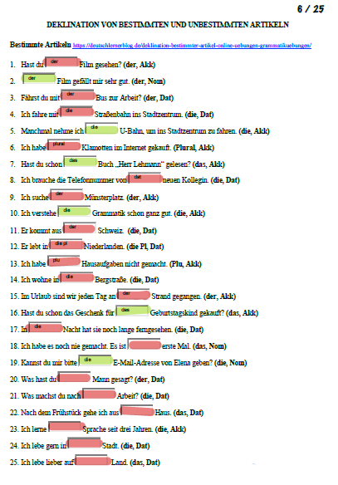

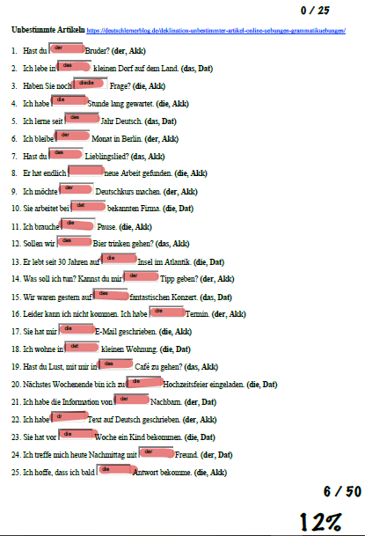

#### **Teacher’s Thoughts**

I was surprised how many answers she got right because of the fact that only listening to a lecture and having no visual material, even if it is just a text is hard. I estimated the correct answers to be between 0 and 20 percent and I am happy with the results which say and overall of 12%.

#### **Student’s Thoughts**

The test was very hard, since it was difficult to match the words heared to the word in brackets. There was one mistake we didn’t think of: the task was not labelled in English so I predicted that I should choose form the words in brackets, later on after the 2nd test I found out that the brackets mark the case, by then I had a chart and could fill out the questions much more easily.

### **2nd Test**

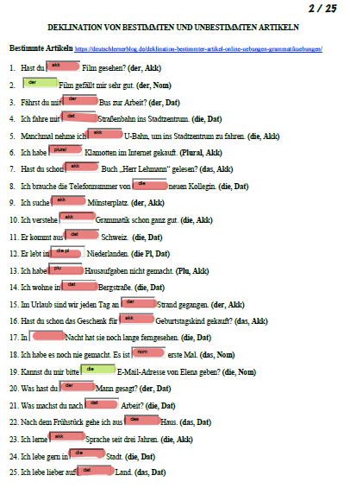

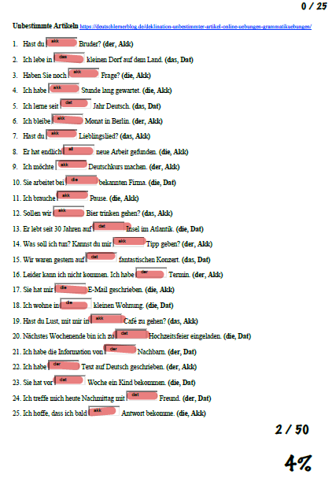

#### **Teacher’s Thoughts**

I was not sure what was going on this time, I thought that the reading material will be helpful, and it will make it clearer, but maybe it was a bit too confusing. I estimated the percentage to be between 20-30, but the result was 4%, which was interesting for me.

#### **Student’s Thoughts**

This was a little easier, however it was still difficult to try to remember everything I needed to pay attention to. I kept looking back at the material, but as I mentioned earlier, I still thought that I should choose between the words in the brackets. I thought I understood the material better, but as I mentioned, we figured out the problem only later.

### **3rd Test**

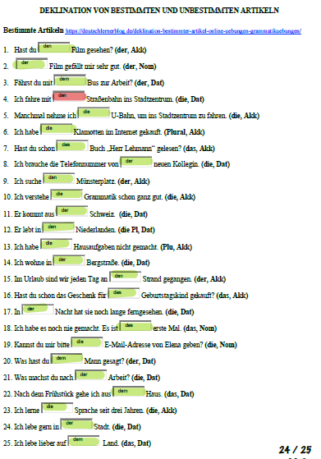

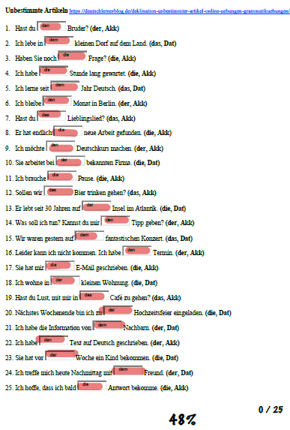

#### **Teacher’s Thoughts**

With the results of this test, I was somewhat satisfied. The first part of the test was almost perfect with only one mistake which was probably due to some abstraction of the mind. The results of the second part are something that still I don’t completely understand. I will ask the student about it after the full test was done.

#### **Student’s Thoughts**

At this point we clarified a misunderstanding which caused the results of the first part of the test to plummet. It was very easy now to answer the test, but as I mentioned there was no task description so I still did not know what the difference between the frist and second part was. I still do not know what was the task there.

### **4th Test**

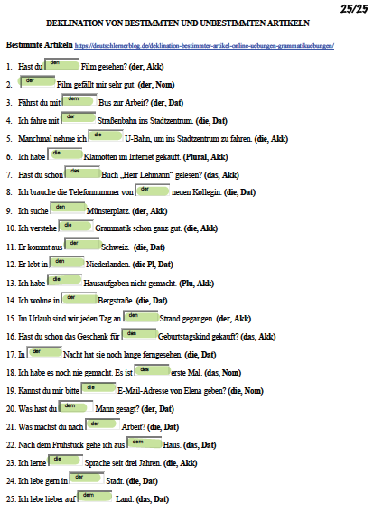

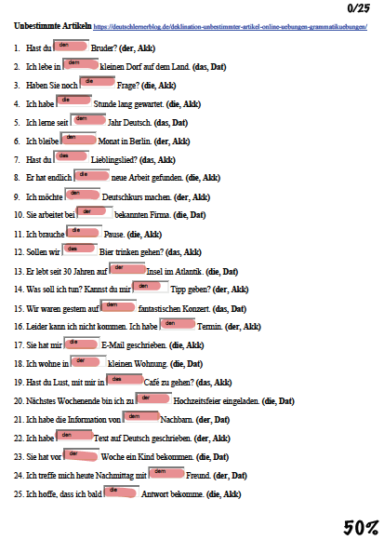

#### **Teacher’s Thoughts**

The results of the first part of the test were something I anticipated, it was 100%, but because the second part was incorrect, the overall score was 50%.

#### **Student’s Thoughts**

Again logically the results were 100% in the first part, but the 2nd was still misunderstood. I am overall satisfied with the results, we could see that the students understanding of tasks affects the result of tests given. It was also clear that demonstrations are very useful at completing the picture, and filling in any gaps in knowledge.

## **Reflection**

### **Teacher’s Reflection**

I found this research extremely interesting and got similar results to the ones I imagined. I was almost completely sure, that one can understand the German declination without understanding the German language itself. Although the 2nd part of the tests did not provide the results that I was aiming for, after a discussion with the student we found out that this was mostly due to the lack of a full and detailed description of the test. If more description would have been provided, that the results would probably have been different.

This is a topic I would consider for further research because it not only examines the person's language sense but also the complex logical thinking since without understanding the language one can only base its knowledge on the logic.

### **Student’s Reflection**

In terms of the chart we can conclude also the following (based on the 1st and useful part of the tests):

1. We do not need to go through all of the steps to achive knowledge retention.
2. Lectures and reading are wuite similar, and therefore a huge step cannot necessarily be accepted between the two. These are the part where the student is only familiarising themselves with the material.
3. Demonstartion is always key, in any cases this is a crucial part, especially when discussing a knew language.
4. The percentages definitely cannot be taken to face value.
5. Student teacher competence is not enough to predict results, since any mistakes and misunderstanding can be made.
6. Perhaps we could next test the following: a key element is missing from this graph I believe: “consultation”. I fell that perhaps this is most important, since students cannot just learn with materials. Although there is a “discussion element, I fell that it would be of vital importance, to consult a teacher at each step to maximise effective learning.

1. "knowledge." Merriam-Webster.com. Merriam-Webster, 2020. Web. 25 March 2020. <https://www.merriam-webster.com/dictionary/knowledge>
2. Meinwald, Constance C. “Plato”. Encyclopædia Britannica. 2020. Web 25 March 2020. https://www.britannica.com/biography/Plato.
3. Simmons, Michael. “Explanation Effect: Why You Should Always Teach What You Learn.” Medium. 15 Feb. 2020. Web. 25 March 2020. https://medium.com/accelerated-intelligence/explanation-effect-why-you-should-always-teach-what-you-learn-9800983a0ea1.
4. Charman, Aimee. “How Learning Languages Affects Our Brain - EPALE - European Commission.” EPALE, 22 Dec. 2016, epale.ec.europa.eu/en/resource-centre/content/how-learning-languages-affects-our-brain
5. Cenoz, Jasone, “The influence of bilingualism on third language acquisition: Focus on multilingualism” *Language Teaching*, vol. 46, no. 1, 2011, pp. 71–86., doi:10.1017/s0261444811000218.
6. Dronkers NF, Plaisant O, Iba-Zizen MT, Cabanis EA (May 2007). "Paul Broca's historic cases: high resolution MR imaging of the brains of Leborgne and Lelong". *Brain*. **130** (Pt 5): 1432–41
7. Kennison, Shelia (2013). Introduction to language development. Los Angeles: Sage
8. From point of view of the course where this publication got initialized: the environmental/personal/etc. factorsm indicators around of the learning/teaching success make possible to derive solver-oriented, objectivity-driven production functions. These production functions should analyse each available data (incl. Logs – c.f. big-data) in order to estimate the real learning/teaching success with models in an arbitrary close way.
9. For the whole projects concerning the learning-success-pyramide, the order of treatments is important (c.f. environmental/etc. factors above).
10. Grimm Grammar. „Determiners: Bestimmte und Unbestimmte Artikel“. 2020. Web 13 June 2020. <https://coerll.utexas.edu/gg/gr/det_01.html>.
11. The estimation of the learning/teaching success is depending ont he test-logic: the random fitting may not be excluded from the calculations. From point of view of the course where this publication got initialzed: it is a very hard challenge to be capable of deriving which answer in a test process may be seen as a random fitted one and which answers seems to be well-known or really understood?!
12. Grimm Grammar. „Determiners: Bestimmte und Unbestimmte Artikel“. 2020. Web 13 June 2020. https://coerll.utexas.edu/gg/gr/det_01.html.
13. deutschlernerblog.de „Deklination bestimmter Artikel – Online Übungen – Grammatikübungen. 2020. Web 15 May 2020. <https://deutschlernerblog.de/deklination-bestimmter-artikel-online-uebungen-grammatikuebungen/>
14. deutschlernerblog.de „Deklination unbestimmter Artikel – Online Übungen – Grammatikübungen. 2020. Web 15 May 2020. <https://deutschlernerblog.de/deklination-unbestimmter-artikel-online-uebungen-grammatikuebungen/>