MIAU – HU ISSN 141921652 – Special Edition 2020 Spring - Editorials: The papers in MIAU Nr.261 (2020.V) are products of a new education frame system “QuILT” (https://miau.my-x.hu/mediawiki/index.php/QuILT). The goals of QuILT are supporting/conducting Students on the way of KNUTH, who said (1992): Knowledge is, what can be transformed into source code, each other human activity is a kind of artistic performance. It also means we need to leave the world of the magic of words step by step. A solid evidence that we all are capable of going this way is: creating publications behind which the human expertise and the robotized knowledge (like online engines: https://miau.my-x.hu/myxfree/coco/index.html --- offering context free = quasi General-Problem-Solving force fields) can be integrated in case of a rational and relevant decision making scenario. The cyborg effects make possible to face the classic naïve and/or intuitive approaches and parallel the optimized approximations. This way can be realized without deep competences about mathematics, Excel (spreadsheets), statistics, etc. The new (inter/trans/multi-disciplinary) way just expects from us to be able and willing to co-operate with the best moments of the history – it means, with the already prepared robotized elements in order to build something creative one! Parallel, in the second QuILT-semester - https://miau.my-x.hu/mediawiki/index.php/QuILT2_parts - there are not only classic publication possibilities like robotizing the investigative journalism – there are further specific tasks too like 2DM-games, gamification in general, thinking experiments, etc.

# Food Kaleidoscope: Case of Pakistan

By: Nazir Nelson

Abstract: This paper report large amounts of agricultural production and the continuously increasing population places high demands on Pakistan’s water and food resource. Situation is especially bad in rural areas, despite the importance of agriculture of the ruler economy. The paper also report includes specific finding on the number of food production and agriculture. The Food-Kaleidoscope is capable of deriving two relevant/suspected years/periods: 1965/1966 and 2001/2002 – the two war-situations with India.

Keywords: Food and agriculture, food production, food crises and food security, Pakistan-India-Wars

# Introduction

## Pakistan:

The Islamic Republic of Pakistan is located in South Asia. Covering a total area of 796,095 km2, Pakistan shares 6,774-kilometres of land border with Afghanistan (to the west), China (to the northeast), India (to the east) and Iran (to the south west) and has a 1,046-kilometre coastline along the Arabian Sea and the Gulf of Oman in the south. Pakistan is separated narrowly from Tajikistan by Afghanistan's Wakhan Corridor in the northwest, and also shares a maritime border with Oman.

Pakistan is the world’s sixth-most populous country with a population exceeding 212 million people. Around 64% of the population (136 million) lives in rural areas. The most populous city is Karachi (15 million people), followed by Lahore (11.1 million) and Faisalabad (3.8 million), whereas Islamabad (the Capital city of Pakistan) has a population of around 1.0 million.

Created in 1947, Pakistan is a federal parliamentary republic consisting of four provinces (Balochistan, Khyber Pakhtunkhwa, Punjab and Sindh) and three federal territories (Azad Jammu and Kashmir, the Islamabad Capital Territory and Gilgit Baltistan). The country is a member of the United Nations, the Commonwealth of Nations, the Next Eleven Economies, SAARC, ECO, D8, Cairns Group, Kyoto Protocol, ICCPR, RCD, UNCHR, Group of Eleven, CPFTA, Group of 24, the G20 developing nations, ECOSOC, founding member of the Organization of the Islamic Conference (now the Organisation of Islamic Cooperation) and CERN.

Pakistan is an ethnically and linguistically diverse country, with a similar variation in its geography and wildlife. Climate varies from northern arid high desert at 5000-meter altitude, to southern coastal sub-tropical. The national language of Pakistan is Urdu while Urdu is also the official language along with English. The country has several regional languages, including Punjabi, Saraiki, Pashto, Sindhi, Balochi, Brahvi, Hindko, Kashmiri, Shina, Balti amongst other local languages.

## Targeted groups

The target groups are to make better policy makers, researchers, nutritionists and health care professionals.

## Benefits

The economy will be rise, production the food will be increase so we can export the products to in other countries

## Motivations

The government should provide to industries better facilities, take less tax and provide them good machinery. Government need to purchase food production machines and provide to their farmers and food industries.

# Literature

Pakistani food industry has been playing an important role in order to satisfy community needs with respect to availability, distribution and quality of food. Since 2010 after making more food industries, they are meeting the needs of local consumers; manufacturers need to adapt products and services to fit their needs. Food processing industry has the typical characteristics, due to the nature of the food products that are relatively perishable, bulky and seasonal; therefore, these characteristics have to be handled properly.

## Food and Agriculture situation in Pakistan:

Pakistan has a semi-industrialised economy with a well-integrated agriculture sector. The country’s economy was the 23rd largest in the world in 2018 in terms of nominal Gross Domestic Product (purchasing power parity, PPP).

According to the Labour Force Survey of 2017-18 conducted by Pakistan Bureau of Statistic, thirty-nine percent of the country’s labour force is engaged in agriculture (30.2 percent males and 67.2 percent females). In total, the agriculture sector contributes 18.5 percent to the country’s GDP.

Out of the total area of 79.6 million hectares, 22.1 million hectares are cultivated; the rest of the territory is comprised of culturable waste, densely populated forests and rangelands. Cropped area constitutes 23.3 million hectares, while forests cover 4.6 million hectares of the total land. The country has the world’s largest contiguous irrigation system with almost 80 percent of the cultivated area irrigated.

Pakistan is also amongst the world’s top ten producers of wheat, cotton, sugarcane, mango, dates and kinnow oranges, and is ranked 10th in rice production. Major crops (wheat, rice, cotton and sugar cane) contribute around 4.9 per cent, while minor crops contribute 2.1 percent to the country’s total GDP.

Livestock sector contributes 11 per cent to the country’s GDP (60.5 per cent in agriculture sector) and employs approximately 35 million people. Fisheries and forestry sectors each contribute an estimated 0.4 per cent to the GDP (2.1 per cent in agriculture sector).

Despite its impressive and continuously growing agricultural production, the country is still facing high levels of food insecurity. According to a global report published jointly by FAO, WFP, UNICEF, WHO and IFAD in 2019, 20.3 per cent of Pakistan’s population (40.0 million people) is undernourished/food insecure.  The prevalence of malnutrition amongst children aged 6-59 months is also very high, with an estimated 40% children stunted, 28% underweight, 18% wasted and 10% overweight. Further, around one-fourth (24 per cent) of the country’s population is living below national poverty line and 39.0 per cent is poor based on multidimensional poverty index (MPI).

Large amounts of agricultural production and the continuously increasing population places high demands on Pakistan’s water resources. At present, the annual per capita availability of water in Pakistan is estimated at about 1,100 cubic meters; below 1,000 cubic meters, countries begin experiencing chronic water stress (Population Action International, 1993). Vast majority of the country’s water resources – some 90 percent – are used for agriculture, while the remaining share is split equally between industry and for domestic use.

The country faces numerous natural and manmade disasters such as floods, earthquakes, landslides, droughts, and conflicts, such as the flood of 2010 which affected 20 million people, drought of 2013-15 and 2018 and the earthquake of 2005.

## Pakistan - Food production index

Food production index (2004-2006 = 100)

The latest value for Food production index (2004-2006 = 100) in Pakistan was 130.37 as of 2016. Over the past 55 years, the value for this indicator has fluctuated between 131.05 in 2015 and 20.29 in 1961.

Definition: Food production index covers food crops that are considered edible and that contain nutrients. Coffee and tea are excluded because, although edible, they have no nutritive value.



Figure Nr.1: Pakistan Food Index

(Source: Food and Agriculture Organization URL: www.foa.org/pakistan

## What makes the Pakistani market attractive?

Pakistan is an agricultural country. Agriculture is a vital sector of Pakistan’s economy and accounted for 25.9 percent of the GDP in 2016-2017. In addition, Pakistan with a population of 196 million people and a growing middle-class is a giant market. All of these aspects make this part of the world enormously attractive for Bühler, whose focus is on food safety, hygiene as well as cost efficient and innovative solutions.

## What is the market potential of the food processing sector in Pakistan?

The market potential is huge: Pakistan is the world’s 7th largest consumer market by virtue of its more than 196 million citizens. In addition, Pakistan is the largest wheat producer and rice exporter in the world. Wheat products made from flour are one of the main foodstuffs in Pakistan.

Q: As you can see, we have a suspicion (based on the doubled model), that something (crisis?) could happen in Pakistan 2011-2012, because this is the most negative scenario… Could you confirm that in these years e.g. the world crisis could have a relatively small but visible impact to the food consumption in Pakistan?

Pakistan:

Yes, I confirm that. Pakistan has made significant progress in increasing the per capita availability of all major food items, such as, cereals, meat, milk, sugar and eggs over time. As a result, the average per capita calorie intake increased from 2078 in 1949-50 to 2450 in 2011-12. The persistent rise in the price of essential food items since 2008 and the decline in real wages have adversely affected the access to food. These trends have serious implications for food security and poverty in the country. National survey (based household level data) shows that on average households spend nearly half of their total expenditure on food - leaving very little for the other expenditures necessary for safeguarding human welfare 2011-12.

Q: The naïve scenario (in the doubled model) makes possible, that another small crisis could be given in the period of 1990-1993…. Is this maybe to confirm?

Pakistan:

In 1990 the Pakistan banks began casting aspersions on bureaucracy’s ability to promote order and development in the country. Corruption, inefficiency, bloated sixe, absence of accountability, and resistance to change were portrayed as the manifestations of bureaucracy 1990-1993. The academic community raised concerns about authoritarian values. In short negative images of bureaucracy and a cry for reform dominated the policy and academic research environment 1990-1993.

Q: The solo-model for Pakistan shows a suspicion for 2008. Is this year specific? Could you say something as reason for this suspicion concerning the food consumption of the average citizen in Pakistan?

Pakistan:

The average Pakistani eats approximately 1793.2 pounds of food per year. Pakistan has made significant progress in increasing the per capita availability of all major food items, are roots and tubers (82% of households), fruits (60%), corn (70%), vegetables (51%) and oilseeds (40%). Other foods are in large cities, which are milk (80 %), sugar (95%), rice (60%), palm oil (55%), and meat (80%). Pakistan’s household production and other food sources are unable to meet the food needs of the majority of households.

The main problems are:

* Rising population.
* Rising incomes, changing diets.
* Falling water tables.
* More foodless days.
* Slowing irrigation.
* Increasing soil erosion.

Possible actions could be:

* Create job opportunities.
* Open new factories.
* Give education to farmers about using of seeds and water.
* Government takes things serious.

# **DATA ASSETS**

FAO: <https://miau.my-x.hu/miau/quilt/2020/food_project/>

The last Figures of the Annex contains the details list of food-categories and countries.

* The number of the potential records: 799038
* The number of the food-categories: 89
* The number of the involved countries: 217
* The number of the affected years: 53 (1961-2013)
* (Worth knowing not each food-category leads to a data-position in the database. The combinatorial space would be more voluminous: 217*89*53=1023589 > 799038)

Each data position has the same unit: g/capita/day. Fortunately, it is a standardized/relativized unit – which makes immediately possible to compare countries and/or years

# Methodology:

An online solver-based engine (COCO-Y0) was involved into the analytical steps. The COCO-Y0 is an antidiscriminative engine and it delivers an optimized aggregation of the annual numbers of the daily averages of the food-categories. The naïve alternative way would be to build a total value of the grams independent from each content.

# Results

The next figures are views of the Food-Kaleidoscope depending on the number of countries and the number of modelling steps increasing model sensitivity:

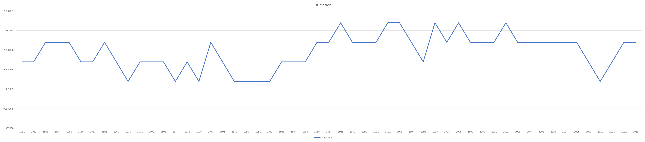

Figure Nr. 2 Step-1 Explaining (1 country, 1 step) – (source: own presentation)

Most characteristic negative peaks/periods: 1965-66, 1970, 1979-81, 1995, 2010

Figure Nr. 3 Step-2 Explaining (1 country, 2 steps) – (source: own presentation)

Most characteristic negative peaks/periods: 1968, 1975/76, 1985, 1998/99, 2005, 2010

Figure Nr.4 Estimation Pakistan (1 country, 3 steps) – (source: own presentation)

Most characteristic negative peaks/periods: 1961-66, 1972, 1978, 1987, 2002

Pakistan has made significant progress in increasing the per capita availability of all major food items, are roots and tubers (82% of households), fruits (60%), corn (70%), vegetables (51%) and oilseeds (40%). Other foods are in large cities, which are milk (80 %), sugar (95%), rice (60%), palm oil (55%), and meat (80%). Pakistan’s household production and other food sources are unable to meet the food needs of the majority of households.

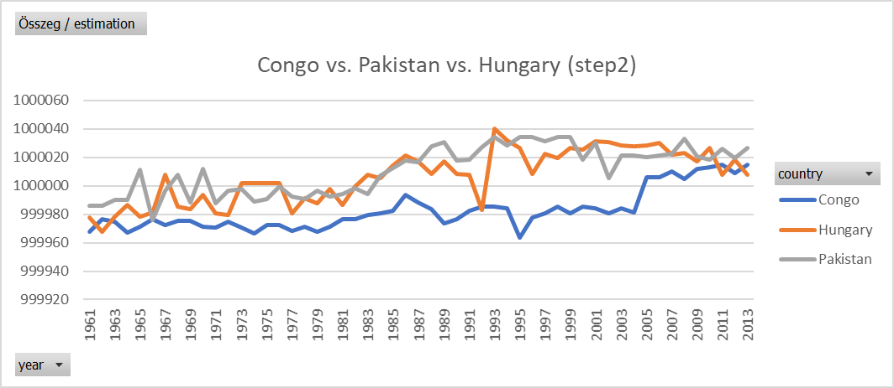

Figure Nr.5 Congo vs Pakistan vs Hungary (3 countries, 2 steps – absolute values) – (source: own presentation)

Most characteristic negative peaks/periods: 1966, 2002

In this chart we can see that Congo’s food estimation drops sharply in 1976 and recover and then stay stable until 2013. A relatively good year is 1986, good period is 1983-1986. In terms of absolute numbers, the prevalence of wasting results in more than one million children affected by acute malnutrition needing support and the prevalence of stunting results in more than six million Congolese children with delayed growth.

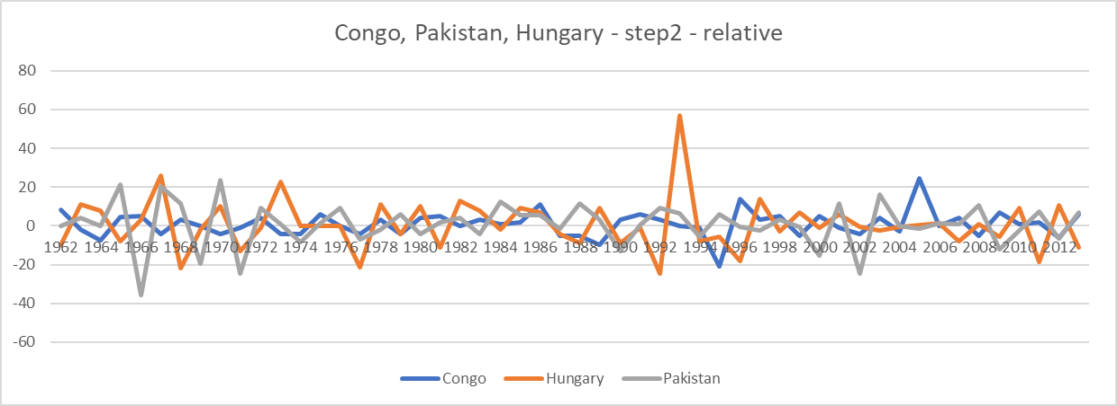

Figure Nr. 6 Relativity (3 countries, 2 steps, relative values = differences) – (source: own presentation)

Most characteristic negative peaks/periods: 1966, 2002

Interpretations (For Figure Nr.6): We know now what’s happening in those countries all of them are facing a lot of crisis, conflict, war and dispute. As you can see in the chart in case of Congo the suspicion decline in 1995 – and 1979 is the last “bad” year before a long increasing period. A relatively good year for Congo is 1986. In Hungary the suspicion drops sharply in 1992-1993.

**In Pakistan we can notice that we have two suspicion between years in 1965 and in 2001 but we can also notice that there is also some little crisis.** The chart shows us that in some years those countries remain stable.

Relevant similarities in the history of Pakistan:

* 2002 vs. <https://en.wikipedia.org/wiki/2001%E2%80%9302_India%E2%80%93Pakistan_standoff>
* 1965/1966 vs. <https://en.wikipedia.org/wiki/Indo-Pakistani_War_of_1965>

# Discussions

The Kaleidoscope model provides a structured framework for indefinitely the key factors that drive policy change. The model includes four basic diagnostic tools:

1: Policy chronology

2: Stakeholder mapping

3: Circle of influence

4: Hypothesis testing

Interested stakeholders can apply the KM diagnostic tools to look forward or backward. Looking backwards, the timing of key help to trace the policy changes and understand the reasons for past policy outcome. Looking forward the diagnostic tools can help to indemnify promising opportunities for future policy reform.

The policy chronology provides a starting point in both applications. The chronology incentivizes major policy decisions as well as key individuals, interest groups, information and events shaping these policy changes. The policy chronology provides several benefits to stakeholders. It serves to I identify the key players in a given policy system. In addition, the reconstruction of policy events, debates and outcomes helps to distinguish the timing of key decisions and key influencing factors often helps to understand how to contribute most effectively to future policy discussions.

# Conclusions

The Closing the Quality Gap series evaluates the state of quality improvement (QI) science for eight high-priority health care topics, while also providing a window into the evolution of QI research overall. Individually, each of the eight reports synthesizes the most up-to-date evidence about its topic bundled Payment, the Patient-Cantered Medical Home (PCMH), Disparities, Medication Adherence, Public Reporting, Healthcare-Associated Infections (HAI), Disability Outcomes, and Palliative Care providing a key resource for stakeholders with an interest in QI in these areas. Taken together, the reports in the series provide a broad view of QI science, revealing trends, advances, gaps, and challenges that are common across topics. While highlighting key results of each topic review, this methods report focuses primarily on this broad view, summarizing take-home messages for key stakeholders, identifying common challenges and solutions across topics, and discussing implications for future evidence synthesis and QI research in light of lessons learned from all eight topic teams.

# References

* Case of Japan: <https://miau.my-x.hu/miau/184/japhun.doc>

# Annexes

* <https://miau.my-x.hu/miau/quilt/2020/quilt2/launching2020IV22/CONGO_HU%202%20(3).xlsx>
* <https://miau.my-x.hu/miau/quilt/2020/quilt2/launching2020IV22/part4.html>
* <https://miau.my-x.hu/miau/quilt/2020/quilt2/launching2020IV22/food_kaleidoscope.docx>
* <https://miau.my-x.hu/miau/261/food_kaleidoscope_case_congo.docx>
* <https://miau.my-x.hu/miau/quilt/2020/food_project/?C=M;O=D>

