MIAU – HU ISSN 1419-1652 – Special Edition 2020 Spring - Editorials: The papers in MIAU Nr.261 (2020.V) are products of a new education frame system “QuILT” (https://miau.my-x.hu/mediawiki/index.php/QuILT). The goals of QuILT are supporting/conducting Students on the way of KNUTH, who said (1992): Knowledge is, what can be transformed into source code, each other human activity is a kind of artistic performance. It also means we need to leave the world of the magic of words step by step. A solid evidence that we all are capable of going this way is: creating publications behind which the human expertise and the robotized knowledge (like online engines: https://miau.my-x.hu/myxfree/coco/index.html --- offering context free = quasi General-Problem-Solving force fields) can be integrated in case of a rational and relevant decision making scenario. The cyborg effects make possible to face the classic naïve and/or intuitive approaches and parallel the optimized approximations. This way can be realized without deep competences about mathematics, Excel (spreadsheets), statistics, etc. The new (inter/trans/multi-disciplinary) way just expects from us to be able and willing to co-operate with the best moments of the history – it means, with the already prepared robotized elements in order to build something creative one! Parallel, in the second QuILT-semester - https://miau.my-x.hu/mediawiki/index.php/QuILT2_parts - there are not only classic publication possibilities like robotizing the investigative journalism – there are further specific tasks too like 2DM-games, gamification in general, thinking experiments, etc.

**Hungarian Economy between 2010-2020**

**or preferred terms for political communication/marketing**

Dániel Fülöp, KJU

Abstract: The goal of the paper seems to be very simple: which term can be seen as the most positive one from point of view of the political marketing concerning of the GDP-related alternatives. A term can be evaluated as positive compared to other terms, if the aggregated values of the statistical descriptors with their directions do not lead to the anti-discriminative principle: each object can have the same evaluation value.

Keywords: big-data, solver-oriented analyses, artificial intelligence

# Introduction

Hungary is an open, export-driven economy. As a consequence, the global slowdown and faltering demand in its main export markets has had a negative impact on economic growth, especially in the export-orientated automotive and consumer electronics sectors.

In 2009, the Hungarian economy shrank by 6.3%. This was attributable to three factors: the slump in agricultural output following the sector's outstanding growth in 2008; the increasingly rapid decline in other sectors that began as early as 2008, and, finally, the continuing downturn in the construction sector that began two years ago (although at that stage, it was limited to only 5%).

In 2010 the new government implemented a number of changes including cutting business and personal income taxes, but imposed "crisis taxes" on financial institutions, energy and telecom companies, and retailers. The economy began to recover in 2010 with a big boost from exports, especially to Germany, and achieved a growth of approximately 1.4% in 2011.

Since 2010, the government has back-pedaled on reforms and taken a more nationalist and populist approach towards economic management. The government has favoured national industries, and specifically government-linked businesses, through legislation, regulation, and public procurements. In 2010 and 2012, the government increased taxes on foreign-dominated sectors, such as banking and retail, because the move helped to raise revenues and decrease the budget deficit, thereby allowing Hungary to maintain access to EU development funds. The policy deterred private investment, however.

In 2011 and 2014, Hungary nationalized private pension funds. The move squeezed financial service providers out of the system, but it also helped Hungary curb its public debt and lower its budget deficit to below 3% of GDP, as subsequent pension contributions have been channelled into the state-managed pension fund. Hungary’s public debt (at 73.9% of GDP) is still high compared to EU peers in Central Europe. Despite these reversals, real GDP growth has remained robust in the past several years because EU funding increased, EU demand for Hungarian exports rose, and domestic household consumption rebounded. To further boost household consumption, the government increased the minimum wage and public sector salaries, decreased taxes on foodstuffs and services, cut the personal income tax from 16% to 15%, and introduced a uniform 9% business tax for small and medium-sized enterprises and large companies. Real GDP growth increased to 3.8% in 2017, and 4.4 in 2018.

Data assets

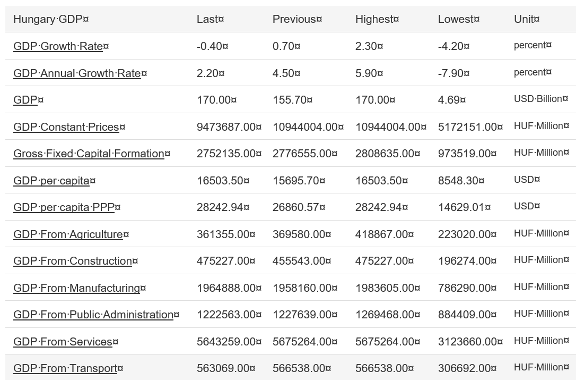

Figure Nr 1 – Term-variations with descriptors (source: own presentation)

Since 2010, the government has back-pedaled on many economic reforms and taken a more populist approach towards economic management. The government has favoured national industries and government-linked businesses through legislation, regulation, and public procurements. In 2011 and 2014, Hungary nationalized private pension funds, which squeezed financial service providers out of the system, but also helped Hungary curb its public debt and lower its budget deficit to below 3% of GDP, as subsequent pension contributions have been channelled into the state-managed pension fund. Hungary’s public debt (at 74.5% of GDP) is still high compared to EU peers in Central Europe. Real GDP growth has been robust in the past few years due to increased EU funding, higher EU demand for Hungarian exports, and a rebound in domestic household consumption. To further boost household consumption ahead of the 2018 election, the government embarked on a six-year phased increase to minimum wages and public sector salaries, decreased taxes on foodstuffs and services, cut the personal income tax from 16% to 15%, and implemented a uniform 9% business tax for small and medium-sized enterprises and large companies. Real GDP growth slowed in 2016 due to a cyclical decrease in EU funding but increased to 3.8% in 2017 as the government pre-financed EU funded projects ahead of the 2018 election.

Systemic economic challenges include pervasive corruption, labour shortages driven by demographic declines and migration, widespread poverty in rural areas, vulnerabilities to changes in demand for exports, and a heavy reliance on Russian energy imports.

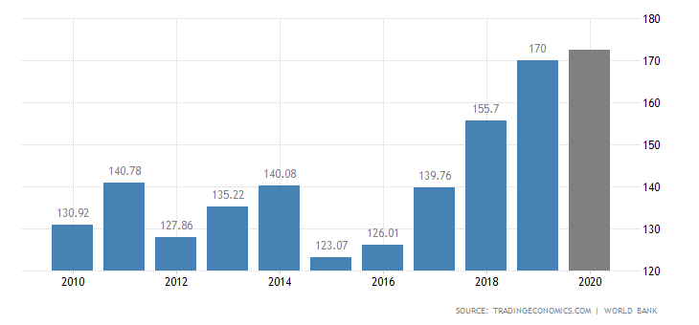

Figure Nr. 2

# Methodology

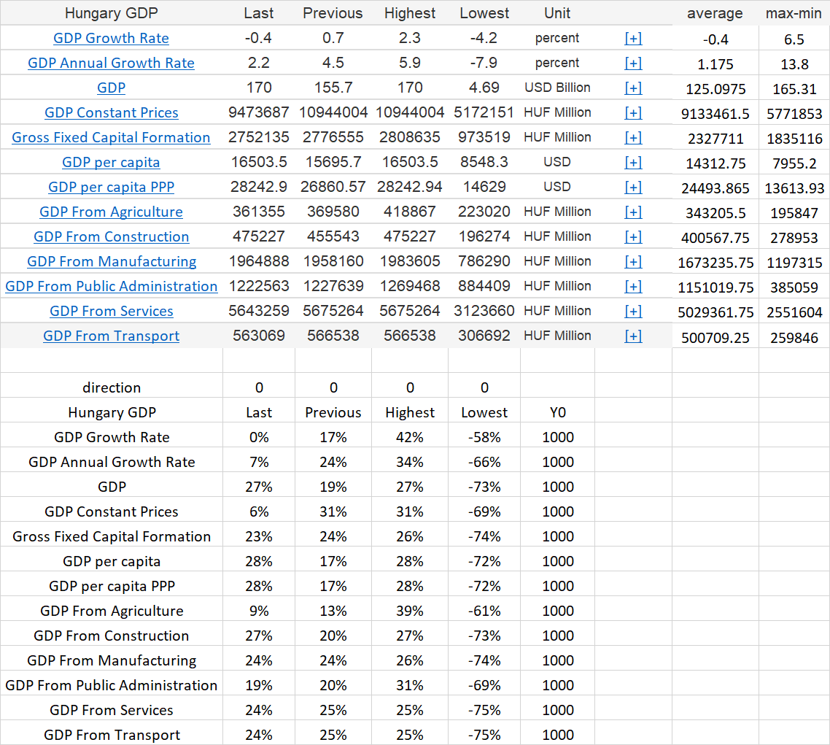

Figure Nr. 3 – Raw/relativized/ranked OAM (source: own calculations)

# Results

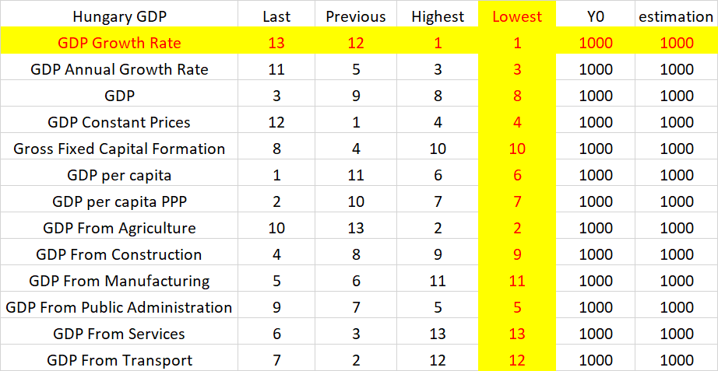

Figure Nr. 4 – Step by step evaluation of the alternative terms (source: own presentation based on <https://miau.my-x.hu/cocoy0>)

The alternative terms (row-headers or objects) lead to the anti-discriminative principle based on the first 3 attributes (last, previous, highest) but the attribute about the lowest values of the time series is not integrated into the model (see: <https://miau.my-x.hu/miau/quilt/2020/political_marketing_GDP_terms/gdp_terms.xlsx>). Therefore, the not included variable is relevant for the ranking of the terms.

The winner is the GDP-Growth-Rate! The second best is the GDP_from_agriculture.

The most inadequate variable is the GDP_from_service (and from_transport).

# Discussion

The terms with the partial different units seem to be not comparable. However, an appropriate relativizing makes possible to analyse similarities.

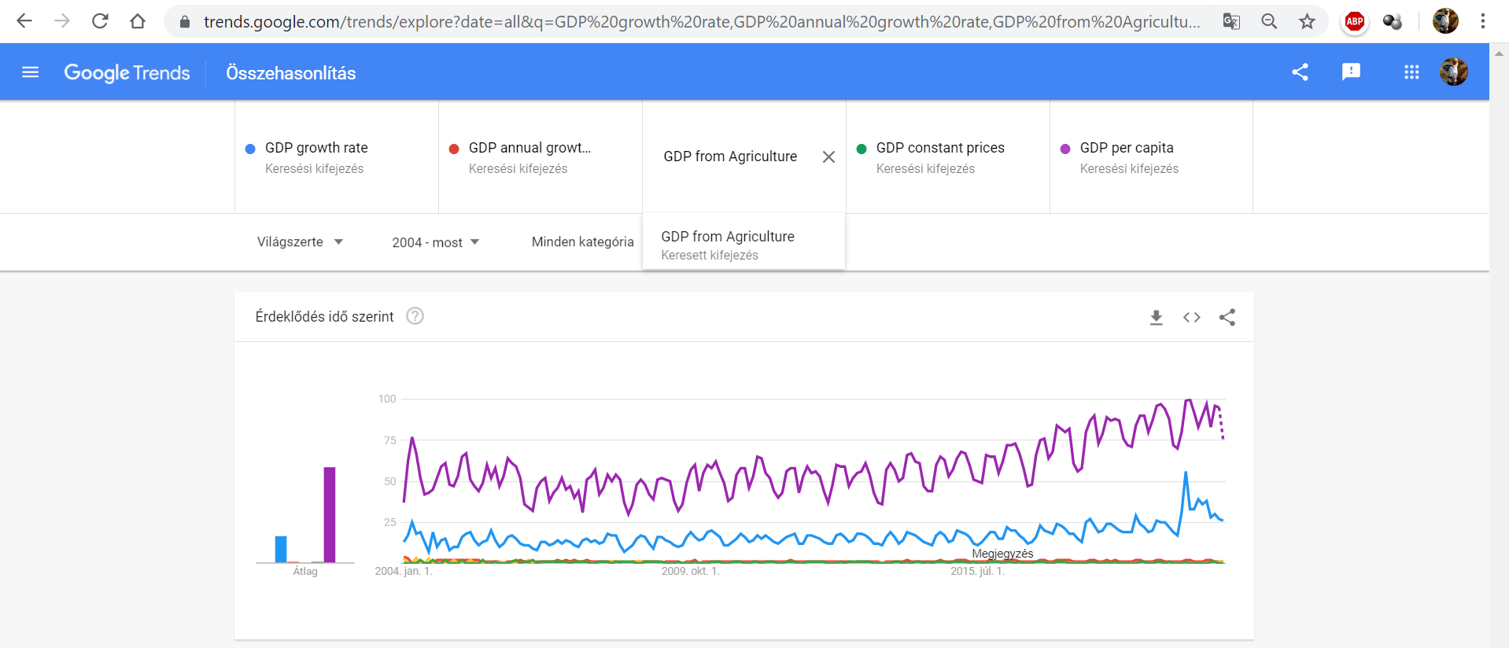

Figure Nr. 5 – Google Trends about curiosity of the population (source: Google Trends)

The Figure Nr.5 is not specific for Hungary, but the term-names are in English.

# Conclusions

The experts of the political marketing can be robotized concerning this high-abstracted problem. The GDP-growth-rate says more than the simple GDP-term because the part about the growth is a kind of core message as such.

The blue line (see Figure Nr. 5) derived by the robot expert is the second best compared to the magenta line (GDP/capita) worldwide.

The robot-opinion could be accepted in frame of a Turing test.

# Sources/references

<https://www.ceicdata.com/en/indicator/hungary/gdp-per-capita>

<https://tradingeconomics.com/hungary/gdp>

<https://countryeconomy.com/gdp/hungary>