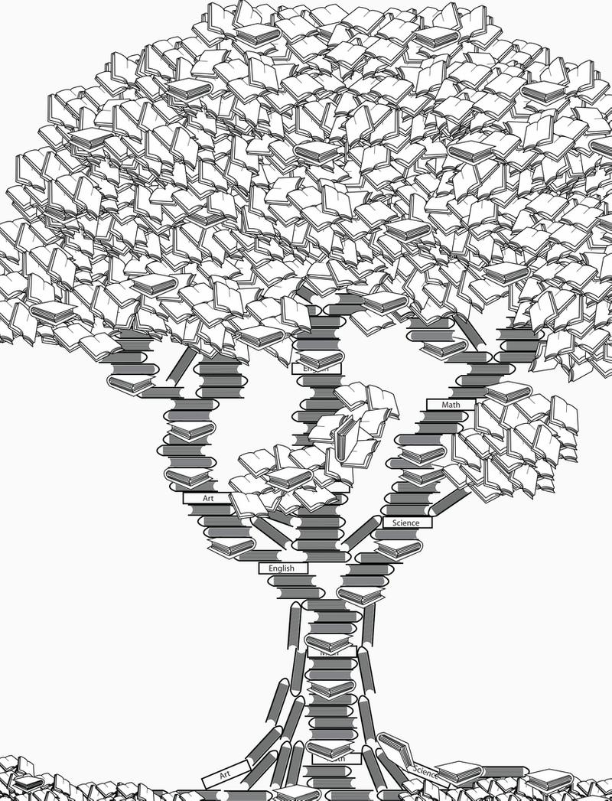
KODOLÁNYI JÁNOS UNIVERSITY
INTERNATIONAL RELATIONS
SERVICE SCIENCE AND KNOWLEDGE ECONOMY
22.06.2020

Conductor: Laszlo Pitlik
Author: Kitti Visnyei (HW0HDD)

content
Introduction 3
Conductor’s method (example) 3
Basic rules 3
Version 1.1 4
Casework 1 5
Casework 2 5
Version 1.2 7
Casework 1 7
Casework 2 9
Conclusion 9

MIAU – HU ISSN 1419-1652 – Special Edition 2020 Spring - Editorials: The papers in MIAU Nr.261 (2020.V) are products of a new education frame system “QuILT” (https://miau.my-x.hu/mediawiki/index.php/QuILT). The goals of QuILT are supporting/conducting Students on the way of KNUTH, who said (1992): Knowledge is, what can be transformed into source code, each other human activity is a kind of artistic performance. It also means we need to leave the world of the magic of words step by step. A solid evidence that we all are capable of going this way is: creating publications behind which the human expertise and the robotized knowledge (like online engines: https://miau.my-x.hu/myxfree/coco/index.html --- offering context free = quasi General-Problem-Solving force fields) can be integrated in case of a rational and relevant decision making scenario. The cyborg effects make possible to face the classic naïve and/or intuitive approaches and parallel the optimized approximations. This way can be realized without deep competences about mathematics, Excel (spreadsheets), statistics, etc. The new (inter/trans/multi-disciplinary) way just expects from us to be able and willing to co-operate with the best moments of the history – it means, with the already prepared robotized elements in order to build something creative one! Parallel, in the second QuILT-semester - https://miau.my-x.hu/mediawiki/index.php/QuILT2_parts - there are not only classic publication possibilities like robotizing the investigative journalism – there are further specific tasks too like 2DM-games, gamification in general, thinking experiments, etc.

Title: Game development approaches

Introduction

This publication shows a game development with several casework. There are different versions of the game, each version has casework and conclusions. The aim of the game is to improve educational tools, support ongoing and autodidact studies and ensure a new level of learning in a playful form – especially in international learning environments.
The inspiration and idea came from my university conductor’s practice in acquaintance and knowledge management, which is used in courses and trainings.

Literature

The new game (workname = FreeStyle-2DM = FS-2DM) is a variant of the 2DM: https://miau.my-x.hu/miau2009/index.php3?x=e0&string=2dm
The new game makes possible to dissolve the constraints of the 2DM game. The players have the possibility to choose arbitrary rows and columns for the 2DM-playground and they are responsible for the row- and column-headers too. This freedom makes possible to be unlimited interactive. The goal of this development phase is, to optimize motivation levels of the players based on the flexible game rules.
The game development is a kind of continuation of the publication: Sovereignty-oriented/PLA-based future of the (higher) education or case study how to measure the future-readiness?! - https://miau.my-x.hu/miau2009/index.php3?x=e0&string=sover

Conductor’s method (example)

Aim: It turns out what are we good at, what we have to develop in our own knowledge and how fast and effective can we search.
Participants: students from international departments
Participants number: not limited
Each participant can say e.g. a country (an object for the one of the row-headers) which is not mentioned before and “well-known” (should-be-known) by the others.
Each participant can say a phenomenon (an attribute for one of the column-headers) he or she is well acquainted with and not mentioned before by the others.
Each participant has to give his/her own solution regarding the country they chose.
Then everyone has to try first by brainstorming and then use the internet search to find answers to all the other questions / attributes / characteristics related to their country that others have said.
Then everyone has to find answers for each additional country first by brainstorming and then use the internet search to find answers.
The scoring / evaluation of the answers is a specific part of the game development. It is possible that each proper answer brings one point independent from the country (e.g. own or foreign). But it is also possible to measure the needed time, the steps of searching activities, etc. The number of proper answers, the need time, the complexity of the search activities are parallel attributes for an anti-discriminative performance evaluation system where the basic question is: can each player has the same evaluation value?

Basic rules

The primary goal of the game is to improve education and promote self-taught learning. This allows players to play within such topics, but not only are they within the framework of institutional education, but they can also develop their everyday knowledge.
The game is shaped by the players among themselves. First, players are given a specific theme (either by them or by a server). The topic is down by players based on factors such as countries, chronology, field of expertise, tools, and so on. (this is more understandable in the caseworks).
In this way, they can not only share their own knowledge with each other, but also learn from each other. Based on the characteristics of others, they see what their weaknesses and strengths are in a given topic, giving them guidance on what they still need to develop.

Version 1.1
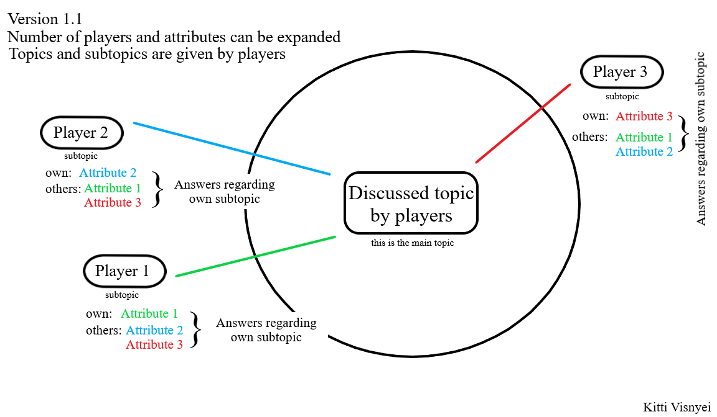
The topic of the game is given by the players, each of them suggests a topic, they discuss it, and decide by voting. Then each player has to choose a subtopic regarding the main topic.
This version has two rounds. In the first one, each player gives an attribute and they have to answer their own and others’ attributes. They are not allowed to use any kind of hints or help, just brainstorming. They will have 20 sec time for each attribute. Correct answers value 2 points.
In the second round they have the opportunity to use the internet, and try to search all of the answers, in 30 seconds. Correct answers value 1 point.
Winner: the one who has the most points.

Casework 1

Players: 21,21,23 years old females, two of them are university students.

I presented the rules of the game, the two rounds, the conductor’s method, and the image of this version to them on a recorded Skype meeting. After that, I asked them to discuss a topic, but it turned out that this is too hard to understand and decide.
They were unsure about this kind of ‘freedom’, they couldn’t even think a topic what they could use, because they didn’t know how big the topic should be.
I tried to dispel the doubts and give some hint, example to them but they didn’t want to use this kind of freedom, because they thought that they are not able to do this.
I really wanted to play in this way, but after ca. 30 minutes it went nowhere, so we skipped this version with this team.

Before we went for the other version, I asked them if they have any suggestions, remarks, recommendation.
They needed stricter rules, because they cannot take this kind of freedom (c.f. Sovereignty-oriented/PLA-based future of the (higher) education or case study how to measure the future-readiness?! - https://miau.my-x.hu/miau2009/index.php3?x=e0&string=sover).
.

Casework 2

Players: 21, 21 years old females, 22 years old male. All of them are university students.

I presented the rules of the game, the two rounds, the conductor’s method, and the image of this version to them on a recorded Skype meeting. After that, I asked them to discuss a topic and they decided to play the conductor’s method example, but with cultural attributes.

Main topic: Different Countries
Player 1 subtopic: Italy // Player 1 attribute: gastronomy (one famous cuisine)
Player 2 subtopic: Greece // Player 2 attribute: architecture (one famous building)
Player 3 subtopic: Germany // Player 3 attribute: capital

First round answers:
1st attribute: one famous cuisine
Player 1: Pasta – 2 points
Player 2: Gyros – 2 points
Player 3: Currywurst – 2 points

2nd attribute: one famous building
Player 1: Pantheon – 2 points
Player 2: Temple of Zeus – 2 points
Player 3: Reichstag – 2 points
3rd attribute: capital
Player 1: Rome – 2 points
Player 2: Athens – 2 points
Player 3: Berlin – 2 points

Player 3 was the fastest every time, so she was the winner.

They didn’t need the second round, because they gave answers to every attribute by brainstorming. It was interesting, that the game lasted ca. 5 minutes with this team.
A relevant question is: Could the attributes be reformulated with more constraints? E.g. instead of “one famous building” it would also be possible to speak about “the most famous building”?!
At the end of the game I asked them if they have any suggestions, remarks, recommendation. They said that the game is too easy, too short, and they don’t have the pleasure as in other games, it has no game nature. They said that I should implant more attributes or more subtopics to each player, and make stricter rules, because they made this game too easy (by themselves) and they didn’t learn anything. They said the framework is too wide, it gives too much freedom to the participants and everyone tries to form the game in the easiest way.
After that we talked about the winner-rules and rewards, but for now, there are only vague ideas for this (c.f. https://miau.my-x.hu/miau/quilt/2020/game_development/diegco_komplex_jatek.xlsx).

Version 1.2
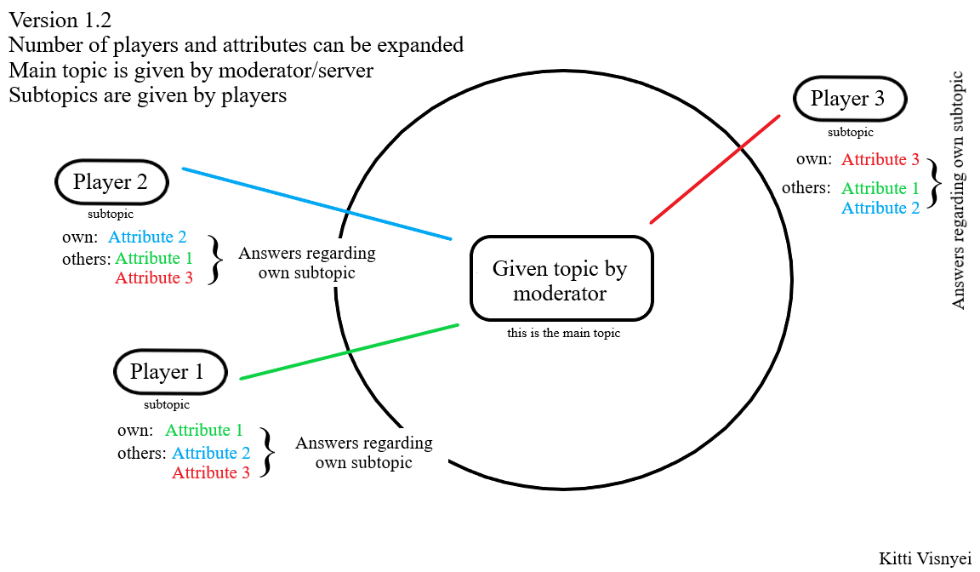
The topic of the game is given by the moderator. Then each player has to choose a subtopic regarding the main topic.
This version also has two rounds. In the first one, each player gives an attribute and they have to answer their own and others’ attributes. They are not allowed to use any kind of hints or help, just brainstorming. They will have 20 sec time for each attribute. Correct answers value 2 points.
In the second round they have the opportunity to use the internet, and try to search all of the answers, in 30 seconds. Correct answers value 1 point.
Winner: the one who has the most points.

Casework 1

Players: 21,21,23 years old females.
Same team from Version 1.1 Casework 1.

I presented the rules, the image, and the conductor’s method again, to make everything clear for the team.

I gave them the following topic: Hungarian Cultural History
After that I asked them to choose a subtopic regarding the main topic.

Player 1 subtopic: literature // Player 1 attribute: one famous, outstanding person regarding own subtopics
Player 2 subtopic: painting // Player 2 attribute: female representation (own subtopics)
Player 3 subtopic: everyday habits // Player 3 attribute: Easter habits

The first two players went on an art scheme, while the third player chose another, which made it difficult to find common ground, so the players agreed that Player 3 would choose another subtopic. The main topic had to be narrowed down, because the players considered the topic of Hungarian Cultural History to be too broad, making it difficult to choose a subtopic.

Final topics and attributes:
Given main topic: Hungarian Cultural History in 18th Century
Player 1 subtopic: literature // Player 1 attribute: one famous, outstanding person regarding own subtopics
Player 2 subtopic: painting // Player 2 attribute: female representation (own subtopics)
Player 3 subtopic: architecture // Player 3 attribute: baroque style representation

First round answers
1st attribute: one famous, outstanding person
Player 1: Ferenc Kazinczy – 2 points
Player 2: no answer – 0 point
Player 3: no answer – 0 point

2nd attribute: female representation
Player 1: no answer – 0 point
Player 2: returning to the prehistoric female ideal: venus figures – 2 points
Player 3: no answer – 0 point

3rd attribute: baroque style representation
Player 1: no answer – 0 point
Player 2: no answer – 0 point
Player 3: no answer – 0 point

Second round answers:

1st attribute: one famous, outstanding person
Player 2: Asam Brothers – 1 point
Player 3: no answer – 0 point

2nd attribute: female representation
Player 1: exaggerated, pathetic representation of "venus" types of women and emotions – 1 point
Player 3: no answer – 0 point

3rd attribute: baroque style representation
Player 1: no answer – 0 point
Player 2: representation in motion, dynamism – 1 point
Player 3: no answer – 0 point

Player 2 got 4 points, so she was the winner.

At the end of the game I asked them if they have any suggestions, remarks, recommendation.
For them, the structure of the game is too complicated, confusing them not to have to answer a specific question but to give a characteristic through their own theme. They don’t know what to do with the freedom, it makes their choice of topic difficult, it would be easier to specify the subtopic with a much more specific, generated main topic. More control is needed in the game.
They also mentioned that in the 2nd round, 30 seconds time limit is too short.

Casework 2

The second team didn’t play with this version, because they started to improve the Version 1.1 and keep the sovereignty of the game.

Conclusion

As a final conclusion, I set up the theory that overly detailed subtopic choices and the lack of specific rules cause confusion and chaos in the game and do not achieve the required result, based on relatively simple but still style-appropriate rules.
Without these specifics, players get lost in the possibilities and in too much detail and their approach is very different, based on this, practically three people play three different games, which is not always a positive outcome.
In the case of setting up a suitable schema system in which they can choose their own topics, they can be more easily steered in one direction, making it significantly easier to achieve a common end result, even to choose a winner.

Since the games in the two versions produced quite extreme results between the two teams, the idea does not necessarily cover a game, but practically an IQ test to measure practical, logical, visual and verbal intelligence.

E.g. the own country, county, city in case of an international group of Students

