MIAU – HU ISSN 141921652 – Special Edition 2020 Spring - Editorials: The papers in MIAU Nr.261 (2020.V) are products of a new education frame system “Quilt”(https://miau.myx.hu/mediawiki/index.php/QuILT). The goals of Quilt are supporting/conducting Students on the way of KNUTH, who said (1992): Knowledge is, what can be transformed into source code, each other human activity is a kind of artistic performance. It also means we need to leave the world of the magic of words step by step. A solid evidence that we all are capable of going this way is: creating publications behind which the human expertise and the robotized knowledge (like online engines: https://miau.my-x.hu/myxfree/coco/index.html -- - offering context free = quasi General-Problem-Solving force fields) can be integrated in case of a rational and relevant decision making scenario. The cyborg effects make possible to face the classic naïve and/or intuitive approaches and parallel the optimized approximations. This way can be realized without deep competences about mathematics, Excel (spreadsheets), statistics, etc. The new (inter/trans/multi-disciplinary) way just expects from us to be able and willing to co-operate with the best moments of the history – it means, with the already prepared robotized elements in order to build something creative one! Parallel, in the second QuILT-semester - https://miau.myx.hu/mediawiki/index.php/QuILT2_parts - there are not only classic publication possibilities like robotizing the investigative journalism – there are further specific tasks too like 2DMgames, gamification in general, thinking experiments, etc.

**Title: How to select the best location for a business activity?**

**Author: Raj Md Saidul Islam**

**Abstract:** This paper report includes specific findings on the number of new service insecure and vulnerable people in the country. A stratified approach was used to provide estimate service in our countries. The goal of the paper is to demonstrate, how make a Start-up a catering service and let me give some ideas on what to look for and tactics to help ease the way to start a business.

**Keywords**: Idea, Obstacles, Potential, Finance, Legal Structure.

# **Introduction**

Catering is usually done by prearranged contract—food and drink provided at a certain cost to a specific number of people. The menu at a catered event is usually more limited than a restaurant menu and is chosen in advance by the client. The way the food is prepared is different, too.

Although both restaurant and catering chefs do the mise en place, or prepare the food ahead of time to a certain extent, catering chefs prepare their food so that it only needs brief final cooking, reheating, or assembly prior to service.

There are two main categories of catering.

Institutional: These caterers at hospitals, universities, airlines, large hotels, and retirement centres provide a wide variety of food and drink to a large number of people on an ongoing basis—usually at the institution itself. The institution usually contracts with a catering company to have this service provided.

Social: These caterers provide food and beverage services to civic groups, charities, corporations, businesses, and individual’s on premise at a catering or banquet hall or off-premise at a selected location.

The opportunities for a catering business multiply every year, given the right demographics—individuals, groups, or businesses who are able to pay for the service.

**Our services is famous among people** because. We love to throw a good party, but let’s face it , organizing, planning, and hosting can make it an exhausting task. You’ve got to find the venue, figure out entertainment, and arrange for the most important portion of any good party-- good food. Sometimes, it really pays off to pay someone else to handle the menu. Whether it’s a social event or a corporate gathering, we have a few important reasons why you should consider hiring a caterer.

1 - Saves Time and Effort

Planning the meal, shopping for ingredients, handling setup, serving, and clean up... for the right person it can be fun, but it can also be a real hassle. When you hire a catering company, all those tasks get outsourced to somebody else. And you don’t just get great food in return-- you get time! Instead of wandering the aisles in search of seasonings, you’ve got time to find the perfect decorations. Instead of offering refills, you’re mingling and enjoying yourself! And instead of worrying about dishes, you can wave goodbye to your guests, kick back, and relax.

2 - It’s Cost Effective!

There are sometimes when DIY really is the cheaper option. This is not one of those times. Unless you have experience with meal and event planning, it can be difficult to effectively execute large-scale food service. With access to wholesale vendors, and familiarity with portion estimates, a professional caterer can save you money on food costs. You won’t pay retail prices for ingredients, and you won’t have to worry about purchasing too many portions that might never get eaten. Plus, a caterer can break down your price per person, making it easy to stay on top of your budget.

3 - Impress Guests with Unique Flavours!

Caterers know how to plan a great menu designed to please a lot of different palates. After all, it’s totally their job! Whether you’re looking for classic American fare, tapas, or Polynesian fusion, a great catering company can elevate your menu with unique flavours and presentations designed to delight. As a host, you should try to be aware of any food allergies or meal preferences, and pass those along. While it might be difficult to handle any special request meals on your own, a professional food handler can prevent cross contamination and alter individual dishes to keep everyone happy.

**Our Mission and Vision**

**Mission**

Our mission is to provide unmatched creative cuisine, artistic presentation, exceptional value, and professional service from first contact through planning and execution of your event and for all future events. As proud members of the community, we are members of the Dripping Springs Chamber of Commerce and support many local charities including The Austin Zoo and Animal Sanctuary, Emancipate, the Mar bridge Foundation and many other local non-profit organizations.

**Vision**

Our service is for profit business, but it is not entirely about money. We profit from our relationship with you, your events’ success, your happiness and your guests enjoyment, and your repeat and referral business.

**Key Feature for Catering and Event Management services**

Room Planning: with multiple room plans, furniture hire, display equipment and a ‘menu’ of costs

Calendar-based: online calendar validation of room availability

Food Production: chef’s listings and ingredient pick list management for individual and bulk production

EPoS: integrated POS for adhoc food and bar sales

Multiple Pricing Structures: for wholesale or staff sales

Income vs Expenditure: profit and loss analysis of functions based on cost and flexible selling price options

**Customer analysis**

**Market Analysis Summary**

The catering industry serves private, corporate, and non-profit events with food, drinks, event management and other services. Events are generally held by clients in order to celebrate, communicate, or both.

* **Celebration**: Parties and banquets as part of key events in life (birthdays, weddings, bar and bat mitzvahs, engagements, bridal and baby showers, retirement parties, etc.) or for a business (holiday or end-of-year parties, retirements, honoree galas, etc.)
* **Communication:** Events to communicate a message for the benefit of attendees or the press (product launches, press events, trade shows, conferences, presentations, lectures, fundraisers) or to stimulate discussion (corporate meetings, summits, etc.)

The U.S. market for caterers was estimated at $6.9 billion in 2008 by IBISWorld. The market is prone to economic cycles, as events, especially corporate events, are one of the first expenses cut during a downturn. Celebratory events may be scaled back a bit, but are generally not canceled during a downturn (i.e., spending on weddings, bar mitzvahs, etc., continues). The industry contracted by 1.5% in 2008 due the economic downturn and a similar decline is apparent for 2009. In 2010 the industry is expected to return to positive growth. The industry is relatively mature, as 33,000 catering companies serve the U.S., or one company for every 9,000 Americans.

There is a movement towards horizontal integration in the greater event industry, with some full-service event providers growing to provide entertainment, audio-visual and technology, catering, rentals, decor, venues and more. Businesses that provide these additional services may take on assets that are not as fully utilized as a specialist's would be, but they can earn greater margins on the sales they make. With its opening of The Sumptuous Ballroom, Sumptuous Cuisine Catering will become part of this integration movement.

**Market Segmentation**

The market analysis chart is provided for the Doeuvreville area in a radius of ten miles.

The corporate market is defined as businesses which hold at least one off-site event each year. Businesses often have A/V and public relations needs in concert with their events which may serve a marketing function for the business. Whether entertaining the press, clients, or board members,

Businesses require professional execution, delicious food and drinks, and alignment between the event managers/caterers and their business's objectives for the event.

The private market includes households with a combined household income of over $80,000 per year (those most likely to throw an upscale event in a rented venue). This group puts a great deal of pressure on caterers and requires added attention, as lavish events may be uncommon for them. They require hands-on work and planning as well as expert advice and referrals throughout the process.

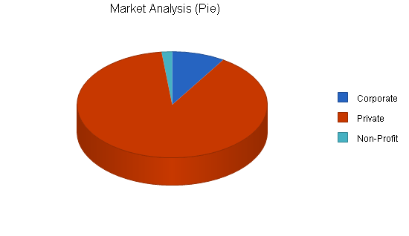The non-profit market is defined as non-profit organizations which hold at least one off-site event each year. Very price conscious, the non-profit market looks for in-kind donations and discounted services whenever possible. Some non-profits realize the benefit of paying for great events which lead, in kind, to improved perception of the organization and donations, while others will take the lowest price available at the minimal quality level acceptable.

|  |  |  |  |  |  |  |  |
| --- | --- | --- | --- | --- | --- | --- | --- |
| **MARKET ANALYSIS** | | | | | | | |
|  |  | 2010 | 2011 | 2012 | 2013 | 2014 |  |
| Potential Customers | Growth |  |  |  |  |  | CAGR |
| Corporate | 1% | 2,500 | 2,525 | 2,550 | 2,576 | 2,602 | 1.00% |
| Private | 2% | 25,000 | 25,500 | 26,010 | 26,530 | 27,061 | 2.00% |
| Non-Profit | 1% | 500 | 505 | 510 | 515 | 520 | 0.99% |
| Total | 1.89% | 28,000 | 28,530 | 29,070 | 29,621 | 30,183 | 1.89% |

**Target Market Segment Strategy**

Sumptuous Cuisine Catering has, traditionally, targeted the private and corporate markets primarily. They will continue this focus with the launch of The Sumptuous Ballroom. Private clients, although requiring additional labor and handholding, can be charged somewhat higher rates than corporate clients. Furthermore, they help to "recession-proof" the business by providing steadier revenue streams in economic downturns.

**Service Business Analysis**

The catering industry is extremely fragmented, with 33,000 companies across the United States. Customers find caterers through referrals, online searches, Yellow Pages, and through businesses which run restaurants they are already familiar with. They will generally contact the catering company by phone to discuss the details of their events directly.

Some businesses and private clients hire event planners or producers to handle the details of their event, including choice of caterer. In this case, these firms, which are more familiar with the industry, may act as a buffer between the end client and the caterer, sometimes making the process of planning smoother.

**Our area customers choose caterers for their events based on the following characteristics:**

* **Cuisine Options:**Private clients will often seek out caterers who can offer, or specialize in, specific cuisine. Businesses looking to use a caterer multiple times are more likely to seek a caterer who can serve many different cuisine so they can vary the options from event to event (or even within a given event) to better please their clients or guests.
* **Quality:**Quality is determined through reviews and references as well as through tastings of the food. Basic quality is a must, but high-quality is sought out for once-in-a-lifetime private events and the fanciest of business functions.
* **Added Services:**Private clients and businesses/non-profits who are relatively new to event planning will prefer caterers who offer a wide range of event services (one-stop shops if possible) rather than working with half a dozen separate event vendors.
* **Price:**Especially for corporate and non-profit customers, price is a key factor. Businesses seek discounted rates for a higher volume of events, which private clients cannot provide.

**Target market, customers’ needs and wants**

Our target markets are middle to upper-middle class families, couples, individuals, or private and public organizations. We chose these groups because they are most able to afford event planners, and have the least amount of time to spare for event planning in general.

Stock control is multi location which allows for function areas to be stock managed for accurate usage, including wet goods and brought-in products

Management of mixed goods to allow for purchase, hire and selling of bought-in items, with markup and profitability reporting. Generates time saving efficiencies through the automation of procedures and relevant reporting. Effective staff management, including staff rostering, work schedules, reviews, contact information, disciplinary summaries and links to HR Better control of cash management via integrated payment systems including contactless and cashless Integration to other systems such as venue-access control, membership, general retail and supporter direct marketing solutions

**Motivation**

We believe that .Our catering and event organisation has excellent opportunity to take the leading position in the market due to its unique products and niche in the market. The organisation has internal strength such as advanced equipment, well-trained personnel and sufficient financial resources.

However, this organization does not have extensive experience of operating in the local market. But with hard work we will counter that problem

**OAM scores**

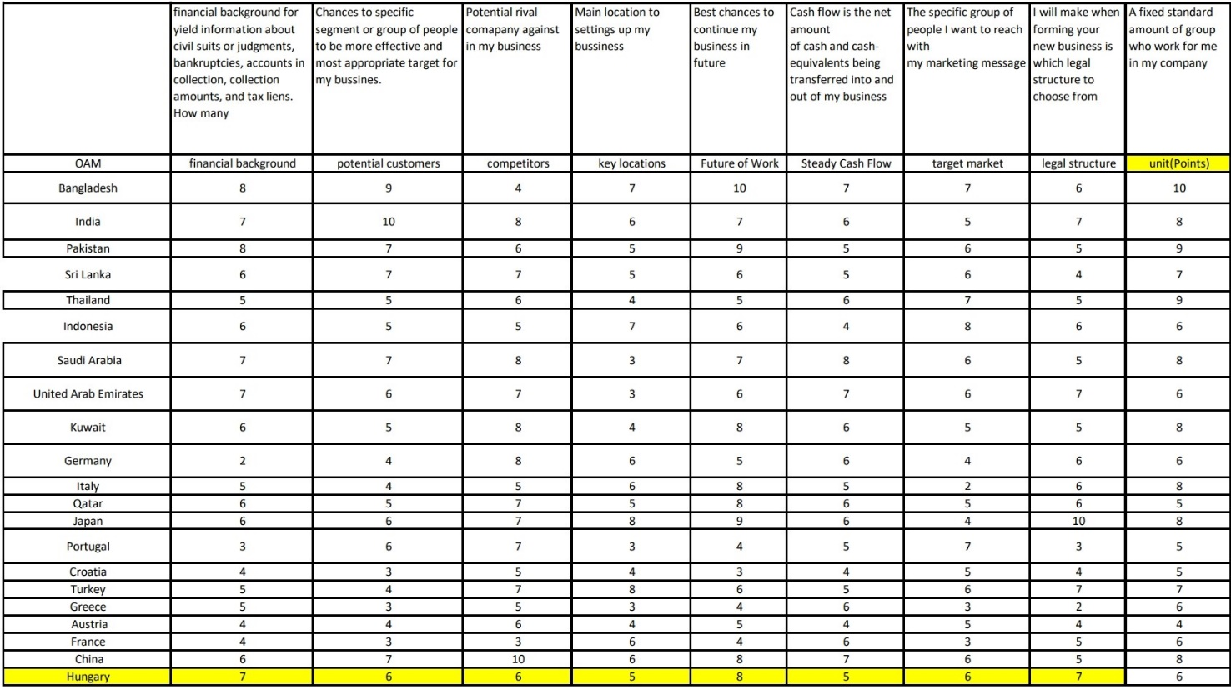**These are the OAM ranking numbers for all the countries we have**

**Figure Nr.1 – Ranking numbers (source: own presentation)**

**The general problem is (assumed, that the ranking of the countries according each column can be derived in an automated way – it means by robot judges.**

**Naive, Rank, Instinctive, Modelled of the table**

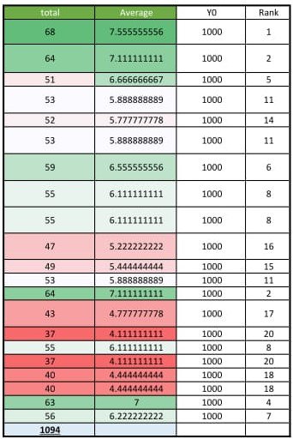

**Figure Nr.2 – Alternative evaluation of objects best_location_v2 (Nr.1-Nr.20) – (own presentations)**

**More details:** [**https://miau.my-x.hu/miau/quilt/2020/best_location_project/best_location_v4.xlsx**](https://miau.my-x.hu/miau/quilt/2020/best_location_project/best_location_v4.xlsx)

**Figure Nr.2 demonstrates a naïve evaluation where the ranking numbers of the Figure Nr.1 lead to an average value without the proving possibility of the antidiscriminative principle “each countries could have the same evaluation value”. The model was derived in an online way here:** [**https://miau.my-x-hu/cocoy0**](https://miau.my-x-hu/cocoy0)

**MacroAsia wins Singapore Airlines’ catering award**

Merit awards received from Singapore Airlines (SQ) for 2014 and 2015

Date Achieved: March 7, 2017

Organization: Singapore Airlines

SQ has awarded MacroAsia Catering the Merit Award for Excellence in Catering for FY15/16. To celebrate this achievement, an appreciation dinner was hosted by Country Manager Ms. Carol Ong and Station Manager - Mr. Eugene Goh on 07 Mar 2017 at the Spectrum Restaurant in Fairmont Makati. No trophy was received.

For the SQ Excellence in Catering Award FY2014/15, MacroAsia Catering Services was awarded as Merit Winner. The award was received on 26 May 2016 given by Country Manager Ms. Carol Ong and Station Manager Mr. Eugene Goh.

We have received the Merit award from SQ General Manager Ms. Carol Ong and Station Manager Mr. Kelvin Kwan on 12Dec14. We are the Merit Winner in Group 1 in the Singapore Airlines Excellence in Catering Award FY2013/14.

MacroAsia Catering Services (MACS) receives Gold Award for the 3rd time in a row in Cathay Pacific's (CX) Annual Caterers Performance Recognition Programmed (CPRP) 2014

Date Achieved: June 18, 2015

Organization: Cathay Pacific

For the 3rd time in a row, MACS has been recognized in Cathay Pacific's Annual Caterers Performance Recognition Programmed (CPRP) 2014, achieving the second GOLD award after the Diamond award in 2012. The award was presented to the team during the award ceremony held at MACS's catering facility on 18 June 2015. Representatives from the CX Head Office in Hong Kong, Mr. Aaron Claxton, Manager Catering Services, Mr. Thomas Chung, Regional Catering Manager, as well as Mr. Jojo Aganinta of Manila, Airport Services Manager presented the award to MACS during the ceremony.

**Rules/and method to find best**

1. Financial background- How many possible outcome to make financial background make strong?.

2. Potential customers- How many Potential number of customer have who wants to rake my services?

3. competitors- Rivalry company amount against my business in my chosen location

4. Key locations- Possible effective location to setting up business

5. Future of Work- Chances figure to continue and expand business in future

6. Steady Cash Flow- How many Potential sources to stable business cash flow?

7. Target market- Figure of the specific group of people I want to reach with my marketing message.

8. Legal structure- How much strong as set up business in legal structure point of view

9. Unit (Points)- How much units of service can provide in those business location.

# **Discussions**

* Differences between single- and multi-country views:
  + Each aspect can highlight suspected years periods.
* Differences Between Event Planning and Coordinating
* Outside the industry, many people do not understand the difference between an event planner and an event coordinator. Generally speaking, the planner makes critical decisions regarding what, when, who, and how. An event coordinator, on the other hand, is responsible for making sure all the details are executed and that each vendor shows up on time and performs appropriately.
* What is an optimal food-ratio as such?
  + The nutritional sciences speak about rules for individuals like more vegetables = longer life – without involving the Liebig principle into the interpretations where these rules can be valid in bubbles (it means for shorter periods and not in general).
  + The here and now explore rules seem to be more relevant for the sociologists.
* What are the five stages of the event planning process?

Terms in this set (5)

Phase 1: FEASIBILITY (research) budget. Target audience. ...

Phase 2: DESIGN. Create proposal including recommended agenda & activities. Venue - location search. ...

Phase 3: OPERATIONS. Establish team. Site inspection. ...

Phase 4: ON-SITE EXECUTION. Can take time. On-site team. ...

Phase 5: EVALUATION. Final reconciliation.

**Discussion**

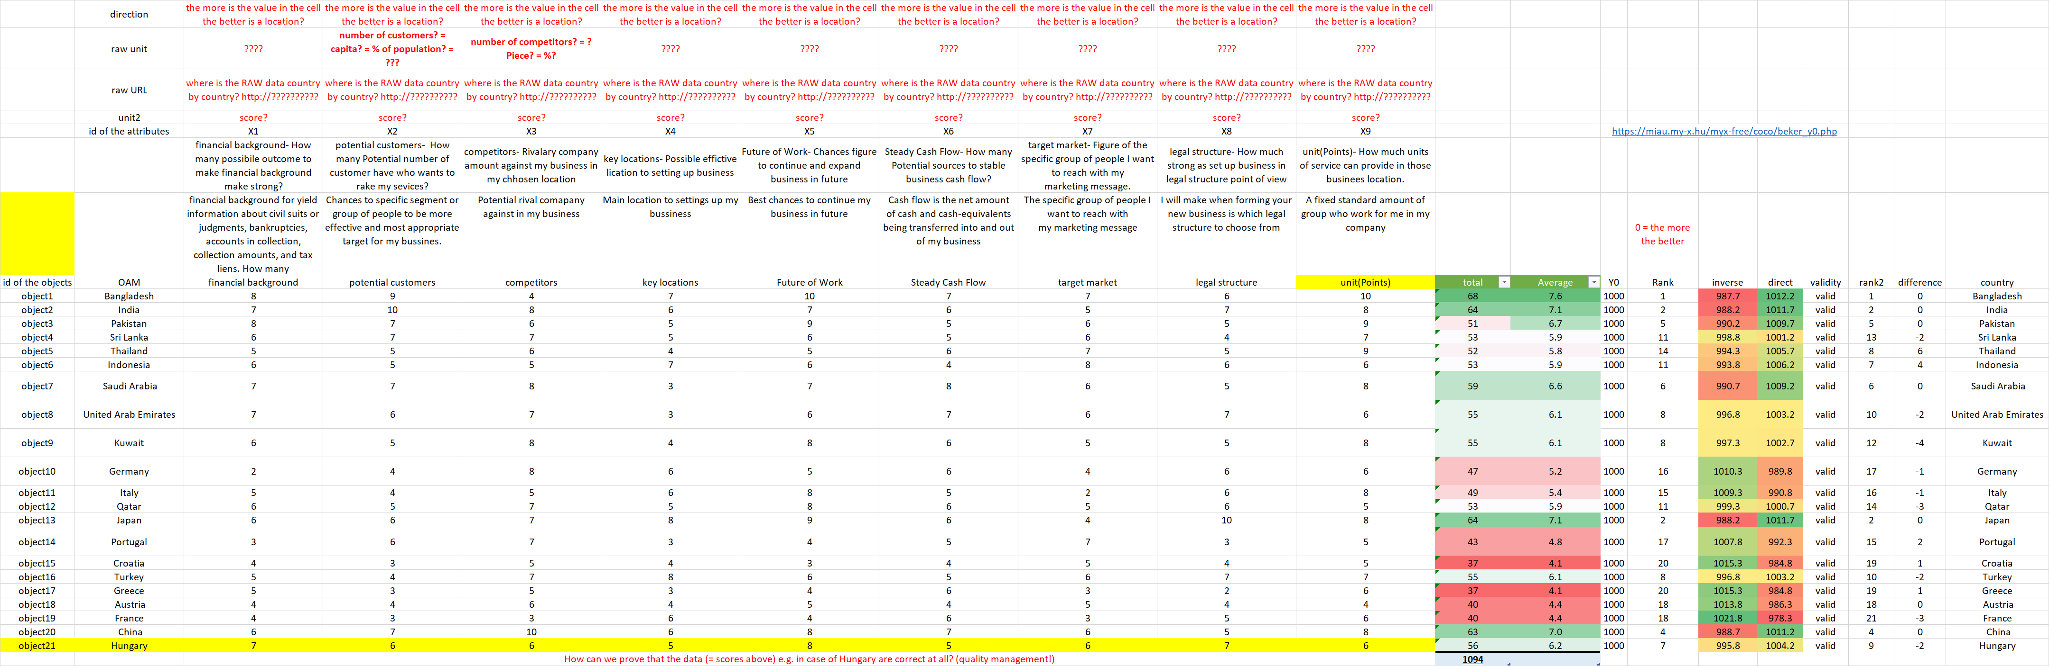

**Figure Nr.3 – What is necessary for an automated process vs. naïve and objective evaluations (source: own presentation)**

**Figure Nr.3 presents (on the top and bottom – red-written) the critical aspects of the approach. The subjective scoring should be changed and derived based on real statistical data (big-data) and appropriate directions for each attribute (column).**

**Figure Nr.3 demonstrates (right side – colored highlighted) a naïve and an optimized approach to select the best location (best country, best object). The greener is a cell in the column “direct” the best is the location based on a solver-oriented (objectivity-driven) online analytical tool.**

**The winner is: Bangladesh. (Hungary’s evaluation as benchmark is quasi norm-like (near to 1000). Good positions have India, Pakistan, Saudi-Arabia, Japan, China. The reddish cells symbolize the bad choices where each objective evaluation is valid (it means: the function-symmetry between a direct and inverse approach is given).**

**More details:** [**https://miau.my-x.hu/miau/quilt/2020/best_location_project/best_location_v4.xlsx**](https://miau.my-x.hu/miau/quilt/2020/best_location_project/best_location_v4.xlsx)

**Conclusion**

A number of factors must be considered when planning an event. While not every aspect of event planning could be presented in this limited amount of space, thought should be given to the elements of event planning presented. Successful event planners well reference multiple sources, especially past events, before undertaking the responsibility involved in producing an important event. Referring to academic event planning sources is an integral part of the initial planning stages of any event. As the planning progresses, organizers are reminded to remain focused on the objectives of the event and incorporate those objectives into the planning process. Budget preparation is a crucial element in this process and may ultimately determine the success or failure of the event itself Other vital considerations include catering or food service, selection of the date and site, promotional strategies, and event activities. Contingency plans must be developed ahead of time to deal with any number of potential problems. The final steps in producing a successful event include objective and subjective evaluation of the event itself, width thanks to those who put effort into the project.

**If the criteria of an award can be seen as measurable attributes, then the involving of a robot judge is more than trivial!**

**Reference**

<https://www.bplans.com/catering_and_ballroom_rental_business_plan/market_analysis_summary_fc.php>

<http://www.macroasiacatering.com/Awards.html>