MIAU – HU ISSN 1419-1652 – Special Edition 2020 Spring - Editorials: The papers in MIAU Nr.261 (2020.V) are products of a new education frame system “QuILT” (https://miau.my-x.hu/mediawiki/index.php/QuILT). The goals of QuILT are supporting/conducting Students on the way of KNUTH, who said (1992): Knowledge is, what can be transformed into source code, each other human activity is a kind of artistic performance. It also means we need to leave the world of the magic of words step by step. A solid evidence that we all are capable of going this way is: creating publications behind which the human expertise and the robotized knowledge (like online engines: https://miau.my-x.hu/myxfree/coco/index.html --- offering context free = quasi General-Problem-Solving force fields) can be integrated in case of a rational and relevant decision making scenario. The cyborg effects make possible to face the classic naïve and/or intuitive approaches and parallel the optimized approximations. This way can be realized without deep competences about mathematics, Excel (spreadsheets), statistics, etc. The new (inter/trans/multi-disciplinary) way just expects from us to be able and willing to co-operate with the best moments of the history – it means, with the already prepared robotized elements in order to build something creative one! Parallel, in the second QuILT-semester - https://miau.my-x.hu/mediawiki/index.php/QuILT2_parts - there are not only classic publication possibilities like robotizing the investigative journalism – there are further specific tasks too like 2DM-games, gamification in general, thinking experiments, etc.

Service Science & Knowledge Economy: Research Method

Topic:

**Management is the best way to increase productivity**

Submitted by:

Aqib Masood, Navid Babaei

Kodolanyi Janos University

Budapest, Hungary

Abstract: The goal of this paper is to demonstrate how to prove a hypothesis about the impacts of the management activities in systems. The thinking experiments are adequate to prove hypothesis like “if a country is having the highest "GDP PPP per capita per hour worked" but not the highest neutral resources and industrial robots, it will be due to nothing else than a good management system.” Similarity analyses helps to understand, that the above listed hypothesis is not robust!

Keywords: big-data, hypothesis, proving, similarity analysis

Introduction

Management is controlling human resources, financial resources, technological resources, and natural resources to reach a goal. Management was appeared as a science to provide the best ways for increase in productivity in 19th and 20th century , when there were only few people who could value the importance of management because most people were still sceptical about it and used to think that it was not related to them and their business and it was something that fitted others.

But due to many challenges that businesses have been facing white, the number of people who can understand the importance of management has been getting more and more and today, very few people would doubt that management is essential. Nowadays, managers have become the essential key resource for economic and social development. Organizations which have good and talented managers, will survive.

Conversely, organizations which have untrained managers will lose the market share and finally will be chased out of business by their competitors.

Organizations today have to deal with so many unexpected challenges related to; increase in productivity of resources, employing resources, motivating employees and etcetera. Challenges like these have changed the playing field on which firms must compete. They have dramatically increased the need for firms to be responsive, flexible, and capable of competing and reacting rapidly in a global marketplace.

The challenge of increasing the productivity of resources

One of the most important challenges for managers today and tomorrow is increasing the productivity of resources. Resources are developed by managers and they are responsible their productivity.

It is above all productivity which is the first responsibility. And the management challenge today and tomorrow will centre on productivity of resources.

Resources are not made by nature. They are made by man. And this is particularly true for two key resources; the human beings and capital. But human being would be a resource only if it became trained to productive work. This is the central challenge of management. It is particularly important in developing countries. In all developing countries there is lack of effective and productive people. One of the central challenges of managers in developing countries is development of people to human resources.

In many ways, capital is perhaps even more crucial, especially in developing countries, than human resource. Capital can be created by providing a surplus of today’s production over cost. Otherwise, capital formation can not take place. Capital formation is a very important factor in the development of a developing country. It is also a crucial factor of continuing prosperity of the developed countries.

According, there are no jobs unless we can invest a significant amount of capital.

Challenge of dealing with changes

Rapid and unexpected changes will be the rule in tomorrow’s environment. It is an unstable environment. In an unstable environment information received by organizations are contradictory. The best estimates that managers can make are actually only guesstimates. It is necessary to calculate the risks in such an environment. In this regard, rapid technological improvements, political instability, and lack of key resources are examples of changes in this unstable environment of 21st century. Accordingly, managers must develop some strategies in order to stay ahead of changes.

Furthermore, today and tomorrow’s managers must also face the challenge of the frequent changes in the environment (which can create psychologically, great tension and stress for the manager) by developing agility in coping with these changes. The manager must thus develop planning strategies that are flexible enough to allow for frequent changes in direction while still accomplishing organizational objectives. Thus, confidence and enthusiasm for a given course of action must be maintained while knowing that the plan may be obsolete before it can be fully carried out. Maintaining the balance between enough stability to pursue plans while remaining flexible enough to make changes when necessary will be more difficult than ever before.

The political challenge

In order to deal with different people with different interests in the best way, managers must have sharp political skills. It is very important to recognize the personalities and interests of the people who you are working with. Or in other aspect, managers should develop and apply some strategies based on consumer’s interest that can help the organization to have a bigger share in market.

The challenge of motivating employees

Nowadays, organizations are populated new generation of workers that are more talented and have more skills and abilities and higher knowledge degree than the previous generations. Managers need to face the challenge of motivating this new type of employees. New generation of workers must be managed differently than the previous generations. they can not be simply ordered and closely monitored because they resist and question the commands and managing models.

new generation of employees are more difficult to motivate them. This is due to a change in value systems coupled with greater knowledge management and rising educational levels. In view of this, greater scepticism concerning large organizations and less reverence for authority figures will be more common; unquestioned acceptance of rules and managing models will be less. While presenting a problem for managers these employees can also be the source of much creativity.

The measurement of productivity:

The GDP (PPP) per hour worked is the best measure of the productivity of a country when not taking into account unemployment or hours worked per week. GDP (PPP) stands for gross domestic product normalised to purchasing power parity.

Rank Country GDP (PPP)

per hour:

|  |  |  |
| --- | --- | --- |
| **Top 10 Most Productive Countries of 2019** | | |
| **Rank** | **Country** | **GDP per hour worked (In dollars)** |
| 1 | Luxembourg | 93.4 |
| 2 | Ireland | 87.3 |
| 3 | Norway | 81.3 |
| 4 | Belgium | 69.7 |
| 5 | United States | 68.3 |
| 6 | Denmark | 67.6 |
| 7 | France | 65.6 |
| 8 | Germany | 65.5 |
| 9 | Netherlands | 65.4 |
| 10 | Switzerland | 64.2 |

Figure Nr.1 – source: own presentation

There are factors to this measurement that differ in different countries. Such as: Natural resources, Size of the country, literacy rate and usage of industrial robots and also the quality level of the management system. Therefore we are going to compare countries in these aspects as well and then we will be able to find the most effective factor to the productivity rate of the most productive country.

Natural resources:

|  |  |  |
| --- | --- | --- |
| **Leading Countries worldwide based on natural resource value as of 2019(In U.S. trillion dollars)** | | |
| **Rank** | **Countries** | **Value (in trillion dollars)** |
| 1 | Russia | 75 |
| 2 | United States | 45 |
| 3 | Saudi Arabia | 34.4 |
| 4 | Canada | 33.2 |
| 5 | Iran | 27.3 |
| 6 | China | 23 |
| 7 | Brazil | 21.8 |
| 8 | Australia | 19.9 |
| 9 | Iraq | 15.9 |
| 10 | Venezuela | 14.3 |

Figure Nr.2 – source: own presentation

Based on this information, the most productive country, which is Luxembourg, is not even among the top 10 countries that have the most national resources in value. This shows that natural resources of a country are not a very effective factor to the productivity of each person in a that country.

Size of the countries:

|  |  |
| --- | --- |
| **Country** | **Total Area (Km2)** |
| Russia | 17,098,242 |
| Canada | 9,984,670 |
| China | 9,833,517 |
| United States | 9,596,961 |
| Brazil | 8,515,767 |
| Australia | 7,692,024 |
| India | 3,287,263 |
| Argentina | 2,780,400 |
| Kazakhstan | 2,724,900 |
| Algeria | 2,381,741 |

Figure Nr.3 – source: own presentation

Based on this information, the most productive country, which is Luxembourg, is not even among the top 10 biggest countries. This shows that the size of a country is not a very effective factor to the productivity of each person in a that country.

About Automation:

1. China — 154,000 industrial robots

China is responsible for 36% of total industrial robotics installations, with about 154,000 units. This is down 1% from 2017, but it’s still more than the Americas and Europe combined. The value of installations reached $5.4 billion, which is 21% higher than in 2017.

With the current economic climate, keep an eye on how China deals with foreign robot suppliers. China’s installations of foreign robot suppliers, including units produced in China by non-Chinese suppliers, decreased 7% from about 122,000 units in 2017 to 113,000 units last year. Installations from domestic Chinese industrial robot manufacturers increased 5% to 27% in 2018. This result is in line with China’s policy of promoting domestic manufacturers.

2. Japan — 55,000 industrial robots

Despite seeing numbers increase 21% in 2018, Japan is still a distant second with 55,000 industrial robots. That is the highest number for ever for the country. Japan is the world’s No. 1 industrial robot manufacturer and delivered 52% of the global supply in 2018.

3. U.S. — 40,300 industrial robots

Robot installations in the U.S. increased for the eighth year consecutive year. The 40,300 industrial robots, which is 22% higher than 2017, catapulted the US into third place and bumped South Korea down one slot.

The IFR said the driver of the growth in all manufacturing industries in the US since 2010 has been the ongoing trend to automate production to strengthen the U.S. industries in both domestic and global markets.

4. Republic of Korea — 38,000 industrial robots

South Korea dropped one spot in 2018 due to a 5% decline in installations of about 38,000. The IFR attributed the decline to a “tough year” for the electronics industry. Korea’s use of industrial robots has increased 12% on average per year since 2013.

5. Germany — 27,000 industrial robots

Germany is the fifth largest industrial robotics market in the world and No. 1 in Europe. In 2018, the number of units sold to Germany increased by 26% to almost 27,000 units – an all-time record. Installations are mainly driven by the automotive industry.

|  |  |
| --- | --- |
| **Top Countries Using Industrial Robots** | |
| **Countries** | **Number of industrial robots** |
| China | 154,000 |
| Japan | 55,000 |
| United States | 40,300 |
| Republic of Korea | 38,000 |
| Germany | 27,000 |

Figure Nr.4 – source: own presentation

Based on this information, the most productive country, which is Luxembourg, is not even among the top 10 countries that have the most industrial robot usage. This shows that usage of industrial robots of a country is not a very effective factor to the productivity of each person in a that country.

Literacy rate:

|  |  |  |
| --- | --- | --- |
| **Literacy Rates** |  |  |
| **Rank (Total)** | **Country** | **Percent** |
| 1 | Andorra | 100 |
| 1 | Greenland | 100 |
| 1 | Korea (North) | 100 |
| 1 | Uzbekistan | 100 |
| 5 | Latvia | 99.9 |
| 5 | San Marino | 99.9 |
| 7 | Azerbaijan | 99.8 |
| 7 | Belarus | 99.8 |
| 7 | Cuba | 99.8 |
| 7 | Estonia | 99.8 |

Figure Nr.5 – source: own presentation

Based on this information, the most productive country, which is Luxembourg, is not even among the top 10 countries that have highest literacy rate. This shows that literacy rate of a country is not a very effective factor to the productivity of each person in a that country.

Levels of Management

The term “Levels of Management’ refers to a line of demarcation between various managerial positions in an organization. The number of levels in management increases when the size of the business and work force increases and vice versa. The level of management determines a chain of command, the amount of authority & status enjoyed by any managerial position. The levels of management can be classified in three broad categories:

1.

2. Top level / Administrative level

3. Middle level / Executory

4. Low level / Supervisory / Operative / First-line managers

Conclusion:

As we mentioned, Luxembourg is having the highest GDP PPP Per Hours which means Luxembourg is the most productive country.

As we analysed, these are major the factors to GDP PPP Per hours worked that can differ in different countries:

Management system quality level,

Natural resources,

The size of the country,

Usage of industrial robots,

Literacy rate.

We compared countries in these aspects excluding Management system quality level, because the Management quality level is not simply measurable.

And our aim was to find out which of these factors is the most effective one on the productivity.

As we observed, the most productive country is Luxembourg, while this country is not among the leading countries in other aspects that we considered and the only aspect that we are left with is the management system quality level. Meaning that, the high productivity rate of Luxembourg is due to nothing else than the high level of management system quality and it is fair to say it is at the “Top Level”.

Now we have Luxembourg as an example to prove that the management is the best way to increase the productivity.

# Proving the hypothesis

For a thinking experiment, we only need an OAM with random values:

see <https://miau.my-x.hu/miau/quilt/2020/management_project/management_scaled.xlsx>

The figures 6-7-8-9 demonstrate the thinking experiment with random values – to derive based on offline (solver-driven) similarity analyses that an object (a country) without the best ranking values (Nr1) concerning the resources (Xi) but with the highest Y value (GDP/capita) can be evaluated as a country with bad management because the estimation for Y in case of the proved object can be higher than the highest value before!

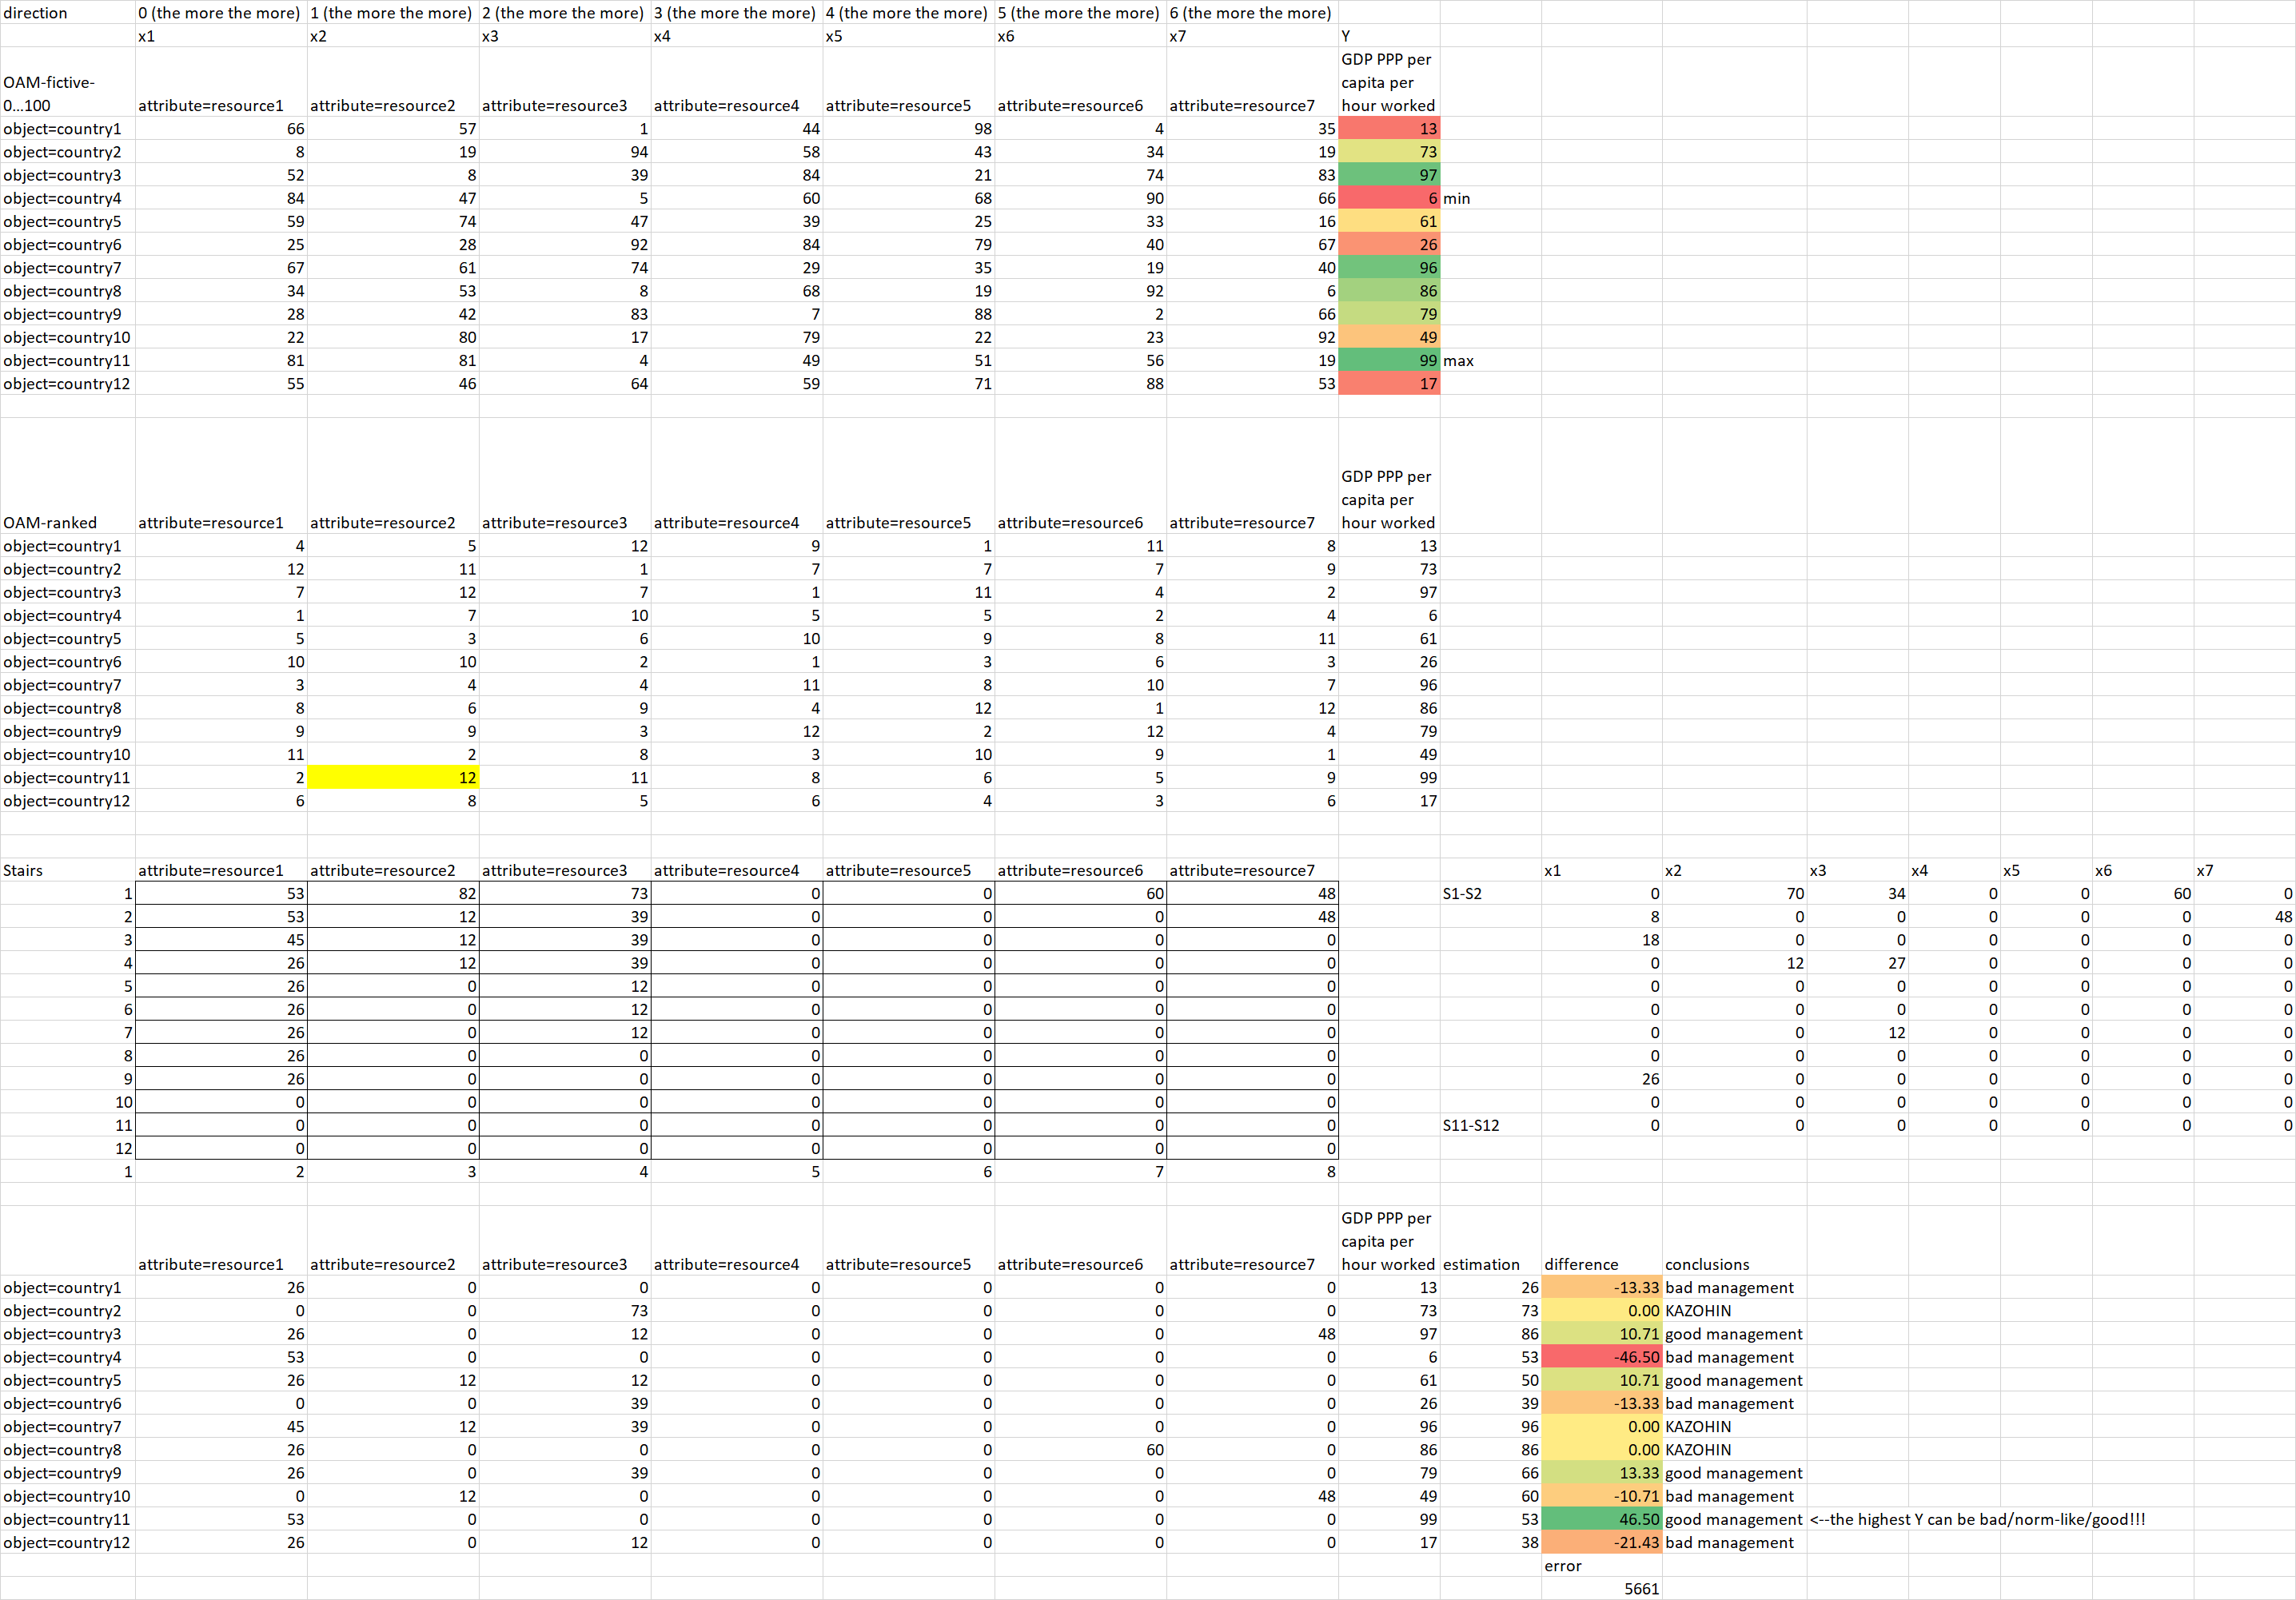

Figure Nr 6 – Good management scenario (source: own presentation)

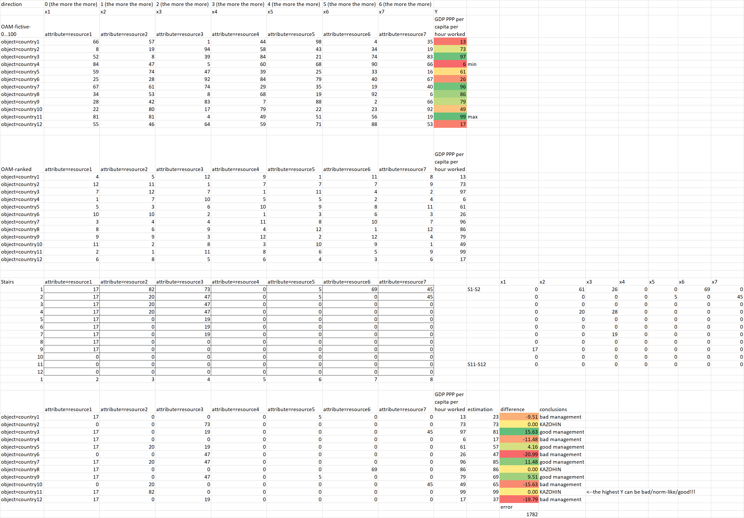

Figure Nr 7 – Norm-like management scenario (source: own presentation)

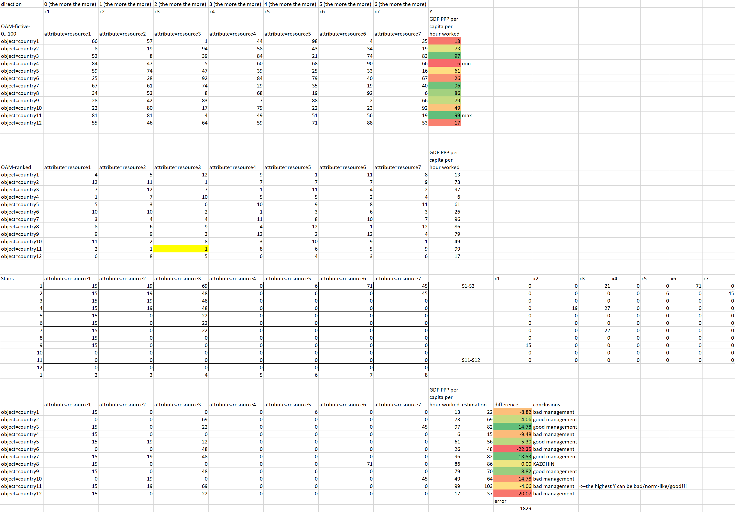

Figure Nr 8 – Bad management scenario (source: own presentation)

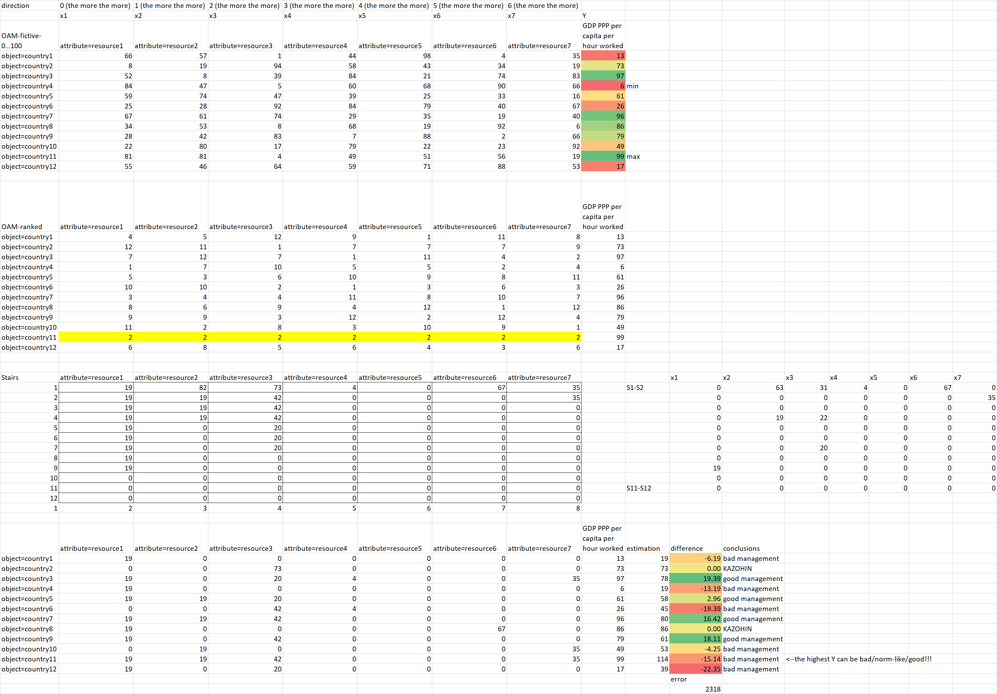

Figure Nr 9 – Bad management scenario without ranking number = 1 positions in the OAM for the object with the highest Y-value (source: own presentation)

# References

<https://miau.my-x.hu/miau/quilt/2020/management_project/>

<https://miau.my-x.hu/miau/quilt/2020/covid19_project/>

<https://miau.my-x.hu/miau/261/health_management_quality_covid.docx>