MIAU – HU ISSN 1419-1652 – Special Edition 2020 Spring - Editorials: The papers in MIAU Nr.261 (2020.V) are products of a new education frame system “QuILT” (https://miau.my-x.hu/mediawiki/index.php/QuILT). The goals of QuILT are supporting/conducting Students on the way of KNUTH, who said (1992): Knowledge is, what can be transformed into source code, each other human activity is a kind of artistic performance. It also means we need to leave the world of the magic of words step by step. A solid evidence that we all are capable of going this way is: creating publications behind which the human expertise and the robotized knowledge (like online engines: https://miau.my-x.hu/myxfree/coco/index.html --- offering context free = quasi General-Problem-Solving force fields) can be integrated in case of a rational and relevant decision making scenario. The cyborg effects make possible to face the classic naïve and/or intuitive approaches and parallel the optimized approximations. This way can be realized without deep competences about mathematics, Excel (spreadsheets), statistics, etc. The new (inter/trans/multi-disciplinary) way just expects from us to be able and willing to co-operate with the best moments of the history – it means, with the already prepared robotized elements in order to build something creative one! Parallel, in the second QuILT-semester - https://miau.my-x.hu/mediawiki/index.php/QuILT2_parts - there are not only classic publication possibilities like robotizing the investigative journalism – there are further specific tasks too like 2DM-games, gamification in general, thinking experiments, etc.

Ranking of countries

concerning

AI-readiness/relatedness

or Impacts Of atificial intelligence

***Author:***

Shahroze

***Abstract:***

The publication gives us the information of the facts how artificial intelligence came to existence and how countries around the globe accept it (mostly targeting one Europe). Through this publication we have determined which of the European state has the most AI-relatedness and by how much. This is shown via graphical illustration and by statistic illustrations. By this research we have also learned how artificial intelligence will help the countries and shows that by 2030 they can add 20 percent in their combined economy output. The analytical steps about AI are made based on AI and in a data-driven way.

***Keywords:***

Artificial intelligence, AI-readiness, AI-relatedness, Europe, big-data, modeling, reproducibility

***Objective:***

This publication will make us realize what role exactly has the artificial intelligence played in human lives, whether it has a positive role or a negative role.

Parallel, based on statistics from the EUROSTAT, a kind of multilayered ranking of the EU-member states will be derived step by step in order to demonstrate that this complex phenomenon (AI-readiness/relatedness) can be processed in an objective way even through AI-components (it means based on big-data and solver-oriented online AI-engines).

***Subjective:***

We might not tend to view the fact or let’s just say we might not be vigilant enough to know that we are surrounded with artificial intelligence but this artificial intelligence gives us more of a help then we have even tried to notice. This publication will explain how much, us as humans, rely on artificial intelligence, just for a small example how smart phones have changed our lives and the ads that we receive are more related to us and our wants and needs this is all artificial intelligence.

***Targeted groups:***

The targeted group here can be the companies that are working and researching more on artificial intelligence or even the countries that have gained good AI-readiness. This is so they can get the idea on how much they have contributed and how far are the other countries ahead of them.

***Introduction:***

This publication will help us to learn what Artificial Intelligence is and give us the benefit of understanding how we are surrounded by all the types of Artificial Intelligence; this also includes a brief history of AI itself. The publication does not target one single group but all the groups which are affected by the AI (Artificial Intelligence). This will include all age groups, surveys about the usage of Artificial intelligence by age, how it affects us in our day to day work. The source of the information that I have used in this publication are:

1. Artificial Intelligence itself (Internet)
2. Surveys
3. Articles
4. Statistics

Introduction of Artificial Intelligence

Artificial intelligence is to make a computer, a robot or even a program reach as close to what a smart human thinks. Artificial intelligence is basically a study of how a human brain thinks, learns and then decides on how to do the work

The aim of Artificial intelligence is to improve computer functions which are all related to human knowledge.

This intelligence is intangible and it consists of 5 process

* Reasoning
* Learning
* Problem solving
* Perception
* Linguistic intelligence

Human behavior and history before Artificial intelligence was introduced:

It all started with myths, stories and rumors about artificial beings. The seed of AI was planted by a classical philosopher who tried to describe the process of human thinking as a mechanical manipulation of symbols. This lead up to the invention of programmable digital computer in the 1940s. This device and idea inspired a group of scientist and for the first time think seriously about the possibility of building an electric brain. In 1956 a workshop was founded for research of AI. As they under estimated the difficulties for the research and not finding appropriate research the U.S and the UK government stopped funding the project. 7 years later initiative of a vision by the Japanese government inspired governments to spend billions of dollars on this but then had to be stopped again due to lack of knowledge and difficulties.

In the first decades of 21st Century, the investments and interests in AI boomed due to new methods, the application of powerful computer hardware, and the collection of immense data sets. Machine learning was successfully applied to many problems in academia and industry.

***What is the impact of artificial intelligence on the Society now?***

As there will always be changes in life, there will be positive and negative impacts of artificial intelligence on the society and humans. As the development of AI is growing, there is also a growth in the mindset to address the negative impact now, for a better future.

Negative: Most of the manufacturing companies are now replacing their workforce with machines to have better productivity, which on the other hand is making people lose their jobs.

Most of the Car companies are producing autonomous driving cars (see Figure Nr.0) which could end up having a scenario of the car hitting a pedestrian. Who would be to blame, as the person is not driving the car.  Figure Nr.0 – Self-driving car (source: techradar)

In 2016 a report stated there will be 10 million self-driving cars on the road. Is this alarming or lets think what we can exclude from this?

***Literature:***

While doing the research, I came across an article <https://www.mckinsey.com/featured-insights/artificial-intelligence/tackling-europes-gap-in-digital-and-ai#part4> by Jacques Bughin, Jeongmin Seong, James Manyika, Lari Hämäläinen, Eckart Windhagen, and Eric Hazan that shows exactly how much each of the EU-states has developed and how further have they gone in terms of individual state development and research. The diagram below shows a kind of digital gap of member states within the EU.

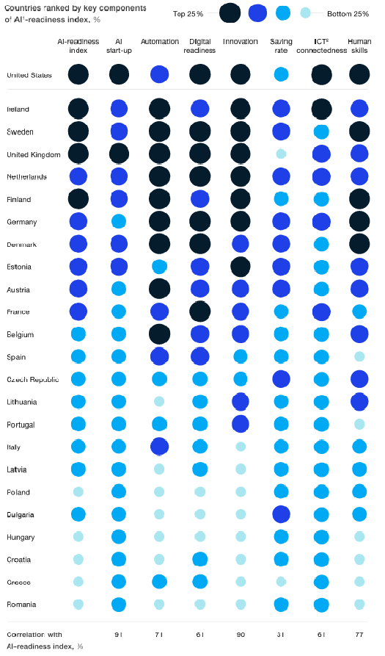

Figure Nr.1

According to this diagram (Figure Nr.1) we are able to see the developments of the EU states and the correlation in AI-readiness index and how they have been ranked accordingly. According to this illustration we can see which countries are on top in percentage and which are at the lowest percent. UK and Sweden has the most top percentage and Romania being on the lowest percentage. It is important to highlight, that the different columns are calculated based on their key components of AI-readiness. As a kind of critiques, it should be highlighted that Figure Nr.1 could not be reproduced by the author based on raw statistics (behind the used indicators), because the source document did not support this investigations: “*We collected a set of indicators by country to gauge how they stand on the key enablers and aggregated them into an AI Readiness Index. Index scores are not pure averages but are based on weighting each enabler according to its relative importance for boosting the economic growth of each countr*y”.

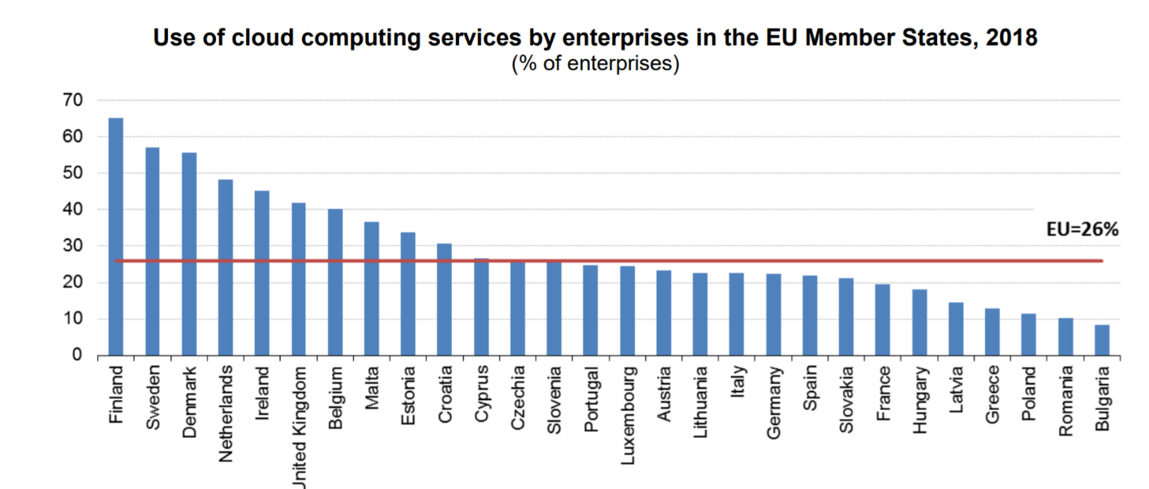

Figure Nr.2.

Over half the enterprises used cloud computing services in Nordic EU Member States. Significant differences can be observed across countries in regards to cloud computing usage. When we look at it (Figure Nr.2) closely we see that over half of the enterprises in Finland (65%), Sweden (57%) and Denmark (56%) used cloud computing. At the opposite end of the scale, cloud computing services were used by 10% or fewer enterprises in Bulgaria (8%) and Romania (10%).

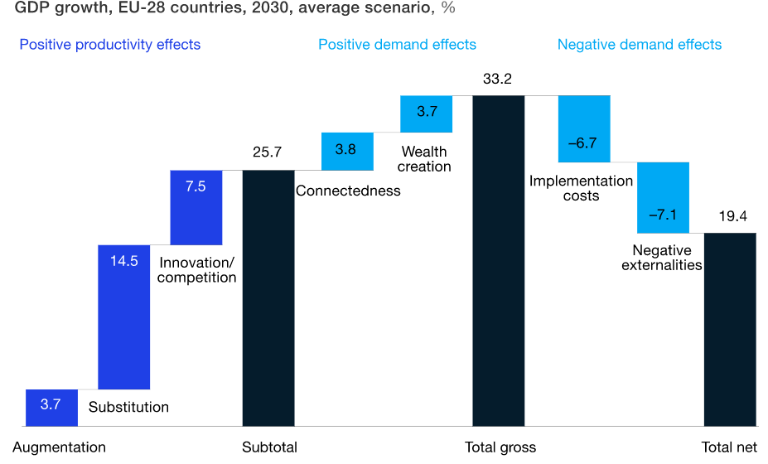

Figure Nr.3.

According to one research (Figure Nr.3) it states that if Europe develops and diffuses AI according to its current assets and digital position relative to the world, it could add some €2.7 trillion, or 20 percent, to its combined economy output, resulting in 1.4 percent compound annual growth through 2030 as shown above. Such an impact would be roughly double that of other general-purpose technologies adopted by developed countries in the past.

***Data assets:***

* FAO: <https://miau.my-x.hu/miau/quilt/2020/AI-project/tutorials_eu/>  
  Data

The next figure (Figure Nr.4) shows the detailed statistic data of the countries

* The number of total data: 990
* The number of countries: 34
* The number of categories for AI-relatedness: 6
* The number of years: 1 (2017)

***Methodology:***

As a methodology of this research we chose secondary data analysis. Below we given a brief explanation to the secondary data analysis to understand the basic of the methodology.

Secondary data analysis is analysis of data that was collected by someone else for another primary purpose. The utilization of this existing data provides a viable option for researchers who may have limited time and resources.

The data collection can be based on primary and secondary data collection. The primary data collection needs to be done by survey method which is more time consuming and costly because of this analyzing the secondary data had fitted our time requirement.

The data was collected from the following URL: <https://appsso.eurostat.ec.europa.eu/nui/show.do?dataset=isoc_eb_bd&lang=en>

to gain our results for our research.

Compared to the AI-readiness-index (see Figure Nr.1) where the authors used non reproducible weightings, here and now, it is important to demonstrate how can we derive a similar index in a reproducible way without any subjective weighting effects. The online similarity analyses (<https://miau.my-x.hu/cocoy0>) can be executed in frame of an online tool providing models where the optimization has only one single goal: deriving in an objective way, whether the objects (countries) could have the same evaluation (index) value. If not, only then the AI-relatedness-index can be interpreted as a new (not arbitrary) term.

***Analysis:***

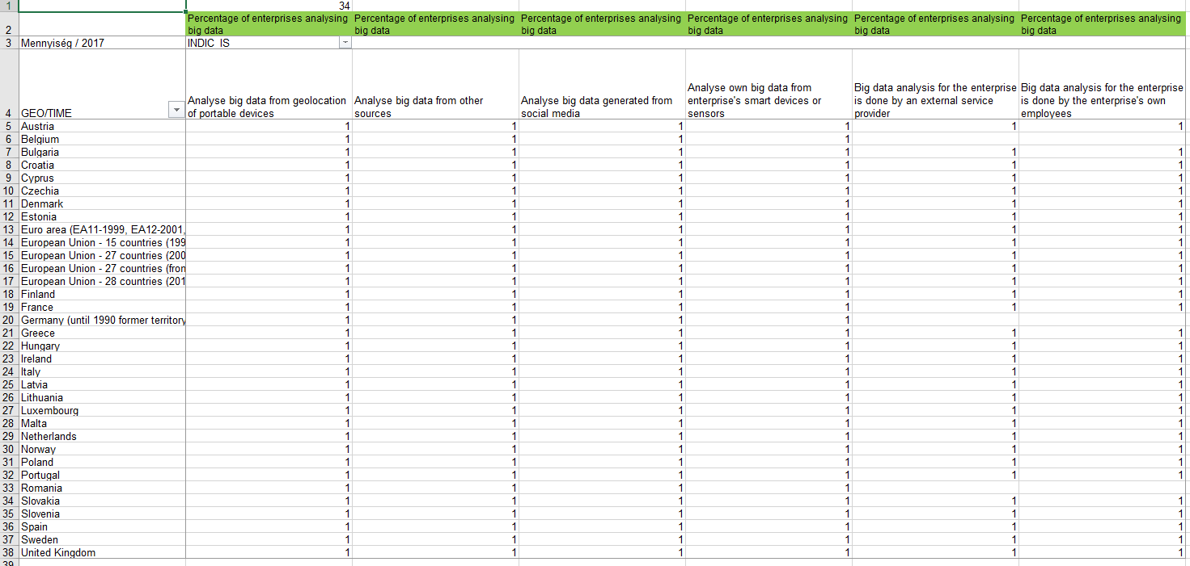  
Figure Nr.4 – Checking data structure (source: own presentation - <https://miau.my-x.hu/miau/quilt/2020/AI-project/tutorials_eu/>)

According to the data taken from <https://appsso.eurostat.ec.europa.eu/nui/show.do?dataset=isoc_eb_bd&lang=en> we are able to see how is the data been analyzed and where does each of the EU member state has been producing its big data from. Whether it is from the social media or enterprise own employees. The geo/time in this is only referring to one specific year which is 2017 – derived as the average value of the available years (2016/2018) in order to ensure the highest number of countries despite lacks in the database.

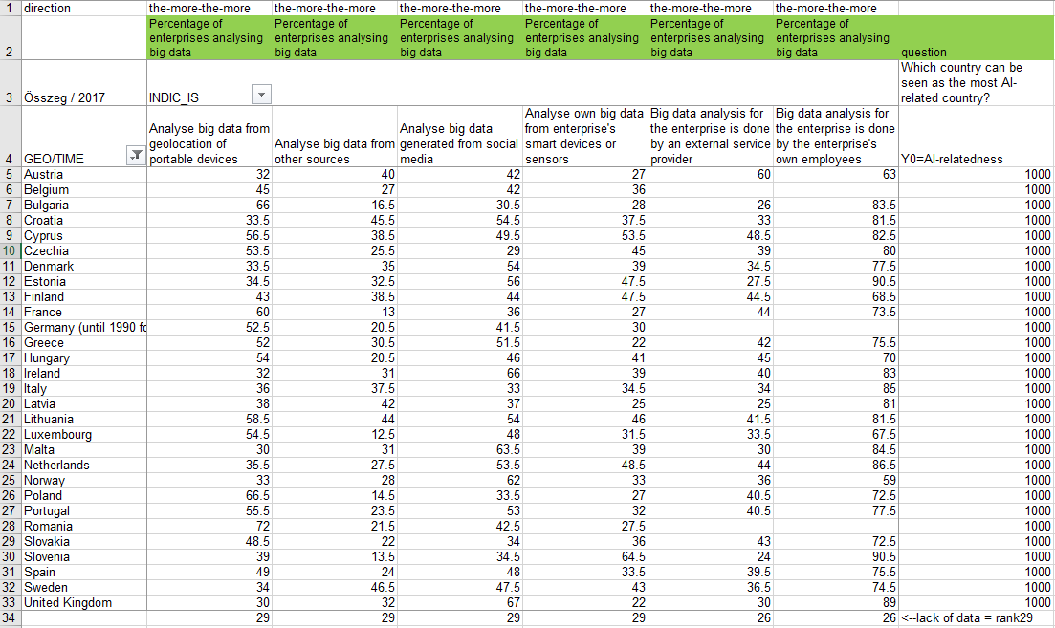  
Figure Nr.5 – Raw OAM with directions (source: own presentation - <https://miau.my-x.hu/miau/quilt/2020/AI-project/tutorials_eu/isoc_eb_bd.xls>)

According to this illustration (Figure Nr.5) of the potential “big data” we will see (Figure Nr.6) an aggregated, optimized index about the Artificial Intelligence relatedness of each of the state based on the raw date about how much percentage they all lie on according to each of the AI Data collection.

Comparing the data from geolocation of portable devices we can analyse that Romania has a high percentage (see ranking value = 1) which is 72% whereas the lowest percentage are of United Kingdom and Malta which are on 30% (ranking value = 28---28 in case of 29 objects=countries).

Geolocation data from the use of portable devices e.g. portable devices using mobile telephone networks, wireless connections or GPS (49 %), followed by data generated from social media e.g. social networks (45 %). Less than one third of enterprises analyzed own big data from smart devices or sensors (29 %) or data from other sources (26 %).

Big data: refers to data generated from activities that are carried out electronically and from machine-to-machine communications and can be characterized by: - significant volume referring to vast amounts of data generated over time; - variety referring to the different format of complex data, either structured or unstructured (e.g. sensor data, activity logs, click streams).

Big data analysis: Shows the use of technologies and software tools for analyzing big data extracted from portable devices, social media and enterprise's own data sources or other data sources.

***Results:***

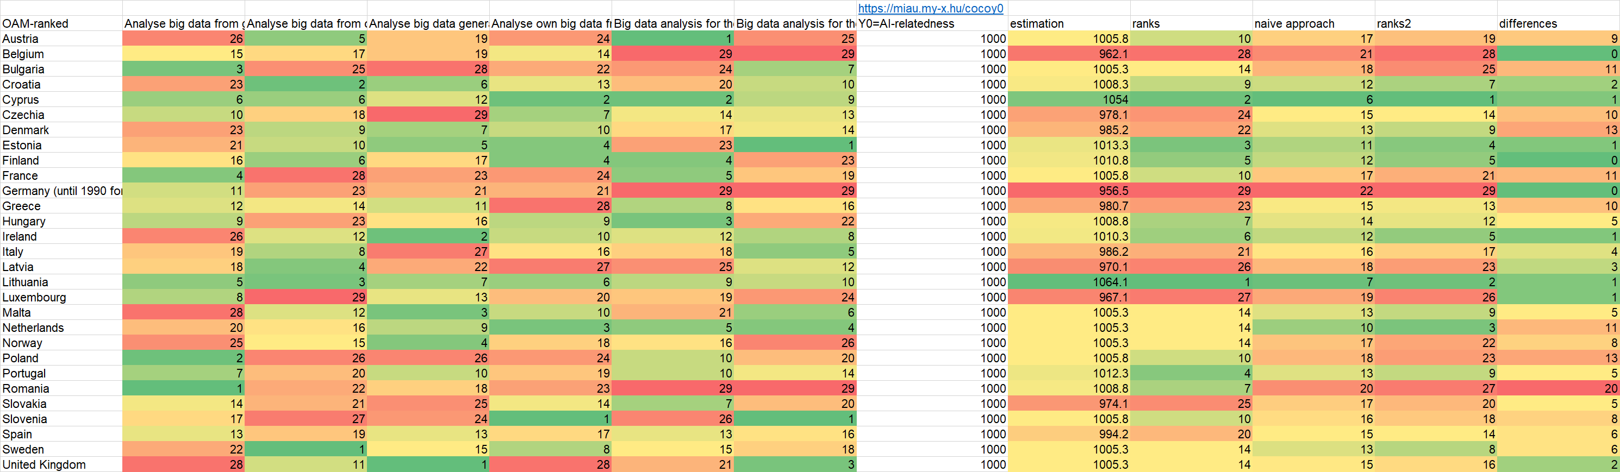

Figure Nr.6 – Estimated AI-relatedness index-values in an optimized and naïve way – and differences between them (source: own presentation)

Significant differences between the naïve and optimized model ranking values can be observed across countries: e.g. 0 difference in case of Germany (with two lacks in the raw data set). In Cyprus, Estonia, Lithuania, the Luxembourg and Ireland: 1. On the other hand, Romania 20 ranking positions in case of 29 ranked objects!

Figure Nr.1 (column about the AI-readiness-index) and the Figure Nr.6 (columns: estimations and ranks) should deliver the same results. But it is not so: The case of Romania (with the highest difference between the optimized and naïve = subjective weighted ranking values) makes clear, that the methodology plays an important role in the derivation of highly abstracted terms like AI-relatedness/readiness.

The winners of the Figure Nr.1 (UK, Sweden, Finland, Ireland) can not be accepted based on the Figure Nr.6 where only Finland and Ireland have good index values.

***Discussions:***

The European Commission puts forward a European approach to Artificial Intelligence and Robotics. It deals with technological, ethical, legal and socio-economic aspects to boost EU's research and industrial capacity and to put AI at the service of European citizens and economy.

Some discussion say AI applications may raise new ethical and legal questions, related to liability or fairness of decision-making. The General Data Protection Regulation (GDPR) is a major step for building trust and the European Commission wants to move a step forward on ensuring legal clarity in AI-based applications.  
European Commission also stated only when all European countries work together we can make the most of the opportunities offered by AI and become a world leader in this crucial technology for the future of our societies.

***Conclusions:***

According to the data we can calculate that Lithuania is the most AI-related country as it is shown in the table which it relays on 1.

On the other hand, the least AI-related country is Germany (until 1990 former territory of the FRG) where as we have the evidence of showing it on 29 (important remark: Germany had lacks in the data structure. Further sensitivity analyses can be seen here: <https://miau.my-x.hu/miau/quilt/2020/AI-project/tutorials_eu/isoc_eb_bd%20(1).xls>)

The naive evaluation has huge differences compared to the optimized model which the evidence shown in the calculated data by 20 which happened to be Romania. Data generated from social media UK has the most percentage of 67% and the least has been taking in at 29% by Czechia.

These are the most ranking taken from 29 states of the EU and the AI-relatedness of 1000 (norm-value).

**References:**

<https://ec.europa.eu/eurostat/data/database>

<https://www.mckinsey.com/featured-insights/artificial-intelligence/tackling-europes-gap-in-digital-and-ai#part4>

**Annexes:**

<https://miau.my-x.hu/miau/quilt/2020/AI-project/tutorials_eu/isoc_eb_bd.xls>

<https://miau.my-x.hu/miau/quilt/2020/AI-project/tutorials_eu/>

<https://appsso.eurostat.ec.europa.eu/nui/show.do?dataset=isoc_eb_bd&lang=en>