MIAU – HU ISSN 141921652 – Special Edition 2020 Spring - Editorials: The papers in MIAU Nr.261 (2020.V) are products of a new education frame system “QuILT” (https://miau.my-x.hu/mediawiki/index.php/QuILT). The goals of QuILT are supporting/conducting Students on the way of KNUTH, who said (1992): Knowledge is, what can be transformed into source code, each other human activity is a kind of artistic performance. It also means we need to leave the world of the magic of words step by step. A solid evidence that we all are capable of going this way is: creating publications behind which the human expertise and the robotized knowledge (like online engines: https://miau.my-x.hu/myxfree/coco/index.html --- offering context free = quasi General-Problem-Solving force fields) can be integrated in case of a rational and relevant decision making scenario. The cyborg effects make possible to face the classic naïve and/or intuitive approaches and parallel the optimized approximations. This way can be realized without deep competences about mathematics, Excel (spreadsheets), statistics, etc. The new (inter/trans/multi-disciplinary) way just expects from us to be able and willing to co-operate with the best moments of the history – it means, with the already prepared robotized elements in order to build something creative one! Parallel, in the second QuILT-semester - https://miau.my-x.hu/mediawiki/index.php/QuILT2_parts - there are not only classic publication possibilities like robotizing the investigative journalism – there are further specific tasks too like 2DM-games, gamification in general, thinking experiments, etc.

Europe between 1960 and 1990

**or what could derive a robot-historian about the second half of the cold war based on big-data?**

**Abstract:** I am going to show how history changed during the cold war with numbers instead of words as we used to. I want to show how the numbers can speak about a piece of European history. The numbers generated by AI can speak about force fields like “Lebensraum”-driven, fortune/asset/wealth-protective motivations behind increasing military expenditures.

**Keywords: history, numbers, big-data, new approaching, high school**

# Introduction

In my publication, I would like to show and make an understanding of how the European state's data were changing between 1960 and 1990. I was dealing with these countries: Austria, Belgium, Bulgaria, Denmark, Finland, France, Greece, Hungary, Ireland, Italy, Netherlands, Poland, Portugal, Spain, and Sweden. I have chosen these countries because I found only enough and believable information to work. Countries should be categorized: western: Austria, Belgium, France, Ireland; eastern: Bulgaria, Croatia, Czech Republic, Hungary, Poland, Romania, Slovakia, Slovenia; northern: Denmark, Estonia, Finland, Latvia, Lithuania, Luxembourg, Netherlands, Sweden; southern: Greece, Cyprus, Italy, Portugal, and Spain.

## **Objectives**

## I am dealing with democracy, history, emissions, male, female, birth, and actual political situation. My aim is to prove with the use of numbers that the numbers say to us the same history that we know.

## **Targeted groups**

## Exactly I mark the high school student because they are in front of further studies and I hope it will be helpful for them to prepare for the school-leaving exam and with it, they can get a simpler picture of an important piece of the history. So, I made this publication to the secondary school’s teachers and students.

## **Benefits**

During the writing part of the publication, I earned useful information on how I can earn data on different modes and learn how to calculate missing information.

## **Motivations**

# I would like to approach the history in that way to use only numbers without words. I think it is an unusual mode to write about the past.

# **Literature**

At least one single publication about the cold war with declarations for the here and now involved countries.

# **Data assets**

URL of the raw data: <https://clio-infra.eu/Countries/Austria.html#countries>

URL of the xls: <https://miau.my-x.hu/miau/quilt/2020/coldwar_military_expenditure_project/>

Armed Conflicts (International):

|  |  |  |  |  |
| --- | --- | --- | --- | --- |
|  | **1960** | **1990** | **Differences** | **Ranks** |
| Austria | 0 | 0 | 0 | 1 |
| Belgium | 1 | 0 | 1 | 13 |
| Bulgaria | 0 | 0 | 0 | 1 |
| Denmark | 0 | 0 | 0 | 1 |
| Finland | 0 | 0 | 0 | 1 |
| France | 0 | 0 | 0 | 1 |
| Greece | 0 | 0 | 0 | 1 |
| Hungary | 0 | 0 | 0 | 1 |
| Ireland | 0 | 0 | 0 | 1 |
| Italy | 0 | 0 | 0 | 1 |
| Netherlands | 1 | 0 | 1 | 13 |
| Poland | 1 | 0 | 1 | 13 |
| Portugal | 0 | 0 | 0 | 1 |
| Spain | 0 | 0 | 0 | 1 |
| Sweden | 0 | 0 | 0 | 1 |

We can say that this period was the peaceful side of European history, only Belgium had an armed conflict as we know it was the Congo Crisis. Therefore, it can be expected, that the decreasing of the number of conflicts will lead to decreasing the military expenditures from 1990-1960.

Biodiversity (definition here: https://clio-infra.eu/Indicators/Biodiversitynaturalness.html)

|  |  |  |  |  |
| --- | --- | --- | --- | --- |
|  | **1960** | **1990** | **Differences** | **Ranks** |
| Austria | 0,8 | 0,8 | 0,036277026 | 7 |
| Belgium | 0,7 | 0,7 | 0,017911319 | 9 |
| Bulgaria | 0,7 | 0,7 | -0,000857792 | 13 |
| Denmark | 0,5 | 0,5 | 0,068200061 | 2 |
| Finland | 0,9 | 0,9 | 0,007370292 | 12 |
| France | 0,6 | 0,7 | 0,045041713 | 5 |
| Greece | 0,7 | 0,7 | -0,025712542 | 15 |
| Hungary | 1,6 | 1,6 | 0,047628585 | 4 |
| Ireland | 0,7 | 0,7 | 0,042069395 | 6 |
| Italy | 0,6 | 0,6 | 0,135334415 | 1 |
| Netherlands | 0,6 | 0,7 | 0,015647656 | 10 |
| Poland | 1,2 | 1,2 | 0,048692299 | 3 |
| Portugal | 0,7 | 0,7 | -0,015907392 | 14 |
| Spain | 0,6 | 0,6 | 0,02715137 | 8 |
| Sweden | 0,9 | 0,9 | 0,011973349 | 11 |

The per cents are the same, so the territory of the states is not changed but these numbers depend on how the military expenditure changed, therefore we see the differences column. Therefore, it can be expected, that the decreasing of the number of biodiversity will lead to decreasing the military expenditures from 1990-1960 (c.f. fortune-protective behaviour).

Book Titles per Capita

|  |  |  |  |  |
| --- | --- | --- | --- | --- |
|  | **1960** | **1990** | **Differences** | **Ranks** |
| Austria | 463,8 | 774,6 | 0,67032463 | 11 |
| Belgium | 509,1 | 989,4 | 0,943639677 | 10 |
| Bulgaria | 428,2 | 383,6 | -0,104141709 | 14 |
| Denmark | 1020,7 | 2604,6 | 1,551658702 | 8 |
| Finland | 562,8 | 2036,1 | 2,61781918 | 3 |
| France | 254,9 | 717,2 | 1,814316573 | 4 |
| Greece | 189,1 | 459,1 | 1,42763249 | 9 |
| Hungary | 1564,1 | 2407,1 | 0,538979814 | 12 |
| Ireland | 81,2 | 383,6 | 3,723630663 | 1 |
| Italy | 161,6 | 441,8 | 1,734116055 | 5 |
| Netherlands | 1118,6 | 3041,3 | 1,71889424 | 6 |
| Poland | 493,8 | 537,4 | 0,088330829 | 13 |
| Portugal | 735,4 | 619,8 | -0,157256792 | 15 |
| Spain | 198,6 | 920,9 | 3,637330183 | 2 |
| Sweden | 966,6 | 2483,0 | 1,568857645 | 7 |

As the numbers were growing the military expenditures were decreasing. The military expenditures spreadsheet is on the page 13. Therefore, it can be expected, that the decreasing of the number of book titles/capita will lead to decreasing the military expenditures from 1990-1960 (c.f. more freedom to be worth protecting it).

Cattle per Capita

|  |  |  |  |  |
| --- | --- | --- | --- | --- |
|  | **1960** | **1990** | **Differences** | **Ranks** |
| Austria | 0,3 | 0,3 | 0,014611857 | 7 |
| Belgium | 0,3 | 0,3 | 0,166115015 | 1 |
| Bulgaria | 0,2 | 0,2 | 0,094415662 | 5 |
| Denmark | 0,7 | 0,4 | -0,412580932 | 14 |
| Finland | 0,4 | 0,3 | -0,369527706 | 12 |
| France | 0,4 | 0,4 | -0,06956706 | 8 |
| Greece | 0,1 | 0,1 | -0,503122954 | 15 |
| Hungary | 0,6 | 0,5 | -0,21922916 | 11 |
| Ireland | 1,5 | 1,7 | 0,115002672 | 4 |
| Italy | 0,2 | 0,2 | -0,191696083 | 10 |
| Netherlands | 0,3 | 0,3 | 0,079144868 | 6 |
| Poland | 0,6 | 0,5 | -0,101240789 | 9 |
| Portugal | 0,1 | 0,1 | 0,152029058 | 2 |
| Spain | 0,1 | 0,1 | 0,123424015 | 3 |
| Sweden | 0,3 | 0,2 | -0,398934138 | 13 |

As the military expenditure is decreased as the cattle per capita in general decreased. Therefore, it can be expected, that the decreasing of the number of cattle/capita will lead to decreasing the military expenditures from 1990-1960 (c.f. more assets more need to protect them – or even less asset = less war).

CO2 emissions per capita

|  |  |  |  |  |
| --- | --- | --- | --- | --- |
|  | **1960** | **1990** | **Differences** | **Ranks** |
| Austria | 1,2 | 2,2 | 0,815969051 | 8 |
| Belgium | 2,7 | 2,7 | 0,004087443 | 14 |
| Bulgaria | 0,8 | 2,3 | 2,017510725 | 5 |
| Denmark | 1,8 | 2,6 | 0,490288081 | 9 |
| Finland | 0,9 | 2,8 | 1,976246633 | 6 |
| France | 1,6 | 1,7 | 0,077063777 | 13 |
| Greece | 0,3 | 1,9 | 5,303438762 | 1 |
| Hungary | 3,7 | 4,7 | 0,277232301 | 12 |
| Ireland | 1,1 | 2,4 | 1,209636895 | 7 |
| Italy | 0,6 | 1,9 | 2,145744487 | 4 |
| Netherlands | 1,7 | 2,5 | 0,461166576 | 10 |
| Poland | 3,7 | 5,0 | 0,354086784 | 11 |
| Portugal | 0,3 | 1,2 | 3,57140341 | 2 |
| Spain | 0,4 | 1,5 | 2,39755528 | 3 |
| Sweden | 1,8 | 1,6 | -0,121034784 | 15 |

As the companies working with making fume. The carbon dioxide is the by-product of oil recovery. Therefore, it can be expected, that the increasing of the number of CO2-emission/capita will lead to decreasing the military expenditures from 1990-1960 (c.f. better environment = better Lebensraum).

Cropland per Capita

|  |  |  |  |  |
| --- | --- | --- | --- | --- |
|  | **1960** | **1990** | **Differences** | **Ranks** |
| Austria | 0,2 | 0,2 | -0,212196929 | 6 |
| Belgium | 0,1 | 0,1 | -0,310508639 | 12 |
| Bulgaria | 0,6 | 0,5 | -0,19735768 | 5 |
| Denmark | 0,6 | 0,5 | -0,186576421 | 4 |
| Finland | 0,6 | 0,5 | -0,244436871 | 8 |
| France | 0,5 | 0,3 | -0,279626176 | 9 |
| Greece | 0,4 | 0,4 | -0,120627841 | 3 |
| Hungary | 1,7 | 1,5 | -0,094291845 | 2 |
| Ireland | 0,6 | 0,3 | -0,471551152 | 15 |
| Italy | 0,3 | 0,2 | -0,333711347 | 14 |
| Netherlands | 0,1 | 0,1 | -0,320068083 | 13 |
| Poland | 1,1 | 0,8 | -0,291704379 | 10 |
| Portugal | 0,3 | 0,3 | -0,086672115 | 1 |
| Spain | 0,7 | 0,5 | -0,23697403 | 7 |
| Sweden | 0,5 | 0,3 | -0,300003554 | 11 |

The spreadsheet shows, during the Cold War that cropland is decreased or increased. For example, it causes the cropland to become a construction site. Therefore, it can be expected, that the decreasing of the number of cropland/capita will lead to decreasing the military expenditures from 1990-1960 (less Lebensraum = less war).

Educational Inequality, Gini Coefficient

|  |  |  |  |  |
| --- | --- | --- | --- | --- |
|  | **1960** | **1990** | **Differences** | **Ranks** |
| Austria | 21,4 | 7,4 | -0,653216887 | 15 |
| Belgium | 19,9 | 17,3 | -0,133270876 | 7 |
| Bulgaria | 36,2 | 21,8 | -0,397946707 | 12 |
| Denmark | 14,9 | 8,8 | -0,412320662 | 13 |
| Finland | 12,6 | 16,3 | 0,300634014 | 1 |
| France | 19,1 | 18,9 | -0,013432423 | 3 |
| Greece | 29,0 | 25,2 | -0,130295089 | 6 |
| Hungary | 62,3 | 38,4 | -0,383623026 | 10 |
| Ireland | 16,3 | 17,0 | 0,041886747 | 2 |
| Italy | 24,3 | 20,5 | -0,156705208 | 8 |
| Netherlands | 16,9 | 16,0 | -0,05354177 | 4 |
| Poland | 117,3 | 59,5 | -0,492866835 | 14 |
| Portugal | 45,9 | 27,8 | -0,395368477 | 11 |
| Spain | 22,8 | 20,1 | -0,119361621 | 5 |
| Sweden | 16,7 | 12,2 | -0,265806052 | 9 |

These numbers tell us, from 1960 to 1990, the inequality of the education sector on average is decreased. Except for Finland and Ireland when it is increased. Therefore, it can be expected, that the decreasing of the number of education problems will lead to decreasing the military expenditures from 1990-1960 (c.f. smarter people fight less).

Female life expectancy at Birth

|  |  |  |  |  |
| --- | --- | --- | --- | --- |
|  | **1960** | **1990** | **Differences** | **Ranks** |
| Austria | 71,9 | 78,9 | 0,096940195 | 6 |
| Belgium | 72,6 | 79,3 | 0,092235683 | 7 |
| Bulgaria | 70,9 | 74,8 | 0,054412179 | 13 |
| Denmark | 74,0 | 77,7 | 0,050547371 | 15 |
| Finland | 72,4 | 78,9 | 0,089653267 | 8 |
| France | 73,6 | 81,0 | 0,099837001 | 5 |
| Greece | 70,4 | 79,5 | 0,129582268 | 2 |
| Hungary | 210,5 | 221,3 | 0,051446487 | 14 |
| Ireland | 72,0 | 77,7 | 0,079594388 | 9 |
| Italy | 71,7 | 80,3 | 0,119559152 | 4 |
| Netherlands | 75,3 | 80,1 | 0,063338202 | 12 |
| Poland | 141,3 | 150,6 | 0,065836047 | 11 |
| Portugal | 66,9 | 77,7 | 0,161261396 | 1 |
| Spain | 71,7 | 80,5 | 0,123656664 | 3 |
| Sweden | 74,9 | 80,4 | 0,07386136 | 10 |

The female life expectancy at birth is improved. The average female life expectancy is 76. Therefore, it can be expected, that the increasing of the number of female life expectancy will lead to decreasing the military expenditures from 1990-1960 (c.f. longer life = smarter people = less war).

GDP per Capita

|  |  |  |  |  |
| --- | --- | --- | --- | --- |
|  | **1960** | **1990** | **Differences** | **Ranks** |
| Austria | 6519,0 | 16894,6 | 1,591590735 | 7 |
| Belgium | 6952,0 | 17197,0 | 1,473673763 | 8 |
| Bulgaria | 2912,0 | 5596,9 | 0,922012363 | 13 |
| Denmark | 8812,0 | 18452,4 | 1,094011575 | 10 |
| Finland | 6230,0 | 16866,4 | 1,707284109 | 6 |
| France | 7398,0 | 17647,0 | 1,385375777 | 9 |
| Greece | 3146,0 | 10015,4 | 2,183534647 | 3 |
| Hungary | 10947,0 | 19376,4 | 0,770021924 | 14 |
| Ireland | 4282,0 | 11817,7 | 1,759864549 | 5 |
| Italy | 5456,2 | 16313,1 | 1,989839064 | 4 |
| Netherlands | 8287,0 | 17262,1 | 1,083030047 | 11 |
| Poland | 6430,0 | 10226,8 | 0,59048367 | 15 |
| Portugal | 2956,0 | 10826,4 | 2,662516915 | 2 |
| Spain | 3072,0 | 12054,8 | 2,924091797 | 1 |
| Sweden | 8687,5 | 17608,9 | 1,026923041 | 12 |

It can show us the well-being changed during the Cold War. The biggest development was in Spain during the Francisco Franco dictatorship. Therefore, it can be expected, that the increasing of the number of GDP/capita will lead to decreasing the military expenditures from 1990-1960 (c.f. more money less war).

Latent Democracy Variable

|  |  |  |  |  |
| --- | --- | --- | --- | --- |
|  | **1960** | **1990** | **Differences** | **Ranks** |
| Austria | 1,2 | 1,1 | -0,125610553 | 7 |
| Belgium | 1,2 | 1,1 | -0,058544835 | 3 |
| Bulgaria | -0,8 | 0,8 | -1,95012036 | 12 |
| Denmark | 1,2 | 1,1 | -0,105138174 | 5 |
| Finland | 1,3 | 1,1 | -0,130947115 | 10 |
| France | 0,9 | 1,0 | 0,18137458 | 2 |
| Greece | 0,4 | 1,0 | 1,778256451 | 1 |
| Hungary | -2,4 | 3,3 | -2,385458483 | 15 |
| Ireland | 1,2 | 1,0 | -0,129896284 | 9 |
| Italy | 1,2 | 1,1 | -0,087831004 | 4 |
| Netherlands | 1,3 | 1,1 | -0,127548839 | 8 |
| Poland | -1,6 | 1,0 | -1,616234173 | 11 |
| Portugal | -0,9 | 1,0 | -2,149436275 | 13 |
| Spain | -0,8 | 1,1 | -2,37216217 | 14 |
| Sweden | 1,2 | 1,1 | -0,118649493 | 6 |

The chart consists of the data of how democracy is changed during the examined period. Clearly show us how the states' forms diversified. Therefore, it can be expected, that the decreasing of the number of latent democracy will lead to decreasing the military expenditures from 1990-1960 (c.f. more latent transparency more war).

Male life Expectancy at Birth

|  |  |  |  |  |
| --- | --- | --- | --- | --- |
|  | **1960** | **1990** | **Differences** | **Ranks** |
| Austria | 65,4 | 72,3 | 0,106132436 | 3 |
| Belgium | 66,7 | 72,7 | 0,089941538 | 6 |
| Bulgaria | 67,5 | 68,1 | 0,009041055 | 14 |
| Denmark | 70,4 | 72,0 | 0,022430437 | 12 |
| Finland | 65,4 | 70,9 | 0,08470948 | 8 |
| France | 67,0 | 72,7 | 0,085036551 | 7 |
| Greece | 67,2 | 74,5 | 0,109456441 | 2 |
| Hungary | 197,8 | 195,5 | -0,011680825 | 15 |
| Ireland | 68,5 | 72,1 | 0,053300234 | 9 |
| Italy | 66,7 | 73,6 | 0,104094795 | 4 |
| Netherlands | 71,5 | 73,8 | 0,033170049 | 11 |
| Poland | 129,6 | 132,5 | 0,022373091 | 13 |
| Portugal | 61,3 | 70,6 | 0,152741514 | 1 |
| Spain | 66,7 | 73,3 | 0,100060006 | 5 |
| Sweden | 71,2 | 74,8 | 0,050259722 | 10 |

The highest male life expectancy is Hungary. Therefore, it can be expected, that the increasing of the number of male life expectancy will lead to decreasing the military expenditures from 1990-1960 (cf. longer life = smarter people = less war – see the same in cs of the female life expectancy).

Openness of Executive Recruitment (XROPEN)

|  |  |  |  |  |
| --- | --- | --- | --- | --- |
|  | **1960** | **1990** | **Differences** | **Ranks** |
| Austria | 4,0 | 4,0 | 0 | 1 |
| Belgium | 4,0 | 4,0 | 0 | 1 |
| Bulgaria | 4,0 | 4,0 | 0 | 1 |
| Denmark | 4,0 | 4,0 | 0 | 1 |
| Finland | 4,0 | 4,0 | 0 | 1 |
| France | 4,0 | 4,0 | 0 | 1 |
| Greece | 4,0 | 4,0 | 0 | 1 |
| Hungary | 12,0 | 12,0 | 0 | 1 |
| Ireland | 4,0 | 4,0 | 0 | 1 |
| Italy | 4,0 | 4,0 | 0 | 1 |
| Netherlands | 4,0 | 4,0 | 0 | 1 |
| Poland | 8,0 | 8,0 | 0 | 1 |
| Portugal | 4,0 | 4,0 | 0 | 1 |
| Spain | 0,0 | 4,0 | 0 | 1 |
| Sweden | 4,0 | 4,0 | 0 | 1 |

It shows how society is feudal. As we see almost the same in both years. Therefore, it can be expected, that the decreasing of the number of openness of executive recruitment will lead to decreasing the military expenditures from 1990-1960 (c.f. more transparency = less feudalism = more war – remark: the data did not change between 1960 and 1990).

Pasture per Capita

|  |  |  |  |  |
| --- | --- | --- | --- | --- |
|  | **1960** | **1990** | **Differences** | **Ranks** |
| Austria | 0,3 | 0,3 | -0,146791982 | 9 |
| Belgium | 0,1 | 0,1 | -0,019978414 | 6 |
| Bulgaria | 0,1 | 0,2 | 0,851276934 | 1 |
| Denmark | 0,1 | 0,0 | -0,381371762 | 15 |
| Finland | 0,0 | 0,0 | 0,195113178 | 2 |
| France | 0,3 | 0,2 | -0,168249753 | 10 |
| Greece | 0,6 | 0,6 | -0,007712565 | 4 |
| Hungary | 0,4 | 0,4 | -0,194920682 | 13 |
| Ireland | 1,4 | 1,6 | 0,131412909 | 3 |
| Italy | 0,1 | 0,1 | -0,062554486 | 8 |
| Netherlands | 0,1 | 0,1 | -0,182170197 | 11 |
| Poland | 0,3 | 0,3 | -0,057834686 | 7 |
| Portugal | 0,1 | 0,1 | -0,015477761 | 5 |
| Spain | 0,4 | 0,3 | -0,200494835 | 14 |
| Sweden | 0,1 | 0,1 | -0,185198041 | 12 |

Pasture importance is getting less important in the 20th century. Therefore, it can be expected, that the decreasing of the number of pasture/capita will lead to decreasing the military expenditures from 1990-1960 (c.f. more Lebensraum = more war – see also cropland/capita).

Pigs per Capita

|  |  |  |  |  |
| --- | --- | --- | --- | --- |
|  | **1960** | **1990** | **Differences** | **Ranks** |
| Austria | 0,4 | 0,5 | 0,160579753 | 13 |
| Belgium | 0,2 | 0,7 | 3,00738154 | 1 |
| Bulgaria | 0,3 | 0,5 | 0,713005569 | 6 |
| Denmark | 1,5 | 1,8 | 0,180049035 | 12 |
| Finland | 0,1 | 0,3 | 1,478901543 | 3 |
| France | 0,2 | 0,2 | 0,228364094 | 10 |
| Greece | 0,1 | 0,1 | 0,318668848 | 9 |
| Hungary | 1,6 | 2,2 | 0,377622711 | 8 |
| Ireland | 0,3 | 0,3 | 0,052464971 | 14 |
| Italy | 0,1 | 0,2 | 0,937793712 | 5 |
| Netherlands | 0,3 | 0,9 | 2,561180644 | 2 |
| Poland | 0,9 | 1,0 | 0,199896439 | 11 |
| Portugal | 0,2 | 0,3 | 0,529625475 | 7 |
| Spain | 0,2 | 0,4 | 1,21402493 | 4 |
| Sweden | 0,3 | 0,3 | 0,036314365 | 15 |

Pigs are very important if we researching about catering. Therefore, it can be expected, that the increasing of the number of pigs/capita will lead to decreasing the military expenditures from 1990-1960 (c.f. more asset = less war – see also cattle/capita, etc.).

Political Competition

|  |  |  |  |  |
| --- | --- | --- | --- | --- |
|  | **1960** | **1990** | **Differences** | **Ranks** |
| Austria | 55,8 | 58,5 | 0,048387097 | 10 |
| Belgium | 53,5 | 70,0 | 0,308411215 | 4 |
| Bulgaria | 0,0 | 47,3 | 0 | 11 |
| Denmark | 57,9 | 62,6 | 0,081174439 | 9 |
| Finland | 70,0 | 64,0 | -0,085714286 | 15 |
| France | 50,8 | 65,6 | 0,290354331 | 5 |
| Greece | 58,0 | 53,1 | -0,084482759 | 14 |
| Hungary | 3,0 | 210,0 | 69 | 1 |
| Ireland | 51,7 | 55,9 | 0,081237911 | 8 |
| Italy | 57,6 | 65,9 | 0,144097222 | 6 |
| Netherlands | 68,4 | 64,7 | -0,054093567 | 13 |
| Poland | 3,2 | 88,2 | 26,5625 | 2 |
| Portugal | 23,8 | 49,0 | 1,056722689 | 3 |
| Spain | 0,0 | 60,4 | 0 | 11 |
| Sweden | 52,2 | 56,8 | 0,088122605 | 7 |

Absolutely, we examine that the time passed the actual political system was getting changed in Europe. Finally, democracy won against the dictatorship and communism. Therefore, it can be expected, that the increasing of the number of political competition will lead to decreasing the military expenditures from 1990-1960 (c.f. more transparency = less war).

Political Participation

|  |  |  |  |  |
| --- | --- | --- | --- | --- |
|  | **1960** | **1990** | **Differences** | **Ranks** |
| Austria | 62,2 | 61,0 | -0,020565553 | 13 |
| Belgium | 58,6 | 62,2 | 0,061955965 | 10 |
| Bulgaria | 68,1 | 68,1 | 0,000881575 | 11 |
| Denmark | 53,1 | 63,0 | 0,18700565 | 5 |
| Finland | 44,5 | 60,5 | 0,359955006 | 3 |
| France | 22,8 | 48,9 | 1,142982456 | 2 |
| Greece | 55,0 | 66,5 | 0,208030523 | 4 |
| Hungary | 197,2 | 143,5 | -0,272174045 | 14 |
| Ireland | 42,5 | 47,1 | 0,110221385 | 9 |
| Italy | 60,3 | 67,1 | 0,112972794 | 8 |
| Netherlands | 52,9 | 59,9 | 0,132803632 | 6 |
| Poland | 118,9 | 82,2 | -0,308610831 | 15 |
| Portugal | 11,4 | 57,4 | 4,028021016 | 1 |
| Spain | 0,0 | 52,2 | 0 | 12 |
| Sweden | 57,1 | 63,7 | 0,115216249 | 7 |

We cannot say, all inhabitants took part in the politic. But the big differences are in the socialist countries. Therefore, it can be expected, that the decreasing of the number of political participation will lead to decreasing the military expenditures from 1990-1960 (less transparency = less war).

Polyarchy

|  |  |  |  |  |
| --- | --- | --- | --- | --- |
|  | **1960** | **1990** | **Differences** | **Ranks** |
| Austria | 34,7 | 35,7 | 0,026778002 | 13 |
| Belgium | 31,4 | 43,6 | 0,389154705 | 5 |
| Bulgaria | 0,0 | 32,2 | 0 | 14 |
| Denmark | 30,7 | 39,5 | 0,283669486 | 6 |
| Finland | 31,1 | 38,7 | 0,243251928 | 8 |
| France | 11,6 | 32,0 | 1,76597582 | 4 |
| Greece | 31,9 | 35,3 | 0,105889724 | 11 |
| Hungary | 2,0 | 100,5 | 49,74242424 | 1 |
| Ireland | 22,0 | 26,4 | 0,200455581 | 10 |
| Italy | 34,7 | 44,2 | 0,273329493 | 7 |
| Netherlands | 36,2 | 38,7 | 0,071349558 | 12 |
| Poland | 1,3 | 54,0 | 39,93939394 | 2 |
| Portugal | 2,7 | 28,1 | 9,334558824 | 3 |
| Spain | 0,0 | 31,6 | 0 | 14 |
| Sweden | 29,8 | 36,2 | 0,213686682 | 9 |

The polyarchy is a government form when the power is shared in two on more people. The big differences are in the socialist countries and the Western driven countries. Therefore, it can be expected, that the decreasing of the number of polyarchy will lead to decreasing the military expenditures from 1990-1960 (less centralism = less war).

Regulation of Participation (PARREG)

|  |  |  |  |  |
| --- | --- | --- | --- | --- |
|  | **1960** | **1990** | **Differences** | **Ranks** |
| Austria | 5,0 | 5,0 | 0 | 5 |
| Belgium | 5,0 | 5,0 | 0 | 5 |
| Bulgaria | 4,0 | 2,0 | -0,5 | 14 |
| Denmark | 5,0 | 5,0 | 0 | 5 |
| Finland | 5,0 | 5,0 | 0 | 5 |
| France | 5,0 | 5,0 | 0 | 5 |
| Greece | 4,0 | 5,0 | 0,25 | 1 |
| Hungary | 12,0 | 15,0 | 0,25 | 1 |
| Ireland | 5,0 | 5,0 | 0 | 5 |
| Italy | 5,0 | 5,0 | 0 | 5 |
| Netherlands | 5,0 | 5,0 | 0 | 5 |
| Poland | 8,0 | 4,0 | -0,5 | 14 |
| Portugal | 4,0 | 5,0 | 0,25 | 1 |
| Spain | 4,0 | 5,0 | 0,25 | 1 |
| Sweden | 5,0 | 5,0 | 0 | 5 |

It means how strict is the participation in politics. Therefore, it can be expected, that the increasing of the number of regulation of participation will lead to decreasing the military expenditures from 1990-1960 (c.f. more regulation = less freedom = less war).

Sheep per Capita

|  |  |  |  |  |
| --- | --- | --- | --- | --- |
|  | **1960** | **1990** | **Differences** | **Ranks** |
| Austria | 0,0 | 0,0 | -0,070025914 | 2 |
| Belgium | 0,1 | 0,1 | -0,361477873 | 15 |
| Bulgaria | 0,5 | 0,5 | -0,095540866 | 5 |
| Denmark | 0,2 | 0,2 | -0,09031047 | 4 |
| Finland | 0,0 | 0,0 | -0,08800448 | 3 |
| France | 0,6 | 0,5 | -0,182954578 | 11 |
| Greece | 0,2 | 0,2 | -0,172527622 | 10 |
| Hungary | 0,2 | 0,2 | -0,022893139 | 1 |
| Ireland | 0,4 | 0,3 | -0,153673666 | 9 |
| Italy | 0,1 | 0,1 | -0,122550104 | 8 |
| Netherlands | 0,1 | 0,0 | -0,210693111 | 13 |
| Poland | 0,1 | 0,0 | -0,21153051 | 14 |
| Portugal | 0,2 | 0,2 | -0,101949228 | 6 |
| Spain | 0,5 | 0,4 | -0,209439794 | 12 |
| Sweden | 0,2 | 0,2 | -0,104745566 | 7 |

These dates are not much changed. Therefore, it can be expected, that the decreasing of the number of sheep/capita will lead to decreasing the military expenditures from 1990-1960 (c.f. less asset = less war – see also cattle and/or pigs / capita).

SO2 Emissions per Capita

|  |  |  |  |  |
| --- | --- | --- | --- | --- |
|  | **1960** | **1990** | **Differences** | **Ranks** |
| Austria | 0,0 | 0,0 | -0,796227761 | 14 |
| Belgium | 0,1 | 0,0 | -0,667101775 | 12 |
| Bulgaria | 0,1 | 0,2 | 2,314508122 | 3 |
| Denmark | 0,1 | 0,0 | -0,509888405 | 11 |
| Finland | 0,1 | 0,0 | -0,434537836 | 10 |
| France | 0,0 | 0,0 | -0,424977982 | 9 |
| Greece | 0,0 | 0,0 | 2,521094345 | 2 |
| Hungary | 0,4 | 0,3 | -0,346834033 | 8 |
| Ireland | 0,0 | 0,1 | 0,548856095 | 5 |
| Italy | 0,0 | 0,0 | 0,086878758 | 7 |
| Netherlands | 0,1 | 0,0 | -0,77712442 | 13 |
| Poland | 0,1 | 0,2 | 0,479851153 | 6 |
| Portugal | 0,0 | 0,0 | 2,714332527 | 1 |
| Spain | 0,0 | 0,1 | 1,723012233 | 4 |
| Sweden | 0,1 | 0,0 | -0,876239574 | 15 |

The air pollution was not significant. Therefore, it can be expected, that the decreasing of the number of SO2 emission/capita will lead to decreasing the military expenditures from 1990-1960 (c.f. less emission = less war).

**Military expenditure (Y)**

|  |  |  |  |  |
| --- | --- | --- | --- | --- |
|  | **1960** | **1990** | **Differences** | **Correlation USD** |
| **Austria** | **1,5** | **2,4** | **-0,178082192** | **821917** |
| **Belgium** | **3,4** | **3,8** | **-0,305882353** | **694117** |
| **Bulgaria** | **6,4** | **2,0** | **-0,401290312** | **598709** |
| **Denmark** | **2,7** | **1,6** | **-0,285714286** | **714285** |
| **Finland** | **1,8** | **1,6** | **-0,118644068** | **881355** |
| **France** | **6,5** | **3,3** | **-0,482972136** | **517027** |
| **Greece** | **4,9** | **3,8** | **-0,218106996** | **781893** |
| **Hungary** | **4,6** | **2,6** | **-0,445966174** | **554033** |
| **Ireland** | **1,3** | **1,2** | **-0,097744361** | **902255** |
| **Italy** | **3,1** | **2,1** | **-0,307189542** | **692810** |
| **Netherlands** | **3,7** | **2,4** | **-0,359459459** | **640540** |
| **Poland** | **4,8** | **2,6** | **-0,461491772** | **538508** |
| **Portugal** | **3,4** | **2,4** | **-0,278106509** | **721893** |
| **Spain** | **2,3** | **2,3** | **0,017777778** | **1017777** |
| **Sweden** | **3,8** | **2,6** | **-0,32010582** | **679894** |

**The most militarized country was in 1960 is France and in 1990 it was Belgium and Greece. Each former expectation about more/less X and more/less Y is the opinion of the author. The data-driven relationships (correlations) can be seen in the annex (Figure Nr.2) where the explored relationships (see Figure Nr.1) can also be compared to the expections and correlations. In ideal case: the expectations = correlations = explorations. This could lead to a positive Turing-test in case of the Robot-Historian.**

# **Methodology**

# Firstly, I searched for countries for basic pieces of information. Secondly, I tried to look for a data site where all state documents are. The above-interpreted data should be processed in frame of a solver-based online engine (<http://miau.my-x.hu/cocostd>). The OAM (where the objects are the countries and the attributes are the phenomena of the country profile) makes possible to derive a complex production function with a doubled set of the X-attributes. It is necessary because I wanted to explore what kind of relationships between the changes of the X-attributes (from 1960 to 1990) and the changes of the Y-values (1960-1990) can be existing?

A robot-historian is namely then realistic, if the Turing-test can be absolved.

The expected relationships between Xi and Y could be seen below the tables about the raw data.

The results will demonstrate whether the expectation could be confirmed and what kind of reasons can be derived behind the unexpected connections?

# Finally, I made an excel file to organize the data and figured out the missing places.

# **Results**

The OAM can be seen in the annex (see Figure Nr ….) where the two raw OAM for 1960 and 1990 makes possible to derive the changes.

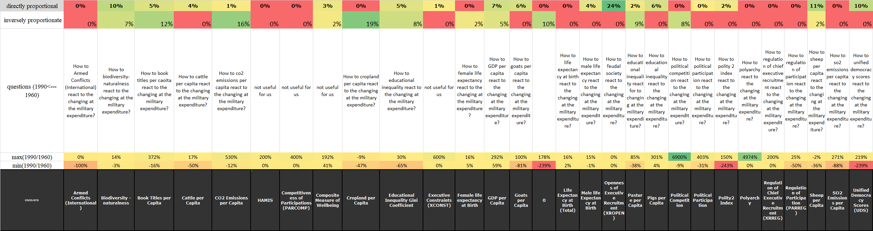

Figure Nr.1 – The explored relationships between each X and the Y variables (source: own presentation)

This is the spreadsheet that I used to make this publication. We can see together data on how changed. In this picture, the numbers speak instead of the word. As we can see in the spreadsheet that different kinds of numbers, I could represent European history.

# **Discussions**

# For me, it would be easier if I don't use spreadsheets because I prefer the written statements and I do not like dealing with numbers instead of the words.

# **Conclusions**

# As I see, the results as numbers are correct, I see the historical fact behind the numbers. I have started to write this publication to prove or not to we can get real information to the high school student and teachers. I think I could do this.

# **References**

* <https://data.worldbank.org/indicator/SP.POP.TOTL?end=2018&start=2018&view=map&year=1960>
* [https://databank.worldbank.org/reports.aspx?source=2&series=SP.POP.TOTL&country=#](https://databank.worldbank.org/reports.aspx?source=2&series=SP.POP.TOTL&country=)
* <https://www.econstor.eu/bitstream/10419/52393/1/67100039X.pdf>
* <https://www.rand.org/content/dam/rand/pubs/reports/2009/R3444.pdf>
* <https://onlinelibrary.wiley.com/doi/full/10.1111/1758-5899.12328>
* <https://books.google.hu/books?id=rYXso9XK1AMC&pg=RA1-PA12&lpg=RA1-PA12&dq=east+germany+female+population&source=bl&ots=VE-scnTjlb&sig=ACfU3U0p5pnWD8kjZij5RTm9mLuKKrTJRw&hl=hu&sa=X&ved=2ahUKEwjr8LWVl67oAhW8TxUIHVakC9Y4FBDoATADegQICBAB#v=onepage&q=east%20germany%20female%20population&f=false>
* <https://books.google.hu/books?id=2FBGAQAAIAAJ&pg=RA14-PA5&lpg=RA14-PA5&dq=west+german+sex+ratio+1960&source=bl&ots=qX9XK6SCPS&sig=ACfU3U1hZVpcekV0F6ce1HnudJ7svk4OVQ&hl=hu&sa=X&ved=2ahUKEwil34q7oK7oAhWKSxUIHUnlDPYQ6AEwBHoECAoQAQ#v=snippet&q=sex%20ratio%20west%20german&f=false>
* <https://www.rand.org/content/dam/rand/pubs/reports/2009/R3444.pdf>
* <https://miau.my-x.hu/myx-free/> (COCO-STD)

# Annexes

More details: <https://miau.my-x.hu/miau/quilt/2020/coldwar_military_expenditure_project/coldwar.xlsx>

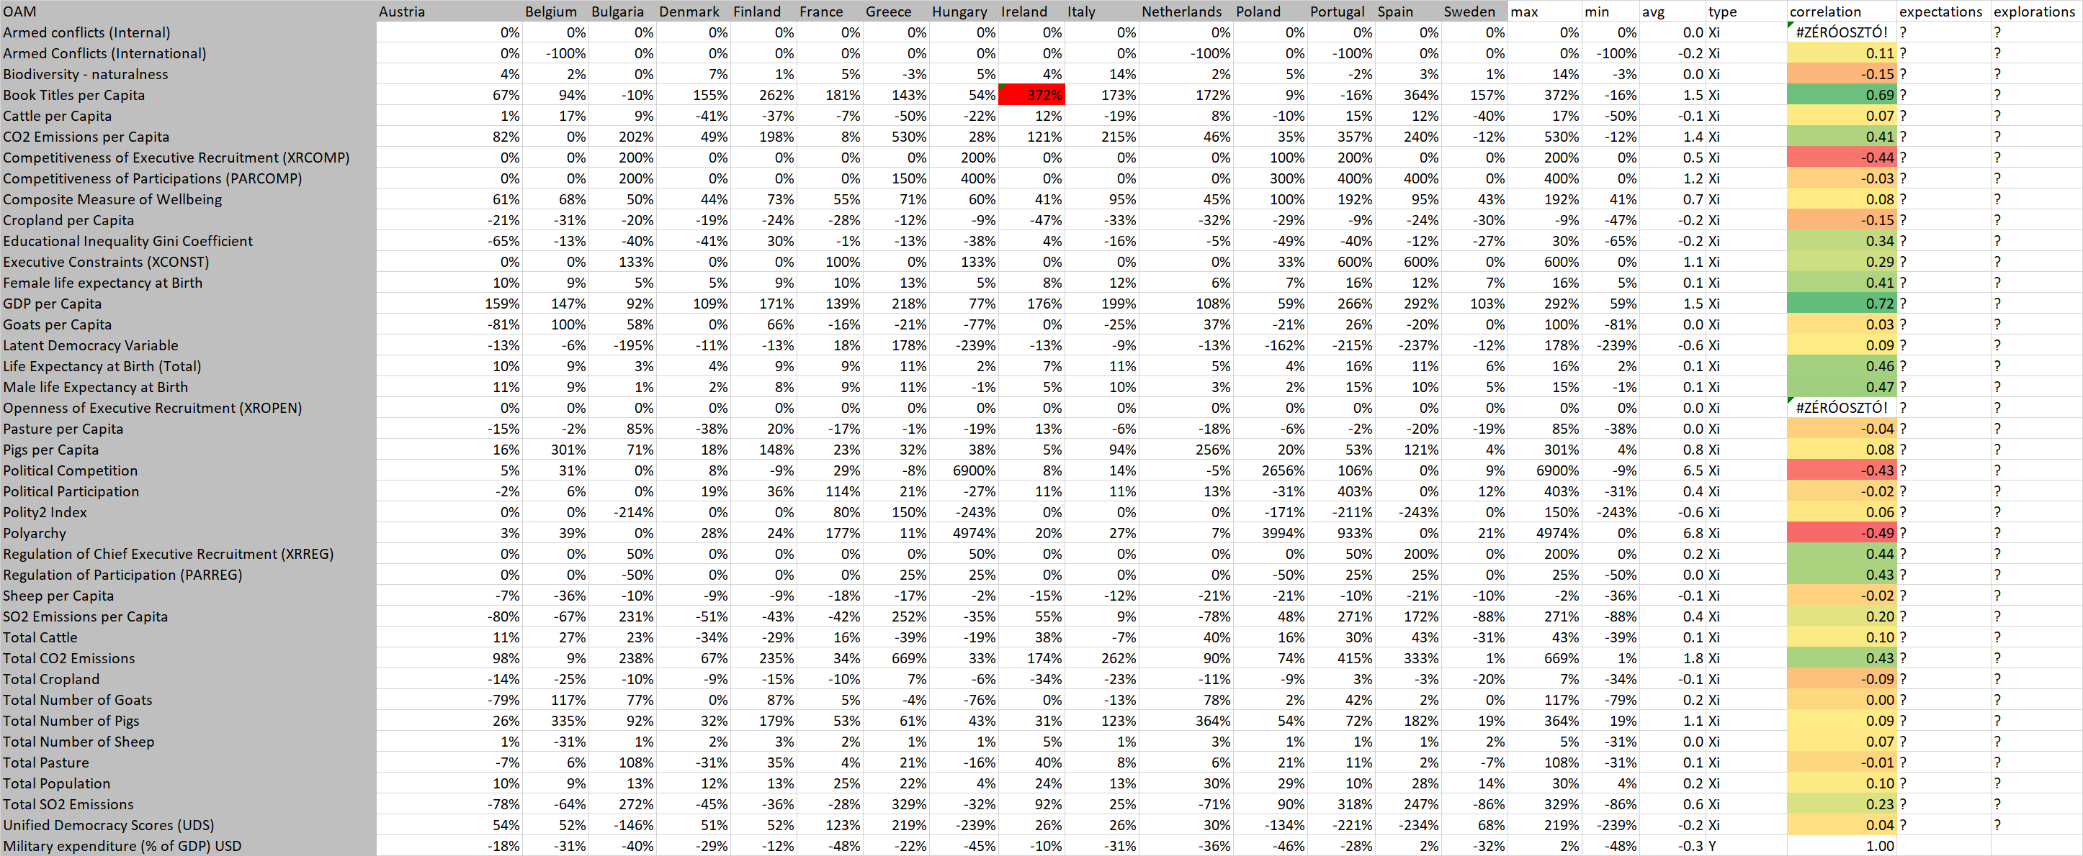

Figure Nr.2 - OAM (with differences and correlations – incl. expectations and explorations) – (source: own presentation)

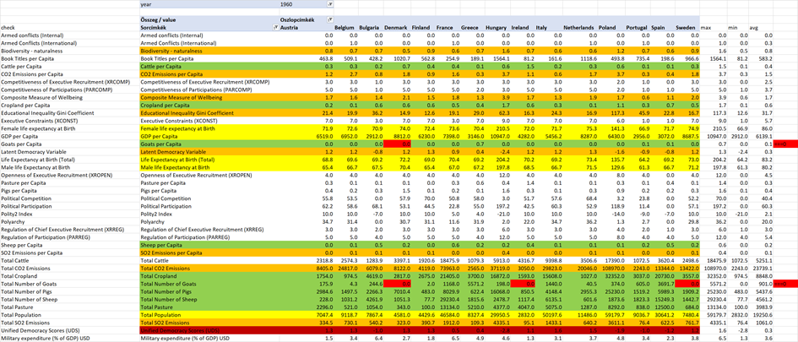

Figure Nr.3 - OAM (1960) – (source: own presentation)

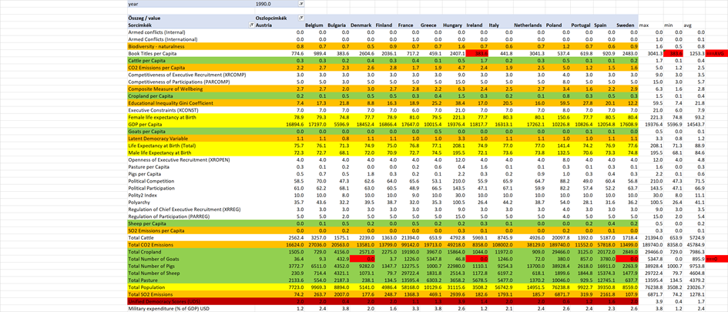

Figure Nr.4 - OAM (1990) – (source: own presentation)