MIAU – HU ISSN 1419-1652 – Special Edition 2020 Spring - Editorials: The papers in MIAU Nr.261 (2020.V) are products of a new education frame system “QuILT” (https://miau.my-x.hu/mediawiki/index.php/QuILT). The goals of QuILT are supporting/conducting Students on the way of KNUTH, who said (1992): Knowledge is, what can be transformed into source code, each other human activity is a kind of artistic performance. It also means we need to leave the world of the magic of words step by step. A solid evidence that we all are capable of going this way is: creating publications behind which the human expertise and the robotized knowledge (like online engines: https://miau.my-x.hu/myxfree/coco/index.html --- offering context free = quasi General-Problem-Solving force fields) can be integrated in case of a rational and relevant decision making scenario. The cyborg effects make possible to face the classic naïve and/or intuitive approaches and parallel the optimized approximations. This way can be realized without deep competences about mathematics, Excel (spreadsheets), statistics, etc. The new (inter/trans/multi-disciplinary) way just expects from us to be able and willing to co-operate with the best moments of the history – it means, with the already prepared robotized elements in order to build something creative one! Parallel, in the second QuILT-semester - https://miau.my-x.hu/mediawiki/index.php/QuILT2_parts - there are not only classic publication possibilities like robotizing the investigative journalism – there are further specific tasks too like 2DM-games, gamification in general, thinking experiments, etc.

Coronavirus publication

**Author**: Várkonyi Sára (IYEOP4)

**Abstract**: In this publication I will show how the coronavirus numbers changed in a month. I will write about the death rates and the infection rates (with different calculations) in my chosen countries: Austria, Belgium, Croatia, Czech Republic, Finland, Germany, Greece, Hungary, Iceland, Ireland, Italy, Netherlands, Norway, Spain, Sweden, Switzerland, and the United Kingdom. These are all European countries, with different populations, healthcare and Covid-19 cases.

**Keywords**: Coronavirus, Death rate, Infection rate, Population, Change in rate

Introduction

In this table I have gathered all the basic informations regarding the pandemic. I have chosen two days with about a month inbetween them, so that I could get an overall picture of how the numbers changed.

|  |  |  |  |  |
| --- | --- | --- | --- | --- |
|  | **Értékek (05.16)** | | **Értékek (06.15)** | |
| **Sorcímkék** | **Összeg /cases** | **Összeg / deaths** | **Összeg / cases** | **Összeg / deaths** |
| **Europe** | **1095676** | **124469** | **1234061** | **138377** |
| Austria | 16068 | 628 | 17038 | 677 |
| Belgium | 54644 | 8959 | 60029 | 9655 |
| Croatia | 2222 | 95 | 2252 | 107 |
| Czechia | 8406 | 295 | 10024 | 329 |
| Finland | 6228 | 293 | 7104 | 326 |
| Germany | 173772 | 7881 | 186461 | 8791 |
| Greece | 2810 | 160 | 3121 | 183 |
| Hungary | 3473 | 448 | 4076 | 563 |
| Iceland | 1802 | 10 | 1810 | 10 |
| Ireland | 23956 | 1518 | 25303 | 1706 |
| Italy | 223885 | 31610 | 236989 | 34345 |
| Netherlands | 43681 | 5643 | 48783 | 6059 |
| Norway | 8197 | 232 | 8606 | 242 |
| Spain | 230183 | 27459 | 243928 | 27136 |
| Sweden | 29207 | 3646 | 51614 | 4874 |
| Switzerland | 30431 | 1594 | 31034 | 1676 |
| United_Kingdom | 236711 | 33998 | 295889 | 41698 |
| **Végösszeg** | **1095676** | **124469** | **1234061** | **138377** |

The first coloumn shows the given countries, the second shows all the Covid-19 cases up to 16th of May, the third shows all coronavirus deaths until 16th of May. The fourth coloumn shows all the cases up to 15th of June and the last one shows the numbers of the updated deaths.

Death rate

Everybody can Google the exact death rate of the pandemic but I wanted to observe it from a different angle. Usually death rates are given per 1000 people. What I have done however, was taking the nuber of deaths in each counrty and divided them by the numbers of all of the infections. This way I got a number that indicated the amount of deaths compared to the actual cases. I analysed the death rate within the number of the infected people.

Then, I have compared these percentages with the numbers from one month later , and I could see a change in the rate of deaths. In the table below, I highlighted the growth rates in green and the shrinking in pink.

Growth in these rates mean that the death rate is higher now than it was a month ago, and shrinking means that there are less deaths in those certain countries.

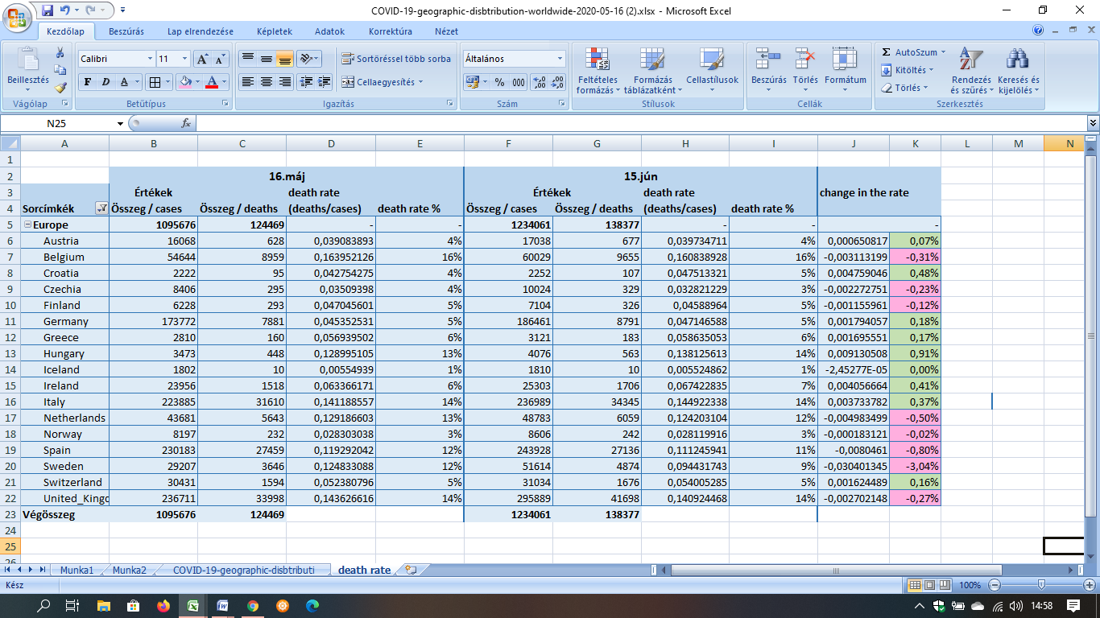

1. figure: Death rate of Covid-19 (where death rate is calculated by dividing the total number of deaths with the total number of cases) source: <https://www.ecdc.europa.eu/en/publications-data/download-todays-data-geographic-distribution-covid-19-cases-worldwide>

I also wanted to see how different countries’ deaths were compared to the number of the population. Again, I did not calculate the proper death rate, but instead I came up with numbers that show how each country’s deaths grew in the past month. Greece had the least bit of growth which indicates that they have had the least deaths compared to the population, and the United Kingdom’s numbers were the highest, which means that they have had the most fatalities compared to the population.

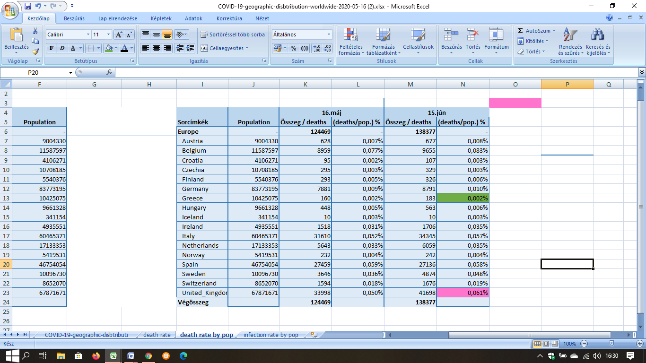

2. figure: Death rate (where we divide all deaths with the population’s number, and get a percentage of the growth)

Source: own calculations, and <https://www.worldometers.info/population/europe/> for the exact population numbers

Rate of Infections

I also wanted to see how the numbers of coronavirus infections were. I calculated the infection rate by dividing all cases with the population. The percentage I got this way shows the rate of infections, the number of people that got ill compared to the number of people that live in the given country.

The third figure shows a table with these said calculations. I still worked with the data from the 16th of May and the 15th of June. I also added an extra column with the total growth of infections in this one month span.

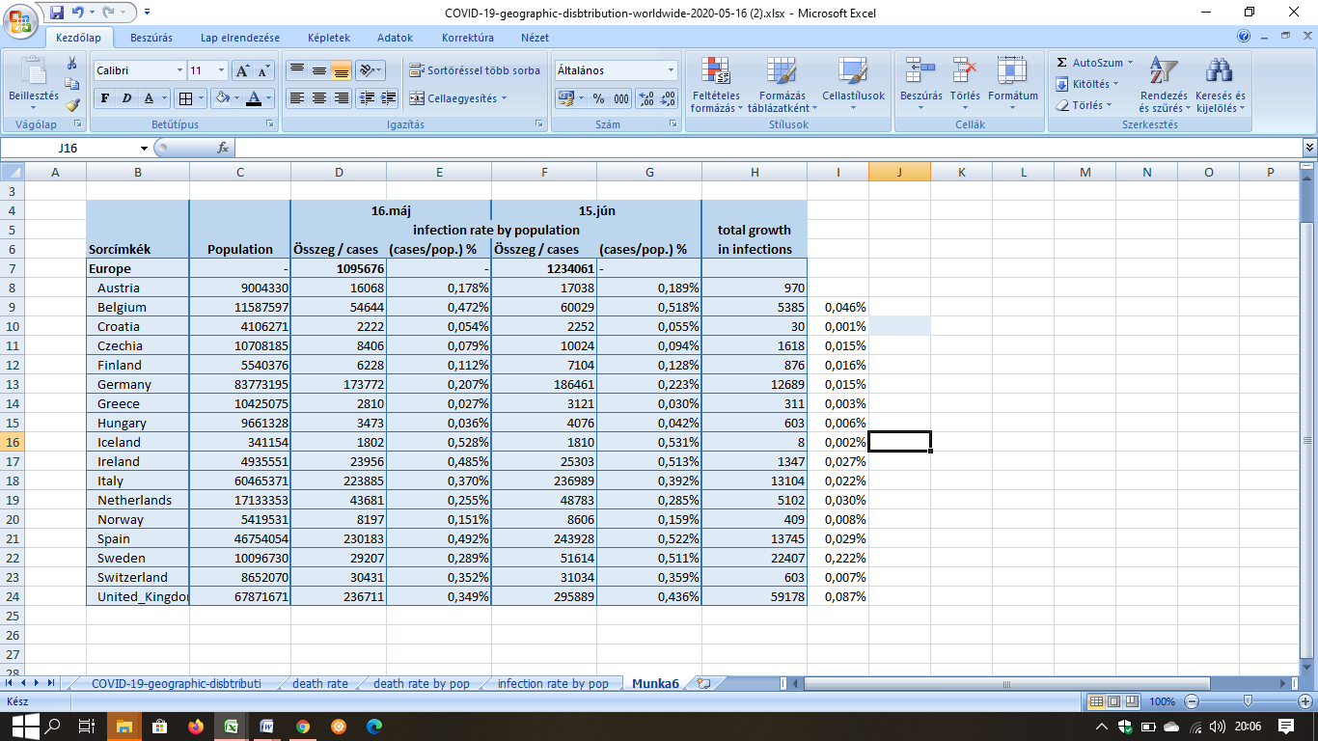

3. figure: Infection rate by total poulation (what percentage of given country's population got infected with the Coronavirus)

Source: my own calculations.

In the table below I took these results even further, and calculated the change of the infection rate in the past month. The green number shows that Greece had the lowest percentage of infection cases by the number of the population, and the pink highlight indicates that Iceland had the most cases compared to its’ population.

The change in rate column shows how these percentages had changed in one month. The lowest this number is, the more consistent the country’s health care is, and had the least bit of change since May. When these percentages seemingly change a lot, that means that country had rising numbers of infections.

Even though the UK has had the most cases on my list, Sweden’s number is a lot higher when we look at the rates. This is due to the fact that there are more than 6 times more people living in the UK than in Sweden, and when we compare the infection numbers with the population, their rate comes out the highest. Croatia has had the lowest change in the infection’s rate, which means that they registered the least cases in the past month (compared to the population).

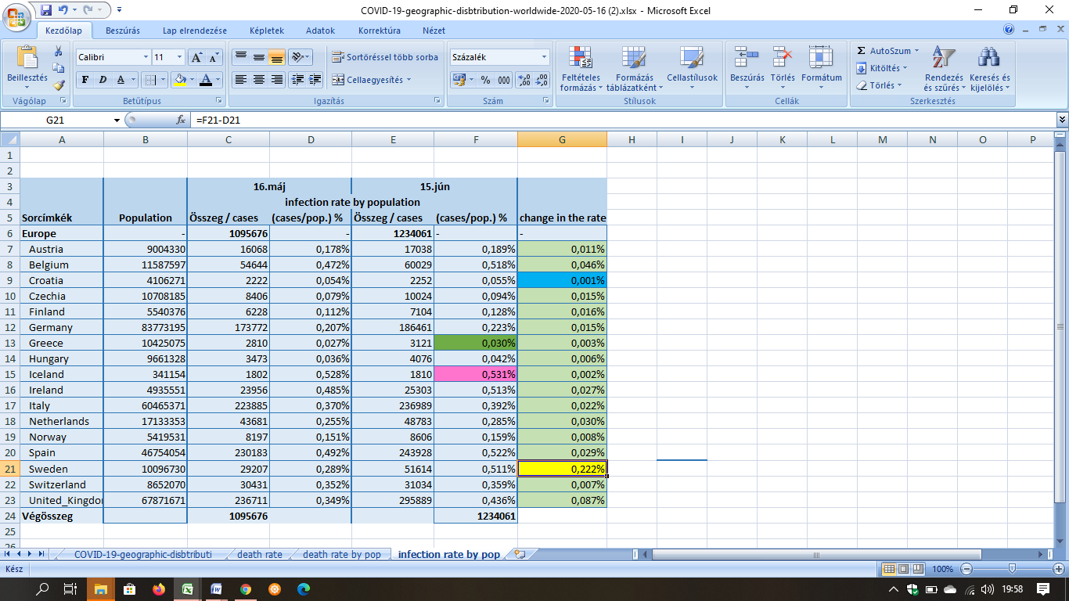

4. figure: Change in the rate (where I subtracted the May 16th data from June 15th)

The lower numbers indicate fewer cases registered in the past month.

Source: my own calculations.

Best Results (all things considered)

I gathered all the information from the tables that I have worked on and made a final one, presenting all the collected data and the changes in the rates (infection and death). The blue columns indicate the death rate calculated from dividing all the deaths with all the infections in the given countries, the greens show the death rate of the population, and the pinks show the infection rates from dividing all cases with the population.

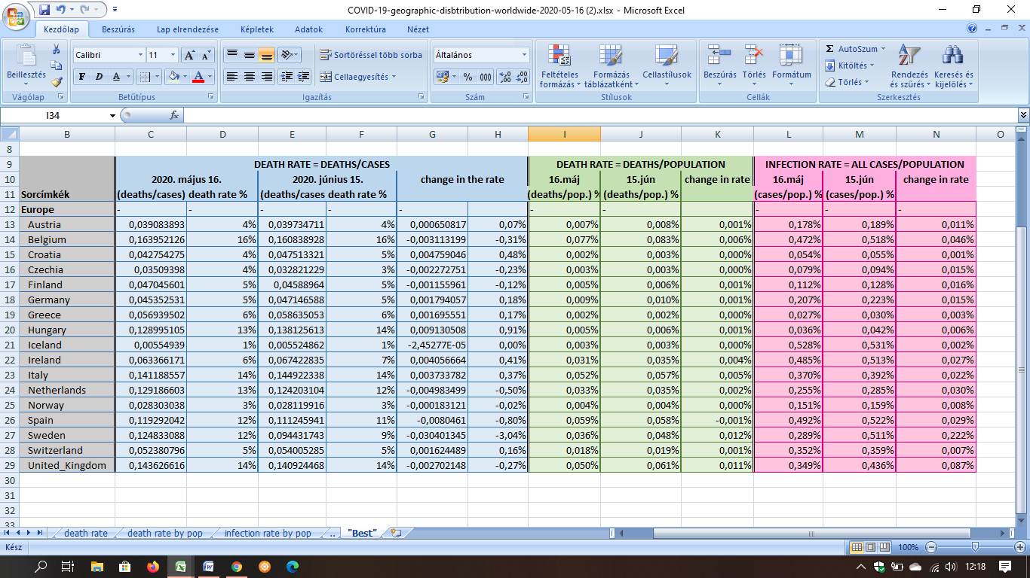

5. figure: Collective data table (gathering information from previous tables) Source: own calculations

Then I had a look at the numbers and highlighted the “best results” with yellow, in the columns that showed the difference from the previous month.

In the third column (death rate) I highlighted Iceland and Norway. Their numbers were the lowest from the list, meaning that they have had the least amount of deaths considering the number of all cases.

Then, in the next column I highlighted the negative changes in the rate (negative change means a drop in the death rate, as in fewer deaths).

In the 6th column I highlighted Greece because they had the lowest rate, meaning they have had the least death cases/population.

In the following column I focused on the lowest changes in the rate. The lower the rate is, the less people died in one month’s span.

In the 9th column I highlighted Greece again. Their infection rate was the lowest of the list.

And finally, in the last column I highlighted the lowest changes in the infections’ rate. The lower rates mean that those countries had the least infections in the previous month.

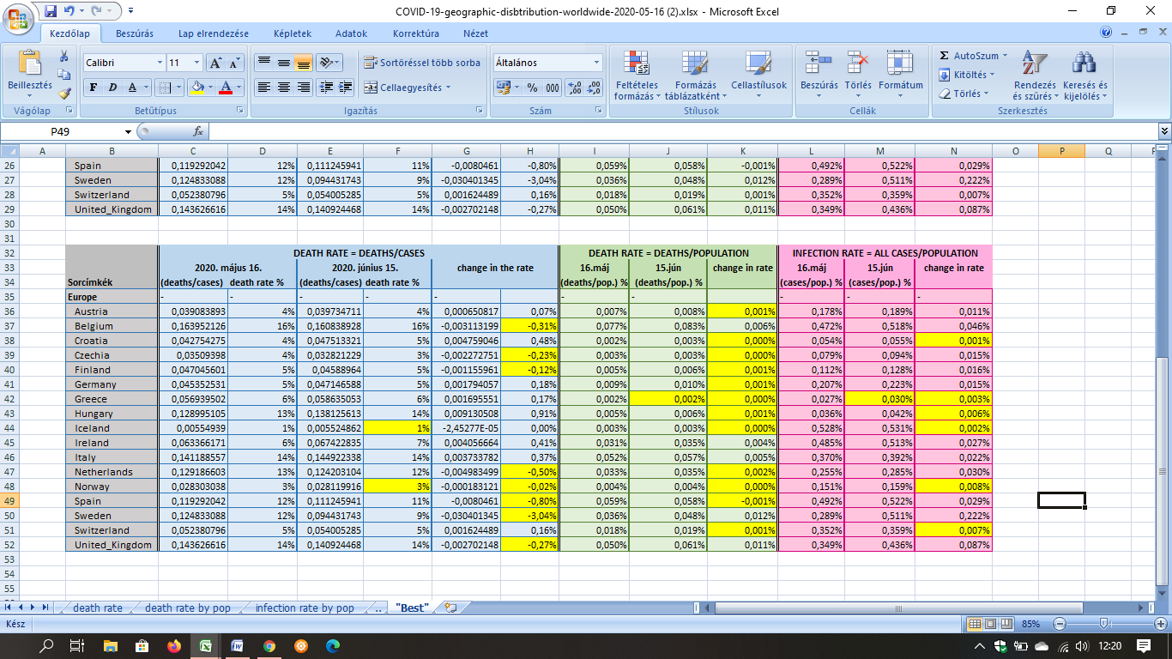

6. figure: Best cases – highlighted (source: own presentation)

According to this table I could easily find out which country had the best results overall. I highlighted more than one country in almost all categories, but two of them stood out the most: Greece and Norway. These two countries were the ones that had the most highlights in their row, meaning that they have had the most “best cases” of all the countries on my list.

Both countries had restrictions from the beginning of this pandemic, and had very low fatality numbers. This is probably due the fact that both of them closed everything very early on to stop and cut all the possible ways the virus could spread and many people were tested to filter the Covid-19 cases.

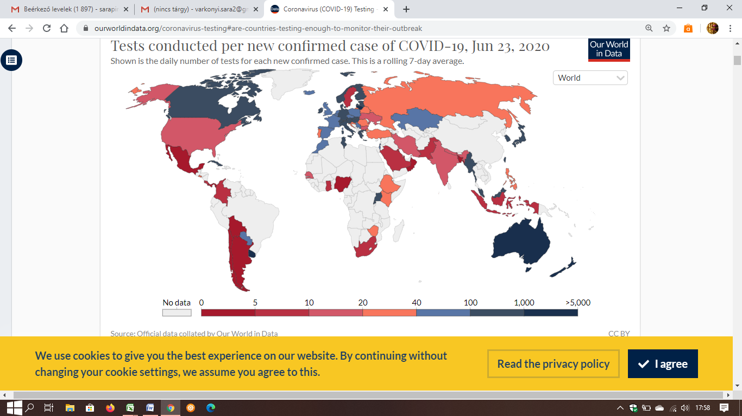

7. figure: Amounts of tests per new cases

Source: <https://ourworldindata.org/coronavirus-testing#are-countries-testing-enough-to-monitor-their-outbreak>

Not just out of the countries on my list but in the whole world, these two countries performed very well compared to others.

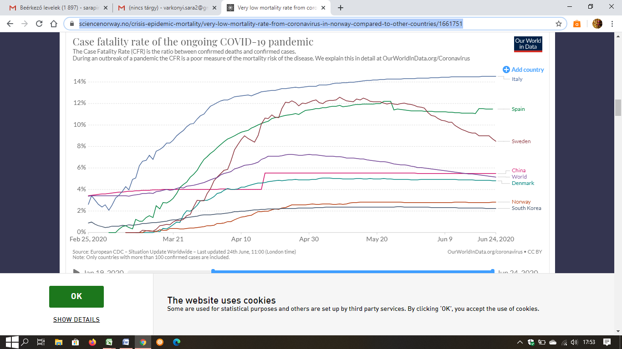

8. figure: Fatality rate in the World

Source: <https://sciencenorway.no/crisis-epidemic-mortality/very-low-mortality-rate-from-coronavirus-in-norway-compared-to-other-countries/1661751>

Conclusion

In conclusion, out of the countries that I had examined Greece and Norway came out as “winners” (see Annex). In the previous table I highlighted 4-4 “best cases” at each of their rows and they have had the least cases, or slightest changes in the rates leading them to be the most suitable for a pandemic.

In the last table below, I highlighted these winners in purple, so the difference between their numbers and others’ is visible.

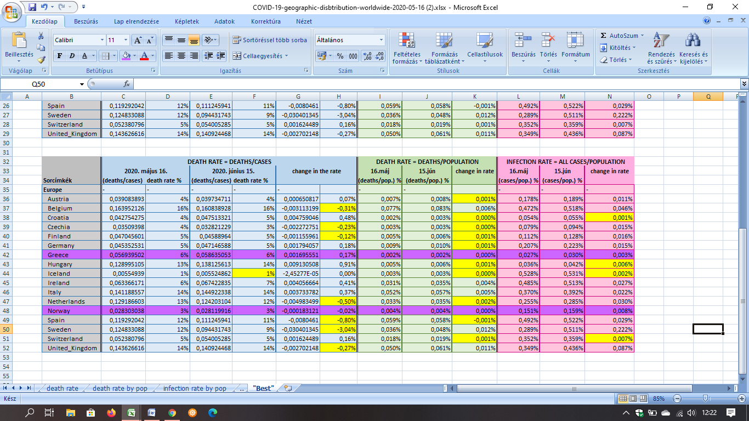

9. figure: The “winners” of Best cases highlighted in purple – source: own calculations

References:

<https://sciencenorway.no/crisis-epidemic-mortality/very-low-mortality-rate-from-coronavirus-in-norway-compared-to-other-countries/1661751>

<https://sciencenorway.no/epidemic-mortality-virus/norways-mortality-rate-during-the-coronavirus-pandemic-is-probably-lower-than-usual/1678780>

<https://time.com/5824836/greece-coronavirus/>

<https://www.ecdc.europa.eu/en/publications-data/download-todays-data-geographic-distribution-covid-19-cases-worldwide>

<https://www.worldometers.info/population/europe/>

Annexes

<https://miau.my-x.hu/cocoy0>

<https://miau.my-x.hu/miau/quilt/2020/covid19_project/COVID-19-geographic-disbtribution-worldwide-2020-05-16%20(2).xlsx>

