MIAU – HU ISSN 1419-1652 – Special Edition 2020 Spring - Editorials: The papers in MIAU Nr.261 (2020.V) are products of a new education frame system “QuILT” (https://miau.my-x.hu/mediawiki/index.php/QuILT). The goals of QuILT are supporting/conducting Students on the way of KNUTH, who said (1992): Knowledge is, what can be transformed into source code, each other human activity is a kind of artistic performance. It also means we need to leave the world of the magic of words step by step. A solid evidence that we all are capable of going this way is: creating publications behind which the human expertise and the robotized knowledge (like online engines: https://miau.my-x.hu/myxfree/coco/index.html --- offering context free = quasi General-Problem-Solving force fields) can be integrated in case of a rational and relevant decision making scenario. The cyborg effects make possible to face the classic naïve and/or intuitive approaches and parallel the optimized approximations. This way can be realized without deep competences about mathematics, Excel (spreadsheets), statistics, etc. The new (inter/trans/multi-disciplinary) way just expects from us to be able and willing to co-operate with the best moments of the history – it means, with the already prepared robotized elements in order to build something creative one! Parallel, in the second QuILT-semester - https://miau.my-x.hu/mediawiki/index.php/QuILT2_parts - there are not only classic publication possibilities like robotizing the investigative journalism – there are further specific tasks too like 2DM-games, gamification in general, thinking experiments, etc.

# Sanbayeva Aidana

# Eurovision - event tourism (festivals) as an attractor

# Abstract

Tourism provides the opportunity to travel across the country, as well as provide services related to the provision of services. As they grow and bolster tourism is also getting diversified and more modern. One of the diversified parts of tourism is an event, which is also important and indivisible for society. This paper examines event tourism by definitions and classification depending on researches made by Getz, Babkin, etc. The goal of this paper is to address the positions of events in contemporary tourism and to identify their sources, description, tourist interest, impacts, and outcomes.

The used methodology makes possible to follow the KUNTH’s principle: knowledge is what can be transformed into source code. Here and now, it means: strategic planning needs AI-based, big-data-driven models in order to derive different forms of touristic potentials.

Keywords: AI, robot-analyst, production function, similarity analyses, big-data

INTRODUCTION

Event tourism is a unique tourist offer that includes participation in the world's most interesting events in addition to traditional recreation. These tours are becoming increasingly popular and more and more people are appearing who want to spend as interesting as possible on their holidays or weekends.

Organizing tourism events has a positive effect on the area of the country by raising economic income on the basis of sales from the selling of goods and services of the different activities related to the event by increasing the number of visitors, which increases the quality of restaurants and facilities.

In this paper definition and further development of the event tourism, types, impacts and brief elaboration of each type will be discussed. The emphasis is on comparison of events with another destination based on events and expert assessments of tourism itself and how countries encourage tourism through events.

Since the main attention in this work will be given to the study of a specific type of event events - festivals, we will consider them in more detail. The festival is a mass celebration, showing the achievements of amateur and professional creativity, with which you can attract the attention of the target audience. The festival involves varying target groups using thematic focus and content. The advantage of this type of event is the large audience coverage, a festive atmosphere, and most importantly, the creation of positive emotions among the participants.

Event tourism includes the following components: event as a basis, infrastructure, advertising and promotion, a tourist and information center, attractions associated with international organizations Since the focus will be on the study of entertainment and accessibility, which, interacting with elements of the external environment.

LITERATURE

DEFINITION AND CLASSIFICATION OF EVENT TOURISM

An important feature of special events is the emotional component, personal impressions of the participants, the feeling of a single emotional upsurge, which involves visitors in the territory's value system. If in the process of this contact the participant receives positive emotions, then he spreads his impressions to the territory as a whole, which contributes to the creation of a positive image of the place, a favorable attitude towards the population as well as local enterprises, and to future events.

Researchers have provided multiple interpretations of the "events":

* Donald Getz (2008) has described events as "a spatial-temporal process, each of which is unique due to relationships between environments, individuals and management processes like structural elements and the plan. Part of the charm of experiences is that they are rarely the same, so to truly enjoy the unforgettable experience you have to 'be there;' if you miss it, it is a missed chance.'
* The Accepted Practices Exchange Industry Glossary of TERMS (APEX, 2005) describes an event as "a coordinated occasion such as a conference, gathering, exhibition, special engagement, gala dinner, etc. An occurrence is always made up of many distinct but connected functions.
* Goldblatt (2005) reflects on special occasions as "a rare moment in time, marked with pomp and tradition to fulfill individual needs." Getz (2008) argues that occasions are spatial-temporal anomalies and that each is distinctive because of relationships with the environment, participants and management processes, including architectural elements and the plan. He emphasizes the fact that the greatest appeal of activities is that they're never the same and that the visitor needs to "be there" to truly enjoy the experience. He proposes two interpretations, from the event organizers' viewpoint, as well as the guests':

1. A special occurrence is a one-time or rarely occurring occurrence outside of the sponsoring or coordinating the body's usual programs or events.

2. A special occasion is an opportunity for the client or visitor to enjoy recreation, social or cultural experiences beyond the usual set of options or outside the daily life.

"Event Tourism is formal planning, creation and promotion of festivals and special activities, such as tourist attractions, identity creators, infrastructure and economic growth catalysts, and designed attraction animators" (Getz & Wicks, 1993).

Donald Getz (2008) placed tourism events between tourism management-tourism studies and event management-studies of the event. Tourism management deals with the growth of tourism by evaluating the actions and inspiration of visitors of any kind. On the other hand, event management deals with planning, organizing and managing an event. Also, seek to grasp and control the perspectives of the case. Event tourism is thus in the midst of both sectors. In other words, event tourism seeks to leverage the potential of events to the full in order to support the growth of tourism in host communities. Event tourism managers must take into account all the aspects of event management and conduct sedulous work on event management from a tourism perspective. Today, 'event tourism' is widely accepted as involving all scheduled activities in an organized approach to growth and marketing. Event tourism is somewhat similar to other unique types of tourism. This is why it is important to examine the market for tourism and the supply side in the event (Getz, 2008). The demand-side research must be carried out by who flies to events and who are the intentions of such travelers. According to various researchers, there are several domains of event tourism motivation: escape, novelty, family unity, socialization, excitement, etc. (Uysal, Gahan & Martin, 1993; Mohr, Backman, Gahan & Backman, 1993; Crompton & McKay, 1997; Formica & Uysal, 1996; 1998; Lee, 2000; Kim, Uysal & Chen, 2002; Lee, Lee & Wicks, 2004). In fact, from the supply side view, activities should be handled and controlled successfully in order to generate positive impacts and the adverse effects of organizing an event.

Events will have a positive effect on the economy, tourism, community and culture of the hosting city. In the first location, activities raise income for the region and build jobs (Yolal, Cetinel & Uysal, 2009). They also contribute to tourism as a tool for destination marketing and promotion by increasing awareness of the region and as a catalyst for the creation of new accommodation and tourist infrastructure. Furthermore, the socio-cultural impacts of activities such as: an improvement in living conditions, an increase in social identity and civic spirit, an increase in political engagement, a strengthening of the culture and beliefs of the hosting area (Hall, 1992; Arcodia & Witford, 2006). The enhancement of the area's connectivity and facilities will also have a positive effect on the environment. On the other hand, activities may negatively affect the hosting area (increased costs and crime during the event time, the poor reputation of the region due to inadequate facilities, etc.). The following table (Table 1) describes the impacts of event tourism in five major categories: cultural, tourism/commercial, physical/environmental, psychological and political/ administrative.

#### Table 1. Event Tourism Influence

|  |  |  |
| --- | --- | --- |
| **Types of influence** | **Positive Influence** | **Negative Influence** |
| *Economic* | * Increased expenditures * Creation of employment * Increase in labor supply * Increase in standard of living | * Price increases during the event * Real estate speculation * Failure to attract tourists * Better alternative investments * Inadequate capital * Inadequate estimation of costs of the event |
| *Tourism/ commercial* | * Increased awareness of the region as a travel/tourism destination * Increased knowledge concerning the potential for investment and commercial activity in the region * Creation of new accommodation and tourist attractions * Increase inaccessibility | * Acquisition of a poor reputation as a result of inadequate facilities, improper practices or inflated prices * Negative reactions from existing enterprises due to the possibility of new competition for local manpower and government assistance |
| *Physical/ environmental* | * Increase in the permanent level of local interest and participation in types of activity associated with the event * Strengthening of regional values and traditions | * Commercialization of activities which may be of a personal or private nature * Modification of nature of event or activity to accommodate tourism * Potential increase in crime * Changes in community structure * Social dislocation |
| *Psychological* | * Increased local pride and community spirit * Increased awareness of non-local perceptions | * The tendency toward defensive attitudes concerning the host region * Culture shock * Misunderstanding leading to varying degrees of host/visitor hostility |
| *Political/ administrative* | * Enhanced international recognition of region and values * Development of skills among planners | * Economic exploitation of the local population to satisfy the ambitions of the political elite * Distortion of the true nature of the event to reflect elite values * Failure to cope * Inability to achieve aims * Increase in administrative costs * Use of event to legitimate unpopular decisions * Legitimation of ideology |

Source: Hall (1992)

## Classifications of event tourism

The Getz case classification system is one of the most frequently quoted classifications. Getz (2008) grouped activities into eight major categories according to their meaning, type and program as;

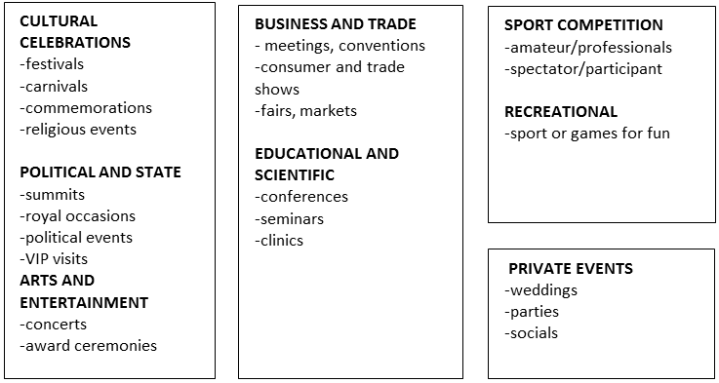

Table Nr.3.

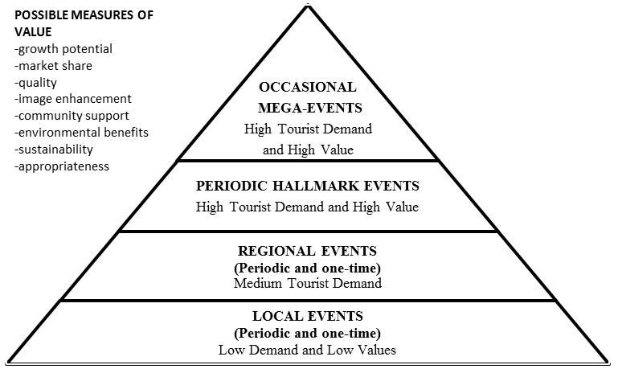

Figure Nr.1.

Based on Babkin’s research there are several thematic types of event tourism:

|  |  |
| --- | --- |
| National Festivals and Holidays:  - St. Patrick's Festival in London (Great Britain);  - St. Patrick's Festival in Dublin (Ireland);  - festival of cultures in Berlin (Germany);  - Pride London parade of sexual minorities in London (UK);  - Love Parade in Berlin (Germany);  - Pride Amsterdam sexual minority parade in Amsterdam (Netherlands);  - Parade of military tattoos in Edinburgh (Scotland);  - Celebration of the birthday of Napoleon Bonaparte, Ajaccio (Corsica); | Theatrical shows:  - holiday on ice, Romanza show (Germany);  - show Lord of the Dance (Great Britain);  - a feast on ice, the Mystery show (Germany);  - festival "Circus of the Future", Paris (France);  - holiday on ice, Romanza show, Vienna (Austria); |
| Film and Theater Festivals:  - Short film festival in Oberhausen (Germany);  - Cannes Festival, Cannes (France);  - Theatrical festival Spierlart, Munich (Germany);  - festival "Cherry Forest", Moscow (Russia);  - Opera Festival, Verona (Italy); | Gastronomic Festivals:  - International Beer Festival, Berlin (Germany);  - Great British festival, London (Great Britain);  - Oktoberfest, Munich (Germany);  - seafood festival, about in Grove (Spain);  - Feast of the young wine of Beaujolais Nouveau (France);  - Paris Chocolate Salon, Paris (France); |

|  |  |
| --- | --- |
| Festivals and Flower Shows:  - flower show in Chelsea, London (Great Britain);  - flower exhibition at Hampton Court Palace, London (UK);  - Chrysanthemum Festival (Japan);  - exhibition of tulips (Netherlands);  - Bonsai Festival, Nara (Japan); | Fashion Shows:  - Ready to Wear, Paris (France);  - Men s Fashion, Paris (France);  - Milano Moda Bouna, Milan (Italy); |
| Auctions:  - Sotheby's auctions;  - Christie's auctions;  - auctions Drouot, Paris (France); | Music Festivals and Music Competitions:  - Caprices festival, Crans Montana (Switzerland);  - Festival Ars Musica, Brussels (Belgium);  - Festival "Snow and Symphony", St. Moritz (Switzerland);  - TDK TIME WARP festival, Mannheim (Germany);  - Festival of Pop Music Pink Pop, Landgraaf (Netherlands);  - Jazz Festival in Montreux (Switzerland);  - Festival of music and arts in Henley (Great Britain);  - Jazz festival in Stockholm (Sweden);  - Music competition to them. P.I. Tchaikovsky, Moscow (Russia);  - Music contest "Eurovision"; |
| Sporting Events:  - Olympics and international competitions;  - Formula 1 auto racing;  - NASCAR auto racing, USA;  - Rally;  - Motorcycle racing; | International Technical Salons:  - air show in Le Bourget, Paris (France);  - aerospace show in Zhukovsky (Russia);  - air show in Zhuhai (China);  - air show on the island of Langkawi (Malaysia);  - Motor show in Geneva (Switzerland);  - a car dealership in Moscow (Russia);  - "Watch Salon", Geneva, Zurich (Switzerland). |

Table Nr.4.

THE ROLE OF ATTRACTORS IN TOURISM

Global experience shows that well-organized and marketed event tourism activities can become an aspect of a positive picture of a city, area, and nation as a whole. The United States, France, Germany, Italy, Great Britain, Australia, and South Korea are known as pioneers in planning event tourism. To date, activities have become the staple of the economic development of several dozen destinations. Every year the tourism infrastructure of the event is updated with new events that attain iconic and annual status.

Events can be classified according to their tourism attractiveness. Even if most activities are tourist-driven, there are a small number of those with little to no consideration is given to their appeal to capacity for tourism. Getz (2008) states that this is either due to the particular goals of the organizers, or the relationship between specific events and tourism is clearly not known. They can be divided into three following groups according to the attractiveness of events for tourism:

1. Festivals and events planned exclusively for area people and mostly with the aid of volunteers. While, in most instances, these activities are small and have little to no tourist attractions, they can also serve as a great resource for tourists to the city. However, most local activities do not need to be tourism-oriented; their organizers also feel threatened by it and take pride in their non-commercial affairs. This should not come as a shock given that they are community-based and culturally focused, and that mass tourism will have possible detrimental impacts which would possibly distort their credibility.
2. Events of national and local importance that could have considerable potential for tourist attraction. Such events are rarely meant to be larger. Nevertheless, their tourism potential can be established with the aid of visitors drawn to the event and possible investments. The activities in this category typically have professional personnel.
3. In terms of travel, events of national and international interest are most enticing. Such activities draw both national and foreign visitors and will further improve a certain destination's prestige and attractiveness. In comparison to local events, their primary aim is to enhance the tourist attraction of the host city.

Mega Events

Mega sporting activities should be illustrated in a specific way between all things that are appealing to visitors. Olympics, World and European Football Championships, British Commonwealth Games, Asian and Pan American games typically feature fantastic sports competitions. The Olympic games have been regarded as a vehicle for tourism as the world's oldest and most prestigious mega sporting event. That is because they are capable of establishing high profiles for the host cities and drawing visitors even after the games. The host city typically enhances tourism capacity, develops tourism facilities and launches new tourism goods, and uses marketing techniques through the Olympic Games. These initiatives are aimed not only at raising demand for tourism, but also attracting new buyers and repositioning the hosts to the global tourism board. Despite the fact that the Games are a special experience for this country, the effect on all facets of the life of host cities is important and long-lasting. The modern history of the Olympic Games may show how tourism and image production influenced host countries. The Sydney Olympic Games in 2000 offered Australia's tourism industry tremendous advantages. Increased foreign visits were the first apparent consequence. There was a 16 % increase between 1998 and 2002, two years before and after the games.

The International Olympic Committee called Sydney 2000 "The Greatest Ever Olympics." The Tourism Policy of the Australian Tourism Commission (ATC) has given huge benefits for tourism in Australia.

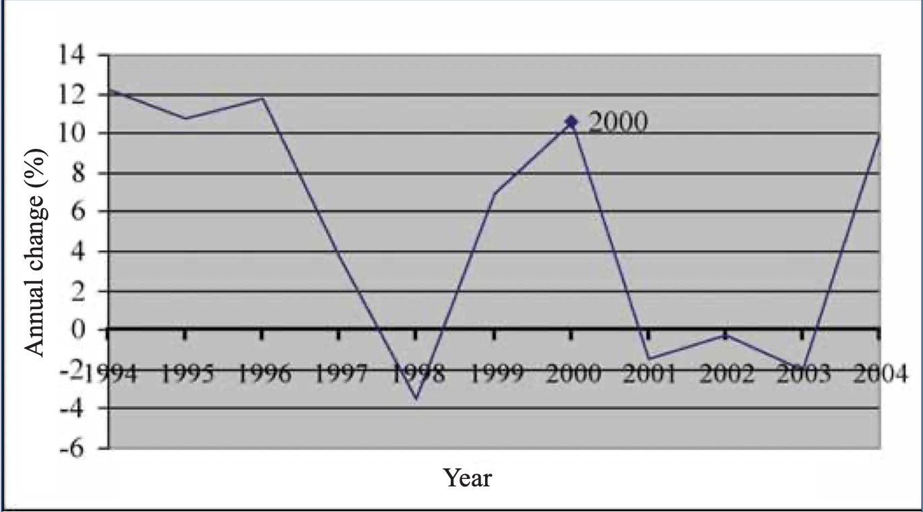

Figure Nr.2.

Two years prior to the Games, the "name Australia" campaign was introduced to increase the potential number of visitors, money spent and the identity of the region. The plan of the post-Games comprised four main components, which directly addressed Australia's success during the Match. These components were: a) designing cooperative campaigns with over 200 business partners; b) undertaking over 90 collaborative targeted promotional campaigns to support village sales, launched shortly after the Games; c) an ambitious direct marketing strategy to rebuild and upgrade Australia's website, Australia.com.

Thus, the following data was identified by the sociological study approach of international tourists, who visited Sydney during the Olympic Games in 2000: 88% of the 110,000 visitors of the city wished once again to visit Australia as tourists; about 50% of those surveyed from America showed interest in a second return to Australia.

In comparison, since the Olympics, traffic to the Australian Tourist Commission website has increased by nearly seven times, showing a proportionate growth in interest in the tourism potential of the region.

Another example is the 2014 Winter Olympic Games which took place in Sochi, Russia. In the first place, winter games are almost four times smaller than the summer games. In order to achieve a) a quantitative growth and enhanced quality of the placement objects, tourism infrastructure is developed; b) the number of hotels that belong to the hotel chains in the world; c) the introduction of new show items and entertainment facilities (including Olympic Games). The Russian government prepared a plan and sports and recreation facilities and their contact assistance were planned in a timely manner as a part of the implementation of the program. Following the Sochi Olympic Games, the tourist heritage has provided real prerequisites for tourism growth in the town of Sochi and the Krasnodar region at a modern, higher quality level.

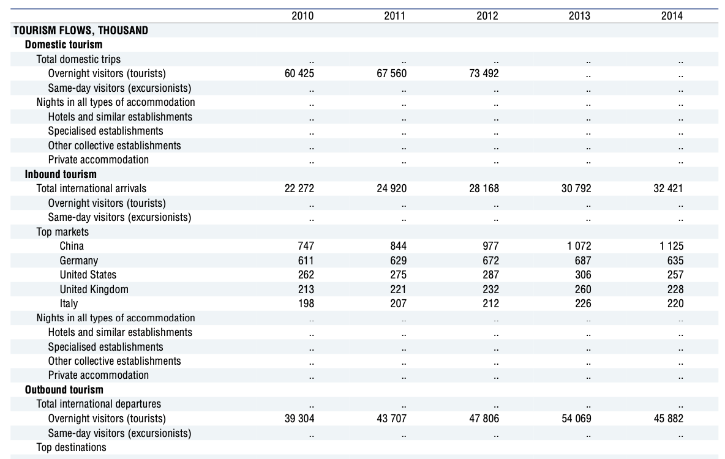

*Source:* OECD Tourism Statistics (Database).

Figure Nr.3.

32.4 million foreign arrivals were registered in Russia in 2014. This is 5% more visitors worldwide than it was in 2013. The total number of visitors to Russia for recreational tourism decreased by 3%. However, business visits increased by 8%. Around the same time, outbound tourism from Russia declined dramatically in 2014 by 15.1% compared to the last year.

The destination used to have tourists only during the summer months before the Olympic Games, particularly in August. In total, however, the 2014 Winter Olympic Games had drawn over three million people visiting Sochi in 2014 – a rise of 28 percent year-on-year. In addition to the 2014 Olympic Winter Games, new activities like the Russian Grand Prix have helped raise the number of spectators, with 65,000 people watching the opening race in Sochi in October. The event was set to visit the Sochi Autodrom circuit which will prove to be a fascinating choice for F1 fans worldwide for three important reasons: Sochi has the scenery, atmosphere which F1 fans are looking for, it's an alternative to the normal destinations and will be much cheaper. Since then, for visitors from 120 countries, Sochi has remained an enticing destination. It increased a daily direct air connection with neighboring countries and within Russia.

# Music Festivals

Music festivals have recently become popular with activities taking place around the world. As music festivals are giving the appreciators an amazing experience and the sensation of being alive right now, they continue to attend more and more festivals. Music festivals all over the world attract some hundred thousand music appreciators. They are held each year and last for several days or a week.

The Sziget Music Festival started as Deaksziget or Student Island in 1993 and takes place in Budapest, Hungary, for one week in August each year. It is also one of the most loved and attended music festivals in Europe. More than 1,000 musicians from 62 countries participated in the festival. This can be seen that 50% of Sziget tourists are Hungarians and most of the other half are from the Netherlands, but this festival is also targeted at people of the United Kingdom, Belgium, France, Italy and Germany.

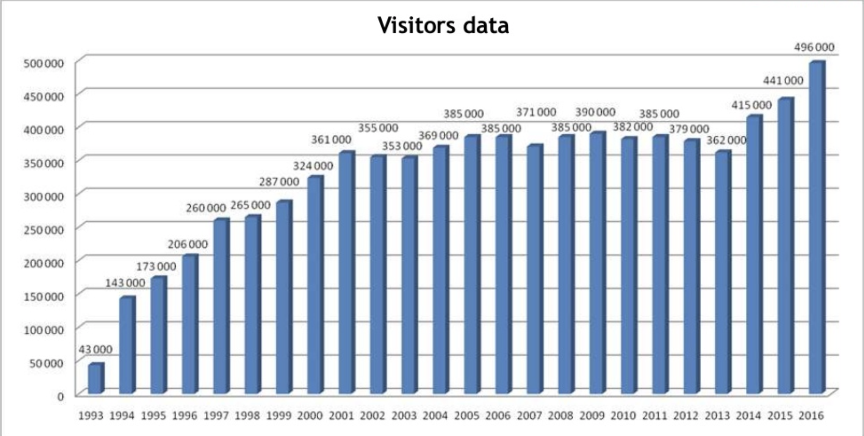

*Source*: <https://en.wikipedia.org/wiki/Sziget_Festival>

Figure Nr.4.

The number of tourists is rising per year and hit its highest in 2018 with 565,000 tourists. Last year's attendance was low at an estimated 530,000 visitors. As a result, the Sziget Festival has been one of the five most preferred festivals in Europe by The Independent and two-time winner of the voted Best Big European Festival at the European Festivals Awards. Hungary's most famous summer festival has won the Greener International Festival Award from the European Festivals Association. The goal of the Greener Festival is to help various events and festivals build and encourage environmentally sustainable activities around the world.

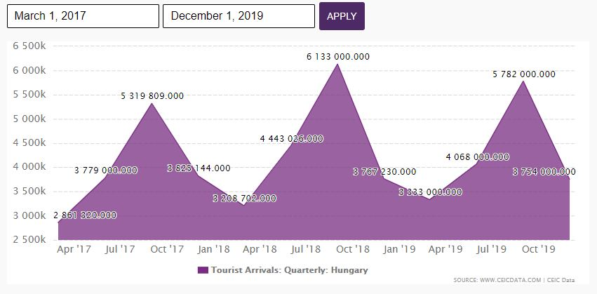

Figure Nr.5.

The first time the Eurovision Grand Prix took place in the Swiss town of Lugano. Only 7 states participated, each of them presented two songs. The very next year, the number of applicants increased significantly, and countries began to send one performer. Most often, Norway, Germany, Ireland, Sweden, Great Britain, Luxembourg, and France won. Russia, participating in the competition since 1994, was recognized as the first only once, but was awarded prizes 8 times.

According to the data from UNWTO, host countries from 2010 to 2019 have grown in overseas tourist numbers not only during Eurovision but during the whole year. Of course, holding a mass event in the city attracts the attention of the world press and the public, and this is beneficial for the tourism industry. For example, 30,000 tourists came to the Malmo contest in 2013. Many viewers of Eurovision, perhaps because of it, learned about the existence of such a city, and this is also beneficial to the authorities.

However not always the number of city guests on the announced Eurovision dates exceeds the usual norms. More than 30,000 people came to Copenhagen in 2014, but at the same time, hotel occupancy remained at the same level - 70%.

The number of Eurovision guests in Tel Aviv, Israel in 2019 was an unpleasant surprise. 30 thousand foreigners were waiting, but there was no overbooking in the hotels, and the prepared cruise liners and tent towns remained almost empty. The number of guests was only around 10 thousand people. Although just a week earlier, the Israeli Ministry of Tourism was afraid that spectators would have to settle even in Herzliya, Netanya and Jerusalem. It is pointed to the high cost of tickets for the show itself, sky-high prices for hotel rooms, which did not decrease even when it became obvious that most of them would remain unpopulated. According to observers, this scared away those tourists who were going to Israel not for Eurovision. However, the overall amount of tourists were a bit more than previous year with 4,5 million visitors.

It is the changes taking place with the city and new initiatives that are usually called among the main positive factors of the competition. It is not always possible to attract a crowd of tourists and earn a lot of money, or at least recapture the spent, but the economic atmosphere of the city, as a rule, changes for the better after a large-scale holiday.

Eurovision has long gone beyond just a music competition and has become a large-scale festival that lasts two weeks and takes complete control of the city. It attracts thousands of tourists from all over the world, changes the urban environment, inspires local business - in general, leaves an important imprint, both economic and cultural. And how these opportunities will be used in the future, whether the constructed facilities will remain empty or adapt them to other events, what business will learn, what experience will be learned from errors, depends not on investors, but on residents and authorities of each city.

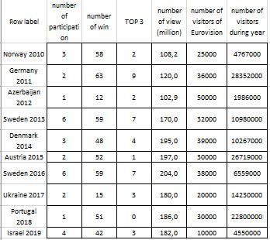

Figure Nr.6. – Eurovision demo OAM

source: https://miau.my-x.hu/miau/quilt/2020/eurovision_project/eurovision_v3.xlsx

# Carnival of Venice

Venice is one of the romantic and affected destinations in Europe. As a UNESCO World Heritage Site since 1987, Venice has attracted people all over the world with its arts and architecture, a famous lagoon and an evocative labyrinth of bridges and canals. Spread over a group of 118 small islands, the capital of the North-Eastern region of Veneto is one of the most popular tourist resorts in Italy. In fact, the number of overnight stays in the Serenissima – as Venice is nicknamed – has roughly doubled from 2003 to 2018, making it the second Italian municipality by a number of overnight stays.

Focusing on the number of overnight stays, it is important to consider the main role played by international tourism in Venice. In 2018, the city reported a total of nearly 12 million overnight stays, of which 10.4 million were undertaken by foreign travelers. As of the same year, visitors from the United States had the largest number of overseas overnight stays, led by passengers from France and the United Kingdom. On the other hand, if you look at the domestic numbers, the statistics suggest that most Italian overnight stays in Venice were linked to tourists coming from Lombardia in 2018.

Apart from the attractiveness of the city itself, due to its artistic traditions and institutions, Venice has always drawn national and foreign visitors. The Peggy Guggenheim Collection on the Grand Canal and the Venice Film Festival is among the most famous. In addition, the Biennale International Art Exhibition (which takes place in odd-numbered years) and the Biennale International Architecture Exhibition (organized in even-numbered years) welcomed 593 thousand and 275 thousand visitors, respectively, during their latest edition. Talking about Carnival of Venice which welcomes more than 3 million guests every year is considered one of the popular events in Italy.

Carnival of Venice (Carnevale di Venezia) is a grand event in Italy and one of the most famous carnivals in the world. This costumed masquerade ball is the oldest of all carnivals on the planet, annually held in Venice.

The traditional Venice Carnival lasts more than two weeks - the date of its opening depends on the beginning of the Catholic Lent, and it ends on the eve of the Ash Wednesday. Every year the Carnival has a theme, which inspires the festivals and cultural events of the outline. Some editions have also been characterized by combinations and twinings with other Italian and European cities. In this way, providing further involvement of the event internationally. The current Carnival of Venice has become a great and spectacular tourist event, which attracts thousands of visitors from all over the world. Tourists flock to the city to participate in this festival considered unique in history, atmosphere, and masks.

It is worthwhile to participate in the Venice Carnival at least once in your life in order to admire the numerous and splendid masks and costumes. Every year there is also an award ceremony for the best masks and a magnificent event takes place every evening in Piazza San Marco. The Carnival ends with spectacular fireworks on Shrove Tuesday and Venice slowly returns to its normal life.

# Pusan International Film Festival

The Ministry of Culture and Tourism picked 10 big activities and festivals in its presentation to "Visit Korea 2001." Among such, the Pusan International Film Festival (PIFF) receives sponsorship from locals as well as visitors. The Ministry of Culture and Tourism supports and promotes this cultural event in particular for the development of the tourism industry in Korea. Tourism for the cultural festival aims to draw international visitors. Around the same time, the metropolitan community has positive results as it provides residents regional culture and gives residents knowledge about national and global culture. Since 1996 PIFF has been Asia's biggest film festival. At the same time, the event is gaining fame for its economic potential and its artistic and imaginative purpose. The festival's aim is to select programs that are ideal for the new millennium, enhance the festival's marketability and highlight the discovery of new Korean and Asian cinemas. Pusan Promotion Plan (PPP) opens during the festival. It is a free market, where hopeful Asian filmmakers can meet worldwide co-producers and co-executive producers.

The PIFF 's continued progress and development have prompted urban regeneration at Busan. After the year 2000 several new multiplexes have been built in the city center's Gwangbok-dong and Nampo-dong districts. Both areas played significant festival roles, often conducting viewing or parties throughout the 1990s. A redevelopment plan for the Haeundae area was developed by the city government but for a long time, it moved at the pace of a snail. However, the success of the PIFF has stimulated urban regeneration plans by the city government from the early 2000s (Ahn, 2012). As a consequence, Marine City and Centum were established in the Haeundae region from the mid-2000s onwards. Marine City is a trendy new community with premium high-rise mixed-use apartments and condominiums. Centum is a state-of-the-art urban multiplex, housing high-tech manufacturing areas, mega-sized shopping centers, entertainment amenities, parks, COAX, aquariums, etc., where PIFF 's headquarters are situated. All of those city developments resulted in the attraction of a high number of foreign tourists not only for visiting Busan, however other major destinations in South Korea. Bikeways compared with bigger film festivals such as Berlinale, both of them have differences and similarities. International film festivals are one of the important events which attract tourists and boost tourism in countries. Even Berlinale is much bigger in size, numbers of visitors are higher as Berlinale is older than PIFF, we obey the similar success in both festivals, since the meaning that a variety of additional programs have been created, such as foreign film markets and academies for young talented filmmakers. These diversification initiatives are future fields from which local film and television industries will benefit.

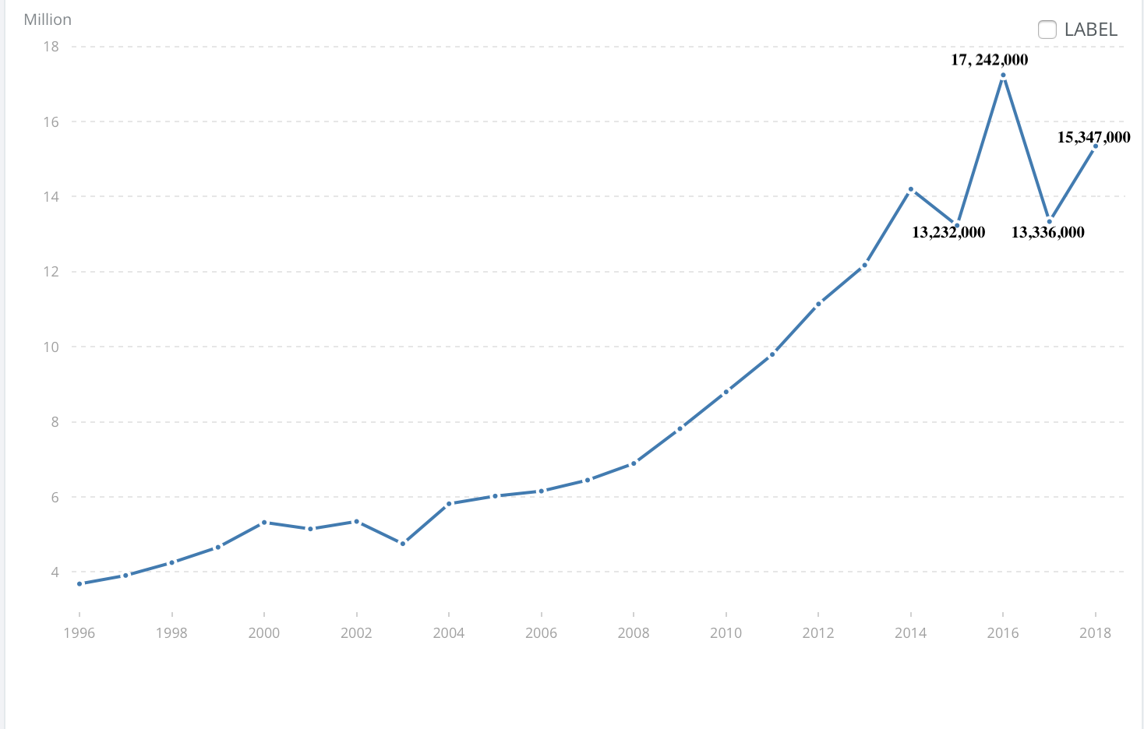

*Source*: data.worldbank.org

Figure Nr.7.

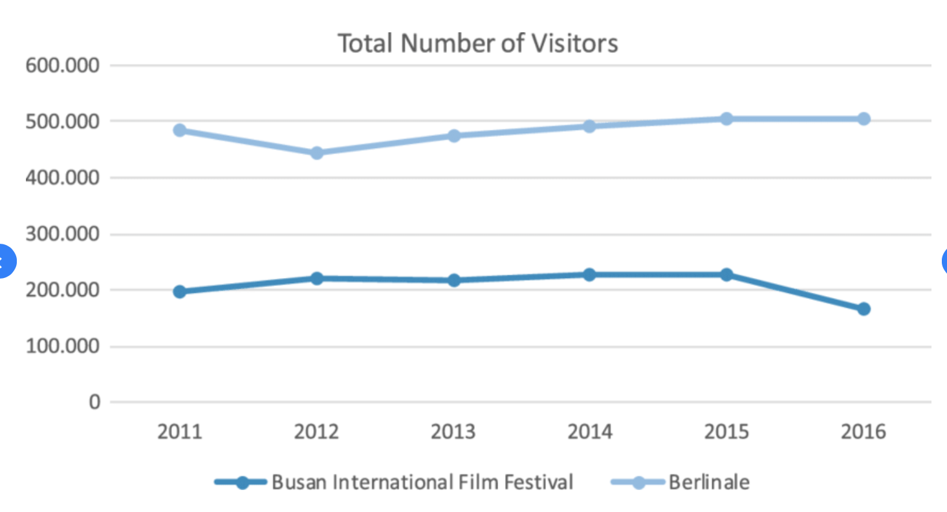

*Sources:* berlinale.de, .biff.kr

Figure Nr.8.

METHODOLOGY

The online AI-based analytical tool (<https://miau.my-x.hu/myx-free/coco/index.html> - COCO-STD) made possible to analyze the data of Figure Nr.6. in two parallel model series. The online similarity analysis is a modelling tool where context free production function can be derived in an automated, optimized way.

RESULTS

The parallel models led to following parameters of the production funcions (see Figure Nr.9-10):

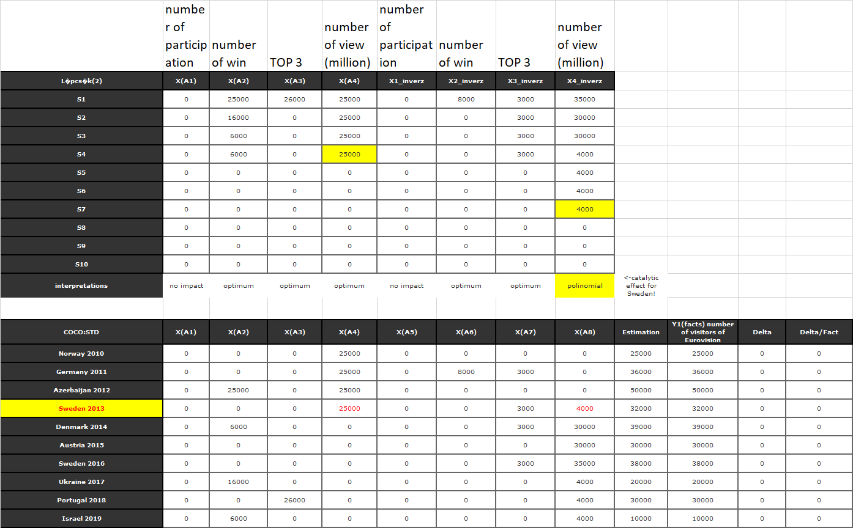

Figure Nr.9. – Y1 = number of visitors of the Eurovision (source: own presentation)

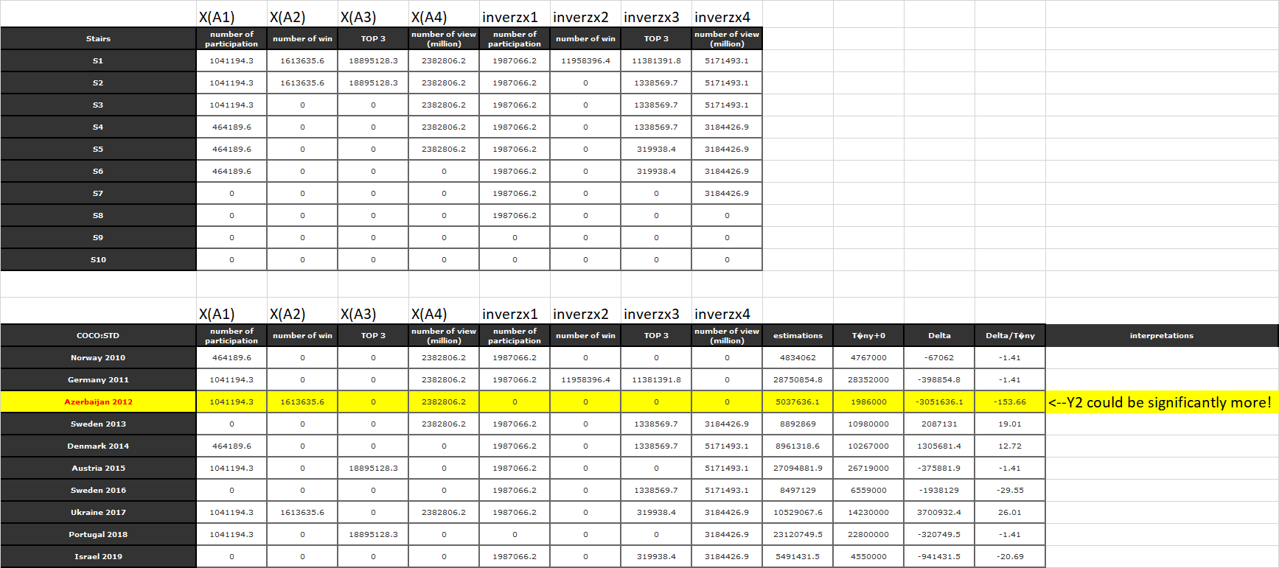

Figure Nr.10. – Y2 = number of visitors during the year (source: own presentation)

CONCLUSION

Event planners involved in maximizing their tourism capacity will preferably become active partners in the neighborhood or destination tourism planning phase. By working as a group and marketing organization, events will aim to control the positioning and branding of the venue, funding and advancement projects, testing, and assessment initiatives, all to advance the cause of specific events and the event industry.

Popular issues include supremacy by a few 'hallmark' events that have become permanent institutions, ignorance of local and regional festivals and events due to their perceived lack of tourism focus or potential, and an overemphasis on bidding on one-time mega-events. Fostering a robust portfolio approach to event tourism will benefit all stakeholders by ensuring that all events' potential contributions are recognized and appropriate support structures are developed.

The first model about the number of visitors of the Eurovision (Y1) – based on a doubled input-variable-set - led to the result, that only in case of Sweden (2013) can we speak about a kind of catalytical effect where the number of the visitors of the Eurovision could be unlimited high. This potential means, the Eurovision is for Sweden very relevant. Sweden is the most successful country among the involved 10 objects. In the holistic view, Sweden is the second country in the top list after Ireland – let alone – Sweden’s ranking numbers belong to the recent years compared to Ireland with an older success story (c.f. <http://www.escstats.com/best.htm>).

The second model (Y2) about the number of visitors during the year – based again on the same doubled input-set as before – let derive a production function where the most characteristic phenomenon belongs to Azerbaijan (2012) where the touristic potential could have been significantly more. Based on further analyses, this potential can be the force field for more and more new projects in the tourism in Azerbaijan.

Based on the same logic, it is possible to simulate future impacts – especially, if the inputs are more influenceable phenomena.

References:

* + - 1. Getz, D. 2012 Event Studies: Theory, Research and Policy for Planned Events.
      2. Getz, D. 2013 Event Tourism: Concepts, International Case Studies, and Research.
      3. Getz, D., and T. Andersson 2010 The Event-tourist Career Trajectory: A Study of High-involvement Amateur Distance Runners. Scandinavian Journal of Hospitality and Tourism
      4. Hinch, T., and J. Higham 2011 Sport Tourism Development.
      5. Picard, D., and M. Robinson (eds.) 2006 Festivals, Tourism and Social Change: Remaking Worlds.
      6. Richards, G., and R. Palmer 2012 Eventful Cities: Cultural Management and Urban Revitalization.
      7. Ritchie, J., and D. Beliveau 1974 Hallmark Events: An Evaluation of a Strategic Response to Seasonality in the Travel Market.
      8. H. Preuss, The Economics of Staging the Olympics. A comparison of the Games 1972-2008.
      9. Leonidova E. G. Event tourism as a new direction of the Russian tourist market.
      10. Alekseeva O. V. Event tourism as a factor in the socio-economic development of a region.
      11. Babkin A.V. Special types of tourism. Rostov-on-Don, 2008.
      12. Vlasova T. I. Event tourism is an effective anti-crisis tool for attracting tourist flows to the region. 2015.
      13. Preuss, H. (2003). Rarely considered economic legacies of Olympic Games. Paper presented at the Legacy of the Olympic Games 1984–2000.
      14. Preuss, H. (2004). The economics of staging the Olympics: a comparison of the games, 1972-2008.
      15. Nishio, T. Lim, C. and P. Downward, P. (2009). Analysing the economic impact of the olympics using stock market indices of host countries.
      16. <https://www.olympic.org/news/sochi-region-enjoying-tourism-boost-following-winter-games-1-1>
      17. "Sziget 2018: 9 Millionth Visitor, Record Number of Festival Goers and Last Concerts in the Rain". Hungary Today. 2018-08-15.
      18. <https://hungarytoday.hu/sziget-festival-2019-visitors-attendance/>
      19. <https://eurovision.tv>
      20. Venice Carnival 2013. Book Venice Carnival Balls and Events
      21. Eun-song Bae, Meehyang Chang, Eung-Suk Park and Dae-cheol Kim. The effect of Hallyu on tourism in Korea
      22. <http://www.escstats.com/>
      23. <https://miau.my-x.hu/myx-free/coco/index.html>