MIAU – HU ISSN 1419-1652 – Special Edition 2020 Spring - Editorials: The papers in MIAU Nr.261 (2020.V) are products of a new education frame system “QuILT” (https://miau.my-x.hu/mediawiki/index.php/QuILT). The goals of QuILT are supporting/conducting Students on the way of KNUTH, who said (1992): Knowledge is, what can be transformed into source code, each other human activity is a kind of artistic performance. It also means we need to leave the world of the magic of words step by step. A solid evidence that we all are capable of going this way is: creating publications behind which the human expertise and the robotized knowledge (like online engines: https://miau.my-x.hu/myxfree/coco/index.html --- offering context free = quasi General-Problem-Solving force fields) can be integrated in case of a rational and relevant decision making scenario. The cyborg effects make possible to face the classic naïve and/or intuitive approaches and parallel the optimized approximations. This way can be realized without deep competences about mathematics, Excel (spreadsheets), statistics, etc. The new (inter/trans/multi-disciplinary) way just expects from us to be able and willing to co-operate with the best moments of the history – it means, with the already prepared robotized elements in order to build something creative one! Parallel, in the second QuILT-semester - https://miau.my-x.hu/mediawiki/index.php/QuILT2_parts - there are not only classic publication possibilities like robotizing the investigative journalism – there are further specific tasks too like 2DM-games, gamification in general, thinking experiments, etc.

Title: Food-Kaleidoscope – the case of Belgium

Author: LUBO NGOIE JUNIOR

Abstract: This paper report includes historical and political views of Belgium about the food consumption of the country findings on the number of food insecure and analysis household survey designed by the FAO. A stratified and multi-sage sampling approach was used to provide estimate of set of food and nutritional security indicators countries. Based on the Food-Kaleidoscope-technology, it will be possible to demonstrate how can we decide about pattern-like situations or continuously stable food supply concerning a society/country. A good methodology should also be able to have the answer of none – like ethical human experts do. This specific knowledge is a part of the Turing test if we involve AI into the analytical processes.

Keywords: History, Growth, crisis, food security, AI, Turing test, answer-option=none

# Introduction

Belgium, country of northwestern Europe. It is one of the smallest and most densely populated European countries, and it has been, since its independence in 1830, a representative democracy headed by a hereditary constitutional monarch. Initially, Belgium had a unitary form of government. In the 1980s and ’90s, however, steps were taken to turn Belgium into a federal state with powers shared among the regions of Flanders, Wallonia, and the Brussels-Capital Region.

Belgium and the political entities that preceded it have been rich with historical and cultural associations, from the Gothic grandeur of its medieval university and commercial cities and its small, castle-dominated towns on steep-bluffed winding rivers, through its broad traditions in painting and music that marked one of the high points of the northern Renaissance in the 16th century, to its contributions to the arts of the 20th century and its maintenance of the folk cultures of past eras. The Belgian landscape has been a major European battleground for centuries, notably in modern times during the Battle of Waterloo (1815) and the 20th century’s two world wars. Given its area and population, Belgium today is one of the most heavily industrialized and urbanized countries in Europe. It is a member of the Benelux Economic Union (with the Netherlands and Luxembourg), the European Union (EU), and the North Atlantic Treaty Organization (NATO)—organizations that all have headquarters in or near the capital city of Brussels.

Only a small percentage of the country’s active population engages in agriculture, and agricultural activity has continued to shrink, both in employment and in its contribution to the GDP. About one-fourth of Belgium’s land area is agricultural and under permanent cultivation; more than one-fifth comprises meadows and pastures. Major crops are sugar beets, chicory, flax, cereal grains, and potatoes. The cultivation of fruits, vegetables, and ornamental plants also is important, particularly in Flanders. However, agricultural activity in Belgium centers primarily on livestock; dairy and meat products constitute more than two-thirds of the total farm value.

## Goals

Why it is important to produce this publication? The case of Belgium is a part of the series of the Food-Kaleidoscope. Belgium had quasi no problems in the last decades therefore this country is a good extreme object for testing the Food-Kaleidoscope-approach.

## Targeted groups

Who should be interested to have this publication? The case study is a kind of evidence for the value of the Food-Kaleidoscope-concept. Therefore, this case study is relevant for each Reader of the Food-Kaleidoscope series.

## Benefits

What is the benefit in case of the targeted groups if they have this publication? The more complex proofs about a methodology is a kind of trivial benefit for each user.

## Motivation

Why it is relevant for the author to support the targeted groups? To realize these goals…

# Literature

What kind of sources got involved into the publication process and why even these (about the already written parts concerning the Belgian history)?

The studies based on the Food-Kaleidoscope can be downloaded here: <https://miau.my-x.hu/miau/261/?C=M;O=D>

# Data assets

Source URLs, objects, attributes, units, preparation steps like pivot report, ranking can be identified in the XLS-file: <https://miau.my-x.hu/miau/quilt/2020/food_project/Belgium_only%20(1).xlsx>

Further details: <https://miau.my-x.hu/miau/quilt/2020/food_project/?C=M;O=D>

# Methodology

An abstract from the already closed publication concerning the model-steps can be seen as a kind of methodological tutorial. Parallel, this description makes possible to have an introduction into the similarity analysis: https://miau.my-x.hu/miau/196/My-X%20Team_A5%20fuzet_EN_jav.pdf

# Results

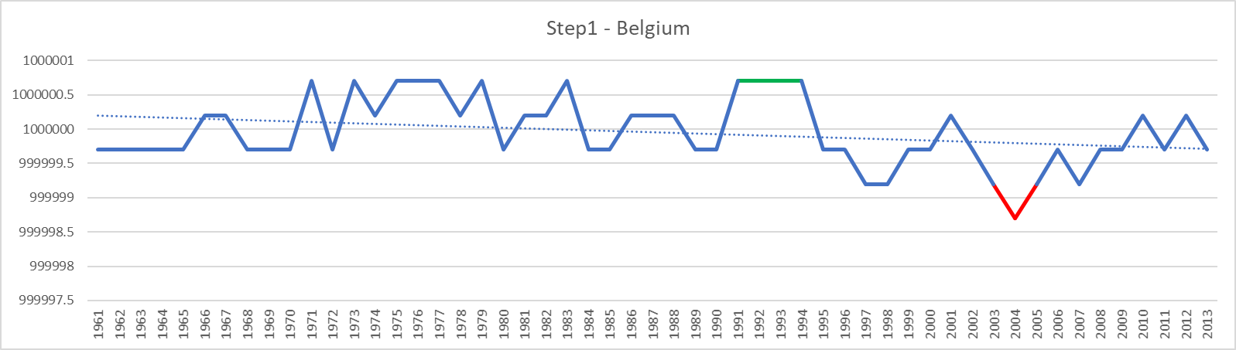

Figure Nr.1 – title, source

Interpretation of the Figure Nr.1: After world war II, Ghent and Antwerp experienced a rapid expansion of the chemical and petroleum industries. The [1973](https://en.wikipedia.org/wiki/1973_oil_crisis) and 1979 oil crises sent the economy into a recession; it was particularly prolonged in Wallonia, where the steel industry had become less competitive and experienced a serious decline. In the 1980s and 1990s, the economic center of the country continued to shift northwards and is now concentrated in the populous [Flemish Diamond](https://en.wikipedia.org/wiki/Flemish_Diamond) area.

events occurring in the year 2004 in Belgium. Major events include a gas explosion in Ghislenghien, which killed 24 people, and the restructuring of the Vlaams Blok political party.

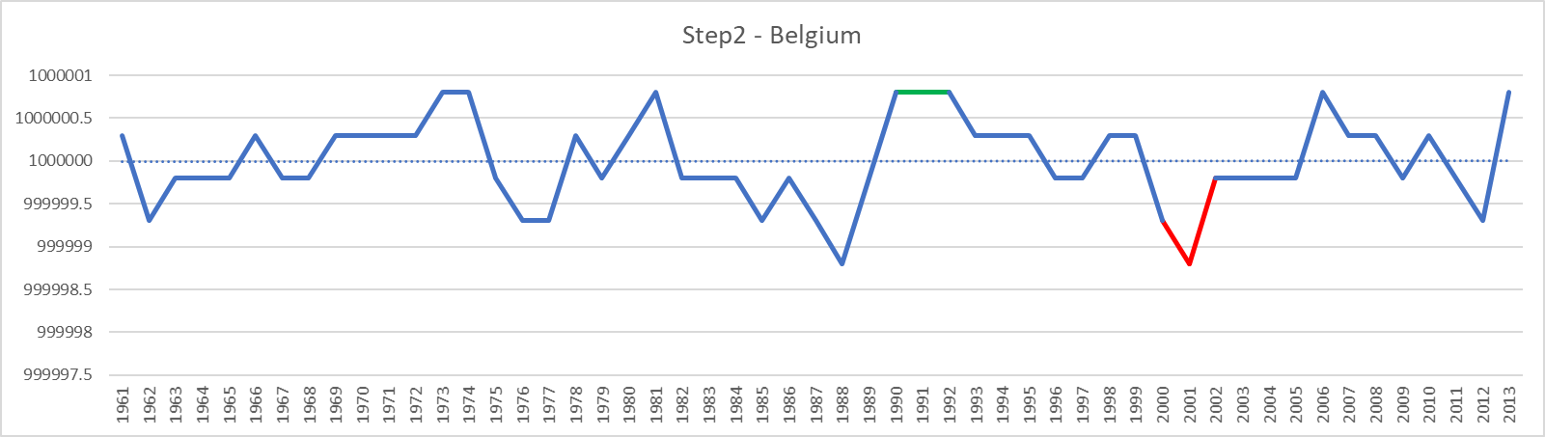

Figure Nr.2 – title, source

Interpretation of the Figure Nr.2: In 2001, a public report announced that high dioxin levels were detected in Belgians' blood plasma compared to other European populations (The Dioxin affair was a political crisis that struck in Belgium during the spring of 1999. Contamination of feedstock with polychlorinated biphenyls (PCB) was detected in animal food products, mainly eggs and chickens.)

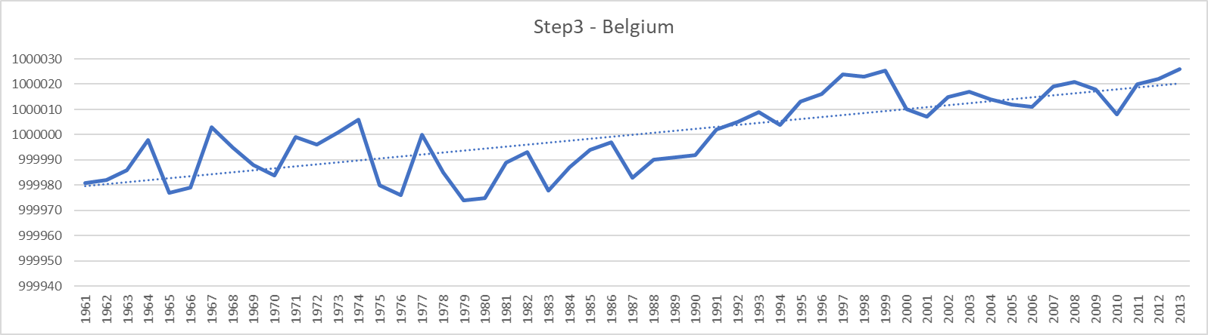

Figure Nr.3 – title, source

Interpretation of the Figure Nr.3: Belgium experiences some of the most congested traffic in Europe. In 2010, commuters to the cities of Brussels and Antwerp spent respectively 65 and 64 hours a year in traffic jams. Like in most small European countries, more than 80% of the airways traffic is handled by a single airport, the Brussels Airport. The ports of Antwerp and Zeebrugge (Bruges) share more than 80% of Belgian maritime traffic, Antwerp being the second European harbor with a gross weight of goods handled of 115 988 000 t in 2000 after a growth of 10.9% over the preceding five years.

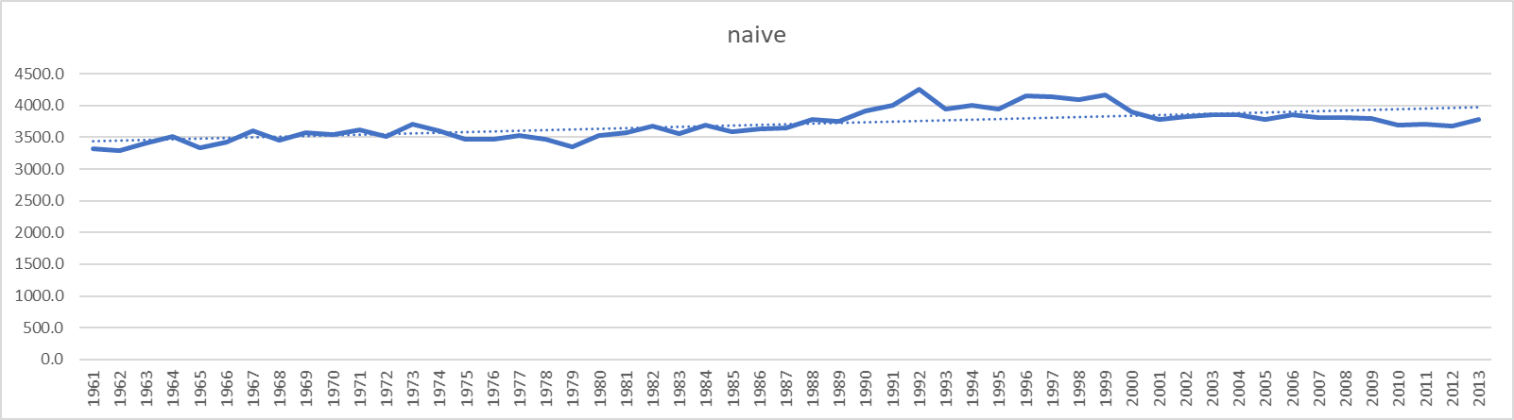

Figure Nr.4 – title, source

Interpretation of the Figure Nr.4:

This naive scenario is quite good but we can notice a little crisis in the earlier of 1978-1979. Belgium's political crisis may indeed be protracted, but it is by no means unconstitutional or unusual. In 1978-79 putting in place a new government took 106 days, in 1987 it took 148 days and in 2007 seven months were required.

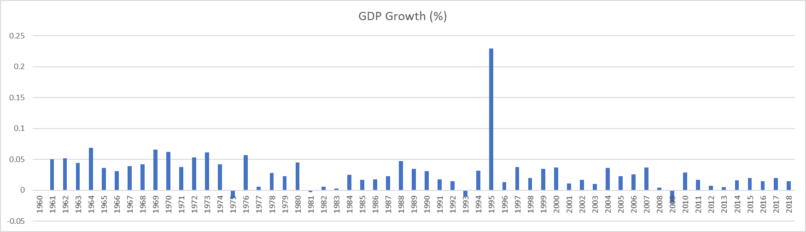

Figure Nr.5 – title, source

Interpretation of the Figure Nr.5: By the end of the 1980s, Belgian macroeconomic policies had resulted in a cumulative government debt of about 120% of GDP. As of 2006, the budget was balanced and public debt was equal to 90.30% of GDP.[106] In 2005 and 2006, real GDP growth rates of 1.5% and 3.0%, respectively, were slightly above the average for the Euro area. Unemployment rates of 8.4% in 2005 and 8.2% in 2006 were close to the area average. By October 2010, this had grown to 8.5% compared to an average rate of 9.6% for the European Union as a whole (EU 27). From 1832 until 2002, Belgium's currency was the Belgian franc. Belgium switched to the euro in 2002, with the first sets of euro coins being minted in 1999. The standard Belgian euro coins designated for circulation show the portrait of the monarch (first King Albert II, since 2013 King Philippe).

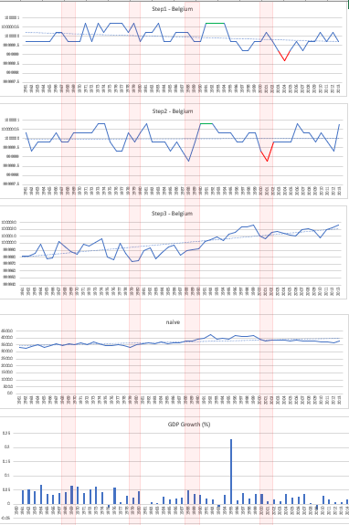

Figure Nr.6: Searching for patterns (source: own presentation)

Interpretation of the Figure Nr.6: The central question of the Food-Kaleidoscope is whether critical periods/years in case of a given country (here and now: Belgium) can be derived in an automated so that the all figures or at least the most of the figures highlight the same years/periods as critical ones. Based on the Figure Nr.6 and on the parallel cases of Congo/Pakistan/Japan/Hungary, it was not possible to identify such years/periods!

Control questions:

Does the year demonstrate any similarities where e.g. the GDP has a huge positive peak if the step1-2-3+naïve figures are interpreted in a visual way?

Do the years demonstrate any similarities where e.g. the GDP has negative peaks if the step1-2-3+naïve figures are interpreted in a visual way?

The transparent red “windows” do not make possible to identify patterns.

The answer-options are simple:

* Yes, there is/are rule-like pattern(s)! Which? Why?
* **No, there is/are no pattern(s) to see!**

# Discussions

Should be existing patterns in case of each countries? No, a good methodology should be capable of being muted.

# Conclusions

Is it good, if we could not identify patterns in case of a given country compared to other cases? Yes, this characteristic is an important extreme value for Turing-tests.

# References

<https://miau.my-x.hu/miau/261/?C=M;O=D><https://miau.my-x.hu/miau/quilt/2020/food_project/?C=M;O=D>