MIAU – HU ISSN 141921652 – Special Edition 2020 Spring - Editorials: The papers in MIAU Nr.261 (2020.V) are products of a new education frame system “QuILT” (https://miau.my-x.hu/mediawiki/index.php/QuILT). The goals of QuILT are supporting/conducting Students on the way of KNUTH, who said (1992): Knowledge is, what can be transformed into source code, each other human activity is a kind of artistic performance. It also means we need to leave the world of the magic of words step by step. A solid evidence that we all are capable of going this way is: creating publications behind which the human expertise and the robotized knowledge (like online engines: https://miau.my-x.hu/myxfree/coco/index.html --- offering context free = quasi General-Problem-Solving force fields) can be integrated in case of a rational and relevant decision making scenario. The cyborg effects make possible to face the classic naïve and/or intuitive approaches and parallel the optimized approximations. This way can be realized without deep competences about mathematics, Excel (spreadsheets), statistics, etc. The new (inter/trans/multi-disciplinary) way just expects from us to be able and willing to co-operate with the best moments of the history – it means, with the already prepared robotized elements in order to build something creative one! Parallel, in the second QuILT-semester - https://miau.my-x.hu/mediawiki/index.php/QuILT2_parts - there are not only classic publication possibilities like robotizing the investigative journalism – there are further specific tasks too like 2DM-games, gamification in general, thinking experiments, etc.

Title: Food-Kaleidoscope – the case Congo

Author: Kitoto Ngoie Jennifer

Abstract: This paper report includes specific findings on the number of food insecure and vulnerable people in the country and analysis household survey designed by the FAO. A stratified and multi-sage sampling approach was used to provide estimate of set of food and nutritional security indicators countries.

Keywords: Food insecurity, Congo, crisis, suspicion, robot-eye, robot-sociologist

# Introduction

Located on the right bank of the eponymous river in Central Africa, the Congo is a **resource-rich, middle-income country that has the potential to achieve Sustainable Development Goal (SDG) 2** on Zero Hunger and improved nutrition by 2030.

The country, however, continues to face high levels of poverty and inequality, recurring localized conflict, regional insecurity, macroeconomic instability and high rates of malnutrition and food insecurity.

Almost 90 percent of arable land remains uncultivated and agriculture is largely limited tosubsistence production and cash crops such as beans, sugar cane, cocoa and coffee. Because domestic food production covers only 30 percent of the needs, Congo relies extensively on food imports from overseas.  WFP estimates that 15 percent of households’ report poor or limited food consumption, with peaks of 30 percent in rural areas.

The Congo faces a triple burden of malnutritionamong children under 5, with the coexistence of stunting (affecting 21.3 percent), overweight (affecting 5.9 percent) and deficiencies in iron,vitamin A and iodine. The diets of only 6 percent of children under 2 meet minimum dietary diversity requirements.

Gender inequalities and disability status have a direct impact on poverty, food security and nutrition – as does ethnicity. Indigenous people, whose traditional livelihoods are affected by climate change-related deforestation, experience difficulties in accessing resources and social services. UNICEF estimates that 65 percent of indigenous children are not in school.

The recurrence of social and political conflict has affected the Congo’s ability to break the cycle of hunger and poverty by forcing people to abandon their land, homes and jobs and discouraging long-term investments.

Hostilities in Pool department resulted in massive population displacement and a serious humanitarian emergency, with displaced families experiencing food insecurity and precarious nutrition conditions. At the end of 2017, the number of people in need of food assistance in Pool was estimated at 160,000.

Refugees from neighbouring countries including CAR and DRC have poor access to food and limited prospects of becoming self-sufficient, thus depending on humanitarian food assistance.

Building on its long experience in responding to crises and building resilience both in the Congo and globally the World Food Programme (WFP) is working across the country to support government efforts to achieve SDG2. WFP is also seizing opportunities to leverage digital innovation in Congo, a well-connected middle-income country. WFP’s role is increasingly shifting from operational to advisory, with the gradual strengthening of government capacities to scale up and institutionalize mechanisms for social protection, particularly school feeding and safety nets, emergency preparedness and crisis response.

WFP works with the Government to ensure social protection interventions are effective, equitable and sustained by sound data and technologies. In order to ensure these programs are evidence-based and data-driven, WFP works with the local technology ecosystem to develop digital systems and tools for Congo. WFP works with 2,000 smallholder farmers – in their vast majority women – with technical support, training and knowledge so they can better aggregate food production, store it safely and get it to markets. In order to overcome the specific barriers faced by women farmers, WFP works with women members of farming cooperatives, fostering their access to decision making roles. WFP is also helping smallholder farmers adapt to a changing climate by improving weather services and diversifying rural livelihoods.

# Literature

The first experiment about involving food-supply-data from FAO/UNO for analyses critical years/time-periods in case of one or more country was 2013: <https://miau.my-x.hu/miau/184/japhun.doc> The experiment can be seen as a kind of kick-off for further more complex analyses.

The first analyses did not use the possibilities increasing the sensitivity of the analyses. Parallel, it is also possible to use the FAO-data and the data about the life expectancy for year and countries to derive a kind of ideal food ratios. A similar analysis could also be identified on the course-server (miau.my-x.hu): <http://miau.my-x.hu/miau/160/saltseer.doc> where the goal was to derive whether the salt consumption has an optimum-like relationship to the life expectancy – or where this optimum can be?

# Data assets

* FAO:
* <https://miau.my-x.hu/miau/quilt/2020/food_project/>
* CLIO (c.f. cold-war-project:
* <https://miau.my-x.hu/miau/quilt/2020/coldwar_military_expenditure_project/>

The last Figures of the Annex contains the details list of food-categories and countries.

* The number of the potential records: 799038
* The number of the food-categories: 89
* The number of the involved countries: 217
* The number of the affected years: 53 (1961-2013)
* (Worth knowing not each food-category leads to a data-position in the database. The combinatorial space would be more voluminous: 217*89*53=1023589 > 799038)

Each data position has the same unit: g/capita/day. Fortunately, it is a standardized/relativized unit – which makes immediately possible to compare countries and/or years.

# Methodology

Online solver-based engines (COCO-STD, COCO-Y0) were involved into the analytical steps. The COCO-Y0 is an antidiscriminative engine and it delivers an optimized aggregation of the annual numbers of the daily averages of the food-categories. The naïve alternative way would be to build a total value of the grams independent from each content.

The COCO-STD is a kind of optimized function-generator – here and now used for generating production function. A production function is a model where the Xi variables (see food-categories) are responsible for the consequence variable (Y = life expectancy).

## Could we evaluate each year as the same?

This hypothesis can be evaluated based on the antidiscriminative model – more exactly – based on the first step of these models where we are searching for a weighted combination of food-categories leading to the same evaluation value. However, not each food-category have a higher weight-structure (pro food-supply-level = ranking value) than the basic level, then the model can be made more sensitive in one or more additional steps. The new steps will involve less and less food-categories – and exclude more and more (already weighted food-categories). The number of steps is always unlimited because the number of the weighted food-categories is limited. Here and now, maximal 3 steps could be executed in order to break the sameness-principle or to involve each potential food-category.

## Could we derive what is a proper food-consumption structure?

A production function delivers parameters about the impact volumes of the independent variables. It is possible to derive to set of parameters: a direct set and an inverse set. The direct set means: each food-category has a relationship to the life expectancy concerning the type “the-more-the-more”. The inverse case is a mirrored case (type of each relationship = the-more-the-less). These parameters can be re-formulated as follows in case the estimation of the Y-values is proper enough: Is food-category rather inverse-oriented (it means the less is better for a longer life) or vice versa?

The correlations between the estimated values and the statistics about life expectancy in both cases (direct and inverse): 1.000

More details: <https://miau.my-x.hu/miau/quilt/2020/food_project/CONGO_HU%202.xlsx>

# Results

## Antidiscriminative modelling

### Multi-country-view

Figure Nr.1 (source: own presentation – 2 countries – only 1 modelling-step)

An interview-like interpretation:

As you can see (Figure Nr.1), we have a suspicion (based on the doubled = two-country-model), that something (crisis?) could happen in Congo 2011-2012, because this is the most negative scenario… Could you confirm that in these years e.g. the world crisis could have a relatively small but visible impact to the food consumption in Congo?

Yes, I can confirm that. The crisis was due to the conflict and political instability, the majority of Congo population remains widely exposed to food insecurity, malnutrition and hunger despite the country’s enormous agricultural potential. Population displacement remains one of the largest causes of food insecurity and chronic poverty in Congo. Knowing that during those year (2011-2012) a possible food crisis happens in the world will eventually affect the food consumption in Congo. As we can see in the chart the food consumption in Congo drops sharply those year and recover, in conclusion the world crisis had an impact to the food consumption in Congo and it’s not just a small but a huge crisis. Higher food prices too were in that crisis.

Further suspicions:

* Negative: 1968, 1977-1978, 1998, 2003, 2008
* Positive: 1987-1990, 1993,

Figure Nr.2 (source: own presentation – 2 countries – no AI-based modelling)

An interview-like interpretation:

The naïve scenario (in the doubled model) makes possible, that another small crisis could be given in the period of 1990-1993…. Is this maybe to confirm based on Figure Nr.2?

In the 1990s, Congo's major employer was the state [bureaucracy](https://en.wikipedia.org/wiki/Bureaucracy), which had a payroll of 80,000, which is enormous for a country of Congo's size. The [World Bank](https://en.wikipedia.org/wiki/World_Bank) and other international financial institutions pressured Congo to institute sweeping [civil service](https://en.wikipedia.org/wiki/Civil_service) reforms in order to reduce the size of the state bureaucracy and pare back a civil service payroll that amounted to more than 20% of GDP in 1993. The effort to cut back began in 1994 with a 50% devaluation that cut the payroll in half in dollar terms and by a mid-year reduction of nearly 8,000 in civil service employment and resulted in [inflation](https://en.wikipedia.org/wiki/Inflation) of 61%. Inflation has since subsided. But I also add the Economy problem.

Further suspicions:

* Negative: -
* Positive: -

### Single country-view

Figure Nr.3 (source: own presentation – 1 country and 1 modelling step)

An interview-like interpretation:

The solo-model for Congo shows a suspicion for 2008 (see Figure Nr.3). Is this year specific? Could you say something as reason for this suspicion concerning the food consumption of the average citizen in Congo?

The foods, for which the main source of availability comes from own household production, are roots and tubers (63% of households), fruits (50%), corn (48%), vegetables (46%) and oilseeds (70%). Other foods are mainly obtained by purchases at the market, especially in large cities. These foods are milk (93%), sugar (91%), rice (70%), palm oil (69%), meat (68%) and legumes (58%). Own household production, and other food sources are unable to meet the food needs of the majority of households, leaving the country still in a state of food insecurity.

Further suspicions:

* Negative: 1977, 1996
* Positive: 1987, 1994

Figure Nr.4 (source: own presentation – 2 countries – 2 modelling steps = more sensitivity)

Interpretations for Figure Nr.4: I think these two countries have really gone through difficult times over the years. The graph shows a suspicion year between 1976 and 1979 to 1981 for Congo. A good year is: 1983, a good period is 1983-1986 For Hungary is in 1976 (a year close to the world-wide oil-crisis - <https://en.wikipedia.org/wiki/1973_oil_crisis>) and in 1993 (a year close to the bloodless independence - <https://en.wikipedia.org/wiki/End_of_communism_in_Hungary_(1989)>). I think at national level the food production is steadily declining and increasing in some years and stay stable. Congo faces serious nutritional problems. According to various surveys and studies, these issues are complex and vary from one province to another. They affect not only young children, but also adult’s especially pregnant and lactating women, and displaced populations.

Figure Nr.5 (source: own presentation – 1 country – 2 modelling steps = more sensitivity)

Interpretations (for Figure Nr.5): In this chart we can see that Congo’s food estimation drops sharply in 1976 and recover and then stay stable until 2013. A relatively good year is 1986, good period is 1983-1986. In terms of absolute numbers, the prevalence of wasting results in more than one million children affected by acute malnutrition needing support and the prevalence of stunting results in more than six million Congolese children with delayed growth.

Figure Nr.6 (source: own presentation – 3 countries – 2 modelling steps = more sensitivity)

Interpretations (For Figure Nr.6): We know now what’s happening in those countries all of them are facing a lot of crisis, conflict, war and dispute. As you can see in the chart in case of Congo the suspicion decline in 1995 – and 1979 is the last “bad” year before a long increasing period. A relatively good year for Congo is 1986. In Hungary the suspicion drops sharply in 1992-1993 and in Pakistan we can notice that we have two suspicion between years in 1965 and in 2001 but we can also notice that there is also some little crisis. The chart shows us that in some years those countries remain stable.

In case of Congo, the Food-Kaleidoscope makes clear, that the most suspected years/periods could be the years/periods of 1976-1979 (bad), 1983-1986 (good) because more figures contain signs for these years.

Kurt Vonnegut famous fable (Hocus-pocus = <https://miau.my-x.hu/miau/quilt/2020/hocus_pocus_vonnegut_3888.png>) is a kind of coincidence-driven interpretation. But suspected yellow and blue numbers of the Food-Kaleidoscope and the number in Wikipedia about the same historical period of Congo are really only coincidental?

<https://en.wikipedia.org/wiki/History_of_the_Republic_of_the_Congo>

## **Assassination of Ngouabi and election of Sassou-Nguesso[**[**edit**](https://en.wikipedia.org/w/index.php?title=History_of_the_Republic_of_the_Congo&action=edit&section=17)**]**

On March 18, 1977 President Ngouabi was assassinated. A number of people were accused of shooting Ngouabi were tried and some of them executed, including former President [Alphonse Massemba-Débat](https://en.wikipedia.org/wiki/Alphonse_Massemba-D%C3%A9bat) and a fisherman, Chanrithy Moukoko, but there was little evidence to prove their involvement, and the motive behind the assassination remains unclear.

An 11-member Military Committee of the Party (CMP) was named to head an interim government with Col. (later Gen.) [Joachim Yhombi-Opango](https://en.wikipedia.org/wiki/Joachim_Yhombi-Opango) to serve as President of the Republic. After two years in power, Yhombi-Opango was accused of corruption and deviation from party directives, and removed from office on February 5, 1979, by the Central Committee of the PCT, which then simultaneously designated Vice President and Defense Minister Col. [Denis Sassou-Nguesso](https://en.wikipedia.org/wiki/Denis_Sassou-Nguesso) as interim President.

The Central Committee directed Sassou-Nguesso to take charge of preparations for the Third Extraordinary Congress of the PCT, which proceeded to elect him President of the Central Committee and President of the Republic. Under a congressional resolution, Yhombi-Opango was stripped of all powers, rank, and possessions and placed under arrest to await trial for high treason. He was released from house arrest in late 1984 and ordered back to his native village of [Owando](https://en.wikipedia.org/wiki/Owando" \o "Owando).[[12]](https://en.wikipedia.org/wiki/History_of_the_Republic_of_the_Congo#cite_note-12)

## Production function – life expectancy

<https://miau.my-x.hu/miau/quilt/2020/food_project/CONGO_HU%202.xlsx>

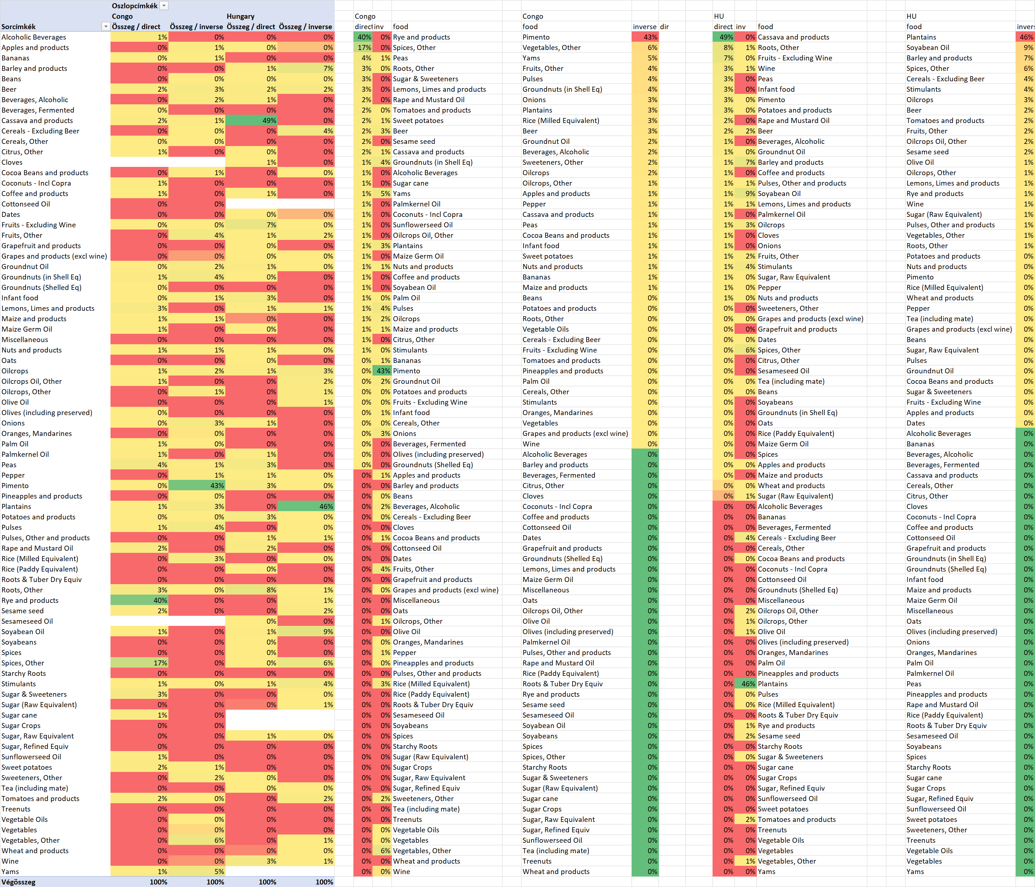

Figure Nr.7 – Direct and inverse force fields of the food-categories concerning the life expectancy in case of Congo and Hungary (source: own presentations)

Figure Nr.7 demonstrates a confuse and different feeling concerning the comparison of countries – although the models have an ideal correlation-level.

The food-categories and their impact-levels can not be interpreted based on the classic theories of the nutritional sciences, but the relevant positive/negative food-categories (see top positions in direct=positive and inverse =negative columns) can be interpreted from point of view of a robot sociologist:

* More rice = longer life means: the average citizen needs basic food
* More spices = longer life means: if the average citizen can have more (expensive) spices than spices are a kind of indicator for better financial background = longer life…
* The potential rule “more pimento = shorter life” needs further investigations…

# Discussions

* Differences between single- and multi-country views:
  + Each aspect can highlight suspected years periods.
  + The Food-Kaleidoscope delivers a massive suspicion if more view brings the same years/periods as potential suspected.
* Differences between naïve and optimized views:
  + The naïve view can not be interpreted in a proper way – the total values year by year can not support the sensitivity of the robot eyes.
  + The optimized views (one or more countries, one or more steps) are the real views of the Food-Kaleidoscope.
* Micro-pattern vs. real lacks in the antidiscriminative models
  + The 1-step-result delivers micro-patterns – as if the involved countries and years could be interpreted/evaluated with the same evaluation value.
  + Sensitive (more-step-models) can really be helpful to derive relevant changes year by year. Important remark: the figures (time-series) can be constructed based on the absolute estimation-values but also based on their differences! The negative and positive peaks can be seen better based on both views parallel. Here and now, each view is based on the absolute values – but the evaluations highlight relevant changes/differences too.
* What is an optimal food-ratio as such?
  + The nutritional sciences speak about rules for individuals like more vegetables = longer life – without involving the Liebig principle into the interpretations where these rules can be valid in bubbles (it means for shorter periods and not in general).
  + The here and now explore rules seem t be more relevant for the sociologists.

# Conclusions

The main problems are:

* A clack of political will to take into account the complexity of food systems with food security as an outcome. How to put food security higher in the hierarchy of priorities and how to overcome the bureaucratic and organisational hurdles;
* Limited actions of the civil society
* Limited actions of private sector
* Lack of purchasing power
* Underperforming agriculture
* Managing nutrition transition by rebuilding local food system and strength of links between local small-scale producers and urban consumers

Possible actions could be:

* Increase agriculture production by increased arable lands, proper use of water, minimizing post-harvest losses, improved access to credit; more entrants at reasonable prices, better extension services
* Increase food accessibility
* Create job opportunities
* Make food available at local markets

The Food-Kaleidoscope seems to be capable of seeing like a robot eye and exploring rules like a robot-sociologist.

# References

<https://miau.my-x.hu/miau/184/japhun.doc>

# Annexes

<https://miau.my-x.hu/miau/quilt/2020/food_project/?C=M;O=D>

<https://miau.my-x.hu/cocoy0>

<https://miau.my-x.hu/cocostd>

