MIAU – HU ISSN 1419-1652 – Special Edition 2020 Spring - Editorials: The papers in MIAU Nr.261 (2020.V) are products of a new education frame system “QuILT” (https://miau.my-x.hu/mediawiki/index.php/QuILT). The goals of QuILT are supporting/conducting Students on the way of KNUTH, who said (1992): Knowledge is, what can be transformed into source code, each other human activity is a kind of artistic performance. It also means we need to leave the world of the magic of words step by step. A solid evidence that we all are capable of going this way is: creating publications behind which the human expertise and the robotized knowledge (like online engines: https://miau.my-x.hu/myxfree/coco/index.html --- offering context free = quasi General-Problem-Solving force fields) can be integrated in case of a rational and relevant decision making scenario. The cyborg effects make possible to face the classic naïve and/or intuitive approaches and parallel the optimized approximations. This way can be realized without deep competences about mathematics, Excel (spreadsheets), statistics, etc. The new (inter/trans/multi-disciplinary) way just expects from us to be able and willing to co-operate with the best moments of the history – it means, with the already prepared robotized elements in order to build something creative one! Parallel, in the second QuILT-semester - https://miau.my-x.hu/mediawiki/index.php/QuILT2_parts - there are not only classic publication possibilities like robotizing the investigative journalism – there are further specific tasks too like 2DM-games, gamification in general, thinking experiments, etc.

Food-Kaleidoscope – Case of Zambia

By Yama Abdiani

Abstract:

This paper report large amounts of agricultural production and the continuously increasing population places high demands on Zambia water and food resource. Situation is especially bad in rural areas, despite the importance of agriculture of the ruler economy. The paper also report includes specific finding on the number of food production and agriculture. The suspected year identifying through the Food-Kaleidoscope is 2004 and this year could also be identified in Wikipedia as one of the most critical year.

Keywords: Food and agriculture, food production, food crises and food security

# INTRODUCTION

Zambia derives its name from the Zambezi River, which rises in the northwest corner of the country and forms its southern boundary. She lies between latitudes 100 and 180 South and longitudes 220 and 330 East. Zambia is landlocked, sharing boundaries with eight neighbors: The Democratic Republic of Congo to the north and northwest, Tanzania to the northwest, Malawi to the east. Mozambique to the southeast, Zimbabwe to the south, Botswana, and Namibia to the southwest, and Angola to the west. With a land area of 752,614 square kilometers and an estimated 75 million hectares of arable land. The overall land-person ratio is one of the smallest in Africa. Most of Zambia lies on a high plateau with an average height of 3,500 to 4,500 feet above sea level. Zambia's vegetation is of the savannah type and over half the country is covered by trees, varying from the more open conditions in the south to tall dense woodlands in the north and northwest. These woodlands contain only hardwoods. Apart from minerals and forests, the country is also richly endowed with fish and wildlife resources. The country's climate makes possible the cultivation of a wider range of crops: maize, tobacco, cotton, rice, wheat, and groundnuts. One can also grow a variety of vegetables and citrus fruit, bananas, pineapples, mangoes, avocados, and grapes. Tea, co Zambia is one of the countries in the southern Africa sub-region faced with a food crisis attributed to a complex combination of unfavorable weather pattern, poor health standards and unfavorable socio-economic conditions and high prevalence of HIV/AIDS. The current crisis has been further compounded by reduced food production in the last two consecutive seasons (2000/2001 and 2001/2002) resulting in the country experiencing substantial deficits of the staple food. Whilst weather and other exogenous factors may have limited the sectors' ability to grow, by and large, agricultural policies of the past, imposed limitations on growth prospects. The HIV/AIDS pandemic has also had some etc. on agricultural production and productivity. Today about 80 per cent of Zambians live in income poverty from other deprivation such as little access to social services and poor quality of the services. Poverty is more prevalent in rural areas compared to the urban areas (83 percent and 56 percent respectively) but it has risen faster in urban areas lately due to failing industries and rising unemployment. Most of the rural poor are small- scale farmers followed by medium scale farmers. Their low productivity, which provides bare subsistence, largely explains their poverty.

# Literature

“In an effort to reach HIPC completion in 2004, the government drafted an austerity budget for 2004, freezing civil service salaries and increasing a number of taxes. The tax hike and public sector wage freeze prohibited salary increases and new hires. This sparked a nationwide strike in February 2004.”

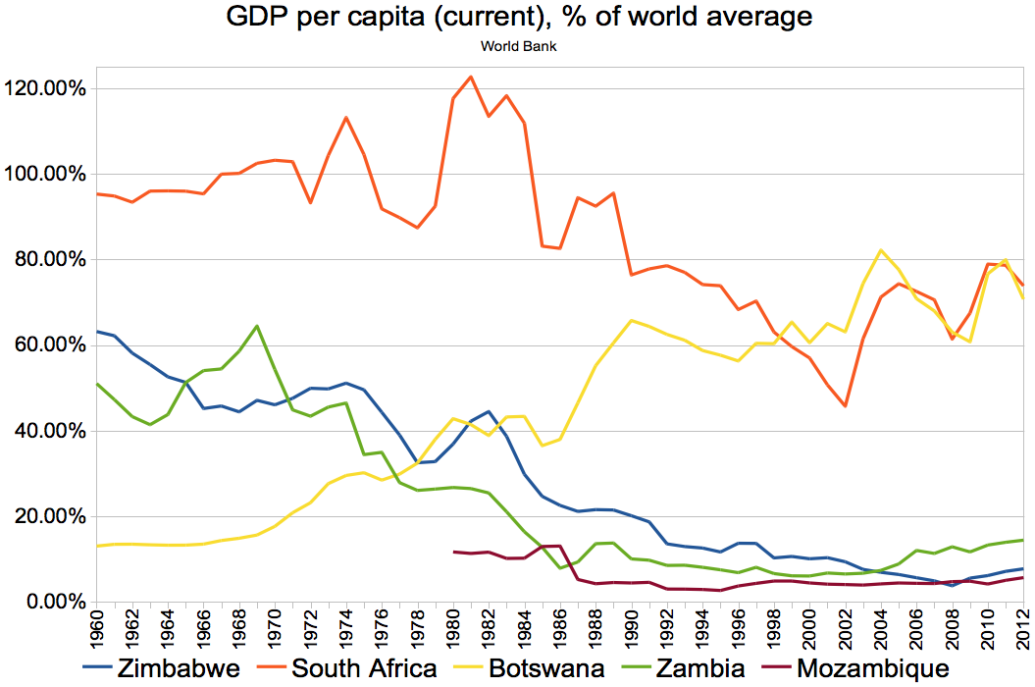

Figure Nr.1: 2004 – the Year?! (source: <https://en.wikipedia.org/wiki/Zambia>)

# Data assets

FAO: <https://miau.my-x.hu/miau/quilt/2020/food_project/>

# Methodology

Online solver-based engine: <https://miau.my-x.hu/cocoy0>

# Results

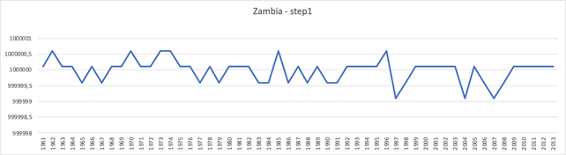

Figure Nr.2 – Modelled food-supply index – modelling step1 (source: own presentation)

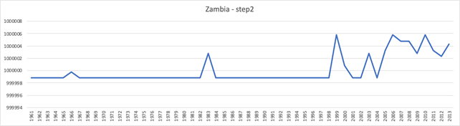

Figure Nr.3 – Modelled food-supply index – modelling step2 (source: own presentation)

As you can see, we have a suspicion (based on the doubled model), that something (crisis?) could happen in Zambia in 2004, because this is the most negative scenario… Yes, I can confirm that. The crisis was due to the conflict and political instability, the majority of Zambia population remains widely exposed to food insecurity, malnutrition, and hunger despite the country’s enormous agricultural potential. Population displacement remains one of the largest causes of food insecurity and chronic poverty in Zambia. Knowing that during this year 2004 a possible food crisis happens in the world will eventually affect the food consumption in Zambia. As we can see in the chart the food consumption in Zambia drops sharply those year and recover, in conclusion the world crisis had an impact to the food consumption in Zambia, and its not just a small but a huge crisis. Higher food prices too was in that crisis.

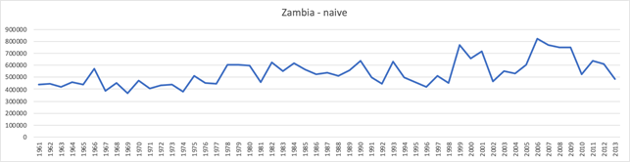

Figure Nr.4 - The naive evaluation (source – own presentation)

The naïve scenario (in the doubled model) makes possible, that another small crisis could be given in the period of 2004.

Zambia has been an exporter of maize to the region, but last year’s production was 21 percent down in 2004. Zambia’s ample stocks enabled it to still export to neighboring and needy Zimbabwe, but close to 800,000 Zambians are also at risk of food and livelihoods insecurity.

Zambia is a landlocked country in Southern Africa. Roughly the size of France, it is boarded by Tanzania to the northeast, Malawi to the east, Mozambique to the southeast. Zimbabwe and Botswana to the south and a narrow strip of Namibia to the southwest and the Democratic Republic of the Congo to the northwest. Two sources of information about hunger in Zambia appear to be relevant here.

Why Has Poverty Remained So High, Despite GDP Growth? Growth averaging 7.4 percent between 2004 and 2014 meant the economy more than doubled in size. In per capita terms, with the population growing at 2.8 percent, the change is smaller but still sizeable. This has led many to question why poverty rates remained stubbornly high. The answer is linked to the increasing inequality. The growth was thus exclusive (benefiting those well-off already) and not inclusive (not reaching the poorest households).

# Discussions

Background data: <https://miau.my-x.hu/miau/quilt/2020/food_project/zambia_v2.xlsx>

The case of Zambia is the ideal case of the Food-Kaleidoscope-technology. There is one single suspected year which can be seen parallel in each figure (see Figure Nr.5):

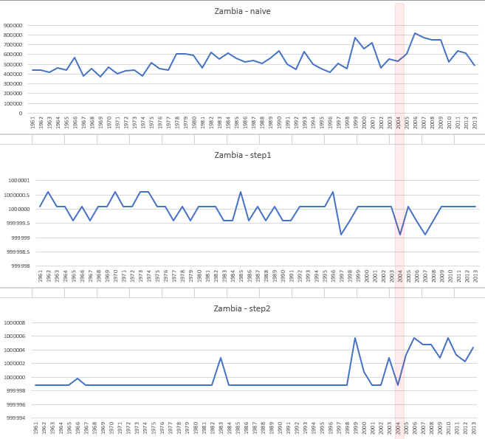

Figure Nr.5 – The validation of the suspected year of 2004 (source: own presentation)

# Conclusions

The main problems are:

* A clack of political will to take into account the complexity of food systems with food security as an outcome. How to put food security higher in the hierarchy of priorities and how to overcome the bureaucratic and organisational hurdles.
* Limited actions of the civil society
* Limited actions of private sector
* Lack of purchasing power
* Underperforming agriculture
* Managing nutrition transition by rebuilding local food system and strength of links between local small-scale producers and urban consumers

Possible actions could be:

* Increase agriculture production by increased arable lands, proper use of water, minimizing post-harvest losses, improved access to credit; more entrants at reasonable prices, better extension services
* Increase food accessibility
* Create job opportunities
* Make food available at local markets

The Food-Kaleidoscope in case of Zambia could be involved in a successfully way to detect critical periods of the history.

# References

<https://miau.my-x.hu/miau/184/japhun.doc>

<https://miau.my-x.hu/miau/261/?C=M;O=D>

# [https://miau.my-x.hu/miau2009/index.php3?x=miau128&where[indexkod]=miau261](https://miau.my-x.hu/miau2009/index.php3?x=miau128&where%5bindexkod%5d=miau261)

# Annexes

<https://miau.my-x.hu/miau/quilt/2020/food_project/?C=M;O=D>