

# **Transnational Cooperation for COVID’19 Control & Prevention**

## Khalid Hafiz Waqar

## Course: European Governance: Recent Developments & Challenges

## Kodolányi János University

## Budapest, 2020

MIAU – HU ISSN 1419-1652 – Special Edition 2020 Spring - Editorials: The papers in MIAU Nr.261 (2020.V) are products of a new education frame system “QuILT” (https://miau.my-x.hu/mediawiki/index.php/QuILT). The goals of QuILT are supporting/conducting Students on the way of KNUTH, who said (1992): Knowledge is, what can be transformed into source code, each other human activity is a kind of artistic performance. It also means we need to leave the world of the magic of words step by step. A solid evidence that we all are capable of going this way is: creating publications behind which the human expertise and the robotized knowledge (like online engines: https://miau.my-x.hu/myxfree/coco/index.html --- offering context free = quasi General-Problem-Solving force fields) can be integrated in case of a rational and relevant decision making scenario. The cyborg effects make possible to face the classic naïve and/or intuitive approaches and parallel the optimized approximations. This way can be realized without deep competences about mathematics, Excel (spreadsheets), statistics, etc. The new (inter/trans/multi-disciplinary) way just expects from us to be able and willing to co-operate with the best moments of the history – it means, with the already prepared robotized elements in order to build something creative one! Parallel, in the second QuILT-semester - https://miau.my-x.hu/mediawiki/index.php/QuILT2_parts - there are not only classic publication possibilities like robotizing the investigative journalism – there are further specific tasks too like 2DM-games, gamification in general, thinking experiments, etc.

Transnational Cooperation for COVID’19 Control & Prevention

Abstract: The paper presents a big-data-(OAM)-based approach, how the health management system of countries can be evaluated in an objective way involving online AI-oriented analytical tools in order to produce production functions based on similarities of the observed objects. The best managed countries are, where the ratio of deaths could be significantly more than in the reality.

Keywords: AI, big-data, solver-orientation, objectivity, automation

**Introduction**

Transnational Cooperation for COVID’ 19 Control and Prevention is a collaborative health initiative taken via cooperation of relevant ministries in Portugal, Spain and Germany. Coronavirus disease 2019 (COVID-19) is defined as illness caused by a novel coronavirus now called severe acute respiratory syndrome coronavirus 2. The novel coronavirus disease that emerged at the end of 2019 began threatening the health and lives of millions of people after a few weeks. Highly contagious with the possibility of causing severe respiratory disease, it has quickly impacted governments and public health systems. The coronavirus is also spreading in developing countries, and the impact on them is especially severe. The COVID-19 pandemic is having a drastic effect on people’s health and social lives as well as on the economy. It is in every country’s interests to support other states in the fight to overcome the COVID-19 crisis in order to limit the further spread of the pandemic and its devastating impact. This is why we decided to create cooperation about Covid-19.

The crisis caused by the spread of Covid-19 has demonstrated how difficult European cooperation can be, especially in policy areas where the EU has only a legal competence to support member states. Some commentators have suggested that this marks the death knell of European integration, and even the most optimistic of them recognize it as one of the greatest challenges the EU has ever faced in terms of crisis management and demonstrating supranational added value.

As the cooperation within the EU seems to be difficult, the idea was born to create a transnational cooperation between some European states. As part of the transnational cooperation project, 3 major EU countries Portugal, Spain and Germany will be pooling together economic, financial and administrative resources for an effective control and prevention of the ongoing COVID’19 Pandemic. Health, Finance ministries of the partner countries have primary involvement in the project while Education and Media reporting sectors shall also play an important role within the framework of cooperation.

About the cooperation

**Main Fields of Cooperation**

1. **Prevention and control of further spread of the COVID-19 Virus**

As the partner countries work towards a successful cooperation and developing effective immunization techniques, it must be ensured that their citizens must follow general preventive measures set in place against the pandemic. These include:

1. Wearing a protective shield (Surgical masks, scarves, covering) over the face at all times when outside.
2. Going out only when necessary.
3. Keeping a social distance of at least 2 meters when in Public gatherings.

Within the framework of the cooperation the partner countries work in creating a common methods of preventing and controlling the further spread of the virus. Collaborating countries also take responsibilities of ensuring policy compliance. In order for the collaborative health initiatives to be successful, it is imperative that all the partner countries ensure 100% compliance with the developed and suggested policies. This can be guaranteed via involvement of local law enforcement and administrative sectors and may include measures like: The general public and defaulters being subject to state regulated and imposed fines for not following directives of the collaborative initiative.

Causing public discomfort or imposing health risks via non-compliance of the general preventive measures.

1. **Economical Help**

As the WHO acknowledged the COVID’19 as a pandemic, there is a fear of post-pandemic financial and economic crisis in the world. COVID-19 will force a rebirth of many industries as we all sit at home in lockdown, re-assessing and re-imagining modes of consumption, supply, interaction and productivity. The economic damage is mounting across all countries, tracking the sharp rise in new infections and containment measures put in place by governments. To overcome this pandemic, we need a global, coordinated health and economic policy effort. The transnational cooperation collaboration with other partners—will be doing everything it can to ensure rapid support is available to involved countries through emergency financing, policy advice, and technical assistance.

Within the cooperation, Germany, Spain and Portugal will provide essential financial and economic aid that is needed in order to help affected regions as much as the legislation of the EU allowed it. A fund should be created to issue common debt with a common guarantee.

1. **Humanitarian Aid**

Humanitarian Aid is one of the main fields of cooperation. As a humanitarian aid most important thing is supporting Health Ministries, local hospitals and clinics through training and protective measures for medical staff. With the help of different training programs, projects and medical exchange programs the cooperation will create a great opportunity of sharing experience and strengthening the medical system of the 3 countries.

Second important part of the humanitarian aid is improving medical facilities to help healthcare facilities address near-term needs related to the current COVID-19 pandemic. Help with the facilities is especially necessary in the clinics outside the capitals. Meeting the needs of those affected by the COVID-19 is also an important part of the collaboration.

Another important aspect of humanitarian aid is psychological help for those affected. Infectious disease outbreaks, like the current coronavirus (COVID-19), can be scary and can affect mental health. While it is important to stay informed, there are also many things we can do to support and manage wellbeing of people during such times. In public mental health terms, the main psychological impact to date is elevated rates of stress or anxiety. But as new measures and impacts are introduced – especially quarantine and its effects on many people’s usual activities, routines or livelihoods – levels of loneliness, depression, harmful alcohol and drug use, and self-harm or suicidal behavior are also expected to rise. In populations already heavily affected issues of service access and continuity for people with developing or existing mental health conditions are also now a major concern. As part of its public health response, our transnational cooperation will work to develop a center for help and a set of new materials on the mental health and psychosocial support aspects of COVID-19.

1. **Research**

The main part of the collaboration between the countries is about the medical research needed for the prevention of the virus. It seems to be difficult to distinguish between the Corona virus and the normal flu, but main difference is that there is not medicine or vaccination against the COVID’19.

Researchers of the cooperation will be joining forces with scientists around the world to find solutions that will end the COVID-19 pandemic. The collaboration ranges from experiments to adapt a measles vaccine to prevent COVID-19 to efforts to understand how the human immune system’s antibodies attack the coronavirus. Cooperation will support rapid development of vaccines to prevent COVID-19 infections. In order to conduct these kind of researches there will be created a laboratory located in Madrid, Spain.

1. **Raising Awareness (education, fighting against disinformation about the virus)**

Another important field of cooperation is raising awareness among the population of the tree countries. Cooperation will work hard to raise awareness about the corona virus. It will spread knowledge about the nature of the virus, its danger and most importantly how to avoid contamination. And it will explain the importance of social distancing in this critical period. The work will also be done on social media in order to raise awareness. On the social pages of the cooperation there will be all kinds of information and news concerning the virus in four languages, German, Spanish, Portuguese and English. With the help of articles and scientific researchers conducted by the professionals, cooperation will be able to help the education. It is important to help people distinguish between the normal flu and COVID’19 symptoms.

One important part of the education will be fact-checking. With the help of online platform people will have the opportunity of fact-checking news about the virus as the disinformation about the COVID’19 is widespread even in developed countries as well. While answering online tests, people will be able to understand how much they know about the virus and it will give as an important data as well.

As the collaborative program continues, the partner countries shall keep receiving research inputs as well as suggestions for improvement from worldwide research collaborations which will work towards adding to the measures already in place. Some of the future improvements suggested with regards to more effective prevention are: Developing interactive public socializing methods via virtual networks to promote mental and physical wellbeing while encouraging the general public to stay home. Government regulated monthly or quarterly payments to ensure continued supplied of essential items to all citizens of the partner countries.

Structural Framework & Hierarchy

Even though the workload is divided by the countries, which they take responsibilities for, within the transnational cooperation there will be hierarchy of beaurocracy as well.

The headquarter of the cooperation will be located in Berlin, Germany.

**General Assembly**

General Assembly is a deliberative organ. The assembly is represented by the governors of the countries and the ministers of Health, Finances, Education and corresponding ministries. General Assembly will meet 4 times a year. It will approve the budget and programmer of work and debate topics of vital importance to the health sector. Twice a year assembly will elect Secretary General from the ministers.

**Executive Council**

Executive Council will be responsible for ensuring that the organization carries out its work and adheres to its budget.

**Regional Commissions**

There will be three regional commissions in Germany, Portugal and Spain. The transnational cooperation will have its representative commissioners in every country. Their main obligation will be monitoring the policy compliance.

**Committees**

As the transnational Cooperation has a wide range of varieties in the field of cooperation, there will be corresponding committees as well. The following committees are:

1. Committee of Education
2. Committee of Research
3. Committee of Health
4. Committee of Economics

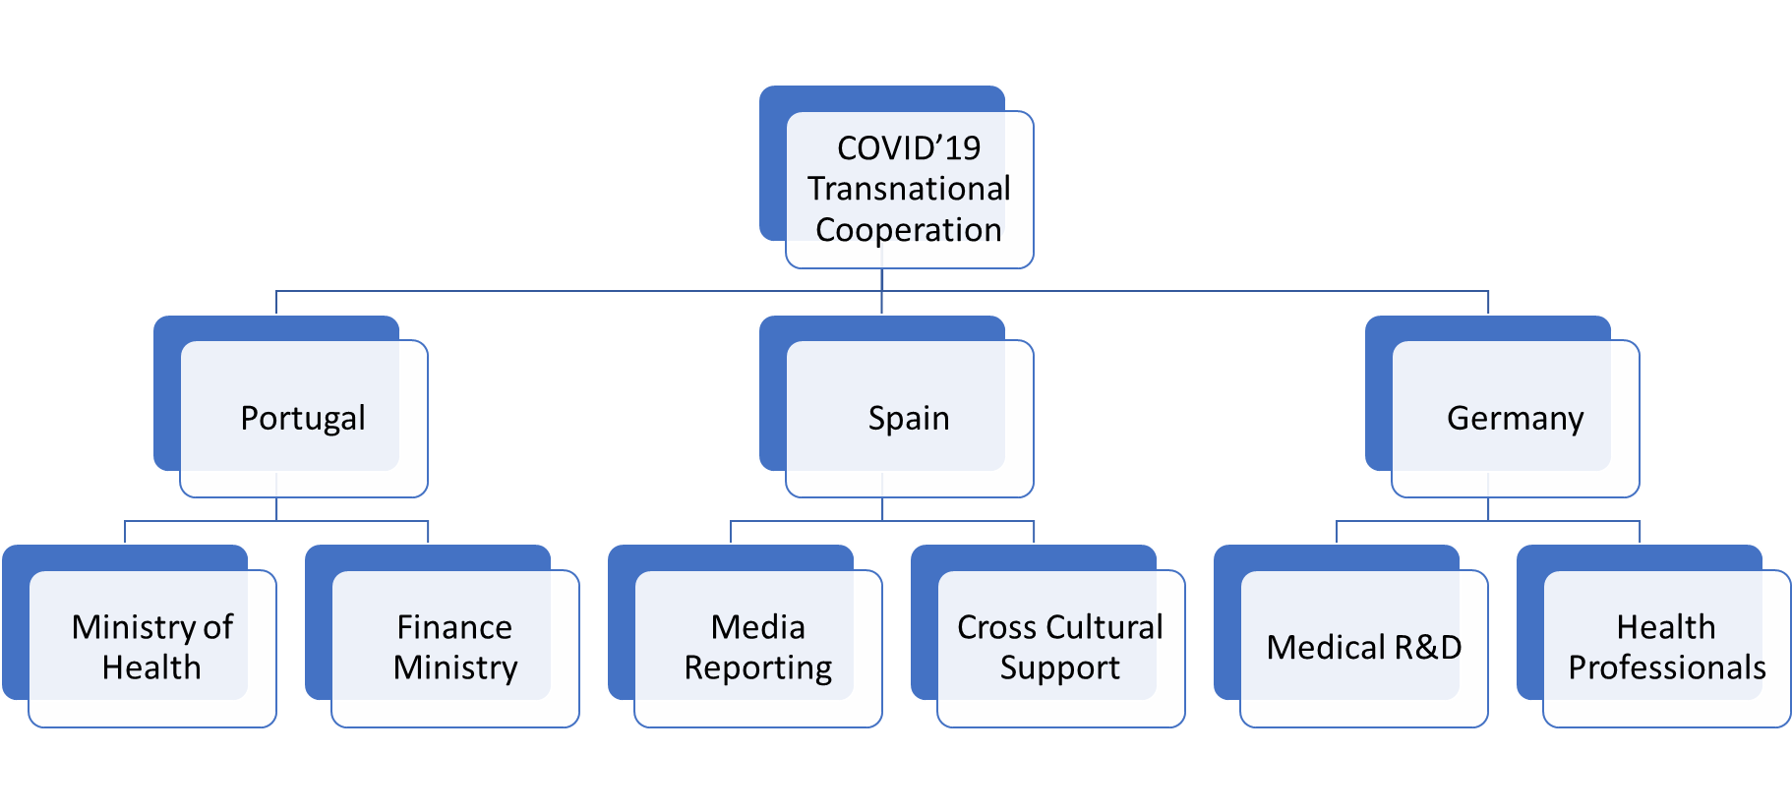

As depicted in the previous Hierarchical chart, according to the transnational agreement, the partner countries will divide incumbent workload amongst various organizations for which they are able to pool in more resources. Workload division and management shall be ensured by non-governing bodies and third party verification for an unbiased and smooth adjudication of the processes.

All of the partner countries shall share equal responsibilities contributing financially as well as administratively to ensure effective management of the entire project. The specific country roles will be detailed as well as the contribution required via medical professionals and administrative facilities.

**Portugal**

Portugal will take the responsibility of overseeing the Finance and economical perspectives of the collaboration project.

The Ministry of Health will ensure effective dispatchment of medical information and the development of relevant health policies with regards to control and prevention of COVID’ 19.

The developed policies will be shared with the remaining 3 partner countries and strict implementation shall be ensured within Portugal itself.

**Spain**

Media coverage and specialized televised broadcasts shall fall under the jurisdiction of Spain as a partner country.

The developed health policies and important information regarding economic measures being taken by the other participating partner countries shall be shared in all of the partner state languages as well as English to help ensure complete understanding of the policies and procedures.

**Germany**

As the most technologically advanced country out of the transnational coalition, Germany will be responsible for investing heavily into COVID’19 specific research in order to discover the most effective preventive measures as well as work towards a working vaccine to fend off the current pandemic.

The high number of advanced medical facilities existing within the country in addition to state of the art manufacturing companies lending their support for R&D ventures shall enable Germany to effectively contribute with high tech medical equipment and trained medical personnel to the other partner countries.

Case study

Also as part of the transnational Cooperation, a number of studies were conducted and the results found from these can be summarized and interpreted as follows:

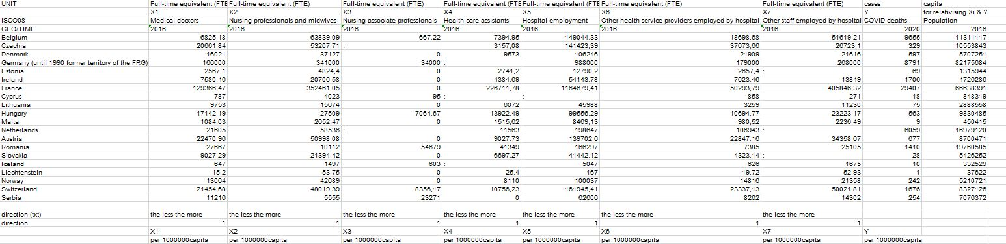

1. Figure FTE of Transnational Cooperation and European Countries

Figure 1 shows the current situation of the different categories related to medical professionals within general Europe and primarily focusing on the transnational cooperation countries. With most European countries there is almost always a shortage of highly qualified medical personnel and the current state of the country’s economy generally reflects the state of qualified medical personnel within that country or region.

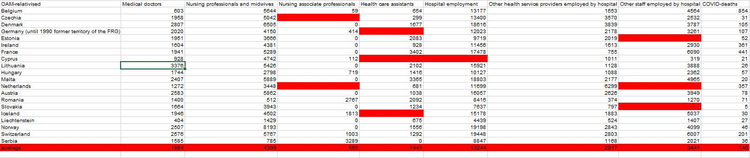

2. Figure OAM Relativized for Transnational and Other EU Countries

Figure 2 depicts the condition of different European countries and the transnational cooperation countries with respect to their current economy and hence the term Relativized OAM is used for the description of this set of data. The method used to calculate relativized OAM included the multiplication of all the data sets by the general population of the concerned country in order to derive the “per capita” values for all of the different data sets.

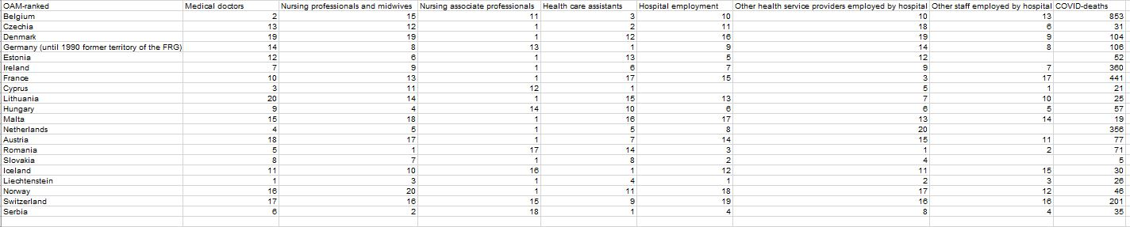

3. Figure OAM ranked by EU and Transnational Cooperation Countries

Figure 3 depicts the overall countries ranked by the different categories of medical proficiency such as the number of Medical Doctors, the number of medical nurses and other general health professionals. The inclusion of this ranking within the data set can better help understand potential researchers of how capable certain countries are with regards to an effective response dealing with COVID.

Results

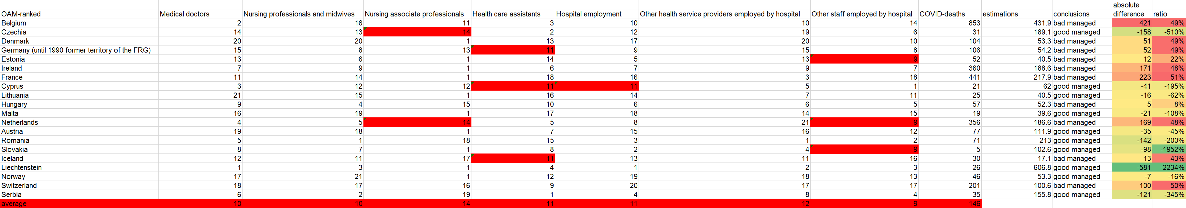

Figure Nr.4 – Evaluation of countries

Figure 4 demonstrates that Liechtenstein > Slovakia > Czechia (green highlighted in column “ratio”) are the best managed countries if the less the better principles for each attribute are valid. The presented methodology can be used for more attributes and counties – it means: such kind of analyses should be produced in an automated way for the unlimited access of the total population of the planet…

More details:

<https://miau.my-x.hu/miau/quilt/2020/covid19_project/health_management_quality_v2.xls>

<https://miau.my-x.hu/miau/quilt/2020/covid19_project/eurostat_views.docx> (incl. handling of missing data positions)

Rapid-project-tutorial: <https://miau.my-x.hu/miau/quilt/2020/quilt2/launching2020IV29/part5.html> +

<https://miau.my-x.hu/miau/quilt/2020/AI-project/tutorials_eu/?C=M;O=A>

Discussion

The above presented logic assumes that we are capable of declaring directions for each attribute and these directions may be simple (see: the more the more or the more the less). It would also be possible to use doubled directions for simulating optimum-like connections between Xi and Y: c.f.

<https://miau.my-x.hu/miau/quilt/2020/quilt2/launching2020III25/part1a.html>

Conclusion

The spread of new COVID’19 viruses has affected a lot of countries. In general, all member states of the EU were initially inward-looking in their reactions; they unilaterally closed borders and focused on crisis management at home. European solidarity has largely been absent while there is a need of preventing the further spread of the virus. This fact leads us to creating a transnational Cooperation.

We believe that 3 countries working together pooling all their strongest resources for a common goal will lead to highly optimized results.

As the policies will be developed on a consensus basis, the general public will be much more likely to follow these regulations leading to an overall improved enforcement of the regulations.

The success of such a transnational project shall hold as a hallmark for other countries to follow suit and ideally lead into a European Union wide cooperation to effectively combat the current global pandemic.