MIAU – HU ISSN 141921652 – Special Edition 2020 Spring - Editorials: The papers in MIAU Nr.261 (2020.V) are products of a new education frame system “QuILT” (https://miau.myx.hu/mediawiki/index.php/QuILT). The goals of QuILT are supporting/conducting Students on the way of KNUTH, who said (1992): Knowledge is, what can be transformed into source code, each other human activity is a kind of artistic performance. It also means we need to leave the world of the magic of words step by step. A solid evidence that we all are capable of going this way is: creating publications behind which the human expertise and the robotized knowledge (like online engines: https://miau.my-x.hu/myxfree/coco/index.html -- - offering context free = quasi General-Problem-Solving force fields) can be integrated in case of a rational and relevant decision making scenario. The cyborg effects make possible to face the classic naïve and/or intuitive approaches and parallel the optimized approximations. This way can be realized without deep competences about mathematics, Excel (spreadsheets), statistics, etc. The new (inter/trans/multi-disciplinary) way just expects from us to be able and willing to co-operate with the best moments of the history – it means, with the already prepared robotized elements in order to build something creative one! Parallel, in the second QuILT-semester - https://miau.myx.hu/mediawiki/index.php/QuILT2_parts - there are not only classic publication possibilities like robotizing the investigative journalism – there are further specific tasks too like 2DMgames, gamification in general, thinking experiments, etc.

**Title:** **Pizza to go – A Best Pizza Award – based on a robot judge**

**Author: Nadeem Azhar**

**Abstract:** This paper report includes specific findings on the number of food insecure and vulnerable people in the country. A stratified approach was used to provide estimate of set of food and nutritional security indicators countries. The goal of the paper is to demonstrate, how an online robot judge could be work in case of a pizza award.

**Keywords**: artificial intelligence, big data, objectivism, term of the Best, automation

# **Introduction**

Ever since its introduction, pizza has been a national favourite throughout the Hungary. As it became more popular. The average pizzeria uses roughly 55 pizza boxes per day. We consume around 251,770,000 pounds of pepperonis every year some popular pizza toppings in Hungary are chicken, szalámi, squid and Mayo Jaga (mayonnaise, potato and bacon) newly introduced pizza restaurant in city is Pizza to go

**Our pizza is famous among people** because. These pizzas consist of the same basic design but include many choice of ingredients, such as anchovies, egg, pineapple, lamb, couscous, chicken, fish, meats prepared in styles such as Turkish lamb, Doner or chicken tikka masala, and non-traditional spices such as curry and Thai sweet chili. Pizzas can also be made without meat for vegetarians and without cheese for vegans.

**Mission, vision, objectives and growth strategies**

Our Pizza Restaurant focuses on gaining the attention of costumers and formation a core of loyal customer, who attend the restaurant on the regular basis. Our pizza restaurant should maintain the customer loyalty to its products and services and attract new customers. It is through the combination of the maintenance of existing customers and attraction of new ones, the pizza restaurant can succeed in the market. The vision of the pizza restaurant is to provide products and services of high quality to mass customers.

**Products, pricing, promotion, supply chain**

The pizza restaurant offer its customers not only pizza, which should be definitely the chief dish of the restaurant but also other dishes, which are easy and fast to cook and service to customers but the dishes served in the restaurant should be healthy and do not cause any harm to customers health. The price of products offered in the pizza restaurant should be affordable for average customers. The restaurant should position itself as democratic and open to all customers. The pizza restaurant should conduct a large scale promotional campaign including local media, focusing on television, print media and radio.

As for the supply chain, the restaurant should use local suppliers to provide customers with fresh products, which customers are accustomed to. If necessary, pizzas and other dishes should be adapted to tastes of the local population. The use of local suppliers will allow the restaurant to save costs on the delivery of products and guarantee the high quality of products.

**Customer analysis**

Basically our pizza restaurant targets at the large masses of customers. We should count for huge masses of customers that will consume its products regularly. What is meant here is the fact that, ideally, the pizza restaurant menu should overcome all social or age boundaries and become a part of food culture of people living in different socioeconomic and socio-cultural environment.

It is worth mentioning the fact that the initial orientation on the young customers is quite logical and potentially may be very effective. The reason for the choice of young people as the target customer group is quite simple. In fact, young people traditionally tend to experiments and they readily accept products offered by the pizza restaurant. This is why if our restaurant is accepted by young people, it will more likely that they will become loyal customers.

**Target market, customers’ needs and wants**

The target market is families because the restaurant should attract families. In actuality, family traditions are strong and the pizza restaurant can offer family members excellent opportunities to gather and dine in the restaurant. In such a way, customers will enjoy the communication with family members and good dishes served in the restaurant. The pizza restaurant can become a place of traditional family meetings that will become a tradition for many families to attend the restaurant.

Our restaurant will meet needs and wants of customers, especially the need of products of the high quality served at affordable prices.

**Uniqueness of our pizza restaurant**

The pizza restaurant should take an advantageous position in the market due to the unique style of pizza. To put it more precisely, the pizza offered in the restaurant should be diverse but meet local tastes and preferences of customers. The unique pizza will be a blend of traditional pizza and local cuisine. Customers will enjoy traditional taste and products being offered in a new, trendy restaurant

**Competitors and their strategies**

At the moment, the pizza restaurant can face a competition from the part of four main restaurants. However, the competitors focus on upper-class customers, whereas our pizza restaurant focuses on mass customers belonging to middle and lower classes. In such a way, the restaurant can reach the high number of customers in a short run.

**Motivation**

We believe that .Our pizza restaurant has excellent opportunity to take the leading position in the market due to its unique products and niche in the market. The pizza restaurant has internal strength such as advanced equipment, well-trained personnel and sufficient financial resources.

However, the pizza restaurant does not have extensive experience of operating in the local market. But with hard work we will counter that problem

**OAM scores**

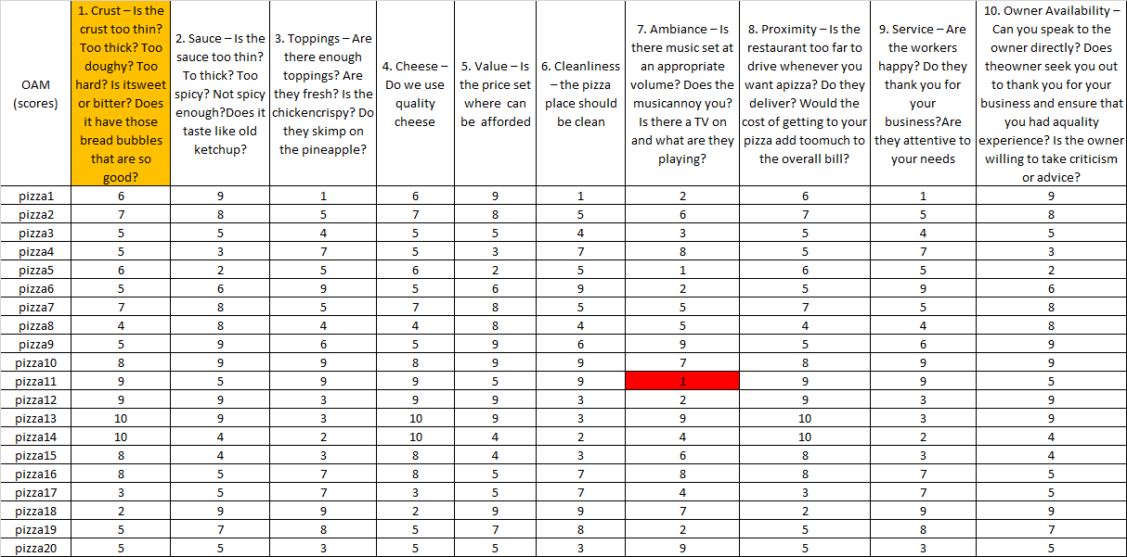**These are the OAM ranking numbers for all the pizzas we have**

**Figure Nr.1 – Ranking numbers (source: own presentation)**

**The general problem is (assumed, that the ranking of the pizzas according each column can be derived in an automated way – it means by robot judges): how can we evaluate the OAM by an online robot judge?**

**Naive, Rank, Instinctive, Modelled of the table**

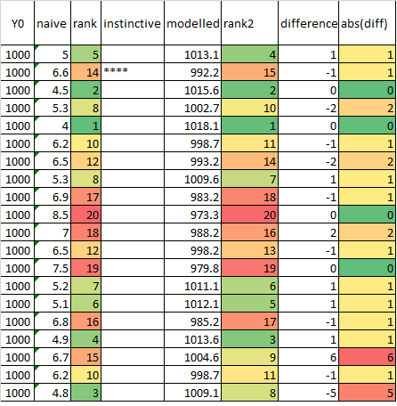

**Figure Nr.2 – Alternative evaluation of objects (pizzas Nr.1-Nr.20) – (own presentations)**

**More details:** [**https://miau.my-x.hu/miau/quilt/2020/pizza_business_google_trends/pizza_y0_v3.xlsx**](https://miau.my-x.hu/miau/quilt/2020/pizza_business_google_trends/pizza_y0_v3.xlsx)

**Figure Nr.2 demonstrates a naïve evaluation where the ranking numbers of the Figure Nr.1 lead to an average value without the proving possibility of the antidiscriminative principle “each pizza could have the same evaluation value”. The model was derived in an online way here:** [**https://miau.my-x-hu/cocoy0**](https://miau.my-x-hu/cocoy0)

**Annual Pizza Award**

**The Largest U.S. Pizza-Making Competition**

**Pizza Makers Vie for Prizes in Five Divisions**

Since its inception in 2007, the International Pizza Challenge™ has evolved and grown in stature and prize money to become the best pizza-making competition in North America. There are now five divisions in the pizza bake-off attracting approximately 200 pizzaioli. They bake a pie from their pizza menu on the spot at Pizza Expo and present it to a panel of judges, with cash prizes and plaques going to the winners. The five divisions include Traditional, Non-Traditional, Pan, Pizza Napolitano and Roman.

The bake-offs run Tuesday through Thursday at Pizza Expo. A maximum of 60 entries are accepted in the Traditional and Non-Traditional divisions; contestants are capped at 30 in the Pizza Napoletana and 20 in the Pan and Roman divisions. The top four preliminary-round scores from the Traditional and Non-Traditional fields advance to the division finals on Thursday. After winners are named in all the divisional finals, the winners will face off against each other in a mystery-ingredient bake-off for Pizza Maker of the Year. The winning pizzaiolo selected by the judges receives $5,000 and a trophy to add to earnings of either $4,000 (if he or she advanced through Pizza Napoletana, Pan or Roman) or $7,500 (through Traditional or Non-Traditional). All top finishers claim bragging rights for their pizza marketing campaigns.

A “Best of the Best” bake-off is held Thursday as well, featuring past champions in a blind-box event. The four competitors must use all of the ingredients in the blind box revealed to them just before bake time, plus ingredients from a common table.

Here are some thing that judges we keep in their mind while announcing best pizza award

**Rules/and method to find best**

1 Crust – Is the crust too thin? Too thick? Too doughy? Too hard? Is it sweet or bitter? Does it have those bread bubbles that are so good? (all criteria need a very detailed description in order to ensure the KNUTH-principle: knowledge is what can be transformed into source code)

2. Sauce – Is the sauce too thin? To thick? Too spicy? Not spicy enough? Does it taste like old ketchup? (all criteria need a very detailed description in order to ensure the KNUTH-principle: knowledge is what can be transformed into source code)

3. Toppings – Are there enough toppings? Are they fresh? Is the chicken crispy? Do they skimp on the pineapple? (all criteria need a very detailed description in order to ensure the KNUTH-principle: knowledge is what can be transformed into source code)

4. Cheese – Do we use quality cheese? (all criteria need a very detailed description in order to ensure the KNUTH-principle: knowledge is what can be transformed into source code)

5. Value – Is the price set where can be afforded (all criteria need a very detailed description in order to ensure the KNUTH-principle: knowledge is what can be transformed into source code)

6. Cleanliness – the pizza place should be clean (all criteria need a very detailed description in order to ensure the KNUTH-principle: knowledge is what can be transformed into source code)

7. Ambiance – Is there music set at an appropriate volume? Does the music annoy you? Is there a TV on and what are they playing? (all criteria need a very detailed description in order to ensure the KNUTH-principle: knowledge is what can be transformed into source code)

8. Proximity – Is the restaurant too far to drive whenever you want pizza? Do they deliver? Would the cost of getting to your pizza add too much to the overall bill? (all criteria need a very detailed description in order to ensure the KNUTH-principle: knowledge is what can be transformed into source code)

9. Service – Are the workers happy? Do they thank you for your business? Are they attentive to your needs? (all criteria need a very detailed description in order to ensure the KNUTH-principle: knowledge is what can be transformed into source code)

10. Owner Availability – Can you speak to the owner directly? Does the owner seek you out to thank you for your business and ensure that you had quality experience? Is the willing to take criticism or advice? (all criteria need a very detailed description in order to ensure the KNUTH-principle: knowledge is what can be transformed into source code)

# **Discussions**

* Differences between single- and multi-country views:
  + Each aspect can highlight suspected years periods.
  + The Pizza to go delivers a massive suspicion if more view brings the same years/periods as potential suspected.
* Differences between naïve and optimized views:
  + The naïve view cannot be interpreted in a proper way – the total values year by year cannot support the sensitivity of the robot eyes.
  + The optimized views are the real views of the Food-Kaleidoscope
* What is an optimal food-ratio as such?
  + The nutritional sciences speak about rules for individuals like more vegetables = longer life – without involving the Liebig principle into the interpretations where these rules can be valid in bubbles (it means for shorter periods and not in general).
  + The here and now explore rules seem to be more relevant for the sociologists.
* The adaptation of the antidiscriminative, robotized methodology for evaluation of awards needs therefore measurable criteria at any rate!

**Conclusion**

**Pizza to go could be a successful place. It has its weak points and strong points. Some of the strong points are that Pizza to go is most suitable for socializing with friends and extremely easy to access for students. The main use of Pizza to go eating space is used for eating, however students have also made the area useful for socializing and doing other activities. In addition, with swipes and ready-made food, Pizza to go is great for students that are in a rush. On the other hand, some of the weak points are the line is not constant throughout the day and the food served is made to eat as lunch rather than dinner. These weak points did not affect the success of restaurant because the business still continues to operate fairly well. Swipes are offered daily but these observations showed it does not seem to play a huge role in a student’s decision to eat here. It is successful because Pizza to go is convenient for students in a rush and wants to have pizza to eat.**

**If the criteria of an award can be seen as measurable attributes then the involving of a robot judge is more than trivial!**

**Reference**

Wikipedia <https://www.pizzaexpo.com/competition-events/international-pizza-challenge/>