

2D MATRIX GAME

Service Science & Knowledge Economy: Research Methods

Conductor: Laszlo Pitlik

Motto: everybody can turn a stone into a diamond

Syed Nabeel (B4RIRL)

Saad Muhammad Adil

MIAU – HU ISSN 141921652 – Special Edition 2020 Spring - Editorials: The papers in MIAU Nr.261 (2020.V) are products of a new education frame system “QuILT” (<https://miau.my-x.hu/mediawiki/index.php/QuILT>). The goals of QuILT are supporting/conducting Students on the way of KNUTH, who said (1992): Knowledge is, what can be transformed into source code, each other human activity is a kind of artistic performance. It also means we need to leave the world of the magic of words step by step. A solid evidence that we all are capable of going this way is: creating publications behind which the human expertise and the robotized knowledge (like online engines: <https://miau.my-x.hu/myxfree/coco/index.html> --- offering context free = quasi General-Problem-Solving force fields) can be integrated in case of a rational and relevant decision making scenario. The cyborg effects make possible to face the classic naïve and/or intuitive approaches and parallel the optimized approximations. This way can be realized without deep competences about mathematics, Excel (spreadsheets), statistics, etc. The new (inter/trans/multi-disciplinary) way just expects from us to be able and willing to co-operate with the best moments of the history – it means, with the already prepared robotized elements in order to build something creative one! Parallel, in the second QuILT-semester - <https://miau.my-x.hu/mediawiki/index.php/QuILT2_parts> - there are not only classic publication possibilities like robotizing the investigative journalism – there are further specific tasks too like 2DM-games, gamification in general, thinking experiments, etc.

Table of Contents

Game Explaining 2

Unsolved Game 3

Answer cards 3

Solution Explained 4

Solved Game 4

Solving the problem of repetitions 5

Vision 5

References 5

Game Explaining Part 2 6

Unsolved Game Part 2 6

Helping Cards Part 2 7

Answer Cards Part 2 7

Solution Explained Part 2 9

Solved Game Part 2 9

Vision 10

References 10

Content PART I

# Game Explaining

We have created this game in a way that even a person with little mathematical knowledge can solve it. This game is based of little mathematical problems. There are three rows and three columns. The person playing has to pick a picture and put it in a box where it belongs. It will only be solved if the person playing will put all the pictures in correct boxes. Since it is a 2D game, the person playing has to consider correct row and column otherwise it will be wrong.

# Unsolved Game



Figure Nr.1 – Empty game (source: own presentation)

Above you can see an empty game (Figure Nr.1), in which there are some numbers in light green boxes. The solution is linked to these numbers.

# Answer cards

  * 2

  *2



 

Figure Nr.2 – Answer cards (source: own presentation)

As you can see some numbers above, these numbers will be used to solve the game.

# Solution Explained

The important thing about the solution is the link between these numbers and the numbers in the empty game. If you think and try to solve you will realize that these numbers are multipliers of the numbers in the empty game. If you want to solve you will have to find a link between these numbers and the numbers in the empty game.

# Solved Game



Figure Nr.3 – Solution visualized (source: own presentation)

Now if you look at the solved game above that if you find the link between all the numbers it is very easy to solve.

# Solving the problem of repetitions

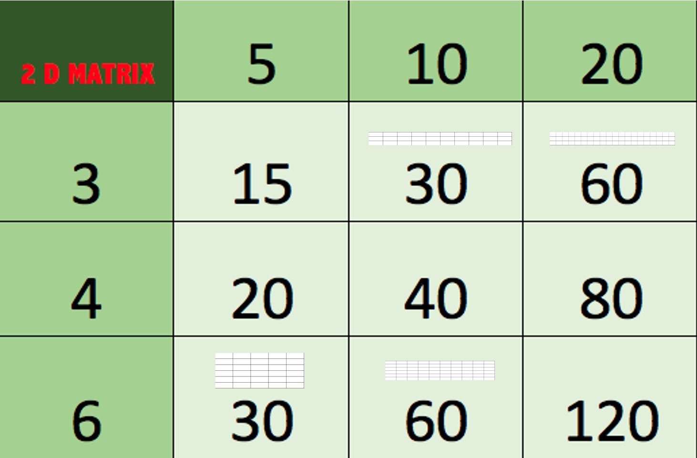

Figure Nr.4 – Repetitions and their treatments (source: own presentation)

As you can see, the repetitive answer cards should have an additional pattern. These patterns are the bordered figures of Excel-cells in row*column-view. The users/players have to identify these additional patterns before setting the cards.

# Vision

The game can be produced in two different mode: the row- and column-headers could namely be changed. This can lead to different reaction times and solving patterns. The LOG-data could analyzed for example: to detect reading preferences (origin, mother-tongue) and/or robustness of symmetry in calculation challenges (e.g. 6*5 <?=?>6*5).

# References

* <https://miau.my-x.hu/miau2009/index.php3?x=e0&string=2dm>
* <https://miau.my-x.hu/mediawiki/index.php/QuILT-IK045-Diary>

Content PART II

# Game Explaining Part 2

To create this game (basically for adults), we really had to work hard and think outside of the box. Finally, we came up with this great idea (shaping sudoku), in which shapes are used. Each shape is equal to a numerical value. Numerical values of the shapes are not always directly given. To find the numerical values players will have to solve little equations which are mixtures of shapes and numbers, but they are very easy to solve. Once, players have the numerical values of the shapes they will then use those to solve the game.

# Unsolved Game Part 2



Figure 5. Unsolved game (Source: own presentation)

Above you can see the unsolved game (Figure 5), once the users have the numerical values of the shapes, they will put those shapes in the empty boxes to complete the game.

# Helping Cards Part 2

 



Figure 6. Helping cards (source: own presentation)

Above you can see the helping cards (Figure 6), these will be used to find out the values of the shapes. Once the players have values of the shapes, they will be able to use the shapes to solve the game. The equations can be built in a more sophisticated way, where no shape has a direct defined value (see references with examples how to use solver-based techniques for solving the equations and/or a kind of sudoku)

# Answer Cards Part 2

 =40-15=25

 = 30-20 = 10

 = 165-130 = 35

 = 60-40=20

 = 80

 = 5

 = 130-80=50

 = 20-5=15 (c.f. monkey)

 = 15 (c.f. horse)

Figure 7. Answering cards (source: own presentation)

Answer cards (figure 7) will be used to solve the game.

# Solution Explained Part 2

After looking at the helping cards (figure 6) you will realize that this game only requires little mathematical knowledge or even the capability to use solver-based engines as an other sort of mathematical knowledge, and is very easy to solve. Once, the players find the numerical values of the shapes they will then use the shapes in the empty game to solve it. As each shape could be converted toa numerical value, the players will have to put shapes in the game in a way that the sum of the rows and columns are equal to the values on the particular row- and column-header.

# Solved Game Part 2

Rows:

* 95 = 50 + 20 + 25
* 105= 15 + 80 + 10
* 55 = 15 + 5 + 35

Columns:

* 80 = 50 + 15 + 15
* 105 = 20 + 80 + 5
* 70 = 25 + 35 + 10



Figure 8. Solved game (source: own presentation)

Looking at the above solved game (figure 8) you will realize that it’s not difficult and just a trick to “confuse” the players.

# Vision

The “Shaping-Sudoku” is a new form of the 2DM-games where chained effects lead to a solution. Therefore, this kind of task can also be used for IQ-tests.

It would also be possible to define parameters where 2 potential rules are hidden. But one of the rules are not entirely correct – it means: e.g. 5-6-7 answer cards can be placed so that both rules could still be valid, and the further cards may only follow one of the rules. This complexity could really confuse the players putting the first n cards to the right place based on a wrong rule (as they will see the trap later:-)

# References

* <https://miau.my-x.hu/miau/256/sc2019_solver.xlsx>
* <https://miau.my-x.hu/miau2009/index.php3?x=e0&string=sudoku>