**Abstract:**[**https://miau.my-x.hu/bprof/2023/FINANCE%20PROCESS%20AUTOMATION%20abstract_pl2.docx**](https://miau.my-x.hu/bprof/2023/FINANCE%20PROCESS%20AUTOMATION%20abstract_pl2.docx)

**FINANCE PROCESS AUTOMATION WITH NUMBERICAL DECISION MAKING**

István Vancsura (<https://orcid.org/0000-0002-5402-8186>)

E-mail address: [vancsura.pisti@gmail.com](mailto:vancsura.pisti@gmail.com) / Mobile phone numbers: +36 20 276 9700

László Pitlik (<https://orcid.org/0000-0001-5819-0319>)

E-mail address: [pitlik.laszlo@kodolanyi.hu](mailto:pitlik.laszlo@kodolanyi.hu) / Mobile phone numbers: +36 30 981 6001

Budapest, Hungary, Kodolányi János University / MY-X research team

Demo: <https://miau.my-x.hu/miau/296/risk_index_naive_regression_coco.xlsx>

# Introduction

The article will provide an in-depth discussion on the advantages of numerical decision making in banking transactions, as well as its differences with binary (logical rule-based) decision making. It will highlight the importance of using numerical decision making in today's digital age.

Numerical decision making is based on data-driven analyses. On the other hand, binary decision making is a simplified approach of decision making (c.f. circuit diagrams) that only considers two options in general, such as yes or no, pass or fail – like in the classic mathematical logic (c.f. decision trees). Numeric decisions produce fuzzy-like and/or quantum-like interpretation possibilities.

Numerical decision-making is based on the application of mathematical and statistical models (more and more AI-approaches: like similarity analyses – c.f. <https://miau.my-x.hu/myx-free/>), which allows banks to determine the best decision based on data.

Objects and attributes form the basis of creating a data model, which is used to represent the structure and relationships of data, and is essential for effective data management and processing. It is important to collect the objects and attributes that make up the system. This is the first step in understanding business processes and user needs.

The keywords and their relationships can be modelled in this simple structure:

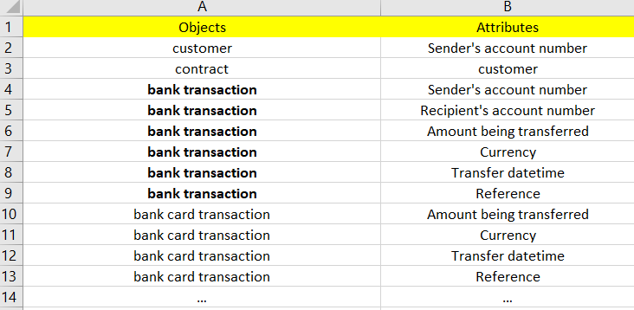

Figure#1 (from Sheet keywords) (Source: <https://miau.my-x.hu/miau/296/risk_index_naive_regression_coco.xlsx>)

The focus will be on bank transactions.

# Literature review

This literature review examines the advantages of numerical decision-making in banking transactions and its process, highlighting the role of data in decision-making.

Advantages of Numerical Decision Making in Banking Transactions

An article by Henk Broeders and Somesh Khanna (2015) on strategic choices for banks in the digital age (URL: [https://www.mckinsey.com/industries/financial-services/our-insights/strategic-choices-for-banks-in-the-digital-age](https://www.mckinsey.com/industries/financial-services/our-insights/strategic-choices-for-banks-in-the-digital-age%20)) discusses the advantages of numerical decision-making in banking transactions. The article highlights how digital technology is changing the competitiveness and strategic choices of banks, leading to a shift from rule-based decision-making to data-driven decision-making. The authors note that numerical decision-making enables banks to leverage data to improve risk management, customer experience, and profitability. (c.f. Strategic choices for banks in the digital age | McKinsey by Henk Broeders and Somesh Khanna.)

According to the McKinsey article, numerical decision-making allows banks to process vast amounts of data from different sources, leading to better insights and decision-making. For instance, banks can use data analytics to identify patterns and trends in customer behaviour, enabling them to tailor their services to meet customer needs better. Additionally, data analytics can help banks identify potential risks and fraud, leading to better risk management practices. (c.f. Strategic choices for banks in the digital age | McKinsey by Henk Broeders and Somesh Khanna.)

## Process of Numerical Decision Making in Banks

Guilhem Vincens (2020), in a LinkedIn post about the data-driven decision-making journey in banking (URL: <https://www.linkedin.com/pulse/data-driven-decision-making-journey-banking-guilhem-vincens>), details how banks can leverage data to achieve business objectives and value creation. Vincens notes that banks need to have a clear understanding of their business objectives and align their data analytics strategies with these objectives. He highlights that banks need to collect and analyse data from different sources to gain insights into customer behaviour and identify potential risks and opportunities. (c.f. The data-driven decision-making journey in banking - Guilhem Vincens)

Vincens emphasizes that the success of numerical decision-making in banks depends on a robust data governance framework. This framework includes data quality, data security, and data privacy, among other factors. Additionally, banks need to ensure that their staff has the necessary skills to analyse and interpret data accurately. (c.f. The data-driven decision-making journey in banking - Guilhem Vincens)

Lynn Medcalf's article (2021) (URL: <https://believeinbanking.com/2021/05/11/data-driven-decision-making-in-banking/>) highlights the importance of data-driven decision-making in the banking industry. She argues that the banking industry is undergoing a significant transformation due to the availability of data and the use of advanced analytics. Banks can leverage big data to gain valuable insights into their customers' behaviour, preferences, and needs. This information can be used to make data-driven decisions that can help banks improve customer satisfaction, reduce costs, and increase revenue (c.f. Data-Driven Decision-Making in Banking - Believe in Banking by Lynn Medcalf).

The article also emphasizes the importance of using machine learning and predictive analytics in the banking industry. By analysing historical data, machine learning algorithms can identify patterns and trends that can help banks predict future outcomes. Predictive analytics can be used to identify potential risks and opportunities, allowing banks to make informed decisions. (c.f. Data-Driven Decision-Making in Banking - Believe in Banking by Lynn Medcalf)

## Similarity analysis

COCO Y0 (component-based object comparison for objectivity) Algorithm: c.f. <https://miau.my-x.hu/miau/196/My-X%20Team_A5%20fuzet_EN_jav.pdf> / <https://miau.my-x.hu/miau/297/esport.mp4>“marking of anti-discrimination calculations, alias ideal searching model where in case of every X after the giving of direction effecting towards ideality that object is searching which mostly differs from the average in the framework of optimization so that the aim of optimization is all along to compel identity of objects.”

# Data and methods

## Problem

Binary data comparison can lead to unsuccessful results if we want to determine the exact differences between two datasets. During binary comparison, we only check if the data is equal or not, and we do not take into account its precise value. If the differences between the two datasets are systematically zero, the binary comparison (the check of the sameness) may be successful. However, if the differences between the datasets are significant or diverse, the binary comparison will not be able to determine the similarity level of differences we want to identify.

With other words: we can speak about totally or partially sameness (like concerning the genetic codes or we can ask the following question: what is a the most similar dataset of arbitrary alternatives - compared to a benchmark and/or reference dataset?

The problem with binary comparison is that this method does not show the nuances and subtle differences that may exist between the data. For example, if the difference between two datasets is only a slight variation in numerical value, but this difference is essential for the analysis, the binary comparison will not display this variation. Therefore, binary data comparison may not provide a complete and accurate (fine-scaled) picture of the differences between datasets.

In the demo (<https://miau.my-x.hu/miau/296/risk_index_naive_regression_coco.xlsx>), you can see the presented to unsuccessful results and that we did not receive data on the ratio of the differences. "NA" values represent the possibility of error, while "no" values represent the possibility of error handling.

Figure#2 (from sheet difference binary, A1:G13)

Source: (<https://miau.my-x.hu/miau/296/risk_index_naive_regression_coco.xlsx>)

The most simple evaluation of differences between scanned transaction-data and expected data is a direct comparison with binary outputs (e.g., yes or no). This evaluation has only one single case for a YES-conclusion (if each comparison leads to yes and each other combination leads to the no-conclusion - independent from the amount and quality of lack/similarity-level/etc.

Binary solutions can be modelled in EGO frame system: <https://miau.my-x.hu/myx-free/ego_en/>

To achieve more precise and detailed results, it is worth considering other comparison methods, such as determining/evaluating numerical differences.

Numbering the data is necessary to determine the difference between two datasets. Numeration involves transforming the data (incl. attribute definitions) into numerical values to enable mathematical operations on them.

In the demo (<https://miau.my-x.hu/miau/296/risk_index_naive_regression_coco.xlsx>), you can see the (quasi randomly) calculated differences per attribute in numbers, and the summed difference of the attributes in the „benchmark2” column. (see: Figure#3). Column H (benchmark2) is a kind of aggregation (a kind of knowledge representation form. Benchmark2 is the sum of the raw values in the same row from the column B to column H.

However, the correlation (between column D and H) shows that “Amount being transferred” column is too dominant, because of its massive numerical volume compared to each other value in the OAM below (see Figure#3).

Figure#3 (from sheet difference)

Source: (<https://miau.my-x.hu/miau/296/risk_index_naive_regression_coco.xlsx>)

A more sophisticated approach than the randomly created addition (see Figure#3) is the derivation of numeric attributes measuring differences/similarities. If a numeric value (like amount being transferred) is too dominant, a simple addition (see Benchmark2) leads to hardly or quasi unchanging correlation between the column H and column D. This anomaly is a conscious technique in case of public procurement where a “mafia-like” partner does have to win a tendering process ...)

Bencmark1 and Benchmark2 are suboptimal examples of numerical difference and decision making. When we need to sum attributes that belong to different intervals, a simple addition is not ideal. In this case the „Amount being transferred difference length” is too dominant.

Figure#4 (from sheet difference)

Source: (<https://miau.my-x.hu/miau/296/risk_index_naive_regression_coco.xlsx>)

The equal weighting can be the reason for the dominance of the "Amount being transferred" column in the table. Equal weighting means that the columns are treated with equal importance during the creation of the table, and the data in all columns receive the same weight. This results in higher values in the "Amount being transferred" column having a stronger influence on the final result than the data in the other columns.

Figure#5 (from sheet difference (3))

Source: (<https://miau.my-x.hu/miau/296/risk_index_naive_regression_coco.xlsx>)

(The only difference between benchmark1 and benchmark2 is that benchmark1 show the „hidden” weights behind benchmark2. You can see in the demo, the values of benchmark1 is the same as benchmark2, and the rank column has no change.)

## Solution

If we used more appropriate method for determining the importance of the columns instead of equal weighting, the result would be more uniform and the dominance of the "Amount being transferred" column could be reduced.

If it is important to ensure that each involved attribute should have a chance to change the final ranking of objects (see benchmark1), then it is possible to optimize weights (having before the hidden values of "1" (see worksheet of difference3)

The values were ranked by attributes.

The optimal column is a norm-value for anti-discrimination analysis because we need a fictive basic value as zero point. The similarity-based risk-scale. 1000 is not too high for data visualisation (in a case of a small analysis)

The closest to the optimum transaction has the less risk.

We used COCO Y0 Algorithm to calculate the optimal:   
<https://miau.my-x.hu/miau/196/My-X%20Team_A5%20fuzet_EN_jav.pdf>



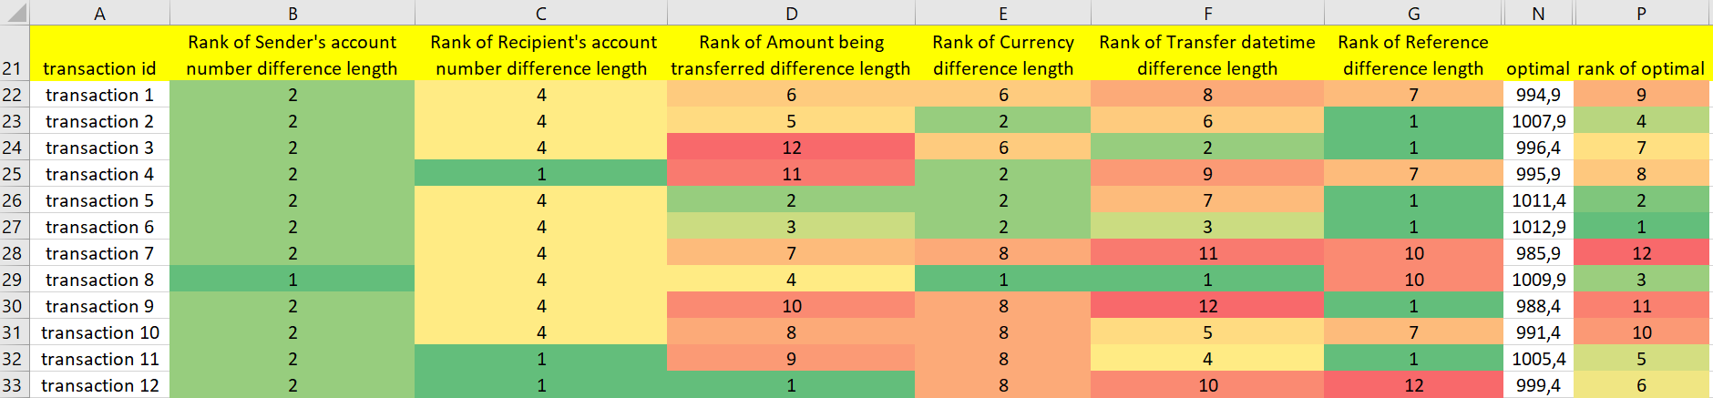

Figure#5 (from sheet difference (2))

Source: <https://miau.my-x.hu/miau/296/risk_index_naive_regression_coco.xlsx>

# Conclusion & Discussion

The advantage of numerical decision making is only realized if the sophisticated weightings have been properly determined and applied. Checking for this is important to ensure the objectivity and reliability of the decision-making process.

The relationship between weighting and correlation (c.f. between the observed phenomena) in numerical decision-making is important. Weighting allows the bank making the decision to give priority to different options. Correlations then show how the different options influence each other.

The decision-maker must re-consider the weightings to ensure that risk management and profitability are in balance. Even if we want to give equal weights to all options (c.f. attributes or even level of attribute-values), correlations can still help in decision making by showing how the different options affect each other. Despite equal weighting, there may be a case where one option has a greater impact on the other, and correlations can demonstrate this.

This can be used as useful information in the decision-making process, for example, if one option significantly affects the other, the bank making the decision should reconsider whether they really want to give equal weights to both options, or, if they should weigh them according to the degree of influence.

# References

Online tool for similarity analyses: <https://miau.my-x.hu/myx-free> Downloaded March 15, 2023.

History of similarity analysis: <https://miau.my-x.hu/miau/196/My-X%20Team_A5%20fuzet_EN_jav.pdf> Downloaded March 15, 2023.

Strategic choices for banks in the digital age by Henk Broeders and Somesh Khanna (McKinsey). <https://www.mckinsey.com/industries/financial-services/our-insights/strategic-choices-for-banks-in-the-digital-age> Downloaded March 15, 2023.

The data-driven decision-making journey in banking by Guilhem Vincens (LinkedIn). <https://www.linkedin.com/pulse/data-driven-decision-making-journey-banking-guilhem-vincens> Downloaded March 15, 2023.

Data-Driven Decision-Making in Banking - Believe in Banking by Lynn Medcalf <https://believeinbanking.com/2021/05/11/data-driven-decision-making-in-banking/> Downloaded March 15, 2023.

Conference presentation about COCO (2023): <https://miau.my-x.hu/miau/297/esport.mp4>, Downloaded March 15, 2023.

Background calculations of this article (2023): <https://miau.my-x.hu/miau/296/risk_index_naive_regression_coco.xlsx>, Downloaded March 15, 2023.

EGO- online expert system generator (2010): <https://miau.my-x.hu/myx-free/ego_en/>, Downloaded March 15, 2023.