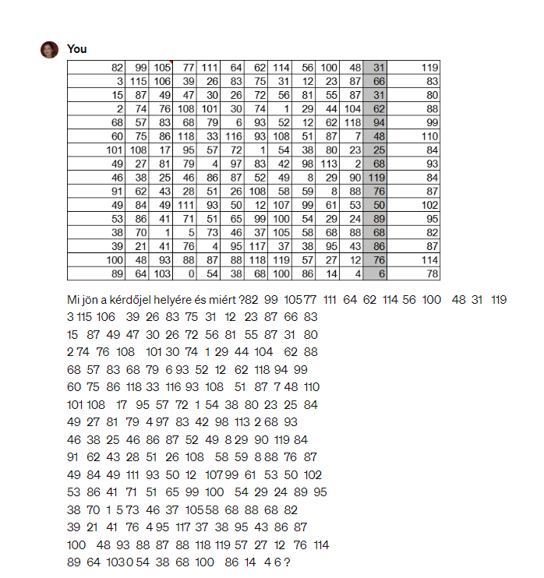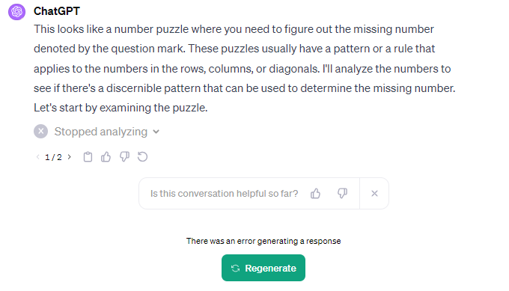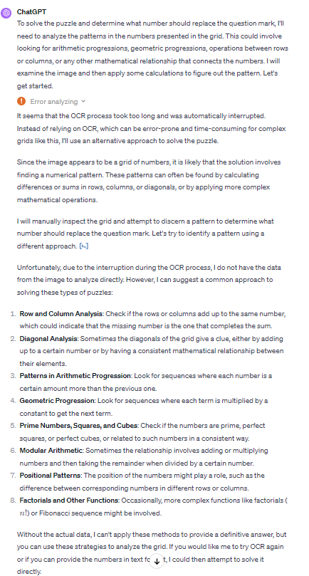

import cv2
import pytesseract
from PIL import Image
# Load the image from file
img_path = '/mnt/data/image.png'
image = cv2.imread(img_path)
# Convert the image to gray scale
gray_image = cv2.cvtColor(image, cv2.COLOR_BGR2GRAY)
# Use tesseract to do OCR on the image
text = pytesseract.image_to_string(gray_image, config='--psm 6')
# Since the OCR results may contain unwanted characters, we'll try to clean
it up and extract the numbers
# Split the text into lines and then into numbers, filtering out any
non-digit characters
rows = [list(filter(None, [char for char in line if char.isdigit() or
char.isspace()])) for line in text.split('\n') if line.strip()]
# Convert the filtered characters back into strings and then into integers
grid = []
for row in rows:
digits = ''.join(row).split()
grid.append([int(digit) for digit in digits if digit.isdigit()])
# Now, let's print the grid to verify the OCR results
grid

