Derivation/creation of abstractions/terms based on AI – case study: EU-homogeneity
Table of content
Abstract 2
List of Abbreviations: 3
List of figures 4
Introduction: In a nutshell about me 5
Personal background: 5
Academic Transition: 5
Business Process Management 6
Use Case: Measuring homogeneity in the European Union 9
Introduction 9
Problem Statement, Hypotheses 11
Objectives 12
Motivations 13
Target Groups 14
Usefulness 14
Tasks 15
Inclusion of Artificial Intelligence (COCO Y0) and Characteristics in the Analysis 21
Connections to BPM 23
Tasks and Goals: 23
Results: 23
Conclusions and Answers: 24
References 24

Abstract
This paper investigates the application of Business Process Management (BPM) principles in analyzing the homogeneity of European Union (EU) member states. BPM offers a structured framework for improving organizational processes to achieve strategic objectives. In this study, BPM is employed to develop an algorithm for assessing the homogeneity of EU member states using diverse economic indicators such as average annual wages, GDP, life expectancy, and the unemployment rate. Utilizing time-series data sourced from the Organisation for Economic Co-operation and Development (OECD), this research demonstrates how BPM methodologies can be applied in a multidisciplinary context. The findings contribute to a deeper understanding of BPM's role in addressing complex challenges and informing strategic decision-making within the EU and beyond.
Keywords: Business Process Management (BPM), European Union (EU), homogeneity, economic indicators, time-series data, Organisation for Economic Co-operation and Development (OECD), strategic decision-making.

List of Abbreviations:
BPM - Business Process Management: A systematic approach to improving organizational processes to achieve strategic objectives.
EU - European Union: A political and economic union of 27 member states located primarily in Europe.
GDP - Gross Domestic Product: A monetary measure of the market value of all final goods and services produced in a period within a country.
OECD - Organisation for Economic Co-operation and Development: An international organization that promotes policies to improve the economic and social well-being of people around the world.
AI - Artificial Intelligence: Intelligence demonstrated by machines, in contrast to the natural intelligence displayed by humans and animals.
ML - Machine Learning: A subset of artificial intelligence that focuses on the development of algorithms that allow computers to learn from and make predictions or decisions based on data.
RPA - Robotic Process Automation: The use of software robots (bots) to automate repetitive tasks and processes, typically in business environments.
OAM - Object-Attribute-Matrix: A structured approach used to analyze and measure the homogeneity of EU member states based on various economic indicators.
GDP - Gross Domestic Product: The total value of goods and services produced within a country during a specific period.
GNI - Gross National Income: The total domestic and foreign output claimed by residents of a country.

List of figures
1. Figure: Additional calculations on raw-data 17
2. Figure: Calculating standard deviation effects 18
3. Figure: OAM structure 19
4. Figure: Calculating correlations between attributes 20
5. Figure: Indexed OAM table 21
6. Figure: COCO Y0 output table 21
7. Figure: Excel pivot table based on COCO Y0 outputs 22
8. Figure: Implementing characteristics and indexing results 22

Introduction: In a nutshell about me
In this session, I will showcase the methodology used in crafting my Bachelor's thesis, and its connection to subjects I learnt during my studies. Having graduated from the Business Administration and Management faculty with a specialization in Digital Economy at KJU, my aim is to furnish a comprehensive understanding of the structural elements and thematic congruence within my thesis. The primary intent is to provide a template for prospective Bachelor's theses, enriched with personal insights that may serve as motivational benchmarks for aspiring individuals in their future career and academic pursuits.

Personal background:
Originating from Hungary, I completed my high school education in Kaposvar. Subsequently, I embarked on an international journey, residing initially in Madrid (Spain), followed by Rome (Italy), and ultimately settling in Frankfurt and Berlin (Germany), where I held positions as a Flight Attendant with various European airlines. Towards the latter stages of my aviation career, a growing inclination for continuous learning and skill development beyond the confines of my current profession became palpable. This innate motivation to acquire new knowledge facilitated my transition from aviation to the Software as a Service (SaaS) industry.

Academic Transition:
Opting for the Digital Economy major at the university marked a pivotal point in my academic trajectory. An encounter with my professor exposed me to the realm of data analytics and logical reasoning, illuminating the profound impact of data and AI in the field. I found particular fascination in the myriad scenarios one could construct to formulate diverse models, ranging from ostensibly straightforward to intricately complex configurations. This realization broadened my perspective and catalysed a deeper appreciation for the potency of data-driven methodologies. Here you can find a snippet from my work so far, which will also showcased in our classes: https://miau.my-x.hu/miau2009/index.php3?x=e0&string=V%C3%A1radi.D Also, if you would like to listen to some of my presentations during conferences and see the slides please follow this link: https://miau.my-x.hu/miau2009/index.php3?x=e0&string=l.V%C3%A1radi

Business Process Management
In this section I would like to highlight the meaning of Business Process Management (BPM) and some information about the overall approach in organisations. Then we will take a closer look on my own BSc thesis to identify these aspects and tell you more how I managed to craft all the stages of BPM. In the following pages I summarised the most important aspects of BPM relying on different sources, such as the webpage of TechTarget, videos from YouTube and internal previous KJU presentations which you can find on Moodle as well.
To begin, it's essential to understand the foundational components of BPM. At its core, BPM involves a systematic and holistic approach to managing and optimizing business processes. This comprehensive methodology encompasses various interconnected steps, including defining, modeling, analyzing, improving, and automating processes. By defining processes, organizations establish a clear roadmap, while modeling enables the visualization of process flow. Analysis identifies inefficiencies, leading to improvement, and automation leverages technology to streamline workflows. Together, these components form the backbone of BPM, enabling organizations to drive efficiency and enhance performance across their operations (Tucci, 2024).
BPM : Structured and holistic approach to improving processes to achieve business goals. (Eye on Tech, 2022)
BPM might include goals such as:
- developing a new product
- fulfilling product orders
- managing customer service
- onboarding new employee
- etc.
These processes might include several tasks which are being accomplished by stakeholders such as IT tools, outside providers, internal stakeholders (front-line employee).
One of the distinguishing features of BPM is its multifaceted nature, encompassing a range of interconnected components that collectively contribute to its effectiveness. Process modeling provides a visual blueprint, offering stakeholders a clear understanding of process flows and dependencies. Process analysis identifies areas for improvement, guiding organizations in optimizing their workflows to enhance efficiency and effectiveness. Process design focuses on redesigning processes to align with organizational goals and objectives, while process automation leverages technology to streamline workflows and reduce manual effort. Finally, process monitoring ensures continuous alignment with organizational goals, allowing organizations to track performance metrics and identify opportunities for further optimization. Together, these components form a cohesive framework for effective BPM implementation, enabling organizations to achieve tangible results and drive continuous improvement across their operations (Dumas , és mtsai., 2013).
Implementing BPM initiatives offers a myriad of benefits for organizations. Operational efficiency is heightened through streamlined processes, leading to reduced costs and improved resource allocation. Quality improvements enhance customer satisfaction, driving loyalty and retention. Agility in processes enables organizations to respond quickly to market changes, gaining a competitive edge in dynamic environments. Compliance ensures adherence to regulatory standards and industry best practices, reducing the risk of non-compliance and associated penalties. By fostering a culture of continuous improvement, BPM drives innovation and creativity, empowering organizations to adapt and thrive in an ever-changing business landscape (Dumas , és mtsai., 2013 old.: 1-30).
However, successful BPM implementation is not without its challenges. Organizations may encounter various hurdles, including cultural resistance, integration complexity, data security concerns, and the need for executive buy-in. Overcoming these challenges requires effective change management, careful planning, and stakeholder engagement. By addressing these challenges head-on, organizations can mitigate risks and ensure the successful adoption of BPM initiatives, driving sustainable results and achieving long-term success.
Looking ahead, emerging trends are reshaping the future of BPM and influencing how organizations manage and optimize their business processes. Integration with emerging technologies such as Artificial Intelligence (AI), Machine Learning (ML), and Robotic Process Automation (RPA) will revolutionize process automation, enabling organizations to achieve unprecedented levels of efficiency and effectiveness. Customer-centric BPM will prioritize personalized customer experiences, driving customer satisfaction and loyalty. Agile BPM will enable organizations to adapt quickly to changing market dynamics, gaining a competitive advantage in dynamic environments. Data-driven BPM will leverage advanced analytics and predictive modeling to drive actionable insights, empowering organizations to make informed decisions and optimize performance. Finally, digital transformation will align BPM initiatives with broader digital transformation strategies, driving innovation and enabling organizations to remain competitive in an increasingly digital world (Tucci, 2024).

Use Case: Measuring homogeneity in the European Union

Introduction
Since the establishment of the European Union, creating European cohesion and a unified European economy has been an ongoing ambition. The Union takes this goal so seriously that its strategy includes the cohesion policy, which has played a significant role from 1950 to the present day and is included in the Single European Act (Article 130a) (European Union, 1986). Each year, the EU invests billions of euros within various structural programs, distributing this amount among member states to support individual countries and thereby achieve the community's cohesion goals (Európai Unió, 1986)
In 2004, Cyprus, Malta, Estonia, Poland, the Czech Republic, Slovenia, Slovakia, Estonia, Lithuania, Latvia, and Hungary joined the European Union. To achieve this, each country had to meet the Copenhagen criteria laid down by the European Council in 1993 (Európai Bizottság), which include, among other things:
"the stability of institutions guaranteeing democracy, the rule of law, human rights, and respect for and protection of minorities
a functioning market economy and the ability to cope with the competitive pressures and market forces within the Union;
the obligations of membership, including the ability to assume the objectives of the political, economic, and monetary union and to accept the common rules, standards, and policies that make up the central part of the Union's legal framework – the acquis communautaire."
Additionally, during the accession negotiations, plans were made for the phased introduction and forms of existing EU regulations, and decisions were made on the support provided by the European Union to facilitate the successful achievement of accession goals.
Based on the above, it is evident that every acceding country relinquishes a certain degree of its sovereignty and becomes a member of the European Union, initiating a kind of integration process. The measurement of the extent of integration, cohesion, or convergence – whatever term is used – lacks an algorithm that would determine the homogeneity of countries or regions in a consolidated manner based on statistical data. In the 21st-century economy, data-driven decision-making plays a crucial role because "data is the new gold," as emphasized by Deloitte (Deloitte, 2022)
In the economy, platforms are gaining increasing prominence, which are important not only for sales but also for decision support. Zoltán Cséfalvay, a university professor who also worked at the OECD, outlines the economic changes of the 20th and 21st centuries and the increasingly important role of platforms or decision support systems in our economy in the introduction chapter of his book, "The Great Epochal Change" (Cséfalvay, 2017). Below, I summarize briefly the relevant part of the mentioned work to illustrate the fundamental importance of digitization and relevant platforms in the 21st-century economy:
From around the 1980s until the late 2010s, we experienced the era of globalization, where manufacturing companies aimed to conduct their logistics, production, and sales processes covering multiple countries or even continents with the lowest possible costs, through mass production. Thus, their products became available in most countries worldwide. However, starting from 2010, after the global economic crisis, this process began to slow down, and a new era emerged: the era of technology. With the strong penetration of the internet, the innovations of digital technology also became increasingly important economically, primarily based on sharing and recycling. Platforms and applications such as Amazon, Uber, Car2Go appeared, creating a radically new economic model: they transformed traditional industrial products into digital services. This proved to be more efficient than the traditional economy because digital technology has large databases and a large user network and works with optimized algorithms, thus creating a connection between supply and demand more efficiently, quickly, and cheaply, reducing the costs of market entry (no need for traditional companies). Consequently, value creation no longer focuses on industrial companies but on digital platforms, as those who solve the transaction between supply and demand most efficiently will win (Cséfalvay, 2017).
The strong and dynamic spread of decision support systems in economic life has led to unprecedented data generation, the conversion of which into information has become critical. In order to make decisions more quickly, with less human labor, and more efficiently for complex tasks, the introduction of decision support systems during decision-making is inevitable. Simply put, because these platforms – as Cséfalvay also pointed out – can monitor multiple databases simultaneously and generate information in seconds, which would require weeks of persistent, self-checking work by human labor.

Most economic convergence analyses rely heavily on GDP (Gross Domestic Product) and GNI (Gross National Income) as relevant economic indicators (Dedák, 2022)or they rely on capital flows and labor productivity, which are indeed important indicators from an economic perspective, but they are not sufficient on their own to measure the extent of convergence compared to other countries. Ákos Kengyel also addresses this issue and discusses attempts throughout history to measure homogeneity. Examples include the neoclassical Solow model (Katits, és mtsai., 2018) and the Heckscher-Ohlin model, as well as alternative growth models. He further explains that the conclusions of these models often contradict each other, making the measurement of homogeneity chaotic (Kengyel, 2016)
It is noticeable that the above-mentioned methods do not take into account the characteristics of the statistical data of countries or regions compared to the characteristics of identical data of other countries or regions. In cases where we disregard the values of GDP and volume indices and instead consider the characteristics of raw data assets (such as dispersion, average, steepness, minimum, maximum), there is an opportunity to measure changes in characteristics of raw data for each country, such as the evolution of average wages per country, time spent on work, unemployment rate, life expectancy, and changes in GDP raw data characteristics (Pittlik, 2023), which allows the development of an algorithm that objectively and consistently measures the degree of homogeneity by country, based on raw data.
The experiences gained throughout my life, the inspiration of Dr. László Pitlik, and the fact that Hungary will have been a member of the European Union for twenty years in 2024 and will also hold the rotating presidency (Európai Unió Tanácsa, 2016) have all contributed to the selection and preparation of the topic of this thesis.
In the subsequent subsections of the introduction, I will elaborate on the purpose, tasks, and my own motivation for the study.

Problem Statement, Hypotheses
"Coherence," "integration," and "homogeneity" are terms commonly used in politics in general, and particularly in EU leadership, yet there is currently no officially accepted Knuthian definition of homogeneity, nor is there a clear (mathematical/algorithmic) definition. There is no "homogeneity curve" that would illustrate the dynamics of homogeneity (time series development) in different countries and in the European Union. Thus, speaking of "European standards" based on average or variance results (naive approach) in the absence of a mathematical definition of homogeneity can lead to misleading information, which can also influence the success of decisions made about support. Fundamentally, these decisions have social and economic implications for all residents of EU territories because the implementation of a new project fundamentally determines the economy of the respective member state, as well as the local labor organization.
Since our world is based on the principles of consistency (e.g., everything is related and everything has an impact on everything else), there is a need for an algorithm that "teaches" this understanding precisely to computers (or robots) in order to understand the correlations and relationships that affect various statistical indicators, thereby promoting consistency-based decision-making. Thus, there is a need to build a complex model that essentially calculates the homogeneity of EU member states through different raw data. In the context of this thesis, consistency refers to the aggregated relationship determined by the difference calculated between various data components.
Following this logic, it is conceivable to create a time-series decision support system that measures EU homogeneity, based on completely independent layers of data, to provide the homogeneity index of the countries under examination. If such a system can be created, it fundamentally raises the question of which countries follow or do not follow the aggregated EU trends.
Based on this line of reasoning, the following hypotheses can be formulated:
H1: A time-series decision support system can be created that measures EU homogeneity based on completely independent layers of data.
H2: Each country may be equally homogeneous differently based on input data, i.e., kazohin EU.
H3: Life expectancy and an economic indicator (e.g., wages) function "significantly" differently only with pre-Covid19 and Covid19 data combined.
H4: A naive and/or optimized text template robot function can be created.
The responses to these hypotheses and their justifications are discussed in detail in the fourth main chapter of the thesis.

Objectives
In this thesis, I attempt to develop a new algorithm that takes into account the principles of consistency and the principle of Donald Knuth (Standfordi Egyetem), a renowned computer scientist and university professor ("Science is what can be written in source code, everything else is just art"), which processes statistical data publicly available from the OECD (Organisation for Economic Co-operation and Development) for 22 European countries (Hirschmann, 2022). Thus, the aim of the thesis is to create a decision support system that is universal in terms of input data, capable of measuring homogeneity from any time-series statistical dataset, which simultaneously means defining homogeneity in source code (this is Knuth's criterion, see above).
In this context, consistency means that everything is related and has an impact. Donald Knuth's principle means that everything that can be written in source code has added information surplus. Thus, the analysis system presented in the thesis must be programmable and automatable. The processed data will be analyzed both by layer (e.g., average salary, average annual working hours, etc.) and collectively to illustrate the differences between the "naive," i.e., non-optimized, and the machine, i.e., optimized analysis approaches.
In summary, the goal is to incorporate the objective measurement of homogeneity (e.g., country-specific convergence dynamics) into a decision support system that not only focuses on individual economic phenomena (e.g., measuring the volume of capital and labor or changes in purchasing power) but also on the characteristics of time-series statistical data for the economy and thus for all EU member countries. Thus, the goal is to develop a program or platform that consistently and objectively describes the concept of homogeneity, thereby meeting Donald Knuth's principle. In addition, since the algorithm is "context-free" from the input side, there is an opportunity to include non-economic time-series data (e.g., life expectancy) in the analysis.
It is important to emphasize here and now that the analyses presented in the thesis are free from any political affiliation or interest representation, therefore political stance is not among the objectives of the thesis. The conducted examinations rely solely on OECD statistical data and draw conclusions from them, striving for methodological maximum objectivity (e.g., robot controlling).

Motivations
Living in several countries and cities within the European Union (Hungary, Madrid, Rome, Frankfurt, and Berlin), the thought of imaginarily comparing cities and countries, as well as assessing the positives and negatives, naturally occurred to me. This is one of the fundamental motivations for writing this thesis and the personal background for choosing this topic. I have always been interested in whether Hungary has been able to catch up or homogenize with the other EU member states to what extent.
Today, we find numerous articles in both electronic and print media about where Hungary currently stands in terms of EU convergence (Tamásné Szabó, 2023), but these do not provide a consistent answer based on objective data. Furthermore, in 2024, Hungary will celebrate the 20th anniversary of its accession to the European Union, which provides further impetus for a comprehensive analysis of the extent to which Hungary has succeeded in catching up with the other EU member states. All of this with objective, consistent, and data-based examinations. For this thesis, I used five seemingly randomly selected raw data layers that also influence the lives of everyday people, including both economic and non-economic statistical results:
- Evolution of average wages,
- Measurement of time spent on work,
- Life expectancy,
- Unemployment rate,
- GDP.
The central question of the thesis is where Hungary ranks compared to the other EU member states in terms of convergence. In other words: can a time-series EU homogeneity index be established, and if so, which countries temporally or permanently follow or do not follow the aggregated trend? I aim to approach the question from several aspects: regional level (e.g., Central Europe, Western Europe, Visegrád Group), based on the time of accession (e.g., countries that joined in 2004), and aggregated, i.e., using data from all member states.

Target Groups
The project's target groups primarily include the organizations responsible for distributing EU funds and monitoring member states. Additionally, the governments and statistical offices of all EU member countries, as well as global and local management consulting firms.

Usefulness
In the future, the model will likely enable a more accurate and objective assessment of whether a country is approaching or moving away from European trends. This can provide added informational value to the project's target groups in seconds, as after specifying the selected countries or regions and the layers to be examined, they will receive a summary along with explanatory tables and diagrams. Thus, if we use the model from the perspective of a country's government or EU leadership, it can save the cost of a comprehensive analysis, which starts at $20,000, but a survey conducted by a globally recognized consulting firm can cost up to $500,000 (Kinnary, 2022).
If we use the model from the perspective of management consulting firms, it can add value to the presentation of the results examined by the system, contributing to the more successful and expensive sale of their analytical products and increasing their prestige.

Tasks
The raw data used in the thesis were downloaded from the OECD's official statistical website (www.stats.oecd.org) in Excel format. The seemingly arbitrarily selected five substantially different time-series layers suitable for measuring the economy are as follows: average annual wages per capita in dollars; average hours worked per capita in hours; life expectancy in years; GDP per capita in dollars; and finally, the unemployment rate expressed as a percentage. It is important to note regarding the layers that while wage homogenization can indeed be interpreted as homogenization, age is a matter of catching up, as no society is expected to take steps to ensure that its members die earlier, while following the FAIR-trade logic, giving up extra profits is a realistic homogenization (Kazohin) goal. This subsection presents a summary of the tasks performed during the preparation of the thesis with a strategic focus.
Since the OECD database is incomplete for Romania, Malta, Cyprus, and Bulgaria, or (still) does not exist, the raw databases were downloaded and analyzed without these countries. Furthermore, I note that the United Kingdom exited the European Union on February 1, 2020, so its data were not used in this study. After downloading the raw data, the necessary data processing steps are the same for each data layer. Therefore, the worksheets and cell ranges presented in this subsection as examples apply to the worksheets of each raw data layer. An algorithm based on Object-Attribute-Matrix (OAM) was developed to establish aggregated EU homogeneity rankings and indexes to objectively identify similarities (My-x & Pitlik, 2014).

1. Data Collection from the OECD Website and Downloading Excel Files
To ensure uniform handling of all data layers, facilitating the speed of research work, presenting results uniformly, and enabling easier reproducibility, each raw data layer was downloaded from the OECD statistical database with the same settings.
Before downloading, it was necessary to set the data to be displayed annually and to show the raw data from the earliest available year to 2021. This is necessary because, for example, there were no available data for average working hours in 2022, so the validity of the comparison could have been questionable at the time of preparing the thesis.
In the second step, all EU member countries must be selected, which includes the following 22 countries: Austria, Belgium, Czech Republic, Denmark, Estonia, Finland, France, Germany, Greece, Hungary, Ireland, Italy, Lithuania, Latvia, Luxembourg, Netherlands, Poland, Portugal, Slovakia, Slovenia, Spain, and Sweden. The downloaded raw data worksheets from the OECD website are labeled with the name "OECD.Stat export." The five downloaded and used raw data layers are as follows:
- Average working hours per employee annually (average working hours.xlsx)
- Annual average wages per employee in dollars (average annual wages.xlsx)
- Life expectancy in years (life expectancy.xlsx)
- GDP expressed in dollars (GDP.xlsx)
- Unemployment rate (unemployment.xlsx)

2. Additional Calculations in the Raw Data Layers
Before 1995, the raw data for the examined countries were mostly missing, so the data for all five data layers were used from the period between 1995 and 2021, and difference indicators were calculated for consistency. This is necessary because the calculated difference results will constitute the values of the Object-Attribute-Matrix (OAM) table and thus the input data for the algorithm.
To calculate the differences for each country in the 22 examined countries, a separate Excel worksheet is needed for each country. Each worksheet is labeled with the two-letter international code of the country - just like on license plates - and the English name of the examined raw data layer downloaded from the OECD website. For example, for average working hours in Hungary: "working hours HU," or for the unemployment rate in Germany: "unemployment DE."
The raw data is located in the cell range A1-AG38 on these worksheets. The names of the countries and their corresponding raw data values annually (column headers in cell range B4-AG4), as well as the additional difference indicators I calculated, are in cell ranges A5-AG26 and A29-AG28, respectively. The calculated difference indicators are as follows:
a. Overall average: cell range A29-AG29 contains the average for each country over the years.
b. Examined country: cell range A30-AG30 shows the value of the examined country in the table.
c. Relation to the average: cell range A31-AG31 indicates whether the value of the examined country in the table is below or above the average.
d. Absolute difference from the average: cell range A33-AG33 shows the absolute deviation of the examined country from the average.
e. Difference from mean (average=100%): cell range A34-AG34 is an index indicating how many times the absolute deviation is present in the average.
f. Relative deviation from the average: cell range A35-AG35 indicates how many times the deviation from the average occurs in the average.
1. Figure: Additional calculations on raw-dataset
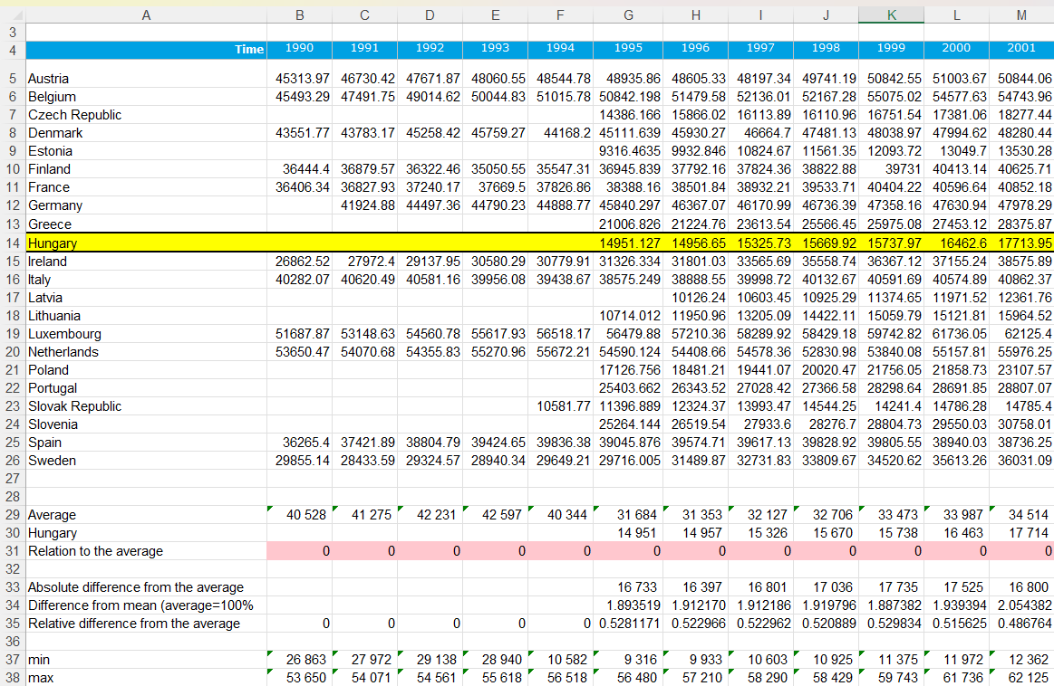
Source: (Váradi, 2023), Average annual wages, unit: USD
To examine the effects of each country's raw data on the overall EU standard deviation, a separate worksheet is needed for each data layer and each country. These worksheets are easily recognizable because their names contain the English equivalents of the examined raw data layer and the examined country, along with a number 2 (e.g., "working hours HU (2)" or "unemployment DE (2)").
The worksheets for standard deviation effects contain the statistical raw data downloaded from the OECD database in the cell range A7-AG29. The indicators calculated in the cell range A3-AG6 measure the effect of the examined country's raw data on the overall standard deviation. These indicators include:
a. Std.dev/avg. Without (country code): cell range A6-AG6 is the column's standard deviation divided by the average without the data of the examined country.
b. Std.dev/avg. With (country code): cell range A5-AG5 is the column's standard deviation divided by the average with the data of the examined country.
c. Diff: cell range A4-AG4 is the difference between the above two indicators.
d. Absolute difference: cell range A3-AG3 contains the absolute values of the differences shown in point c.
2. Figure: Calculating standard deviation effects
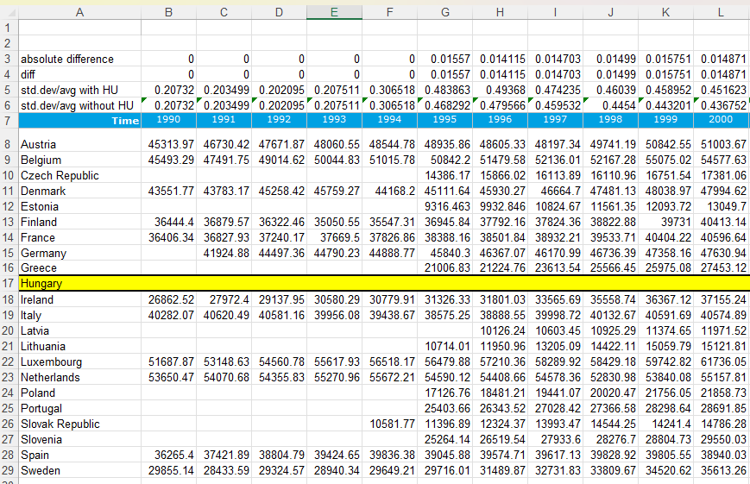
Source: (Váradi, 2023), Average annual wages, unit: USD

3. Creating the Object-Attribute-Matrix (OAM):
To create the OAM, a preparatory/summary table is needed where the columns (attributes) contain the second point's calculated difference results transposed, and the rows (objects) contain the countries and their data for the given year. This summary table is located in the cell range A3-V597 on the "Sum of results" worksheet in the OAM homogeneity.xlsx file.
3. Figure: OAM structure
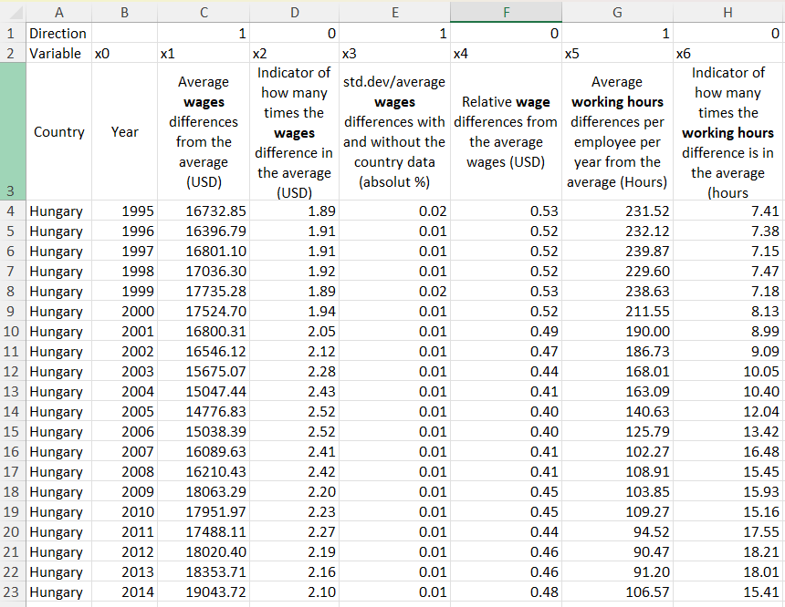
Source: (Váradi, 2023) Unit: Defined on the table
The values in this table need to be ranked by attribute using Excel's built-in RANK() function. Regarding the rankings, it is important to specify their directions, i.e., whether they are increasing or decreasing, to ensure that the importance of the results is correctly taken into account by the artificial intelligence used for measuring homogeneity. The directions are determined by the intercolumn correlation within the data layer (cell range A1-V1 on the "OAM Base modell stairs" worksheet in the OAM homogeneity.xlsx file), and the numbered input data are in the cell range A1198-W1792 on the same worksheet. Additionally, a preferably large Y value is needed, which is a random constant. A large constant Y value is used to allow sufficient room for calculations and processing by the algorithm. In this case, the Y value was set to 1,000,000 for each year and country (cell range W1198-W1792 on the "OAM Base modell stairs" worksheet in the OAM homogeneity.xlsx file).
4. Figure: Calculating correlations between attributes
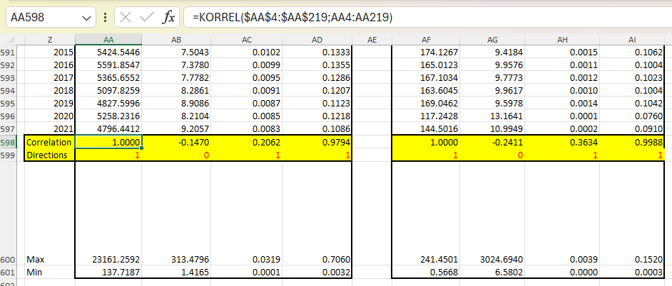
Source: (Váradi, 2023)
The numbering logic presented above can be extended to include the difference results of any countries, which serve as input data for the artificial intelligence. This allows for measuring the homogeneity of different regions and the overall EU with a new numbering scheme. In this study, only the homogeneity of the aggregated European Union (i.e., with the participation of all countries) is presented. Below you will see the ranked numbers based on the results of the additional calculations.

5. Figure: Indexed OAM table
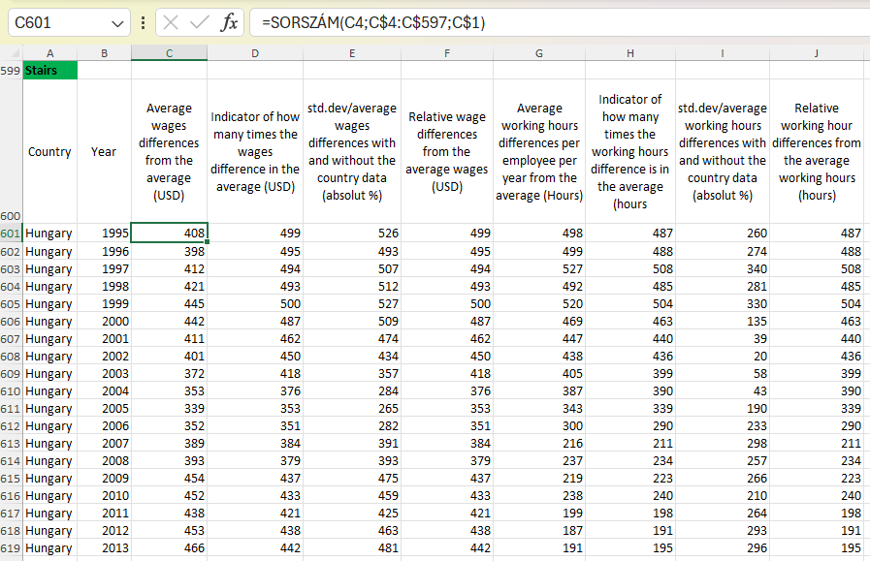
Source: (Váradi, 2023) OAM base model, Unit: index numbers

Inclusion of Artificial Intelligence (COCO Y0) and Characteristics in the Analysis
The artificial intelligence outputs estimate the value of Y based on the input data (as shown in the numbered tables presented in point three), denoted as "Base modell" worksheet, cell range A667-AA1261 in the OAM homogeneity.xlsx file.
6. Figure: COCO Y0 output table
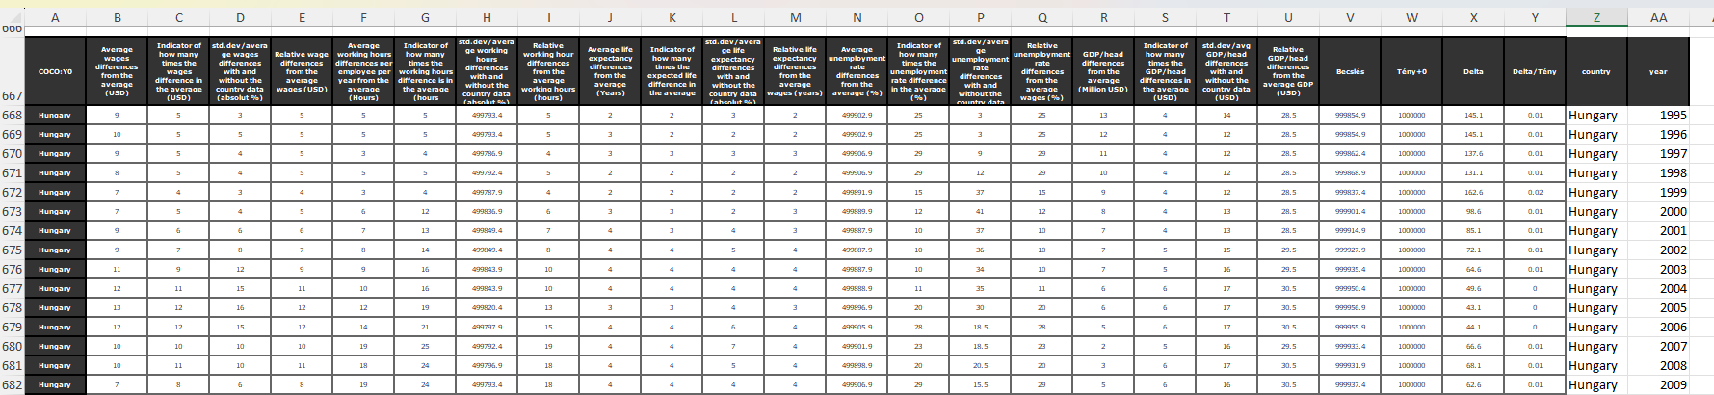
Source: (Váradi, 2023)
This table was summarized using Excel's pivot table function annually and by country (cell range A2-AC27 on the "EU ranking" worksheet in the OAM homogeneity.xlsx file), and country-specific data characteristics were calculated based on these results.
7. Figure: Excel pivot table based on COCO Y0 outputs
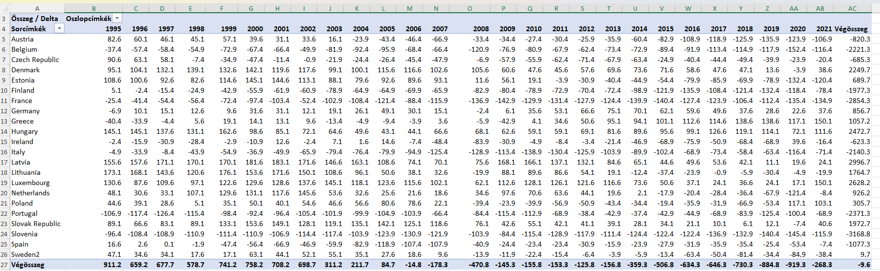
Source: (Váradi, 2023)
These characteristics include minimum, maximum, standard deviation, slope, and average (cell range A31-F54 on the "EU ranking" worksheet in the OAM homogeneity.xlsx file). The results of the data characteristics were again numbered using Excel's built-in RANK() function (cell range I30-O54 on the "EU ranking" worksheet in the OAM homogeneity.xlsx file), followed by another run of COCO Y0, where the Y value was set to 1000. The results are contained in the cell range A135-M157 on the "EU ranking" worksheet in the OAM homogeneity.xlsx file, providing the final outcome of homogeneity.
8. Figure: Implementing characteristics and indexing results
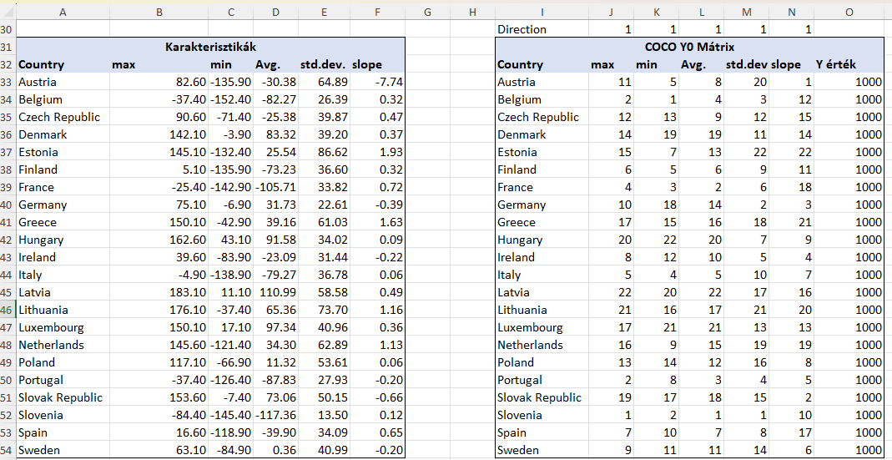
Source: (Váradi, 2023)
Based on the logic presented above, an artificial intelligence algorithm suitable for measuring homogeneity can be generated for any region.

Connections to BPM
The project aims to measure the homogeneity of European Union (EU) member states based on various economic data layers, such as average annual wages, GDP, life expectancy, and unemployment rate. This aligns with BPM principles of defining objectives clearly and aligning processes with organizational goals. The EU's cohesion policy, which involves distributing billions of euros among member states to achieve cohesion goals, requires a systematic approach to ensure resources are allocated effectively and goals are met. Since there is no such algorithm developed so far, this project is the first in a kind of such holistic approaches. In this chapter I will present my own conclusions, how my BSc thesis aligns with the above described BPM principals.

Tasks and Goals:
The project's tasks and goals involve creating holistic algorithms for measuring homogeneity, using context-free time-series data input, and defining homogeneity in source code (following Knuth’s principal). This mirrors BPM practices of setting clear objectives, defining processes, and utilizing data-driven approaches to achieve desired outcomes. By defining tasks and goals upfront, the project establishes a roadmap for its implementation, ensuring alignment with overarching objectives.
Methodology:
The methodology section outlines the data sources, data processing steps, and the development of an Object-Attribute-Matrix (OAM) to measure homogeneity objectively. This methodology reflects BPM principles of process analysis, improvement, and automation. By downloading raw data from official sources, analyzing data uniformly, and developing algorithms for measuring homogeneity, the project demonstrates a systematic approach to data management and analysis, essential aspects of BPM.

Results:
The project presents results from both naive and optimized approaches, showcasing the effectiveness of an AI-driven optimization process. This highlights BPM principles of continuous improvement and leveraging technology to enhance processes. The use of artificial intelligence to optimize data analysis and identify patterns aligns with BPM's focus on innovation and efficiency. Furthermore, the project's emphasis on visualizing data through graphs and maps underscores the importance of data visualization in BPM for informed decision-making.

Conclusions and Answers:
The project concludes by addressing key questions related to the homogeneity of EU member states and the feasibility of building decision support systems based on economic data layers. This demonstrates a data-driven approach to problem-solving, a core tenet of BPM. By providing answers to critical questions and drawing insights from data analysis, the project contributes to informed decision-making and policy formulation, essential aspects of BPM in organizational settings.

References
Researches, which are useful to deeper understand BPM:
Daniel Varadi et. al. 2023-2024: https://miau.my-x.hu/miau2009/index.php3?x=e0&string=V%C3%A1radi.D and https://miau.my-x.hu/miau2009/index.php3?x=e0&string=l.V%C3%A1radi
Anonim Writer – Which Country is the most renitent? - https://miau.my-x.hu/miau2009/index.php3?x=e0&string=renitent
Other resources used in this document:
Az Európai Unió Közösségének Bizottsága A bizottság közleménye az Európai Parlamentnek, a Tanácsnak, az Európai Gazdasági és Szociális Bizottságnak és a Régiók Bizottságának [Online] // Európai Unió hivatalos holapja. - 2007. 12 11. - 2023. 07 01. - https://eur-lex.europa.eu/LexUriServ/LexUriServ.do?uri=COM:2007:0798:FIN:HU:PDF.
Az Európai Unió Tanácsána A Tanács jövővbeli elnökségei 2023-ig [Online] // Az Európai Unió Tanácsának hivatalos weblapja. - https://www.consilium.europa.eu/media/56627/presidencies-until-2030.pdf.
Cséfalvay Zoltán A nagy korszakváltás [Könyv]. - Budapest : Kairosz Kiadó, 2017.
Dedák István Gazdasági felzárkózás Magyarországon: a kártyavár összeomlása [Online] // www.portfolio.hu. - 2022. 06 24. - 2023. 02 26. - https://www.portfolio.hu/gazdasag/20220624/gazdasagi-felzarkozas-magyarorszagon-a-kartyavar-osszeomlasa-552035.
Deloitte Magyarország Az adatmegosztás új korszaka: jó a cégeknek, jó a fogyasztóknak [Online] // Deloitte. - 2022. 02 24. - 2023. 07 15. - https://www2.deloitte.com/hu/hu/pages/technologia/articles/techtrends2022-adatmegosztas.html.
Dr. Pitlik László [és mtsai.] 3rd International Anatolian Congress on Scientific Research Proceeding Books vol. III. [Konferencia] // IKSAD International Publishing House Licenced by Turkish Ministry of Culture / szerk. Dr. Ethem İlhan ŞAHİN Dr. Mustafa Latif EMEK. - Anatolia : [ismeretlen szerző], 2022. december 30.. - old.: 1004 - 1017.
Dumas Marlon [és mtsai.] Fundamentals of Business Process Management [Online] // Moodle KJU - BPM compulsory reading. - Springer-Verlag Berlin Heidelberg, 2013.. - 15. 01 2024. - https://moodle.kodolanyi.hu/pluginfile.php/306401/mod_resource/content/1/Compulsory%20reading.pdf.
Európai Bizottság Conditions for membership [Online] // Európai Unió hivatalos honlapja. - 2023. 02 25. - https://neighbourhood-enlargement.ec.europa.eu/enlargement-policy/conditions-membership_hu.
Európai Bizottság Kohéziós nyílt adatbázis [Online] // Európai Unió hivatalos honlapja. - 2023. 06 29. - 2023. 07 01. - https://cohesiondata.ec.europa.eu/cohesion_overview/14-20.
Európai Bizottság Magyarország Áttekintése [Online] // Európai Unió Hivatalos Portálja. - na... - 2023. 02 25. - https://european-union.europa.eu/principles-countries-history/country-profiles/hungary_hu.
Európai Parlament Gazdasági, társadalmi és területi kohézió [Online]. - 2023.. - 2024. 01 15. - https://www.europarl.europa.eu/factsheets/hu/sheet/93/gazdasagi-tarsadalmi-es-teruleti-kohezio.
Európai Unió Az Európai unió kohéziós politikájának története [Online] // Európai Unió hivatalos honlapja. - 2023. 07 01. - https://ec.europa.eu/regional_policy/policy/what/history_hu.
Európai Unió Az Európai Unió története 1945-től 1959-ig [Online] // Európai Unió hivatalos honlapja. - 1952.. - 2023. 07 07. - https://european-union.europa.eu/principles-countries-history/history-eu/1945-59_hu.
Európai Unió Egységes Európai okmány (1986) [Online] // Európai unió hivatalos honlapja. - 1986.. - 2023. 07 01. - https://eur-lex.europa.eu/legal-content/EN/TXT/PDF/?uri=CELEX:11986U/TXT.
Európai Unió Tanácsa COUNCIL DECISION (EU) 2016/1316 [Online] // Európai Tanács. - 2016. 08 02. - 2023. 02 25. - https://www.consilium.europa.eu/media/56627/presidencies-until-2030.pdf.
Eye on Tech What is Business Process Management? (In About A Minute) [Online] // YouTube. - 2022. 06 2023. - 15. 01 2024. - https://www.youtube.com/watch?v=3m9gJjxkm58&ab_channel=EyeonTech.
Görbe Gréta, Varga Zoltán és Dr. Pitlik László A japán és a magyar történelem a has nézőpontján keresztül [Online] // Magyar Internetes Agrárinformatikai Újság. - 2013. 12 23. - 2023. 02 14. - http://miau.my-x.hu/miau/184/japhun.doc.
Hirschmann Zsófia Választási esélyek egységes rendszerű elemzése több országra párhuzamosan [Online] // Magyar Internetes Agrárinformatikai Újság. - 2022. 03 24. - 2023. 03 25. - https://miau.my-x.hu/miau/291/e_gazsag_eredmenyek.pdf.
Hunyadi László Grafikus ábrázolás a statisztikában [Online] // Statisztikai Szemle / szerk. Szaló Péter. - Központi Statisztikai Hivatal, 2002. I. szám 80. évfolyam. - 2023. 07 01. - https://www.ksh.hu/statszemle_archive/2002/2002_01/2002_01_022.pdf. - 0039 0690.
Járdi Roland Ez már a felzárkózás évtizede lehet [Online] // www.vg.hu. - 2021. 10 13. - 2023. 02 26. - https://www.vg.hu/vilaggazdasag-magyar-gazdasag/2021/10/ez-mar-a-felzarkozas-evtizede-lehet.
Jónás Attila Nyílt adatbázisok automatizált elemzése OAM megközelítés alkalmazásával [Online] // agyar Internetes Agrárinformatikai Újság. - 2023. 03 24. - 2023. 03 25. - https://miau.my-x.hu/miau/291/e_gazsag_program.pdf.
Katits Etelka, Pogátsa Zoltán és Zsupanekné Palányi Ildikó A nemzetgazdasági konjunktúraciklusok és vállalati életciklusok [Könyv]. - Budapest : Akadémiai kiadó, 2018.
Kengyel Ákos Kohéziós politika és felzárkózás az Európai Unióban [Digitális kiadás.] [Online] // www.mersz.hu. - 2016.. - 2023. 03 12. - https://doi.org/10.1556/9789630597760.
Kinnary Nensee How Does McKinsey Make $500,000+ on a Single Presentation? [Online] // Startup Talky. - 2022. 08 27. - 2023. 02 26. - https://startuptalky.com/how-mckinsey-makes-money-with-presentation/.
My-x Team COCO Y0 Működési logikája [Online]. - 2005.. - https://miau.my-x.hu/myx-free/index.php3?x=e091.
My-x Team és Pitlik László My-x Tem i.e. The Innovative "Idea-Breeding-Farm" [Online] // Magyar Internetes Agrárinformatikai Újság / szerk. András Révai. - 2014. 12 20. - 2022. 11 06. - https://miau.my-x.hu/miau/196/My-X%20Team_A5%20fuzet_EN_jav.pdf.
OECD How we work [Online] // OECD hivatalos honlapja. - 2023. 07 02. - https://www.oecd.org/about/how-we-work/.
Pitlik László és Ruff Ferenc Robotszem, avagy Az ideális klaszterszám felismerése hasonlóságelemzések keretében [Online] // Magyar Internetes Agrárinformatikai Újság. - 2016. 02 11. - 2023. 07 19. - http://miau.my-x.hu/miau/209/szigma_folyt_final.doc.
Pittlik László Felzárkózik-e a magyar átlagbér az EU-s átlagbérhez? [Online]. - 2023. 01 19. - 2023. 01 28. - https://miau.my-x.hu/miau/294/atlagber_homogenizalodas.xlsx.
Standfordi Egyetem Standfordi Egyetem Hivatalos Honlapja [Online] // Dr. Donald Knuth profilja. - 2023. 02 16. - https://profiles.stanford.edu/donald-knuth?tab=bio.
Tamásné Szabó Zsuzsanna Hiába voltak jelentős emelések, nyoma sincs a magyar bérfelzárkózásnak [Online] // www.24.hu. - 2023. 01 06. - 2023. 02 26. - https://24.hu/fn/gazdasag/2023/01/06/minimalber-atlagkereset-beremeles-magyarorszag-europa-berfelzarkozas-nyoma/.
Tucci Linda TechTarget [Online] // What is business process management? A guide to BPM. - 2024. 12 01. - 15. 01 2024. - https://www.techtarget.com/searchcio/definition/business-process-management?utm_source=youtube&utm_medium=video&utm_campaign=062022BPM&utm_content=BPM&Offer=OTHR-youtube_OTHR-video_OTHR-BPM_2022June24_BPM.
Váradi Dániel és Pitlik László Measuring Homogeneity of countries in the European Union based on similarity analyses [Konferencia] // Full Text Book // IKSAD Publishing House / szerk. Ayyıldız Ayşegül. - Turkey : IKSAD Publishing House, 2023. - 5. International Anatolian Scientific Research Congress. kötet. - old.: 1078 - 1088. ISBN: 978-625-367-238-6.
Váradi Dániel Az EU monitoring rendszerének Mesterséges Intelligencia alapokra helyezése [Online]. - 2023.. - https://miau.my-x.hu/miau/307/szakdolgozat_vd.pdf.
Varga Zoltán Integrálódik-e az EU? [Online] // Magyar Internetes Agrárinformatikai Újság. - 2015. 06 30. - 2023. 02 15. - http://miau.my-x.hu/miau/202/varga.docx.

