Kulcsár Lilla
Elective 1
20Q Game

Experiment: I will play the barkochba game on 20Q.net to see if it is easier for the game to find out the word I thought of, if I give not only yes or no answer but using the other options that are: unknown, irrelevant, sometimes, maybe, probably, doubtful, usually, depends, rarely, partly. I will try it with the word rose, diamond and happiness.
Method: I will make 2 attempts in case of all the three words, in Attempt 1. I will give only yey or no answers, and then in Attempt 2. I will use the other answer options too.
Hypothesis: It will be easier for the game to find out the word I thought of if I give not only yes or no answer, but I use the other options too.

Attempt 1. with the word rose:
(with only yes or no answers)
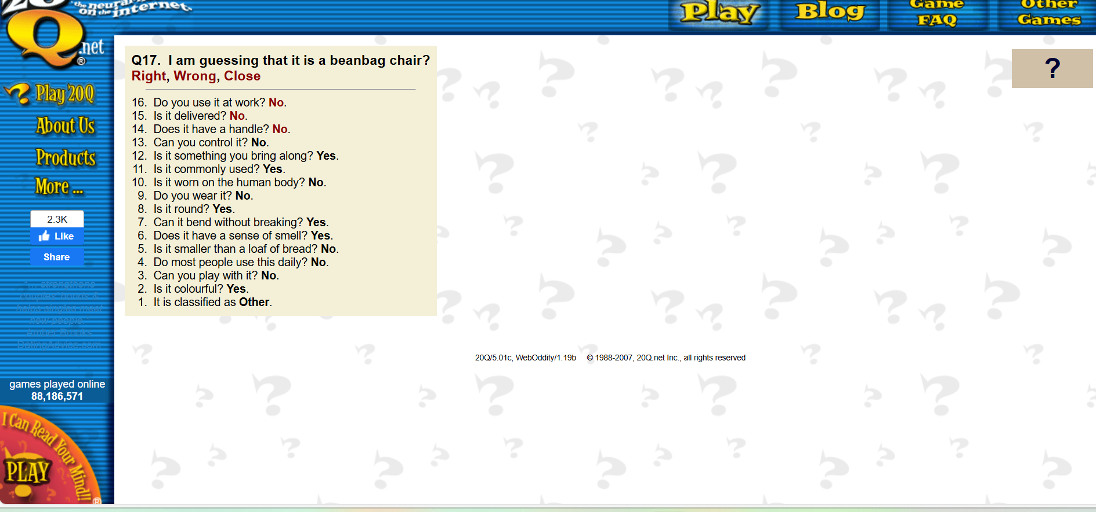
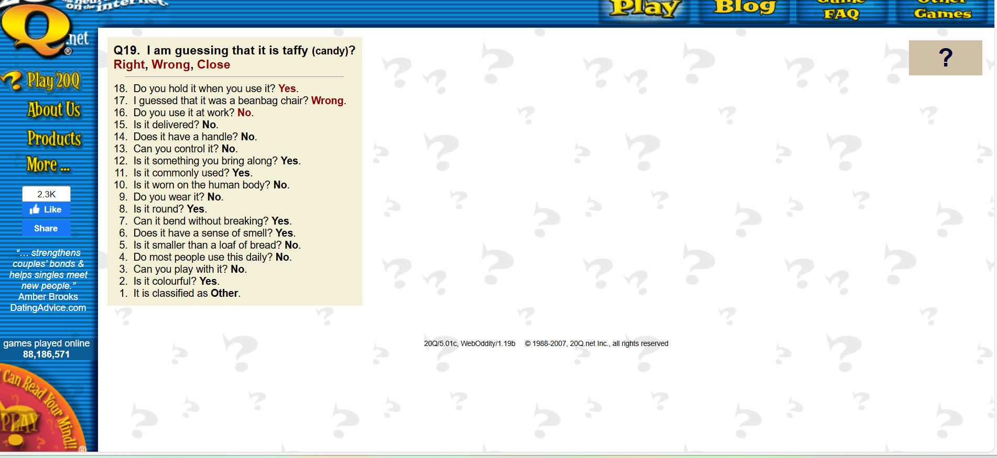
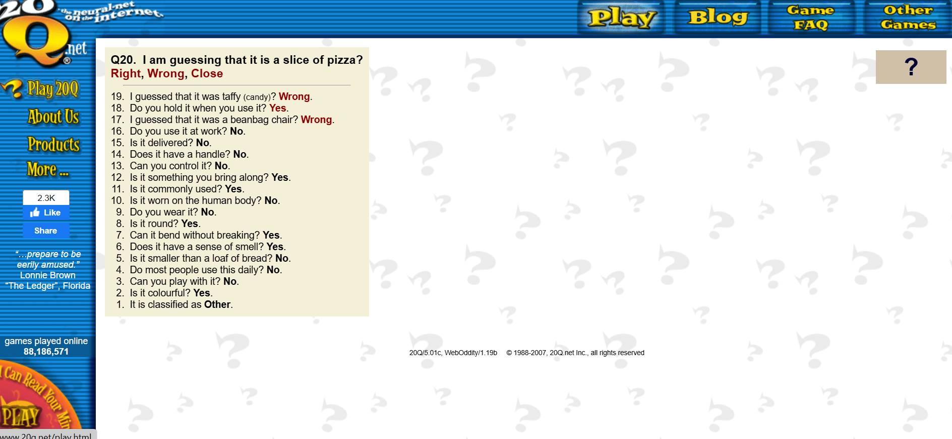

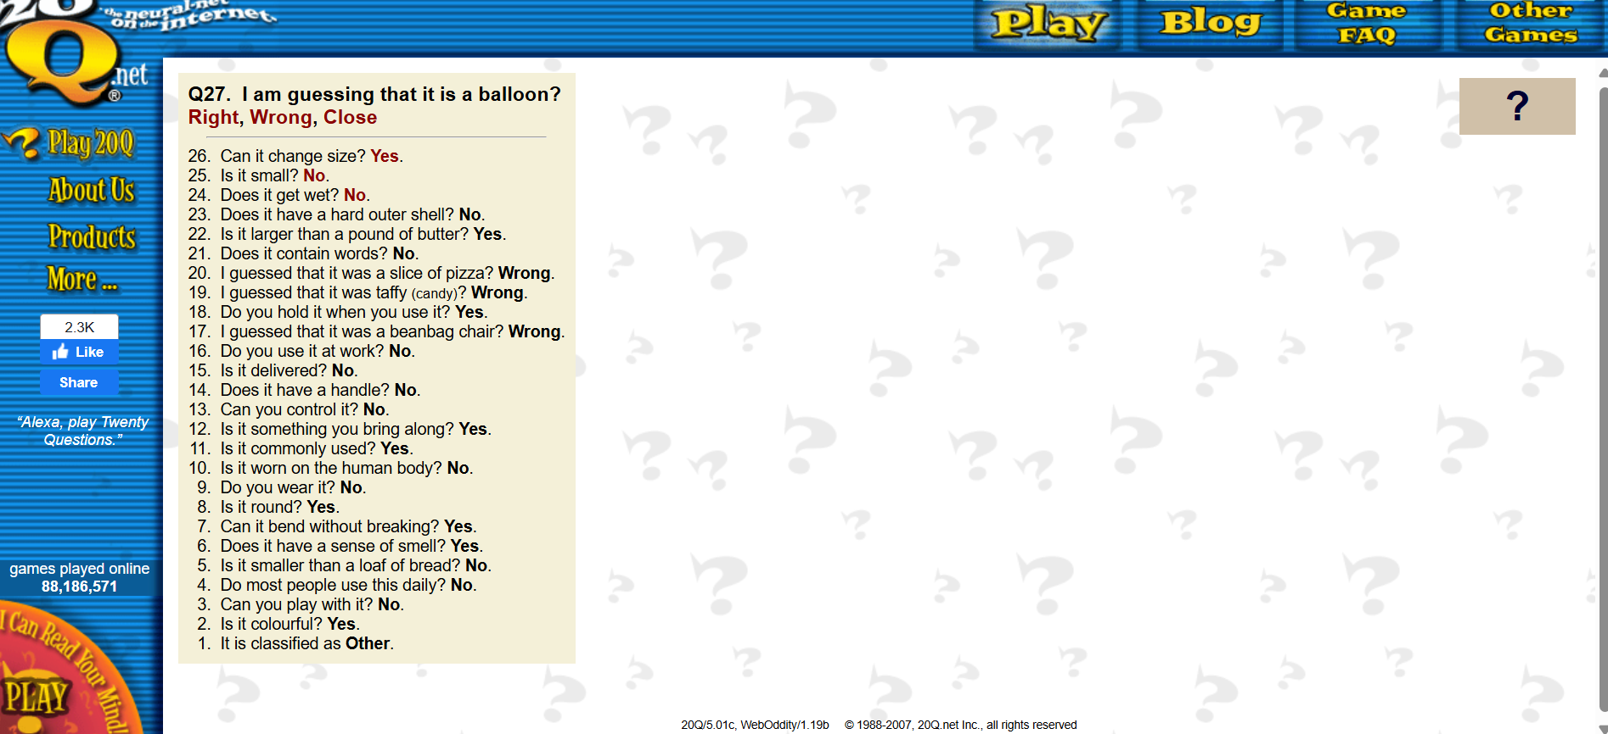
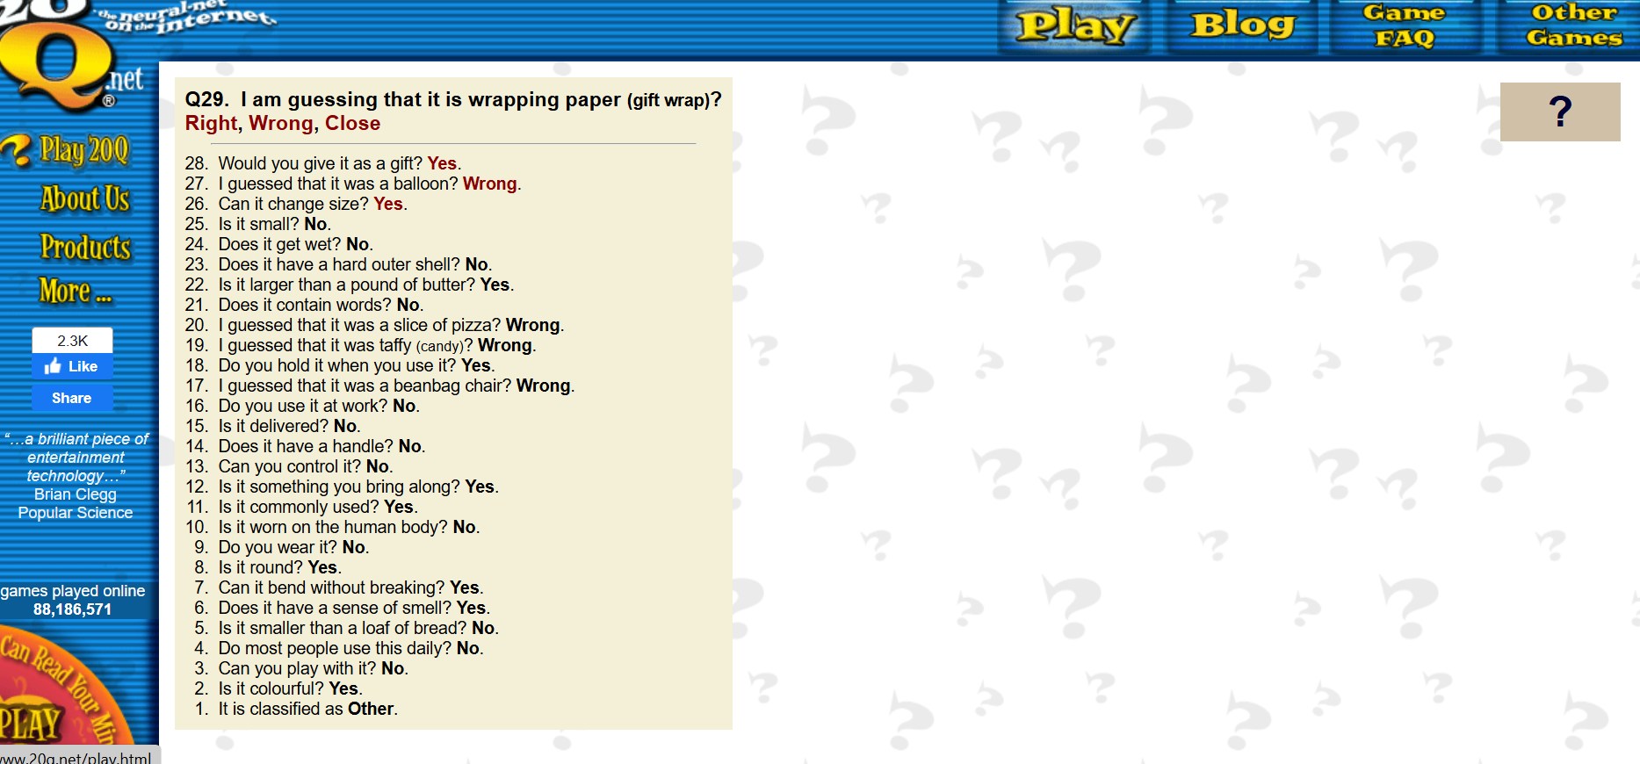
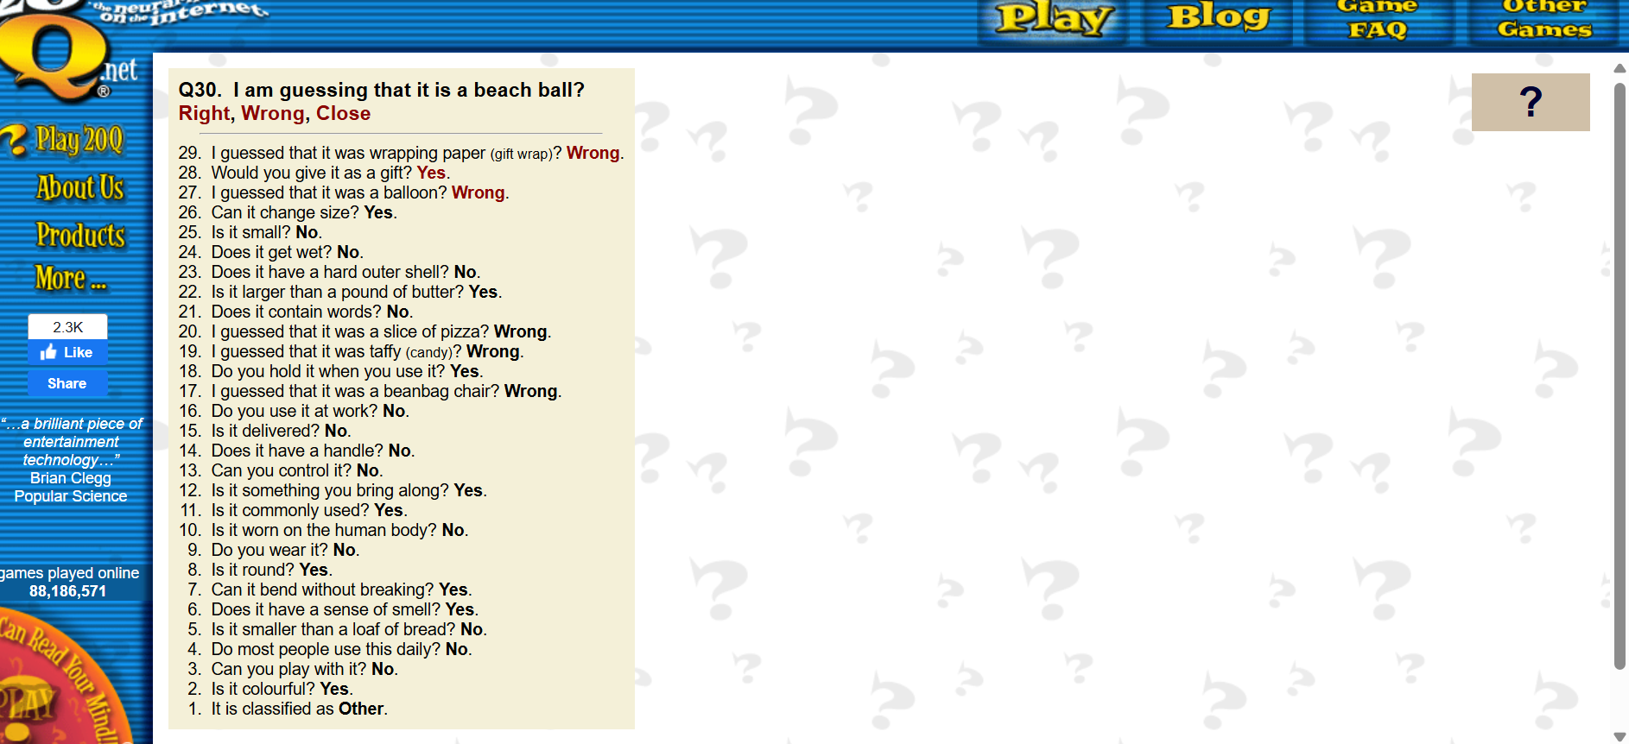
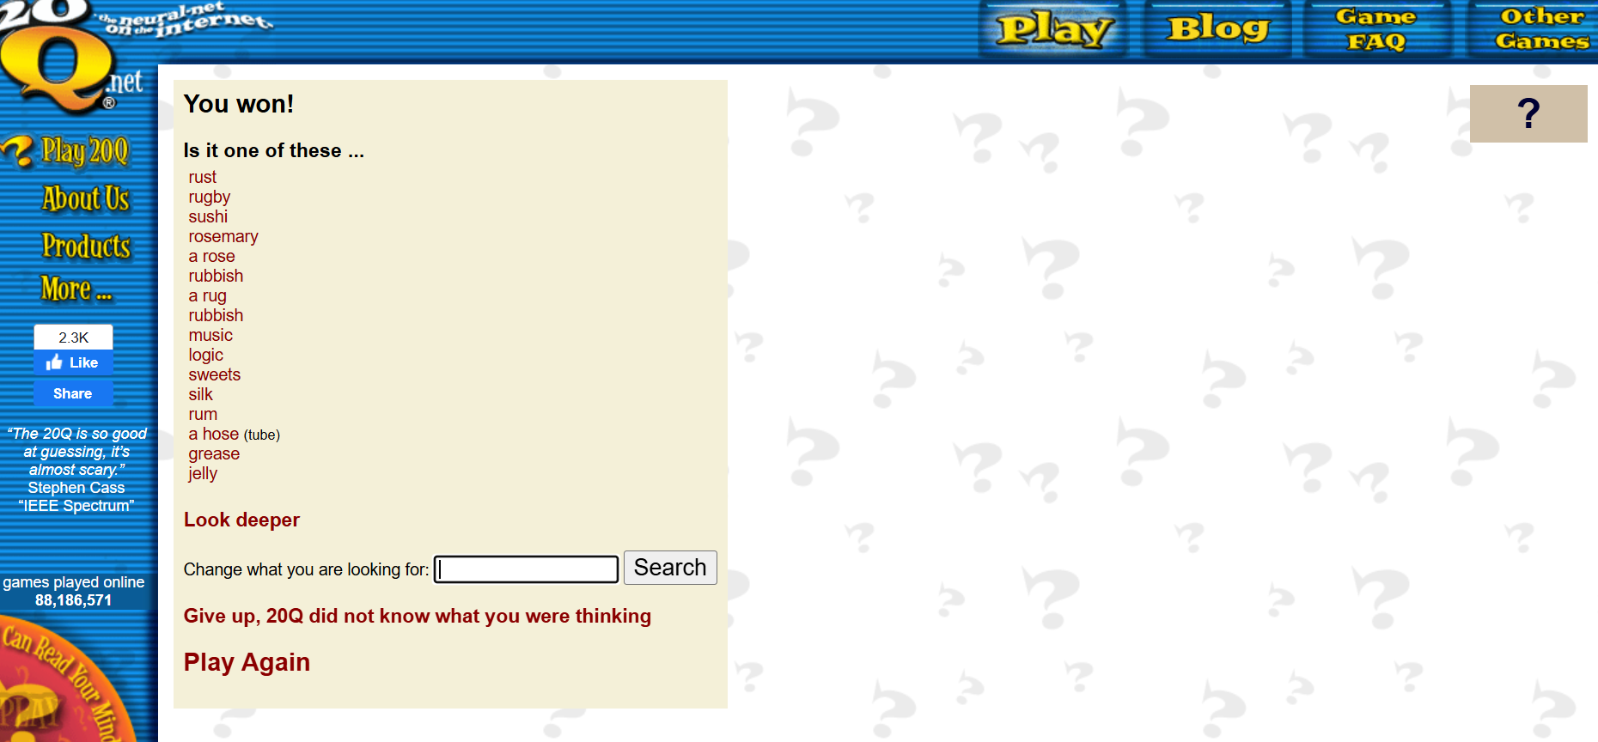

Attempt 2. with the word rose:
(with other answer options)

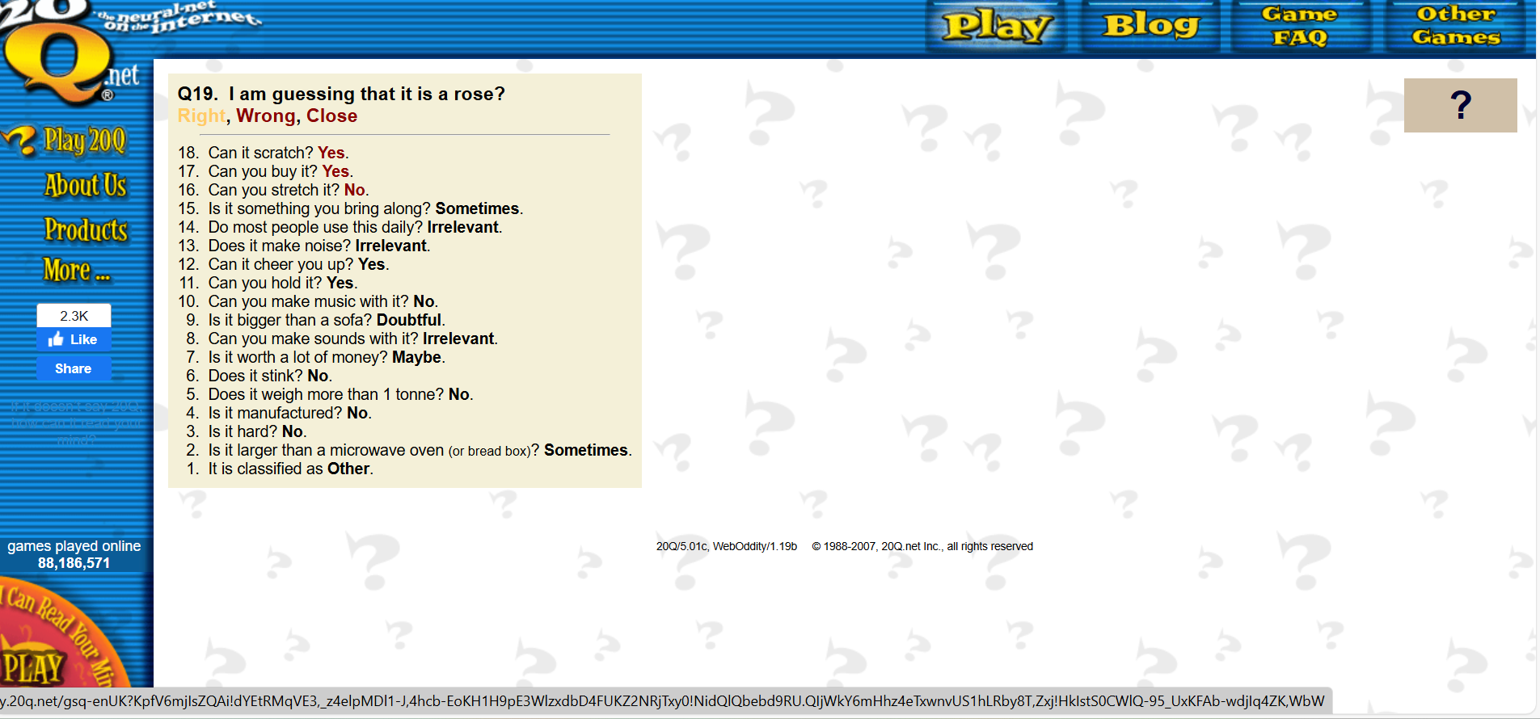
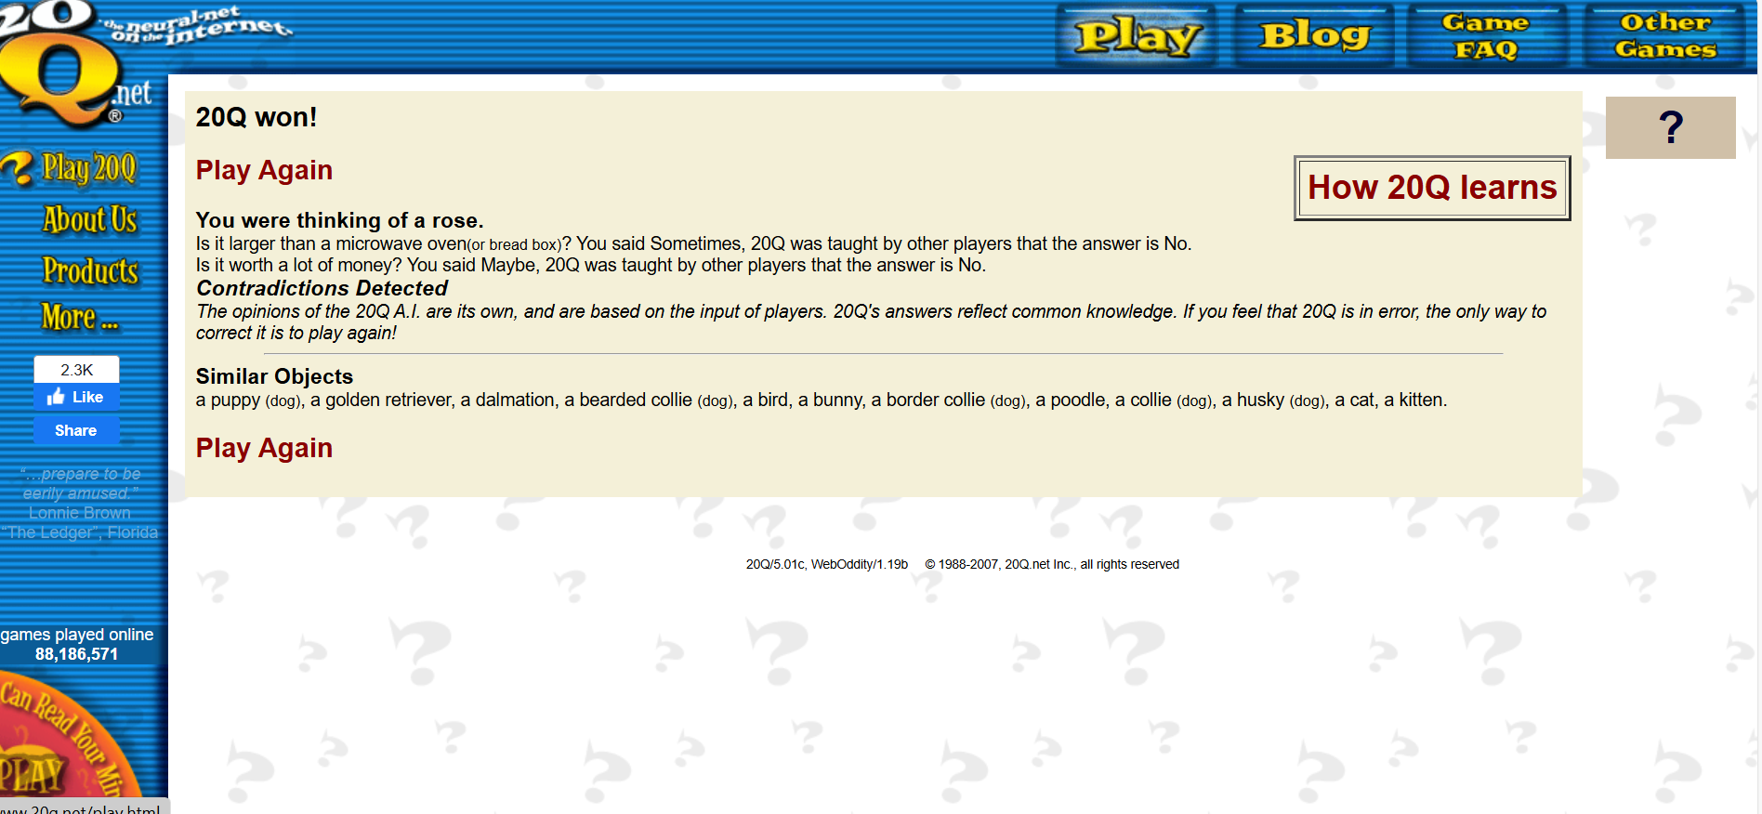

Attempt 1. with the word diamond:
(with only yes or no answers)

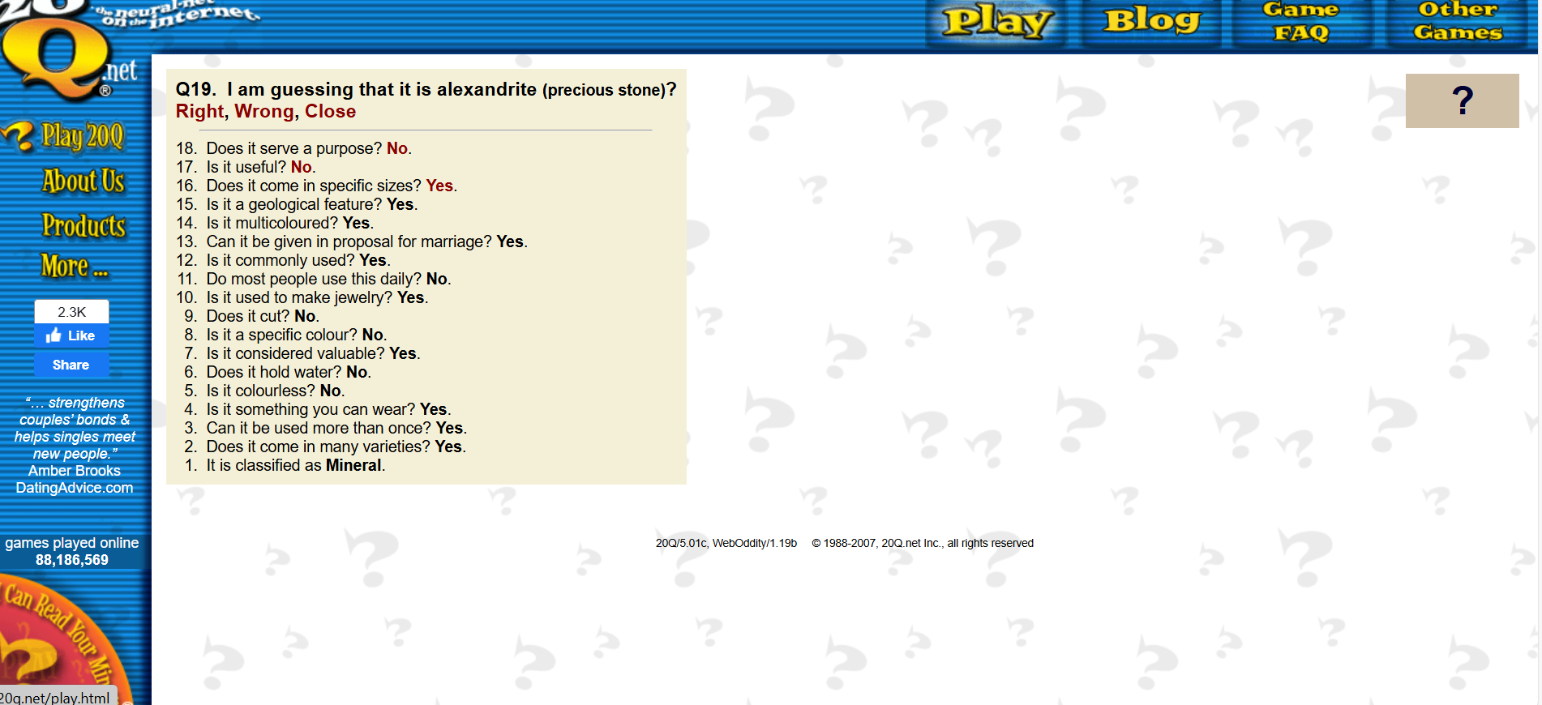

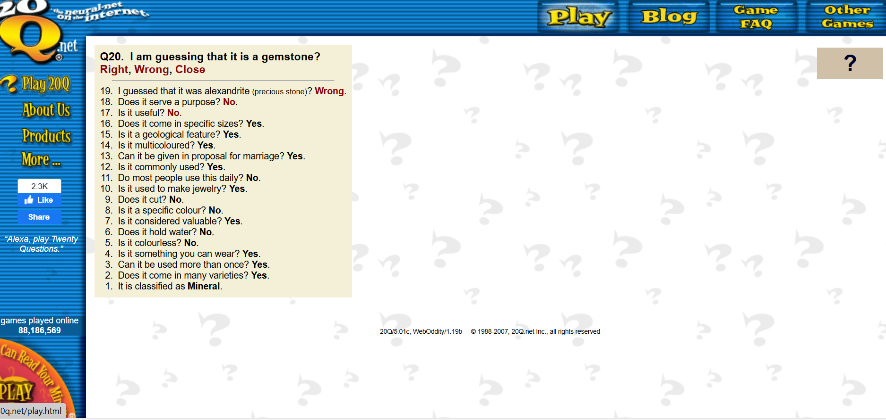
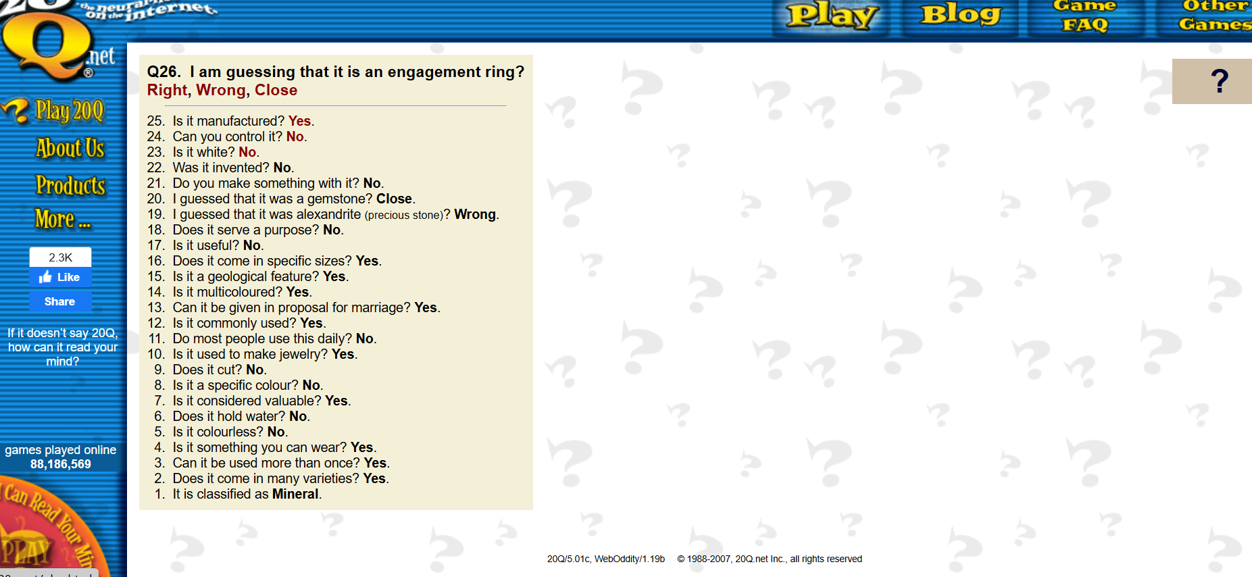

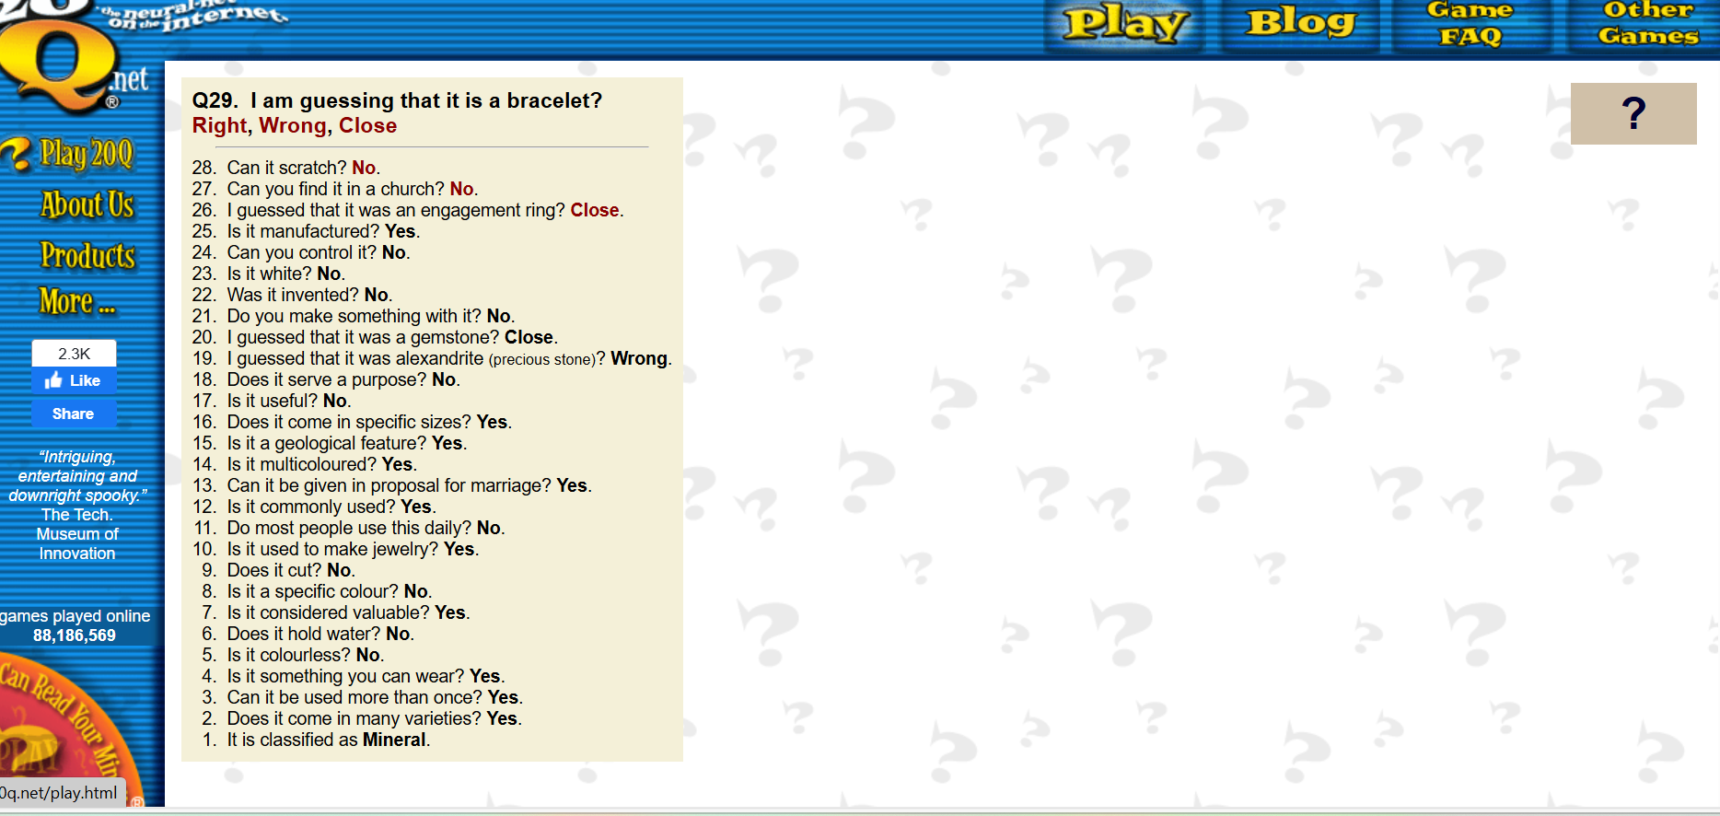
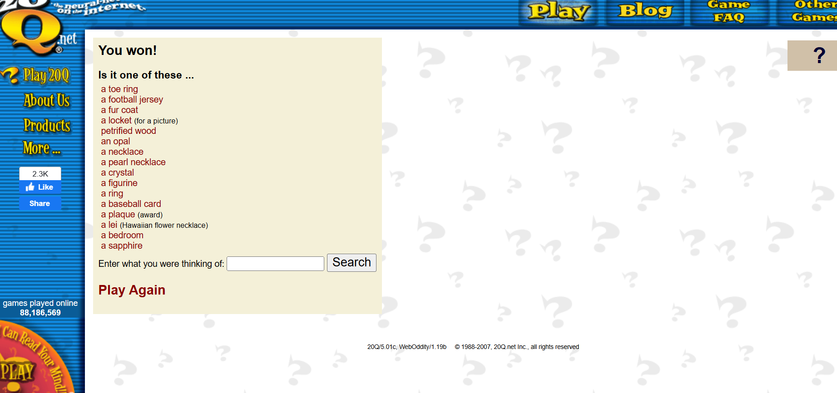

Attempt 2. withthe word diamond:
(with other answer options)
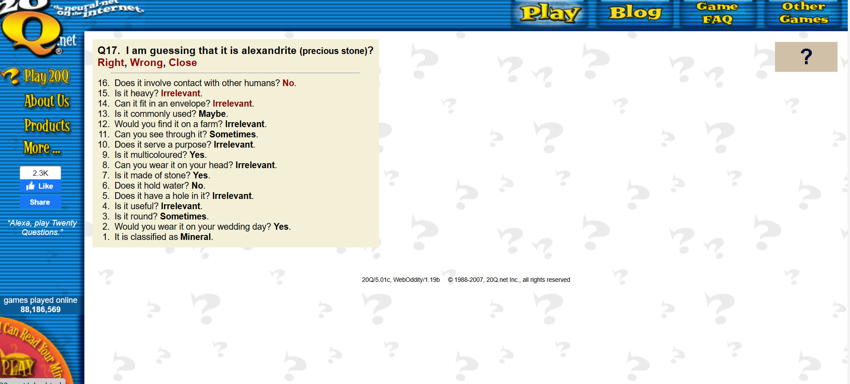
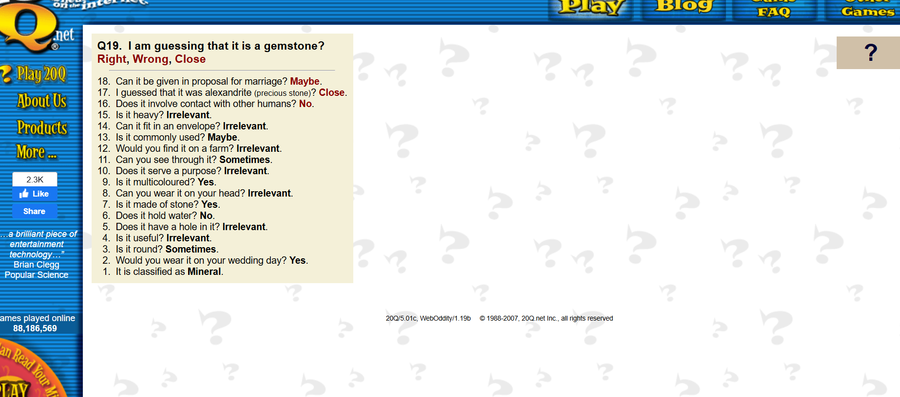
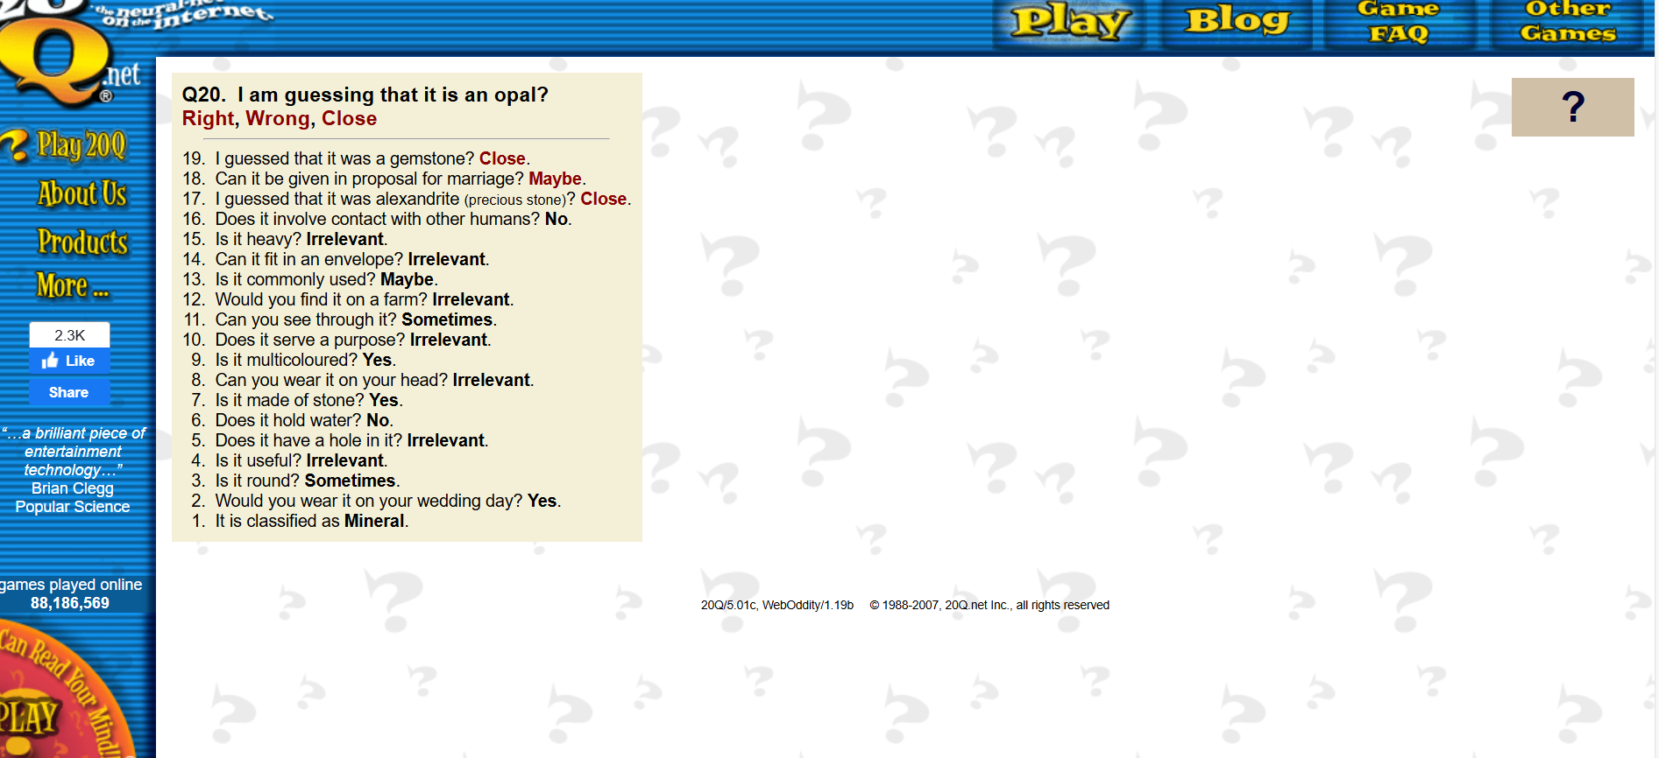
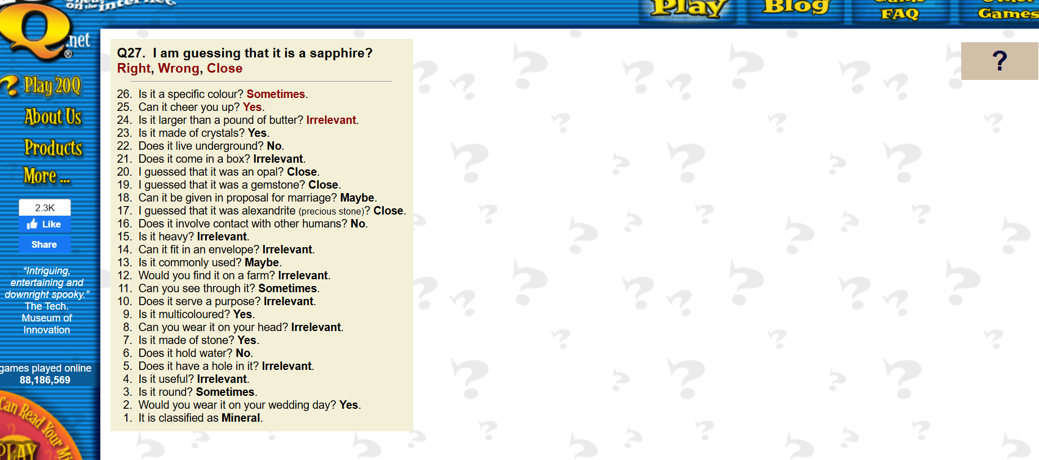
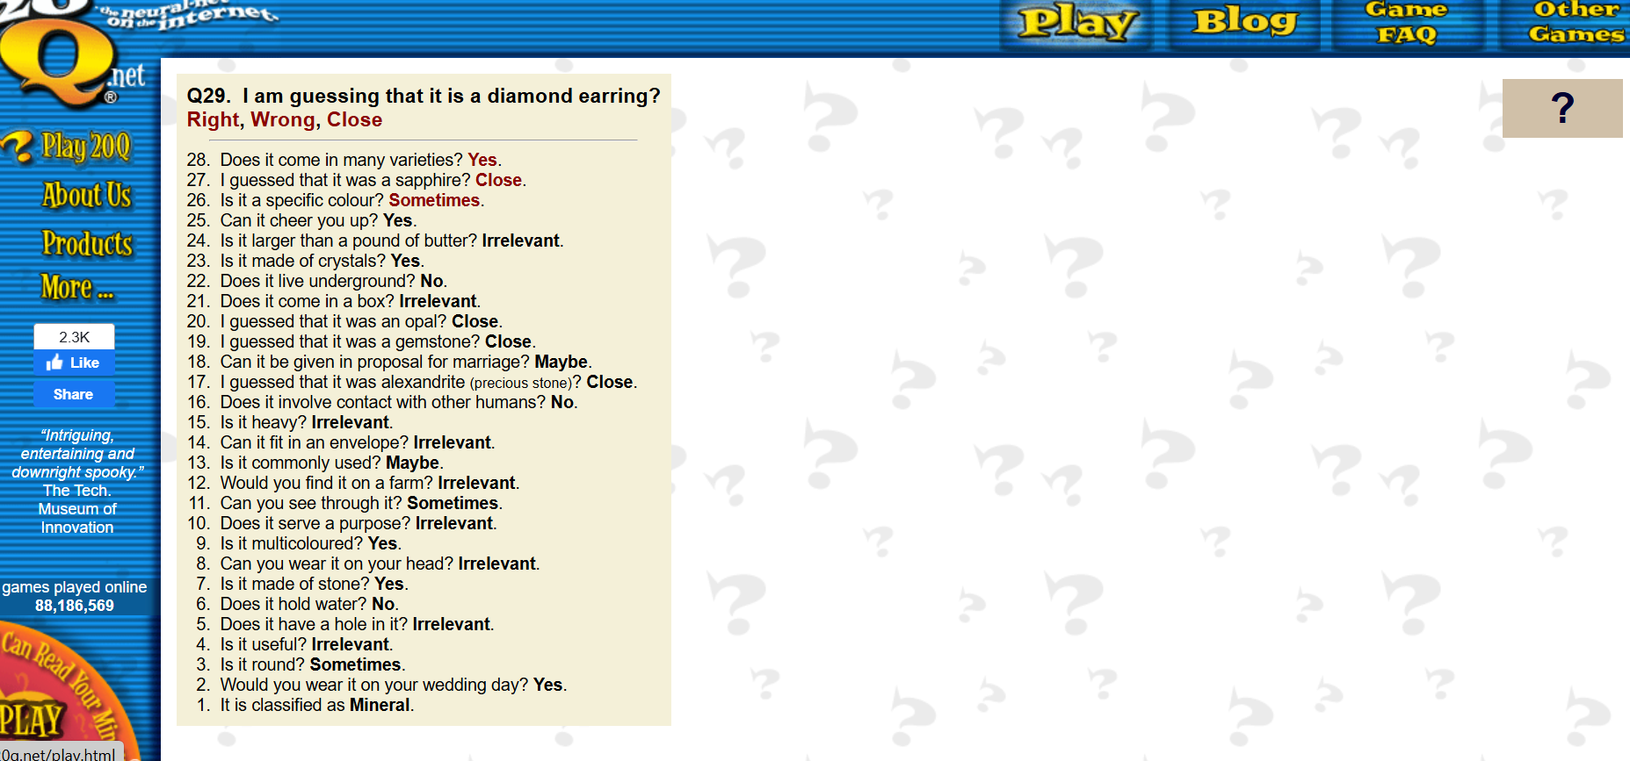
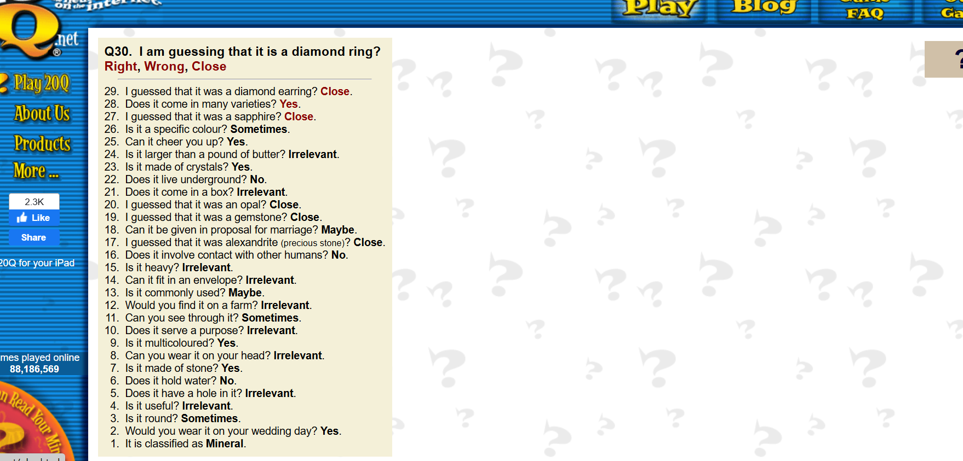
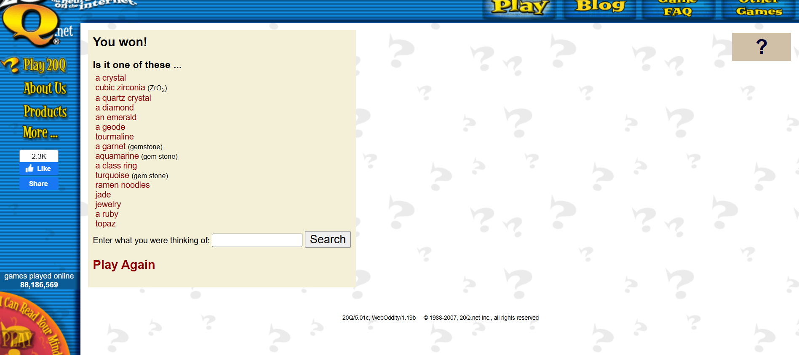

Attempt 1. with the word happiness:
(only with yes or no answers)

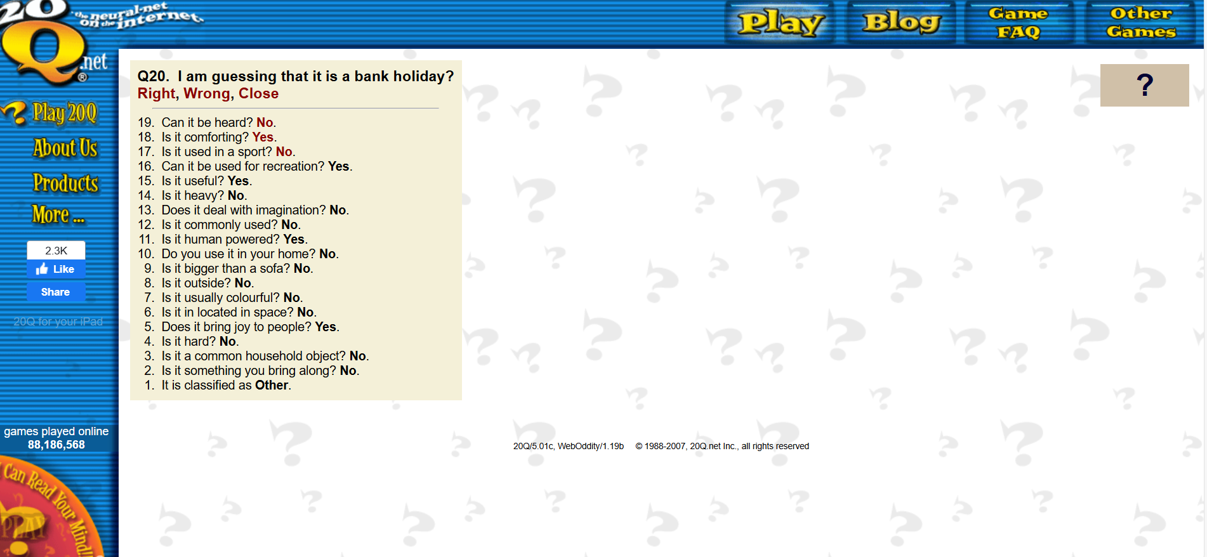

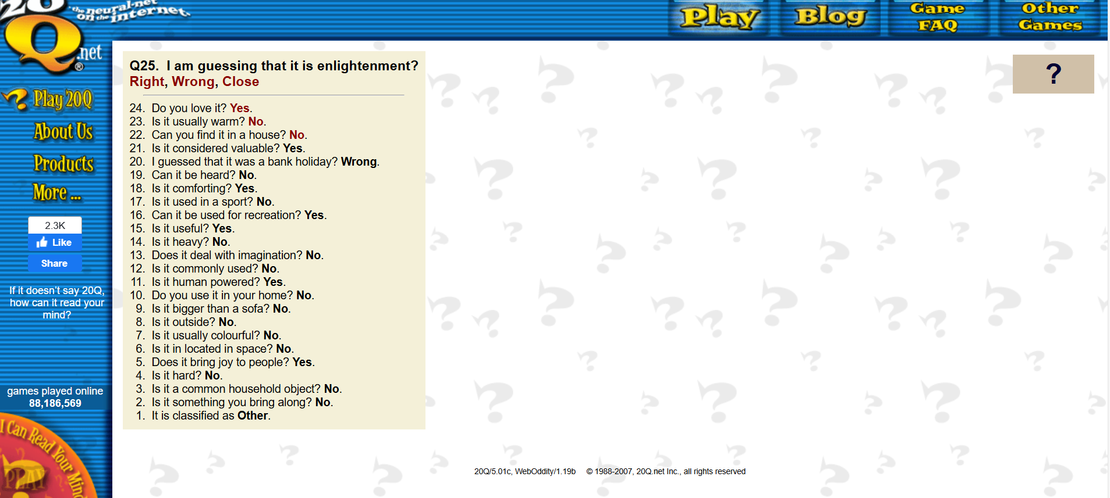

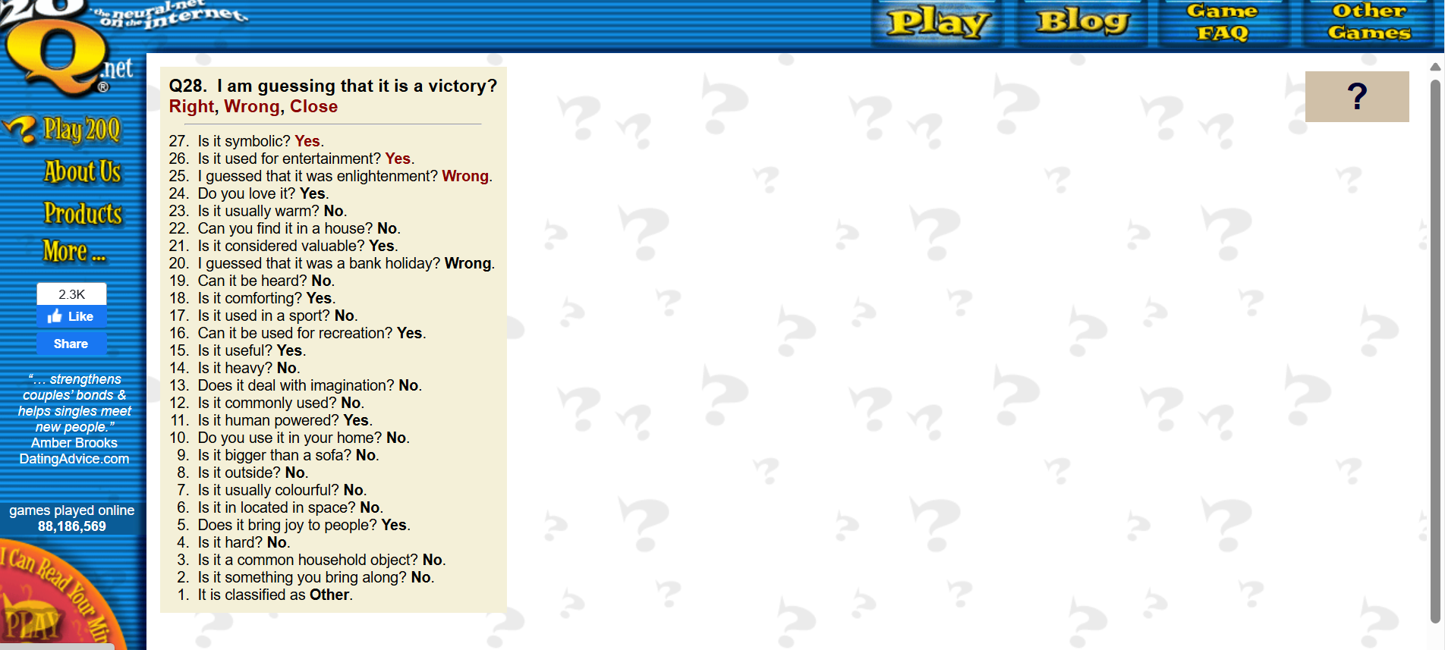

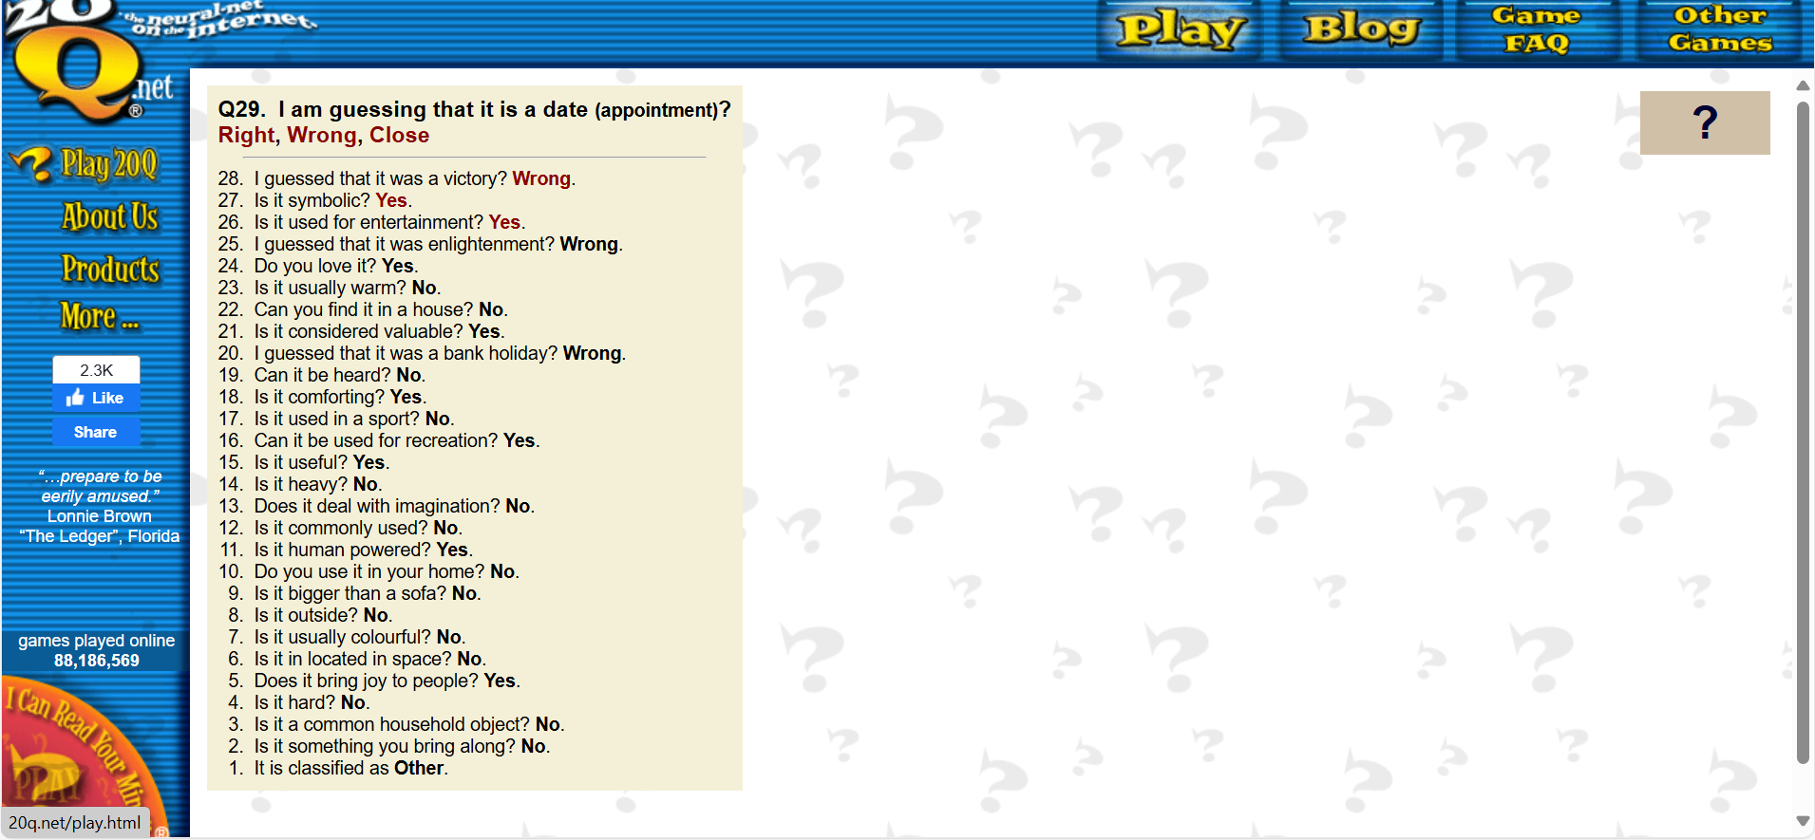
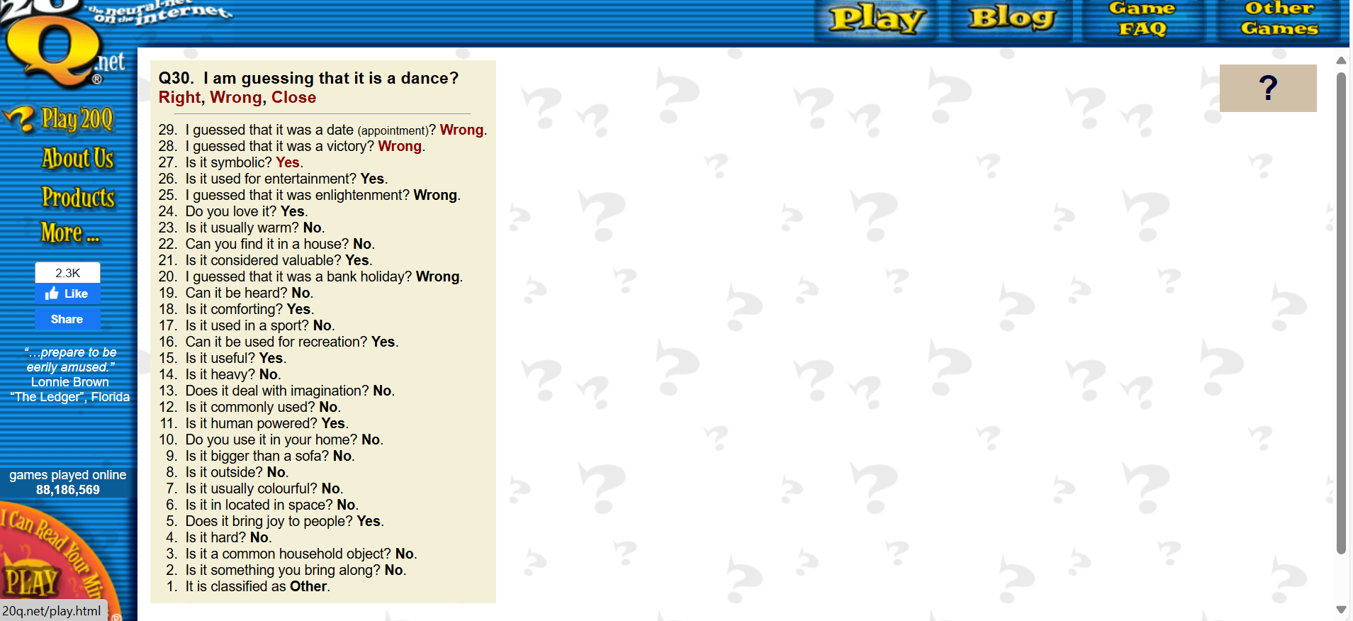

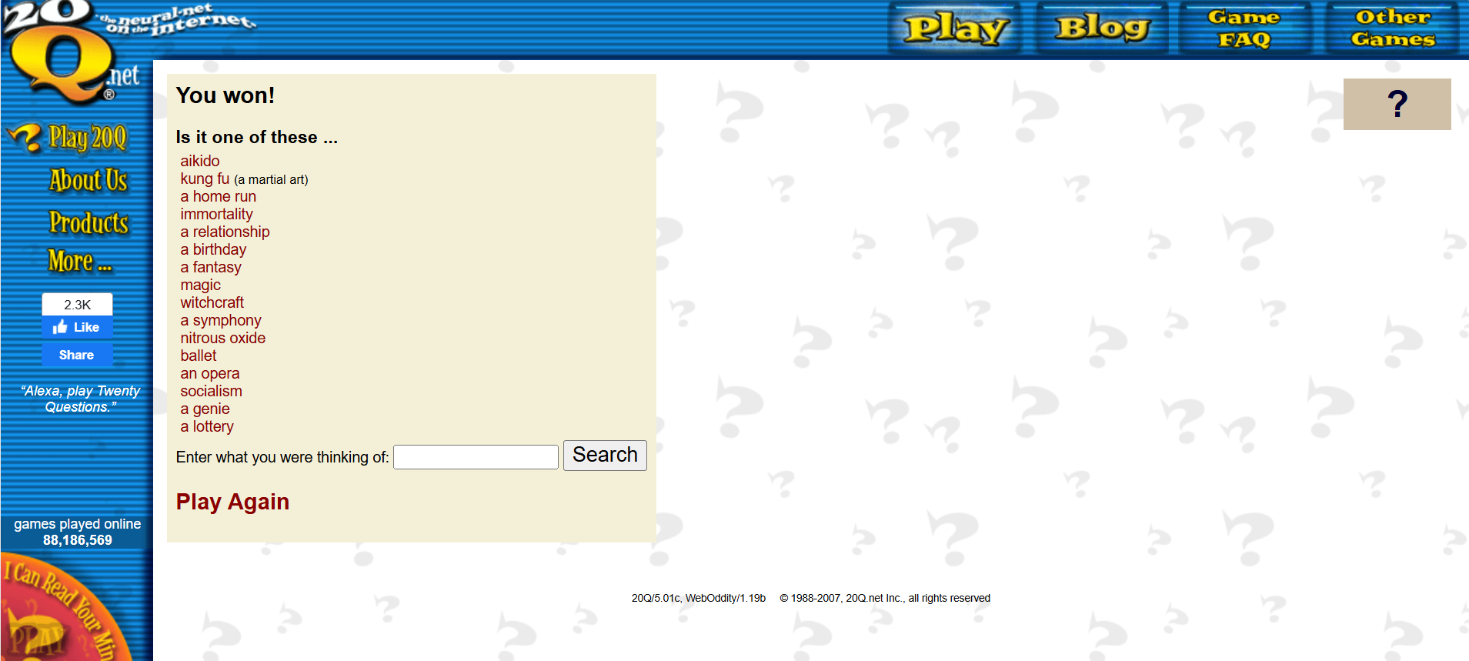

Attempt 2. with the word happiness
(with other answer options)

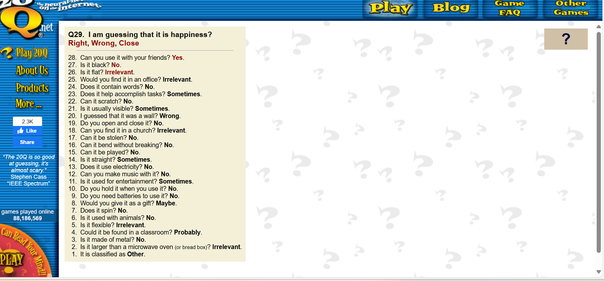

Conclusion:
- In the case of rose, my hypothesis was absolutely right. When I was giving only yes or no answers 20Q game didn’t manage to find out the word rose, but when I used the other options to answer, 18 questions was enough for it to guess I have thought of rose.

- In the case of diamond, it is not that clear if my hypothesis was right, but I think it was also right in the sense that in Attempt 2. it was much closer that the game finds out the word diamond, the last two solution was diamond earing and diamond ring. Although it couldn’t find out the exact word it has given very close guesses.

- In the case of happiness, in Attempt 1. with only yes or no answers it couldn’t guess the word happiness, but in Attempt 2., although it took 28 questions, but it has managed to find out that I thought of happiness.

