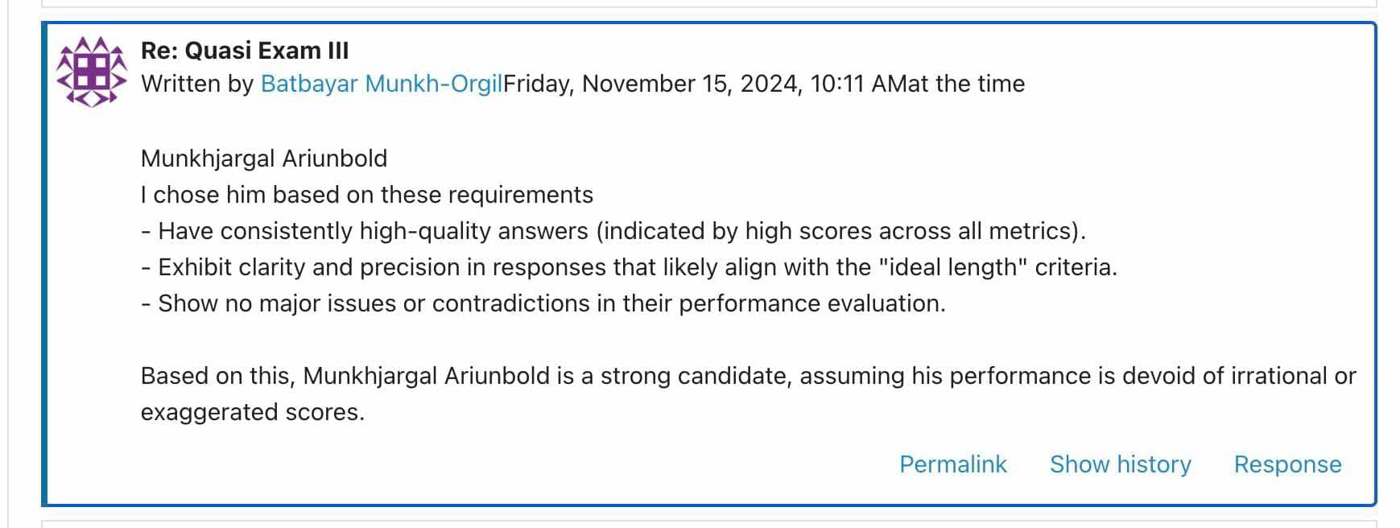
Fact
The selection of the "best student" in the Quasi Exam III discussion was based on assumptions rather than concrete evidence. While Munkhjargal Ariunbold was identified as a strong candidate, the reasoning provided relied on subjective interpretations and unverified performance metrics. valid for all participants working firstly with own feelings instead of log-data
Critical Interpretation
Assuming the best student without concrete evidence can lead to biased judgments and undermine the integrity of the evaluation process. The absence of explicit and objective criteria, such as published rubrics, performance data, or peer reviews, creates room for errors and favoritism. Additionally, reliance on potentially inaccurate assumptions diminishes the fairness of recognition.
Fine-Tuned Solution
Implement transparent evaluation criteria for determining the best student, such as Objective performance indicators (e.g., quantitative data from Moodle logs). finetuning as such = whole project documentation itself

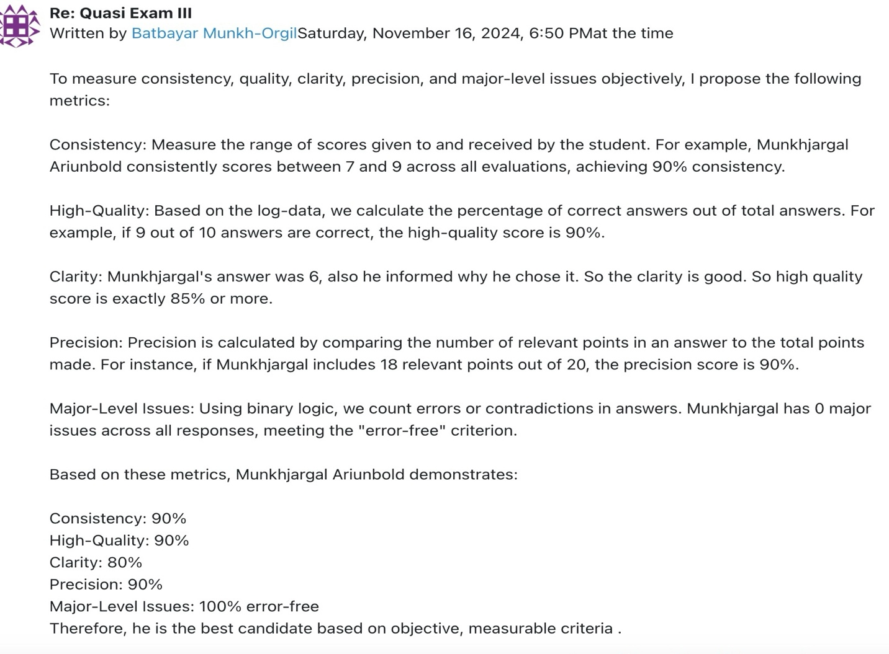
Fact
The precision calculation described for evaluating student responses relies on the term "relevant," but the term is not clearly defined or quantified in a formal, formulaic manner. The lack of a KNUTH-like formula or mathematical rigor to determine relevance creates ambiguity in the scoring process.
Critical Interpretation
Using subjective criteria such as "relevant points" without a clear, measurable definition introduces inconsistencies and potential biases in evaluations. Different evaluators may interpret relevance differently, leading to discrepancies in precision scores. This undermines the objectivity and fairness of the assessment process, making it difficult to replicate or validate results.
Fine-Tuned Solution
Introduce a formalized formula to calculate precision. c.f. log-based attributes and optimized weighting based on similarity analyses
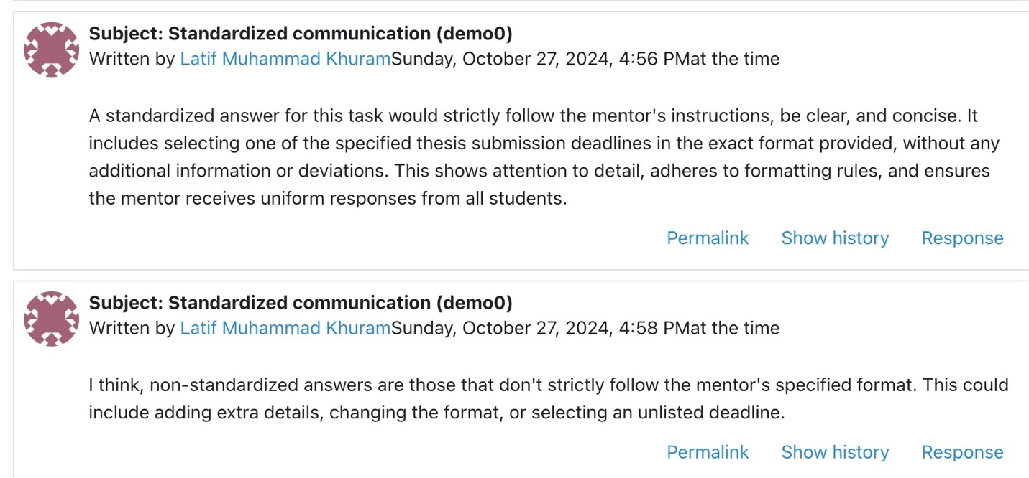
Fact
IT experts are expected to provide clear, concrete examples to support generalized statements, especially when discussing technical or professional phenomena. Without examples, even accurate generalizations may come across as vague or speculative, reducing their practical value. This issue is particularly important for final exams, where good examples can enhance understanding and assessment quality.
Critical Interpretation
Generalized statements without supporting examples may lead to a lack of clarity, making it difficult for readers or students to fully understand or trust the information presented. This "professional gossiping" can result in confusion, misinterpretation, or the perception that the speaker lacks in-depth knowledge. In the context of exams, this approach undermines the learning objectives by prioritizing abstract theory over practical application.
Fine-Tuned Solution: each formulation e.g. with plural forms and/or defining an empty set of elements do exactly need examples in brackets: e.g. “that do not strictly follow the mentor’s specified format” the mentor’s specified format is still an empty bubble in this particular case. Finetuning means the mentor’s specified format (e.g. contextual parameters, lengths, etc.) or the mentor’s specified format (see chapter xxx or see URL=https://…pdf#page=xxx even as jumping point in hypertexts)
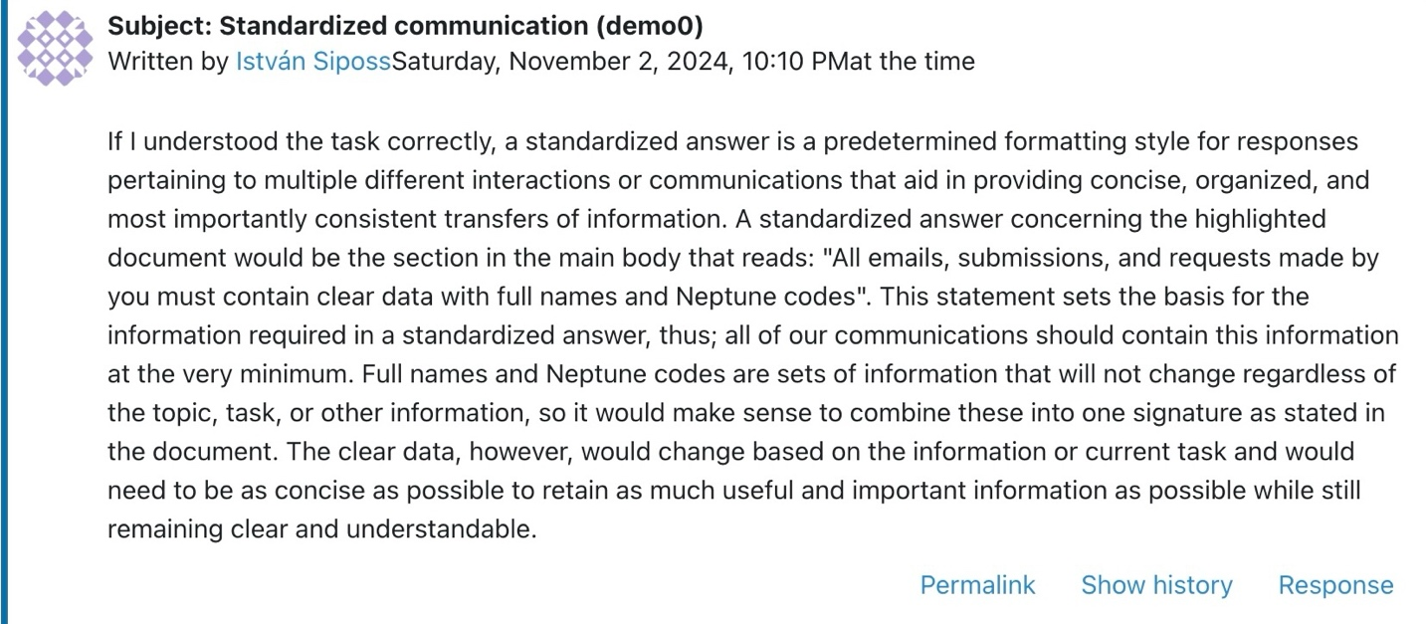
Fact
In the discussion about standardized communication, the responses include seemingly correct text elements but lack actionable precision. The response by István Siposs discusses general concepts of standardized answers but fails to deliver specific, concise, and usable instructions, such as numerical values or pseudo-code-like formats.
Critical Interpretation
Verbose responses that lack direct operational value can be misleading and unproductive in professional or educational contexts. While explanations are important, they should follow—not replace—the delivery of clear, actionable information. Without this clarity, the communication becomes ambiguous and inefficient, especially in scenarios where exactness is crucial, such as task execution or technical planning. This issue undermines the goal of creating standardized, universally understood instructions.
Fine-Tuned Solution
Establish a clear standard for commands: Commands should be concise, precise, and formatted for quick interpretation. Example structure: [Instruction]
[Mandatory Data: Numbers, Proofs, Figures]
[Optional Explanation/Remark]
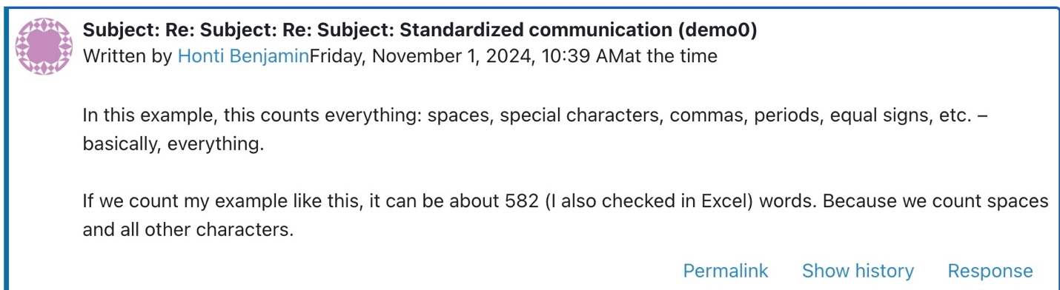
Fact
…
Critical Interpretation
The lack of clarity regarding the exactness of the Excel formula undermines the precision of the task. If the formula used is not refined to account for all nuances, it could lead to discrepancies in the final count. Ensuring exact results is essential when establishing standardized lengths, as even minor inaccuracies can impact how effectively the results align with predefined expectations. Furthermore, if there are misunderstandings about whether the formula can give an exact count, this adds complexity to an otherwise straightforward process.
Fine-Tuned Solution Ensure Formula Accuracy: Double-check the formula in Excel to ensure it accounts for all elements (spaces, special characters, punctuation). A typical Excel formula to count characters including spaces is: =LEN(A1)
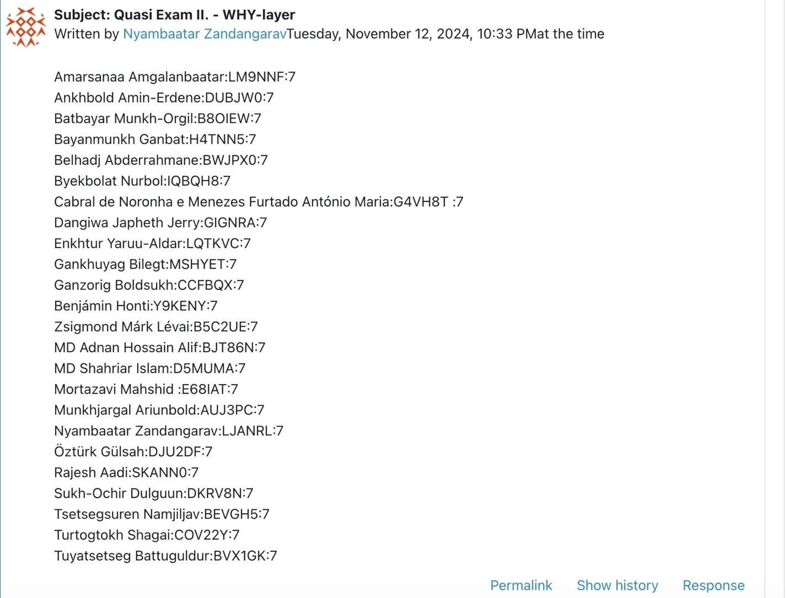
Fact
…
Critical Interpretation
The concern about whether each participant should be evaluated with equal weight based on past data highlights a deeper issue in fairness and consistency in assessment. While standardizing evaluations is important, it is equally critical to account for the individual context of each student, including their historical performance and the quality of their contributions. Simply applying the same value to all responses may overlook important differences in effort, improvement, or depth of analysis. This could lead to unfair assessments that do not truly reflect individual capabilities or progress.
Solution: Create a Rubric for Evaluation: Define clear, objective criteria for scoring, such as:
Logical consistency: Whether the argumentation follows a clear, well-supported path.
Clarity and precision: Whether the student conveys their thoughts clearly.
Relevance of examples and derivations: Whether the provided examples or derivations are relevant to the question and well-executed.

