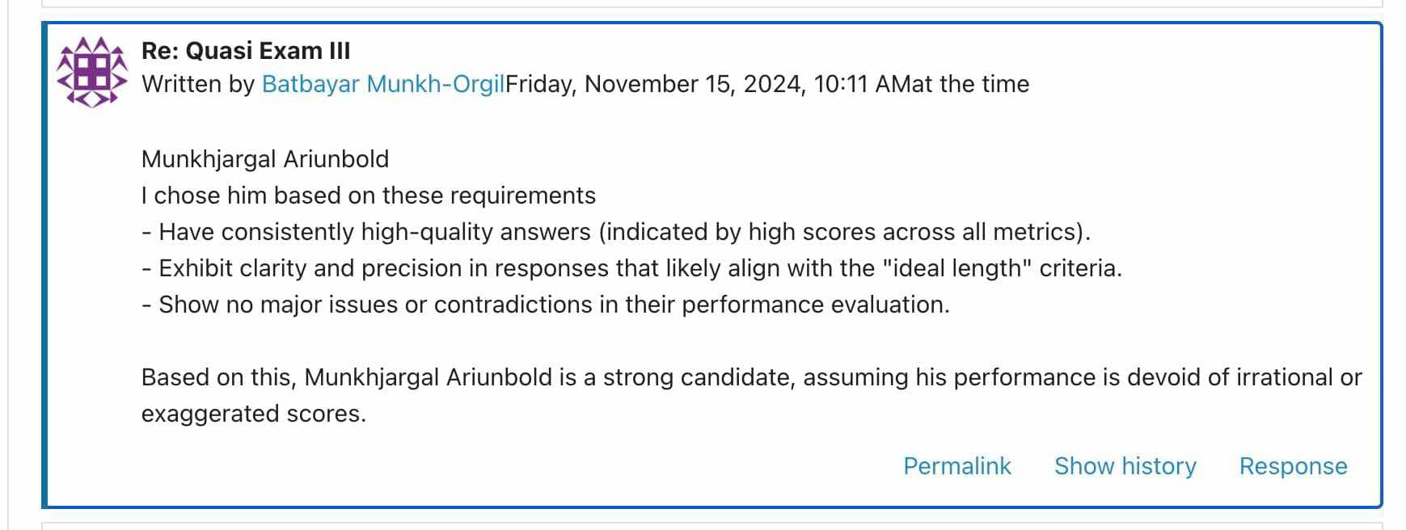
Fact
The selection of the "best student" in the Quasi Exam III discussion was based on assumptions rather than concrete evidence. While Munkhjargal Ariunbold was identified as a strong candidate, the reasoning provided relied on subjective interpretations and unverified performance metrics. This approach was not unique to him but reflected the general trend in the discussion, where all participants seemed to prioritize personal feelings and impressions over objective, data-driven analysis. As a result, the selection process lacked a foundation in verifiable evidence , making it prone to biases and in accuracies.
Critical Interpretation
Assuming the best student without concrete evidence can lead to biased judgments and undermine the integrity of the evaluation process. The absence of explicit and objective criteria, such as published rubrics, performance data, or peer reviews, creates room for errors and favoritism. Additionally, reliance on potentially inaccurate assumptions diminishes the fairness of recognition.
Fine-Tuned Solution
To ensure transparency and fairness in determining the best student, it is essential to implement comprehensive, objective performance indicators throughout the project. This would involve not only quantitative data from Moodle logs, but also other measurable metrics that can be standardized across the project. By integrating these evaluation criteria into the overall project documentation, we can create a unified approach that ensures consistency and accountability in assessments. The clear documentation of evaluation methods, data sources, and performance metrics will provide all stakeholders with transparency and clarity on how decisions are made.

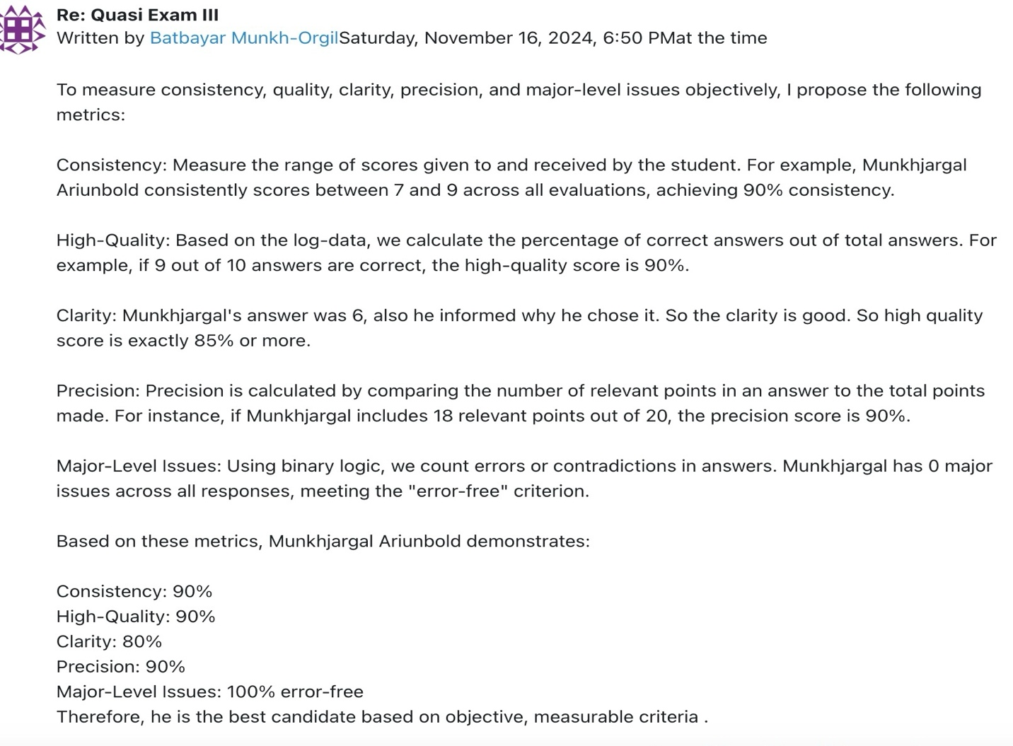
Fact
The precision calculation described for evaluating student responses relies on the term "relevant," but the term is not clearly defined or quantified in a formal, formulaic manner. The lack of a KNUTH-like formula or mathematical rigor to determine relevance creates ambiguity in the scoring process.
Critical Interpretation
Using subjective criteria such as "relevant points" without a clear, measurable definition introduces inconsistencies and potential biases in evaluations. Different evaluators may interpret relevance differently, leading to discrepancies in precision scores. This undermines the objectivity and fairness of the assessment process, making it difficult to replicate or validate results.
Fine-Tuned Solution
Introduce a formalized formula to calculate precision.
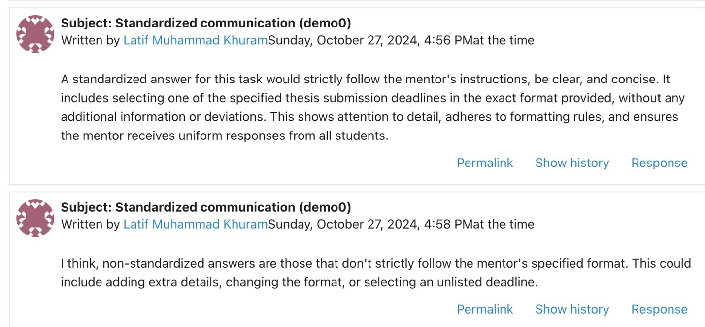
Fact:
IT professionals are expected to provide clear, concrete examples to support generalized statements, particularly when discussing technical or professional topics. This ensures that the information is not vague or speculative, enhancing the clarity and practicality of communication. For instance, a standardized answer for a task would adhere strictly to the mentor’s instructions, ensuring that it is clear, concise, and follows the exact formatting required, as outlined in the task details (e.g., selecting a specified thesis submission deadline in the exact format provided).
Critical Interpretation:
In the context of standardized communication, failing to strictly follow the specified format or adding extraneous information can lead to a breakdown in clarity and consistency. Non-standardized answers that deviate from the established instructions, whether by altering the format, adding unnecessary details, or selecting an unlisted deadline, create confusion and disrupt uniformity. This undermines the purpose of standardized communication, which is to ensure that all students provide responses in a consistent, predictable manner that aligns with the mentor’s expectations.
Solution:
To ensure adherence to standardized communication, each response should strictly follow the instructions provided by the mentor, without deviations or unnecessary additions. For example, when selecting a thesis submission deadline, students should choose one of the listed options in the specified format (e.g., "2024 Nov") and refrain from adding extra details or altering the format. This approach guarantees that responses are uniform, clear, and easily processed, which improves communication efficiency and reduces the chance for misunderstanding.
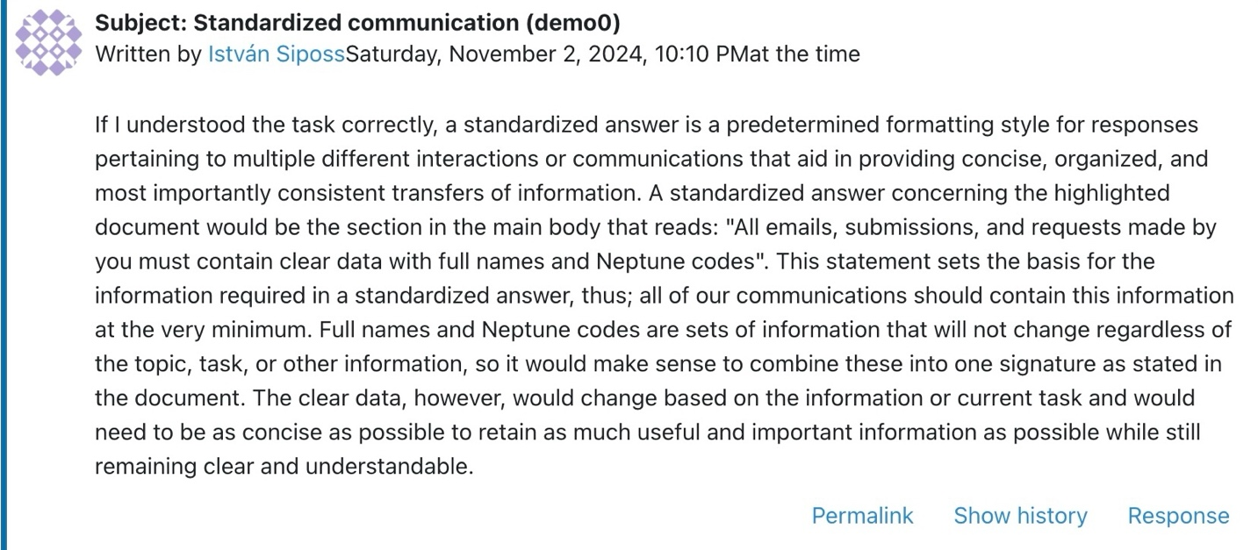
Fact
In the discussion about standardized communication, the responses include seemingly correct text elements but lack actionable precision. The response by István Siposs discusses general concepts of standardized answers but fails to deliver specific, concise, and usable instructions, such as numerical values or pseudo-code-like formats.
Critical Interpretation
Verbose responses that lack direct operational value can be misleading and unproductive in professional or educational contexts. While explanations are important, they should follow—not replace—the delivery of clear, actionable information. Without this clarity, the communication becomes ambiguous and inefficient, especially in scenarios where exactness is crucial, such as task execution or technical planning. This issue undermines the goal of creating standardized, universally understood instructions.
Fine-Tuned Solution
Establish a clear standard for commands: Commands should be concise, precise, and formatted for quick interpretation. Example structure: [Instruction]
[Mandatory Data: Numbers, Proofs, Figures]
[Optional Explanation/Remark]
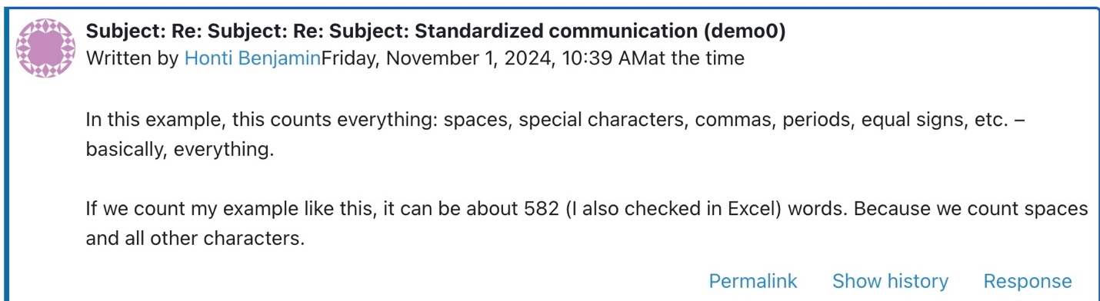
Fact
The Excel formula used in the task does not account for all possible conditions (e.g., rounding, empty cells, or errors in data formatting), which can lead to discrepancies in the final count. This lack of specificity in the formula results in a less precise calculation that could affect the accuracy of the task, especially when dealing with standardized lengths or predefined expectations where exactness is crucial.
Critical Interpretation
The lack of clarity regarding the exactness of the Excel formula undermines the precision of the task. If the formula used is not refined to account for all nuances, it could lead to discrepancies in the final count. Ensuring exact results is essential when establishing standardized lengths, as even minor inaccuracies can impact how effectively the results align with predefined expectations. Furthermore, if there are misunderstandings about whether the formula can give an exact count, this adds complexity to an otherwise straightforward process.
Fine-Tuned Solution Ensure Formula Accuracy: Double-check the formula in Excel to ensure it accounts for all elements (spaces, special characters, punctuation). A typical Excel formula to count characters including spaces is: =LEN(A1)
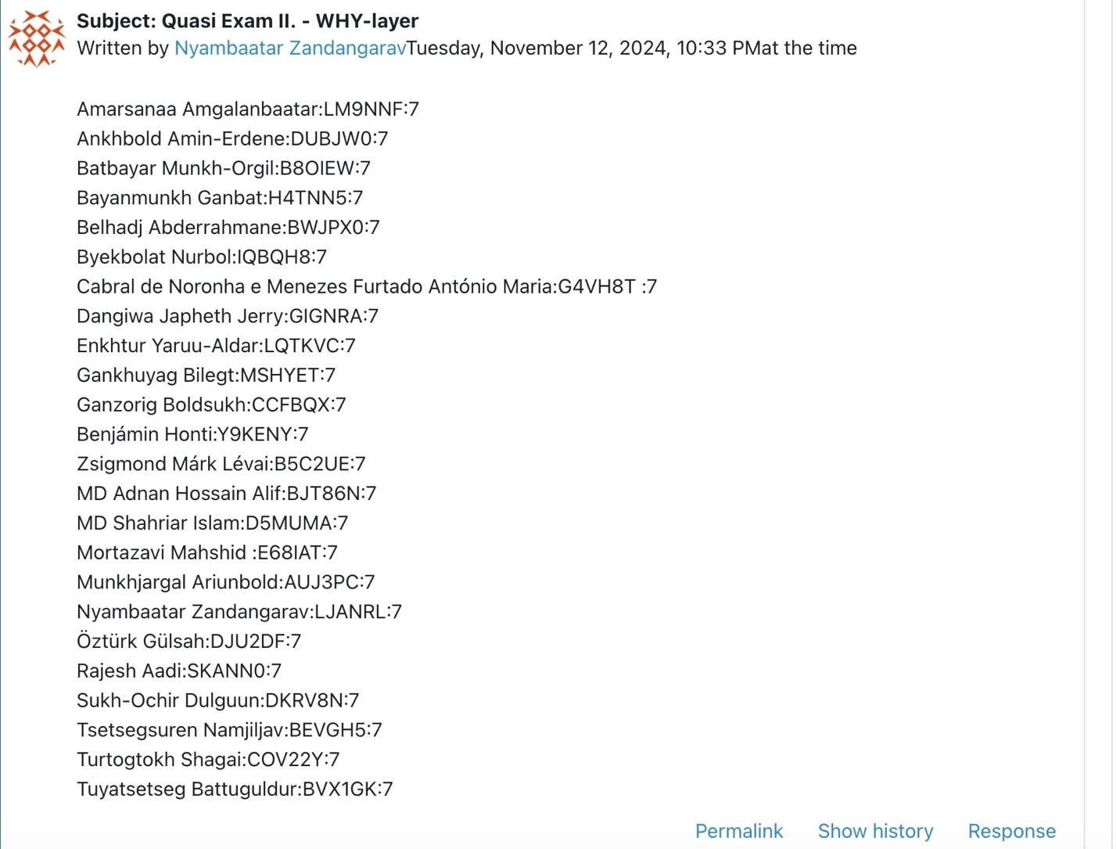
Critical Interpretation
The concern about whether each participant should be evaluated with equal weight based on past data highlights a deeper issue in fairness and consistency in assessment. While standardizing evaluations is important, it is equally critical to account for the individual context of each student, including their historical performance and the quality of their contributions. Simply applying the same value to all responses may overlook important differences in effort, improvement, or depth of analysis. This could lead to unfair assessments that do not truly reflect individual capabilities or progress.
Solution: Create a Rubric for Evaluation: Define clear, objective criteria for scoring, such as:
Logical consistency: Whether the argumentation follows a clear, well-supported path. Clarity and precision: Whether the student conveys their thoughts clearly. Relevance of examples and derivations: Whether the provided examples or derivations are relevant to the question and well-executed.

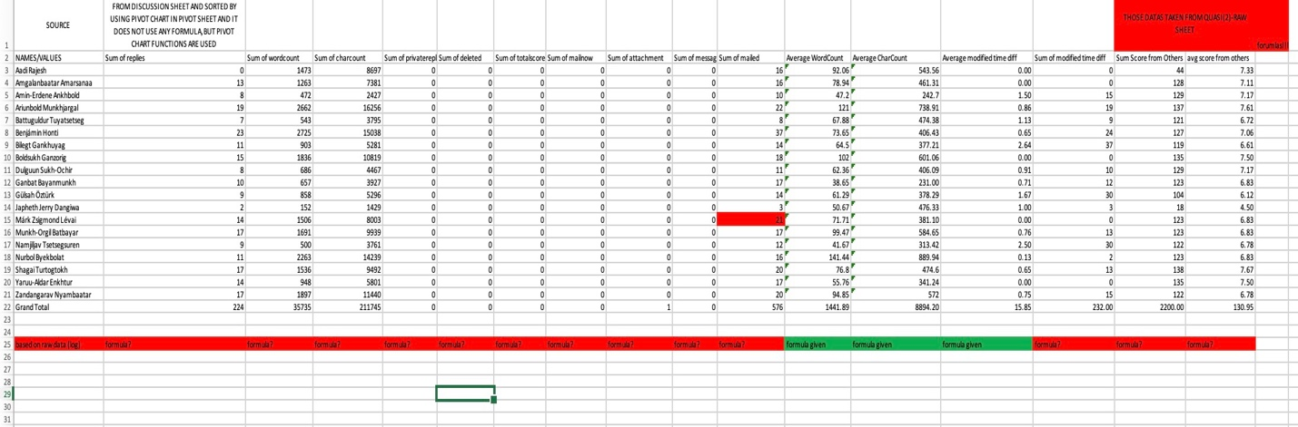
Fact: Some data modeling projects for analyzing student performance lack formulas, suggesting that the importance of formulas in such contexts may not be fully understood.
Critical Interpretation: Formulas are essential in data modeling for student performance because they transform raw data into actionable insights. They provide a structured method to calculate important metrics like averages (mean), progress rates, and performance variations. Without formulas, it is impossible to systematically analyze trends, compare performance between students or groups, or identify outliers.
Solution: Provide specific formulas and examples to guide users in data modeling projects.
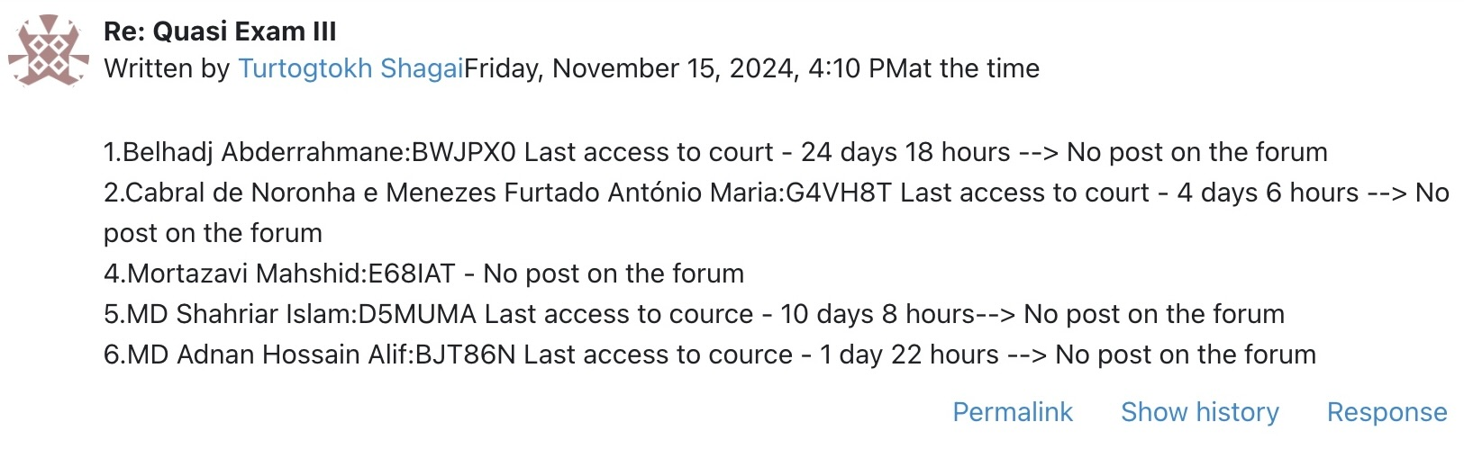
Fact: Inactive users (those who have not interacted with the assigned objects in Moodle, such as completing assignments or participating in discussions) will not have corresponding object-based data (e.g., grades, activity completion) captured in the performance analysis. Their data will be missing from the OAM structure, leaving gaps in the dataset when aggregating student performance metrics.
Critical Interpretation:
Inactive users lead to missing or incomplete data when assessing overall student performance because their interactions with the educational objects (e.g., assignments, quizzes) are not tracked. Without data from inactive users, the OAM structure only reflects the performance of actively engaged students. This results in an incomplete analysis, potentially overlooking factors like the causes of inactivity (e.g., issues with the course material, lack of motivation, or external factors) that could be essential for improving the overall learning experience. The absence of inactive users skews the analysis, giving an overly positive view of student success and potentially missing key areas for improvement.
Finetuned solution:
To improve the accuracy of the OAM-based student performance analysis, inactive users should be considered in the system's data aggregation. This could be achieved by tracking the lack of engagement as a specific attribute in the object, thereby allowing the system to highlight not only the performance of active users but also any students who failed to interact with the learning objects. For example, inactive users could be assigned a "not completed" status, and this could be incorporated into the analysis, ensuring a more comprehensive picture of student engagement and performance. Additionally, it would be beneficial to analyze patterns of inactivity (e.g., which assignments or activities are most likely to be skipped) and identify potential solutions to re-engage these students.
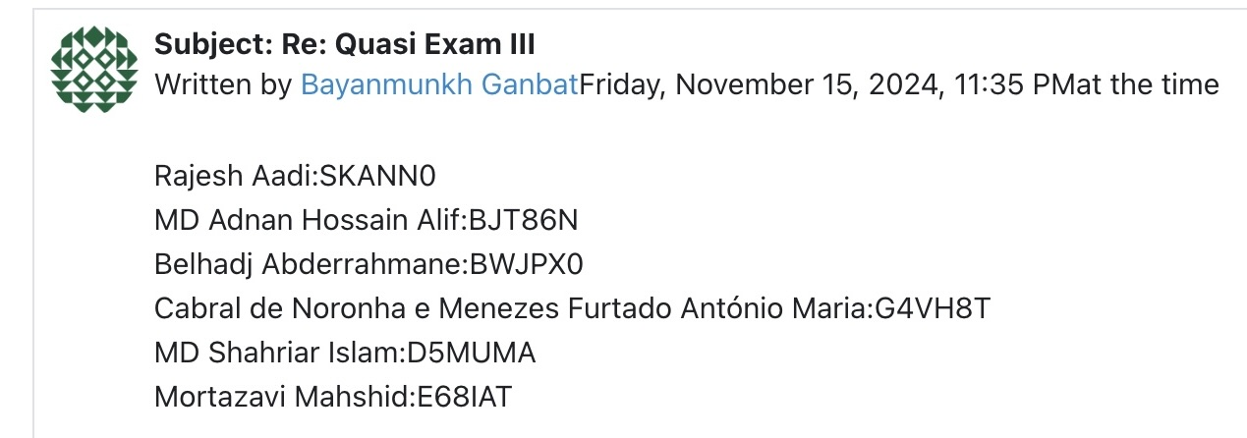
Fact: The list of names provided by Bayanmunkh Ganbat includes individuals with unique identifiers (likely related to their student IDs or system IDs) but does not include any supporting evidence for evaluating the performance or signature for the course. Additionally, there is no explanation for the basis of the evaluation or how these students' work is being assessed in relation to the final evaluation.
Critical Interpretation:
The message lacks clarity and supporting evidence to validate the evaluations for the listed individuals. It is stated that "person-oriented evaluations" are needed, yet no clear criteria or data are provided to support these evaluations. Without clear evidence or context (such as grades, assessments, or any relevant documentation), it is difficult to make a fair and accurate judgment about the students' performance. This undermines the objectivity and transparency of the evaluation process, especially when the final evaluation is dependent on the correctness of the answers. The mention of "diplomatic issues" suggests that there may be a tendency to avoid confrontation or difficult conversations, which can hinder the transparency and integrity of the grading process.
Finetuned Solution: To improve the evaluation process and ensure transparency, it is important to provide concrete evidence for each student's performance. This could include:
Including specific data, assessments, or results for each student mentioned, which will justify their evaluation.
Using a standardized evaluation rubric or clear grading criteria, so all students are assessed based on the same objective standards.
Ensuring that each student’s performance is evaluated independently and backed by documented evidence to prevent misunderstandings or bias.
Providing a clear explanation of the course requirements, expectations, and what constitutes a satisfactory performance, especially in relation to final evaluations.
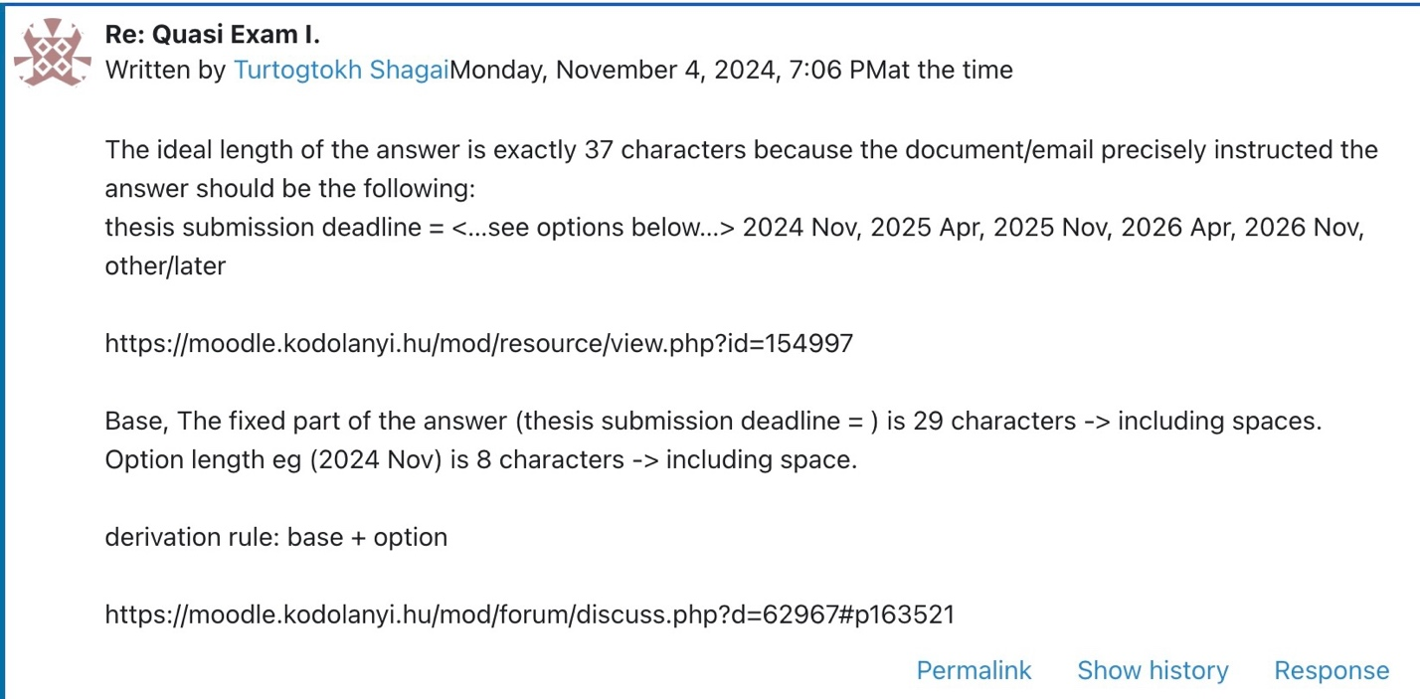
Fact:
Shagai’s entry mentions that the ideal length of the answer is exactly 37 characters, derived by adding the length of the fixed part ("thesis submission deadline = ") and the length of the chosen option (such as "2024 Nov"). The student details the calculation and provides a correct explanation for how the 37 characters are reached.
Critical Interpretation:
While Shagai's calculation is correct, the provided answer does not address potential issues related to formatting or inconsistent use of characters. The requirement of exactly 37 characters is quite rigid, and there might be edge cases where the calculation or formatting could be misinterpreted. Additionally, the explanation seems to rely heavily on character counts, which could overlook other aspects of the task, such as clarity or the appropriateness of the chosen date format. This heavy focus on exact character count might limit flexibility in responding correctly to the task.
Finetuned Solution:
To improve clarity and ensure accuracy, the task should: Emphasize content over strict character count: Rather than focusing solely on character length, ensure the main goal of the task (correct date selection and format) is emphasized. If the system can handle minor variations in the count, that could alleviate unnecessary pressure on the student to match the exact number.
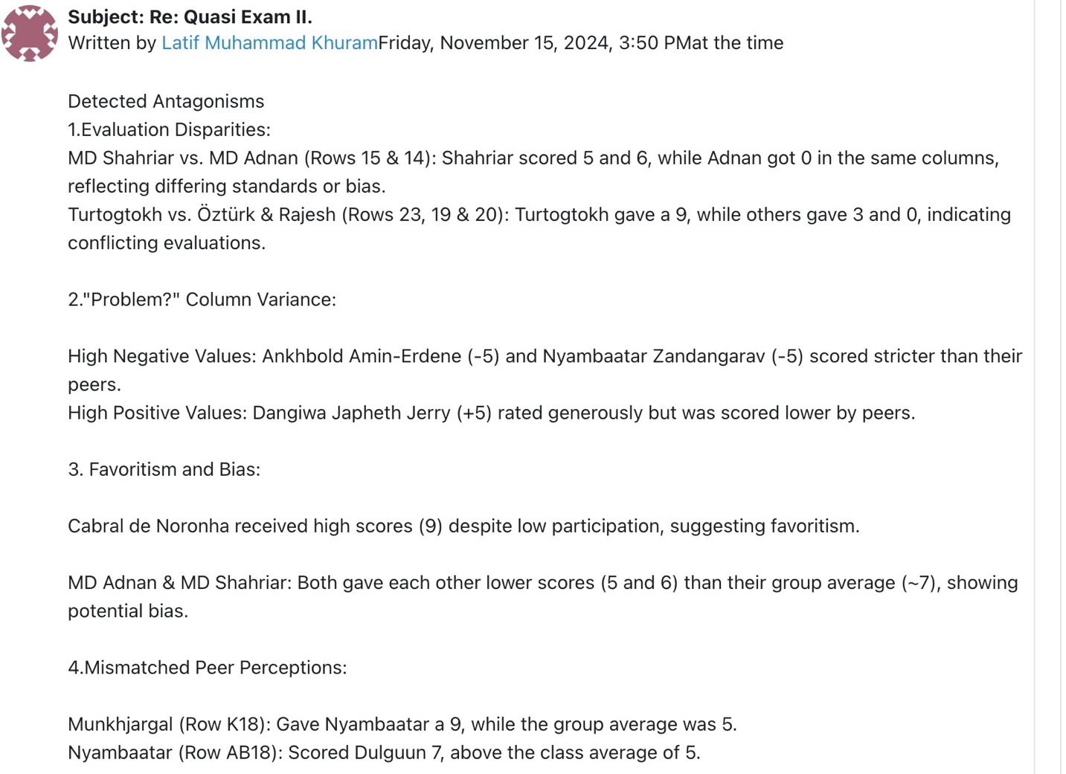
Fact: Latif Muhammad Khuram identifies issues with the evaluation system, including inconsistencies in scoring, favoritism, and mismatched peer perceptions. These issues suggest that evaluations are subjective and potentially biased.
Critical Interpretation: The evaluation process lacks consistency and objectivity, with discrepancies in scores and potential bias affecting fairness. Variations in the "Problem?" column and mismatched peer ratings indicate a need for a more standardized approach.
Finetuned Solution: Standardize evaluation criteria: Implement a clear, objective rubric for all evaluators to ensure consistent scoring. Optimize the evaluation system: Use a mathematical, objective approach to rank students fairly.
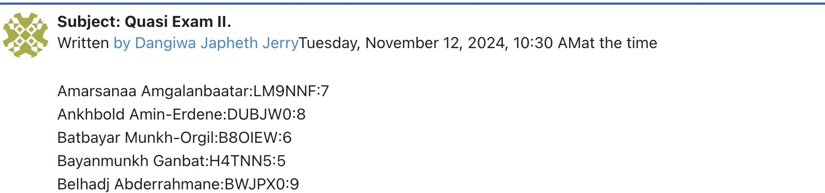
Fact: The evaluation process had a strict deadline of 2024.XI.08.24.00, but Dangiwa Japheth Jerry submitted evaluations after this deadline, specifically on November 12, 2024.
Critical Interpretation: The late submission of evaluations undermines the fairness and consistency of the evaluation process. Allowing late submissions creates an inconsistency between students who followed the deadline and those who did not, leading to potential biases or perceptions of unfairness.
Finetuned Solution: Enforce strict deadlines by implementing an automatic system that prevents submissions after the official deadline. This ensures that all students are held to the same standard, preserving the integrity and fairness of the evaluation process.
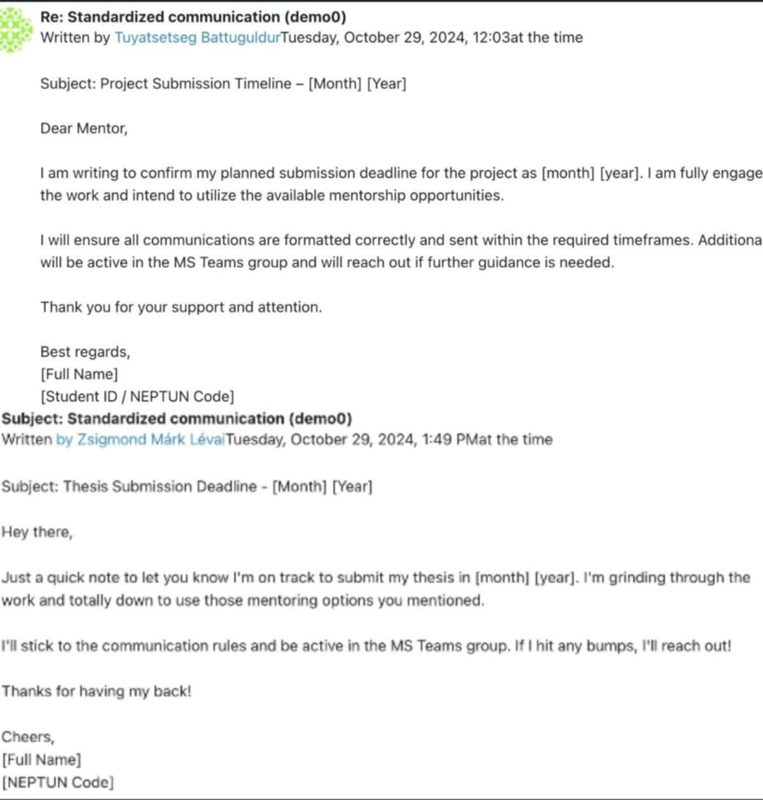
Fact: Some students' answers are very similar, suggesting that they may be relying on generalized sources like ChatGPT instead of professional, subject-specific resources like textbooks. ChatGPT often provides broad, general information that might not be detailed enough for academic or specialized tasks.
Critical Interpretation: The similarity in answers indicates a lack of engagement with authoritative and professional sources, leading to a superficial understanding of the topic. By relying on general AI responses, students may be missing the depth, nuance, and specificity that comes from using textbooks and scholarly resources. This undermines the academic integrity of their work and reduces the quality of their learning experience.
Finetuned Solution: Promote the use of academic sources such as textbooks, peer-reviewed journals, and specialized research materials. Encourage students to critically assess and reference reliable, professional sources to deepen their understanding and produce more original, insightful work. Additionally, provide guidance on how to properly integrate AI-generated content with authoritative sources to ensure academic rigor.

