Reproducible test scenarios about the Statistical Module in Neptun
László Pitlik (MY-X team)

Introduction
The testing project about the statistical module in Neptun has already produced a lot of controversial documents: https://miau.my-x.hu/miau/320/moodle_neptun_tests/?C=M;O=D
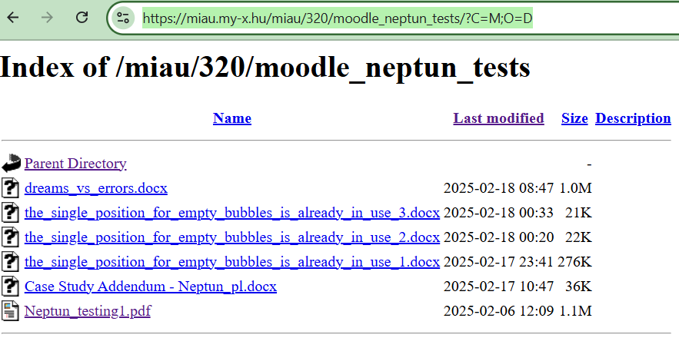
+ https://miau.my-x.hu/miau/319/itsec_index_for_home_workers.docx
Unfortunately, the conclusion is trivial: the desire for concreteness is very weak, quasi still zero. Test scenarios are processes where very-very concrete-defined steps can be executed and all these steps can be repeated in an unlimited way! Each other approach is just an empty bubble. One empty-bubble-system is always useful: the first one! This frame presents a lot of challenges (see needed examples/annexes: https://miau.my-x.hu/miau/320/moodle_neptun_tests/Case%20Study%20Addendum%20-%20Neptun_pl.docx
On the other hand, software testing is not identical with the dreaming process about new and newer functionalities!

New examples with very concrete (reproducible) steps
As we already know, the statistical module in Neptun presented a lot of potential suspicions/risks: https://miau.my-x.hu/miau/320/moodle_neptun_tests/Neptun_testing1.pdf
Starting situation:
- New user (teacher) does log in into the Neptun system…
- The new user does check the statistical module immediately…
- The new user does execute new transactions: 2 new signatures and 2 grades concerning a course with more participants…
The outputs of all Neptun-testing-scenarios are always screenshots (see Figure#1):
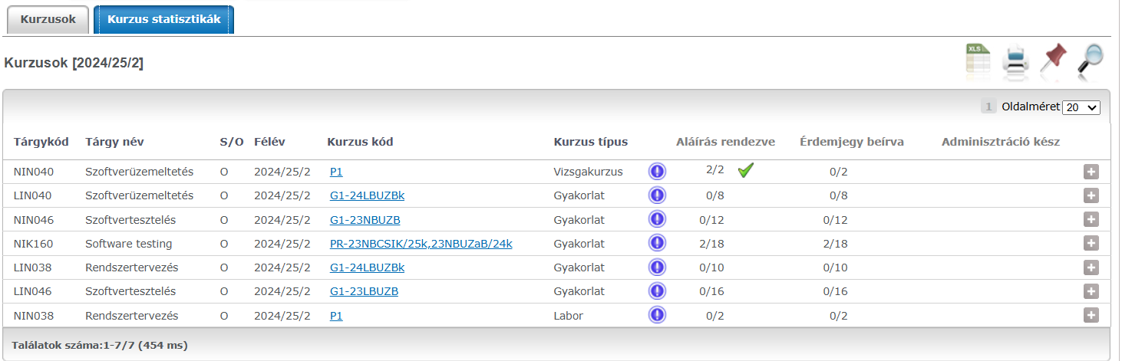
Figure#1: Status after two signature-transactions for course NIK160 (source: Neptun-system)
Each Figure, so the Figure#1 should be analysed immediately: FACTS#...
- We see a single green check mark in case of a course where no transaction was executed! (c.f. NIN040)
- We see the status of 2/2 (see NIN040), although no transaction was executed!
- We see 2 signatures (aláírás=signature): c.f. NIK160: 2/18
- We see 2 grades (érdemjegy=grade): c.f. NIK160: 2/18
- All other statistical positions are zero before the “/”-signs.
Interpretations:
- The already known suspicion about the prepositioned statistical data without any user transaction is given (see FACT#1 and FACT#2).
- The 2 new signatures and the 2 new grades seems to lead to correct visual effects (c.f. FACT#3 and FACT#4).
- The further zeros before the sings of “/” are also correct (as expected without any transactions concerning the other courses).
- The user (or even a robot teacher) may derive following operative conclusions
  - It is not necessary or even not possible to execute transactions in case NIN040 in order to define new signature because 2/2 with a green check mark can only be interpreted in a way that this task is totally done!
  - NEW testing scenario#1 in case of NIN040 (exam-course for system operation with 2 Students):
    - It is to check, whether new grades can be defined immediately! (Because: only one position has a NULL-value (see 0/2) and this position should be increased to the value of “2/2”) – see Figure#3
    - It is to check, whether new signature can not be defined (may not be defined)! (Because the 2/2 status with a green check mark in the column “aláírás=signature” should mean: this position does not need any further transactions) – see Figure#4
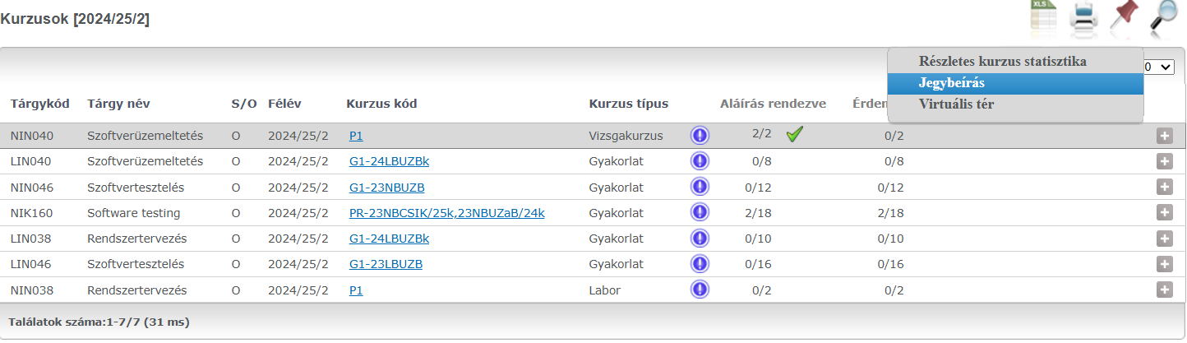
Figure#2: Before new transactions for the NEW Testing Scenario#1 (source: Neptun-system)
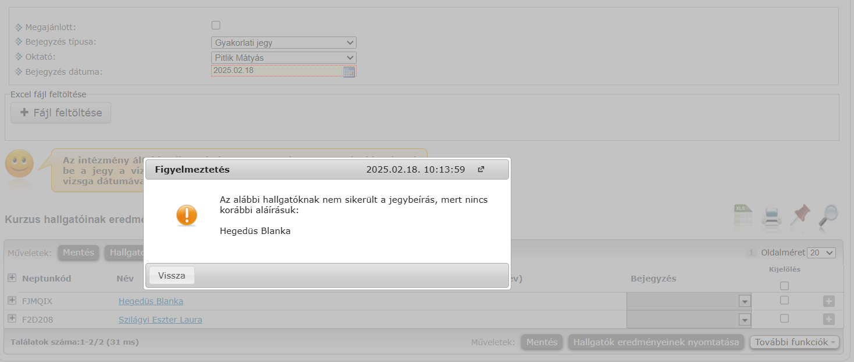
Figure#3: Grading is not possible (Source: Neptun-system)
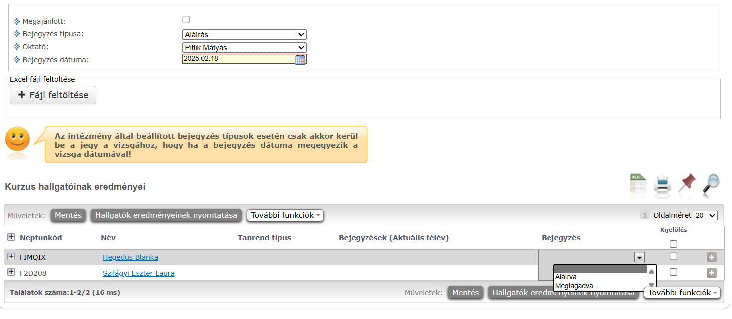
Figure#4: Signature is possible (Source: Neptun-system)

Conclusion
The green check mark can not be interpreted in a trivial way: the signature is needed although the green check mark is given!

