Moodle-testing
László Pitlik (MY-X team)

Introduction
History: https://miau.my-x.hu/miau/320/moodle_neptun_tests/?C=M;O=D
Task: Identifying Moodle anomalies

Catalogue of anomalies

Case: Exporting pdf-versions
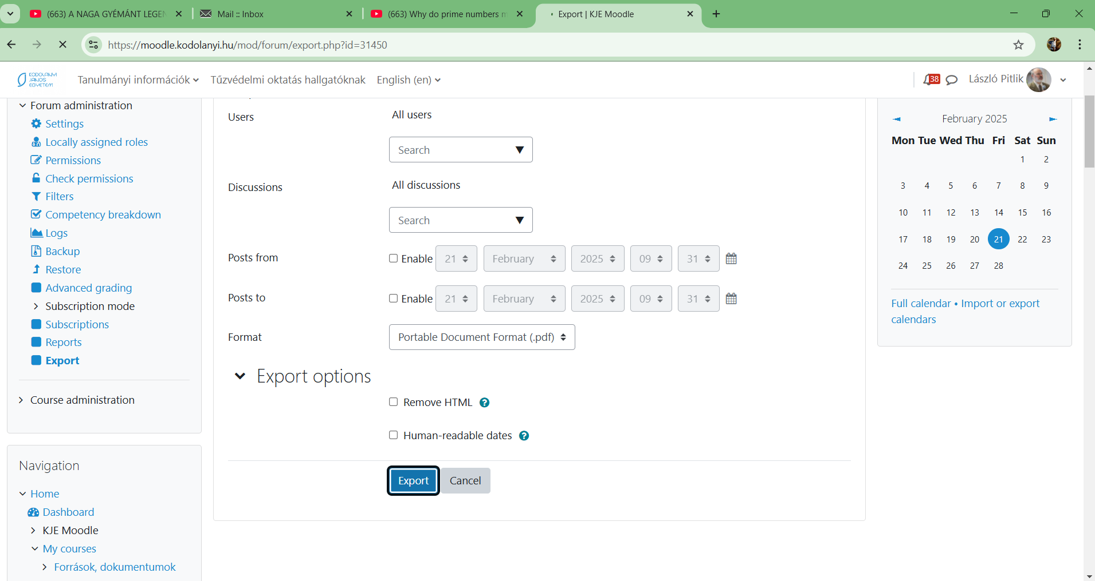
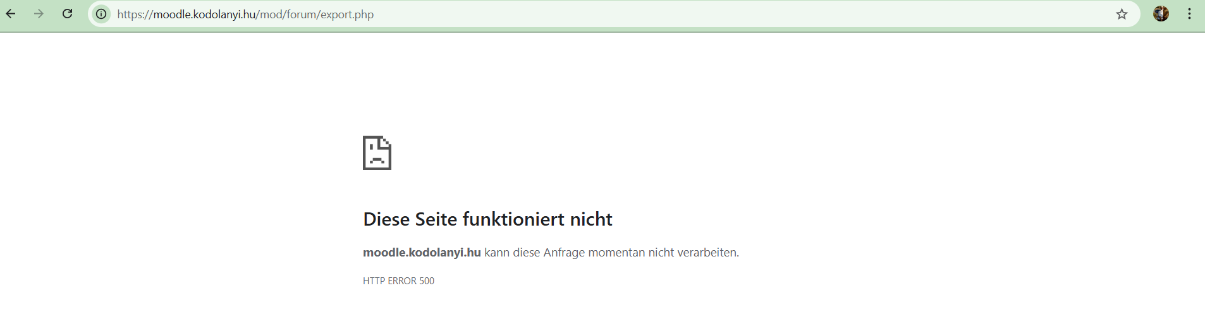
Parameters: Date, URL, role-parameter are given through the figures above!
Anomalies: The export in PDF is (temporarily) not working.
Evidence units: Figures above & the last changes in the robotic-arm-project could only be documented (exported) in form of pdf, csv, html, xls. Previous PDF-versions can be found here: https://miau.my-x.hu/miau/320/moodle_cubes_logic/
Role: Teacher
URL: https://moodle.kodolanyi.hu/mod/forum/export.php
Date: 2025.II.21.
Type: anonymized
…

Case: ?
https://miau.my-x.hu/miau/320/moodle_testing/

