Case: Drag-and-Drop File Upload Issue in e-Portfolio
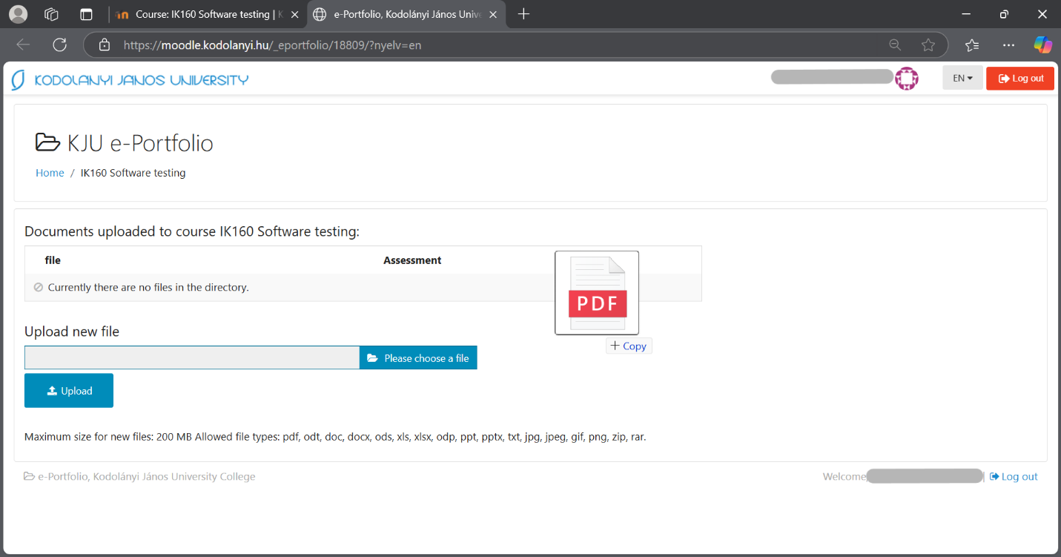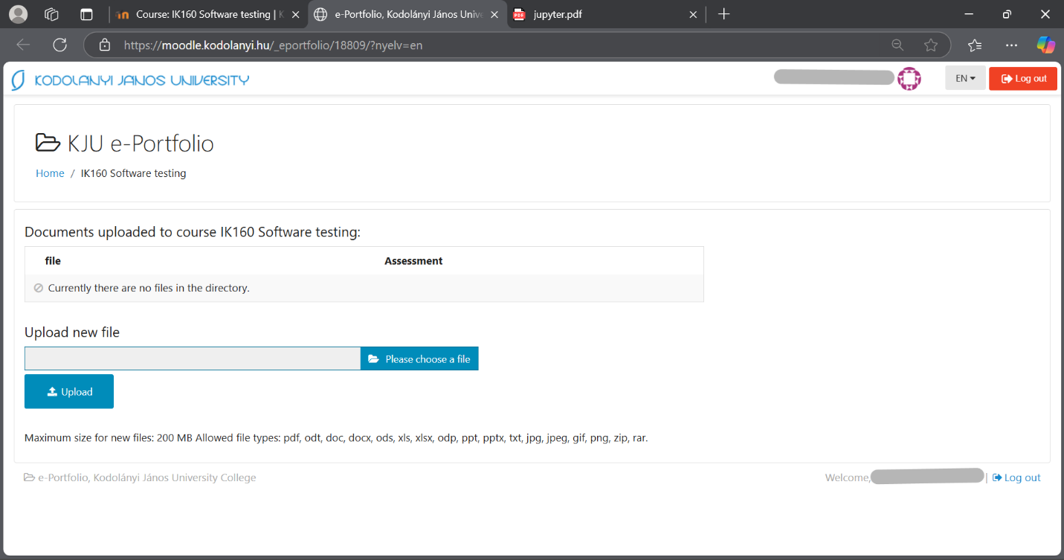
Parameters: Date, URL, role-parameter are given through the figures below!
Anomalies: Attempting to drag and drop a file into the e-Portfolio opens a new browser tab instead of uploading it.
Evidence units: Figures above and this behavior was observed when trying to upload a PDF file (e.g., "jupyter.pdf"). The file opens in a new tab instead of being uploaded. This disrupts the user experience by breaking the upload workflow and confusing users, who might think the system is broken. If drag-and-drop isn’t supported, the system should ignore the action or display a message like “Drag-and-drop not available,” rather than letting the browser open a new tab as an unintended side effect.
Role: Student
URL: https://moodle.kodolanyi.hu/eportfolio/upload
Date: 2025.III.09.
Type: anonymized

