**Case: Anomaly in Moodle's Language Selection Menu When Using Browser Translation**

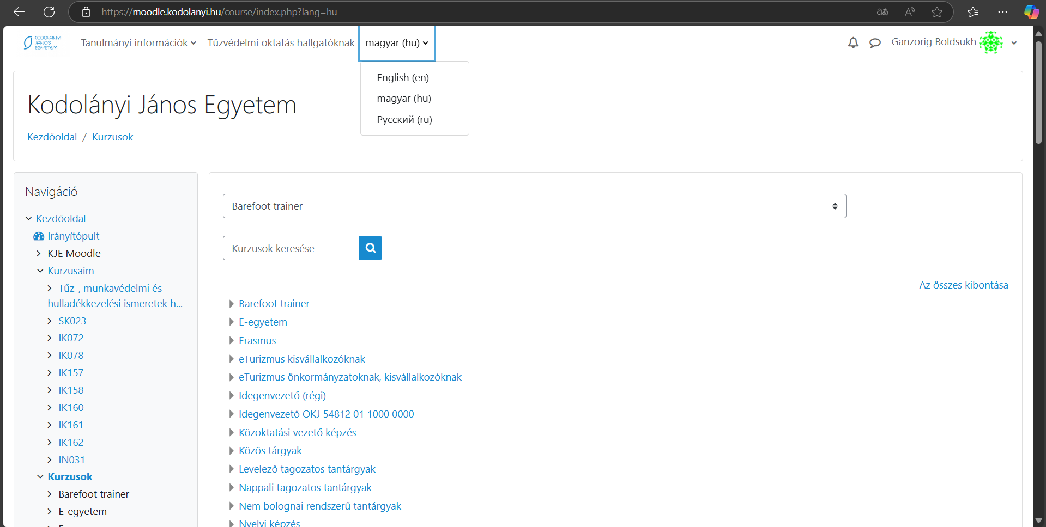



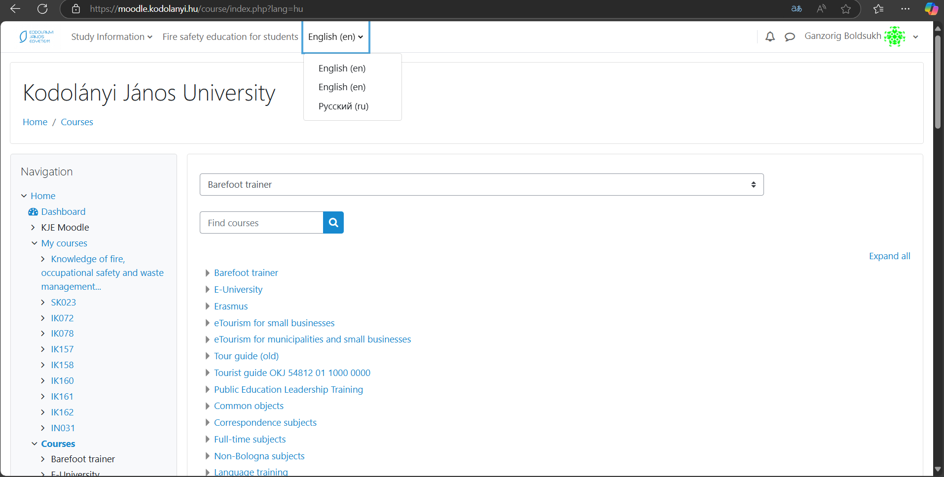



**Parameters:** Date, URL, role-parameter are given through the figures below!

**Anomalies:** The anomaly occurs when the browser's translation feature, such as Google Translate, is used on the Moodle web application.

**Evidence units:** The language selection menu in Moodle, which originally displays options for "English, Hungarian, Russian," changes to show "English, English, Russian" after the browser's translation feature is activated. Specifically, the Hungarian option disappears, and the English option is duplicated. Additionally, some pages in Moodle are not translated by the built-in language selection function, prompting users to rely on browser translation, which then triggers this menu issue.

**Role:** Student

**URL:** <https://moodle.kodolanyi.hu/>

**Date:** 2025.III.09

**Type**: anonymized