Case: Moodle e-Portfolio Navigation Issue

1st Sport 2:e-portfolio,  
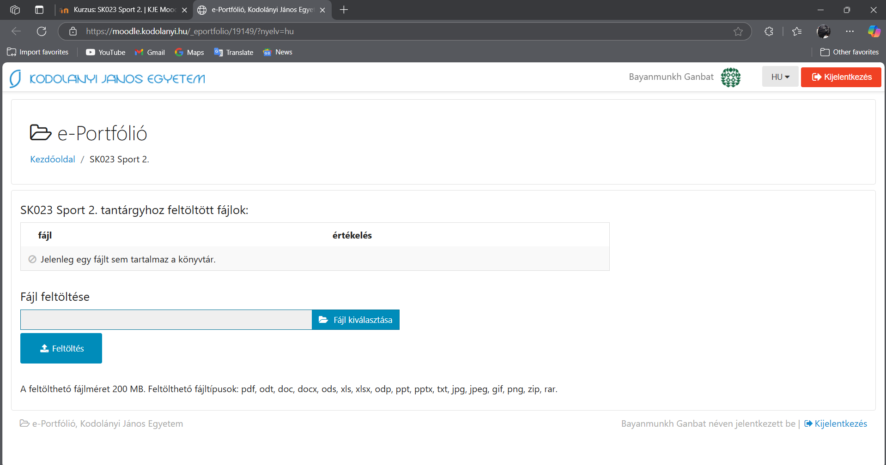  
After i enter Software-testing e-portfolio,  
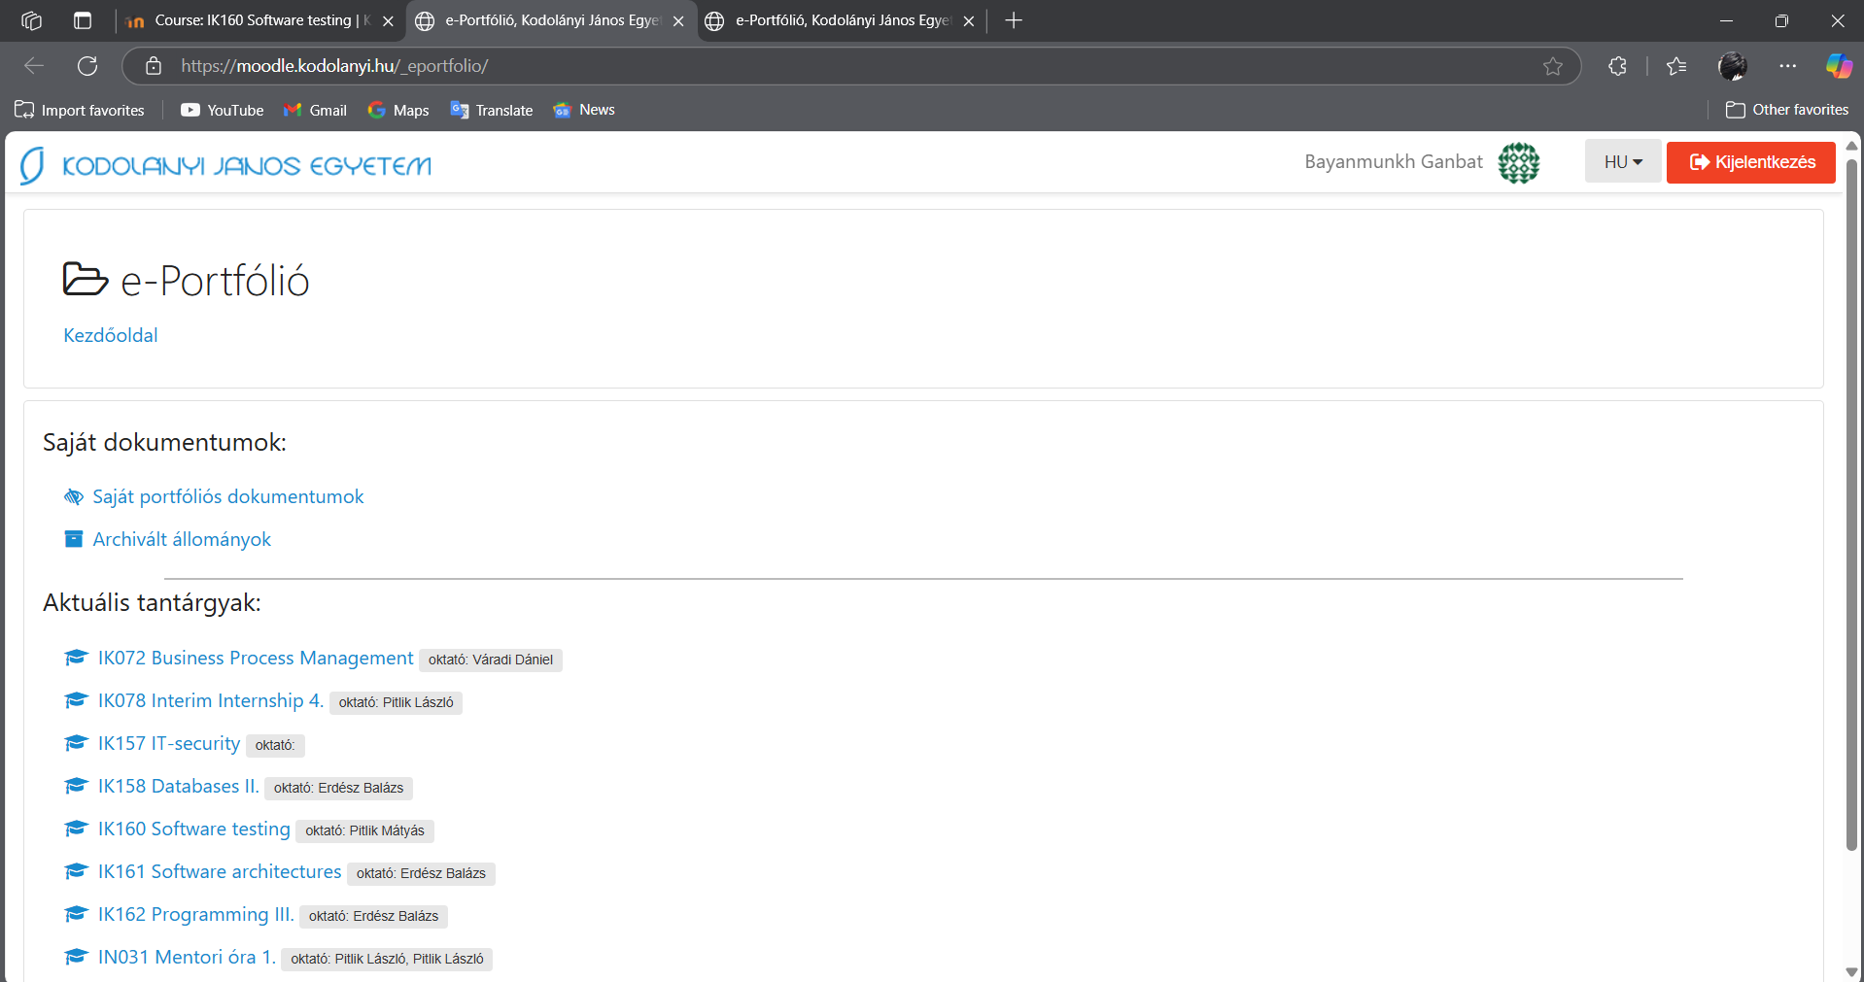  
Parameters: Date, URL, role-parameter are given through the figures above!



Anomalies: After accessing the e-Portfolio for the "Software Testing" (IK160) course, attempting to navigate to other course e-Portfolios (e.g., "SK023 Sport 2") results in redirects to unintended sites or incorrect pages. This behavior persists across sessions until the browser cache is cleared, or the user logs out and back in.

Evidence units: Initially, when I entered the "SK023 Sport 2" e-Portfolio, it was okay and functioned as expected. However, after I entered the "Software Testing" (IK160) e-Portfolio, subsequent attempts to access the "SK023 Sport 2" e-Portfolio or other e-Portfolios resulted in redirects to unnecessary or unintended sites. This redirection issue persists until the browser cache is cleared or I log out and log back into the system.

Role: Student  
URL:[e-Portfólió, Kodolányi János Egyetem](https://moodle.kodolanyi.hu/_eportfolio/)  
Date: 2025.III.09.

Type: anonymized

Remark: IT-security incidence? (the green highlighted lack of information is a kind of evidence, that a subject (IT-security) does not have teacher (see date compared to semesters-begin 2025.II.01). This publication as such is a typical form of the never-wanted information leaking…