Case: Moodle e-Portfolio web direction error

First e-Portfolio web of Interim Internship 4 my documents.

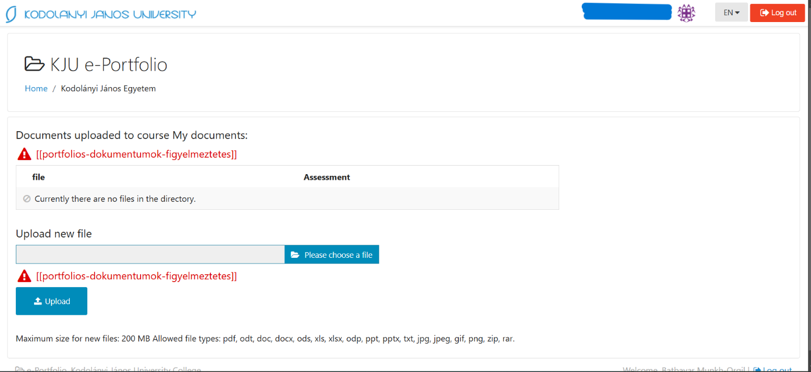

2nd backing to previous page.

Anomalies: After accessing the e-Portfolio for the "Interim Internship 4" (IK078) course, attempting to navigate My documents on top of all courses to in order to see documents. In result, first picture appeared. However, that error occurred tried to back previous page.

Evidence units: Initially, when I entered the " Interim Internship 4" e-Portfolio, it was okay and functioned as expected. However, after I entered the "My Documents" (IK078) e-Portfolio, subsequent attempts to access the "SK023 Sport 2" e-Portfolio or other e-Portfolios resulted in redirects to unnecessary or unintended sites. This redirection issue persists until the browser cache is cleared or I log out and log back into the system.

Role: Student  
URL: https://moodle.kodolanyi.hu/_eportfolio/1  
Date: 2025.III.10.

Type: anonymized