Forum Subscription Notifications Not Triggering

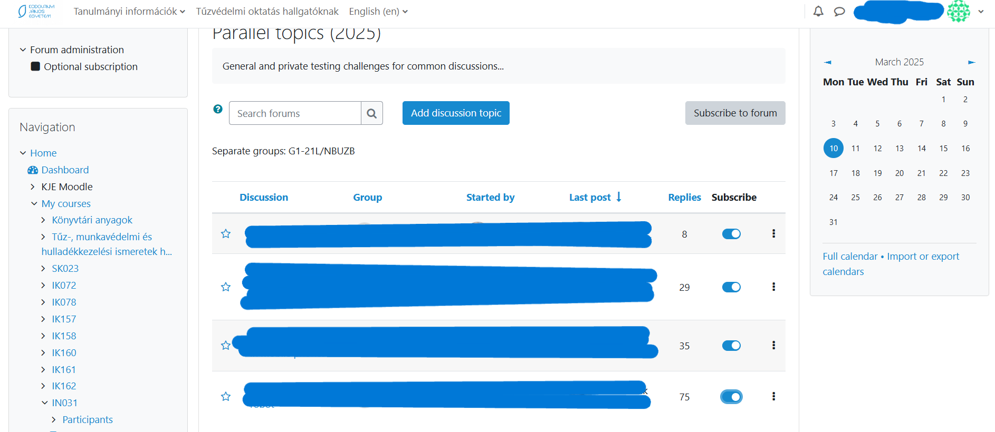

**Parameters:** Date, URL, role-parameter are given through the figures below!

**Anomaly Description**: Students subscribed to forum discussions do not receive email or in-system notifications for new posts, even though the subscription settings are correctly configured.

**Evidence Units**:

* Manual checks show that the “Subscribed” status is active for affected users in the forum settings.
* No error logs are visible to students, but teachers might see delayed or missing notification entries in the system logs.

**Role:** Student

**URL:** <https://moodle.kodolanyi.hu/mod/forum/view.php?id=156721>

**Date:** 2025.III.10.

**Type**: Anonymized (affects multiple users but is not tied to specific identities in this report).