**Case**: Moodle translator

**Anomalies**: Moodle translator can not translate some of texts in home page.

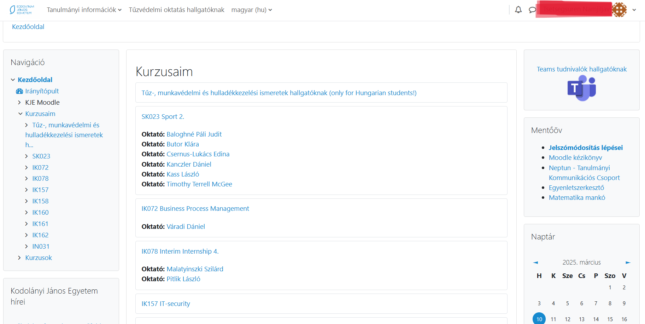Figure 1

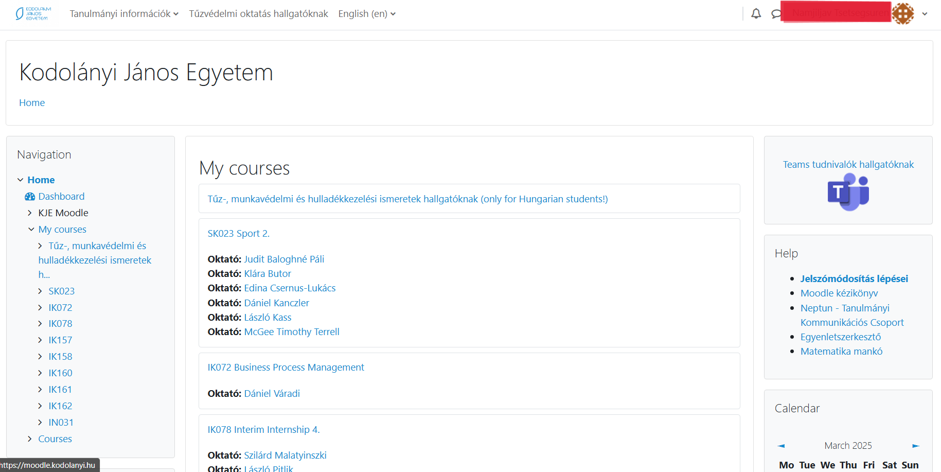Figure 2

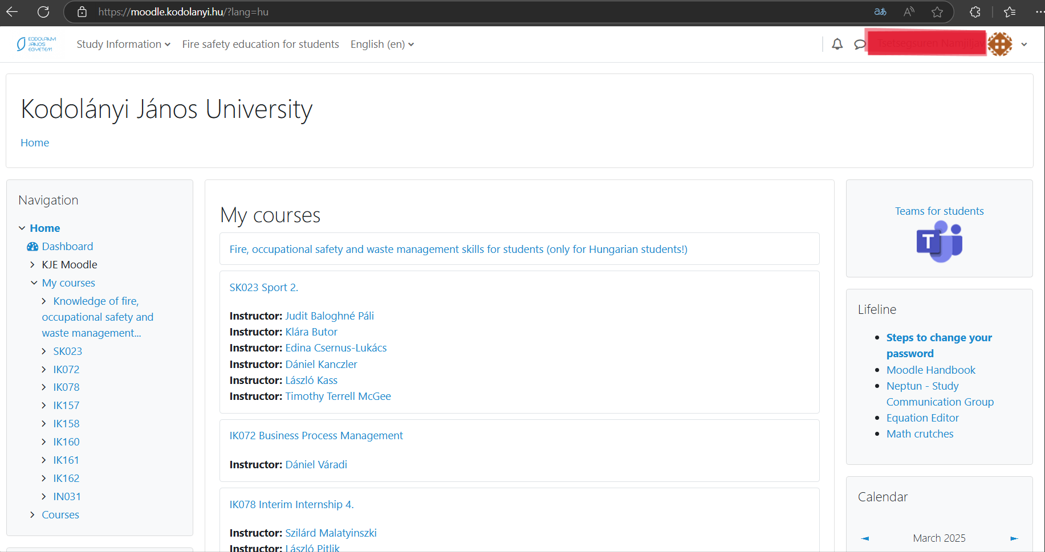Figure 3

**Evidence unit**: If you look close at figure 1,2 and 3 u can see difference in translation issues. In figure 1 everything is in Magyar. In the next picture u can see some of the texts are still in Magyar when I'm using Moodle web translator. In last one, all the texts are in English because I used browser translator. In my opinion, the Moodle-translator should be translating more than browser translator.

**Role**: student

**URL**:[Home | KJE Moodle](https://moodle.kodolanyi.hu/)

**Date**: 2025.03.10