Case: Moodle e-Portfolio email-communication vs. database views
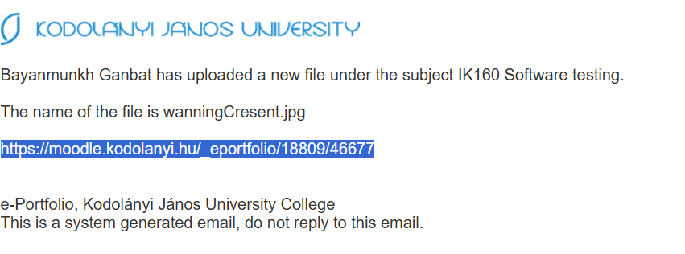
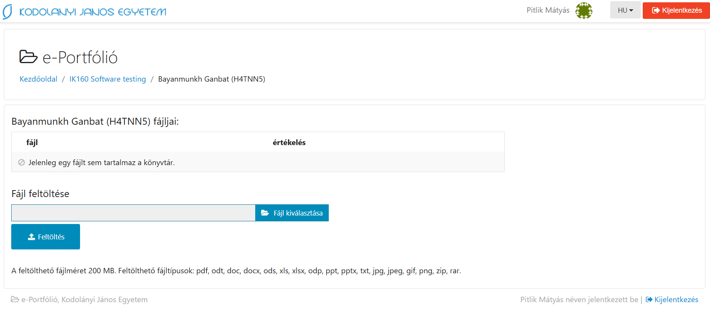
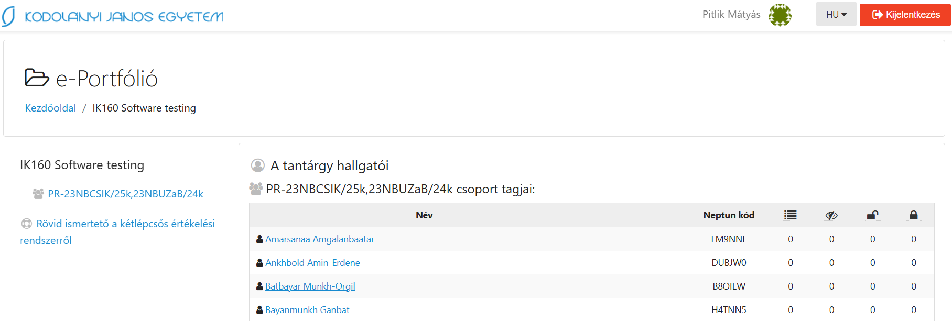
URL = https://moodle.kodolanyi.hu/_eportfolio/18809/46677, ill. https://moodle.kodolanyi.hu/_eportfolio/18809
Role = Teacher
Anomalies: The neptun/moodle-email (see above) signalized an uploaded file (*.jpg), but the Moodle-e_portfolio-service does not present any files and not even a sign for uploaded, but deleted files…
Type = anonymized
Date: 2025.III.10.
Remark: This is a typical case for inconsistency: the teacher getting the email, should try to download the e-portfolio-element. This action will however be unsuccessful. The teacher does not know whether (s)he makes some mistakes, or the system is wrong configurated. If the teacher defines a ticket about the suspected error, the whole system will work but without any real result… This inconsistency is responsible for a lot of resources wasting.

