Teams-testing
Laszlo Pitlik (KJU)

Case#1: Inconsistent user identification
Date: 2025.II.22.
Type: can not be anonymized without losing relevant information (further option-values: anonymized, it does not need to be anonymized, …)
Problem: Inconsistent user identification
URL: https://teams.microsoft.com/l/meetup-join/19%3ameeting_ZDI4ZTQxZjYtYjIxNC00ZDU4LTlkYWMtNjBiYzEyNjRiMWVi%40thread.v2/0?context=%7b%22Tid%22%3a%223f642d0b-8306-4bac-bb72-1484451db6ba%22%2c%22Oid%22%3a%2215e79039-7579-4d2f-afe1-71e5c567d826%22%7d
Functionality: users (further option-values: e.g. chat, sharing, etc. – c.f. menu-elements)
Evidence-layers: Figure#1abcd (see below)
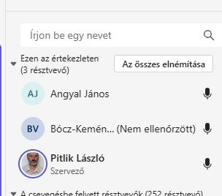
Figure#1a: List of participants I. (from point of view of the channel owner)

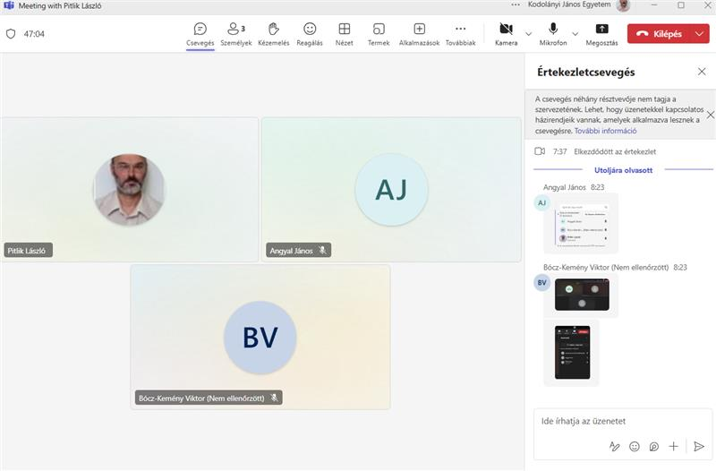
Figure#1b: List of participants II. (from point of view of the channel owner)
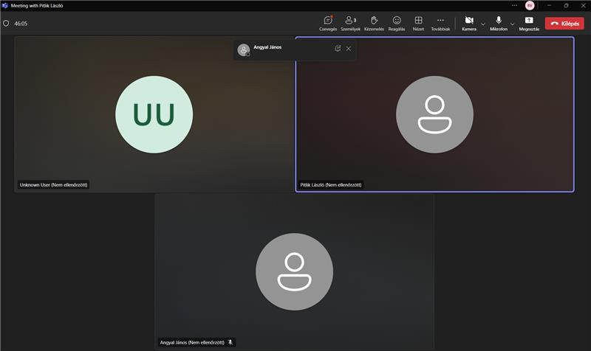
Figure#1c: List of participants III. (from point of view of the inconsistent user)
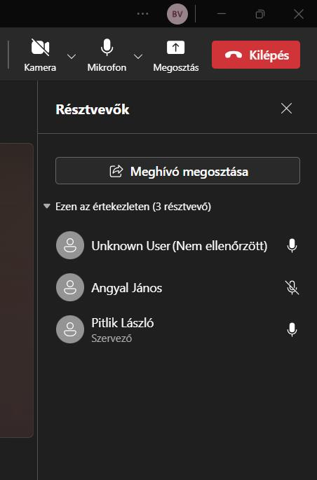
Figure#1d: List of participants IV. (from point of view of the inconsistent user)

Case#2: Formatting Loss in Mathematical Expressions
Date: 2025.III.25.
Type: anonymized
Problem: Copy-pasted mathematical expressions with special characters (%, ^, €, commas as decimal separators) lose formatting or render incorrectly in Teams chats.
URL: https://teams.microsoft.com/
Functionality: users
Figure#1.abc (see below)
Figure#1a:
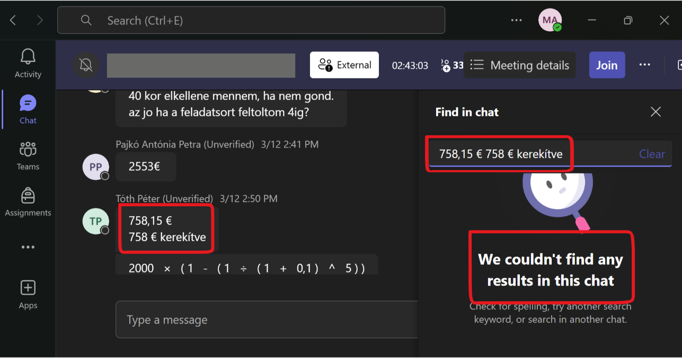
Figure#1b:
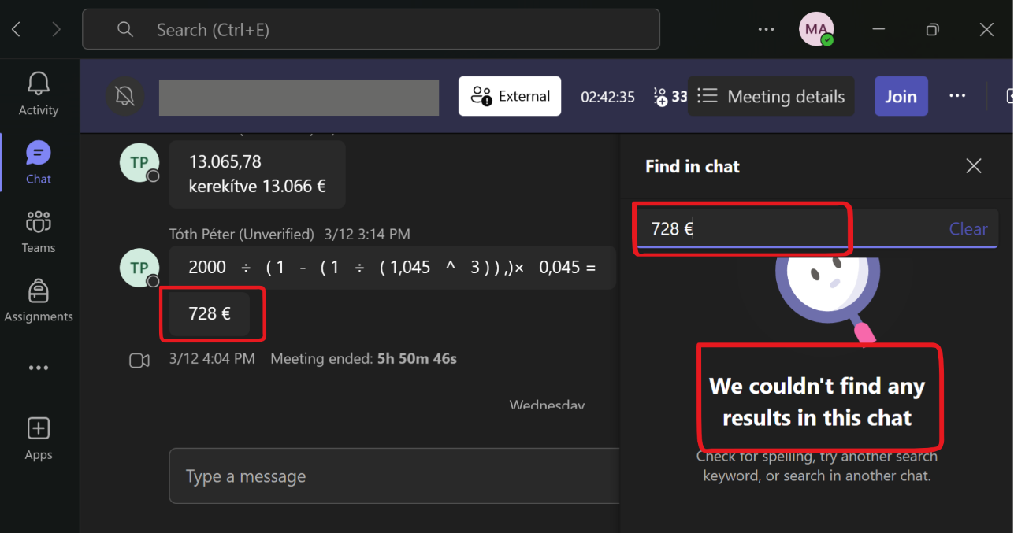
Figure#1c:
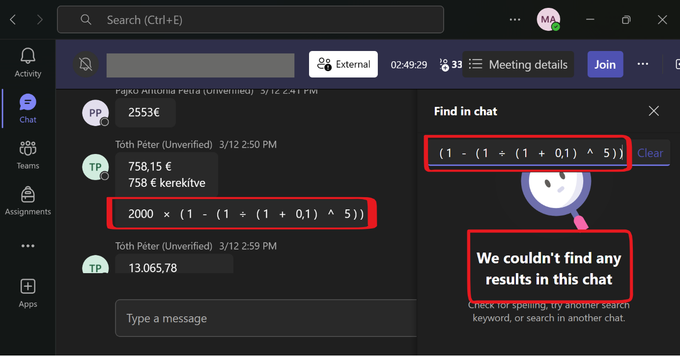

Case#3:
Date: 2025.MM.DD.
Type: (anonymization?)
Problem:
URL: https://teams.microsoft.com/l/meetup-join/19%3ameeting_ZDI4ZTQxZjYtYjIxNC00ZDU4LTlkYWMtNjBiYzEyNjRiMWVi%40thread.v2/0?context=...
Functionality:
Evidence-layers: Figure#... (see below)

Figure#...

