https://www.iksadinstitute.org/
International Asian Congress on Contemporary Sciences - XI / November 06-08, 2025 / Selçuk University, Karapinar, Konya Türkiye
Organised by Selçuk University Karapinar Aydoganlar Vocational School & IKSAD Insitute
Can all companies be equally committed to circular economy?
László Orosz (https://orcid.org/0009-0000-2683-8213)
László Pitlik (https://orcid.org/0000-0001-5819-0319)
e-Mails: laszlo.orosz86@gmail.com, pitlik@my-x.hu
Kodolányi János University
Keywords: Circular economy, automation, AI, objectivity, anti-discrimination, optimization, COCO model, sustainability

Introduction
Objective assessments are rarely made on the international stage / in international forums.
Prominent rating agencies such as Moody’s, Fitch Ratings or S&P Global frequently produce inconsistent evaluations for the same company — even when based on similar datasets.

Example 1: Tesla (2023) — S&P Global Ratings assigned a BB+ speculative-grade rating, while Moody’s classified the same company as Baa3, i.e. investment grade.

Example 2: Shell plc (2024) — ESG (Environmental, Social, Governance) evaluations vary significantly: MSCI ESG Research LLC rated Shell “A”, while ISS assigned only “C+”.
These inconsistencies underline a fundamental problem: global rating systems often depend on subjective criteria and context-dependent weighting.

The goal of this study is therefore to introduce an objective, automatable value judgment methodology in the field of circular economy.

Objective and Methodological Framework
The research introduces a transparent, repeatable evaluation system based on two technical foundations:

Data structure: Object–Attribute Matrix (OAM)
Bias elimination and optimization: COCO (Circular Object Comparison Optimization)

Ten international companies (Siemens, BMW Group, Volkswagen Group, Bosch, Schneider Electric, Apple, Dell Technologies, IKEA, Philips, Unilever) (object) were available for demonstration purposes, with the following ten (X) attributes (ratios on a scale of 1 to 5. Best value: 5, worst value: 1):

- Material circularity ratio
- Product recycling
- Waste recycling
- Digitalization maturity
- Data-driven decision-making
- Circular data integration
- Resource savings
- Secondary revenues
- ROI circular projects
- Energy/cost efficiency

The following rule applies to all of these: the higher the raw value of X(i), the more ideal the objective level of circular economy awareness in each company is compared to other companies for each attribute.

The fundamental goal was to examine whether AI-based automation can deliver equally objective evaluations for companies from different industries — without expert weighting or subjective adjustment.

The source of the data is ChatGPT: the data was collected using AI from real sources provided by the companies (AI collected, but not AI generated data). This type of data is not suitable for processing as the basis for a forensic expert opinion, for example, but it can provide a suitable basis for a methodological recommendation.

Company | Material circularity ratio | Product recycling | Waste recycling | Digitalization maturity | Data-driven decision making | Circular data integration | Resource savings | Secondory revenues | ROI circular projects | Energy/cost efficiency
Siemens | 4,5 | 4,5 | 4,5 | 5,0 | 5,0 | 4,5 | 4,0 | 4,5 | 4,0 | 5,0
BMW Group | 4,0 | 4,0 | 4,5 | 4,0 | 4,0 | 4,5 | 4,0 | 3,0 | 4,5 | 4,0
Volkswagen Group | 4,5 | 4,5 | 4,0 | 4,0 | 4,0 | 3,0 | 4,5 | 3,0 | 3,0 | 4,0
Bosch | 4,0 | 3,0 | 4,0 | 4,5 | 4,0 | 4,0 | 4,5 | 3,0 | 4,5 | 4,5
Schneider Electric | 4,5 | 4,5 | 4,5 | 5,0 | 5,0 | 5,0 | 4,5 | 4,0 | 4,0 | 5,0
Apple | 4,5 | 4,0 | 4,0 | 4,5 | 5,0 | 4,5 | 4,5 | 4,0 | 4,0 | 5,0
Dell Technologies | 4,0 | 4,5 | 4,0 | 4,0 | 4,0 | 4,0 | 4,0 | 4,0 | 4,5 | 4,5
IKEA | 4,5 | 5,0 | 4,0 | 4,5 | 4,5 | 3,0 | 4,0 | 4,0 | 4,5 | 4,0
Philips | 4,5 | 4,0 | 4,5 | 4,0 | 4,0 | 4,0 | 4,0 | 4,5 | 4,5 | 4,0
Unilever | 4,0 | 4,5 | 4,0 | 4,5 | 4,5 | 3,0 | 4,5 | 4,0 | 4,5 | 4,5

Automatable Method (OAM + COCO)

Step 1 – Building the OAM (Object–Attribute Matrix):

A 10×10 matrix was constructed where each row represents a company and each column an attribute of circular performance.

Step 2 – Ranking and Visualization:

Each attribute was ranked independently from 1 (best) to 10 (worst).
Conditional formatting (heat map) was applied:

Dark/Light Green: top performance (1–2)

Yellow–Orange: average (3–7)

Red: weak (8–10)

Step 3 – Naive Benchmarking:

We then took the average of the attributes for each company and used these values to create a naive ranking, where naivety is an expression of mathematical non-optimization.

Step 4 – COCO Optimization:

We then compared these results with the data generated by COCO, which essentially uses anti-discriminatory optimization (compared to the simplifying, i.e., one-attribute-one-parameter solution logic of regression, each attribute is assigned strictly monotonically decreasing parameters for each step/sequence number in order to approximate the constant outcome variable (Y0=1000) as closely as possible for each object.

Step 5 – Validation:

The naive and COCO-derived rankings were compared using symmetry-based similarity analysis.
Identical ranking sequences indicated that the non-optimized and optimized methods converge -> a sign of methodological stability.

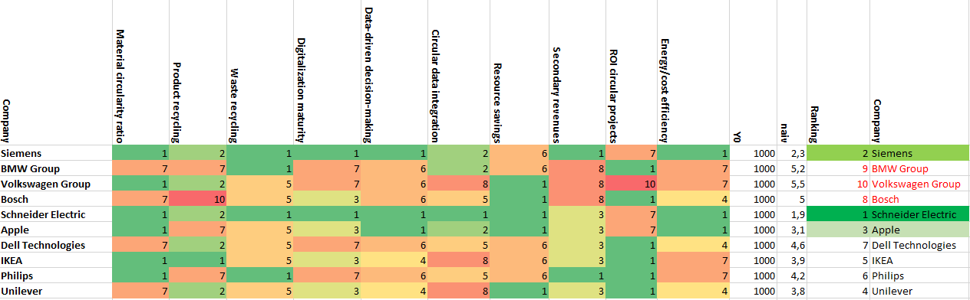
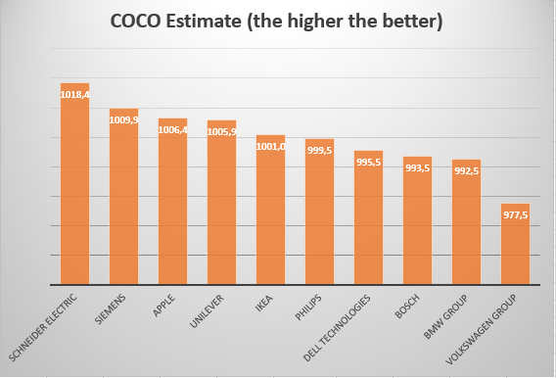

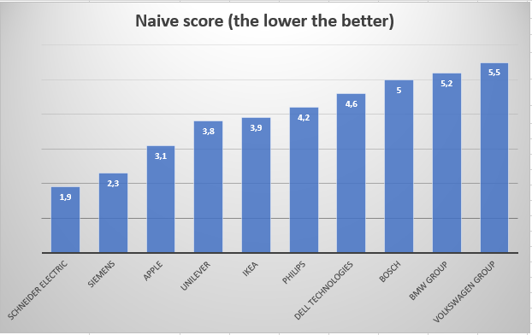

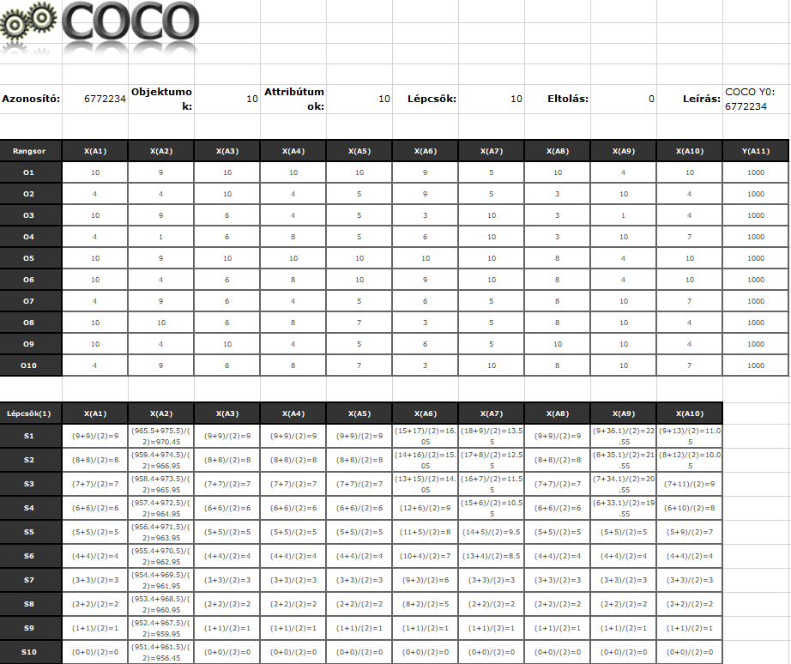

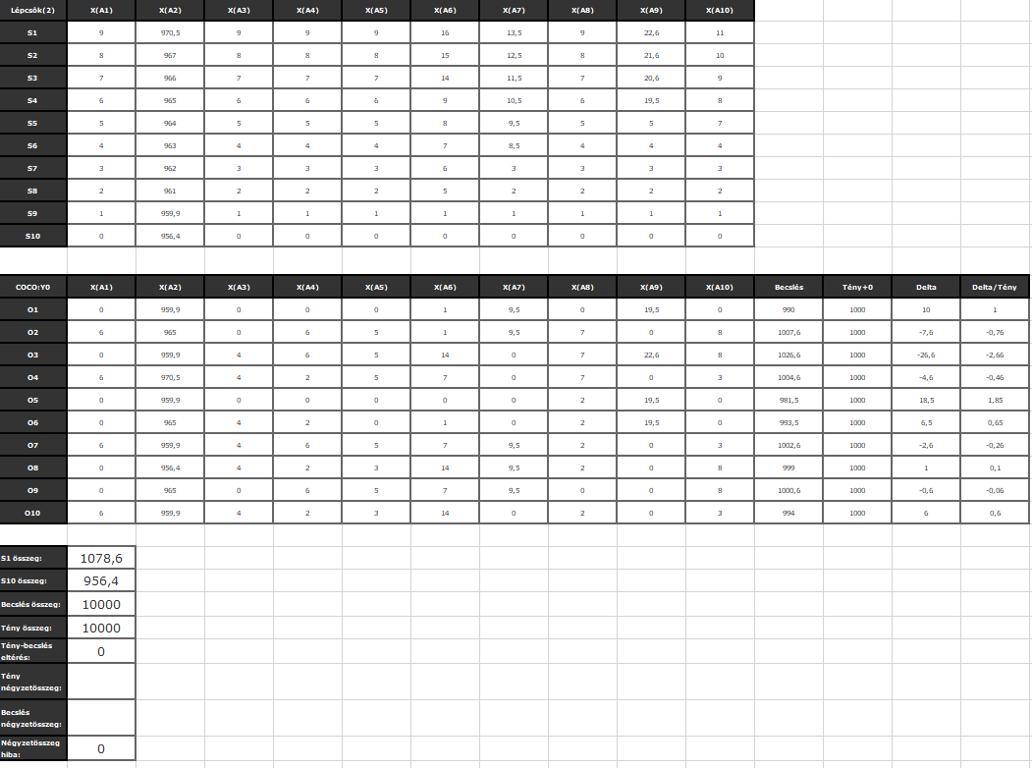

Results and Interpretation

The comparative analysis showed no deviation between naive and COCO rankings.
This outcome validates both the robustness and neutrality of the automated method.

This specific case study result is only one possible outcome of the methodological combinatorial space, in which, in addition to normality, subnormality, supernormality, and non-classifiability are also possible for each object.

Key insights:
No industrial or digitalization bias was observed.

The correlation between naive and optimized rankings exceeded 0.95, confirming near-perfect structural consistency.

The heat-map visualization made company strengths and weaknesses immediately visible for all ten attributes.

Hence, the COCO-based framework successfully provides objectivity without complexity, proving that corporate circular performance can be evaluated uniformly, irrespective of sector, scale, or data origin.

Discussion

The observed alignment between manual and AI-based assessments challenges the assumption that human weighting improves evaluation accuracy.
Instead, anti-discriminative AI frameworks like COCO demonstrate that objective evaluation can emerge from purely mathematical procedures without intuitive adjustments.

In this sense, the model replicates the structure of traditional ESG / financial evaluation but replaces human judgment with algorithmic consistency.
This has two major implications:

Transparency: All parameters are visible, reproducible, and comparable.

Scalability: The same logic can be applied to hundreds or thousands of corporations simultaneously.

Thus, the COCO approach represents a methodological bridge between statistical AI analysis and practical sustainability benchmarking.

Conclusions

Objectivity in circular economy assessment is achievable through AI-supported automation.

The OAM + COCO framework removes human bias and allows identical evaluation rules for all companies.

The method exhibits high reproducibility (rank correlation > 0.95).

This structure can form the foundation for AI-driven ESG / financial rating standardization.

Although corporate operations differ in circular maturity, objective comparability is now technically feasible, making it possible to evaluate all companies within one unbiased analytical framework.

Future
- Extend the OAM dataset to 15+ corporations from multiple sectors.
- Integrate real-time sustainability data APIs.

References
ChatGPT
https://miau.my-x.hu/myx-free/coco/
https://miau.my-x.hu/miau2009/index.php3?x=e0&string=statistical.neurons

