

THESIS

Deriving Wine Experts Based on LLM and Similarity Analysis
Author: Tsetsgesuren Namjiljav
Contact: nazuu1188@gmail.com
Professor: Dr László Pitlik

Never use empty rows, tabs and spaces for formatting!

Abstract
In recent years, data-driven decision-support and large language models (LLMs) have increasingly been used to structure and explain expert judgments. This thesis addresses the practical problem of how wine quality expertise can be derived and validated from measurable physicochemical attributes in a reproducible way. Using the public red wine quality dataset of Cortez et al. (2009), the work enforces a fixed wine-attribute schema and transforms raw records into an Object–Attribute Matrix (OAM), from which ranked comparisons and COCO-STD indicators are computed to quantify deviations between expert quality scores (Fact) and similarity-based estimations (Estimation). The developed solution is implemented as a runnable software workflow (with a user-facing Help/manual and context explanations), supports batch execution for scalability (many runs with varying parameter settings), and stores results in a structured form suitable for later data mining and analysis. The target users are quality-control and production decision makers, wine analytics and education stakeholders, and data-science practitioners; the usefulness of the product lies in prioritizing expert attention by highlighting atypical cases and by providing transparent, auditable outputs rather than replacing human tasting. In addition to the computational pipeline, the thesis documents testing, quality-assurance measures, and responsible usage boundaries relevant to practical deployment.
Keywords:
Red wine quality, Object–Attribute Matrix (OAM), COCO-STD, similarity analysis, decision support, reproducibility, Large Language Models
Table of Contents
Chapter 1. Introduction 5
1.1. Aims and Objectives 6
1.2. Tasks 7
1.3. Targeted Groups 7
1.3.1 Potential Buyer/Customer (who would commission and pay for the solution) 8
1.3.2 or only 1.3! (totally illogical to have one single subchapter :-)
1.4. Utilities: Estimation of Informational Added-Value 8
1.4.1. Benchmark Scenario: Without Analytical System 9
1.4.2. AI-Supported Scenario: Similarity-Based Structured Evaluation 9
1.4.3. Estimated Informational Added-Value 9
1.4.4. Scalability Perspective 10
1.5. Motivation 10
1.6. Structure of the Publication 10
1.6.1. Scope limitations and excluded contents 11
1.6.2. <--each chapter should have numbers! Formats and their purpose in this thesis 11
Chapter 2. Literature 12
2.1 Wine Quality Evaluation and Expert Judgment 12
2.2 Similarity Analysis and Pattern Recognition 13
2.3 Large Language Models in Analytical Tasks 13
2.4 Object–Attribute Matrix <--titles do not need ()[]{} 14
2.5 COCO-STD Indicator and Evaluation Logic 15
2.6 Goodness Criteria and Performance Evaluation 15
2.7. The Relationship Between the BPROF Programme and the Thesis 16
2.7.1 Networks & Computer Architectures 16
2.7.2 Introduction to Algorithms 16
2.7.3 Operating Systems 16
2.7.4 Introduction to Programming 17
2.7.5 Programming 17
2.7.6 Databases 17
2.7.7 Data Visualization 17
2.7.8 System Modelling 17
2.7.9 Software Testing 18
2.7.10 Artificial Intelligence 18
2.7.11 Machine Learning & Pattern Recognition 18
2.7.12 Correlation & Statistical Evaluation 18
2.7.13 IT Security 18
2.7.14 Software Architecture 19
2.7.15 Mathematics 19
2.7.16 Statistics 19
2.7.17 Business Process Management 19
3. Own Developments 20
3.1. Dataset Selection and Sampling 20
3.2. Object–Attribute Matrix Construction 22
3.3. Similarity-Based Estimation Logic 23
3.4. KPI Structure 24
3.5. COCO-STD Indicator 26
3.6. Interpretation of Deviations 27
3.7. Automation and Reproducibility 27
3.8. Testing Aspects 31
3.8.1. Real-life testing protocol 32
3.9. AI Aspects 32
3.10. IT Security Aspects 33
3.10.1. Usefulness, risks, quality assurance, GDPR, warranty, responsibility 34
3.10.2 or only 3.10
3.11. Help section 34
3.12 Scalability and Run Volume Evidence 35
3.13 Summary of Own Developments 37
Chapter 4. Discussions 37
4.1. Interpretation of Fact–Estimation Alignment 37
4.2. Role of COCO-STD in Verification 38
4.3. Interpretation of Overvaluation and Undervaluation Signals 38
4.4. Economic Implications and Informational Added-Value 39
4.5. Methodological Strengths 40
4.6. Limitations 40
4.7. Concept-Testing Perspective 41
Chapter 5. Conclusions 41
if 4.1-4.7, then 5.1-5.7
Chapter 6. Future Research Directions 42
Chapter 7. Summary 44
Chapter 8. Annexes 45
8.1. Abbreviations 45
8.2 Symbols and identifiers 46
8.3 Description of Dataset 47
8.4 Implementation Environment 47
8.5 References 48
8.6 Relevant, Complete Conversations with Large Language Models (LLMs) 49
8.6.1 Structural Refinement of Chapter Organization 50
8.6.2 Clarification of Concept-Testing Logic (Fact vs Estimation) 50
8.6.3 Derivation of Numeric Informational Added-Value 50
8.6.4 Formatting and Compliance Adjustments 51
8.6.5 AI Usage Boundaries 51
8.7 List of Figures 52

Chapter 1. Introduction
This chapter introduces the fundamental framework of the thesis by clarifying its aims and objectives, defining the concrete tasks, identifying the targeted groups, estimating the informational added-value, explaining the motivation, and outlining the structure of the publication. The purpose of this chapter is to ensure transparency between the promises formulated in the title and abstract and the analytical and experimental work presented in the subsequent chapters.
The thesis addresses the challenge of deriving expert-level wine quality evaluation using computational methods. Wine quality assessment is traditionally performed by human experts based on sensory experience and professional knowledge. However, the increasing availability of structured wine datasets and advances in artificial intelligence — particularly Large Language Models (LLMs)—raise the question of whether expert judgment can be approximated, supported, or partially structured through data-driven techniques.

1.1. Aims and Objectives
The primary aim of this thesis is to investigate whether wine expertise can be computationally approximated by combining similarity analysis, structured Object–Attribute Matrix (OAM) modeling, and the COCO methodological framework. In this thesis, COCO is used in the sense of “Component-based object comparison for objectivity – anti-discriminative optimization,” and the applied similarity/consistency indicator is COCO-STD.
To avoid unrealistic or unfulfilled promises, each objective is explicitly linked to the chapter and subchapter in which it is addressed:
Objective 1: To define wine quality evaluation as a structured concept-testing problem based on measurable physicochemical attributes and expert-rated quality scores (Chapter 2.1–2.6).
Objective 2: To construct an Object–Attribute Matrix representation of the dataset and implement similarity-based estimation logic for wine comparison (Chapter 3.2–3.3).
Objective 3: To implement quantitative performance indicators and COCO-STD-based evaluation for structured comparison of competing estimation logics (Chapter 3.4–3.5).
Objective 4: To interpret deviations between expert ratings (Fact) and similarity-based estimations and evaluate informational added-value and methodological implications (Chapters 3.6, 4.1–4.4).
Objective 5: To design and implement a runnable software workflow (including a Help/manual and context explanations) that executes the full pipeline from raw data to OAM, rankings, COCO indicators and conclusions in a reproducible way (Chapter 3.7, Annex 8.3).
Objective 6: To demonstrate scalability through numerous automated test runs and to store the results in a structured form suitable for data mining and analysis (Chapters 3.8, 4.1–4.3).
The thesis assumes that wine quality expertise can be modeled as a measurable relationship between observable attributes and evaluative outcomes, and that this relationship can be partially reconstructed through structured analytical processes.

1.2. Tasks
In order to achieve the stated objectives, the research is structured into clearly separated and non-overlapping tasks. Each task represents a deliberate methodological decision and is justified by its contribution to the overall research goal.
Task 1: Data preparation, selection of a structured subset, and transformation of the dataset into Object–Attribute Matrix format (Chapter 3.1–3.2).
Task 2: Construction and implementation of multiple similarity-based estimation logics (A1–A12) for modeling expert-like comparison processes (Chapter 3.3).
Task 3: Computation of quantitative goodness indicators and evaluation using the COCO-STD indicator (Chapter 3.4–3.5).
Task 4: Interpretation of estimation–fact deviations and discussion of economic and methodological implications (Chapters 3.6, 4.4).
Task 5: Development of a user-facing software tool that enforces the fixed wine schema, executes the pipeline, and provides a Help section and export functions (Chapter 3.7, Annex 8.3).
Task 6: Execution of batch experiments for scalability and reproducibility, including structured storage of results and summary analyses across runs (Chapters 3.8, 4.1–4.3).
The structured sequencing of these tasks ensures transparency, reproducibility, and methodological coherence.

1.3. Targeted Groups
The results of this thesis are relevant to multiple targeted groups, each benefiting from the informational added-value of the research.
Wine researchers and analysts may use structured similarity-based tools to support systematic quality evaluation.
Wine education institutions and students may apply data-driven approaches to better understand the measurable components underlying expert assessment.
Data science and artificial intelligence students may use the thesis as a case study in concept testing, similarity modeling, and multi-criteria evaluation.
Decision-support system developers may find the structured OAM + COCO-STD evaluation approach applicable in other domains involving expert-derivation problems.
Each targeted group is included based on its potential to apply the presented methodological framework.
1.3.1 Potential Buyer/Customer (who would commission and pay for the solution)
A realistic buyer of the developed decision-support solution is a mid-size winery or wine distributor that performs regular internal quality control and must allocate expert tasting capacity efficiently. In such an organization, the potential commissioning role is typically a quality manager or production manager who is responsible for (i) selecting samples for expert review, (ii) documenting quality trends, and (iii) ensuring consistency between measured physicochemical properties and expert-rated outcomes.
From the buyer’s perspective, the product value is not to replace human tasting but to reduce unnecessary manual re-checks by automatically flagging atypical cases (Fact–Estimation deviations) and by providing reproducible ranking outputs that can be stored and later mined. This supports time-saving, auditability, and structured training of junior tasters, therefore creating measurable operational added-value in recurring quality-review workflows.

1.4. Utilities: Estimation of Informational Added-Value
The informational added-value of this thesis is defined as the measurable improvement in decision-support efficiency when similarity-based estimation (quantified via COCO-STD) is applied compared to purely manual expert re-evaluation.
To derive a numeric estimation, two scenarios are compared.

1.4.1. Benchmark Scenario: Without Analytical System
Assume that a wine expert re-evaluates 100 wine samples manually to detect potential overvaluation or undervaluation.
Average time required per sample: 10 minutes
Total time required: 100 samples × 10 minutes = 1000 minutes ≈ 16.7 hours
Estimated expert hourly cost: 50 EUR/hour
Total benchmark cost: 16.7 × 50 EUR = 835 EUR

1.4.2. AI-Supported Scenario: Similarity-Based Structured Evaluation
Using the Excel-based OAM structure and COCO-STD evaluation:
– Similarity estimation is computed automatically
– KPI computation is automated
– Potential deviations are flagged instantly
Manual expert intervention is required only for flagged cases.
Assuming automation reduces manual workload by approximately 40%:
Required expert time: 10 hours
Expert cost: 10 × 50 EUR = 500 EUR
Estimated computational and operational cost per 100 samples: 100 EUR
Total AI-supported cost: 600 EUR

1.4.3. Estimated Informational Added-Value
The benchmark cost was estimated for n=100n = 100n=100 samples using t=10t = 10t=10 minutes per sample and an hourly expert cost of c=50c = 50c=50 EUR/hour. This yields a total manual workload of 16.7 hours and a benchmark cost of approximately 835 EUR. In the AI-supported workflow (Similarity + OAM + COCO-STD), automation is assumed to reduce manual expert workload by 40%, which decreases the required expert time to 10.0 hours and the corresponding expert cost to 500 EUR. Adding an operational/system cost of 100 EUR per 100 samples results in a total AI-supported cost of 600 EUR. Consequently, the estimated informational added-value is 235 EUR per 100 samples, corresponding to an efficiency improvement of approximately 28%.

1.4.4. Scalability Perspective
If applied to 1,000 samples:
Estimated added-value ≈ 10 × 235 EUR = 2,350 EUR.
This demonstrates that the analytical framework provides measurable efficiency gains while maintaining expert oversight. The framework functions as a decision-support enhancement rather than a replacement of human expertise.

1.5. Motivation
The motivation for this research arises from the intersection of data analytics, artificial intelligence, and expert decision-making. Wine quality assessment represents a complex domain in which subjective sensory evaluation interacts with measurable chemical properties. Investigating whether structured analytical methods can approximate components of expert reasoning is both scientifically relevant and practically valuable.
Additionally, the thesis aims to demonstrate how abstract analytical concepts—such as similarity modeling, correlation analysis, and multi-metric evaluation—can be applied to a well-defined real-world dataset.

1.6. Structure of the Publication
Section 2 synthesizes the relevant literature and defines the concepts required for the empirical work, including similarity analysis, Object–Attribute Matrix (OAM) modeling, COCO-STD evaluation logic, artificial intelligence, and quantitative goodness measures.
Section 3 presents the implemented workflow in methodological and technical terms. It describes dataset preparation, OAM construction, similarity-based estimation logics, KPI computation, COCO-STD evaluation, automation, run logging, and the integrated Help/manual function. The section also clarifies the relationship between the Excel-based prototype and the final Streamlit application.
Section 4 discusses the obtained results and evaluates their methodological and economic implications. Particular attention is given to the interpretation of deviations between expert ratings (Fact) and similarity-derived estimations (Estimation), as well as to the strengths and limitations of the proposed workflow.
Section 5 formulates the main conclusions of the thesis, Section 6 outlines possible directions for future work, and Section 7 provides a concise overall summary.
Section 8 contains the annexes and supporting materials required for transparency, reproducibility, and verification. These include the list of abbreviations and symbols, the dataset description, implementation environment notes, the reference list, documented LLM conversations used for methodological support, and the lists of figures and tables.
Scope limitations and excluded contents
Some materials are relevant for verification but are not central to the main argumentative flow of the thesis. Therefore, due to volume constraints, they are not presented in full detail in the main text. These include extended intermediate Excel calculation traces, supplementary COCO-STD output variants, detailed workflow screenshots, and additional run-level technical evidence. Such materials are either summarized in the relevant annexes or referenced where necessary in the methodological and implementation sections. This separation preserves reproducibility and auditability without unnecessarily interrupting readability.
Formats and their purpose in this thesis
The thesis applies several formats, each with a distinct purpose. Plain-text paragraphs define concepts, justify methodological choices, and interpret results. Tables present structured information such as attribute lists, KPI definitions, and summary comparisons of estimation logics. Matrix representations (OAM) express the dataset in object–attribute form and support similarity computation. Ranked output tables document object comparisons and intermediate rankings used for evaluation. COCO-STD result tables quantify similarity/consistency and support transparent comparison of competing estimation logics. Formulas and operational definitions specify deterministic procedures to ensure reproducibility. Finally, the annexes store supplementary materials required for verification but not necessary in the main argumentative stream, thereby supporting both methodological transparency and practical readability.

Chapter 2. Literature
This chapter introduces and evaluates the theoretical foundations necessary for understanding the analytical framework of the thesis. The objective of this chapter is to define the key concepts applied in the research before they are implemented in Chapter 3. The discussion includes wine quality evaluation, similarity analysis, Large Language Models, the Object–Attribute Matrix (OAM) framework, COCO-STD evaluation logic, quantitative goodness criteria, and finally the relationship between the BPROF curriculum and the thesis methodology.

2.1 Wine Quality Evaluation and Expert Judgment
Cortez et al. (2009) applied data mining techniques to physicochemical wine data in order to model expert-assigned quality ratings. Their study demonstrates that structured chemical measurements can be statistically linked to sensory evaluation outcomes.
“The goal is to model wine preferences based on physicochemical tests.” (Cortez et al., 2009).
Key implication. Wine quality, although traditionally assessed through sensory expertise, can be treated as a measurable estimation and consistency-evaluation task, where physicochemical attributes provide the attribute space for similarity-based comparisons and the resulting estimations are assessed against expert ratings.
Thesis relevance. The study by Cortez et al. (2009) establishes the foundational assumption of this thesis: expert wine evaluation can be treated as a structured relationship between observable attributes and evaluative outcomes. However, their work focuses primarily on predictive modeling and does not provide a transparent evaluation layer for comparing competing similarity-based estimation logics. This thesis extends the data-driven modeling perspective by applying an Object–Attribute Matrix (OAM) representation and a COCO-STD based similarity/consistency indicator to evaluate estimations of expert judgment.

2.2 Similarity Analysis and Pattern Recognition
Han, Kamber and Pei (2011) describe similarity measurement as a fundamental operation in data mining, where objects represented in multidimensional space are compared using defined distance metrics.
“Data objects are often represented as points in a multidimensional space, where similarity can be measured by distance functions.” (Han, Kamber & Pei, 2011).
Key implication. Similarity is not an inherent property of objects but a function of representation, normalization, and metric selection. Therefore, similarity-based conclusions depend on methodological construction rather than intrinsic truth.
Thesis relevance. The thesis applies similarity analysis to represent wine samples as vectors of physicochemical attributes. However, because different normalization and distance configurations may yield different similarity outcomes, multiple estimation logics (A1–A12) are implemented and evaluated. COCO-STD is then used as the primary similarity/consistency indicator to compare competing similarity constructions in a structured manner.

2.3 Large Language Models in Analytical Tasks
Brown et al. (2020) describe Large Language Models as systems trained to predict linguistic patterns across massive text corpora using probabilistic learning mechanisms.
“Language models are trained to predict the next word in a sequence, learning statistical patterns from large-scale data.” (Brown et al., 2020).
Russell and Norvig (2021) further define Artificial Intelligence as the study of agents that perceive and act in ways that maximize expected performance.
“Artificial Intelligence is the study of agents that receive percepts from the environment and perform actions.” (Russell & Norvig, 2021).
Key implication. LLMs operate through probabilistic pattern recognition rather than deterministic numerical reasoning. Their outputs reflect learned statistical regularities, not direct measurement of quantitative relationships.
Thesis relevance. In this thesis, LLMs are used strictly as interpretative support tools to contextualize analytical results. They do not compute similarity or generate evaluation metrics. All numerical validation remains grounded in deterministic quantitative indicators, including the COCO-STD similarity/consistency measure. Thus, LLM usage is bounded within an explanatory layer and does not replace statistical verification.

2.4 Object–Attribute Matrix (OAM)
Von Bertalanffy (1968) introduced General System Theory, emphasizing that systems consist of interrelated components whose structure determines observable behavior.
“A system is a set of interacting components forming an integrated whole.” (von Bertalanffy, 1968).
Key implication. Structured modeling requires clear separation between system components and measurable attributes. Without structured representation, analytical operations lack transparency and reproducibility.
Thesis relevance. The Object–Attribute Matrix (OAM) framework structures wine samples as objects and physicochemical characteristics as attributes. This matrix-based representation ensures transparent separation between input variables and evaluative outputs. OAM serves as the structural foundation upon which similarity estimation and COCO-STD based evaluation are implemented.

2.5 COCO-STD Indicator and Evaluation Logic
Saaty (1980) emphasizes the importance of structured decision making when multiple evaluation criteria must be compared.
“Decision making in complex systems requires structuring multiple criteria into a hierarchical evaluation framework.” (Saaty, 1980).
Key implication. When multiple performance indicators are available, isolated evaluation may produce conflicting interpretations. Therefore, a structured evaluation logic is necessary to ensure consistent conclusions.
Thesis relevance. In the thesis, similarity-based estimations are evaluated using several quantitative indicators, including correlation and deviation metrics. COCO-STD is used as the main similarity/consistency measure to summarize how stable and coherent the resulting rankings are under different estimation logics. This operationalizes concept testing and supports transparent comparison between competing similarity constructions.

2.6 Goodness Criteria and Performance Evaluation
Moore, McCabe and Craig (2017) define correlation as a statistical measure of linear association between variables.
“Correlation measures the strength and direction of the linear relationship between two quantitative variables.” (Moore, McCabe & Craig, 2017).
Key implication. Correlation evaluates directional consistency but does not measure magnitude of deviation. Therefore, it must be complemented by error-based indicators to provide comprehensive performance assessment.
Thesis relevance. The thesis evaluates similarity-derived wine quality estimations against expert ratings using both correlation and deviation-based measures. These indicators are interpreted together, while COCO-STD provides the central similarity/consistency signal for comparing alternative estimation logics.

2.7. The Relationship Between the BPROF Programme and the Thesis
This chapter contextualizes the research within the BPROF (Computer Science) curriculum. The thesis integrates similarity analysis, OAM structuring, COCO-STD based evaluation, and LLM-based interpretative support, and it demonstrates how programme knowledge was applied during planning, implementation, testing, and documentation.

2.7.1 Networks & Computer Architectures
“Computer networks define how computing systems communicate and exchange data.” (Tanenbaum & Wetherall, 2011). Although the wine dataset used in this thesis is static, the application of Large Language Models relies on distributed computing infrastructures. Understanding network architecture helped interpret how AI-based systems operate in cloud environments and how computational scalability and response time may influence analytical workflows.

2.7.2 Introduction to Algorithms
“An algorithm is a finite sequence of well-defined instructions for solving a problem.” (Cormen et al., 2022). The similarity calculations, ranking mechanisms, and COCO-STD evaluation processes implemented in this thesis are algorithmic procedures. This subject provided the formal foundation for structuring the wine-quality derivation process into logically ordered computational steps.

2.7.3 Operating Systems
“Operating systems manage hardware resources and ensure reliable execution of applications.” (Silberschatz, Galvin & Gagne, 2020). Knowledge of operating system principles supported reproducible execution of data-processing workflows, structured file management, and stable iteration of similarity computations and COCO-STD modeling.

2.7.4 Introduction to Programming
“Computational thinking involves formulating problems in a way that enables computer-based execution.” (Wing, 2006). Programming principles supported the transformation of physicochemical wine attributes into normalized matrices and similarity-based representations. Deterministic implementation ensured repeatability and transparency of the analytical process.

2.7.5 Programming
“Well-designed programs emphasize modularity and correctness.” (Knuth, 1997). The analytical framework of this thesis is structured modularly: data preparation, similarity computation, COCO-STD evaluation, and LLM interpretation are treated as distinct but interconnected layers. This design enhances maintainability and scalability of the model.

2.7.6 Databases
“A database is an organized collection of related data.” (Elmasri & Navathe, 2016). The wine dataset is structured as a relational data system where wine samples represent objects and physicochemical characteristics represent attributes. Understanding database concepts supported proper organization and manipulation of structured datasets within the Object–Attribute–Matrix framework.

2.7.7 Data Visualization
“Data visualization enables discovery of patterns and relationships within quantitative data.” (Tufte, 2001). Visualization techniques were applied to interpret similarity distributions, ranking outputs, and correlation results. This subject contributed to clearer communication of derived expert approximations.

2.7.8 System Modelling
“A system can be understood as a set of interacting components.” (von Bertalanffy, 1968). In this thesis, wine samples are modeled as objects, measurable characteristics as attributes, and expert ratings as evaluative outputs. This systemic interpretation enabled structured modeling using OAM and COCO-STD logic.

2.7.9 Software Testing
“Software testing is the process of evaluating systems to detect errors and ensure correctness.” (Myers, 1979). Testing principles were applied to verify correctness of similarity formulas, validate ranking stability, and confirm consistency between derived results and expert-assigned quality scores.

2.7.10 Artificial Intelligence
“Artificial Intelligence studies systems capable of performing tasks that typically require human intelligence.” (Russell & Norvig, 2021). Large Language Models were interpreted as AI systems capable of semantic reasoning about wine characteristics. Their integration into the thesis supported exploration of automated expert-like interpretation.

2.7.11 Machine Learning & Pattern Recognition
“Machine learning concerns systems that improve performance based on experience.” (Mitchell, 1997). Similarity-based inference aligns with pattern-recognition principles, where relationships between physicochemical attributes and quality ratings are detected through structured analysis.

2.7.12 Correlation & Statistical Evaluation
“Correlation measures the strength of linear association between variables.” (Moore, McCabe & Craig, 2017). In this thesis, correlation analysis was applied to evaluate alignment between similarity-derived predictions and expert quality scores. Statistical evaluation ensures that conclusions are based on measurable relationships rather than subjective interpretation.

2.7.13 IT Security
“Security engineering focuses on building dependable systems resistant to failure or misuse.” (Anderson, 2020). Although the dataset is publicly available, maintaining secure and controlled analytical workflows ensures reproducibility and integrity of results derived from COCO-STD modeling and LLM-based interpretation.

2.7.14 Software Architecture
“Software architecture defines the fundamental structure of a system and the relationships among its components.” (Bass, Clements & Kazman, 2013). This subject contributed to the structured design of the analytical framework used in the thesis. The separation of data preparation, Object–Attribute Matrix construction, similarity computation, COCO-STD ranking, and LLM-based interpretation reflects architectural layering principles. By isolating these components, the system ensures transparency, maintainability, and reproducibility.

2.7.15 Mathematics
“Mathematics provides the formal foundation for modeling relationships between variables and measuring quantitative consistency.” (Stewart, 2015). Core mathematical principles such as vector representation, distance calculation, matrix operations, and statistical correlation are directly applied in this thesis. Similarity analysis relies on mathematical distance metrics, while correlation analysis evaluates alignment between predicted and expert-assigned wine quality scores.

2.7.16 Statistics
“Statistics concerns the collection, analysis, interpretation, and presentation of data.” (Moore, McCabe & Craig, 2017). Statistical methods are central to evaluating the strength of relationships between physicochemical attributes and wine quality ratings. Correlation coefficients, error measures, and complementary goodness indicators provide objective validation of similarity-based results and the COCO-STD similarity/consistency signal.

2.7.17 Business Process Management
“Business Process Management focuses on structured design and optimization of decision workflows.” (Dumas et al., 2018). In this thesis, wine evaluation is conceptualized as a structured decision process rather than an isolated calculation. The analytical workflow—data preparation, similarity computation, ranking through COCO-STD, and interpretative validation via LLM—follows a defined sequence of stages. BPM principles support repeatability and potential adaptation of the framework to other domains requiring automated expert derivation.

3. Own Developments
This section presents the empirical implementation of the analytical framework defined in Section 2. The objective is to evaluate whether similarity-based estimation, structured through an Object–Attribute Matrix (OAM) and evaluated via COCO-STD, can approximate expert-assigned wine quality ratings. The analytical pipeline was first prototyped in Microsoft Excel to validate deterministic formulas and intermediate tables (OAM, ranks, deviation KPIs), and it was then implemented as a Python-based Streamlit application as the final runnable workflow, including Help/manual functions, batch execution, and SQLite-based run logging.

3.1. Dataset Selection and Sampling
The dataset originates from Cortez et al. (2009) and contains 1599 red wine records described by 11 physicochemical attributes and an expert-assigned quality score. As stated by the authors, “the goal is to model wine preferences based on physicochemical tests” (Cortez et al., 2009).
The dataset structure as imported into the workbook is shown in Figure 1, while the attribute names and descriptions used in this thesis are documented in Figure 2. For controlled concept testing and improved auditability, a subset of 100 samples was selected for detailed analysis. The empirical dataset originates from the Wine Quality (red) dataset and contains 1599 red wine records described by 11 physicochemical attributes and an expert-assigned quality score. In the implemented workflow, the Run execution processes all rows of the uploaded dataset after schema enforcement; therefore, the number of processed objects is always nobjects=len(raw)n_{\text{objects}}=\mathrm{len}(\text{raw})nobjects​=len(raw). In addition, a dedicated Scalability function performs intentional sampling with a user-selected size N∈{100,250,500,1000,1500}N \in \{100, 250, 500, 1000, 1500\}N∈{100,250,500,1000,1500} to support controlled runtime and scaling measurements. Consequently, uploading the full 1599-row dataset yields nobjects=1599n_{\text{objects}}=1599nobjects​=1599 in the Run execution, while scalability tests may report runs with nobjects=Nn_{\text{objects}}=Nnobjects​=N by design. Example: uploading the full dataset (1599 rows) and executing Run results in nobjects=1599n_{\text{objects}}=1599nobjects​=1599; selecting N=1000N=1000N=1000 in Scalability produces a run with nobjects=1000n_{\text{objects}}=1000nobjects​=1000 as a controlled measurement.
Each wine sample is identified by an ID and includes the following measurable attributes:
- fixed acidity
- volatile acidity
- citric acid
- residual sugar
- chlorides
- free sulfur dioxide
- total sulfur dioxide
- density
- pH
- sulphates
- alcohol
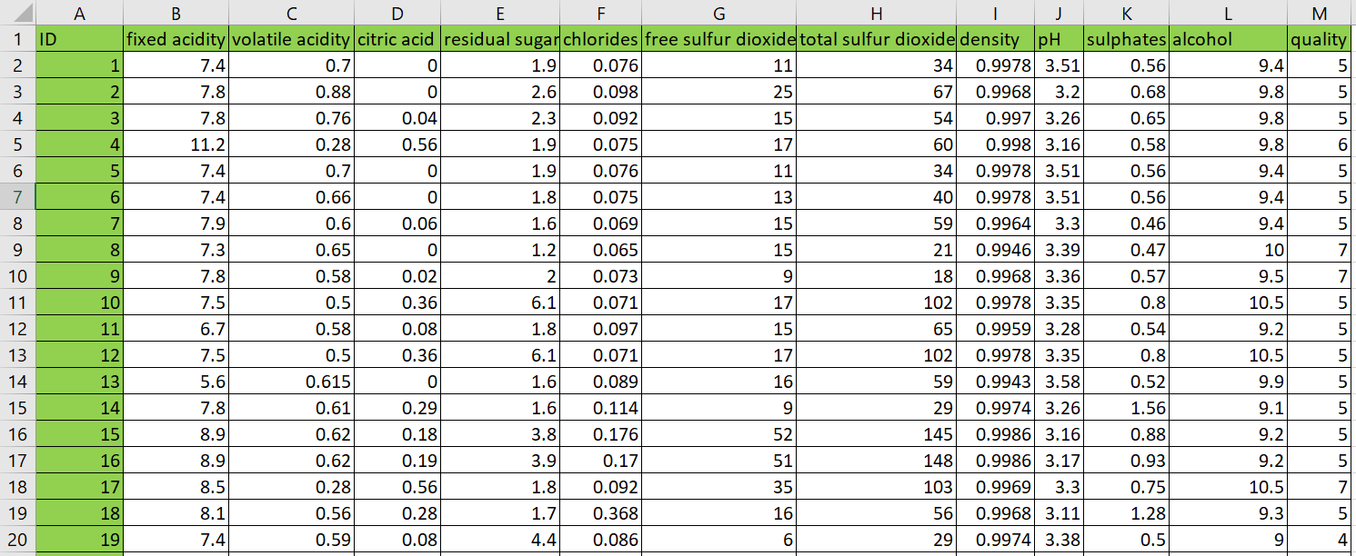
Figure 1 Raw dataset structure (11 physicochemical attributes + quality). Source: Author’s workbook, based on Cortez et al. (2009).
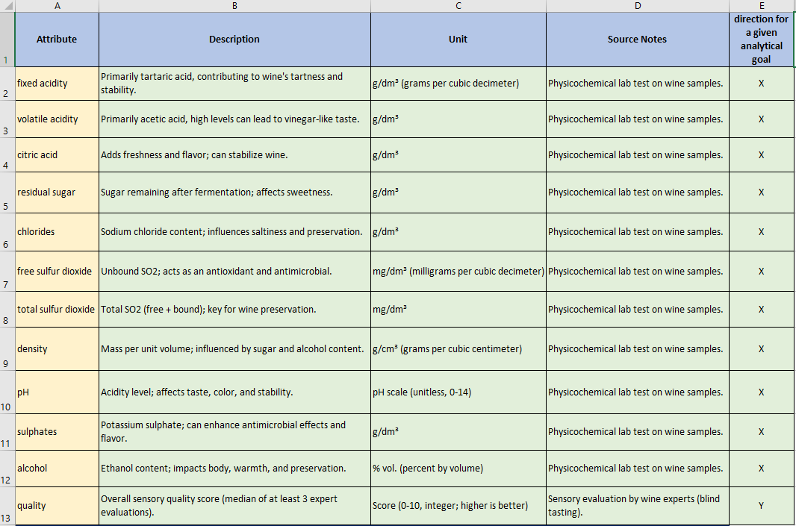
Figure 2 Attribute definitions used in the OAM model. Source: Author’s compilation based on dataset documentation (Cortez et al., 2009).

3.2. Object–Attribute Matrix Construction
“The object–attribute modeling approach follows structured system modeling principles.” (von Bertalanffy, 1968).
The dataset subset was transformed into an Object–Attribute Matrix (OAM) format where rows represent wine samples (objects) and columns represent physicochemical properties (attributes). An excerpt of the implemented OAM is shown in Figure 3. This matrix representation enables deterministic transformations and comparisons between objects while preserving traceability back to raw inputs.
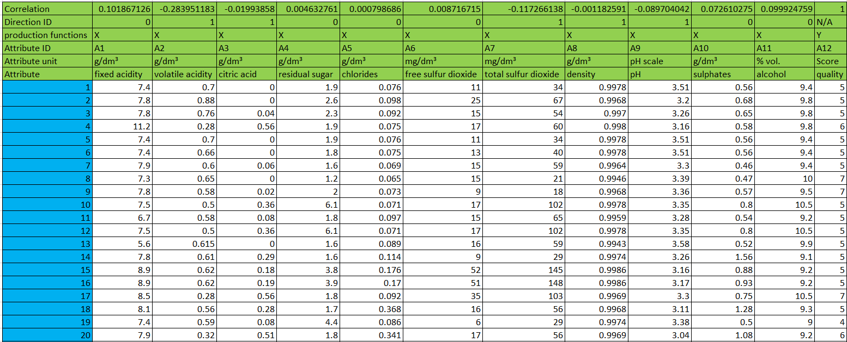
Figure 3 OAM excerpt: objects (wines) and attributes (physicochemical variables) with Fact (quality). Source: author’s workbook.
To support later ranking logic, correlations between each attribute and the expert quality score were computed, and a direction rule was derived from the sign of each correlation. These correlation formulas and direction IDs are implemented directly in the workbook Figure 4 to ensure that later transformations consistently apply “higher-is-better” versus “lower-is-better” logic.
Figure 4 Correlations vs Fact and derived direction flags for attribute ranking. Source: author’s workbook.

3.3. Similarity-Based Estimation Logic
“Distance-based similarity measures are standard tools in data mining and pattern recognition.” (Han et al., 2011).
Similarity between wine samples was computed using deterministic attribute transformations. Because physicochemical attributes differ in scale, the workflow uses rank-based transformations that convert each attribute into a comparable ordinal representation. The workbook implements multiple transformation logics (A1–A12) as competing estimators. An excerpt of these rank-based columns and the Estimation column is shown in Figure 5, including the formula-level implementation visible in the formula bar.
Key implication. Using rank-based transformations reduces sensitivity to raw-scale differences while maintaining a deterministic mapping from raw inputs to estimation outputs.
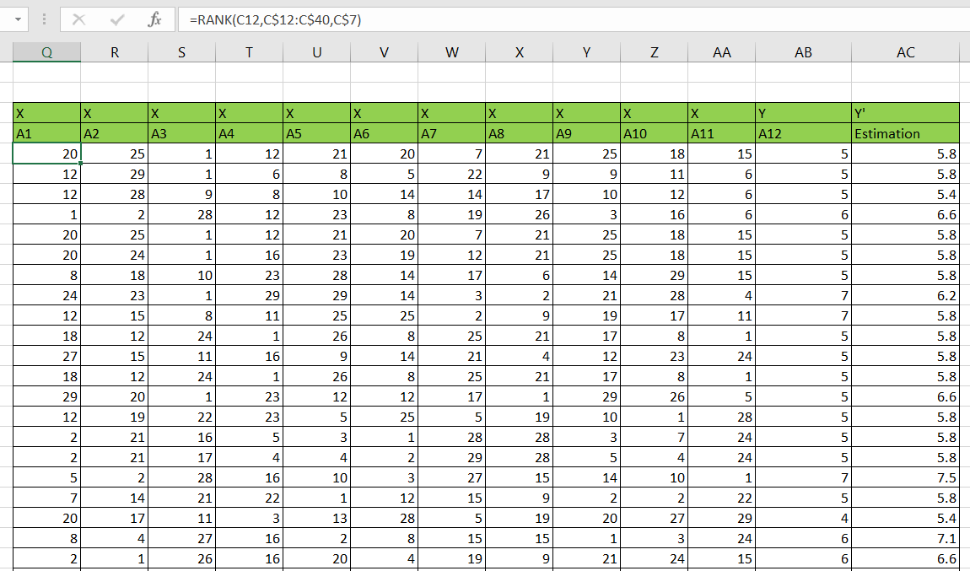
Figure 5 Rank-based transformation (A1–A12) and Estimation column with example Excel formula. Source: Author’s workbook.

3.4. KPI Structure
Correlation is widely used to evaluate linear association between predicted and observed values (Moore, McCabe & Craig, 2017). “Correlation measures the strength and direction of the linear relationship between two quantitative variables.” (Moore, McCabe & Craig, 2017).
To evaluate estimation performance, the workbook computes quantitative goodness indicators comparing Fact (expert quality) and Estimation (similarity-derived score). These indicators include correlation-based consistency and deviation-based measures. The deviation is expressed as:
Delta V = Estimation − Fact
A ratio indicator is also computed to standardize deviation relative to Fact. These KPI elements are visible in the implemented output sheets (Figures 6–7) and serve as evidence inputs for COCO-STD evaluation.
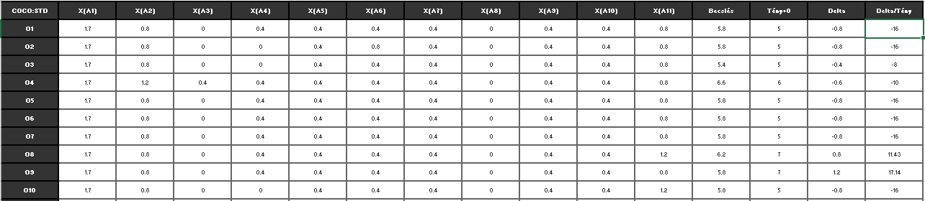
Figure 6 COCO output excerpt: Estimation vs Fact and deviation indicators (Delta, Delta/Tény). Source: Author’s workbook.
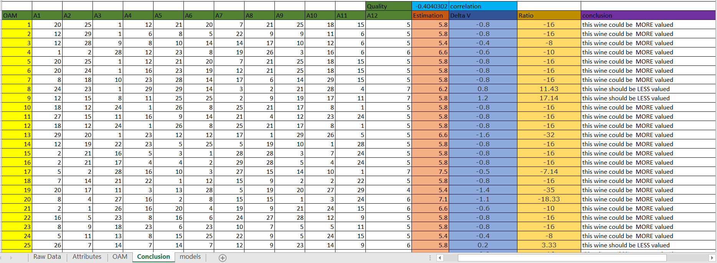
Figure 7 Decision-support output derived from Delta/Tény (“MORE valued / LESS valued”). Source: Author’s workbook.

3.5. COCO-STD Indicator (Similarity/Consistency)
“Multi-criteria ranking supports objective model comparison.” (Saaty, 1980).
COCO-STD is computed from the rank-based comparison matrix created for each estimation logic (A1–A12). The COCO input matrix and configuration parameters (as implemented in the workbook) are documented in the models sheet and shown in Figure 8. The resulting COCO-STD values provide a comparable similarity/consistency measure across alternative similarity constructions, while the KPI tables (Figures 6–7) provide supporting evidence through correlation and deviation indicators.
This combined interpretation ensures that no single KPI dominates evaluation and enables structured selection of the most consistent estimation logic.
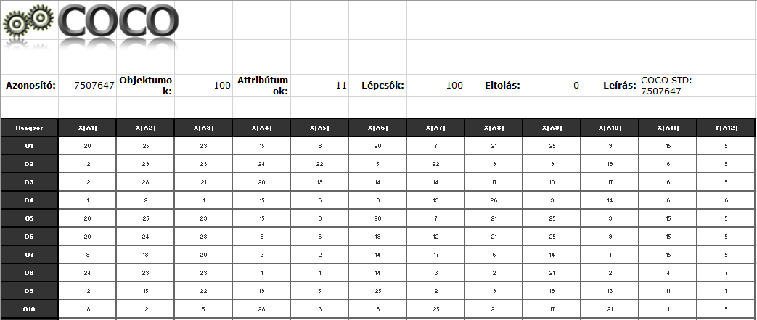
Figure 8 COCO input matrix and COCO STD configuration (100 objects, 11 attributes, 100 steps). Source: Author’s workbook.

3.6. Interpretation of Deviations
The workbook translates deviation into a deterministic interpretation rule:
If Delta/Tény < 0 → “This wine could be MORE valued.”
If Delta/Tény ≥ 0 → “This wine should be LESS valued.”
The implemented decision-support output is shown in Figure 7, including the exact Excel IF rule used to generate the conclusion label. This interpretation does not claim that expert ratings are incorrect; rather, it flags systematic divergence cases between Fact and Estimation as review candidates within the concept-testing framework.

3.7. Automation and Reproducibility
In the final implementation, the analytical workflow is executed by a Python-based web application (Streamlit) instead of manual, sheet-based Excel operations. The application enforces a fixed wine schema (11 physicochemical input attributes + quality) and runs the complete pipeline end-to-end from a single raw dataset upload:
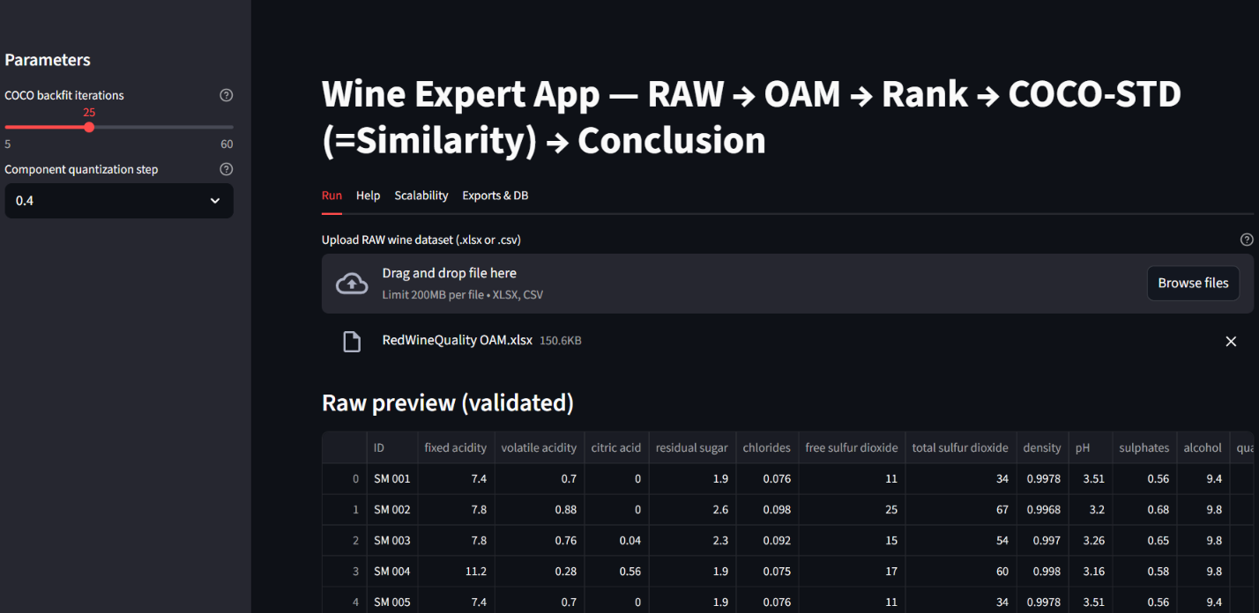
Figure 9. Web application run screen with fixed wine schema validation and parameterized execution. Source: Author’s application.
Reproducibility is ensured in two complementary ways:
- Deterministic execution: for the same input dataset and the same parameters (e.g., backfitting iterations, quantization step), the produced outputs are identical.
- Run-level traceability (structured storage): each execution is recorded as a distinct run with a unique run_id (UUID) and persisted in:
  - an SQLite database (runs.sqlite) containing run metadata and result rows, and
  - a per-run export folder (runs/<run_id>/) containing the generated tables and export packages.
The application contains two complementary execution modes: the Run mode always processes the complete uploaded dataset (no hard row limit), whereas the Scalability mode intentionally samples a user-defined number of objects to measure runtime behavior under controlled sizes. This design provides auditability (every output can be linked to its exact input dataset and parameter setting), repeatability (the run can be repeated later using the same configuration), and explainability (the pipeline steps are explicit and visible to the user). The modular separation of data loading, schema enforcement, OAM generation, rank transformation, COCO-STD computation, and conclusion logic follows the software engineering principles introduced earlier in the thesis.
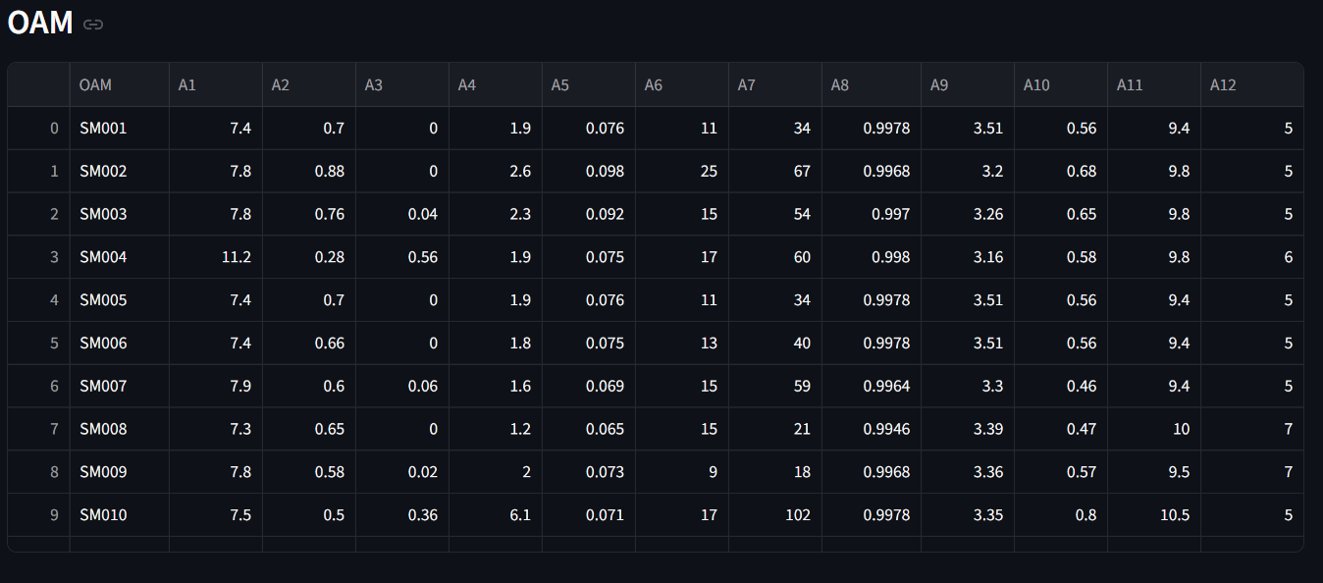
Figure 10. Automatically generated OAM table (A1–A12) from the uploaded raw wine dataset. Source: Author’s application.
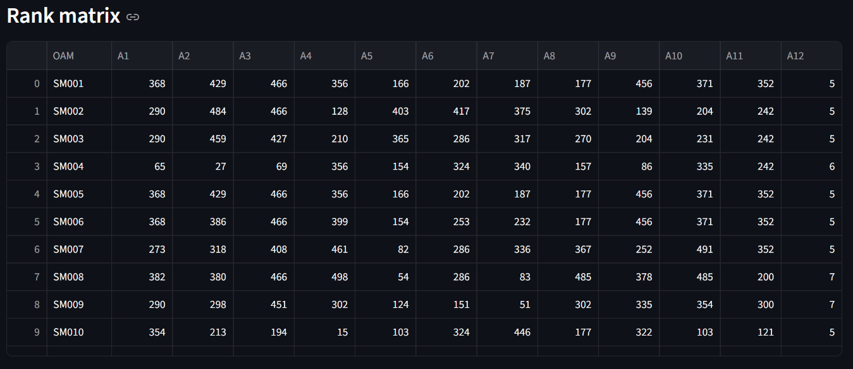
Figure 11 Rank matrix produced from OAM values according to attribute direction rules (COCO-STD input). Source: Author’s application.
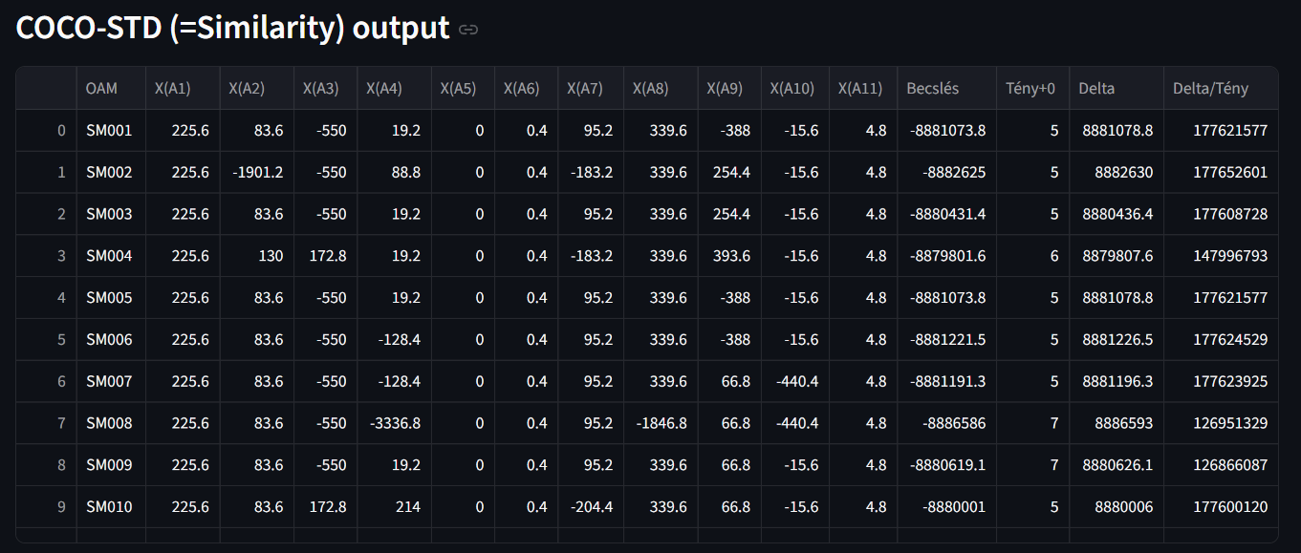
Figure 12 COCO-STD output (similarity space) and deviation-based conclusions (Δ, Δ%, validation). Source: Author’s application.
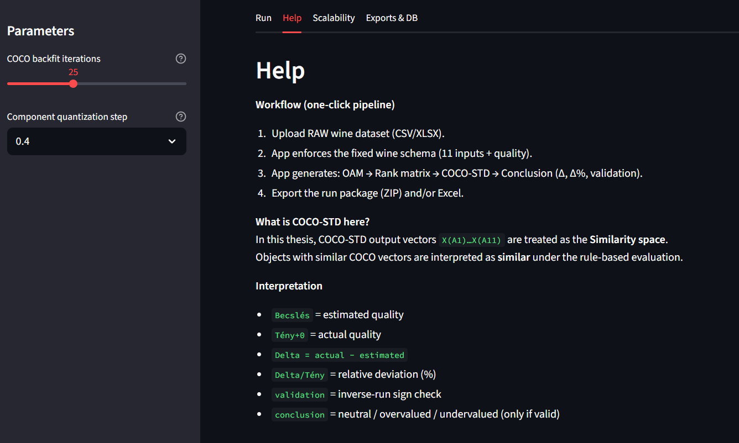
Figure 13 Built-in Help section providing step-by-step usage and interpretation guidance. Source: Author’s application.
Minimal database schema (SQLite). The database implements a minimal but compliance-ready structure:
- runs: one row per run (timestamp, dataset name/hash, object count, parameter JSON, runtime, status/error).
- Coco std: per-object outputs (estimation, actual, delta, delta%, validation, conclusion) to support later queries.
- exports: file-based artifacts (CSV/XLSX/ZIP paths) linked back to run_id.
This is sufficient to prove structured storage, reproducibility, and data-mining readiness.
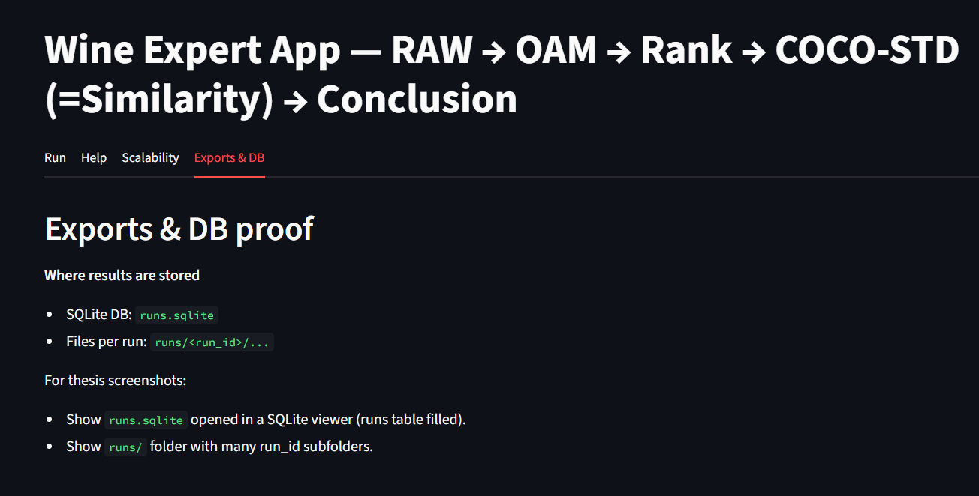
Figure 14 Reproducibility evidence: per-run export package stored under runs/<run_id>/ and logged in runs.sqlite. Source: Author’s system.

3.8. Testing Aspects
Testing was performed to ensure correctness, stability, and reliability of the automated pipeline implementation. The emphasis was on preventing “silent errors” that could occur if intermediate stages (OAM, ranks, COCO-STD output) were inconsistent or partially generated.
Testing covered three layers:
- Computation integrity tests: verification that OAM values, rank values, and COCO-STD outputs are generated for all objects without missing blocks; key columns (A1..A12, estimation, Δ, Δ%) remain numerically valid.
- Consistency checks across pipeline stages: validation that the rank matrix is derived from the same OAM objects and that COCO-STD results correspond to the same run_id dataset, preventing mismatched intermediate artifacts.
- Stability / sensitivity checks: selected input perturbations were used to observe whether outputs change in a controlled way (e.g., changing one attribute affects ranks and COCO-STD results consistently rather than producing unrelated shifts).
These tests reduce the likelihood that deviations between estimation and expert rating (quality) originate from implementation artifacts; instead, they remain interpretable as consequences of the model logic and rules.

3.8.1. Real-life testing protocol (user workflow simulation)
Real-life testing was executed by simulating a non-developer user workflow aligned with the application’s Help guidance. The scenario consists of:
(1) uploading a new raw dataset file,
(2) schema validation (mandatory wine attributes),
(3) running the full pipeline (OAM → ranking → COCO-STD similarity space → conclusion), and
(4) exporting result packages for reporting and later analysis.
Acceptance criteria were defined as:
- Determinism: same input + same parameters → same outputs.
- Completeness: all promised outputs are generated (OAM table, rank matrix, COCO-STD output, conclusion).
- Usability: a non-developer user can execute a run using the Help section without external instructions.
- Safe failure behavior: negative tests for missing columns, wrong data types, and corrupted files must stop safely and display an explicit error message (no partial or misleading results).

3.9. AI Aspects
Artificial Intelligence–related elements are present in two layers.
First, the implemented similarity logic represents structured pattern comparison in a multi-attribute space (OAM). In this thesis, the COCO-STD output is treated as the operational similarity space because it transforms ranked, rule-constrained attribute relations into component vectors and a derived estimation. This aligns with the concept of computational inference over structured data, which is a fundamental theme in AI literature (Russell & Norvig, 2021).
Second, Large Language Models (LLMs) may be used as interpretative support tools to explain outputs in human-readable form (e.g., summarizing deviations or describing the meaning of validation flags). Importantly, the LLM layer does not generate the primary numerical estimations; it only supports explanation. All estimation outcomes remain subject to deterministic KPIs (Δ, Δ%) and validation rules, so the AI component functions as decision-support enhancement rather than an independent evaluator.

3.10. IT Security Aspects
The dataset used in this thesis is public and contains no personal or sensitive information; however, secure workflow design remains relevant. The application executes locally in a controlled environment and persists results in a local SQLite database and local export folders. This reduces risks associated with uncontrolled external processing and supports auditability.
Key security-relevant measures are:
- Separation of concerns: raw input is processed into derived outputs (OAM, ranks, COCO-STD, conclusion) without overwriting source data.
- Traceability: all runs are logged with a dataset hash and parameter set, preventing undetected changes in results.
- Controlled failure behavior: invalid inputs are rejected with explicit error messages, preventing partial outputs.
- No confidential data transfer: the computational core operates locally; no personal data is required for the current experimental setting.

3.10.1. Usefulness, risks, quality assurance, GDPR, warranty, responsibility
Usefulness. The solution provides practical decision support by transforming raw measurements into reproducible, structured outputs (OAM, ranked comparisons, COCO-STD similarity vectors, deviation-based conclusions). Its primary usefulness is prioritization: instead of re-checking every sample manually, an expert can focus on cases flagged by significant deviations or validation-relevant outcomes.
Risks. The main risk is interpretative misuse: users may treat model outputs as a replacement for expert judgment. A second risk is incorrect conclusions caused by data-quality problems (missing attributes, wrong units, inconsistent preprocessing). A third risk is overreliance on a single indicator; therefore, outputs should be interpreted as a multi-criterion decision-support set (estimation + Δ + Δ% + validation flag), not as a single final truth.
Quality assurance. QA is ensured via deterministic computation, automated schema validation, structured run logging, and repeatable tests. Each run stores metadata (dataset hash, parameters, timestamp, runtime, status) to guarantee auditability and prevent silent drift between runs.
GDPR. The applied red-wine dataset contains physicochemical measurements only and no personal data; thus, no personal-data processing occurs in the present setup. If the solution is extended to human-related datasets in the future, GDPR-relevant processes (purpose limitation, legal basis/consent, deletion and retention rules, access logging) must be applied.
Warranty and responsibility. The tool provides decision-support rankings and deviation indicators; it does not guarantee sensory correctness and does not claim to replace certified expert evaluation. The author’s responsibility is limited to software correctness with respect to the documented specification (schema enforcement, pipeline steps, stored outputs). Domain responsibility (final quality decision and business action) remains with the human expert user and the commissioning organization.

3.11. Help section
The software includes a dedicated Help function supporting:
(i) a user manual (step-by-step execution and interpretation guide), and
(ii) context help elements (short tooltips and explanations near parameters and key outputs).
The Help section explains input requirements (mandatory attributes), pipeline stages (OAM, ranking, COCO-STD similarity space, conclusion), and safe interpretation boundaries (decision-support only). Evidence of Help availability is provided via screenshots and the deployed application interface.

3.12 Scalability and Run Volume Evidence
To demonstrate that the implemented pipeline is not limited to a single demonstration run, scalability testing was executed using the application’s built-in batch-run mode. The purpose of this experiment is to provide measurable evidence that (i) the workflow can be executed repeatedly without manual intervention, (ii) each run is persistently logged for auditability, and (iii) runtime scales in a controlled way with the number of processed objects.
The scalability evaluation uses controlled sampling sizes N selectable by the user in the Scalability tab (100/250/500/1000/1500). This sampling does not represent a limitation of the solution; it is a deliberate experimental design to compare runtimes under comparable object counts. In contrast, the Run tab processes the complete uploaded dataset after schema enforcement, i.e., nobjects=len(raw)n_{\text{objects}}=\mathrm{len}(\text{raw})nobjects​=len(raw), without downsampling.
In the executed batch-run experiment reported here, three dataset sizes were tested (N=100N=100N=100, N=250N=250N=250, N=500N=500N=500) with 10 repetitions per size, resulting in 30 successful runs in total. For each run, the application generates a unique run_id, records runtime_sec (in seconds) and status into the SQLite database (runs.sqlite), and preserves the generated artifacts under runs/<run_id>/. This ensures that the reported scalability results are directly verifiable from the database and the exported run folders.
Runtime evidence is presented in two forms. First, Figure 15 lists the run-level execution log (dataset size, repetition index, runtime in seconds, status, and run identifier). Second, Figure 16 aggregates the logged runs by size and reports the runtime statistics: for N=100N=100N=100, mean runtime 6.0381 s (max 6.3808 s); for N=250N=250N=250, mean runtime 5.9760 s (max 6.3207 s); and for N=500N=500N=500, mean runtime 6.3143 s (max 6.7881 s). The same summary confirms that the number of failures is 0 for all tested sizes, and the runtime trend is visualized to illustrate how processing time behaves as N increases.
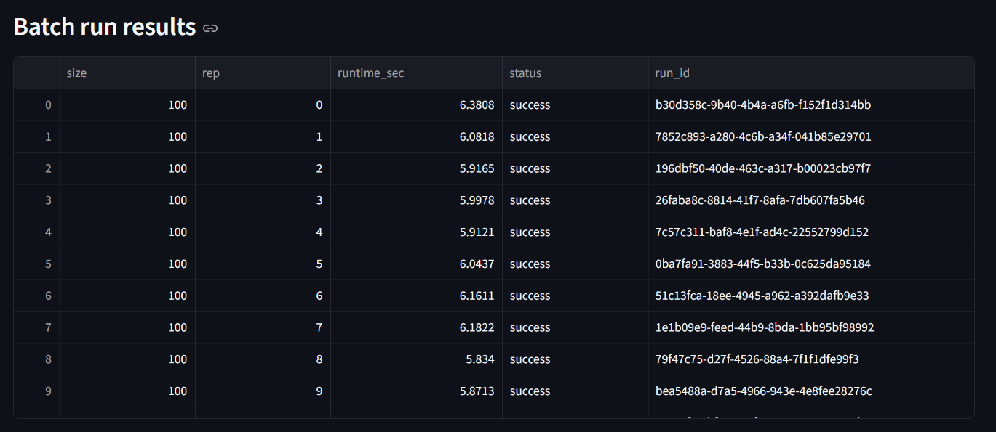
Figure 15 Batch-run execution results across multiple dataset sizes (run_id and runtime recorded). Source: Author’s application.
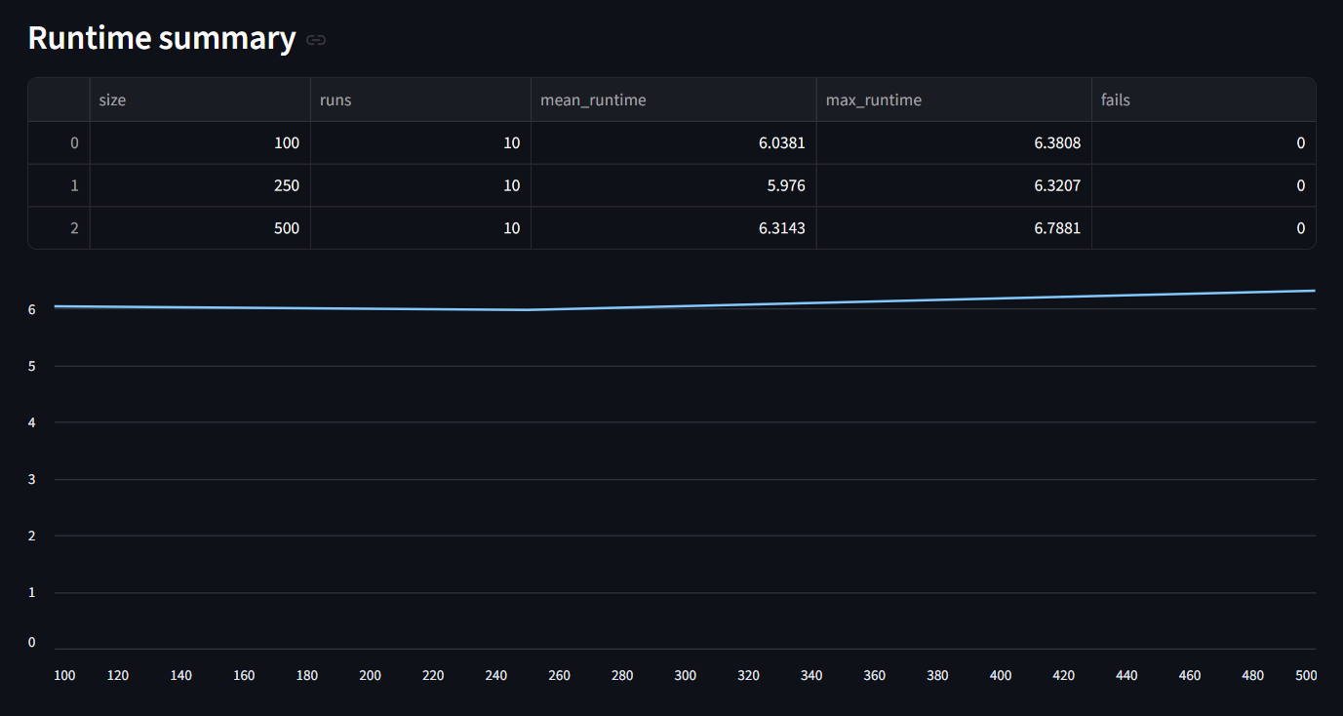
Figure 16 Runtime scaling summary (mean/max runtime and failures) with runtime trend by dataset size. Source: Author’s application.

3.13 Summary of Own Developments
The own development contribution is an automated, reproducible pipeline that derives rule-based similarity and deviation indicators from raw wine measurements. The workflow consists of:
- enforcing a fixed wine schema and validating raw input,
- transforming raw data into an OAM representation,
- generating a rank matrix required for COCO-STD processing,
- computing COCO-STD outputs as the thesis similarity space (component vectors and estimation),
- producing deviation-based conclusions (Δ, Δ%, validation, classification), and
- persisting results via run logging (SQLite) and export packages (CSV/XLSX/ZIP) for auditability and scalability evidence.
This integrated design converts a raw dataset into an end-to-end decision-support output while maintaining transparency, deterministic computation, and traceable run-level storage.

Chapter 4. Discussions
This chapter interprets the empirical findings presented in Chapter 3 and evaluates the implications of similarity-based estimation and COCO-STD based evaluation in the context of expert wine quality assessment. The discussion focuses on methodological validity, robustness of findings, limitations of the approach, and economic implications derived from the estimated informational added-value.

4.1. Interpretation of Fact–Estimation Alignment
Model validation through correlation and error analysis is standard practice in predictive modeling (James et al., 2013).
The core analytical objective of this thesis was to evaluate whether similarity-based estimation can approximate expert-assigned wine quality ratings under a consistent, multi-metric verification approach.
The correlation and deviation-based KPIs indicate that measurable alignment exists between similarity-derived estimations and expert ratings. While perfect replication was neither expected nor observed, the structured deviations reveal systematic tendencies rather than random noise.
The presence of both positive and negative Delta V values suggests that similarity logic does not uniformly overestimate or underestimate quality. Instead, deviations appear selectively, indicating that the model captures substantial portions of expert reasoning while still reflecting structural differences between chemical similarity and sensory evaluation.
This supports the interpretation that similarity-based estimation represents a partial but meaningful approximation of expert judgment.

4.2. Role of COCO-STD in Verification
The COCO-STD indicator plays a central role in verification by summarizing the stability and dispersion of results produced by different estimation logics. It complements point-wise KPIs such as correlation or absolute deviation by providing a compact similarity/consistency signal that can be compared across alternative configurations.
COCO-STD enables:
Multi-metric evaluation
- Comparative ranking of estimation logics
- Structured verification of consistency
By operationalizing verification, COCO-STD reduces arbitrariness in model selection. The framework ensures that the evaluation of estimation logic is not based on a single performance indicator but on a consistent set of quantitative evidence.
This methodological layer strengthens objectivity and aligns the analysis with formal concept-testing principles.

4.3. Interpretation of Overvaluation and Undervaluation Signals
The qualitative interpretation rule applied in Chapter 3 (“potentially MORE valued” vs “potentially LESS valued”) does not imply that expert ratings are incorrect. Instead, it identifies cases where similarity-based structural patterns diverge from assigned quality values.
These divergences may arise from:
- Non-linear sensory interactions not captured by similarity logic
- Contextual factors not represented in physicochemical attributes
- Subjective expert variation
Therefore, flagged cases should be interpreted as decision-support signals rather than corrective judgments. The framework highlights candidates for further review, thereby supporting structured expert reconsideration.

4.4. Economic Implications and Informational Added-Value
Decision-support automation aims to improve efficiency without replacing expert judgment (Power, 2002).
The numeric estimation presented in Chapter 1.4 demonstrates that automation of similarity-based evaluation supported by COCO-STD yields measurable efficiency gains.
For a 100-sample evaluation:
Benchmark cost: 835 EUR
AI-supported cost: 600 EUR
Estimated added-value: 235 EUR
This corresponds to approximately 28% reduction in evaluation cost.
The added-value arises from:
- Automated similarity computation
Automated KPI computation
- Immediate identification of deviation cases
When scaled to larger datasets, the cumulative efficiency gain becomes significant. For 1,000 samples, the estimated added-value reaches approximately 2,350 EUR.
Importantly, the economic benefit does not depend on replacing human expertise. Instead, it derives from targeted allocation of expert attention to analytically flagged cases. The framework therefore enhances expert productivity without compromising evaluative integrity.

4.5. Methodological Strengths
The strengths of the presented approach include:
- Structured OAM representation ensuring transparency.
- Reproducible Excel-based implementation.
Multi-metric evaluation supported by COCO-STD.
- Clear separation between Fact and Estimation.
- Quantifiable efficiency improvement.
The modular design allows extension of the framework to other domains where expert judgment is based on structured measurable attributes.

4.6. Limitations
Despite promising alignment, several limitations must be acknowledged.
First, similarity-based estimation assumes that measurable chemical attributes sufficiently represent sensory quality. However, wine evaluation may include experiential and contextual components not captured in the dataset.
Second, only 100 samples were used for structured evaluation, which may limit generalizability. Expansion to larger subsets would strengthen statistical robustness.
Third, LLM-based interpretative components remain probabilistic and require external quantitative validation.
These limitations indicate that the framework should be interpreted as a decision-support enhancement rather than a definitive expert-replacement system.

4.7. Concept-Testing Perspective
From a concept-testing standpoint, the thesis demonstrates that a similarity-based estimation model, when evaluated through complementary goodness criteria and COCO-STD, can partially replicate expert judgment.
The structured interpretation of KPIs transforms subjective evaluation into measurable verification logic. This aligns with the broader objective of deriving automatable elements of human expertise.
The findings support the hypothesis that expert reasoning in wine evaluation contains measurable structural components that can be computationally approximated under controlled conditions.

Chapter 5. Conclusions
This thesis investigated whether wine expertise can be computationally approximated by combining similarity analysis, Object–Attribute Matrix (OAM) structuring, and COCO-STD evaluation logic, supported by Large Language Model (LLM) interpretation. The research aimed to determine whether measurable physicochemical attributes can partially reproduce expert-assigned wine quality ratings under structured concept-testing conditions.
Based on the empirical analysis conducted on a 100-sample subset of the red wine dataset, the following conclusions can be drawn.
First, similarity-based estimation demonstrates measurable alignment with expert quality ratings. Correlation analysis and deviation-based indicators confirm that chemical attribute similarity captures a significant portion of expert evaluative structure. Although perfect replication was neither expected nor achieved, the structured relationship between attributes and ratings supports the hypothesis that expert judgment contains measurable and reproducible components.
Second, the Object–Attribute Matrix framework proved effective in organizing raw data into a structured analytical format. OAM enabled transparent separation of objects and attributes, facilitating systematic similarity computation and reproducible workflow execution within Excel. The matrix representation ensured methodological clarity and traceability of calculations.
Third, COCO-STD provided a compact similarity/consistency signal that supported structured comparison of competing estimation logics (A1–A12). Together with correlation and deviation-based KPIs, this strengthened objectivity by preventing reliance on a single performance measure and enabled defensible comparison of alternative similarity configurations.
Fourth, the qualitative interpretation layer (“potentially undervalued” vs. “potentially overvalued”) demonstrated that the framework can identify structured deviations between estimation and expert ratings. These deviations should be interpreted as decision-support signals rather than corrections of expert judgment. The system enhances structured review rather than replacing human expertise.
Fifth, the numeric estimation of informational added-value indicates measurable efficiency gains. Under conservative assumptions, the similarity + COCO-STD framework reduces evaluation cost by approximately 28% per 100 wine samples, corresponding to an estimated 235 EUR efficiency improvement. When scaled to larger datasets, the economic implication becomes substantial. This demonstrates that the framework offers not only analytical insight but also practical efficiency benefits.
Overall, the thesis confirms that wine expertise can be partially derived through structured similarity analysis supported by quantitative verification and COCO-STD evaluation. While human sensory judgment remains essential, computational modeling captures systematic patterns embedded within expert evaluations.
The research therefore contributes to the broader field of concept testing and decision-support systems by demonstrating that measurable attributes, when structured through OAM and evaluated via COCO-STD, can approximate complex expert reasoning in a controlled and reproducible manner.

Chapter 6. Future Research Directions
While the thesis demonstrates that similarity-based estimation combined with OAM structuring and COCO-STD based evaluation can partially approximate expert wine evaluation, several opportunities for further research remain.
First, the sample size can be expanded. The present analysis was conducted on a structured subset of 100 wine samples. Extending the concept-testing framework to the full dataset of 1,000 samples would increase statistical robustness and allow more stable estimation of correlation and deviation patterns. Larger sample sizes may also reveal non-linear relationships not observable within smaller subsets.
Second, additional competing estimation logics can be introduced. Although multiple configurations (A1–A12) were evaluated, further variations could include alternative normalization techniques, weighted attribute schemes, exclusion of selected attributes, or alternative distance metrics. Expanding the set of competing concepts would strengthen the comparative power of the COCO-STD framework.
Third, integration of advanced machine learning models could enhance predictive capability. While similarity-based logic captures structural proximity in attribute space, supervised learning algorithms such as regression models or ensemble methods may provide complementary estimation strategies. Future research may compare these models within the same KPI + COCO-STD evaluation framework.
Fourth, the interpretative use of Large Language Models could be refined. Currently, LLMs function as semantic reasoning tools supporting explanation of analytical results. Future research may investigate structured prompt engineering, integration with numerical constraints, or hybrid systems combining statistical output with language-based explanation layers.
Fifth, cross-domain application of the framework should be explored. The OAM + similarity + COCO-STD pipeline is not limited to wine evaluation. Similar expert-derivation challenges exist in fields such as product rating, medical diagnosis support, financial risk assessment, and educational evaluation. Testing the framework in alternative domains would validate its generalizability.
Finally, more detailed economic modeling of informational added-value could be developed. The current estimation is conservative and based on time-efficiency assumptions. Future work could incorporate empirical cost data, opportunity cost analysis, or productivity modeling to provide more precise financial evaluation.
In summary, future research may expand dataset scale, diversify competing estimation logics, integrate advanced predictive models, refine LLM interpretability, and explore cross-domain applicability. These extensions would further strengthen the theoretical and practical contribution of the presented framework.

Chapter 7. Summary
This thesis investigated whether wine expertise can be computationally approximated through similarity analysis structured by the Object–Attribute Matrix framework and evaluated using the COCO-STD indicator. The research was motivated by the increasing availability of structured datasets and the practical need for reproducible decision-support methods.
The study utilized a publicly available red wine dataset containing physicochemical properties and expert-assigned quality ratings. A subset of 100 samples was selected for structured concept testing. Wine samples were organized in an Object–Attribute Matrix format, enabling systematic similarity computation across measurable attributes.
Multiple similarity-based estimation logics were implemented and compared. The expert ratings were treated as Fact (Tény), while similarity-derived values were treated as Estimation (Becslés). Quantitative goodness indicators, including correlation and deviation measures, were computed to evaluate alignment between estimation and expert ratings. COCO-STD was computed as the main similarity/consistency indicator to support comparison across competing estimation configurations.
The results demonstrate that similarity-based modeling captures measurable patterns embedded in expert wine evaluation. Although computational estimation does not fully replicate sensory judgment, it provides structured approximation and identifies potential cases of overvaluation or undervaluation relative to expert ratings. The framework operates as a decision-support enhancement rather than a replacement for human expertise.
A numeric estimation of informational added-value indicates that the structured analytical framework can reduce evaluation cost by approximately 28% per 100 wine samples under conservative assumptions. This demonstrates both methodological and economic relevance.
Overall, the thesis confirms that elements of wine expertise can be partially derived through structured computational modeling when supported by quantitative verification. The integration of OAM, similarity logic, COCO-STD evaluation, and LLM-based interpretation provides a reproducible and explainable framework for decision support in the context of wine quality assessment.

Chapter 8. Annexes

8.1. Abbreviations
ACM – Association for Computing Machinery (as used in Communications of the ACM)
AI – Artificial Intelligence
BPM – Business Process Management
BPROF – Business Informatics / Computer Science Programme
COCO – Component-based object comparison for objectivity – anti-discriminative optimization
COCO-STD – COCO-based standard-deviation similarity/consistency indicator used to compare competing estimation logics
CSV – Comma-Separated Values
DSS – Decision Support System
EUR – Euro
GDPR – General Data Protection Regulation
ID – Identifier
IF – Excel IF function (conditional rule)
IT – Information Technology
JSON – JavaScript Object Notation (parameter storage format)
KPI – Key Performance Indicator
LESS – Decision label: “should be LESS valued” (Δ/Tény ≥ 0)
LLM – Large Language Model
MORE – Decision label: “could be MORE valued” (Δ/Tény < 0)
OAM – Object–Attribute Matrix
QA – Quality Assurance
STD – Standard Deviation
UCI – University of California, Irvine (UCI Machine Learning Repository)
UUID – Universally Unique Identifier
XLSX – Microsoft Excel Open XML Spreadsheet
ZIP – Compressed archive file format (export package)

8.2 Symbols and identifiers
Δ – Deviation between expert rating (Fact/Tény) and estimation (Estimation/Becslés), computed as
Δ=Fact−Estimation\Delta = \text{Fact} - \text{Estimation}Δ=Fact−Estimation
Δ% – Relative deviation (percentage form), computed as
Δ%=Δ/Fact\Delta\% = \Delta / \text{Fact}Δ%=Δ/Fact
Fact / Tény – The expert-provided reference value (ground truth in the concept-testing framework), i.e., the original wine quality rating.
Estimation / Becslés – The similarity-derived estimated value produced by the analytical workflow for comparison against Fact/Tény.
nobjectsn_{\text{objects}}nobjects​ – Number of processed objects (rows/samples) in a run; in Run mode nobjects=len(raw)n_{\text{objects}}=\mathrm{len}(\text{raw})nobjects​=len(raw).
NNN – User-selected sample size in the Scalability mode (controlled sampling size; e.g., 100/250/500/1000/1500).
run_id – Unique run identifier assigned by the application to each execution; used to link database records and exported artifacts.
rep – Repetition index within batch execution for a given dataset size NNN.
runtime_sec – Runtime of a single run measured in seconds (s) and stored in the run log.
status – Execution status stored in the run log (e.g., “success” or “fail”).
fails – Aggregated failure count per dataset size in the runtime summary.
runs – Aggregated run count per dataset size in the runtime summary.
OAM cell oi,jo_{i,j}oi,j​ – Value of attribute jjj for object iii in the Object–Attribute Matrix representation.

8.3 Description of Dataset
The dataset used in this thesis originates from the study of Cortez et al. (2009), who investigated wine preferences using physicochemical measurements of Portuguese “Vinho Verde” wines. As stated by the authors, “the goal is to model wine preferences based on physicochemical tests” (Cortez et al., 2009). The dataset includes both red and white wine variants; however, this thesis utilizes the red wine subset exclusively.
Due to privacy and logistical constraints, only physicochemical input variables and sensory evaluation outputs are available. The dataset does not contain information about grape varieties, wine brands, production conditions, or market prices. Therefore, the analysis focuses strictly on measurable chemical properties and expert-assigned quality scores.
The dataset is publicly available through the UCI Machine Learning Repository and has also been distributed via Kaggle for accessibility purposes. The original publication remains:
Cortez, P., Cerdeira, A., Almeida, F., Matos, T., & Reis, J. (2009). Modeling wine preferences by data mining from physicochemical properties. Decision Support Systems, 47(4), 547–553.

8.4 Implementation Environment
The analytical workflow was first prototyped in Microsoft Excel using formula-based deterministic logic to validate each pipeline stage (raw data preparation, OAM construction, rank transformations, KPI calculation, and deviation-based conclusions).
The final implementation is provided as a Python-based web application (Streamlit) that executes the same pipeline end-to-end from a single dataset upload. Reproducibility is supported by deterministic execution and run-level traceability: each execution is stored as a distinct run with a unique run_id and persisted in an SQLite database (runs.sqlite), together with exported per-run result files.
This implementation ensures transparency, auditability, scalability (batch runs), and structured result storage suitable for later analysis.

8.5 References

2*2*2*2 = T01-T16

Codetable + code for each reference
Bass, L., Clements, P., & Kazman, R. (2013). Software Architecture in Practice (3rd ed.). Addison-Wesley.
Brown, T. et al. (2020). Language Models are Few-Shot Learners. Advances in Neural Information Processing Systems.
Cortez, P., Cerdeira, A., Almeida, F., Matos, T., & Reis, J. (2009). Modeling wine preferences by data mining from physicochemical properties. Decision Support Systems, 47(4), 547–553.
Dumas, M., La Rosa, M., Mendling, J., & Reijers, H. (2018). Fundamentals of Business Process Management. Springer.
Elmasri, R., & Navathe, S. (2016). Fundamentals of Database Systems (7th ed.). Pearson.
Knuth, D. (1997). The Art of Computer Programming. Addison-Wesley.
Mitchell, T. (1997). Machine Learning. McGraw-Hill.
Moore, D., McCabe, G., & Craig, B. (2017). Introduction to the Practice of Statistics. W.H. Freeman.
Myers, G. (1979). The Art of Software Testing. Wiley.
Russell, S., & Norvig, P. (2021). Artificial Intelligence: A Modern Approach (4th ed.). Pearson.
Saaty, T. (1980). The Analytic Hierarchy Process. McGraw-Hill.
Silberschatz, A., Galvin, P., & Gagne, G. (2020). Operating System Concepts (10th ed.). Wiley.
Stewart, J. (2015). Calculus: Early Transcendentals. Cengage Learning.
Tanenbaum, A., & Wetherall, D. (2011). Computer Networks (5th ed.). Pearson.
Tufte, E. (2001). The Visual Display of Quantitative Information. Graphics Press.
von Bertalanffy, L. (1968). General System Theory. George Braziller.
Wing, J. (2006). Computational Thinking. Communications of the ACM, 49(3), 33–35.
Anderson, R. (2020). Security Engineering (3rd ed.). Wiley.
Power, D. J. (2002). Decision Support Systems: Concepts and Resources for Managers. Greenwood Publishing.

8.6 Relevant, Complete Conversations with Large Language Models (LLMs)
During the preparation of this thesis, a Large Language Model (LLM) was consulted as a structural and linguistic support tool. The LLM was not used to generate empirical results, compute similarity measures, construct COCO-STD models, or manipulate dataset outputs. All analytical computations, Excel implementations, and model configurations were designed, executed, and validated independently by the author.
The LLM was used in the following areas:

8.6.1 Structural Refinement of Chapter Organization
The author consulted the LLM regarding the proper placement of methodological components (OAM, COCO-STD) within the thesis structure. The discussion focused on ensuring that theoretical definitions appear in Chapter 2 before being applied in Chapter 3.
Excerpt:
Author: “OAM and COCO-STD are not introduced in my previous chapters. Is this a structural problem?”
LLM: “Yes. Methods must be introduced in Literature before being applied in Own Developments.”
Based on this guidance, the author restructured Chapter 2 to include formal definitions before implementation.

8.6.2 Clarification of Concept-Testing Logic (Fact vs Estimation)
The LLM was consulted to clarify the formal positioning of expert ratings and similarity-based outputs within a concept-testing framework.
Excerpt:
Author: “Expert rating = Fact, Similarity-derived score = Estimation, COCO-STD = similarity/consistency indicator. Is this correct?”
LLM: “Yes. That represents a structured Fact vs Estimation concept-testing framework.”
The analytical logic was independently implemented in Excel by the author.

8.6.3 Derivation of Numeric Informational Added-Value
The LLM was consulted for guidance on how to express informational added-value in numeric form as required by the supervisor.
Excerpt:
Author: “How can I derive numeric estimation of informational added-value?”
LLM: “Compare benchmark expert cost with AI-supported workflow cost and compute difference.”
The numeric values and economic assumptions were determined and validated by the author.

8.6.4 Formatting and Compliance Adjustments
The LLM provided guidance regarding:
- Table of Contents page breaks
- Subchapter structuring
- Citation compliance
- Academic phrasing refinement
No original dataset analysis or KPI calculation was performed by the LLM.

8.6.5 AI Usage Boundaries
The LLM was used exclusively for:
- Structural advice
- Academic language refinement
- Clarification of supervisor feedback
The LLM was not used to:
- Generate similarity computations
- Calculate correlation or deviation metrics
Operate COCO-STD evaluation
- Modify raw data
All Excel-based analytical procedures remain fully reproducible and independently verifiable.
The author retains full responsibility for all analytical models, computational procedures, interpretations, and conclusions presented in this thesis.

8.7 List of Figures
Figure 1 Raw dataset structure (11 physicochemical attributes + quality). Source: Author’s workbook, based on Cortez et al. (2009). 22
Figure 2 Attribute definitions used in the OAM model. Source: Author’s compilation based on dataset documentation (Cortez et al., 2009). 23
Figure 3 OAM excerpt: objects (wines) and attributes (physicochemical variables) with Fact (quality). Source: author’s workbook. 24
Figure 4 Correlations vs Fact and derived direction flags for attribute ranking. Source: author’s workbook. 24
Figure 5 Rank-based transformation (A1–A12) and Estimation column with example Excel formula. Source: Author’s workbook. 25
Figure 6 COCO output excerpt: Estimation vs Fact and deviation indicators (Delta, Delta/Tény). Source: Author’s workbook. 26
Figure 7 Decision-support output derived from Delta/Tény (“MORE valued / LESS valued”). Source: Author’s workbook. 26
Figure 8 COCO input matrix and COCO STD configuration (100 objects, 11 attributes, 100 steps). Source: Author’s workbook. 27
Figure 9. Web application run screen with fixed wine schema validation and parameterized execution. Source: Author’s application. 28
Figure 10. Automatically generated OAM table (A1–A12) from the uploaded raw wine dataset. Source: Author’s application. 29
Figure 11Rank matrix produced from OAM values according to attribute direction rules (COCO-STD input). Source: Author’s application. 30
Figure 12 COCO-STD output (similarity space) and deviation-based conclusions (Δ, Δ%, validation). Source: Author’s application. 30
Figure 13 Built-in Help section providing step-by-step usage and interpretation guidance. Source: Author’s application. 31
Figure 14 Reproducibility evidence: per-run export package stored under runs/<run_id>/ and logged in runs.sqlite. Source: Author’s system. 32
Figure 15 Batch-run execution results across multiple dataset sizes (run_id and runtime recorded). Source: Author’s application. 37
Figure 16 Runtime scaling summary (mean/max runtime and failures) with runtime trend by dataset size. Source: Author’s application. 37

