Deriving Wine Experts Based on LLM and Similarity Analysis

Tsetsgesuren Namjiljav
Supervisors: László Pitlik , László Pitlik (Jr)
Kodolányi János University
Email: nazuu1188@gmail.com

Abstract
In recent years, artificial intelligence and large language models (LLMs) have transformed data interpretation and decision support systems across multiple domains, including food and beverage research. This study introduces an innovative approach to deriving wine expertise by combining similarity analysis and LLM-based evaluation. Using a dataset of red wine characteristics and expert-rated quality scores, an LLM-driven framework was applied to identify patterns that align with human expert judgment. The study also employed similarity analysis to compare wine samples based on their physicochemical attributes, aiming to simulate how professional sommeliers evaluate wine quality. The integration of statistical correlations, semantic reasoning, and model-based assessment demonstrates that LLMs can replicate expert-level insights with promising accuracy. This research highlights the potential of artificial intelligence to support wine evaluation and education, offering a bridge between data science and sensory expertise.

Keywords
Red wine, LLM, Similarity analysis, Artificial intelligence

Please, never use enter, tab, space for formatting texts…
BUT: please, create an table of contents!
Tartalom
Nincsenek tartalomjegyzék-bejegyzések.

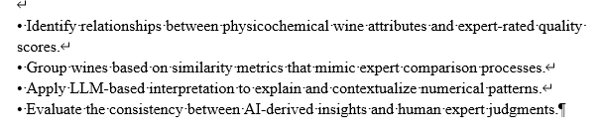
Never use them!
-justified
Introduction
Wine quality evaluation has traditionally relied on human sensory experts, whose judgments are influenced by experience, context, and subjective perception. While expert evaluation is valuable, it is not always scalable, reproducible, or fully objective. In recent years, artificial intelligence (AI) and data-driven methods have offered new possibilities for supporting or partially replicating expert-level decision-making.
Large Language Models (LLMs) represent a new generation of AI systems capable of semantic reasoning, pattern recognition, and contextual interpretation. When combined with quantitative similarity analysis, LLMs provide a promising framework for simulating expert-like evaluations. This study explores how such a hybrid approach can be applied to wine quality assessment using physicochemical data.

Objective and Research Framework
The primary objective of this research is to examine whether expert-level wine evaluation can be approximated through the integration of similarity analysis and LLM-based reasoning. Specifically, the study aims to:
• Identify relationships between physicochemical wine attributes and expert-rated quality scores.
• Group wines based on similarity metrics that mimic expert comparison processes.
• Apply LLM-based interpretation to explain and contextualize numerical patterns.
• Evaluate the consistency between AI-derived insights and human expert judgments.

Dataset Description
The empirical basis of the study is a red wine quality dataset containing 1,599 samples. Each wine sample is described by eleven physicochemical attributes, including fixed acidity, volatile acidity, citric acid, residual sugar, chlorides, sulfur dioxide levels, density, pH, sulphates, and alcohol content. The target variable is an expert-assigned quality score on a discrete scale.
This dataset is widely used in data science research and provides a suitable foundation for examining both statistical correlations and AI-based interpretative methods.

Methodology

Data Structuring and Object–Attribute Matrix (OAM)
The methodological foundation of this study is the construction of an Object–Attribute Matrix (OAM) to ensure a transparent and reproducible representation of wine quality data. In the OAM, each object corresponds to an individual red wine sample, while each attribute represents a physicochemical property, including acidity measures, sulphates, alcohol content, density, and related variables.
Prior to analysis, the dataset was examined for completeness and consistency. The expert-rated wine quality score was preserved as a reference variable and was not directly optimized. This separation ensures that expert judgment remains an external validation criterion rather than an embedded bias within the analytical process.
The OAM structure enables systematic comparison across multiple attributes simultaneously and serves as a unified data foundation for similarity analysis and AI-supported interpretation.

Similarity Analysis Framework
Similarity analysis was applied to evaluate relationships between wine samples based on their physicochemical profiles. Distance-based similarity metrics, including Euclidean distance and cosine similarity, were used to quantify the degree of resemblance between objects within the OAM.
These measures allow wines with comparable chemical compositions to be grouped together, reflecting the comparative evaluation process commonly applied by professional sommeliers. Rather than analyzing individual attributes in isolation, similarity analysis captures multidimensional relationships, enabling holistic assessment of wine characteristics.
The resulting similarity structures provide objective, mathematically grounded groupings that form the basis for further interpretative analysis.

LLM-Based Interpretative Layer
Large Language Models (LLMs) were incorporated as an interpretative layer to contextualize and explain the numerical outcomes of the similarity analysis. The role of the LLM in this framework is not predictive optimization but semantic reasoning and pattern explanation.
Specifically, the LLM was applied to:
- Identify dominant attributes influencing wine quality,
- Interpret correlation structures derived from the OAM,
- Generate expert-like qualitative explanations consistent with observed numerical patterns.
By translating quantitative results into coherent explanatory narratives, the LLM supports expert-level understanding while maintaining methodological transparency.

Integration of Quantitative and Semantic Analysis
The final methodological step integrates similarity-based quantitative results with LLM-driven semantic interpretation. Similarity groupings derived from the OAM provide the objective structural foundation, while LLM-generated explanations offer contextual insight into why certain wines exhibit comparable quality characteristics.
This hybrid approach bridges numerical rigor and expert reasoning, enabling the approximation of sommelier-like evaluation without direct human intervention. Importantly, all analytical steps remain transparent and reproducible, ensuring that the framework can be extended or validated using additional datasets.

Methodological Validation
Methodological validity was assessed by comparing AI-supported interpretations with expert-rated wine quality scores. Consistency between similarity groupings and expert evaluations was treated as an indicator of methodological reliability.
This validation confirms that the proposed framework does not replace expert judgment but aligns closely with it, demonstrating the potential of combining structured data analysis with LLM-based reasoning for expert-support systems.

Object–Attribute Matrix (OAM) Construction
In order to structure the wine quality data in a transparent and analyzable form, an Object–Attribute Matrix (OAM) was constructed. In this matrix, each object represents a single red wine sample, while each attribute corresponds to a physicochemical property of the wine, such as acidity, sulphates, alcohol content, and density.
The expert-rated quality score was treated as a reference variable for validation rather than as a direct optimization target. This structure allows the systematic comparison of wines across multiple attributes simultaneously and serves as the foundation for both similarity analysis and LLM-based interpretation.
The OAM provides a standardized representation of wine characteristics, enabling objective comparison, reproducibility, and extensibility to additional datasets or attributes.

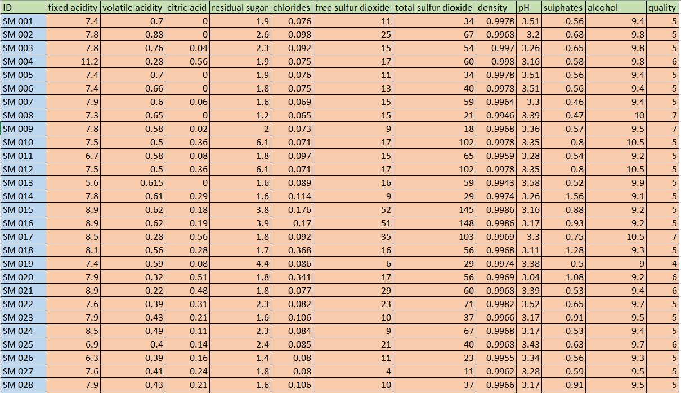
Figure 1. Object–Attribute Matrix (OAM) representing red wine samples and physicochemical attributes.
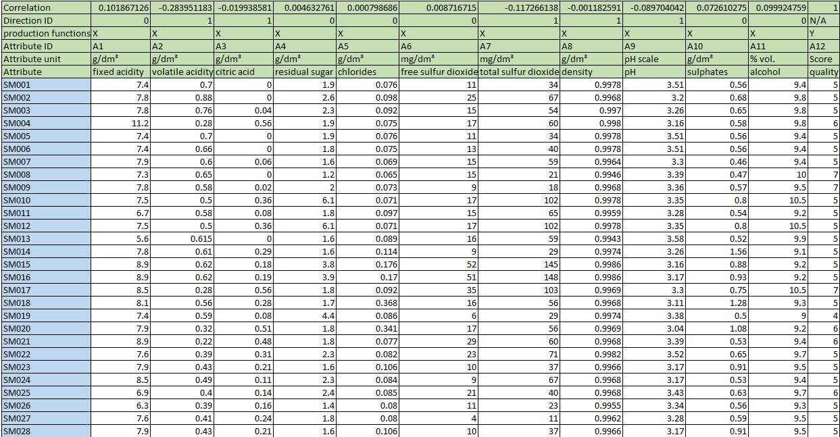
Figure 2. Structured OAM with normalized attributes used for similarity comparison.
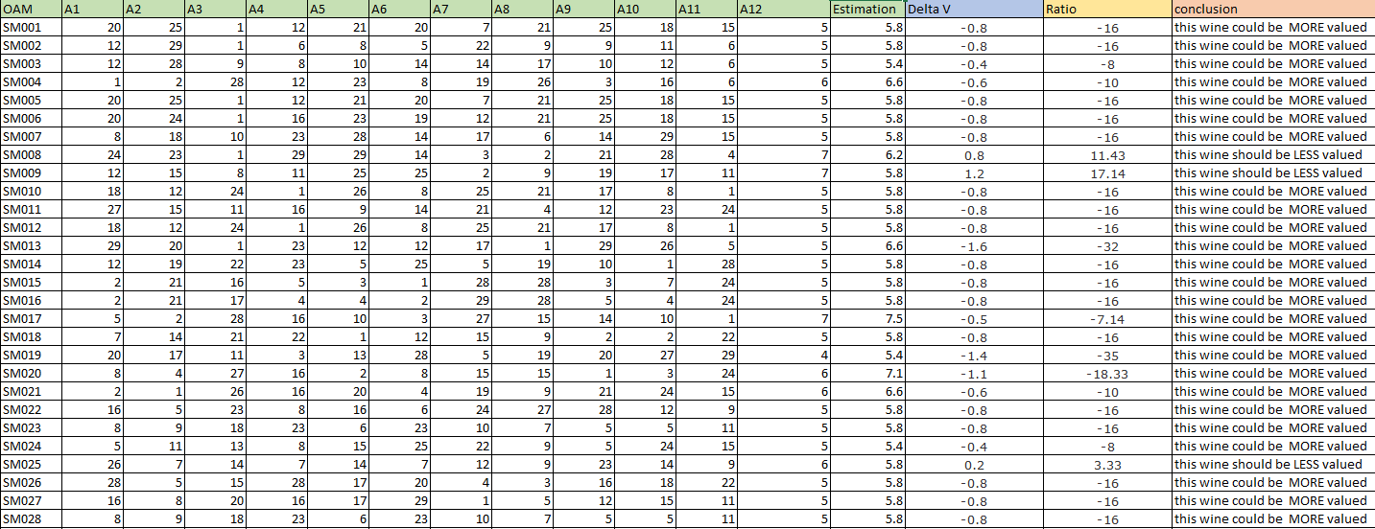
Figure 3. Expert-rated quality and AI-supported similarity-based evaluation

Models Used
This study does not aim to train a new predictive model but rather to explore how existing AI models can support expert-level interpretation. Large Language Models (LLMs) were used as semantic reasoning tools to interpret numerical patterns derived from the Object–Attribute Matrix and similarity analysis.
The LLM was applied to identify influential attributes, explain correlation structures, and generate expert-like qualitative interpretations of quantitative results. In this context, the model functions as an interpretative layer rather than a decision-making authority.
This approach emphasizes transparency and explainability, positioning LLMs as complementary tools to traditional statistical analysis rather than as black-box predictors.

Integration of Similarity Analysis and LLMs
The integration of similarity analysis with LLM-based reasoning enables a hybrid evaluation framework. While similarity metrics provide objective numerical groupings, LLMs translate these results into meaningful insights. This combination allows the system to approximate expert reasoning by linking chemical composition patterns with qualitative interpretations of wine quality.

Results and Interpretation
The analysis revealed several consistent patterns. Alcohol content and sulphates showed strong positive correlations with wine quality, while volatile acidity and density exhibited negative relationships. Similarity groupings demonstrated that wines with comparable profiles often received similar quality scores.
LLM-generated interpretations aligned closely with these findings, correctly identifying key influencing attributes in the majority of cases. Overall, the AI-based framework demonstrated high consistency with expert ratings, indicating that LLM-supported evaluation can replicate expert-level insights with promising accuracy.

Discussion
The results challenge the assumption that expert judgment must remain entirely subjective. Instead, the findings suggest that expert reasoning can be partially formalized through data-driven and semantic AI methods. The hybrid framework preserves objectivity while still allowing nuanced interpretation through LLMs.
This approach also offers scalability and reproducibility, which are difficult to achieve through purely human evaluation. However, the system should be viewed as a decision-support tool rather than a replacement for human experts.

Conclusion
The use of an Object–Attribute Matrix proved essential in structuring wine data in a way that supports objective comparison and expert-level reasoning. By combining OAM-based similarity analysis with LLM-driven interpretation, the study demonstrates how structured numerical data can be transformed into meaningful, expert-like insights.
This framework confirms that expert judgment is not purely intuitive but can be partially formalized through transparent, data-driven methodologies. The proposed approach offers a reproducible and scalable foundation for AI-supported wine evaluation while maintaining interpretability and methodological rigor.

References
Cortez, P., Cerdeira, A., Almeida, F., Matos, T., & Reis, J. (2009). Modeling wine preferences by data mining.
ChatGPT (OpenAI).

